Analysis of Diabetes-Related Health Indicators Using BRFSS 2015 Data
BIOS 585 Final Project
Jiamin Zhao
1. Introduction
Diabetes continues to be one of the most pervasive and costly chronic diseases in the United States. Beyond its well-known complications, diabetes intersects with nearly every dimension of public health—from cardiovascular risk and mobility limitations to healthcare utilization and long-term quality of life. Because the condition is strongly shaped by a combination of demographic, behavioral, and environmental factors, understanding these relationships is essential for designing effective prevention strategies.
In recent years, large-scale surveillance datasets such as the Behavioral Risk Factor Surveillance System (BRFSS) have become especially valuable for studying population-level trends. BRFSS collects extensive self-reported information on health behaviors, chronic conditions, and access to care, creating a rich opportunity to examine how everyday lifestyle factors relate to diabetes in a real-world setting.
The goal of this project is to explore associations between diabetes and several key indicators—smoking, age, BMI, physical activity, and sex—using Python-based data analysis. By combining statistical tests, logistic regression modeling, and data visualization, the project aims to illustrate how publicly available datasets can be used to answer practical epidemiologic questions. Although the analyses are not causal, they provide insight into patterns that may help guide future research or inform public health messaging.
2. Dataset Description
The dataset used in this analysis is derived from the 2015 Behavioral Risk Factor Surveillance System (BRFSS), one of the largest continuously conducted health surveys in the world. The survey relies on a complex sampling design to capture a representative picture of U.S. adults’ health behaviors. For this project, a curated subset of the BRFSS dataset was provided, containing over 253,000 respondents, which allows for robust statistical analysis due to the size and diversity of the sample.
The primary outcome variable is Diabetes_binary, which classifies respondents as having been told by a health professional that they have diabetes (1 = yes, 0 = no). While this measure does not differentiate between Type 1 and Type 2 diabetes, it serves as a widely used indicator in population-level research for understanding diabetes burden.
Key predictor variables include a mix of demographic factors (such as Age and Sex), behavioral indicators (such as Smoker and PhysActivity), and clinical proxies (BMI, HighBP, HighChol). These variables mirror many of the risk factors highlighted in clinical and epidemiologic literature, making the dataset particularly useful for exploring common public health questions.
Prior to analysis, the dataset underwent a structured cleaning process. Several variables used special codes (e.g., 77, 88, 99) to denote missing or non-applicable responses; these were converted to NaN and the affected rows were removed to ensure the validity of statistical procedures. The cleaned version of the dataset was saved as cleaned_diabetes.csv and used for all subsequent analyses.
3. Methods

3.1 Statistical Methods
To address the research questions, a series of statistical procedures were implemented. Each question was paired with a method that appropriately reflects the structure of the variables involved:
- Smoking and diabetes were examined using a chi-square test of independence, which evaluates whether the distribution of diabetes differs between smokers and non-smokers. Chi-square tests are particularly useful for categorical variables and can detect even subtle differences in large samples.
- The association between age and diabetes was assessed using a Pearson correlation coefficient. Since age is continuous and diabetes is binary, the correlation reflects the directional relationship between increasing age and the likelihood of diabetes.
- BMI and age as joint predictors of diabetes were modeled using logistic regression. Logistic models are widely used in epidemiology because they estimate how unit changes in predictors affect the odds of a binary outcome. The model coefficients were interpreted in the context of known risk patterns.
- Differences in diabetes prevalence between males and females were also analyzed using a chi-square test, allowing comparison across the two sex categories.
- The association between physical activity and diabetes was evaluated using another chi-square test. Given the strong emphasis in public health on lifestyle activity as a modifiable risk factor, this question was particularly relevant.

3.2 Software and Packages

All analyses were conducted in Python, leveraging core scientific computing libraries.
- pandas was used for data manipulation and cleaning.
- matplotlib and seaborn were used for visualizations.
- scipy provided statistical testing tools.
- statsmodels was used for fitting the logistic regression model.
These packages together allowed the project to follow a typical workflow used in applied data analysis and modern epidemiologic research.

3.3 Visualization

To support interpretation of the statistical results, a set of visualizations were generated. These included distribution plots, categorical comparison charts, a correlation heatmap, and a scatterplot highlighting the relationship between BMI, age, and diabetes status. Visualizations were intentionally matched to each research question to provide intuitive insight into the underlying patterns.
4. Results

4.1 Summary of Statistical Tests

Table 1. Summary of Statistical Tests
Analysis Question | Test | Statistic | p-value | Interpretation
Smoker vs Diabetes | Chi-square | 937.893 | <0.0001 | Smokers have significantly higher diabetes prevalence
Age vs Diabetes | Pearson r | 0.177 | <0.0001 | Older individuals have higher diabetes risk
BMI + Age → Diabetes | Logistic regression | — | <0.0001 | BMI and Age are significant predictors
Sex vs Diabetes | Chi-square | 250.010 | <0.0001 | Males have slightly higher diabetes prevalence
Physical Activity vs Diabetes | Chi-square | 3537.848 | <0.0001 | Physical activity is strongly protective

4.2 Logistic Regression Results

Table 2. Logistic Regression Coefficients
Variable | Coefficient | Std. Error | z-value | p-value | 95% CI
BMI | 0.0933 | 0.001 | 106.716 | <0.0001 | (0.092, 0.095)
Age | 0.2283 | 0.002 | 96.666 | <0.0001 | (0.224, 0.233)
These results indicate that both higher BMI and older age substantially increase the likelihood of diabetes.

4.3 Figures
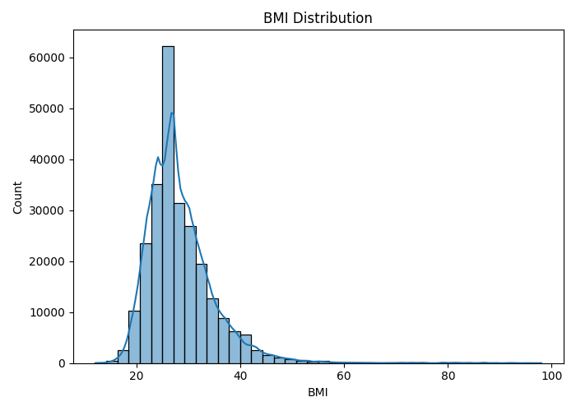

Figure 1. BMI Distribution in the Study Population

This figure shows the distribution of BMI among all participants. Most individuals fall between 20–35, with a slight right skew.

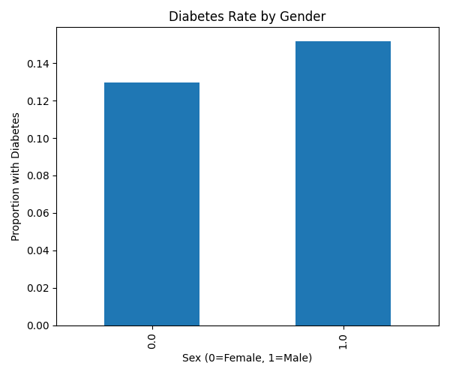

Figure 2. Diabetes Prevalence by Gender
Comparing males and females, males show slightly higher diabetes prevalence.

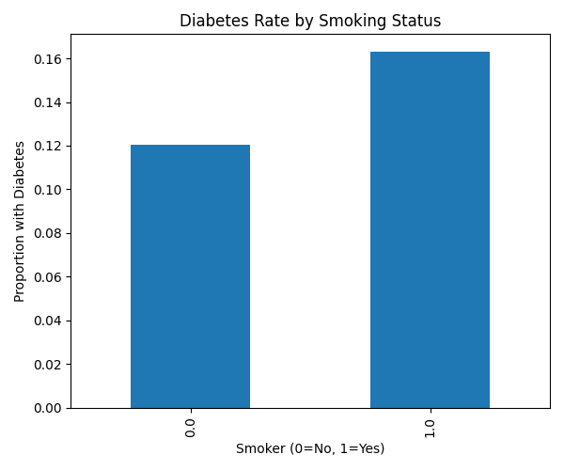

Figure 3. Diabetes Prevalence by Smoking Status
Smokers demonstrate substantially higher diabetes prevalence than non-smokers.

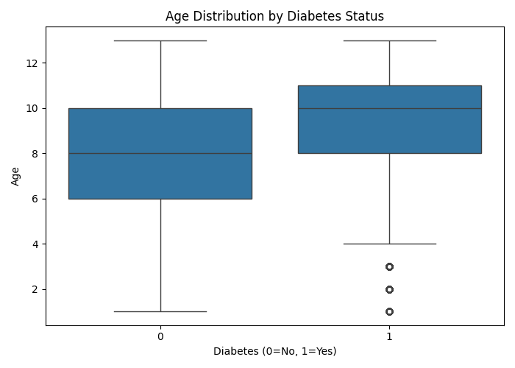

Figure 4. Age Distribution by Diabetes Status
Participants with diabetes tend to be older, with higher medians and greater spread in older age groups.

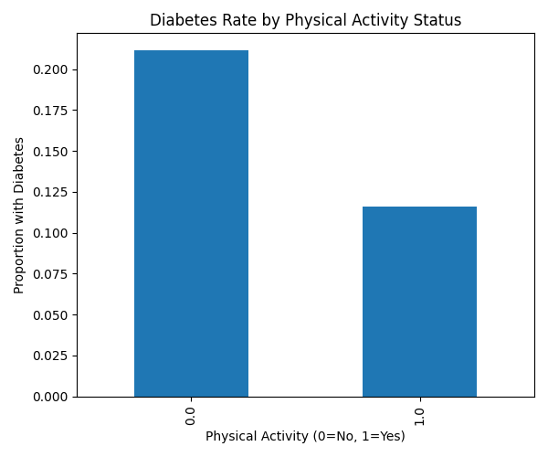

Figure 5. Diabetes Prevalence by Physical Activity
Physically active individuals show much lower diabetes prevalent

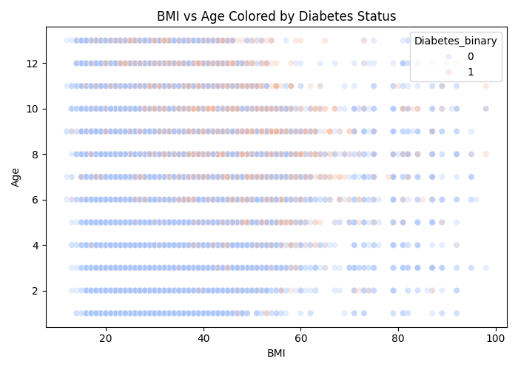

Figure 6. Scatterplot of BMI and Age Colored by Diabetes Status
Shows clustering of diabetes cases at higher BMI and older ages.

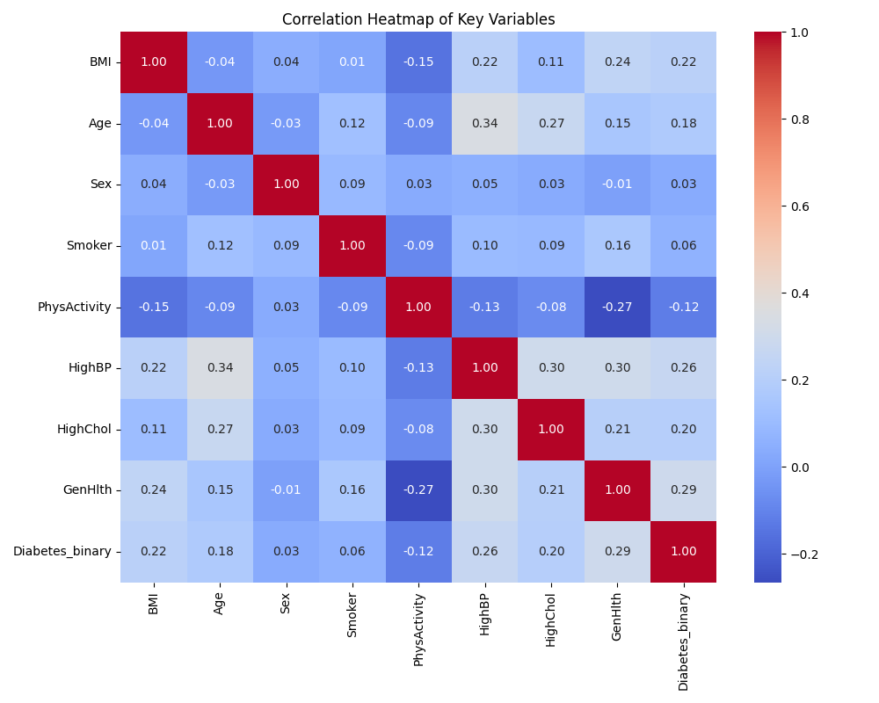

Figure 7. Correlation Heatmap of Key Health Indicators
Illustrates correlations among age, BMI, general health, blood pressure, cholesterol, smoking, physical activity, and diabetes.

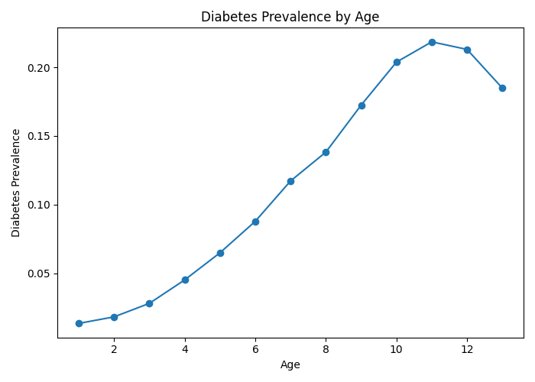

Figure 8. Diabetes Prevalence by Age
Diabetes prevalence increases steadily with age.

5. Discussion
Across all five research questions, several consistent patterns emerged regarding the behavioral and demographic determinants of diabetes prevalence. Smoking, physical inactivity, higher BMI, and older age were each strongly associated with elevated diabetes risk. These findings align with well-established literature showing that metabolic and lifestyle factors play substantial roles in diabetes development. The large sample size of over 250,000 adults allowed these relationships to be detected with high precision, even when effect sizes were modest.
One of the most notable findings was the strength of the association between physical activity and diabetes. Individuals who engaged in regular physical activity showed markedly lower prevalence, reinforcing physical activity as a modifiable protective factor. Similarly, smokers exhibited significantly higher diabetes prevalence. Although smoking is not traditionally categorized as a primary metabolic risk factor, its role in inflammation and insulin resistance may partially explain this elevated risk.
The logistic regression model further clarified the independent contributions of BMI and age. Both predictors remained highly significant even after accounting for one another, suggesting that they contribute unique and non-overlapping risk information. This multivariable evidence supports clinical observations that both excess body weight and advanced age substantially heighten metabolic vulnerability. The relatively large effect size of age also underscores the population-level challenge of diabetes in the context of an aging U.S. demographic.
Sex-based comparisons revealed meaningful but smaller differences: males showed slightly higher diabetes prevalence than females. While the effect is not as striking as BMI or activity patterns, it is consistent with epidemiological trends indicating gendered differences in body composition, hormone profiles, and healthcare utilization.
Despite the strengths of a large, nationally representative dataset, several limitations should be acknowledged. First, the BRFSS relies entirely on self-reported information, which may introduce recall bias or measurement error (e.g., self-reported height and weight). Second, the cross-sectional design prevents establishing causal relationships; associations observed here cannot determine temporal ordering or directionality. Additionally, important confounders—such as diet, family history, or access to care—were not included in this analysis and may influence the observed relationships. Lastly, some variables in BRFSS contain broad or coarse categories, limiting the granularity of the analysis.
Even with these limitations, the consistency across multiple statistical tests and visualizations strengthens confidence in the overall patterns observed.
6. Conclusion
This analysis of BRFSS 2015 data identified several clear and consistent patterns related to diabetes prevalence in U.S. adults. Older age and higher BMI were strongly associated with increased likelihood of diabetes, reflecting well-established metabolic and physiological pathways. Smoking and physical inactivity were also linked to elevated diabetes prevalence, highlighting the continued importance of behavioral risk factors. In contrast, individuals who engaged in regular physical activity exhibited substantially lower prevalence, underscoring the protective role of active lifestyles.
Differences by sex were present but less pronounced, with males showing slightly higher diabetes rates than females. Taken together, these findings align with national epidemiologic trends and reinforce the need for prevention strategies that target both metabolic factors and modifiable health behaviors.
Overall, the study provides a concise overview of key demographic and behavioral correlates of diabetes within a large national sample and supports ongoing public health efforts to reduce the burden of diabetes through targeted risk reduction and lifestyle interventions.
References (APA)
Centers for Disease Control and Prevention. (2015). Behavioral Risk Factor Surveillance System (BRFSS).
Pandas Development Team. (2023). Pandas.
Seaborn Developers. (2023). Seaborn statistical visualization library.
Statsmodels Developers. (2023). Statsmodels: Statistical modeling in Python.

