中核九院_PC与采集模块与管理板三方通信协议

版本 | 更新日期 | 创建者/修订者 | 更新详情
V1.0 | 20190124 | yanly | Init
V1.1 | 20190125 | yanly | 控制类数据增加检验码；  增加Gps等飞控数据；
V1.2 | 20190212 | yanly | GPS数据修改；
V1.3 | 20190214 | yanly | 增加ACK定义；

目录
1 系统构成 3
1.1 系统说明 3
1.2 采集模块物理接口 4
2 PC与采集模块通信协议 5
2.1 通信接口配置 5
2.2 数据协议 5
2.2.1 控制数据具体协议 6
2.2.2 ACK定义 14
2.2.3 心跳数据具体协议 21
3 采集模块与机载管理板通信协议 22
3.1 通信接口配置 22
3.2 数据协议 22
3.2.1 控制数据具体协议 22
3.2.2 心跳数据具体协议 23
4 关于航向规划 23

- 系统构成
  - 系统说明
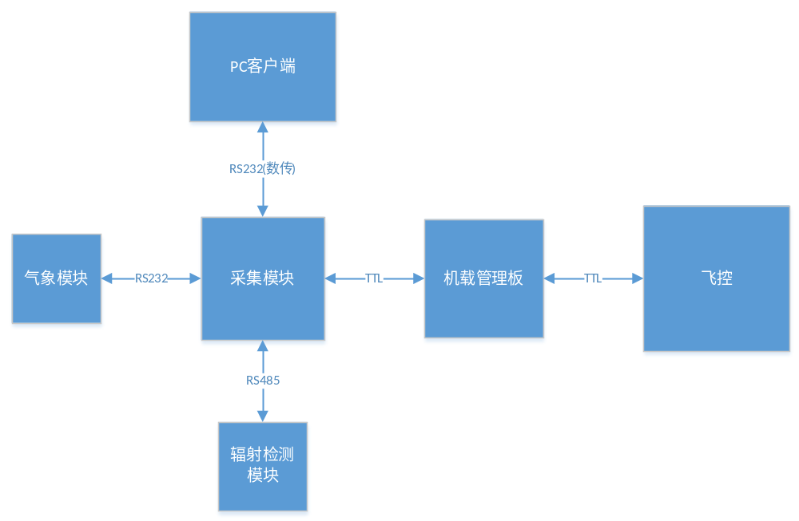
  - 采集模块物理接口
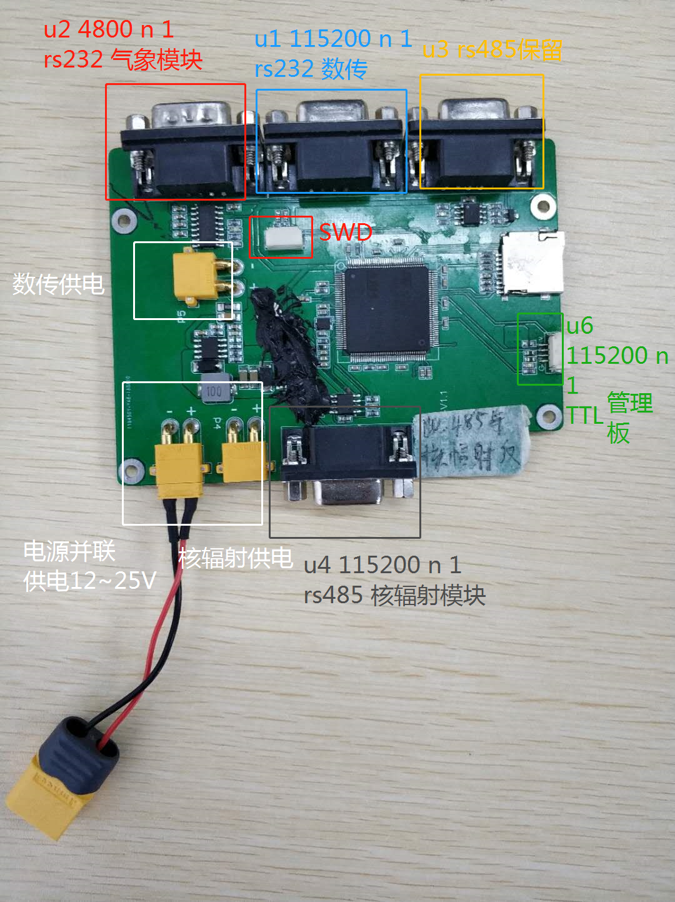

- PC与采集模块通信协议
  - 通信接口配置
接口 | RS232
波特率 | 115200
数据位 | 8
校验位 | 无
停止位 | 1
流控 | 无
  - 数据协议
帧结构总概如下。

- PC→采集模块：
帧首（1byte） | 命令码  （1byte） | 数据  （n bytes） | 检验码  (2 bytes) | 帧尾  (2 bytes)
0x5A | -- | -- | CRC16 | 0x0D | 0x0A

注：0x0D 0x0A其实就是对应的ASCII码 "\r\n"
- 命令码汇总
命令码 | 值 | 方向
设置探头高压 | 0x01 | PC←→Module
设置探头采集时间间隔 | 0x02 | PC←→Module
读取电池容量 | 0x03 | PC←→Module
执行返航 | 0x04 | PC←→Module
upload waypoint mission settings | 0x05 | PC←→Module
upload waypoint data | 0x06 | PC←→Module
start/stop waypoint mission | 0x07 | PC←→Module
pause/resume waypoint mission | 0x08 | PC←→Module
read waypoint init status | 0x09 | PC←→Module
read single waypoint status | 0x0A | PC←→Module
set waypoint mission idle velocity | 0x0B | PC←→Module
get waypoint mission idle velocity | 0x0C | PC←→Module
Gps等飞控数据 | 0xFE | PC←Module

- 采集模块→PC：
帧首 | 具体数据
类型字符串 | --

- 已有类型串：
类型字符串 | 值 | 数据归属
气象类型数据 | $GPGGA, | 心跳数据
气象类型数据 | $GPVTG, | 心跳数据
气象类型数据 | $WIMDA, | 心跳数据
气象类型数据 | $TIROT, | 心跳数据
气象类型数据 | $YXXDR, | 心跳数据
气象类型数据 | $WIMWV, | 心跳数据
气象类型数据 | $GPZDA, | 心跳数据
气象类型数据 | $YXXDR, | 心跳数据
核辐射类型数据 | $HFSSJ, | 心跳数据
飞控状态类型数据 | $WRJSJ, | 心跳数据
控制回复类型数据 | $RESSJ, | 回复/返回数据

- 控制回复类型数据格式（采集模块→PC）：
帧首（7bytes） | 帧首固定码（1byte） | 命令码  （1byte） | 数据  （n bytes） | 检验码  (2 bytes) | 帧尾  (2 bytes)
“$RESSJ,” | 0x5A | -- | -- | CRC16 | 0x0D | 0x0A

- CRC16计算方式
计算范围：帧首固定码（0x5A）~数据。
算法：
void crc_accumulate(uint8_t data, uint16_t *crcAccum) {
/*Accumulate one byte of data into the CRC*/
uint8_t tmp;

tmp = data ^ (uint8_t)(*crcAccum & 0xff);
tmp ^= (tmp << 4);
*crcAccum = (*crcAccum >> 8) ^ (tmp << 8) ^ (tmp << 3) ^ (tmp >> 4);
}
uint16_t crc_calculate(const uint8_t* pBuffer, uint16_t length) {
uint16_t crcTmp = 0XFFFF;

while (length--) {
crc_accumulate(*pBuffer++, &crcTmp);
}
return crcTmp;
}
    - 控制数据具体协议
注1：以下涉及到的所有大于1个字节的数值数据均按照前低后高的小端模式组合。
注2：以下涉及到的数据带前缀0x为16进制数据，不带为10进制数据，带双引号””为ASCII字符串数据。
      - 设置探头高压
-> PC To Module：
0x5A | 0x01 | 高压数据（2 bytes） | 检验码 | 0x0D | 0x0A
- 高压数据：数据范围0~999
->> Module To PC：
“$RESSJ,” | 0x5A | 0x01 | Ack（1 byte） | 检验码 | 0x0D | 0x0A
- Ack定义：
uint8_t ack; //0-success, otherwise-failed
      - 设置探头采集时间间隔
-> PC To Module：
0x5A | 0x02 | 采集时间间隔（2 bytes） | 检验码 | 0x0D | 0x0A
- 采集时间间隔：数据范围0~999
->> Module To PC：
“$RESSJ,” | 0x5A | 0x02 | Ack（1 byte） | 检验码 | 0x0D | 0x0A
- Ack定义：
uint8_t ack; //0-success, otherwise-failed
      - 读取电池容量
-> PC To Module：
0x5A | 0x03 | 0xff | 0xff | 检验码 | 0x0D | 0x0A

->> Module To PC：
“$RESSJ,” | 0x5A | 0x03 | Ack（1 byte） | 检验码 | 0x0D | 0x0A
- Ack定义：
uint8_t ack; //0-success, otherwise-failed

      - 执行返航
-> PC To Module：
0x5A | 0x04 | 0xff | 0xff | 检验码 | 0x0D | 0x0A
->> Module To PC：
“$RESSJ,” | 0x5A | 0x04 | Ack（1 byte） | 检验码 | 0x0D | 0x0A
- Ack定义：
uint8_t ack; //0-success, otherwise-failed
      - upload waypoint mission settings
-> PC To Module：
0x5A | 0x05 | WaypointInitData（n bytes） | 检验码 | 0x0D | 0x0A
- WaypointInitData定义：
typedef struct {
uint8_t indexNumber; //Total number of waypoints
float32_t maxVelocity; //Maximum speed joystick input(2~15m)
float32_t idleVelocity; //Cruising Speed (without joystick input, no more than vel_cmd_range)
uint8_t finishAction; //Action on finish
//0: no action
//1: return to home
//2: auto landing
//3: return to point 0
//4: infinite mode， no exit
uint8_t executiveTimes;//Function execution times
//1: once
//2: twice
uint8_t yawMode; //Yaw mode
//0: auto mode(point to next waypoint)
//1: lock as an initial value
//2: controlled by RC
//3: use waypoint's yaw(tgt_yaw)
uint8_t traceMode; //Trace mode
//0: point to point, after reaching the target waypoint hover, complete waypoints
//action (if any), then fly to the next waypoint
//1: Coordinated turn mode, smooth transition between waypoints, no waypoints task
uint8_t RCLostAction; //Action on rc lost
//0: exit waypoint and failsafe
//1: continue the waypoint
uint8_t gimbalPitch; //Gimbal pitch mode
//0: free mode, no control on gimbal
//1: auto mode, Smooth transition between waypoints
float64_t latitude; //Focus latitude (radian)
float64_t longtitude; //Focus longitude (radian)
float32_t altitude; //Focus altitude (relative takeoff point height)
uint8_t reserved[16]; //Reserved, must be set to 0
} WayPointInitData;
->> Module To PC：
“$RESSJ,” | 0x5A | 0x05 | AckData（n bytes） | 检验码 | 0x0D | 0x0A
- AckData定义：
typedef struct{
uint8_t ack;
} WayPointInitDataAck;
Note: The ACK of task upload is always 0. Developers should check the task parameter by themselves, otherwise error code 0xEA will appear when trying to upload waypoints' data.
      - upload waypoint data
-> PC To Module：
0x5A | 0x06 | WaypointData（n bytes） | 检验码 | 0x0D | 0x0A
- WaypointData定义：
typedef struct {
uint8_t index; //Index to be uploaded
float64_t latitude; //Latitude (radian)
float64_t longitude; //Longitude (radian)
float32_t altitude; //Altitude (relative altitude from takeoff point)
float32_t damping; //Bend length (effective coordinated turn mode only)
int16_t yaw; //Yaw (degree)
int16_t gimbalPitch; //Gimbal pitch
uint8_t turnMode; //Turn mode
//0: clockwise
//1: counter-clockwise
uint8_t reserved[8]; //Reserved
uint8_t hasAction; //Action flag
//0: no action
//1: has action
uint16_t actionTimeLimit; //Action time limit
uint8_t actionNumber : 4; //Total number of actions
uint8_t actionReapeat : 4; //Total running times
uint8_t commandList[16]; //Command list
uint16_t commandParameter[16];//Command parameters
} WayPointData;
- commandList定义：

Commands | Commands value | Command param | Description
WP_ACTION_STAY | 0 | Hover time unit: millisecond | Just hover
WP_ACTION_SIMPLE_SHOT | 1 | N/A | Take a photo
WP_ACTION_VIDEO_START | 2 | N/A | Start record
WP_ACTION_VIDEO_STOP | 3 | N/A | Stop record
WP_ACTION_CRAFT_YAW | 4 | YAW (-180~180) | Adjust the aircraft toward
WP_ACTION_GIMBAL_PITCH | 5 | PITCH | Adjust gimbal pitch 0: head -90: look down

Note: The controller will valid all waypoints' data together after the last one uploaded, which means if there exist at least one invalid waypoint information, the waypoint upload ACK of the last one will be with a error code.
->> Module To PC：
“$RESSJ,” | 0x5A | 0x06 | AckData（n bytes） | 检验码 | 0x0D | 0x0A
- AckData定义：
typedef struct{
uint8_t ack;
uint8_t index;
WayPointData data;
} WayPointDataACK;
      - start/stop waypoint mission
-> PC To Module：
0x5A | 0x07 | start（1 bytes） | 检验码 | 0x0D | 0x0A
- start定义：
uint8_t start;//0-> start, 1-> cancel
->> Module To PC：
“$RESSJ,” | 0x5A | 0x07 | AckData（n bytes） | 检验码 | 0x0D | 0x0A
- AckData定义：
typedef struct{
uint8_t ack;
} Ack;
      - pause/resume waypoint mission
-> PC To Module：
0x5A | 0x08 | pause（1 byte） | 检验码 | 0x0D | 0x0A
- pause定义：
uint8_t pause;//0-> pause, 1-> resume
->> Module To PC：
“$RESSJ,” | 0x5A | 0x08 | AckData（n bytes） | 检验码 | 0x0D | 0x0A
- AckData定义：
typedef struct{
uint8_t ack;
} Ack;
      - read waypoint init status
-> PC To Module：
0x5A | 0x09 | 0x55 | 检验码 | 0x0D | 0x0A
->> Module To PC：
“$RESSJ,” | 0x5A | 0x09 | AckData（n bytes） | 检验码 | 0x0D | 0x0A
- AckData定义：
typedef struct{
uint8_t ack;
WayPointInitData data;
} WayPointInitACK;
      - read single waypoint status
-> PC To Module：
0x5A | 0x0A | index（1 bytes） | 检验码 | 0x0D | 0x0A
- index定义：
uint8_t index;
->> Module To PC：
“$RESSJ,” | 0x5A | 0x0A | AckData（n bytes） | 检验码 | 0x0D | 0x0A
- AckData定义：
typedef struct{
uint8_t ack;
uint8_t index;
WayPointData data;
} WayPointDataACK;
      - set waypoint mission idle velocity
-> PC To Module：
0x5A | 0x0B | idleVeloctity（4 bytes） | 检验码 | 0x0D | 0x0A
- idleVeloctity定义：
float32_t idleVeloctity;
->> Module To PC：
“$RESSJ,” | 0x5A | 0x0B | AckData（n bytes） | 检验码 | 0x0D | 0x0A
- AckData定义：
typedef struct{
uint8_t ack;
float32_t idleVelocity;
} WayPointVelocityACK;
      - get waypoint mission idle velocity
-> PC To Module：
0x5A | 0x0C | 0x55 | 检验码 | 0x0D | 0x0A
->> Module To PC：
“$RESSJ,” | 0x5A | 0x0C | AckData（n bytes） | 检验码 | 0x0D | 0x0A
- AckData定义：
typedef struct{
uint8_t ack;
float32_t idleVelocity;
} WayPointVelocityACK;
      - Gps等飞控数据
该命令实际是心跳数据，定时上报。上报周期1s。
->> Module To PC：
“$RESSJ,” | 0x5A | 0xFE | Data（n bytes） | 检验码 | 0x0D | 0x0A
- Data定义：
typedef struct Data
{
uint8_t ack;
Quaternion q;
GlobalPosition g;
Battery b;
} Data;
typedef struct Quaternion
{
float32_t q0; /*!< w */
float32_t q1; /*!< x */
float32_t q2; /*!< y */
float32_t q3; /*!< z */
};
typedef struct GlobalPosition
{
float64_t latitude; /*!< unit: rad */
float64_t longitude; /*!< unit: rad */
float32_t altitude; /*!< Measured by barometer: WGS 84 reference ellipsoid */
float32_t height; /*!< Ultrasonic height in meters */
uint8_t health; /*!< scale from 0 - 5 signifying gps signal strength <br>
* greater than 3 for strong signal */
};
typedef struct Battery
{
uint32_t capacity;
int32_t voltage;
int32_t current;
uint8_t percentage;
};

    - ACK定义
ACK定义网址：https://developer.dji.com/cn/onboard-sdk/documentation/protocol-doc/ground-station-protocol.html
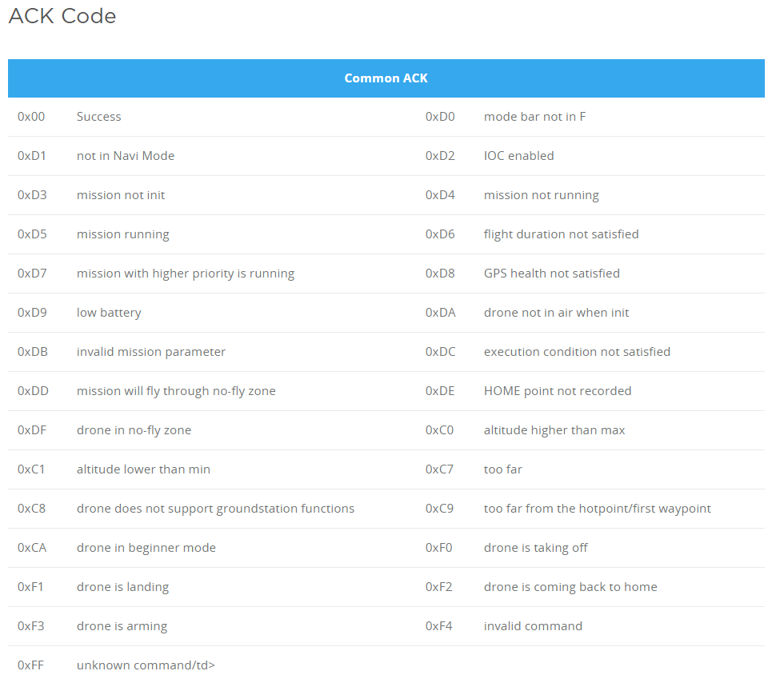
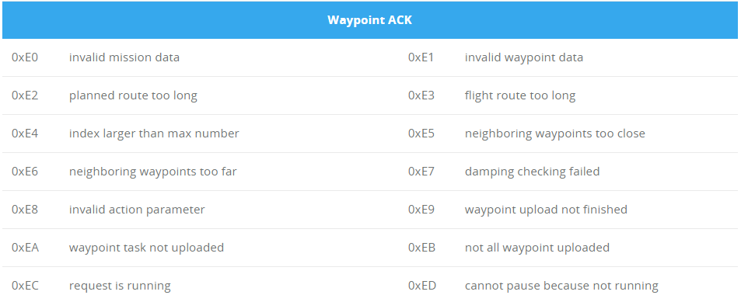

补充（DJI SDK源码）：
const uint16_t DJI::OSDK::ErrorCode::CommonACK::SUCCESS = 0x0000;
const uint16_t DJI::OSDK::ErrorCode::CommonACK::KEY_ERROR = 0xFF00;
const uint16_t DJI::OSDK::ErrorCode::CommonACK::NO_AUTHORIZATION_ERROR = 0xFF01;
const uint16_t DJI::OSDK::ErrorCode::CommonACK::NO_RIGHTS_ERROR = 0xFF02;
const uint16_t DJI::OSDK::ErrorCode::CommonACK::NO_RESPONSE_ERROR = 0xFFFF;
const uint8_t DJI::OSDK::ErrorCode::CommonACK::MOTOR_FAIL_NONE = 0;
const uint8_t DJI::OSDK::ErrorCode::CommonACK::MOTOR_FAIL_COMPASS_ABNORMAL = 1;
const uint8_t DJI::OSDK::ErrorCode::CommonACK::MOTOR_FAIL_ASSISTANT_PROTECTED = 2;
const uint8_t DJI::OSDK::ErrorCode::CommonACK::MOTOR_FAIL_DEVICE_LOCKED = 3;
const uint8_t DJI::OSDK::ErrorCode::CommonACK::MOTOR_FAIL_IMU_NEED_ADV_CALIBRATION = 5;
const uint8_t DJI::OSDK::ErrorCode::CommonACK::MOTOR_FAIL_IMU_SN_ERROR = 6;
const uint8_t DJI::OSDK::ErrorCode::CommonACK::MOTOR_FAIL_IMU_PREHEATING = 7;
const uint8_t DJI::OSDK::ErrorCode::CommonACK::MOTOR_FAIL_COMPASS_CALIBRATING = 8;
const uint8_t DJI::OSDK::ErrorCode::CommonACK::MOTOR_FAIL_IMU_NO_ATTITUDE = 9;
const uint8_t DJI::OSDK::ErrorCode::CommonACK::MOTOR_FAIL_NO_GPS_IN_NOVICE_MODE = 10;
const uint8_t DJI::OSDK::ErrorCode::CommonACK::MOTOR_FAIL_BATTERY_CELL_ERROR = 11;
const uint8_t DJI::OSDK::ErrorCode::CommonACK::MOTOR_FAIL_BATTERY_COMMUNICATION_ERROR = 12;
const uint8_t DJI::OSDK::ErrorCode::CommonACK::MOTOR_FAIL_BATTERY_VOLTAGE_TOO_LOW = 13;
const uint8_t DJI::OSDK::ErrorCode::CommonACK::MOTOR_FAIL_BATTERY_USER_LOW_LAND = 14;
const uint8_t DJI::OSDK::ErrorCode::CommonACK::MOTOR_FAIL_BATTERY_MAIN_VOL_LOW = 15;
const uint8_t DJI::OSDK::ErrorCode::CommonACK::MOTOR_FAIL_BATTERY_TEMP_VOL_LOW = 16;
const uint8_t DJI::OSDK::ErrorCode::CommonACK::MOTOR_FAIL_BATTERY_SMART_LOW_LAND = 17;
const uint8_t DJI::OSDK::ErrorCode::CommonACK::MOTOR_FAIL_BATTERY_NOT_READY = 18;
const uint8_t DJI::OSDK::ErrorCode::CommonACK::MOTOR_FAIL_RUNNING_SIMULATOR = 19;
const uint8_t DJI::OSDK::ErrorCode::CommonACK::MOTOR_FAIL_PACK_MODE = 20;
const uint8_t DJI::OSDK::ErrorCode::CommonACK::MOTOR_FAIL_IMU_ATTI_LIMIT = 21;
const uint8_t DJI::OSDK::ErrorCode::CommonACK::MOTOR_FAIL_NOT_ACTIVATED = 22;
const uint8_t DJI::OSDK::ErrorCode::CommonACK::MOTOR_FAIL_IN_FLYLIMIT_AREA = 23;
const uint8_t DJI::OSDK::ErrorCode::CommonACK::MOTOR_FAIL_IMU_BIAS_LIMIT = 24;
const uint8_t DJI::OSDK::ErrorCode::CommonACK::MOTOR_FAIL_ESC_ERROR = 25;
const uint8_t DJI::OSDK::ErrorCode::CommonACK::MOTOR_FAIL_IMU_INITING = 26;
const uint8_t DJI::OSDK::ErrorCode::CommonACK::MOTOR_FAIL_UPGRADING = 27;
const uint8_t DJI::OSDK::ErrorCode::CommonACK::MOTOR_FAIL_HAVE_RUN_SIM = 28;
const uint8_t DJI::OSDK::ErrorCode::CommonACK::MOTOR_FAIL_IMU_CALIBRATING = 29;
const uint8_t DJI::OSDK::ErrorCode::CommonACK::MOTOR_FAIL_TAKEOFF_TILT_TOO_LARGE = 30;
const uint8_t DJI::OSDK::ErrorCode::CommonACK::MOTOR_FAIL_RESERVED_31 = 31;
const uint8_t DJI::OSDK::ErrorCode::CommonACK::MOTOR_FAIL_RESERVED_32 = 32;
const uint8_t DJI::OSDK::ErrorCode::CommonACK::MOTOR_FAIL_RESERVED_33 = 33;
const uint8_t DJI::OSDK::ErrorCode::CommonACK::MOTOR_FAIL_RESERVED_34 = 34;
const uint8_t DJI::OSDK::ErrorCode::CommonACK::MOTOR_FAIL_RESERVED_35 = 35;
const uint8_t DJI::OSDK::ErrorCode::CommonACK::MOTOR_FAIL_RESERVED_36 = 36;
const uint8_t DJI::OSDK::ErrorCode::CommonACK::MOTOR_FAIL_RESERVED_37 = 37;
const uint8_t DJI::OSDK::ErrorCode::CommonACK::MOTOR_FAIL_RESERVED_38 = 38;
const uint8_t DJI::OSDK::ErrorCode::CommonACK::MOTOR_FAIL_RESERVED_39 = 39;
const uint8_t DJI::OSDK::ErrorCode::CommonACK::MOTOR_FAIL_RESERVED_40 = 40;
const uint8_t DJI::OSDK::ErrorCode::CommonACK::MOTOR_FAIL_INVALID_SN = 41;
const uint8_t DJI::OSDK::ErrorCode::CommonACK::MOTOR_FAIL_RESERVED_42 = 42;
const uint8_t DJI::OSDK::ErrorCode::CommonACK::MOTOR_FAIL_RESERVED_43 = 43;
const uint8_t DJI::OSDK::ErrorCode::CommonACK::MOTOR_FAIL_FLASH_OPERATING = 44;
const uint8_t DJI::OSDK::ErrorCode::CommonACK::MOTOR_FAIL_GPS_DISCONNECT = 45;
const uint8_t DJI::OSDK::ErrorCode::CommonACK::MOTOR_FAIL_INTERNAL_46 = 46;
const uint8_t DJI::OSDK::ErrorCode::CommonACK::MOTOR_FAIL_RECORDER_ERROR = 47;
const uint8_t DJI::OSDK::ErrorCode::CommonACK::MOTOR_FAIL_INVALID_PRODUCT = 48;
const uint8_t DJI::OSDK::ErrorCode::CommonACK::MOTOR_FAIL_RESERVED_49 = 49;
const uint8_t DJI::OSDK::ErrorCode::CommonACK::MOTOR_FAIL_RESERVED_50 = 50;
const uint8_t DJI::OSDK::ErrorCode::CommonACK::MOTOR_FAIL_RESERVED_51 = 51;
const uint8_t DJI::OSDK::ErrorCode::CommonACK::MOTOR_FAIL_RESERVED_52 = 52;
const uint8_t DJI::OSDK::ErrorCode::CommonACK::MOTOR_FAIL_RESERVED_53 = 53;
const uint8_t DJI::OSDK::ErrorCode::CommonACK::MOTOR_FAIL_RESERVED_54 = 54;
const uint8_t DJI::OSDK::ErrorCode::CommonACK::MOTOR_FAIL_RESERVED_55 = 55;
const uint8_t DJI::OSDK::ErrorCode::CommonACK::MOTOR_FAIL_RESERVED_56 = 56;
const uint8_t DJI::OSDK::ErrorCode::CommonACK::MOTOR_FAIL_RESERVED_57 = 57;
const uint8_t DJI::OSDK::ErrorCode::CommonACK::MOTOR_FAIL_RESERVED_58 = 58;
const uint8_t DJI::OSDK::ErrorCode::CommonACK::MOTOR_FAIL_RESERVED_59 = 59;
const uint8_t DJI::OSDK::ErrorCode::CommonACK::MOTOR_FAIL_RESERVED_60 = 60;
const uint8_t DJI::OSDK::ErrorCode::CommonACK::MOTOR_FAIL_IMU_DISCONNECTED = 61;
const uint8_t DJI::OSDK::ErrorCode::CommonACK::MOTOR_FAIL_RC_CALIBRATING = 62;
const uint8_t DJI::OSDK::ErrorCode::CommonACK::MOTOR_FAIL_RC_CALI_DATA_OUT_RANGE = 63;
const uint8_t DJI::OSDK::ErrorCode::CommonACK::MOTOR_FAIL_RC_QUIT_CALI = 64;
const uint8_t DJI::OSDK::ErrorCode::CommonACK::MOTOR_FAIL_RC_CENTER_OUT_RANGE = 65;
const uint8_t DJI::OSDK::ErrorCode::CommonACK::MOTOR_FAIL_RC_MAP_ERROR = 66;
const uint8_t DJI::OSDK::ErrorCode::CommonACK::MOTOR_FAIL_WRONG_AIRCRAFT_TYPE = 67;
const uint8_t DJI::OSDK::ErrorCode::CommonACK::MOTOR_FAIL_SOME_MODULE_NOT_CONFIGURED = 68;
const uint8_t DJI::OSDK::ErrorCode::CommonACK::MOTOR_FAIL_RESERVED_69 = 69;
const uint8_t DJI::OSDK::ErrorCode::CommonACK::MOTOR_FAIL_RESERVED_70 = 70;
const uint8_t DJI::OSDK::ErrorCode::CommonACK::MOTOR_FAIL_RESERVED_71 = 71;
const uint8_t DJI::OSDK::ErrorCode::CommonACK::MOTOR_FAIL_RESERVED_72 = 72;
const uint8_t DJI::OSDK::ErrorCode::CommonACK::MOTOR_FAIL_RESERVED_73 = 73;
const uint8_t DJI::OSDK::ErrorCode::CommonACK::MOTOR_FAIL_NS_ABNORMAL = 74;
const uint8_t DJI::OSDK::ErrorCode::CommonACK::MOTOR_FAIL_TOPOLOGY_ABNORMAL = 75;
const uint8_t DJI::OSDK::ErrorCode::CommonACK::MOTOR_FAIL_RC_NEED_CALI = 76;
const uint8_t DJI::OSDK::ErrorCode::CommonACK::MOTOR_FAIL_INVALID_FLOAT = 77;
const uint8_t DJI::OSDK::ErrorCode::CommonACK::MOTOR_FAIL_M600_BAT_TOO_FEW = 78;
const uint8_t DJI::OSDK::ErrorCode::CommonACK::MOTOR_FAIL_M600_BAT_AUTH_ERR = 79;
const uint8_t DJI::OSDK::ErrorCode::CommonACK::MOTOR_FAIL_M600_BAT_COMM_ERR = 80;
const uint8_t DJI::OSDK::ErrorCode::CommonACK::MOTOR_FAIL_M600_BAT_DIF_VOLT_LARGE_1 = 81;
const uint8_t DJI::OSDK::ErrorCode::CommonACK::MOTOR_FAIL_BATTERY_BOLTAHGE_DIFF_82 = 82;
const uint8_t DJI::OSDK::ErrorCode::CommonACK::MOTOR_FAIL_INVALID_VERSION = 83;
const uint8_t DJI::OSDK::ErrorCode::CommonACK::MOTOR_FAIL_GIMBAL_GYRO_ABNORMAL = 84;
const uint8_t DJI::OSDK::ErrorCode::CommonACK::MOTOR_FAIL_GIMBAL_ESC_PITCH_NO_DATA = 85;
const uint8_t DJI::OSDK::ErrorCode::CommonACK::MOTOR_FAIL_GIMBAL_ESC_ROLL_NO_DATA = 86;
const uint8_t DJI::OSDK::ErrorCode::CommonACK::MOTOR_FAIL_GIMBAL_ESC_YAW_NO_DATA = 87;
const uint8_t DJI::OSDK::ErrorCode::CommonACK::MOTOR_FAIL_GIMBAL_FIRM_IS_UPDATING = 88;
const uint8_t DJI::OSDK::ErrorCode::CommonACK::MOTOR_FAIL_GIMBAL_OUT_OF_CONTROL = 89;
const uint8_t DJI::OSDK::ErrorCode::CommonACK::MOTOR_FAIL_GIMBAL_PITCH_SHOCK = 90;
const uint8_t DJI::OSDK::ErrorCode::CommonACK::MOTOR_FAIL_GIMBAL_ROLL_SHOCK = 91;
const uint8_t DJI::OSDK::ErrorCode::CommonACK::MOTOR_FAIL_GIMBAL_YAW_SHOCK = 92;
const uint8_t DJI::OSDK::ErrorCode::CommonACK::MOTOR_FAIL_IMU_CALI_SUCCESS = 93;
const uint8_t DJI::OSDK::ErrorCode::CommonACK::MOTOR_FAIL_TAKEOFF_EXCEPTION = 94;
const uint8_t DJI::OSDK::ErrorCode::CommonACK::MOTOR_FAIL_ESC_STALL_NEAR_GOUND = 95;
const uint8_t DJI::OSDK::ErrorCode::CommonACK::MOTOR_FAIL_ESC_UNBALANCE_ON_GRD = 96;
const uint8_t DJI::OSDK::ErrorCode::CommonACK::MOTOR_FAIL_ESC_PART_EMPTY_ON_GRD = 97;
const uint8_t DJI::OSDK::ErrorCode::CommonACK::MOTOR_FAIL_ENGINE_START_FAILED = 98;
const uint8_t DJI::OSDK::ErrorCode::CommonACK::MOTOR_FAIL_AUTO_TAKEOFF_LAUNCH_FAILED = 99;
const uint8_t DJI::OSDK::ErrorCode::CommonACK::MOTOR_FAIL_ROLL_OVER_ON_GRD = 100;
const uint8_t DJI::OSDK::ErrorCode::CommonACK::MOTOR_FAIL_BAT_VERSION_ERR = 101;
const uint8_t DJI::OSDK::ErrorCode::CommonACK::MOTOR_FAIL_RTK_INITING = 102;
const uint8_t DJI::OSDK::ErrorCode::CommonACK::MOTOR_FAIL_RTK_FAIL_TO_INIT = 103;
const uint8_t DJI::OSDK::ErrorCode::CommonACK::MOTOR_FAIL_RESERVED_104 = 104;
const uint8_t DJI::OSDK::ErrorCode::CommonACK::MOTOR_FAIL_RESERVED_105 = 105;
const uint8_t DJI::OSDK::ErrorCode::CommonACK::MOTOR_FAIL_RESERVED_106 = 106;
const uint8_t DJI::OSDK::ErrorCode::CommonACK::MOTOR_FAIL_RESERVED_107 = 107;
const uint8_t DJI::OSDK::ErrorCode::CommonACK::MOTOR_FAIL_RESERVED_108 = 108;
const uint8_t DJI::OSDK::ErrorCode::CommonACK::MOTOR_FAIL_RESERVED_109 = 109;
const uint8_t DJI::OSDK::ErrorCode::CommonACK::START_MOTOR_FAIL_MOTOR_STARTED = 110;
const uint8_t DJI::OSDK::ErrorCode::CommonACK::MOTOR_FAIL_INTERNAL_111 = 111;
const uint8_t DJI::OSDK::ErrorCode::CommonACK::MOTOR_FAIL_ESC_CALIBRATING = 112;
const uint8_t DJI::OSDK::ErrorCode::CommonACK::MOTOR_FAIL_GPS_SIGNATURE_INVALID = 113;
const uint8_t DJI::OSDK::ErrorCode::CommonACK::MOTOR_FAIL_GIMBAL_CALIBRATING = 114;
const uint8_t DJI::OSDK::ErrorCode::CommonACK::MOTOR_FAIL_FORCE_DISABLE = 115;
const uint8_t DJI::OSDK::ErrorCode::CommonACK::TAKEOFF_HEIGHT_EXCEPTION = 116;
const uint8_t DJI::OSDK::ErrorCode::CommonACK::MOTOR_FAIL_ESC_NEED_UPGRADE = 117;
const uint8_t DJI::OSDK::ErrorCode::CommonACK::MOTOR_FAIL_GYRO_DATA_NOT_MATCH = 118;
const uint8_t DJI::OSDK::ErrorCode::CommonACK::MOTOR_FAIL_APP_NOT_ALLOW = 119;
const uint8_t DJI::OSDK::ErrorCode::CommonACK::MOTOR_FAIL_COMPASS_IMU_MISALIGN = 120;
const uint8_t DJI::OSDK::ErrorCode::CommonACK::MOTOR_FAIL_FLASH_UNLOCK = 121;
const uint8_t DJI::OSDK::ErrorCode::CommonACK::MOTOR_FAIL_ESC_SCREAMING = 122;
const uint8_t DJI::OSDK::ErrorCode::CommonACK::MOTOR_FAIL_ESC_TEMP_HIGH = 123;
const uint8_t DJI::OSDK::ErrorCode::CommonACK::MOTOR_FAIL_BAT_ERR = 124;
const uint8_t DJI::OSDK::ErrorCode::CommonACK::IMPACT_IS_DETECTED = 125;
const uint8_t DJI::OSDK::ErrorCode::CommonACK::MOTOR_FAIL_MODE_FAILURE = 126;
const uint8_t DJI::OSDK::ErrorCode::CommonACK::MOTOR_FAIL_CRAFT_FAIL_LATELY = 127;
const uint8_t DJI::OSDK::ErrorCode::CommonACK::MOTOR_FAIL_MOTOR_CODE_ERROR = 255;
const uint16_t DJI::OSDK::ErrorCode::ActivationACK::SUCCESS = 0x0000;
const uint16_t DJI::OSDK::ErrorCode::ActivationACK::PARAMETER_ERROR = 0x0001;
const uint16_t DJI::OSDK::ErrorCode::ActivationACK::ENCODE_ERROR = 0x0002;
const uint16_t DJI::OSDK::ErrorCode::ActivationACK::NEW_DEVICE_ERROR = 0x0003;
const uint16_t DJI::OSDK::ErrorCode::ActivationACK::DJIGO_APP_NOT_CONNECTED = 0x0004;
const uint16_t DJI::OSDK::ErrorCode::ActivationACK::NETWORK_ERROR = 0x0005;
const uint16_t DJI::OSDK::ErrorCode::ActivationACK::SERVER_ACCESS_REFUSED = 0x0006;
const uint16_t DJI::OSDK::ErrorCode::ActivationACK::ACCESS_LEVEL_ERROR = 0x0007;
const uint16_t DJI::OSDK::ErrorCode::ActivationACK::OSDK_VERSION_ERROR = 0x0008;
const uint16_t DJI::OSDK::ErrorCode::ControlACK::SetControl::RC_MODE_ERROR = 0x0000;
const uint16_t DJI::OSDK::ErrorCode::ControlACK::SetControl::RELEASE_CONTROL_SUCCESS = 0x0001;
const uint16_t DJI::OSDK::ErrorCode::ControlACK::SetControl::OBTAIN_CONTROL_SUCCESS = 0x0002;
const uint16_t DJI::OSDK::ErrorCode::ControlACK::SetControl::OBTAIN_CONTROL_IN_PROGRESS = 0x0003;
const uint16_t DJI::OSDK::ErrorCode::ControlACK::SetControl::RELEASE_CONTROL_IN_PROGRESS = 0x0004;
const uint16_t DJI::OSDK::ErrorCode::ControlACK::SetControl::RC_NEED_MODE_F = 0x0006;
const uint16_t DJI::OSDK::ErrorCode::ControlACK::SetControl::RC_NEED_MODE_P = 0x0005;
const uint16_t DJI::OSDK::ErrorCode::ControlACK::SetControl::IOC_OBTAIN_CONTROL_ERROR = 0x00C9;
const uint16_t DJI::OSDK::ErrorCode::ControlACK::Task::SUCCESS = 0x0000;
const uint16_t DJI::OSDK::ErrorCode::ControlACK::Task::MOTOR_ON = 0x0001;
const uint16_t DJI::OSDK::ErrorCode::ControlACK::Task::MOTOR_OFF = 0x0002;
const uint16_t DJI::OSDK::ErrorCode::ControlACK::Task::IN_AIR = 0x0003;
const uint16_t DJI::OSDK::ErrorCode::ControlACK::Task::NOT_IN_AIR = 0x0004;
const uint16_t DJI::OSDK::ErrorCode::ControlACK::Task::NO_HOMEPOINT = 0x0005;
const uint16_t DJI::OSDK::ErrorCode::ControlACK::Task::BAD_GPS = 0x0006;
const uint16_t DJI::OSDK::ErrorCode::ControlACK::Task::IN_SIMULATOR_MODE = 0x0007;
const uint16_t DJI::OSDK::ErrorCode::ControlACK::Task::ALREADY_RUNNING = 0x0008;
const uint16_t DJI::OSDK::ErrorCode::ControlACK::Task::NOT_RUNNING = 0x0009;
const uint16_t DJI::OSDK::ErrorCode::ControlACK::Task::INVAILD_COMMAND = 0x0010;
const uint16_t DJI::OSDK::ErrorCode::ControlACK::Task::NO_LANDING_GEAR = 0x0011;
const uint16_t DJI::OSDK::ErrorCode::ControlACK::Task::GIMBAL_MOUNTED = 0x0012;
const uint16_t DJI::OSDK::ErrorCode::ControlACK::Task::BAD_SENSOR = 0x0013;
const uint16_t DJI::OSDK::ErrorCode::ControlACK::Task::ALREADY_PACKED = 0x0014;
const uint16_t DJI::OSDK::ErrorCode::ControlACK::Task::NO_PACKED = 0x0015;
const uint16_t DJI::OSDK::ErrorCode::ControlACK::LegacyTask::SUCCESS = 0x0002;
const uint16_t DJI::OSDK::ErrorCode::ControlACK::LegacyTask::FAIL = 0x0001;
const uint16_t DJI::OSDK::ErrorCode::ControlACK::Task::PACKED_MODE_NOT_SUPPORTED = 0x0016;
const uint16_t DJI::OSDK::ErrorCode::ControlACK::SetArm::AIRCRAFT_IN_AIR_ERROR = 0x0003;
const uint16_t DJI::OSDK::ErrorCode::ControlACK::SetArm::ALREADY_ARMED_ERROR = 0x0002;
const uint16_t DJI::OSDK::ErrorCode::ControlACK::SetArm::OBTAIN_CONTROL_NEEDED_ERROR = 0x0001;
const uint16_t DJI::OSDK::ErrorCode::ControlACK::SetArm::SUCCESS = 0x0000;
const uint8_t DJI::OSDK::ErrorCode::SubscribeACK::SUCCESS = 0x00;
const uint8_t DJI::OSDK::ErrorCode::SubscribeACK::ILLEGAL_DATA_LENGTH = 0x01;
const uint8_t DJI::OSDK::ErrorCode::SubscribeACK::VERSION_DOES_NOT_MATCH = 0x02;
const uint8_t DJI::OSDK::ErrorCode::SubscribeACK::PACKAGE_OUT_OF_RANGE = 0x03;
const uint8_t DJI::OSDK::ErrorCode::SubscribeACK::PACKAGE_ALREADY_EXISTS = 0x04;
const uint8_t DJI::OSDK::ErrorCode::SubscribeACK::PACKAGE_DOES_NOT_EXIST = 0x05;
const uint8_t DJI::OSDK::ErrorCode::SubscribeACK::ILLEGAL_FREQUENCY = 0x06;
const uint8_t DJI::OSDK::ErrorCode::SubscribeACK::PACKAGE_TOO_LARGE = 0x07;
const uint8_t DJI::OSDK::ErrorCode::SubscribeACK::PIPELINE_OVERFLOW = 0x08;
const uint8_t DJI::OSDK::ErrorCode::SubscribeACK::INTERNAL_ERROR_0X09 = 0x09;
const uint8_t DJI::OSDK::ErrorCode::SubscribeACK::PACKAGE_EMPTY = 0x20;
const uint8_t DJI::OSDK::ErrorCode::SubscribeACK::INCORRECT_NUM_OF_TOPICS = 0x21;
const uint8_t DJI::OSDK::ErrorCode::SubscribeACK::ILLEGAL_UID = 0x22;
const uint8_t DJI::OSDK::ErrorCode::SubscribeACK::PERMISSION_DENY = 0x23;
const uint8_t DJI::OSDK::ErrorCode::SubscribeACK::MULTIPLE_SUBSCRIBE = 0x24;
const uint8_t DJI::OSDK::ErrorCode::SubscribeACK::SOURCE_DEVICE_OFFLINE = 0x25;
const uint8_t DJI::OSDK::ErrorCode::SubscribeACK::PAUSED = 0x48;
const uint8_t DJI::OSDK::ErrorCode::SubscribeACK::RESUMED = 0x49;
const uint8_t DJI::OSDK::ErrorCode::SubscribeACK::INTERNAL_ERROR_0X4A = 0x4A;
const uint8_t DJI::OSDK::ErrorCode::SubscribeACK::FAILED_AUTHENTICATION = 0x50;
const uint8_t DJI::OSDK::ErrorCode::SubscribeACK::VERSION_VERSION_TOO_FAR = 0x51;
const uint8_t DJI::OSDK::ErrorCode::SubscribeACK::VERSION_UNKNOWN_ERROR = 0x59;
const uint8_t DJI::OSDK::ErrorCode::SubscribeACK::INTERNAL_ERROR_0XFF = 0xFF;
const uint8_t DJI::OSDK::ErrorCode::MissionACK::Common::SUCCESS = 0x00;
const uint8_t DJI::OSDK::ErrorCode::MissionACK::Common::WRONG_WAYPOINT_INDEX = 0x01;
const uint8_t DJI::OSDK::ErrorCode::MissionACK::Common::RC_NOT_IN_MODE_F = 0xD0;
const uint8_t DJI::OSDK::ErrorCode::MissionACK::Common::OBTAIN_CONTROL_REQUIRED = 0xD1;
const uint8_t DJI::OSDK::ErrorCode::MissionACK::Common::CLOSE_IOC_REQUIRED = 0xD2;
const uint8_t DJI::OSDK::ErrorCode::MissionACK::Common::NOT_INITIALIZED = 0xD3;
const uint8_t DJI::OSDK::ErrorCode::MissionACK::Common::NOT_RUNNING = 0xD4;
const uint8_t DJI::OSDK::ErrorCode::MissionACK::Common::IN_PROGRESS = 0xD5;
const uint8_t DJI::OSDK::ErrorCode::MissionACK::Common::TASK_TIMEOUT = 0xD6;
const uint8_t DJI::OSDK::ErrorCode::MissionACK::Common::OTHER_MISSION_RUNNING = 0xD7;
const uint8_t DJI::OSDK::ErrorCode::MissionACK::Common::BAD_GPS = 0xD8;
const uint8_t DJI::OSDK::ErrorCode::MissionACK::Common::RTK_NOT_READY = 0xCD;
const uint8_t DJI::OSDK::ErrorCode::MissionACK::Common::LOW_BATTERY = 0xD9;
const uint8_t DJI::OSDK::ErrorCode::MissionACK::Common::VEHICLE_DID_NOT_TAKE_OFF = 0xDA;
const uint8_t DJI::OSDK::ErrorCode::MissionACK::Common::INVALID_PARAMETER = 0xDB;
const uint8_t DJI::OSDK::ErrorCode::MissionACK::Common::CONDITIONS_NOT_SATISFIED = 0xDC;
const uint8_t DJI::OSDK::ErrorCode::MissionACK::Common::CROSSING_NO_FLY_ZONE = 0xDD;
const uint8_t DJI::OSDK::ErrorCode::MissionACK::Common::UNRECORDED_HOME = 0xDE;
const uint8_t DJI::OSDK::ErrorCode::MissionACK::Common::AT_NO_FLY_ZONE = 0xDF;
const uint8_t DJI::OSDK::ErrorCode::MissionACK::Common::TOO_HIGH = 0xC0;
const uint8_t DJI::OSDK::ErrorCode::MissionACK::Common::TOO_LOW = 0xC1;
const uint8_t DJI::OSDK::ErrorCode::MissionACK::Common::TOO_FAR_FROM_HOME = 0xC7;
const uint8_t DJI::OSDK::ErrorCode::MissionACK::Common::NOT_SUPPORTED = 0xC8;
const uint8_t DJI::OSDK::ErrorCode::MissionACK::Common::TOO_FAR_FROM_CURRENT_POSITION = 0xC9;
const uint8_t DJI::OSDK::ErrorCode::MissionACK::Common::BEGGINER_MODE_NOT_SUPPORTED = 0xCA;
const uint8_t DJI::OSDK::ErrorCode::MissionACK::Common::TAKE_OFF_IN_PROGRESS = 0xF0;
const uint8_t DJI::OSDK::ErrorCode::MissionACK::Common::LANDING_IN_PROGRESS = 0xF1;
const uint8_t DJI::OSDK::ErrorCode::MissionACK::Common::RRETURN_HOME_IN_PROGRESS = 0xF2;
const uint8_t DJI::OSDK::ErrorCode::MissionACK::Common::START_MOTORS_IN_PROGRESS = 0xF3;
const uint8_t DJI::OSDK::ErrorCode::MissionACK::Common::INVALID_COMMAND = 0xF4;
const uint8_t DJI::OSDK::ErrorCode::MissionACK::Common::UNKNOWN_ERROR = 0xFF;
const uint8_t DJI::OSDK::ErrorCode::MissionACK::Follow::TOO_FAR_FROM_YOUR_POSITION_LACK_OF_RADIO_CONNECTION = 0xB0;
const uint8_t DJI::OSDK::ErrorCode::MissionACK::Follow::CUTOFF_TIME_OVERFLOW = 0xB1;
const uint8_t DJI::OSDK::ErrorCode::MissionACK::Follow::GIMBAL_PITCH_ANGLE_OVERFLOW = 0xB2;
const uint8_t DJI::OSDK::ErrorCode::MissionACK::HotPoint::INVALID_RADIUS = 0xC2;
const uint8_t DJI::OSDK::ErrorCode::MissionACK::HotPoint::YAW_RATE_OVERFLOW = 0xC3;
const uint8_t DJI::OSDK::ErrorCode::MissionACK::HotPoint::INVALID_START_POINT = 0xC4;
const uint8_t DJI::OSDK::ErrorCode::MissionACK::HotPoint::INVALID_YAW_MODE = 0xC5;
const uint8_t DJI::OSDK::ErrorCode::MissionACK::HotPoint::TOO_FAR_FROM_HOTPOINT = 0xC6;
const uint8_t DJI::OSDK::ErrorCode::MissionACK::HotPoint::INVALID_PAREMETER = 0xA2;
const uint8_t DJI::OSDK::ErrorCode::MissionACK::HotPoint::INVALID_LATITUDE_OR_LONGITUTE = 0xA3;
const uint8_t DJI::OSDK::ErrorCode::MissionACK::HotPoint::INVALID_DIRECTION = 0xA6;
const uint8_t DJI::OSDK::ErrorCode::MissionACK::HotPoint::IN_PAUSED_MODE = 0xA9;
const uint8_t DJI::OSDK::ErrorCode::MissionACK::HotPoint::FAILED_TO_PAUSE = 0xAA;
const uint8_t DJI::OSDK::ErrorCode::MissionACK::WayPoint::INVALID_DATA = 0xE0;
const uint8_t DJI::OSDK::ErrorCode::MissionACK::WayPoint::INVALID_POINT_DATA = 0xE1;
const uint8_t DJI::OSDK::ErrorCode::MissionACK::WayPoint::DISTANCE_OVERFLOW = 0xE2;
const uint8_t DJI::OSDK::ErrorCode::MissionACK::WayPoint::TIMEOUT = 0xE3;
const uint8_t DJI::OSDK::ErrorCode::MissionACK::WayPoint::POINT_OVERFLOW = 0xE4;
const uint8_t DJI::OSDK::ErrorCode::MissionACK::WayPoint::POINTS_TOO_CLOSE = 0xE5;
const uint8_t DJI::OSDK::ErrorCode::MissionACK::WayPoint::POINTS_TOO_FAR = 0xE6;
const uint8_t DJI::OSDK::ErrorCode::MissionACK::WayPoint::CHECK_FAILED = 0xE7;
const uint8_t DJI::OSDK::ErrorCode::MissionACK::WayPoint::INVALID_ACTION = 0xE8;
const uint8_t DJI::OSDK::ErrorCode::MissionACK::WayPoint::POINT_DATA_NOT_ENOUGH = 0xE9;
const uint8_t DJI::OSDK::ErrorCode::MissionACK::WayPoint::DATA_NOT_ENOUGH = 0xEA;
const uint8_t DJI::OSDK::ErrorCode::MissionACK::WayPoint::POINTS_NOT_ENOUGH = 0xEB;
const uint8_t DJI::OSDK::ErrorCode::MissionACK::WayPoint::IN_PROGRESS = 0xEC;
const uint8_t DJI::OSDK::ErrorCode::MissionACK::WayPoint::NOT_IN_PROGRESS = 0xED;
const uint8_t DJI::OSDK::ErrorCode::MissionACK::WayPoint::INVALID_VELOCITY = 0xEE;
const uint8_t DJI::OSDK::ErrorCode::MissionACK::IOC::TOO_CLOSE_TO_HOME = 0xA0;
const uint8_t DJI::OSDK::ErrorCode::MissionACK::IOC::UNKNOWN_TYPE = 0xA1;
const uint8_t DJI::OSDK::ErrorCode::MFIOACK::init::SUCCESS = 0x00;
const uint8_t DJI::OSDK::ErrorCode::MFIOACK::init::UNKNOWN_ERROR = 0x01;
const uint8_t DJI::OSDK::ErrorCode::MFIOACK::init::PORT_NUMBER_ERROR = 0x02;
const uint8_t DJI::OSDK::ErrorCode::MFIOACK::init::PORT_MODE_ERROR = 0x03;
const uint8_t DJI::OSDK::ErrorCode::MFIOACK::init::PORT_DATA_ERROR = 0x04;
const uint8_t DJI::OSDK::ErrorCode::MFIOACK::set::SUCCESS = 0x00;
const uint8_t DJI::OSDK::ErrorCode::MFIOACK::set::CHANNEL_ERROR = 0x01;
const uint8_t DJI::OSDK::ErrorCode::MFIOACK::set::PORT_NOT_MAPPED_ERROR = 0x02;
const uint8_t DJI::OSDK::ErrorCode::MFIOACK::get::SUCCESS = 0x00;
    - 心跳数据具体协议
心跳上传顺序：

气象数据 | 100ms | 核辐射数据 | 飞控状态数据 | 心跳间隔 | 气象数据 | 100ms | 核辐射数据 | 飞控状态数据

气象数据：从缓存中取的数据。（初步推论：缓存数据随中断接收，有可能未上传已经有新缓存接收，导致数据包覆盖等情况。）
100ms：核辐射采集等待时间；(主循环阻塞等待100ms，可能导致其它中断接收的数据来不及处理，产生丢包现象)
心跳间隔：可PC设置，开机默认1000ms；
      - 气象数据
数据格式例子：
$GPGGA,062052.40,2309.5015,N,11329.6260,E,2,9,1.0,29.7,M,-4.4,M,,*72
$GPVTG,320.2,T,322.8,M,0.0,N,0.0,K,D*2E
$WIMDA,29.8991,I,1.0125,B,27.9,C,,,48.8,,16.1,C,29.4,T,32.0,M,1.6,N,0.8,M*63
$TIROT,-20.9,A*2D
$YXXDR,C,,C,WCHR,C,,C,WCHT,C,28.2,C,HINX,P,1.0090,B,STNP*55
$WIMWV,56.2,R,1.6,N,A*15
$GPZDA,062053.00,02,04,2018,00,00*69
$YXXDR,A,0.0,D,PTCH,A,1.3,D,ROLL*5F

具体见协议文档《AirMar NMEA 0183__术协议中文》
      - 核辐射数据
数据类型：ASCII字符串。
格式：
“$HFSSJ,xxx
”

解析：
字符串尾有换行。
xxx表示具体数据。因为不需要解析使用，不说明。
      - 飞控状态数据
数据类型：ASCII字符串。
格式：
“$WRJSJ,Battery:12345,ReturnFlag:1
”

解析：
字符串尾有换行。
Battery：unsigned short数值
ReturnFlag：0-没返航，1-已执行返航
- 采集模块与机载管理板通信协议
  - 通信接口配置
接口 | UART TTL
波特率 | 115200
数据位 | 8
校验位 | 无
停止位 | 1
流控 | 无

  - 数据协议
帧结构：
帧首（1byte） | 命令码  （1byte） | 数据  （n bytes） | 检验码（2 bytes） | 帧尾  (2 bytes)
0x5A | -- | -- | CRC16 | 0x0D | 0x0A

命令码简介：
命令码 | 方向 | 命令码类型 | 值
读取电池容量 | Module to MainBoard | 控制/查询类型  （有Respond） | 0x03
执行返航 | Module to MainBoard | 控制/查询类型  （有Respond） | 0x04
upload waypoint mission settings | Module to MainBoard | 控制/查询类型  （有Respond） | 0x05
upload waypoint data | Module to MainBoard | 控制/查询类型  （有Respond） | 0x06
start/stop waypoint mission | Module to MainBoard | 控制/查询类型  （有Respond） | 0x07
pause/resume waypoint mission | Module to MainBoard | 控制/查询类型  （有Respond） | 0x08
read waypoint init status | Module to MainBoard | 控制/查询类型  （有Respond） | 0x09
read single waypoint status | Module to MainBoard | 控制/查询类型  （有Respond） | 0x0A
set waypoint mission idle velocity | Module to MainBoard | 控制/查询类型  （有Respond） | 0x0B
get waypoint mission idle velocity | Module to MainBoard | 控制/查询类型  （有Respond） | 0x0C
飞控数据等上传 | MainBoard To Module | 心跳类型数据  （无Respond） | 0xFE

    - 控制数据具体协议
-> Module to MainBoard数据与PC To Module相同；
->> MainBoard to Module数据与Module To PC类似，在剔除“类型字符串”后相同。
    - 心跳数据具体协议
->> MainBoard to Moudle:
0x5A | 0xFE | Data（n bytes） | 检验码 | 0x0D | 0x0A
- Data定义见2.2.1.13
- 关于航向规划
Waypoint介绍：
https://developer.dji.com/cn/onboard-sdk/documentation/guides/component-guide-missions.html
Waypoint使用：
https://developer.dji.com/cn/onboard-sdk/documentation/application-development-guides/ground-station-programming-guide.html （old）
机载管理板使用航向例子介绍：
https://developer.dji.com/cn/onboard-sdk/documentation/sample-doc/missions.html
机载管理板与飞控通信协议中关于航向的部分：
https://developer.dji.com/cn/onboard-sdk/documentation/introduction/ground-station-protocol.html （old）

