BMI 500 Homework 3
Elara Liu
September 16, 2026

OddJobs and profiling
I connected to OddJobs over SSH and also tried the web portal.
I ran all three datasets with four CPUs and --mem=12G, using Python 3.12.12, Scanpy 1.10.2, and Louvain. Each job finished with exit status 0. I used GNU time for the whole run, time.time() for each section, and cProfile for rank_genes_groups.
Dataset | Input cells | Wall s | CPU s | CPU % | Peak MiB
pbmc3k | 2,700 | 40.45 | 42.83 | 105 | 757.61
pbmc6k | 5,419 | 42.78 | 43.80 | 102 | 828.38
pbmc10k | 11,769 | 80.49 | 85.57 | 106 | 1776.28

Cell counts are from metadata.json. CPU time is user plus system time. GNU time reports peak memory in KiB on Linux, so I divided by 1,024 to get MiB. A CPU value near 100% means about one core was busy on average.
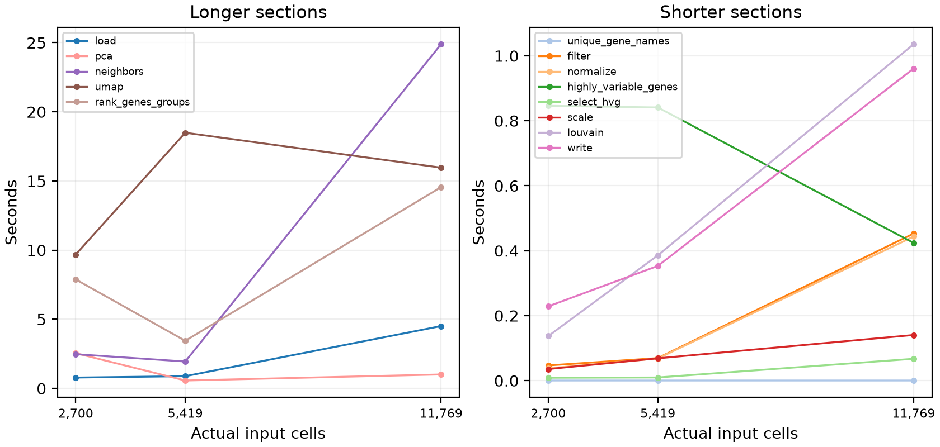
Figure 1. Section times plotted against the actual input cell counts.
UMAP was the largest section for pbmc3k and pbmc6k at 9.68 s and 18.49 s. For pbmc10k, finding neighbors took the most time at 24.89 s.
The timings do not increase smoothly. PCA and marker ranking were faster in pbmc6k than in pbmc3k, and UMAP was faster in pbmc10k than in pbmc6k. I only have one run per dataset, on different nodes, so I would not read too much into these smaller differences.

Marker gene profiling
I compared the saved cProfile results for rank_genes_groups below. Each panel shows the four functions with the largest self times. Self time excludes calls to other functions, while the profile total includes the whole step.
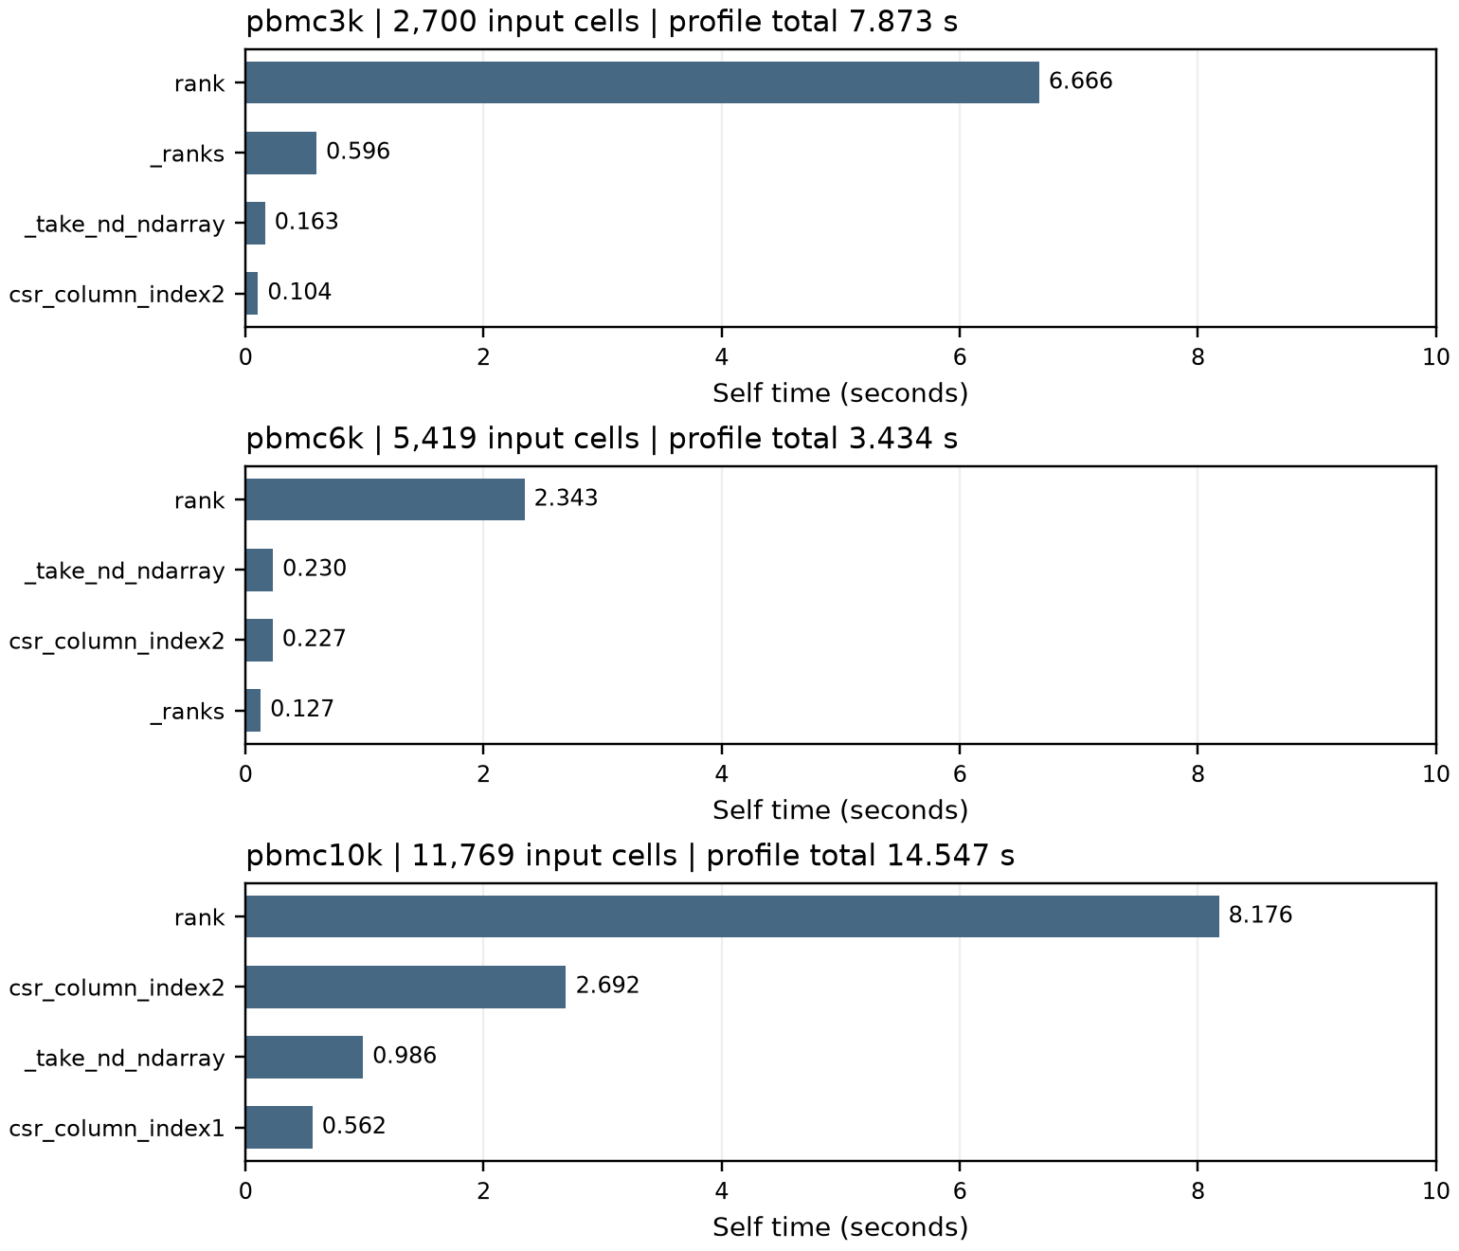
Figure 2. The same time scale is used for all three datasets. Values come from the saved cProfile files.
The rank function took the most self time in every dataset. In pbmc10k, it took 8.18 s, followed by sparse column indexing at 2.69 s. The largest dataset also had more genes and clusters to compare: 20,292 genes and 15 clusters, compared with 13,714 genes and 4 clusters in pbmc3k, and 14,343 genes and 7 clusters in pbmc6k.

Estimate for 20,000 cells
For a rough estimate, I multiplied each section time from the 11,769-cell run by 20,000 / 11,769, or about 1.70. This assumes similar data and hardware. Neighbor finding may grow faster than this, and marker ranking also depends on the genes and clusters.
Section | 11769 cells s | 20000 cells s
load | 4.5069 | 7.6589
unique_gene_names | 0.0004 | 0.0006
filter | 0.4527 | 0.7694
normalize | 0.4435 | 0.7536
highly_variable_genes | 0.4238 | 0.7202
select_hvg | 0.0673 | 0.1143
scale | 0.1405 | 0.2388
pca | 1.0089 | 1.7145
neighbors | 24.8899 | 42.2973
louvain | 1.0357 | 1.7600
umap | 15.9625 | 27.1264
rank_genes_groups | 14.5556 | 24.7355
write | 0.9608 | 1.6327
Total | 64.4484 | 109.5224

The sections add up to 109.52 s. Keeping the 16.04 s spent outside the timed sections gives about 125.56 s for the whole run, or 2.1 minutes.

Matrix vector multiplication and code review
I implemented dot_product() with a for loop and used it row by row in matvec_multiply(). I also added checks for mismatched dimensions and invalid inputs. All 11 tests passed, and the 1,000 by 1,000 example also ran successfully. The separate AI review did not flag any correctness issues.
For the manual review, I looked through Oliver Sun's matvec code and tests. I ran his test file and all 15 tests passed. I also tried a few cases myself and did not find any issues. A more detailed manual review is included in the repo.

Appendix pbmc3k Slurm script
Job 1289350 ran on bignode6. I submitted this script from the repository directory with sbatch.
#!/bin/bash -l
#SBATCH --job-name=bmi500-pbmc3k
#SBATCH --partition=overflow
#SBATCH --nodes=1
#SBATCH --ntasks=1
#SBATCH --cpus-per-task=4
#SBATCH --mem=12G
#SBATCH --time=00:30:00
#SBATCH --output=slurm_outputs/%x-%j.out
set -euo pipefail
cd "$SLURM_SUBMIT_DIR"
source /usr/share/Modules/init/bash
module load bmi/python-3.12.12
source .venv-cluster312/bin/activate
export OMP_NUM_THREADS="$SLURM_CPUS_PER_TASK"
export OPENBLAS_NUM_THREADS="$SLURM_CPUS_PER_TASK"
export MKL_NUM_THREADS="$SLURM_CPUS_PER_TASK"
export NUMBA_NUM_THREADS="$SLURM_CPUS_PER_TASK"
export MPLBACKEND=Agg
export MPLCONFIGDIR="$PWD/.cache/matplotlib"
export NUMBA_CACHE_DIR="$PWD/.cache/numba"
mkdir -p "$MPLCONFIGDIR" "$NUMBA_CACHE_DIR" cluster-results/pbmc3k
echo "JOB=$SLURM_JOB_ID HOST=$(hostname) DATASET=pbmc3k"
date -Is
/usr/bin/time -v -o cluster-results/pbmc3k/time-v.txt \
python -u scanpy_pbmc.py --data-dir data --data-set pbmc3k \
--out-dir cluster-results/pbmc3k --num-threads "$SLURM_CPUS_PER_TASK" \
--profile-output cluster-results/pbmc3k/rank_genes_groups.prof \
> cluster-results/pbmc3k/console.txt 2>&1
cat cluster-results/pbmc3k/console.txt
cat cluster-results/pbmc3k/time-v.txt

Appendix pbmc3k output
Input cells: 2,700. Cells after filtering: 2,700.
using 4 threads
PROFILE section=load seconds=0.784258
PROFILE section=unique_gene_names seconds=0.000383
filtered out 19024 genes that are detected in less than 3 cells
PROFILE section=filter seconds=0.046889
PROFILE section=normalize seconds=0.037830
PROFILE section=highly_variable_genes seconds=0.845978
PROFILE section=select_hvg seconds=0.008927
PROFILE section=scale seconds=0.035645
PROFILE section=pca seconds=2.549231
PROFILE section=neighbors seconds=2.474964
PROFILE section=louvain seconds=0.137149
PROFILE section=umap seconds=9.679466
PROFILE section=rank_genes_groups seconds=7.880974
PROFILE section=write seconds=0.228706

GNU time output
Command being timed: "python -u scanpy_pbmc.py --data-dir data --data-set pbmc3k --out-
dir cluster-results/pbmc3k --num-threads 4 --profile-output cluster-
results/pbmc3k/rank_genes_groups.prof"
User time (seconds): 35.52
System time (seconds): 7.31
Percent of CPU this job got: 105%
Elapsed (wall clock) time (h:mm:ss or m:ss): 0:40.45
Average shared text size (kbytes): 0
Average unshared data size (kbytes): 0
Average stack size (kbytes): 0
Average total size (kbytes): 0
Maximum resident set size (kbytes): 775788
Average resident set size (kbytes): 0
Major (requiring I/O) page faults: 2385
Minor (reclaiming a frame) page faults: 356643
Voluntary context switches: 16552
Involuntary context switches: 138747
Swaps: 0
File system inputs: 529504
File system outputs: 96320
Socket messages sent: 0
Socket messages received: 0
Signals delivered: 0
Page size (bytes): 4096
Exit status: 0
Peak memory: 775,788 KiB / 1,024 = 757.61 MiB.

Appendix pbmc6k Slurm script
Job 1289351 ran on bignode5. I submitted this script from the repository directory with sbatch.
#!/bin/bash -l
#SBATCH --job-name=bmi500-pbmc6k
#SBATCH --partition=overflow
#SBATCH --nodes=1
#SBATCH --ntasks=1
#SBATCH --cpus-per-task=4
#SBATCH --mem=12G
#SBATCH --time=00:30:00
#SBATCH --output=slurm_outputs/%x-%j.out
set -euo pipefail
cd "$SLURM_SUBMIT_DIR"
source /usr/share/Modules/init/bash
module load bmi/python-3.12.12
source .venv-cluster312/bin/activate
export OMP_NUM_THREADS="$SLURM_CPUS_PER_TASK"
export OPENBLAS_NUM_THREADS="$SLURM_CPUS_PER_TASK"
export MKL_NUM_THREADS="$SLURM_CPUS_PER_TASK"
export NUMBA_NUM_THREADS="$SLURM_CPUS_PER_TASK"
export MPLBACKEND=Agg
export MPLCONFIGDIR="$PWD/.cache/matplotlib"
export NUMBA_CACHE_DIR="$PWD/.cache/numba"
mkdir -p "$MPLCONFIGDIR" "$NUMBA_CACHE_DIR" cluster-results/pbmc6k
echo "JOB=$SLURM_JOB_ID HOST=$(hostname) DATASET=pbmc6k"
date -Is
/usr/bin/time -v -o cluster-results/pbmc6k/time-v.txt \
python -u scanpy_pbmc.py --data-dir data --data-set pbmc6k \
--out-dir cluster-results/pbmc6k --num-threads "$SLURM_CPUS_PER_TASK" \
--profile-output cluster-results/pbmc6k/rank_genes_groups.prof \
> cluster-results/pbmc6k/console.txt 2>&1
cat cluster-results/pbmc6k/console.txt
cat cluster-results/pbmc6k/time-v.txt

Appendix pbmc6k output
Input cells: 5,419. Cells after filtering: 5,418.
using 4 threads
PROFILE section=load seconds=0.883246
PROFILE section=unique_gene_names seconds=0.000378
filtered out 1 cells that have less than 200 genes expressed
filtered out 18395 genes that are detected in less than 3 cells
PROFILE section=filter seconds=0.069427
PROFILE section=normalize seconds=0.068270
PROFILE section=highly_variable_genes seconds=0.841044
PROFILE section=select_hvg seconds=0.009747
PROFILE section=scale seconds=0.068673
PROFILE section=pca seconds=0.570714
PROFILE section=neighbors seconds=1.944821
PROFILE section=louvain seconds=0.385676
PROFILE section=umap seconds=18.488595
PROFILE section=rank_genes_groups seconds=3.443477
PROFILE section=write seconds=0.353124

GNU time output
Command being timed: "python -u scanpy_pbmc.py --data-dir data --data-set pbmc6k --out-
dir cluster-results/pbmc6k --num-threads 4 --profile-output cluster-
results/pbmc6k/rank_genes_groups.prof"
User time (seconds): 41.85
System time (seconds): 1.95
Percent of CPU this job got: 102%
Elapsed (wall clock) time (h:mm:ss or m:ss): 0:42.78
Average shared text size (kbytes): 0
Average unshared data size (kbytes): 0
Average stack size (kbytes): 0
Average total size (kbytes): 0
Maximum resident set size (kbytes): 848264
Average resident set size (kbytes): 0
Major (requiring I/O) page faults: 2386
Minor (reclaiming a frame) page faults: 170498
Voluntary context switches: 16882
Involuntary context switches: 46658
Swaps: 0
File system inputs: 529160
File system outputs: 175600
Socket messages sent: 0
Socket messages received: 0
Signals delivered: 0
Page size (bytes): 4096
Exit status: 0
Peak memory: 848,264 KiB / 1,024 = 828.38 MiB.

Appendix pbmc10k Slurm script
Job 1289352 ran on bignode2. I submitted this script from the repository directory with sbatch.
#!/bin/bash -l
#SBATCH --job-name=bmi500-pbmc10k
#SBATCH --partition=overflow
#SBATCH --nodes=1
#SBATCH --ntasks=1
#SBATCH --cpus-per-task=4
#SBATCH --mem=12G
#SBATCH --time=00:30:00
#SBATCH --output=slurm_outputs/%x-%j.out
set -euo pipefail
cd "$SLURM_SUBMIT_DIR"
source /usr/share/Modules/init/bash
module load bmi/python-3.12.12
source .venv-cluster312/bin/activate
export OMP_NUM_THREADS="$SLURM_CPUS_PER_TASK"
export OPENBLAS_NUM_THREADS="$SLURM_CPUS_PER_TASK"
export MKL_NUM_THREADS="$SLURM_CPUS_PER_TASK"
export NUMBA_NUM_THREADS="$SLURM_CPUS_PER_TASK"
export MPLBACKEND=Agg
export MPLCONFIGDIR="$PWD/.cache/matplotlib"
export NUMBA_CACHE_DIR="$PWD/.cache/numba"
mkdir -p "$MPLCONFIGDIR" "$NUMBA_CACHE_DIR" cluster-results/pbmc10k
echo "JOB=$SLURM_JOB_ID HOST=$(hostname) DATASET=pbmc10k"
date -Is
/usr/bin/time -v -o cluster-results/pbmc10k/time-v.txt \
python -u scanpy_pbmc.py --data-dir data --data-set pbmc10k \
--out-dir cluster-results/pbmc10k --num-threads "$SLURM_CPUS_PER_TASK" \
--profile-output cluster-results/pbmc10k/rank_genes_groups.prof \
> cluster-results/pbmc10k/console.txt 2>&1
cat cluster-results/pbmc10k/console.txt
cat cluster-results/pbmc10k/time-v.txt

Appendix pbmc10k output
Input cells: 11,769. Cells after filtering: 11,537.
using 4 threads
PROFILE section=load seconds=4.506889
PROFILE section=unique_gene_names seconds=0.000370
filtered out 232 cells that have less than 200 genes expressed
filtered out 13246 genes that are detected in less than 3 cells
PROFILE section=filter seconds=0.452726
PROFILE section=normalize seconds=0.443482
PROFILE section=highly_variable_genes seconds=0.423808
PROFILE section=select_hvg seconds=0.067274
PROFILE section=scale seconds=0.140522
PROFILE section=pca seconds=1.008918
PROFILE section=neighbors seconds=24.889854
PROFILE section=louvain seconds=1.035697
PROFILE section=umap seconds=15.962540
PROFILE section=rank_genes_groups seconds=14.555593
PROFILE section=write seconds=0.960762

GNU time output
Command being timed: "python -u scanpy_pbmc.py --data-dir data --data-set pbmc10k --out-
dir cluster-results/pbmc10k --num-threads 4 --profile-output cluster-
results/pbmc10k/rank_genes_groups.prof"
User time (seconds): 79.51
System time (seconds): 6.06
Percent of CPU this job got: 106%
Elapsed (wall clock) time (h:mm:ss or m:ss): 1:20.49
Average shared text size (kbytes): 0
Average unshared data size (kbytes): 0
Average stack size (kbytes): 0
Average total size (kbytes): 0
Maximum resident set size (kbytes): 1818912
Average resident set size (kbytes): 0
Major (requiring I/O) page faults: 2384
Minor (reclaiming a frame) page faults: 883539
Voluntary context switches: 25108
Involuntary context switches: 54027
Swaps: 0
File system inputs: 530584
File system outputs: 630944
Socket messages sent: 0
Socket messages received: 0
Signals delivered: 0
Page size (bytes): 4096
Exit status: 0
Peak memory: 1,818,912 KiB / 1,024 = 1776.28 MiB.

