EDA实验二

1181002038 张璐矾

实验目的：使用verilog设计一个带使能的38译码器。0代表灯亮，译码，1代表灯灭，不译码。

实验设计：A是3位，Y是8位，括号里的数字代表位数。

|  |  |  |  |  |  |  |  |  |  |  |  |
| --- | --- | --- | --- | --- | --- | --- | --- | --- | --- | --- | --- |
| input | | | | output | | | | | | | |
| En | A(2) | A(1) | A(0) | Y(7) | Y(6) | Y(5) | Y(4) | Y(3) | Y(2) | Y(1) | Y(0) |
| 0 | 0 | 0 | 0 | 1 | 1 | 1 | 1 | 1 | 1 | 1 | 1 |
| 0 | 0 | 0 | 1 | 1 | 1 | 1 | 1 | 1 | 1 | 1 | 1 |
| 0 | 0 | 1 | 0 | 1 | 1 | 1 | 1 | 1 | 1 | 1 | 1 |
| 0 | 0 | 1 | 1 | 1 | 1 | 1 | 1 | 1 | 1 | 1 | 1 |
| 0 | 0 | 0 | 0 | 1 | 1 | 1 | 1 | 1 | 1 | 1 | 1 |
| 0 | 0 | 0 | 1 | 1 | 1 | 1 | 1 | 1 | 1 | 1 | 1 |
| 0 | 0 | 1 | 0 | 1 | 1 | 1 | 1 | 1 | 1 | 1 | 1 |
| 0 | 0 | 1 | 1 | 1 | 1 | 1 | 1 | 1 | 1 | 1 | 1 |
| 1 | 0 | 0 | 0 | 1 | 1 | 1 | 1 | 1 | 1 | 1 | 0 |
| 1 | 0 | 0 | 1 | 1 | 1 | 1 | 1 | 1 | 1 | 0 | 1 |
| 1 | 0 | 1 | 0 | 1 | 1 | 1 | 1 | 1 | 0 | 1 | 1 |
| 1 | 0 | 1 | 1 | 1 | 1 | 1 | 1 | 0 | 1 | 1 | 1 |
| 1 | 0 | 0 | 0 | 1 | 1 | 1 | 0 | 1 | 1 | 1 | 1 |
| 1 | 0 | 0 | 1 | 1 | 1 | 0 | 1 | 1 | 1 | 1 | 1 |
| 1 | 0 | 1 | 0 | 1 | 0 | 1 | 1 | 1 | 1 | 1 | 1 |
| 1 | 0 | 1 | 1 | 0 | 1 | 1 | 1 | 1 | 1 | 1 | 1 |

代码：

module lab2(in,en,out);

input [2:0]in;

input en;

output [7:0]out;

reg [7:0]out;

wire [3:0]sel;

assign sel = {en,in};

always @(in,en)

case(sel)

4'b1000: out = 8'b11111110;

4'b1001: out = 8'b11111101;

4'b1010: out = 8'b11111011;

4'b1011: out = 8'b11110111;

4'b1100: out = 8'b11101111;

4'b1101: out = 8'b11011111;

4'b1110: out = 8'b10111111;

4'b1111: out = 8'b01111111;

default: out = 8'b11111111;

endcase

endmodule

仿真：

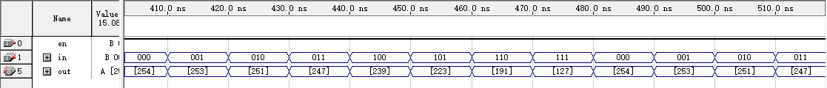

RTL：

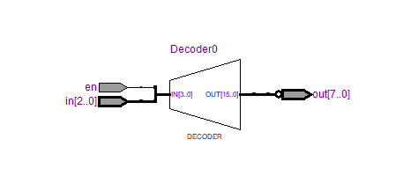

门电路：



实物图：

