Laboratory report №2

Getting things ready

The Task

1. Setup a public Git repository on Github1 and send an e-mail with your name and repository address

to orest.a.lavriv@lpnu.ua (1 point);

2. Commit README.md file to your repository with “HELLO WORLD” text (+1 point);

3. Create a branch “test” with a different README.md file (+1 point);

4. Commit a sample “Hello world” project to your repository into the branch “Seminar01” (+1 point);

5. Provide the project compilation and running instructions in the branch “Seminar01” (+1 point);

So, here is link for my repository - <https://github.com/MichaelMedvetskiy/Distributed-Systems>

And some screenshots:

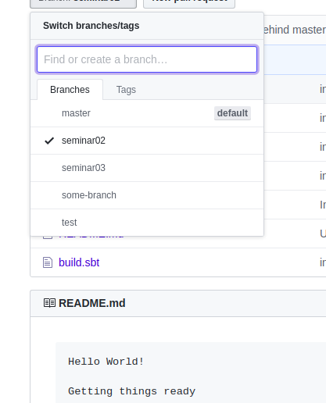

Picture 1. Created branches and “hello world” in readme.md

Conclusion: During laboratory work I have learn basics of CVS Git, and learned basic commands.