Laboratory report №1

Distributed Systems Seminars: Introduction

Tasks

a. If at the verification time your repository contains a \*.java file that runs: you get 1 point;

b. If your \*.java file also prints “HELLo World!”: +1 point;

c. If your \*.java file also asks user for a name and writes “Hello, <username>” (where

<username> is the name user enters): +1 point;

d. If your \*.java file also counts how many letters entered username has and prints factorial of

that count: +1 point;

e. If your \*.java file also asks user for a birth date and writes how many years he/she has: +1

point;

f. BONUS: If you’re the first one to complete all non-bonus points (write “task complete” in

your commit message to be able to assess that): +1 point;

g. BONUS: if your solution also prints the user’s age in days: +1 point;

So, here is link for my repository - <https://github.com/ZLStas/labs\>

Results to first lab placed in master branch

And some screenshots:

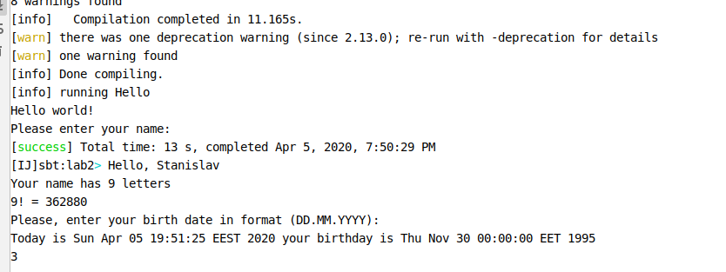

Picture 1. Running a project with fulfilled required information.

Conclusion: During the laboratory I have set up env and wrote simple app.The work results you can find : master branch -> lab2/src/main/scala/Hello.scala