# Laboratory report №03

# Distributed Systems Seminars: TCP Sockets

# Tasks

# 1. Create a branch “Seminar03” from your master’s or “Seminar01” code and perform the following tasks in this branch (1 point);

# 2. Establish a socket connection to the server XX.XX.XX.XX and gracefully shutdown it at the end of an application (+1 point);

# 3. Implement “ping”, “echo” and “exit” commands following the protocol, defined below. (+1 point);

# 4. Implement “login” and “list” commands following the protocol, defined below. (+1 point);

# 5. Implement message sending (“msg” command) and receiving following the protocol, defined below (+1 point);

# 6. BONUS: Implement live user list updates (i.e., printing when user logins or logs out) (+1 point); 7. BONUS: Implement file transfer (and receive) using “file” command. (+1 point);

And some screenshots:

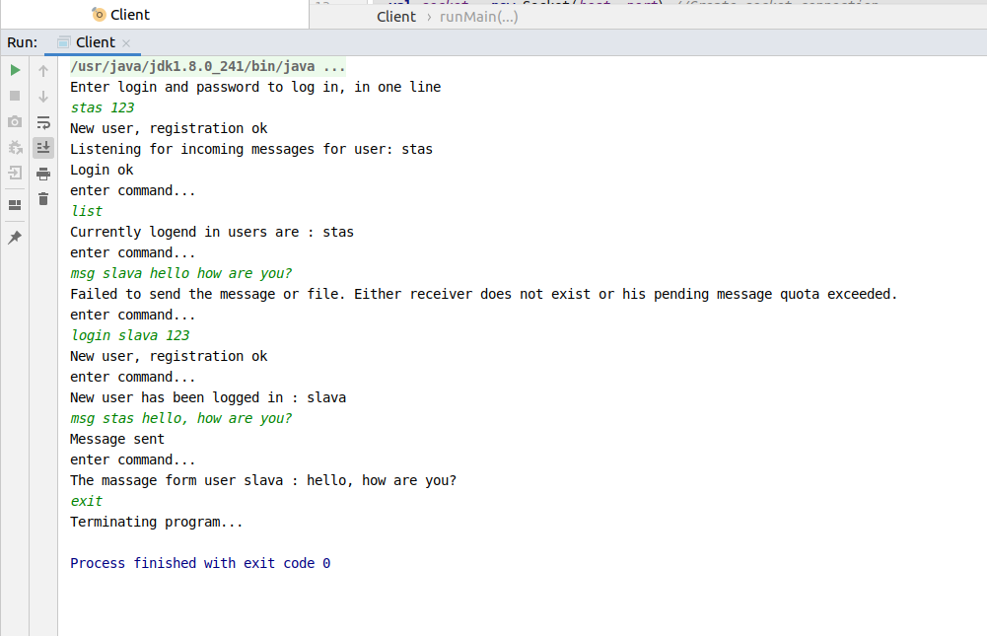

Picture 1. Running a project with fulfilled required information.

# Source code of the project can be found here: <https://github.com/ZLStas/labs/tree/seminar03>

# Conclusion

# During the laboratory I have gain some knowledge about TCP sockets and how to work with them in java, and concluded client application which can send and receive messages from TCP server.