# Laboratory report №04

# Distributed Systems Seminars: Remote Method Invocation

# Tasks

# There is the “Seminar04” branch in your repository: +1 point;

# 2. Application in branch “Seminar03” runs successfully if user is following instructions defined in README file and successfully starts when the server is running and fails with exception or prints a connection error message when the server is not available: +1 point;

# 3. Application allows entering ping and echo commands. Both commands work properly when the server is running and fail when server is unexpectedly turned off. Also, both commands print server response (if any). Finally, application gracefully shuts down when a user types “exit”: +1 point;

# 4. Application allows logging in (and properly handles login error messages) and allows listing currently logged in users: +1 point;

# 5. Application allows sending a messages or files to another user (using “msg” or “file” command) and is able to receive a message/file from the remote user (when the user is logged in). Refuses to invoke commands if the user is not logged in: +1 point;

# 6. Application prints the message when a new user logs in to the server and logs out of the server: +1 point;

# 7. You are the first one to send the e-mail indicating that you solved all 5 tasks and indeed all the tasks are working properly: +1 point; Total: 7 points.

And some screenshots: 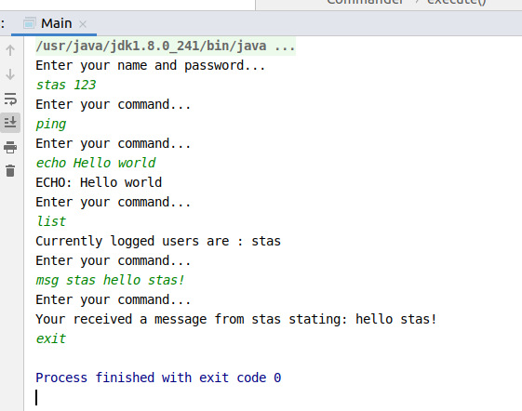

Picture 1. Running a project with fulfilled required information.

Source code of the project can be found here: <https://github.com/ZLStas/labs/tree/seminar04>

Conclusion

During the laboratory I have gain some knowledge about remote method invocation in java, and concluded client application which can send and receive messages from RMI server.