
North America Energy Briefing Packet
Draft delivery shell for Canada, Mexico, and the United States

Contents placeholder

1. Executive Summary
{{SUMMARY_LINE_1}}
{{SUMMARY_LINE_2}}
{{SUMMARY_LINE_3}}
Review comment: replace this section with final delivery text.

2. Country Snapshot
Country | Population (M) | GDP (T USD) | CO2 (Mt) | Top power source | Top source TWh
{{SNAPSHOT_1}} | {{SNAPSHOT_2}} | {{SNAPSHOT_3}} | {{SNAPSHOT_4}} | {{SNAPSHOT_5}} | {{SNAPSHOT_6}}

3. Electricity Mix
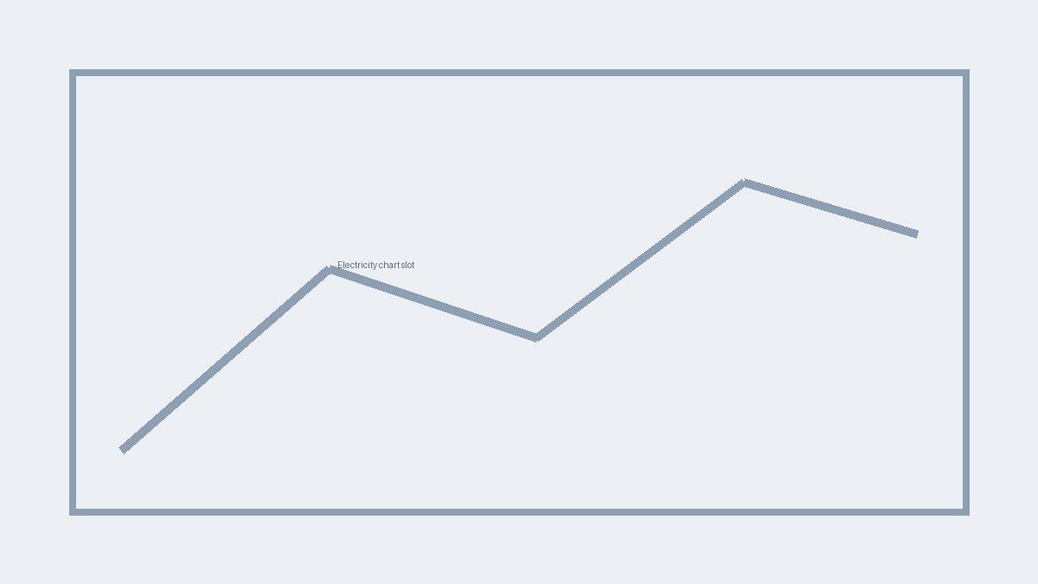
{{ELECTRICITY_CAPTION}}

4. CO2 Trend
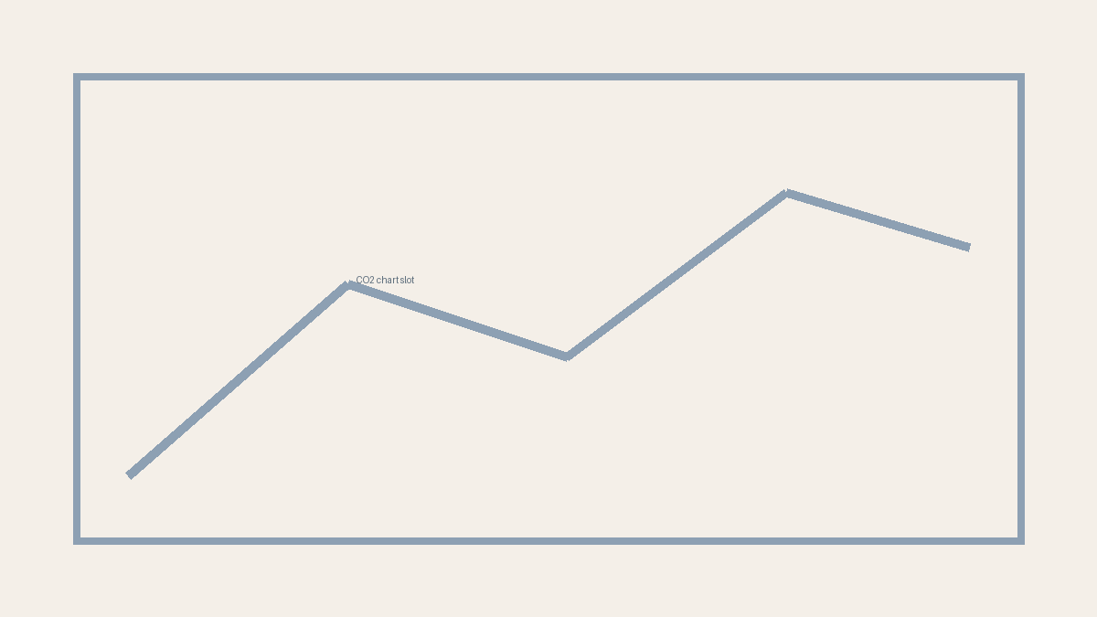
{{CO2_CAPTION}}

5. Source Notes
{{SOURCE_NOTE_LINES}}

Appendix A. Country Profile Notes
Country | Capital | Income level | Region
{{PROFILE_1}} | {{PROFILE_2}} | {{PROFILE_3}} | {{PROFILE_4}}
{{APPENDIX_NOTE}}

