Rugby Management System User Manual

To start, you will need to load in your save files if you have any, by clicking File->Load->Teams/Player  
and navigate to your save file. (Make sure you load in teams before players otherwise your players will lose their teams they are enrolled to.) This will not work if your save file has multiples of the same entry.

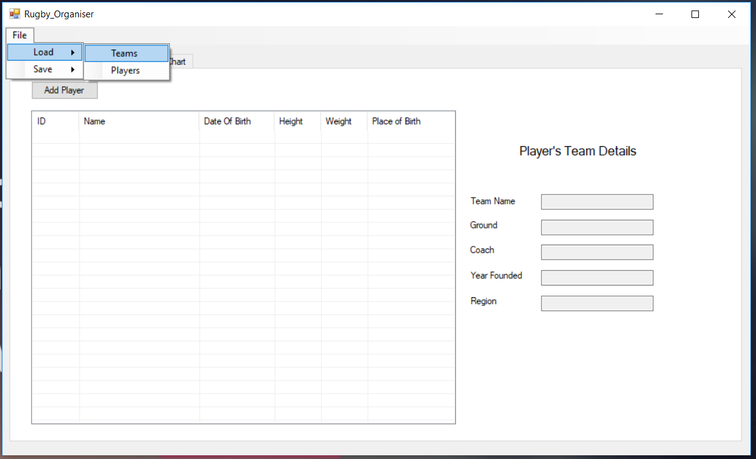

As displayed below you can select a player by simply clicking on the players cell, following this if the player is in a team then the team's details will be displayed on the right hand side.

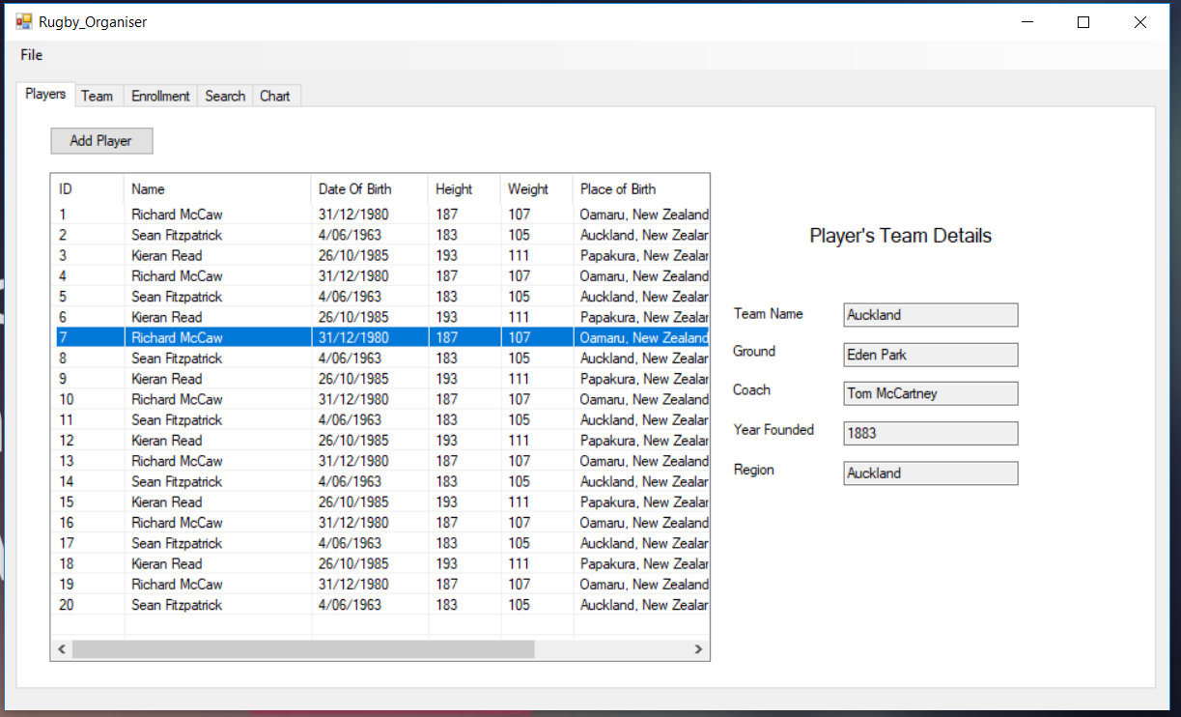

To add a player simply press the "Add Player" button in the top left. This will take you too another window as shown below where you can enter the details of the player you wish to add. Make sure that the ID is unique and that no other player has the same ID. Once you have filled out the details press "Add Player" at the bottom of the window to confirm addition.

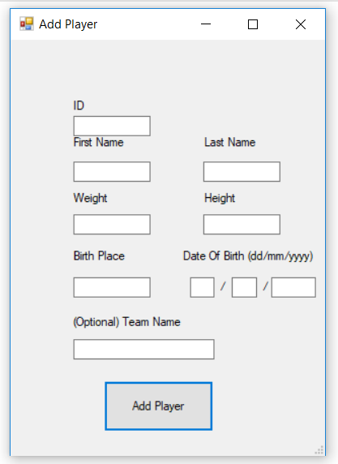

Shown Below is the Team tab which displays teams and their details. When selecting a team by clicking on their cell, this will display the teams signed players(if any exist) on the right side of the window.

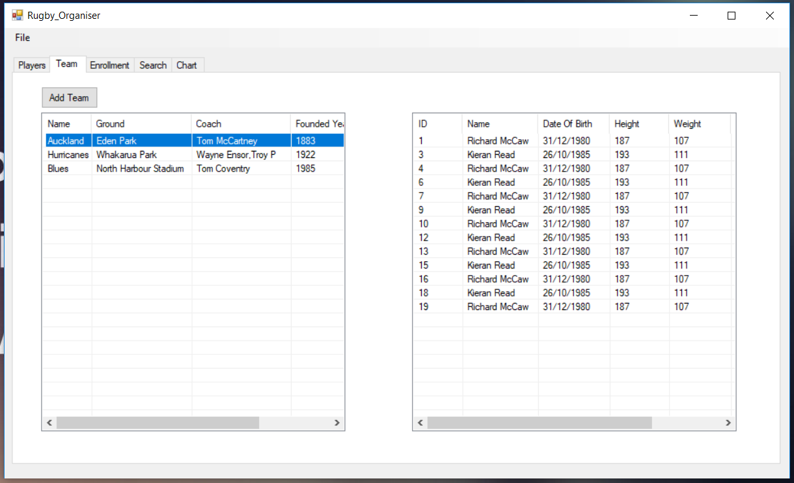

To add a team simply press the "Add Team" button in the top left. This will take you too another window as shown below where you can enter the details of the player you wish to add. Make sure that the Team name is unique and that no other team has the same name. Once you have filled out the details press "Add Team" at the bottom of the window to confirm addition

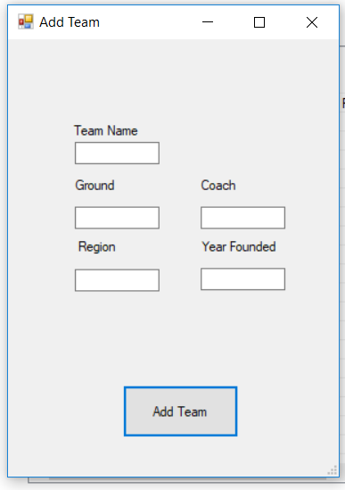

To Enroll a player , you must go to the "Enrollment" tab and then select a player and a team and then click the "Enroll" button. The player then selected will then enroll into the team.

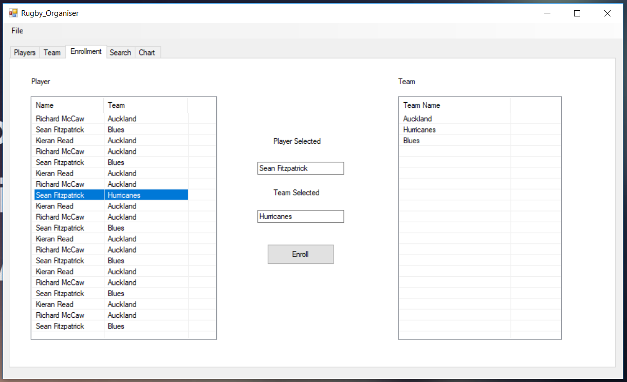

Within the Search tab, you are able to search for players based on their age. Simply input the age you wish to search for, press the Age radio button and then click "Search".

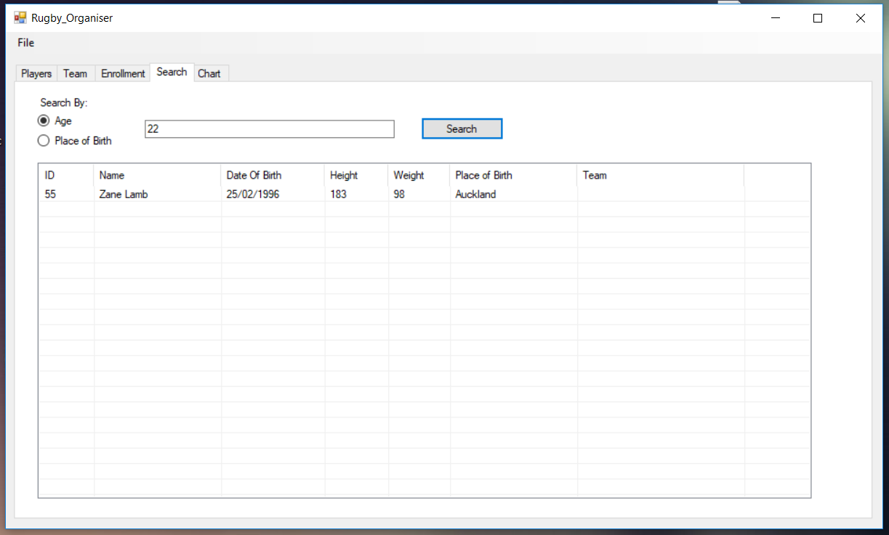

Also within the Search tab, you are able to search for players based on their Place of Birth. Simply input the Location you wish to search for, press the Place of Birth radio button and then click "Search".

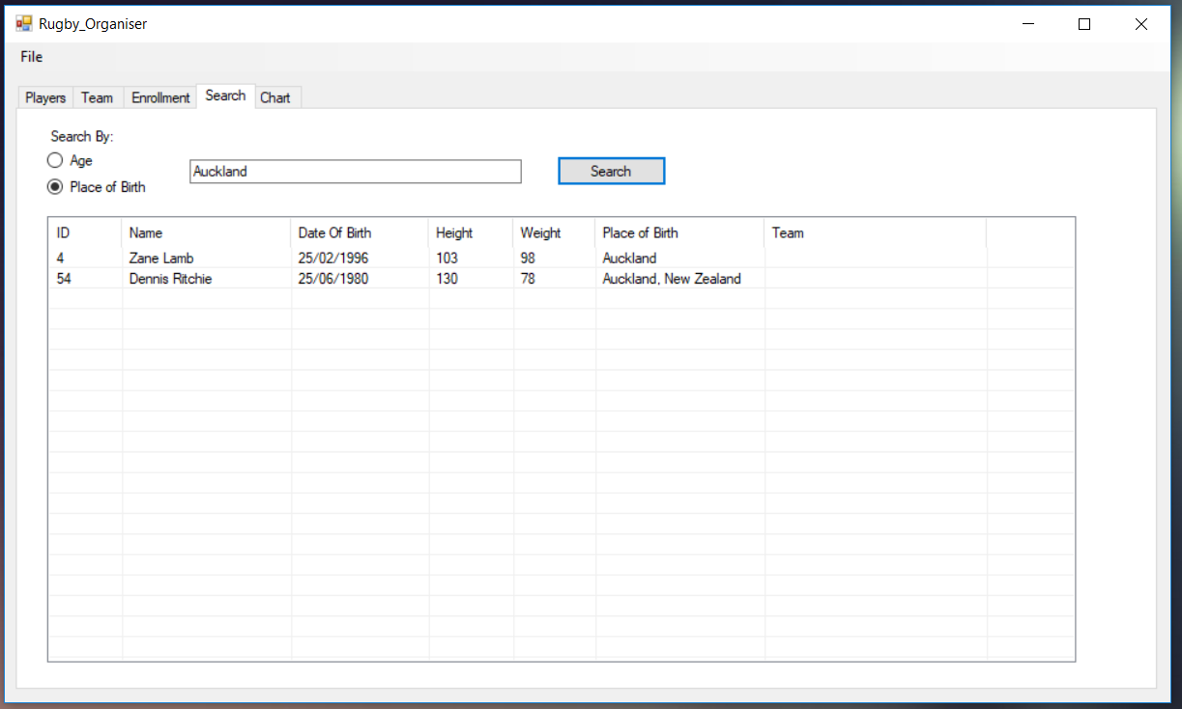

On the "Chart" tab we can see when the Height vs Weight radio button is enabled , this will show a   
Bar chart displaying Height and weight of players.

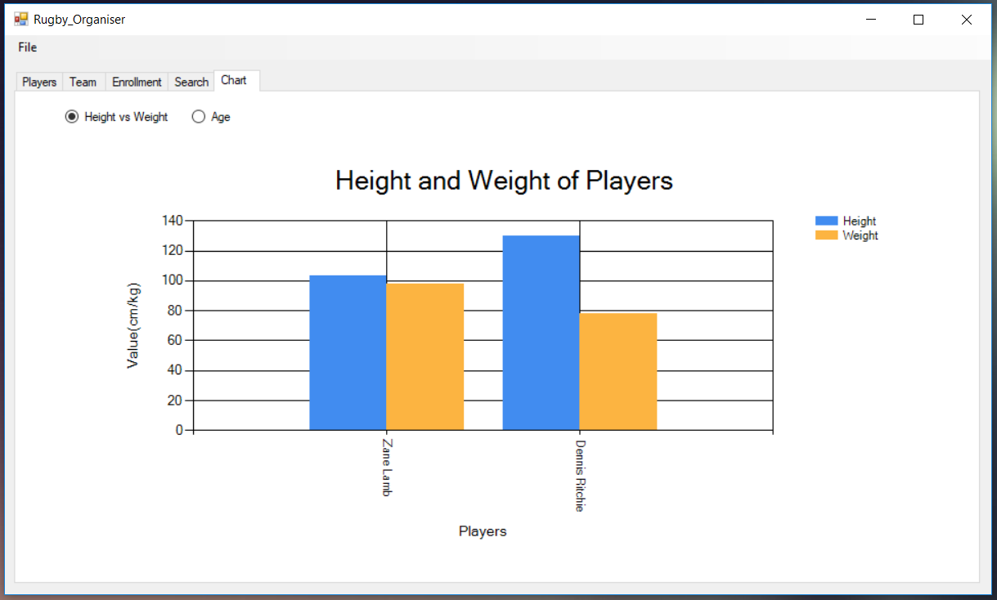

On the "Chart" tab we can see when the Age radio button is enabled , this will show a   
histogram chart displaying age of players in groups of 10 years.

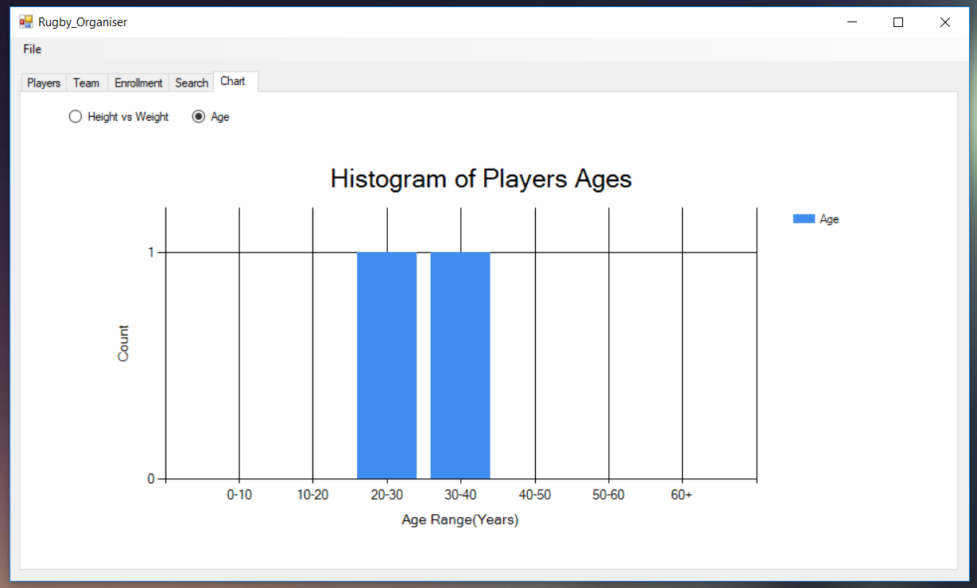

Once you are finished with the application, you can save your additions by clicking on File->Save->Teams/Players and navigate to where you want to save your file.

