**Jason 2 & 3 Tool Box**

This algorithm was developed to automate the process of generating Jason 2 and 3 altimetry time series plot directly from the raw netCDF file.

**NB**: For simplicity, the manual provides a detailed example using the Jason 2 file prefix e.g. j2_FtpDownload.m. To process Jason 3, use the .m files with Jason 3 prefix such as, j3_FtpDownload.m.

******************************************************************************To run this program, you need the following matlab file scripts and functions in your directory

Required matlab files:

* altimetryoutlier.m
* copyNETCDF.m
* decyear2matdate.m
* dirwalk.m
* dy.txt
* iqrange.m
* j2_FtpDownload.m
* j2_SingleProcess_TimeSeries.m
* j3_FtpDownload.m
* j3_SingleProcess_TimeSeries.m
* jason2_gdr_info.m
* jason3_gdr_info.m
* Jason_MyGlobal.prj
* mjd2gre.m
* netcdf_read.m
* uncertainty.m
* VIETNAM_TRAINING.m
* geoidegm2008grid.mat

.

**Disclaimer:**

The software developer is not responsible for any liability or damages arising from the use of this algorithm. The use of all or any part of this algorithm is prohibited without the express reference to the developer/paper below:

Okeowo, M. A., Lee, H., Hossain, F., & Getirana, A. (2017). Automated Generation of Lakes and Reservoirs Water Elevation Changes From Satellite Radar Altimetry. IEEE Journal of Selected Topics in Applied Earth Observations and Remote Sensing.

M.A. Okeowo1, 2, Hyongki Lee1, 2, Faisal Hossain3, Augusto Getirana4

1. Department of Civil and Environmental Engineering, University of Houston, Houston, TX, USA
2. National Center for Airborne Laser Mapping, University of Houston, Houston, TX, USA
3. Department of Civil and Environmental Engineering, University of Washington, Seattle, WA, USA
4. Hydrological Sciences Laboratory, NASA Goddard Space Flight Center, Greenbelt, MD, USA

**Jason-2 Time Series**

**Step 1: Download the NetCDF Jason 2 files.**

* Run the, **j2_FtpDownload.m,** Fill the **“*Download*”** dialogue box that appears with the information of interest andclick **“*OK”***

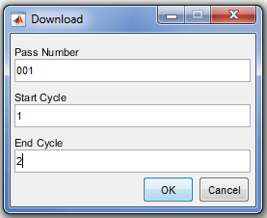

Wait till the progress bar is 100% complete and the status window pops up when download is completed.

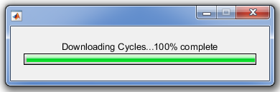 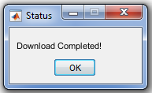

**Step 2: Copy** the **netcdf_read.m** file into the download directory from Step 1 by running the running the **copyNETCDF.m** file**.** This file does not require any input argument.

**Step 3: Extract Information from the netCDF files using jason2_gdr_info.m function.**

* To use the function**; jason2_gdr_info (In_Pass, lat_range, File_Suffix_name)**. Where the input arguments are:
* In_Pass: The pass number
* lat_range: [MINlatitude, MAXlatitude]
* File_Suffix_name: you may use any name to output the txt result.

e.g. **jason2_gdr_info (135, [10.5, 10.7], ‘Kainji_Dam’)**

**NB**: The **output file name** will be: **j2_gdr_p135_Kainji_Dam_info.txt.**

**Step 4: Generate the Time Series plot**

* Run the file, **j2_SingleProcess_TimeSeries.m** to generate the time series plot of the study area.

**NB**: Two dialogue boxes will appear, the first requires user to enter the information as shown below while the second requires the user to select the txt file generated from **Step 3.** Note that the input “Minimum Latitude” and “Maximum Latitude” should be less or equal to the latitude boundary input in Step 3.

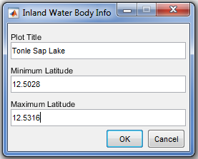 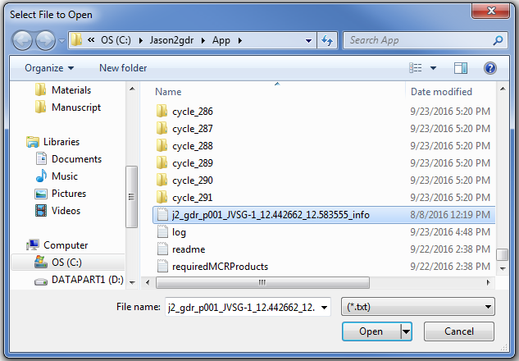

The final output of Step 4 is a Time Series plot window as well as the output files as shown in the figure below.

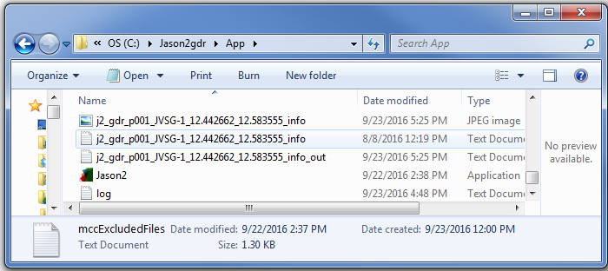As an example, the output file **“j2_gdr_p001_JVSG-1_12.442662_12.583555_info_out.txt”** contains the information below:

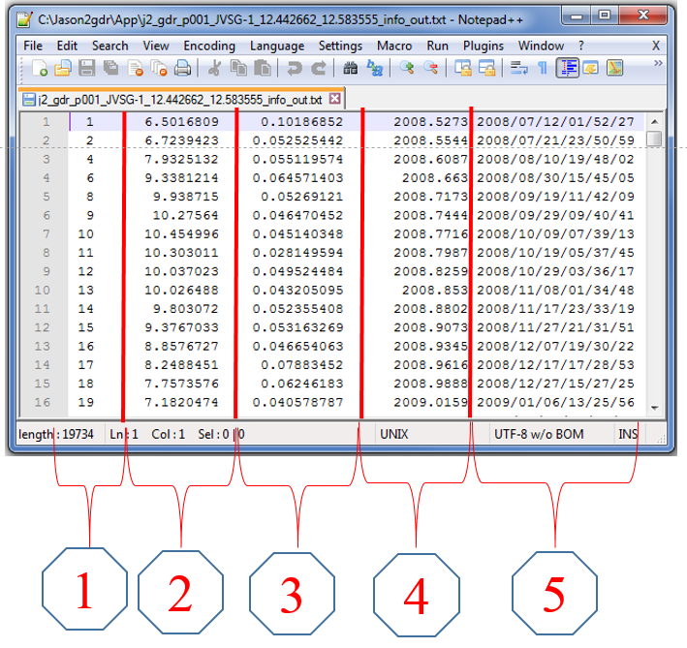

**The description of the columns are given below:**

(1) Jason-2 Cycle Numbers

(2) Height (meter w.r.t. EGM08 Geoid)

(3) Uncertainty (meter)

(4) Decimal year

(5) YYYY/MM/DD/HH/MM/SS