三网服务端详细设计

目录

1. 概述 3

1.1. 文档说明 3

2. 模块 3

2.1. 运营服务 3

2.1.1. 内容管理 3

2.1.2. app升级管理 14

2.1.3. 手动消息 18

2.1.4. 手动消息记录 22

2.1.5. 快捷服务配置管理 27

2.1.6. 快捷服务配置 37

2.1.7. 用户管理 43

2.1.8. 我要合作 46

2.2. 订单服务 49

2.2.1. 订单查询 49

2.3. 物业服务 52

2.3.1. 项目管理 52

2.3.2. 通知公告 61

2.3.3. 项目授权管理 71

2.3.4. 物业员工管理 74

# 概述

## 文档说明

本文档是三网服务端详细技术设计说明。

# 模块

## 运营服务

### 内容管理

#### 前端详细设计

##### UI设计

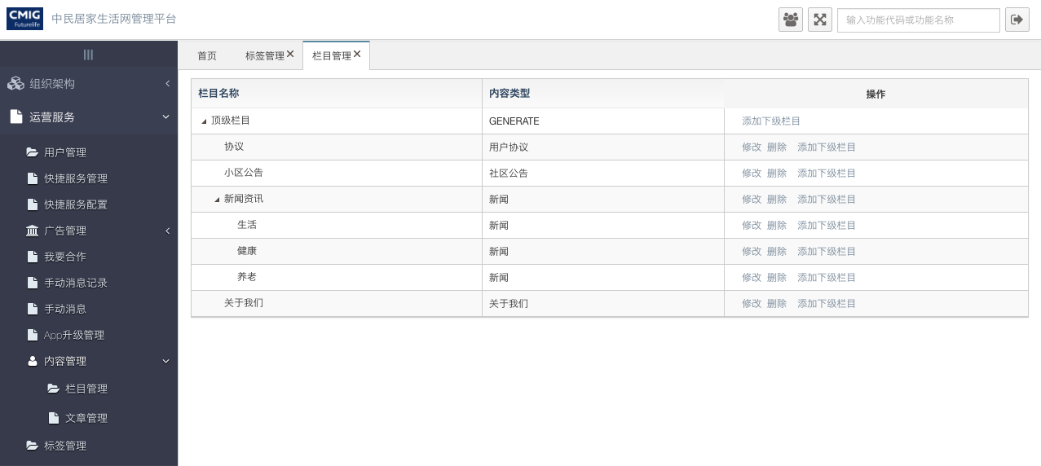

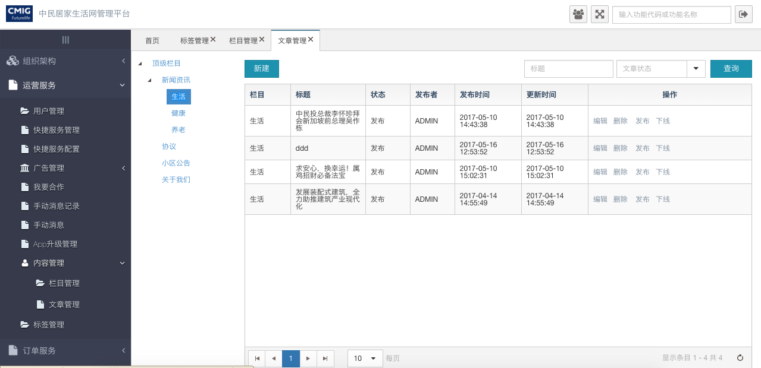

##### 文件清单

|  |  |
| --- | --- |
| **文件名** | **描述** |
| /include/head.html | 公用头部 |
| category_manage.html | 内容类别管理 |
| category_detail.html | 内容类别详情 |
| category_tree.html | 内容分类树 |
| article_manage.html | 文章管理 |
| article_show.html | 文章详情 |
| ljh_cms_article_community.html | 文章小区关联 |

##### 页面URL定义

|  |  |
| --- | --- |
| **URL名称** | 内容类别查询 |
| **URL** | /cms/category/query |
| **URL名称** | 根据id查询内容类别 |
| **URL** | /cms/category/queryById |
| **URL名称** | 更新内容类别 |
| **URL** | /cms/category/update |
| **URL名称** | 删除内容类别 |
| **URL** | /cms/category/updateCategoryDelFlag |
| **URL名称** | /cms/article/query |
| **URL** | 查询文章 |
| **URL名称** | /cms/article/saveOrUpdate |
| **URL** | 更新（新增）文章 |
| **URL名称** | /cms/article/queryByCategory |
| **URL** | 根据类别查询文章 |
| **URL名称** | /cms/article/updateArticle |
| **URL** | （不）发布／文章 |
| **URL名称** | /operate/cms/article/list |
| **URL** | （接口）获取文章列表接口 |
| **URL名称** | /operate/cms/article/detail |
| **URL** | 文章详情接口 |
| **URL名称** | /operate/cms/article/getByContentType |
| **URL** | 根据内容类型获取文章 |

##### 控制事件

| **对象名称** | **事件** | **动作** | **描述** |
| --- | --- | --- | --- |
| 添加按钮 | onClick | articleAdd（） | 新增文章 |
| 删除 | onClick | articleDelete() | 删除文章 |
| 发布 | onClick | publish() | 发布文章 |
| 下线 | onClick | unpublish () | 草稿 |
| 编辑 | onClick | articleEdit() | 编辑文章 |
| 选择小区 | onClick | selectCommunity() | 选择小区 |
| 修改栏目 | onClick | categoryEdit() | 修改栏目 |
| 删除栏目 | onClick | categoryDelete() | 删除栏目 |
| 添加下级栏目 | onClick | categoryAdd() | 添加下级栏目 |

#### 后台详细设计

##### Controller

***1.CategoryController***

|  |  |
| --- | --- |
| 类名：***CategoryController*** | |
| **method** | query |
| **mapping url** | /cms/category/query |
| **参数** | Category dto,  int page,  int pageSize,  HttpServletRequest request |
| **返回值** | ResponseData |
| **详细逻辑** | 调用categoryService. getAllCategories  并返回结果 |

|  |  |
| --- | --- |
| 类名：com.lkkhpg.dsis.admin.bonus.controllers.BonusFinalController | |
| **method** | queryBonusFinal |

|  |  |
| --- | --- |
| **method** | queryById |
| **mapping url** | /cms/category/queryById |
| **参数** | HttpServletRequest request  String id |
| **返回值** | ResponseData |
| **详细逻辑** | 调用categoryService. getCategoryById  并返回结果 |

|  |  |
| --- | --- |
| **method** | updateCategoryDelFlag |
| **mapping url** | /cms/category/ updateCategoryDelFlag |
| **参数** | HttpServletRequest request  Category category |
| **返回值** | ResponseData |
| **详细逻辑** | 调用categoryService. updateByPrimaryKeySelective  并返回结果 |

***2.*** ***ArticleController***

|  |  |
| --- | --- |
| 类名：***ArticleController*** | |
| **method** | query |
| **mapping url** | /cms/article/query |
| **参数** | Article dto,  int page,  int pageSize,  HttpServletRequest request |
| **返回值** | ResponseData |
| **详细逻辑** | 调用articleService. select  并返回结果 |

|  |  |
| --- | --- |
| 类名：com.lkkhpg.dsis.admin.bonus.controllers.BonusFinalController | |
| **method** | queryBonusFinal |

|  |  |
| --- | --- |
| **method** | update |
| **mapping url** | /cms/article/submit |
| **参数** | HttpServletRequest request  List<Article> dto |
| **返回值** | ResponseData |
| **详细逻辑** | 调用articleService. batchUpdate  并返回结果 |

|  |  |
| --- | --- |
| **method** | saveOrUpdate |
| **mapping url** | /cms/category/ updateCategoryDelFlag |
| **参数** | HttpServletRequest request  List<Article> dto |
| **返回值** | ResponseData |
| **详细逻辑** | 调用articleService. saveOrUpdate  并返回结果 |
| **method** | queryByCategory |
| **mapping url** | /cms/article/queryByCategory |
| **参数** | HttpServletRequest request  int page  int pagesize  Article article |
| **返回值** | ResponseData |
| **详细逻辑** | 调用articleService. getArticleByCategory  并返回结果 |
| **method** | saveOrUpdate |
| **mapping url** | /cms/category/ updateCategoryDelFlag |
| **参数** | HttpServletRequest request  List<Article> dto |
| **返回值** | ResponseData |
| **详细逻辑** | 调用articleService. saveOrUpdate  并返回结果 |
| **method** | publishArticle |
| **mapping url** | /cms/article/publish |
| **参数** | HttpServletRequest request  Article article |
| **返回值** | ResponseData |
| **详细逻辑** | 调用articleService. publishArticle  并返回结果 |
| **method** | unpublishArticle |
| **mapping url** | /cms/article/unpublish |
| **参数** | HttpServletRequest request  Article article |
| **返回值** | ResponseData |
| **详细逻辑** | 调用articleService. unpublishArticle  并返回结果 |

***3.*** ***ArticleInterfaceController***

|  |  |
| --- | --- |
| 类名：***ArticleInterfaceController*** | |
| **method** | getArticleListByCommunity |
| **mapping url** | /operate/cms/article/list |
| **参数** | String contentTypeStr  String communityId,  int page,  int pageSize,  HttpServletRequest request |
| **返回值** | RetApp |
| **详细逻辑** | 文章列表接口 |
| **method** | getArticleById |
| **mapping url** | /operate/cms/article/detail |
| **参数** | String articleId  HttpServletRequest request |
| **返回值** | RetApp |
| **详细逻辑** | 文章详情接口 |
| **method** | getByContentType |
| **mapping url** | /operate/cms/article/getByContentType |
| **参数** | String contentType  HttpServletRequest request |
| **返回值** | RetApp |
| **详细逻辑** | 根据内容类型得到文章：1.用户协议。2.关于我们 |

##### Service

***1.*** ***ICategoryService***

|  |  |
| --- | --- |
| 类名：***ICategoryService*** | |
| **method** | getAllCategories |
| **参数** | Category dto,  int page,  int pageSize,  HttpServletRequest request |
| **返回值** | List<Category> |
| **详细逻辑** | 调用categoryMapper. getAllCategories  并返回结果 |
| **method** | getCategoryById |
| **参数** | Category dto,  String id |
| **返回值** | List<Category> |
| **详细逻辑** | 调用categoryMapper. getCategoryById  并返回结果 |
| **method** | getCategoryByParentId |
| **参数** | Category dto,  String parentId |
| **返回值** | Category |
| **详细逻辑** | 调用categoryMapper. getCategoryByParentId  并返回结果 |

***2.*** ***IArticleService***

|  |  |
| --- | --- |
| 类名：***IArticleService*** | |
| **method** | getArticleById |
| **参数** | IRequest requestContext,  String id |
| **返回值** | Article |
| **详细逻辑** | 调用articleMapper. getArticleById  并返回结果 |
| **method** | getArticleByCategory |
| **参数** | IRequest requestContext,  Article article,  int page,  int pagesize |
| **返回值** | List<Article> |
| **详细逻辑** | 调用articleMapper. getArticleByCategory  并返回结果 |
| **method** | saveOrUpdate |
| **参数** | IRequest requestCtx,  List<Article> dto |
| **返回值** | List<Article> |
| **详细逻辑** | 调用articleMapper. getCategoryByParentId  并返回结果 |
| **method** | publishArticle |
| **参数** | IRequest requestCtx,  Article article |
| **返回值** | Article |
| **详细逻辑** | 调用articleMapper. publishArticle  并返回结果 |
| **method** | unpublishArticle |
| **参数** | IRequest requestCtx,  Article article |
| **返回值** | Article |
| **详细逻辑** | 调用articleMapper. unpublishArticle  并返回结果 |
| **method** | getArticleListByCommunity |
| **参数** | IRequest requestCtx,  String contentTypeStr,  String communityId, |
| **返回值** | List<Article> |
| **详细逻辑** | 调用articleMapper. getArticleListByCommunity  并返回结果 |

##### Mapper

***1.*** ***CategoryMapper***

|  |  |
| --- | --- |
| 类名：***CategoryMapper*** | |
| **method** | getAllCategories |
| **参数** |  |
| **返回值** | List<Category> |
| **method** | getCategoryById |
| **返回值** | Category |
| **method** | getCategoryByParentId |
| **返回值** | Category |

***1.*** ***ArticleMapper***

|  |  |
| --- | --- |
| 类名：***ArticleMapper*** | |
| **method** | getArticleById |
| **参数** | String id |
| **返回值** | Article |
| **method** | getArticleByCategory |
| **参数** | Article article |
| **返回值** | List<Article> |
| **method** | getArticleListByCommunity |
| **参数** | Map<String, Object> params |
| **返回值** | List<Article> |
| **method** | getArticleAppById |
| **参数** | String articleId |
| **返回值** | Article |
| **method** | getByContentType |
| **参数** | String contentType |
| **返回值** | Article |

### app升级管理

#### 前端详细设计

##### UI设计

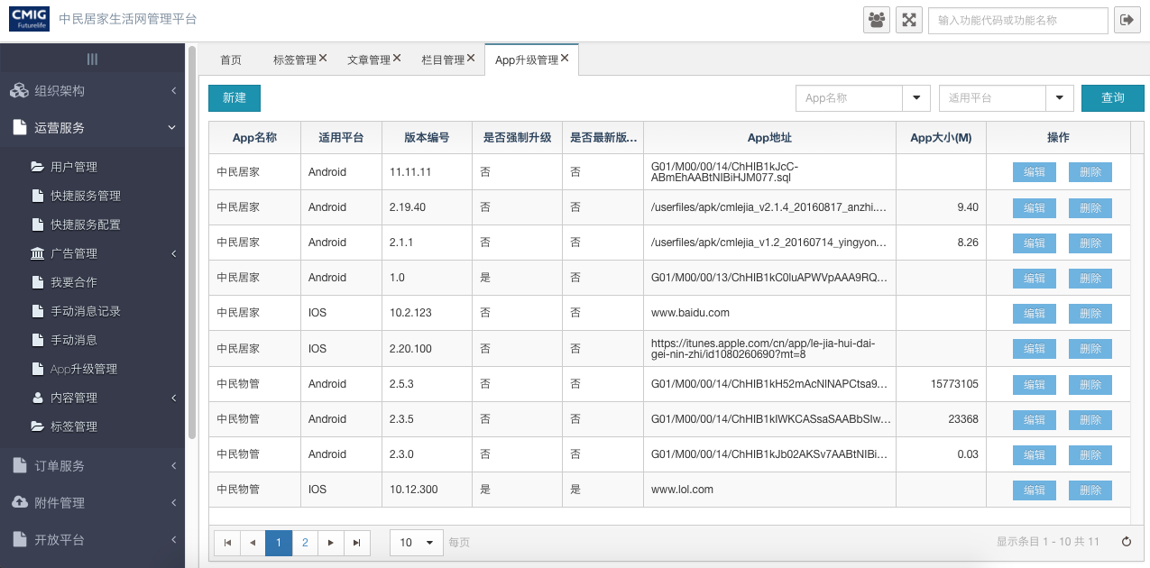

##### 文件清单

|  |  |
| --- | --- |
| **文件名** | **描述** |
| /include/head.html | 公用头部 |
| ljh_app_download.html | app管理 |
| app_detail.html | app详情 |

##### 页面URL定义

|  |  |
| --- | --- |
| **URL名称** | App查询 |
| **URL** | /csp/ljh/app/download/query |
| **URL名称** | 根据id查询app |
| **URL** | /csp/ljh/app/download/queryById |
| **URL名称** | 更新 |
| **URL** | /csp/ljh/app/download/saveOrUpdate |
| **URL名称** | 删除 |
| **URL** | /csp/ljh/app/download/remove |

##### 控制事件

| **对象名称** | **事件** | **动作** | **描述** |
| --- | --- | --- | --- |
| 添加按钮 | onClick | appAdd（） | 新增app |
| 删除 | onClick | appDelete() | 删除app |
| 编辑 | onClick | appEdit() | 编辑app |

#### 后台详细设计

##### Controller

***1.*** ***LjhAppDownloadController***

|  |  |
| --- | --- |
| 类名：***LjhAppDownloadController*** | |
| **method** | query |
| **mapping url** | /csp/ljh/app/download/query |
| **参数** | LjhAppDownload dto,  int page,  int pageSize,  HttpServletRequest request |
| **返回值** | ResponseData |
| **详细逻辑** | 调用service. findList  并返回结果 |

|  |  |
| --- | --- |
| 类名：com.lkkhpg.dsis.admin.bonus.controllers.BonusFinalController | |
| **method** | queryBonusFinal |

|  |  |
| --- | --- |
| **method** | queryById |
| **mapping url** | csp/ljh/app/download/queryById |
| **参数** | HttpServletRequest request  LjhAppDownload dto |
| **返回值** | ResponseData |
| **详细逻辑** | 调用service. selectApp  并返回结果 |

|  |  |
| --- | --- |
| **method** | saveOrUpdate |
| **mapping url** | /csp/ljh/app/download/saveOrUpdate |
| **参数** | HttpServletRequest request  List<LjhAppDownload> dto |
| **返回值** | ResponseData |
| **详细逻辑** | 调用service. saveOrUpdate  并返回结果 |
| **method** | delete |
| **mapping url** | csp/ljh/app/download/remove |
| **参数** | HttpServletRequest request  LjhAppDownload dto |
| **返回值** | ResponseData |
| **详细逻辑** | 调用service. updateByPrimaryKeySelective  并返回结果 |

***2.*** ***AppUpgradeController***

|  |  |
| --- | --- |
| 类名：***AppUpgradeController*** | |
| **method** | getLastVersionAppInfo |
| **mapping url** | /appdownload/appDownload/getLastVersionAppInfo |
| **参数** | LjhAppDownload dto,  HttpServletRequest request |
| **返回值** | RetApp |
| **详细逻辑** | 获取最新版的app |

##### Service

***1.*** ***ILjhAppDownloadService***

|  |  |
| --- | --- |
| 类名：***ILjhAppDownloadService*** | |
| **method** | selectApp |
| **参数** | I IRequest requestContext,  LjhAppDownload dto,  int page,  int pageSize |
| **返回值** | List<LjhAppDownload> |
| **详细逻辑** | 调用ljhAppDownloadMapper. selectApp  并返回结果 |
| **method** | saveOrUpdate |
| **参数** | IRequest requestCtx,  List<LjhAppDownload> dto |
| **返回值** | List<LjhAppDownload> |
| **详细逻辑** | 调用ljhAppDownloadMapper. saveOrUpdate  并返回结果 |
| **method** | findLastVersionApp |
| **参数** | LjhAppDownload appDownload |
| **返回值** | LjhAppDownload |
| **详细逻辑** | 调用ljhAppDownloadMapper. findLastVersionApp  并返回结果 |
| **method** | findList |
| **参数** | IRequest requestContext,  LjhAppDownload ljhAppDownload,  int page,  int pagesize |
| **返回值** | List<LjhAppDownload> |
| **详细逻辑** | 调用ljhAppDownloadMapper. findList  并返回结果 |

##### Mapper

***1.*** ***LjhAppDownloadMapper***

|  |  |
| --- | --- |
| 类名：***LjhAppDownloadMapper*** | |
| **method** | selectApp |
| **返回值** | List< LjhAppDownload> |
| **method** | findLastVersionApp |
| **返回值** | LjhAppDownload |
| **method** | findList |
| **返回值** | List<LjhAppDownload> |
| **method** | findListByNameAndType |
| **返回值** | List<LjhAppDownload> |

### 手动消息

#### 前端详细设计

##### UI设计

手动消息主页

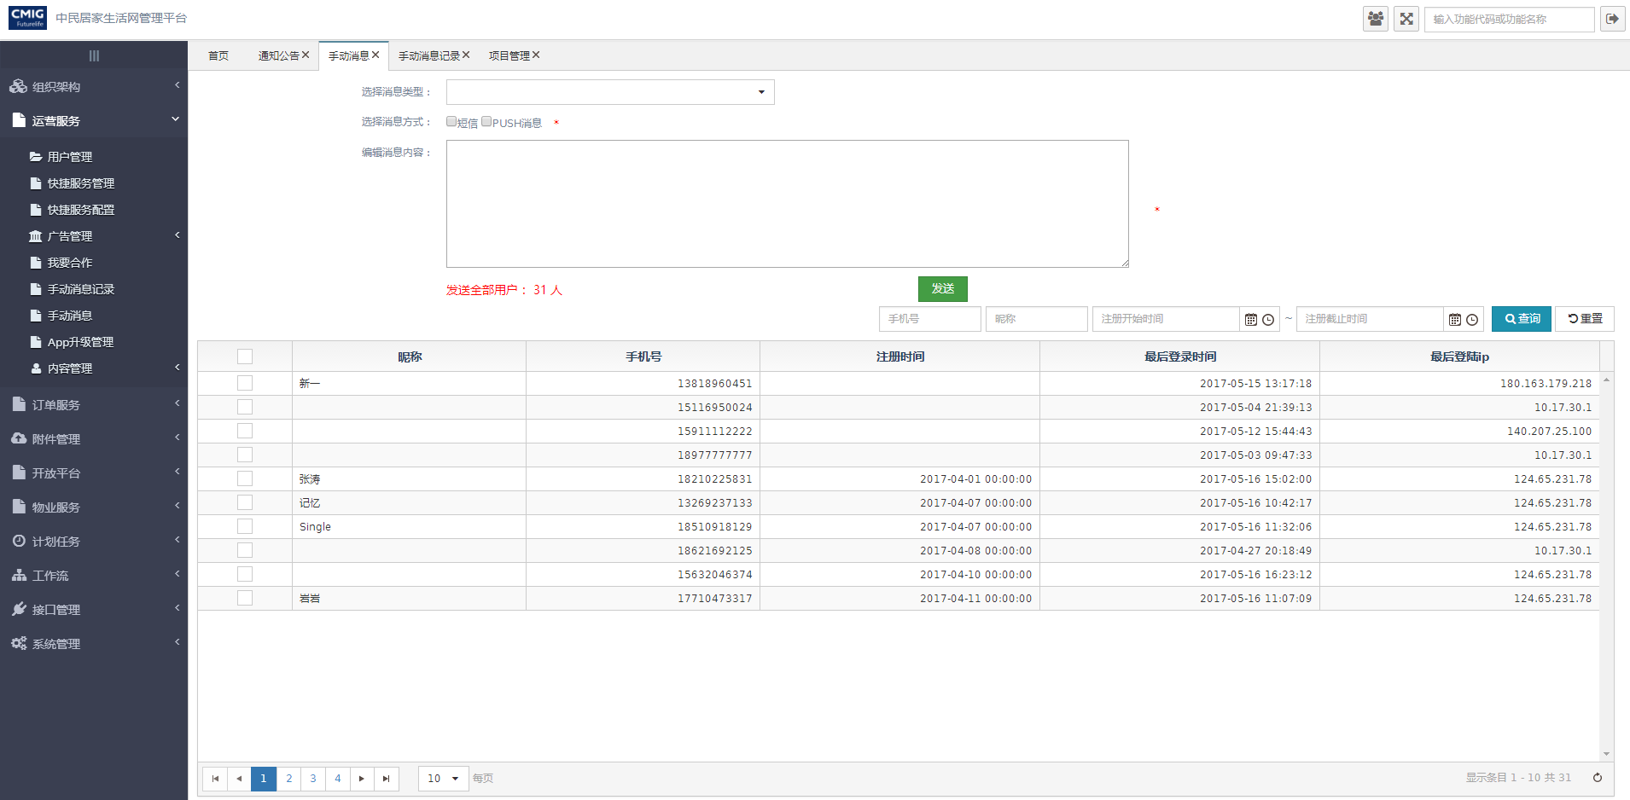

##### 文件清单

|  |  |
| --- | --- |
| **文件名** | **描述** |
| /include/head.html | 公用头部 |
| business_msg.html | 手动消息页面 |

##### 页面URL定义

|  |  |
| --- | --- |
| **URL名称** | 查询用户信息列表 |
| **URL** | /ljh/app/user/findList |
| **URL名称** | 发送信息 |
| **URL** | /businessMsg/publishToAppUser |
| **URL名称** | 查询用户列表,拼接用户手机号信息 |
| **URL** | /ljh/app/user/appUserList |

##### 控制事件

| **对象名称** | **事件** | **动作** | **描述** |
| --- | --- | --- | --- |
| 查询按钮 | onClick | queryResource() | 根据表单查询条件，将查询结果显示在表格中 |
| 重置按钮 | onClick | reset() | 重置查询条件 |
| 发送按钮 | onClick | saveGrid() | 根据勾选用户发送信息 |

#### 后台详细设计

##### Controller

###### BusinessMsgController

|  |  |
| --- | --- |
| 类名：com.cmig.future.csportal.module.operate.businessMsg.controllers.BusinessMsgController | |
| **method** | publishToAppUser |
| **mapping url** | /businessMsg/publishToAppUser |
| **参数** | HttpServletRequest request  List<SysNotifyRecord> list |
| **返回值** | ResponseData(List<SysNotifyRecord>) |
| **详细逻辑** | 如果发送消息方式选择短信,调用businessMsgService.smsToAppUser;如果发送消息方式选择push消息,调用businessMsgService.pushToAppUser  并返回结果 |

##### Service

###### IBusinessMsgService

|  |  |
| --- | --- |
| 类名：com.cmig.future.csportal.module.operate.businessMsg.service.IBusinessMsgService | |
| **method** | pushToAppUser |
| **参数** | IRequest requestCtx  String category  String content  String mobiles |
| **返回值** | void |
| **详细逻辑** | 调用appUserMapper.getByMobile根据电话查询用户,调用sysNotifyRecordMapper.insertSelective记录数据,调用JPushUtils.pushAlertWithMessage发送push消息 |
| **method** | smsToAppUser |
| **参数** | IRequest requestCtx  String category  String content  String mobiles |
| **返回值** | void |
| **详细逻辑** | 调用appUserMapper.getByMobile根据电话查询用户,调用sysNotifyRecordMapper.insertSelective记录数据,调用SmsUtil.sendSyne发送短信 |

###### IAppUserService

|  |  |
| --- | --- |
| 类名：com.cmig.future.csportal.module.user.appuser.service.IAppUserService | |
| **method** | getByMobile |
| **参数** | String mobile |
| **返回值** | AppUser |
| **详细逻辑** | 调用appUserMapper.getByMobile并返回结果 |
| **method** | findList |
| **参数** | IRequest request  AppUser appUser  int page  int pagesize |
| **返回值** | List<AppUser> |
| **详细逻辑** | 调用appUserMapper.findList并返回结果 |

##### Mapper

###### AppUserMapper

|  |  |
| --- | --- |
| 类名：com.cmig.future.csportal.module.user.appuser.mapper.AppUserMapper | |
| **method** | getByMobile |
| **参数** | String mobile |
| **返回值** | AppUser |
| **method** | findList |
| **参数** | AppUser appUser |
| **返回值** | List<AppUser> |

###### SysNotifyRecordMapper

|  |  |
| --- | --- |
| 类名：com.cmig.future.csportal.module.sys.notifyrecord.mapper.SysNotifyRecordMapper | |
| **method** | insertSelective |
| **参数** | SysNotifyRecord sysNotifyRecord |
| **返回值** | SysNotifyRecord |

### 手动消息记录

#### 前端详细设计

##### UI设计

手动消息记录主页

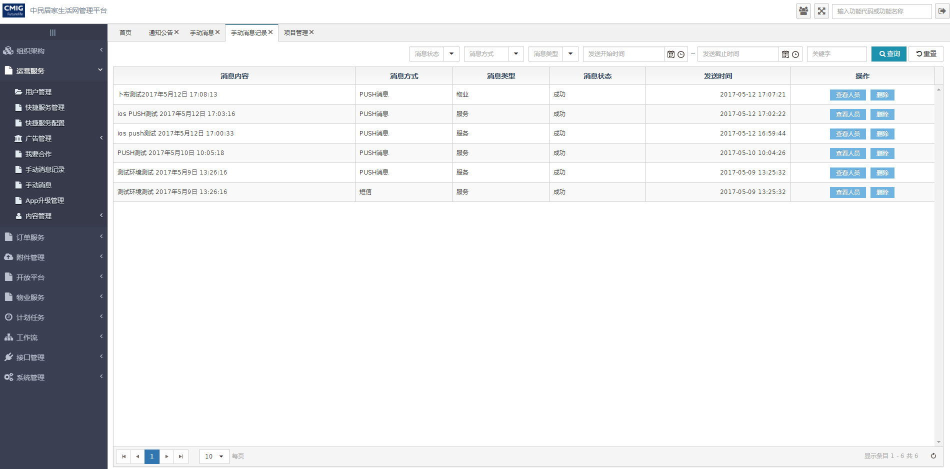

查看发送人员列表页面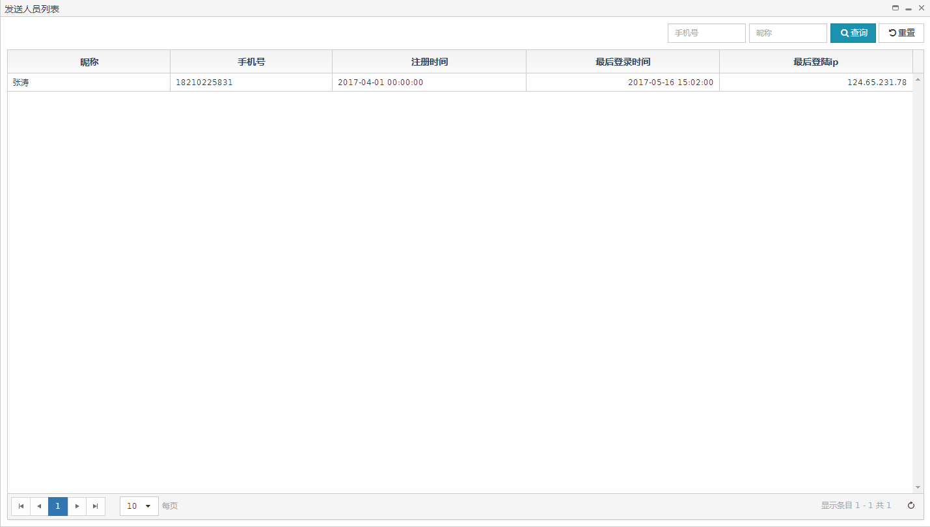

##### 文件清单

|  |  |
| --- | --- |
| **文件名** | **描述** |
| /include/head.html | 公用头部 |
| business_msg_list.html | 手动消息记录页面 |
| business_msg_userList.html | 查看发送人员列表页面 |

##### 页面URL定义

|  |  |
| --- | --- |
| **URL名称** | 查询手动消息列表 |
| **URL** | /businessMsg/query |
| **URL名称** | 删除信息记录 |
| **URL** | /businessMsg/delete |
| **URL名称** | 根据手动消息的类型、时间、种类分组的人员列表 |
| **URL** | /businessMsg/groupByTimeAndCateoryAndType |

##### 控制事件

| **对象名称** | **事件** | **动作** | **描述** |
| --- | --- | --- | --- |
| 查询按钮 | onClick | queryResource() | 根据表单查询条件，将查询结果显示在表格中 |
| 重置按钮 | onClick | reset() | 重置查询条件 |
| 查看人员按钮 | onClick | userInfoCard(id) | 根据id查看发送人员列表 |
| 删除按钮 | onClick | deleteRecor(id) | 根据id删除信息 |

#### 后台详细设计

##### Controller

###### BusinessMsgController

|  |  |
| --- | --- |
| 类名：com.cmig.future.csportal.module.operate.businessMsg.controllers.BusinessMsgController | |
| **method** | query |
| **mapping url** | /businessMsg/query |
| **参数** | SysNotifyRecord dto  int page  int pageSize  HttpServletRequest request |
| **返回值** | ResponseData(List<SysNotifyRecord>) |
| **详细逻辑** | 调用businessMsgService.findListByMsg  并返回结果 |
| **method** | delete |
| **mapping url** | /businessMsg/delete |
| **参数** | SysNotifyRecord dto  HttpServletRequest request |
| **返回值** | ResponseData(SysNotifyRecord) |
| **详细逻辑** | 调用businessMsgService.deleteByTimeAndCateoryAndType  并返回结果 |
| **method** | groupByTimeAndCateoryAndType |
| **mapping url** | /businessMsg/groupByTimeAndCateoryAndType |
| **参数** | SysNotifyRecord dto  int page  int pageSize  HttpServletRequest request |
| **返回值** | ResponseData(List<SysNotifyRecord>) |
| **详细逻辑** | 调用businessMsgService.groupByTimeAndCateoryAndType  并返回结果 |

##### Service

###### IBusinessMsgService

|  |  |
| --- | --- |
| 类名：com.cmig.future.csportal.module.operate.businessMsg.service.IBusinessMsgService | |
| **method** | groupByTimeAndCateoryAndType |
| **参数** | IRequest requestCtx  SysNotifyRecord dto  int page  int pageSize |
| **返回值** | List<SysNotifyRecord> |
| **详细逻辑** | 调用appUserMapper.groupByTimeAndCateoryAndType并返回结果 |
| **method** | deleteByTimeAndCateoryAndType |
| **参数** | SysNotifyRecord dto |
| **返回值** | int |
| **详细逻辑** | 调用sysNotifyRecordMapper.deleteByTimeAndCateoryAndType并返回结果 |

###### IAppUserService

|  |  |
| --- | --- |
| 类名：com.cmig.future.csportal.module.user.appuser.service.IAppUserService | |
| **method** | getByMobile |
| **参数** | String mobile |
| **返回值** | AppUser |
| **详细逻辑** | 调用appUserMapper.getByMobile并返回结果 |
| **method** | findList |
| **参数** | IRequest request  AppUser appUser  int page  int pagesize |
| **返回值** | List<AppUser> |
| **详细逻辑** | 调用appUserMapper.findList并返回结果 |

##### Mapper

###### AppUserMapper

|  |  |
| --- | --- |
| 类名：com.cmig.future.csportal.module.user.appuser.mapper.AppUserMapper | |
| **method** | groupByTimeAndCateoryAndType |
| **参数** | SysNotifyRecord dto |
| **返回值** | List<AppUser> |

###### SysNotifyRecordMapper

|  |  |
| --- | --- |
| 类名：com.cmig.future.csportal.module.sys.notifyrecord.mapper.SysNotifyRecordMapper | |
| **method** | deleteByTimeAndCateoryAndType |
| **参数** | SysNotifyRecord sysNotifyRecord |
| **返回值** | SysNotifyRecord |

### 快捷服务配置管理

#### 前端详细设计

##### UI 设计

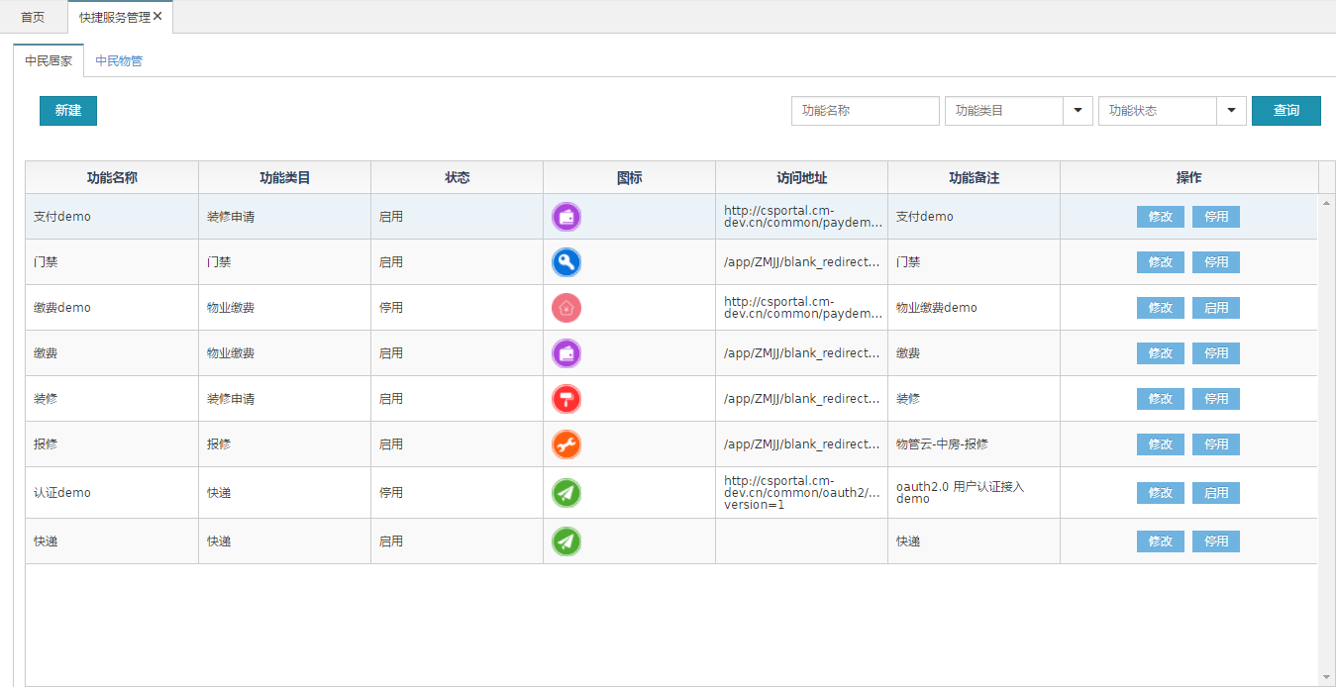

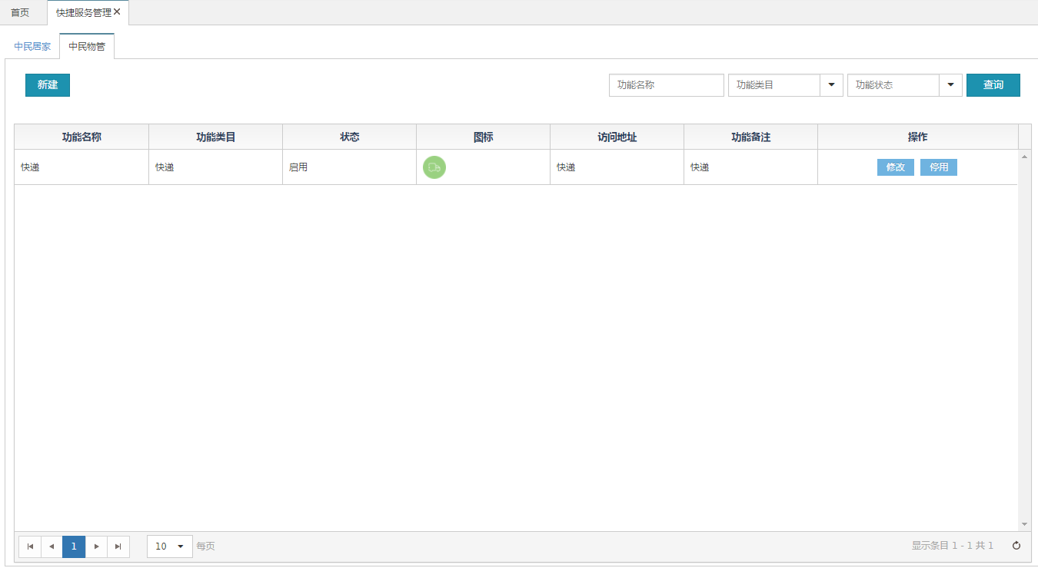

##### 文件清单

|  |  |
| --- | --- |
| **文件名** | **描述** |
| /include/head.html | 公用头部 |
| app_config_function.html | 中民居家列表界面 |
| app_config_function_edit.html | 中民居家修改界面 |
| mgtuser_edit.html | 中民居家修改界面 |

|  |  |
| --- | --- |
| **文件名** | **描述** |
| /include/head.html | 公用头部 |
| app_config_function.html | 中民物管列表界面 |
| app_config_function_edit.html | 中民物管修改界面 |
| mc_app_config_function_edit.html | 中民物管修改界面 |

##### 页面url定义

|  |  |
| --- | --- |
| **URL名称** | 查询中民居家列表数据 |
| **URL** | **/csp/ljh/app/config/function/queryOwner** |

|  |  |
| --- | --- |
| **URL名称** | 查询中民物管列表数据 |
| **URL** | **/csp/ljh/app/config/function/queryMC** |

|  |  |
| --- | --- |
| **URL名称** | 中民居家新增 |
| **URL** | **/csp/ljh/app/config/function/addOwner** |

|  |  |
| --- | --- |
| **URL名称** | 中民物管新增 |
| **URL** | **/csp/ljh/app/config/function/addPropertyMC** |

|  |  |
| --- | --- |
| **URL名称** | 中民居家修改 |
| **URL** | **/csp/ljh/app/config/function/updateOwner** |

|  |  |
| --- | --- |
| **URL名称** | 中民物管修改 |
| **URL** | **/csp/ljh/app/config/function/updatePropertyMC** |

|  |  |
| --- | --- |
| **URL名称** | 停止中民居家app状态 |
| **URL** | **/csp/ljh/app/config/function/stopStatusOwner** |

|  |  |
| --- | --- |
| **URL名称** | 开启中民居家app状态 |
| **URL** | **/csp/ljh/app/config/function/startStatusOwner** |

|  |  |
| --- | --- |
| **URL名称** | 停止中民物管app状态 |
| **URL** | **/csp/ljh/app/config/function/stopStatusPropertyMC** |

|  |  |
| --- | --- |
| **URL名称** | 开启中民物管app状态 |
| **URL** | **/csp/ljh/app/config/function/startStatusPropertyMC** |

##### 控制事件

| **对象名称** | **事件** | **动作** | **描述** |
| --- | --- | --- | --- |
| 查询按钮 | onClick | queryOwner | 根据表单查询条件，将查询中民居家结果显示在表格中 |
| 查询按钮 | onClick | **queryMC** | 根据表单查询条件，将查询中民物管结果显示在表格中 |
| 修改-保存 | onClick | editAppConfigFunction(id) | 根据id跳转到中民居家修改界面，进行修改用户的信息 |
| 修改-保存 | onClick | editAppConfigFunctionMC(id) | 根据id跳转到中民物管修改界面，进行修改用户的信息 |
| 停用 | onClick | stopstatusOwner  (id) | 根据id停用中民居家的app的状态 |
| 开启 | onClick | startstatusOwner(id) | 根据id开启中民居家的app的状态 |
| 停用 | onClick | stopstatusMC(id) | 根据id停用中民物管的app的状态 |
| 开启 | onClick | startstatusMC(id) | 根据id开启中民物管的app的状态 |

#### 后台详细设计

##### Controller

|  |  |
| --- | --- |
| 类名：com.cmig.future.csportal.module.sys.appconfig.controllers.AppConfigFunctionController | |
| method | queryt |
| mapping url | /ljh/mgt/user/queryOwner |
| 参数 | HttpServletRequest request  MgtUser mgtUser  int page  int pagesize |
| 返回值 | ResponseData(List<AppConfigFunction >) |
| 详细逻辑 | 调用appConfigFunctionService.select  并返回结果 |
| method | queryMC |
| mapping url | /ljh/mgt/user/queryMC |
| 参数 | HttpServletRequest request  MgtUser mgtUser  int page  int pagesize |
| 返回值 | ResponseData(List<AppConfigFunction >) |
| 详细逻辑 | 调用appConfigFunctionService.select  并返回结果 |
| method | get |
| mapping url | /csp/ljh/app/config/function/get |
| 参数 | HttpServletRequest request  AppConfigFunction dto |
| 详细逻辑 | 调用appConfigFunctionService.selectByPrimaryKey  并返回结果 |
| method | addOwner |
| mapping url | /csp/ljh/app/config/function/addOwner |
| 参数 | HttpServletRequest request  AppConfigFunction dto |
| 详细逻辑 | 调用appConfigFunctionService.save(dto)添加中民居家app |
| method | updateOwner |
| mapping url | /csp/ljh/app/config/function/updateOwner |
| 参数 | HttpServletRequest request  AppConfigFunction dto |
| 详细逻辑 | 调用appConfigFunctionService. updateByPrimaryKeySelective(requestContext,dto)更新中民居家的数据 |
| method | addPropertyMC |
| mapping url | /csp/ljh/app/config/function/addPropertyMC |
| 参数 | HttpServletRequest request  AppConfigFunction dto |
| 详细逻辑 | 调用appConfigFunctionService. insertSelective  (requestContext,dto)添加中民物业app的数据 |
| method | updatePropertyMC |
| mapping url | /csp/ljh/app/config/function/updatePropertyMC |
| 参数 | HttpServletRequest request  AppConfigFunction dto |
| 详细逻辑 | 调用appConfigFunctionService. updateByPrimaryKeySelective  (requestContext,dto)更新中民物业app的数据 |
| method | stopLoginStatus |
| mapping url | /csp/ljh/app/config/function/stopStatusOwner |
| 参数 | HttpServletRequest request |
| 详细逻辑 | 调用appConfigFunctionService. updateByPrimaryKeySelective  (requestContext,dto) 停用中民居家app的状态 |
| method | startStatusOwner |
| mapping url | /csp/ljh/app/config/function/startStatusOwner |
| 参数 | HttpServletRequest request |
| 详细逻辑 | 调用appConfigFunctionService. updateByPrimaryKeySelective  (requestContext,dto) 开启中民居家app的状态 |
| method | startStatusPropertyMC |
| mapping url | /csp/ljh/app/config/function/startStatusPropertyMC |
| 参数 | HttpServletRequest request |
| 详细逻辑 | 调用appConfigFunctionService. updateByPrimaryKeySelective  (requestContext,dto) 开启中民物管app的状态 |
| method | stopStatusPropertyMC |
| mapping url | /csp/ljh/app/config/function/stopStatusPropertyMC |
| 参数 | HttpServletRequest request |
| 详细逻辑 | 调用appConfigFunctionService. updateByPrimaryKeySelective  (requestContext,dto) 停止中民物管app的状态 |
| method | findommunityConfig |
| mapping url | /csp/ljh/app/config/function/communityConfig |
| 参数 | HttpServletRequest request  Model model |
| 详细逻辑 | 调用appConfigFunctionService. getCommunityConfig  (requestContext,dto)查询业主端开通了哪些app功能 |
| method | findCommunityConfigMC |
| mapping url | /csp/ljh/app/config/function/communityConfigMC |
| 参数 | HttpServletRequest request  Model model |
| 详细逻辑 | 调用appConfigFunctionService. getCommunityConfigMC  (requestContext,dto)查询中民物管开通了哪些app功能 |
| method | findOtherCommunityConfig |
| mapping url | /csp/ljh/app/config/function/findOtherCommuntiyConfig |
| 参数 | HttpServletRequest request  Model model |
| 详细逻辑 | 调用appConfigFunctionService. findOtherCommuntiyConfig  (requestContext,dto)查询中民居家之外app功能 |
| method | findOtherCommunityConfigMC |
| mapping url | /csp/ljh/app/config/function/findOtherCommuntiyConfigMC |
| 参数 | HttpServletRequest request  Model model |
| 详细逻辑 | 调用appConfigFunctionService. findOtherCommuntiyConfigMC  (requestContext,dto)查询中民物管之外app功能 |
| method | updateCommuntiyConfig |
| mapping url | /csp/ljh/app/config/function/updateCommuntiyConfig |
| 参数 | HttpServletRequest request  Model model |
| 详细逻辑 | 调用appConfigFunctionService. findOtherCommuntiyConfigMC  (requestContext,dto)更新小区开通了哪些功能 |
| method | getAppConfigFunction |
| mapping url | /csp/ljh/app/config/function/getAppConfigFunctionById |
| 参数 | HttpServletRequest request  Model model |
| 详细逻辑 | 调用appConfigFunctionService. selectByPrimaryKey  (requestContext,dto)根据id查询app的详细信息 |

##### Service

|  |  |
| --- | --- |
| 接口名：com.cmig.future.csportal.module.sys.appconfig.service  . IAppConfigFunctionService | |
| **method** | selectOwner |
| **参数** | IRequest requestContext,  AppConfigFunction dto,  int page,  int pageSize |
| **返回值** | List<AppConfigFunction> |
| **详细逻辑** | 调用appConfigFunctionMapper  .selectOwner返回MgtUser对像 |
| **method** | selectMC |
| **参数** | IRequest requestContext,  AppConfigFunction dto,  int page,  int pageSize |
| **返回值** | List<AppConfigFunction> |
| **详细逻辑** | 调用appConfigFunctionMapper  . selectMC  返回数据 |
| **method** | selectAppConfigByIdPropertyMC |
| **参数** | String id |
| **返回值** | List<AppConfigFunction> |
| **详细逻辑** | 调用appConfigFunctionMapper  . selectAppConfigByIdPropertyMC  查询小区配置的详细信息 |
| **method** | getCommunityConfig |
| **参数** | String id |
| **返回值** | List<AppConfigFunction> |
| **详细逻辑** | 调用appConfigFunctionMapper  . selectAppConfigByIdPropertyMC  查询小区配置的详细信息 |
| **method** | getCommunityConfigMC |
| **参数** | String id |
| **返回值** | List<AppConfigFunction> |
| **详细逻辑** | 调用appConfigFunctionMapper  . getCommunityConfigMC  查询物业小区配置的详细信息 |
| **method** | findOtherCommuntiyConfig |
| **参数** | String id |
| **返回值** | List<AppConfigFunction> |
| **详细逻辑** | 调用appConfigFunctionMapper  . findOtherCommuntiyConfig  查询业主端开通了app配置之外的功能 |
| **method** | findOtherCommuntiyConfigMC |
| **参数** | String id |
| **返回值** | List<AppConfigFunction> |
| **详细逻辑** | 调用appConfigFunctionMapper  . findOtherCommuntiyConfigMC  查询物业端开通了app配置之外的功能 |

##### Mapper

|  |  |
| --- | --- |
| 类名：com.cmig.future.csportal.module.sys.appconfig.mapper. AppConfigFunctionMapper | |
| **method** | selectOwner |
| **参数** | AppConfigFunction dto |
| **返回值** | List<AppConfigFunction> |
| **method** | selectMC |
| **参数** | AppConfigFunction dto |
| **返回值** | List<AppConfigFunction> |
| **method** | selectAppConfigById |
| **参数** | String id |
| **返回值** | List<AppConfigFunction> |
| **method** | getCommunityConfig |
| **参数** | String id |
| **返回值** | List<AppConfigFunction> |
| **method** | findOtherCommuntiyConfig |
| **参数** | String id |
| **返回值** | List<AppConfigFunction> |
| **method** | findOtherCommuntiyConfigMC |
| **参数** | String id |
| **返回值** | List<AppConfigFunction> |
| **method** | getCommunityConfigMC |
| **参数** | String id |
| **返回值** | List<AppConfigFunction> |
| **method** | selectAppConfigByIdPropertyMC |
| **参数** | String id |
| **返回值** | List<AppConfigFunction> |

### 快捷服务配置

#### 前端详细设计

#### UI设计

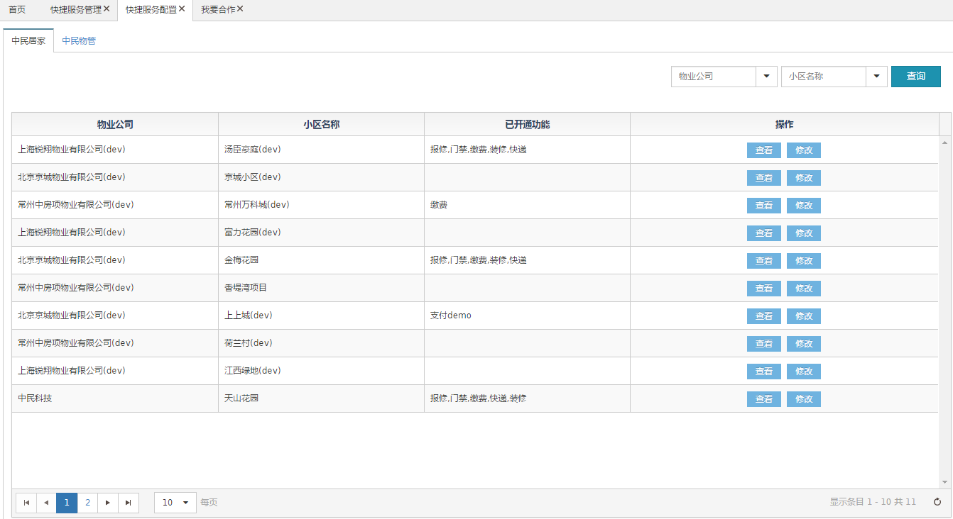

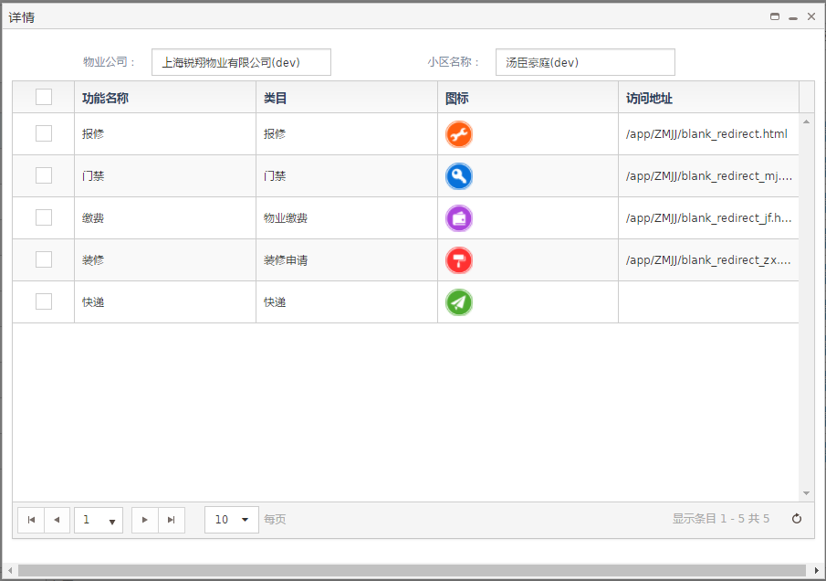

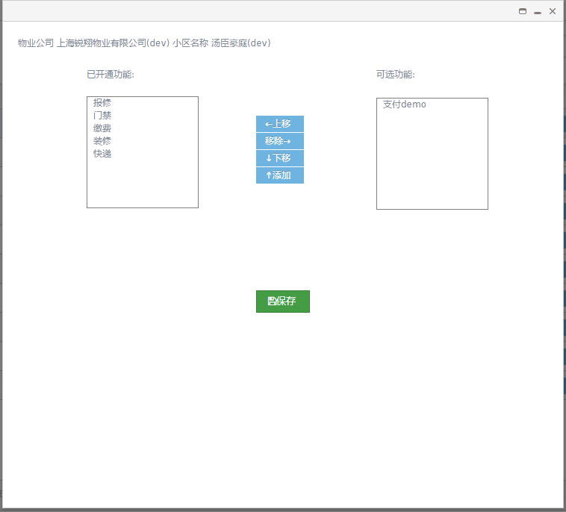

#### 文件清单

|  |  |
| --- | --- |
| **文件名** | **描述** |
| /include/head.html | 公用头部 |
| app_config_community.html | App配置界面列表 |
| app_config_community_detailMC.html | 物业端详细信息界面 |
| app_config_community_detailowner.html | 业主端详细信息界面 |
| app_config_community_edit.html | 物业端修改界面 |
| app_config_community_edit_propertymc.html | 业主端修改界面 |

#### 页面url

|  |  |
| --- | --- |
| **URL名称** | 查询中民居家业主端app配置列表 |
| URL | /csp/ljh/app/config/community/queryOwner |

|  |  |
| --- | --- |
| URL名称 | 查询中民物管端app配置列表 |
| URL | /csp/ljh/app/config/community/queryPropertyMC |

|  |  |
| --- | --- |
| URL名称 | 查询中民物管端app配置列表 |
| URL | /csp/ljh/app/config/community/queryPropertyMC |

|  |  |
| --- | --- |
| URL名称 | 查看app配置业主端详细信息 |
| URL | /csp/ljh/app/config/community/detail |

|  |  |
| --- | --- |
| URL名称 | 查看app配置物业端详细信息 |
| URL | /csp/ljh/app/config/community/detailProperty |

|  |  |
| --- | --- |
| URL名称 | 查看app配置物业端详细信息 |
| URL | /csp/ljh/app/config/community/detailProperty |

#### 控制事件

| **对象名称** | **事件** | **动作** | **描述** |
| --- | --- | --- | --- |
| 查询按钮 | onClick | queryOwner | 根据表单查询条件，将查询中民居家结果显示在表格中 |
| 查询按钮 | onClick | queryPropertyMC | 根据表单查询条件，将查询中民物管结果显示在表格中 |
| 查看-关闭 | onClick | detailOwner  (id) | 根据id跳转到中民居家修改界面，进行修改用户的信息 |
| 查看-关闭 | onClick | propertyMCdetail  (id) | 根据id跳转到中民物管修改界面，进行修改用户的信息 |
| 修改-保存 | onClick | editOwner  (id) | 根据id停用中民居家的app的状态 |
| 修改-保存 | onClick | editPropertyMC  (id) | 根据id开启中民居家的app的状态 |

#### 后台详细设计

##### Controller

|  |  |
| --- | --- |
| 类名：com.cmig.future.csportal.module.sys.appconfig.controllers. AppConfigCommunityController | |
| method | query |
| mapping url | /ljh/mgt/user/query |
| 参数 | HttpServletRequest request  AppConfigCommunity dto  int page  int pagesize |
| 返回值 | ResponseData(List<AppConfigFunctionCommunity >) |
| 详细逻辑 | 调用appConfigCommunityService.selectOwner  并返回结果 |
| method | queryPropertyMC |
| mapping url | /csp/ljh/app/config/community/queryPropertyMC |
| 参数 | HttpServletRequest request  AppConfigCommunity dto  int page  int pagesize |
| 返回值 | ResponseData(List<AppConfigFunctionCommunity >) |
| 详细逻辑 | 调用appConfigCommunityService. selectPropertyMC  并返回结果 |
| method | detail |
| mapping url | /csp/ljh/app/config/community/detail |
| 参数 | HttpServletRequest request  AppConfigCommunity dto |
| 返回值 | ResponseData(AppConfigCommunity) |
| 详细逻辑 | 调用appConfigCommunityService. getAppConfigCommunityById  并返回结果 |
| method | detailPropertyMC |
| mapping url | /csp/ljh/app/config/community/detailProperty |
| 参数 | HttpServletRequest request  AppConfigCommunity dto |
| 返回值 | ResponseData(AppConfigCommunity) |
| 详细逻辑 | 调用appConfigCommunityService. getAppConfigCommunityByIdPropertyMC  并返回结果 |
| method | queryAppConfig |
| mapping url | /csp/ljh/app/config/community/queryAppListOwner |
| 参数 | HttpServletRequest request  AppConfigFunction dto |
| 返回值 | ResponseData(AppConfigCommunity) |
| 详细逻辑 | 调用appConfigFunctionService  . selectAppConfigById  查看该小区开通了哪些功能 |

#### Service

|  |  |
| --- | --- |
| 接口名：com.cmig.future.csportal.module.sys.appconfig.service  . IAppConfigCommunityService | |
| method | selectOwner |
| 参数 | IRequest requestContext,  AppConfigFunction dto,  int page,  int pageSize |
| 返回值 | List<AppConfigCommunity> |
| 详细逻辑 | 调用appConfigCommunityMapper  .selectOwner返回业主端AppConfigCommunity对像 |
| method | selectPropertyMC |
| 参数 | IRequest requestContext,  AppConfigFunction dto,  int page,  int pageSize |
| 返回值 | List<AppConfigCommunity> |
| 详细逻辑 | 调用appConfigCommunityMapper  .selectOwner返回物业端AppConfigCommunity对像 |
| method | getAppConfigCommunityById |
| 参数 | AppConfigCommunity dto |
| 返回值 | AppConfigCommunity |
| 详细逻辑 | 调用appConfigCommunityMapper  . getAppConfigCommunityById  返回对象 |
| method | getAppConfigCommunityByIdPropertyMC |
| 参数 | AppConfigCommunity dto |
| 返回值 | AppConfigCommunity |
| 详细逻辑 | 调用appConfigCommunityMapper  . getAppConfigCommunityByIdPropertyMC  返回物业对象 |
| method | updateAppCommunityFunction |
| 参数 | AppConfigCommunity dto |
| 返回值 | AppConfigCommunity |
| 详细逻辑 | 调用appConfigCommunityMapper  . updateAppCommunityFunction  更新对象 |

#### Mapper

|  |  |
| --- | --- |
| 类名：com.cmig.future.csportal.module.sys.appconfig.mapper. AppConfigCommunityMapper | |
| method | selectOwner |
| 参数 | AppConfigCommunity dto |
| 返回值 | List<AppConfigFunction> |
| method | selectPropertyMC |
| 参数 | AppConfigCommunity dto |
| 返回值 | List<AppConfigFunction> |
| method | getAppConfigCommunityById |
| 参数 | AppConfigCommunity dto |
| 返回值 | AppConfigCommunity |
| method | getAppConfigCommunityByIdPropertyMC |
| 参数 | AppConfigCommunity dto |
| 返回值 | AppConfigCommunity |
| method | updateAppCommunityFunction |
| 参数 | String AppConfigCommuntiyId |
| 返回值 | Void |
| method | findAppCommunity |
| 参数 | AppConfigCommunity dto |
| 返回值 | List< AppConfigCommunity > |

### 用户管理

#### 前端详细设计

##### UI 设计

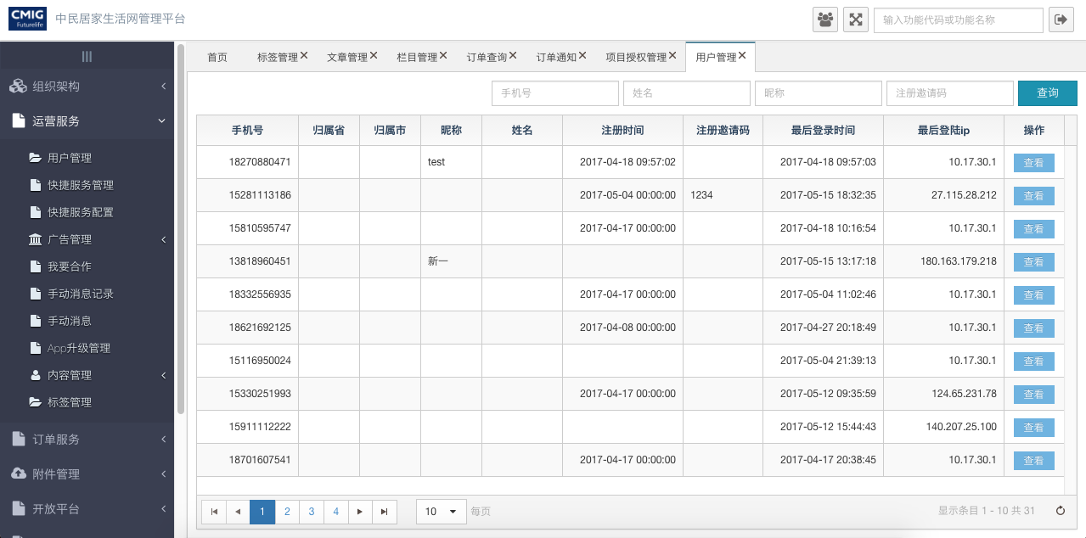

##### 文件清单

|  |  |
| --- | --- |
| **文件名** | **描述** |
| /include/head.html | 公用头部 |
| app_user.html | 用户管理 |
| app_user_info_card.html | 用户详情 |

##### 页面url定义

|  |  |
| --- | --- |
| **URL名称** | 查询用户 |
| **URL** | **/ljh/app/user/appUserList** |

|  |  |
| --- | --- |
| **URL名称** | 查询用户关注小区 |
| **URL** | **/ljh/app/user/getCommunityList** |

##### 控制事件

| **对象名称** | **事件** | **动作** | **描述** |
| --- | --- | --- | --- |
| 查询按钮 | onClick | queryOwner | 根据表单查询条件，将查询用户显示在表格中 |
| 查看 | onClick | queryUser | 用户详情 |

#### 后台详细设计

##### Controller

|  |  |
| --- | --- |
| 类名：AppUserWebController | |
| method | appUserList |
| mapping url | /ljh/app/user/appUserList |
| 参数 | AppUser dto,  HttpServletRequest request |
| 返回值 | ResponseData |
| 详细逻辑 | 调用appUserService. appUserList  并返回结果 |
| method | getCommunityList |
| mapping url | /ljh/app/user/getCommunityList |
| 参数 | HttpServletRequest request,  AppUser dto |
| 返回值 | ResponseData |
| 详细逻辑 | 调用attentionCommunityUserService.getCommunityList  并返回结果 |

##### Service

|  |  |
| --- | --- |
| 接口名：IAppUserService | |
| **method** | appUserList |
| **参数** | IRequest requestContext,  AppUser dto,  int page,  int pageSize |
| **返回值** | List<AppUser> |
| **详细逻辑** | 调用AppUserMapper  . appUserList |
| **method** | updateUserMobileInfo |
| **参数** | AppUser appUser |
| **返回值** | Void |
| **详细逻辑** | 更新用户信息 |
| **method** | getByMobile |
| **参数** | String mobile |
| **返回值** | AppUser |
| **详细逻辑** | 调用电话获取用户 |

##### Mapper

|  |  |
| --- | --- |
| 类名：AppUserMapper | |
| **method** | getBySourceSystemId |
| **参数** | String openid |
| **返回值** | AppUser |
| **method** | groupByTimeAndCateoryAndType |
| **参数** | SysNotifyRecord dto |
| **返回值** | List<AppUser> |
| **method** | findList |
| **参数** | String id |
| **返回值** | List<AppUser> |

### 我要合作

#### 前端详细设计

##### UI设计

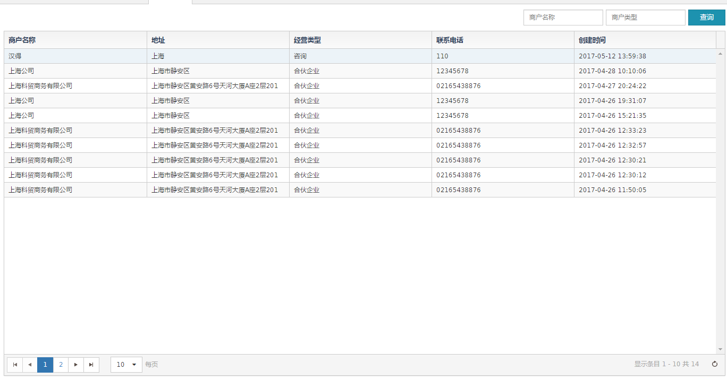

##### 文件清单

|  |  |
| --- | --- |
| **文件名** | **描述** |
| /include/head.html | 公用头部 |
| cooperate.html | 我要合作列表界面 |

##### 页面URL定义

|  |  |
| --- | --- |
| **URL名称** | 查询我要合作界面列表数据 |
| **URL** | /csp/ljh/cooperate/query |

##### 控制事件

| **对象名称** | **事件** | **动作** | **描述** |
| --- | --- | --- | --- |
| 查询按钮 | onClick | query | 根据表单查询条件，将查询我要合作结果显示在表格中 |

#### 后台详细设计

##### Controller

|  |  |
| --- | --- |
| **method** | query |
| **mapping url** | csp/ljh/cooperate/query |
| **参数** | HttpServletRequest request  Cooperate dto  Int page  Int pagesize |
| **返回值** | ResponseData(List<Cooperate>) |
| **详细逻辑** | 调用cooperateService.selectAllCooperate  并返回结果 |

##### Service

|  |  |
| --- | --- |
| 接口名：com.cmig.future.csportal.module.cooperate.service  . ICooperateService | |
| method | selectAllCooperate |
| 参数 | IRequest request,  Cooperate cooperate,  int pageNum,  int pageSize |
| 返回值 | List<Cooperate> |
| 详细逻辑 | 调用cooperateMapper  . selectAllCooperate  返回Cooperate列表 |

##### Mapper

|  |  |
| --- | --- |
| 类型com.cmig.future.csportal.module.cooperate.mapper.CooperateMapper | |
| method | selectAllCooperate |
| 参数 | Cooperate cooperate |
| 返回值 | List<Cooperate> |

## 订单服务

### 订单查询

#### 前端详细设计

##### UI设计

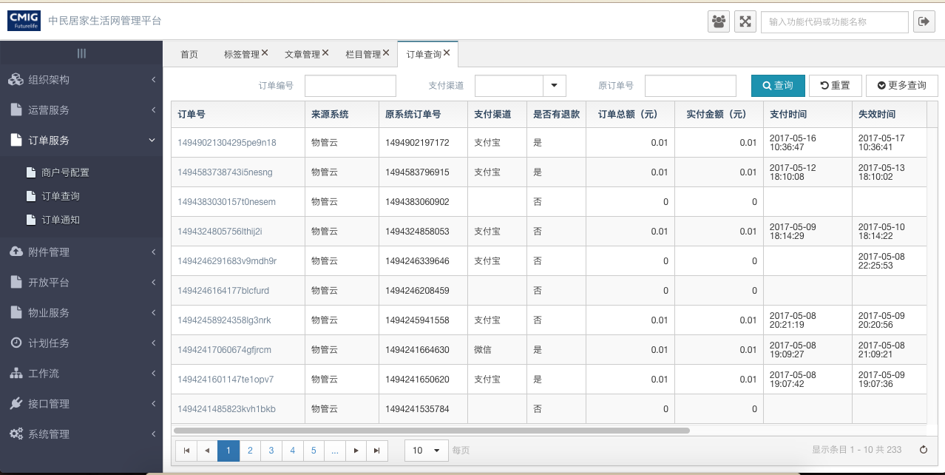

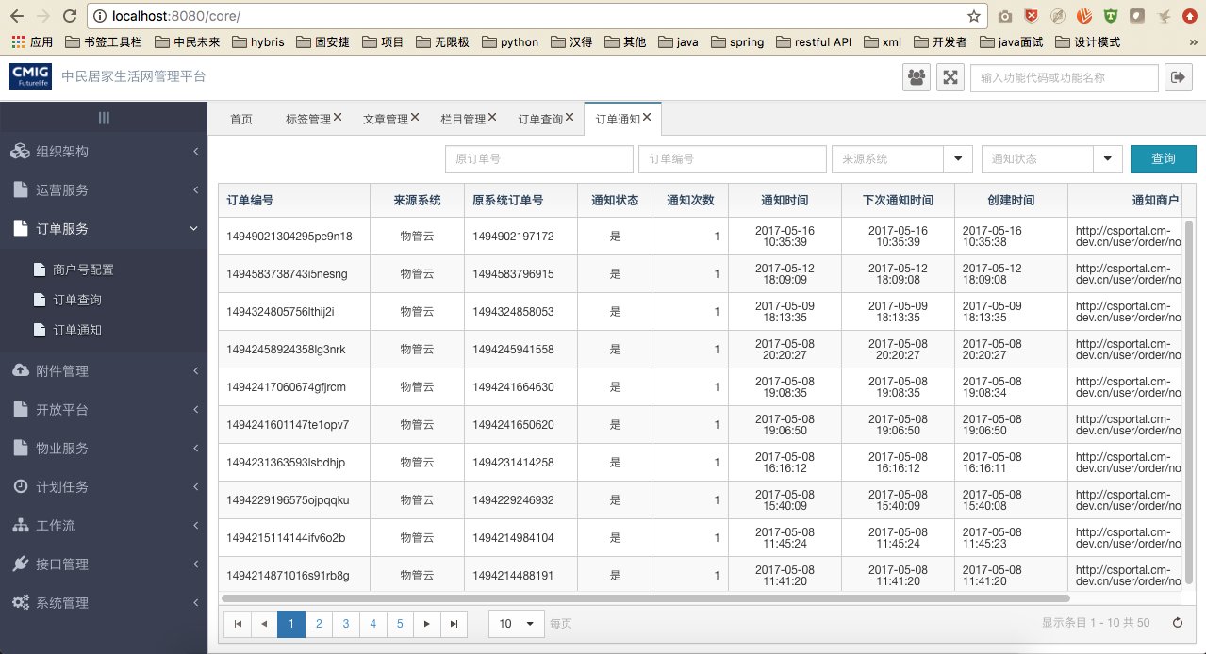

##### 文件清单

|  |  |
| --- | --- |
| **文件名** | **描述** |
| /include/head.html | 公用头部 |
| order_form.html | 订单查询 |
| order_form_detail.html | 订单详情 |
| order_form_notify_mc.html | 订单通知 |

##### 页面URL定义

|  |  |
| --- | --- |
| **URL名称** | 订单查询 |
| **URL** | /csp/order/form/query |
| **URL名称** | 根据id查询订单 |
| **URL** | / csp/order/form/queryById |

##### 控制事件

| **对象名称** | **事件** | **动作** | **描述** |
| --- | --- | --- | --- |
| 订单编号 | onClick | query（） | 查看订单 |

#### 后台详细设计

##### Controller

***1.*** ***OrderFormController***

|  |  |
| --- | --- |
| 类名：***OrderFormController*** | |
| **method** | query |
| **mapping url** | /csp/order/form/query |
| **参数** | OrderForm dto,  int page,  int pageSize,  HttpServletRequest request |
| **返回值** | ResponseData |
| **详细逻辑** | 调用service. select  并返回结果 |
| **method** | query |
| **mapping url** | /csp/order/form/queryById |
| **参数** | OrderForm dto,  HttpServletRequest request |
| **返回值** | ResponseData |
| **详细逻辑** | 调用service. selectByPrimaryKey  并返回结果 |

##### Service

***1.*** ***IOrderFormService***

|  |  |
| --- | --- |
| 类名：***IOrderFormService*** | |
| **method** | findByOrderNumber |
| **参数** | String orderNumber |
| **返回值** | OrderForm |
| **详细逻辑** | 调用orderFormMapper.findByOrderNumber  并返回结果 |
| **method** | createCharge |
| **参数** | OrderForm orderForm,  Map<String, Object> chargeMap |
| **返回值** | Charge |
| **详细逻辑** | Ping++创建订单 |
| **method** | chargeSucceeded |
| **参数** | Charge charge |
| **返回值** | void |
| **详细逻辑** | 处理支付成功通知 |
| **method** | findBySourceOrderNumber |
| **参数** | OrderForm orderForm, |
| **返回值** | OrderForm |
| **详细逻辑** | 根据原订单号查询订单 |
| **method** | excuteOrderNotifyJob |
| **参数** | OrderFormNotifyMc orderFormNotifyMc, |
| **返回值** | Void |
| **详细逻辑** | 支付成功通知定时任务 |
| **method** | excuteOrderRefundNotifyJob |
| **参数** | OrderFormRefundNotifyMc orderFormRefundNotifyMc, |
| **返回值** | Void |
| **详细逻辑** | 退款成功通知定时任务 |

##### Mapper

***1.*** ***OrderFormMapper***

|  |  |
| --- | --- |
| 类名：***OrderFormMapper*** | |
| **method** | findByOrderNumber |
| **返回值** | OrderForm |
| **method** | select |
| **返回值** | List<OrderForm> |
| **method** | findBySourceOrderNumber |
| **返回值** | OrderForm |

## 物业服务

### 项目管理

#### 前端详细设计

##### UI设计

项目管理主页

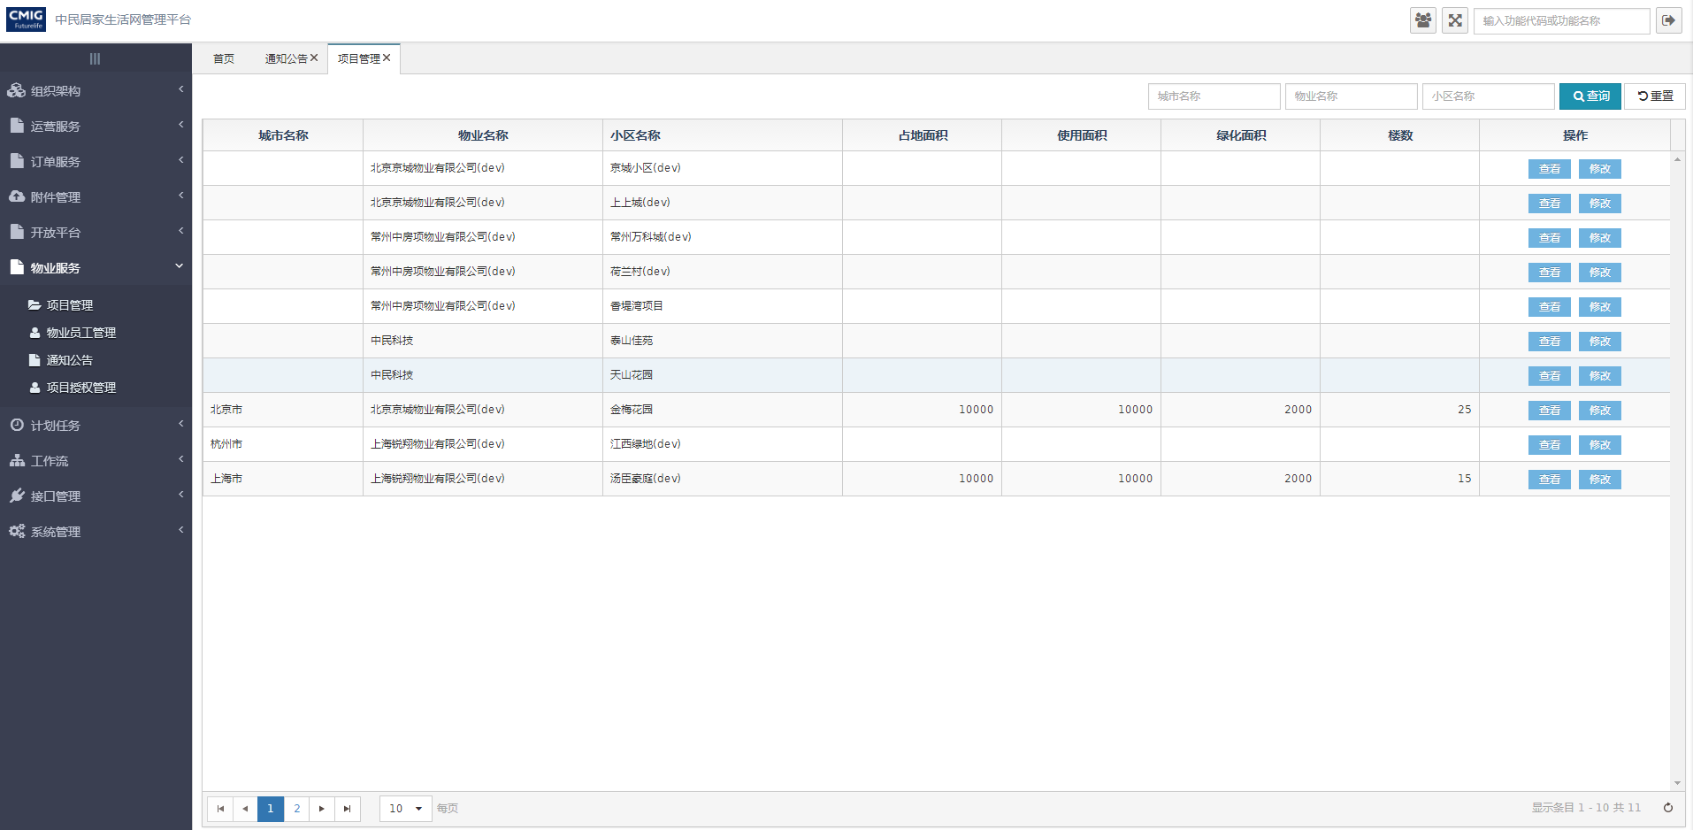

项目详情页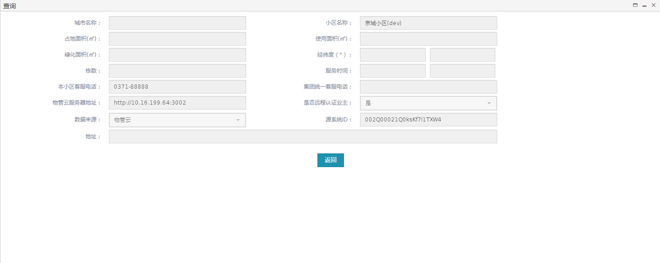项目修改页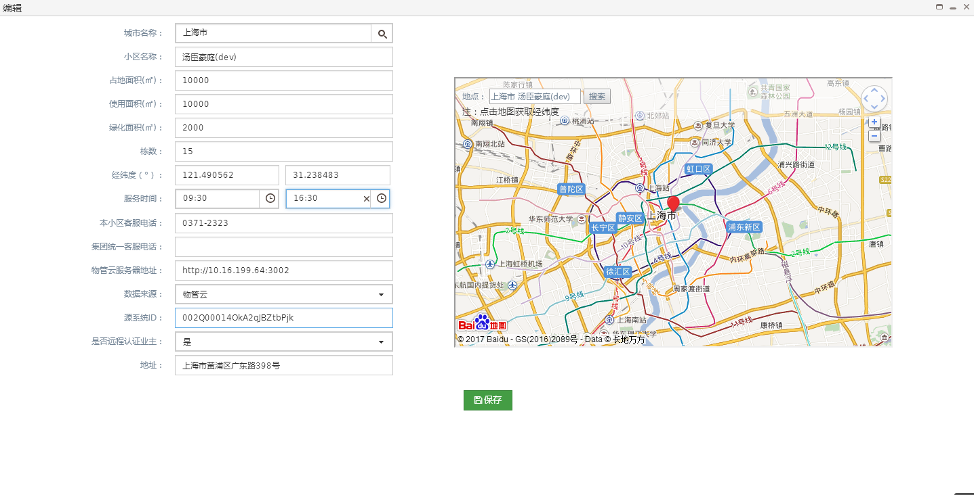

##### 文件清单

|  |  |
| --- | --- |
| **文件名** | **描述** |
| /include/head.html | 公用头部 |
| base_community.html | 项目管理页面 |
| base_community_detail.html | 项目详情页面 |
| base_community_edit.html | 项目修改页面 |

##### 页面URL定义

|  |  |
| --- | --- |
| **URL名称** | 查询项目信息 |
| **URL** | /ljh/base/community/query |
| **URL名称** | 修改项目信息 |
| **URL** | /ljh/base/community/update |
| **URL名称** | 根据id查询项目信息 |
| **URL** | /ljh/base/community/get |

##### 控制事件

| **对象名称** | **事件** | **动作** | **描述** |
| --- | --- | --- | --- |
| 查询按钮 | onClick | queryResource() | 根据表单查询条件，将查询结果显示在表格中 |
| 重置按钮 | onClick | reset() | 重置查询条件 |
| 查看按钮 | onClick | communityQuery(id) | 根据项目id查看项目信息 |
| 修改按钮 | onClick | communityEdit(id) | 根据项目id跳转修改页面 |
| 返回按钮 | onClick | back() | 返回项目管理页面 |
| 保存按钮 | onClick | save() | 保存项目信息 |

#### 后台详细设计

##### Controller

###### BaseCommunityController

|  |  |
| --- | --- |
| 类名：com.cmig.future.csportal.module.properties.community.controllers.BaseCommunityController | |
| **method** | query |
| **mapping url** | /ljh/base/community/query |
| **参数** | BaseCommunity dto  HttpServletRequest request  int page  int pageSize |
| **返回值** | ResponseData(List< BaseCommunity>) |
| **详细逻辑** | 调用baseCommunityService.selectCommunity  并返回结果 |
| **method** | get |
| **mapping url** | /ljh/base/community/get |
| **参数** | HttpServletRequest request  String id |
| **返回值** | ResponseData(BaseCommunity) |
| **详细逻辑** | 调用baseCommunityService.get并返回结果 |
| **method** | updateCommunity |
| **mapping url** | /ljh/base/community/update |
| **参数** | HttpServletRequest request  BaseCommunity dto |
| **返回值** | ResponseData(BaseCommunity) |
| **详细逻辑** | 调用ljhSysAreaService.queryCityNameById方法获得城市名称保存到BaseCommunity中,调用baseCommunityService.save方法返回结果 |

##### Service

###### IBaseCommunityService

|  |  |
| --- | --- |
| 类名：com.cmig.future.csportal.module.properties.community. service.IBaseCommunityService | |
| **method** | save |
| **参数** | BaseCommunity community |
| **返回值** | void |
| **详细逻辑** | 根据对象id是否为空判断,如果不为空调用baseCommunityMapper.updateCommunity  更新,如果为空调用baseCommunityMapper.insertCommunity插入 |
| **method** | getBySourceSystemId |
| **参数** | BaseCommunity community |
| **返回值** | BaseCommunity |
| **详细逻辑** | 调用baseCommunityMapper.getBySourceSystemId并返回结果 |
| **method** | findByCommunityName |
| **参数** | BaseCommunity community |
| **返回值** | BaseCommunity |
| **详细逻辑** | 调用baseCommunityMapper.findByCommunityName并返回结果 |
| **method** | findCommunityListByName |
| **参数** | BaseCommunity community |
| **返回值** | List<BaseCommunity> |
| **详细逻辑** | 调用baseCommunityMapper.findCommunityListByName并返回结果 |
| **method** | delete |
| **参数** | BaseCommunity community |
| **返回值** | int |
| **详细逻辑** | 调用baseCommunityMapper.deleteCommunity并返回结果 |
| **method** | findUserCommunityList |
| **参数** | BaseCommunity community |
| **返回值** | List<BaseCommunity> |
| **详细逻辑** | 调用baseCommunityMapper.findUserCommunityList并返回结果 |
| **method** | get |
| **参数** | String communityId |
| **返回值** | BaseCommunity |
| **详细逻辑** | 调用baseCommunityMapper.getById并返回结果 |
| **method** | findCommunityByLikeCommunityName |
| **参数** | IRequest request  BaseCommunity community  int pageNum  int pageSize |
| **返回值** | List<BaseCommunity> |
| **详细逻辑** | 调用baseCommunityMapper. findCommunityByLikeCommunityName并返回结果 |
| **method** | findCommunityByLngLat |
| **参数** | BaseCommunity community |
| **返回值** | BaseCommunity |
| **详细逻辑** | 调用baseCommunityMapper. findCommunityByLngLat并返回结果 |
| **method** | selectCommunity |
| **参数** | IRequest request  BaseCommunity community  int pageNum  int pageSize |
| **返回值** | List<BaseCommunity> |
| **详细逻辑** | 调用baseCommunityMapper.selectCommunity并返回结果 |
| **method** | findList |
| **参数** | IRequest request  BaseCommunity community  int pageNum  int pageSize |
| **返回值** | List<BaseCommunity> |
| **详细逻辑** | 调用baseCommunityMapper.findList并返回结果 |

##### Mapper

###### BaseCommunityMapper

|  |  |
| --- | --- |
| 类名：com.cmig.future.csportal.module.properties.community. mapper.BaseCommunityMapper | |
| **method** | insertCommunity |
| **参数** | BaseCommunity community |
| **返回值** | int |
| **method** | updateCommunity |
| **参数** | BaseCommunity community |
| **返回值** | int |
| **method** | getBySourceSystemId |
| **参数** | BaseCommunity community |
| **返回值** | BaseCommunity |
| **method** | findByCommunityName |
| **参数** | BaseCommunity community |
| **返回值** | BaseCommunity |
| **method** | findCommunityListByName |
| **参数** | BaseCommunity community |
| **返回值** | List<BaseCommunity> |
| **method** | deleteCommunity |
| **参数** | BaseCommunity community |
| **返回值** | int |
| **详细逻辑** | 调用baseCommunityMapper.deleteCommunity并返回结果 |
| **method** | findUserCommunityList |
| **参数** | BaseCommunity community |
| **返回值** | List<BaseCommunity> |
| **method** | findCommunityByLikeCommunityName |
| **参数** | IRequest request  BaseCommunity community  int pageNum  int pageSize |
| **返回值** | List<BaseCommunity> |
| **详细逻辑** | 调用baseCommunityMapper. findCommunityByLikeCommunityName并返回结果 |
| **method** | findCommunityByLngLat |
| **参数** | BaseCommunity community |
| **返回值** | BaseCommunity |
| **method** | selectCommunity |
| **参数** | IRequest request  BaseCommunity community  int pageNum  int pageSize |
| **返回值** | List<BaseCommunity> |
| **method** | findList |
| **参数** | IRequest request  BaseCommunity community  int pageNum  int pageSize |
| **返回值** | List<BaseCommunity> |
| **method** | getById |
| **参数** | BaseCommunity community |
| **返回值** | BaseCommunity |

### 通知公告

#### 前端详细设计

##### UI设计

通知公告主页

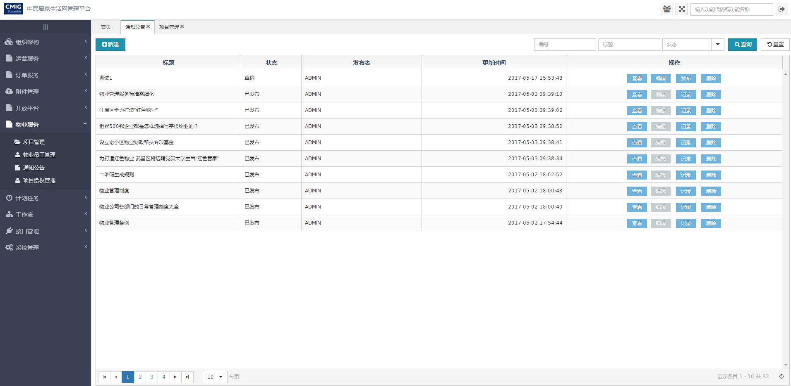

查看通知公告内容页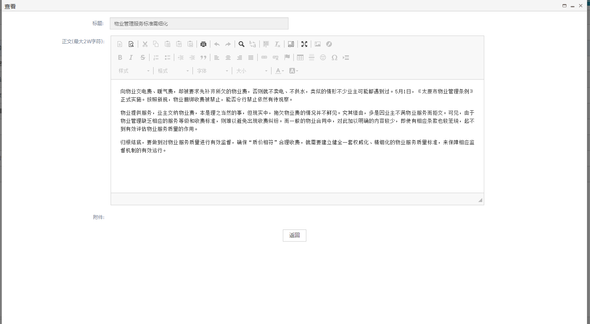通知公告编辑页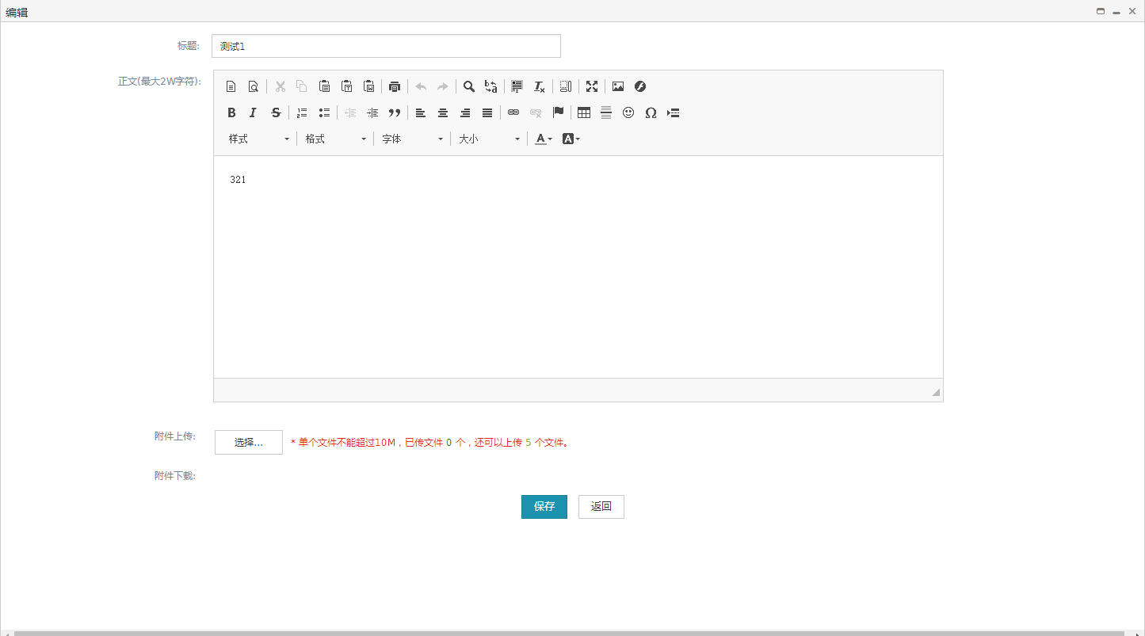通知公告发布页

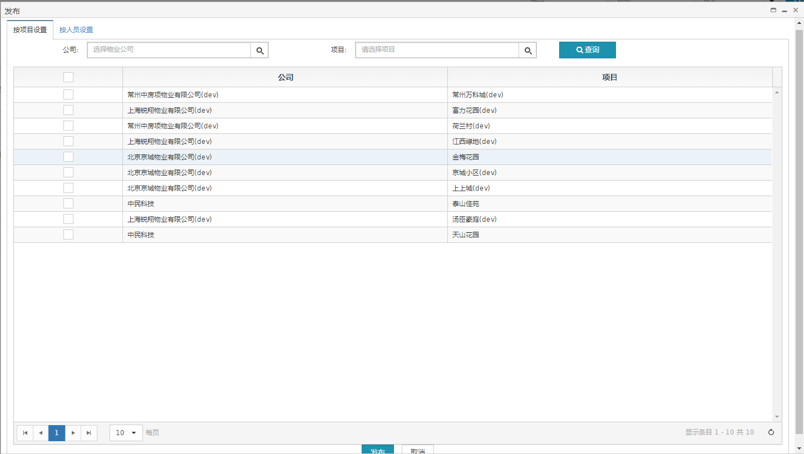

通知公告记录页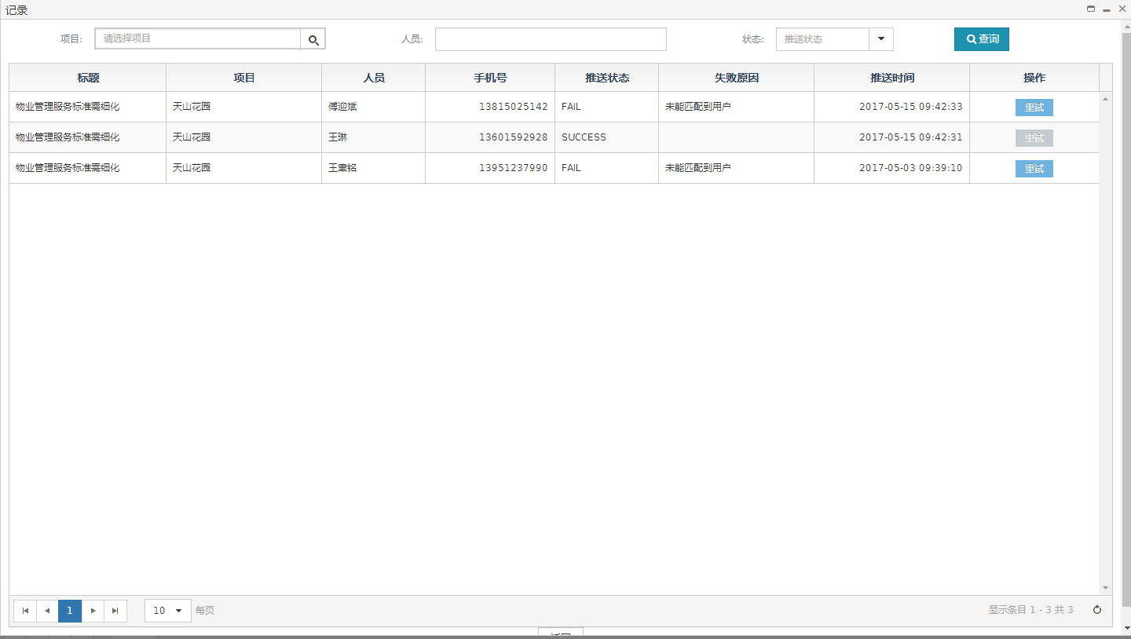

##### 文件清单

|  |  |
| --- | --- |
| **文件名** | **描述** |
| /include/head.html | 公用头部 |
| article_notify.html | 通知公告页面 |
| article_notify_detail.html | 查看通知公告内容页面 |
| article_notify_edit.html | 编辑通知公告页面 |
| article_notify_public.html | 通知公告发布页面 |
| article_notify_record.html | 通知公告记录页面 |

##### 页面URL定义

|  |  |
| --- | --- |
| **URL名称** | 根据id删除通知公告 |
| **URL** | /articleNotify/deleteArticleNotifyById |
| **URL名称** | 通知公告查询 |
| **URL** | /articleNotify/query |

##### 控制事件

| **对象名称** | **事件** | **动作** | **描述** |
| --- | --- | --- | --- |
| 查询按钮 | onClick | queryResource() | 根据表单查询条件，将查询结果显示在表格中 |
| 重置按钮 | onClick | reset() | 重置查询条件 |
| 查看按钮 | onClick | articleShow(id) | 根据通知公告id跳转查看页面 |
| 编辑按钮 | onClick | articleEdit(id) | 根据通知公告id跳转修改页面 |
| 发布按钮 | onClick | publish(id) | 根据通知公告id跳转发布页面 |
| 记录按钮 | onClick | articleRecord(id) | 根据通知公告id跳转记录页面 |
| 删除按钮 | onClick | articleDelete(id) | 根据通知公告id删除 |
| 返回按钮 | onClick | back() | 返回通知公告主页 |
| 保存按钮 | onClick | save() | 保存From表单中的信息 |
| 发布按钮 | onClick | public2() | 根据勾选对象发布通知公告 |
| 重试按钮 | onClick | repush(id) | 发送失败的通知公告重新发送 |

#### 后台详细设计

##### Controller

###### ArticleNotifyController

|  |  |
| --- | --- |
| 类名：com.cmig.future.csportal.module.operate.articleNotify.controllers.ArticleNotifyController | |
| **method** | query |
| **mapping url** | /articleNotify/query |
| **参数** | ArticleNotify dto  HttpServletRequest request  int page  int pageSize |
| **返回值** | ResponseData(List<ArticleNotify>) |
| **详细逻辑** | 调用articleNotifyService.selectArticleNotify  并返回结果 |
| **method** | update |
| **mapping url** | /articleNotify/submit |
| **参数** | HttpServletRequest request  List<ArticleNotify> dto |
| **返回值** | ResponseData(List<ArticleNotify>) |
| **详细逻辑** | 调用articleNotifyService.batchUpdate并返回结果 |
| **method** | delete |
| **mapping url** | /articleNotify/remove |
| **参数** | HttpServletRequest request  List<ArticleNotify> dto |
| **返回值** | ResponseData(List<ArticleNotify>) |
| **详细逻辑** | 调用articleNotifyService.batchDelete并返回结果 |
| **method** | saveOrUpdate |
| **mapping url** | /articleNotify/saveOrUpdate |
| **参数** | HttpServletRequest request  List<ArticleNotify> dto |
| **返回值** | ResponseData(List<ArticleNotify>) |
| **详细逻辑** | 调用articleNotifyService.saveOrUpdate并返回结果 |
| **method** | queryArticleNotifyById |
| **mapping url** | /articleNotify/queryArticleNotifyById |
| **参数** | HttpServletRequest request  String id |
| **返回值** | ResponseData(ArticleNotify) |
| **详细逻辑** | 调用articleNotifyService.queryArticleNotifyById并返回结果 |
| **method** | deleteArticleNotifyById |
| **mapping url** | /articleNotify/deleteArticleNotifyById |
| **参数** | HttpServletRequest request  String id |
| **返回值** | ResponseData(List<ArticleNotify>) |
| **详细逻辑** | 调用articleNotifyService.deleteArticleNotifyById并返回结果 |
| **method** | publishForCommunity |
| **mapping url** | /articleNotify/publishForCommunity |
| **参数** | HttpServletRequest request  MgtUserCommunity mgtUserCommunity  int page  int pageSize |
| **返回值** | ResponseData(List<MgtUserCommunity>) |
| **详细逻辑** | 调用articleNotifyService.findPublishCommunityList并返回结果 |
| **method** | publishForUser |
| **mapping url** | /articleNotify/publishForUser |
| **参数** | HttpServletRequest request  MgtUserCommunity mgtUserCommunity  int page  int pageSize |
| **返回值** | ResponseData(List<MgtUserCommunity>) |
| **详细逻辑** | 调用articleNotifyService.findPublishUserList并返回结果 |
| **method** | publishToCommunity |
| **mapping url** | /articleNotify/publishToCommunity |
| **参数** | HttpServletRequest request  String article  String selectIds |
| **返回值** | ResponseData(List<ArticleNotify>) |
| **详细逻辑** | 调用sysNotifyRecordService.publishToCommunity并返回结果 |
| **method** | publishToUser |
| **mapping url** | /articleNotify/publishToUser |
| **参数** | HttpServletRequest request  String article  String selectUserIds |
| **返回值** | ResponseData(List<ArticleNotify>) |
| **详细逻辑** | 调用sysNotifyRecordService.publishToUser并返回结果 |
| **method** | querySysAttachmentByObjectId |
| **mapping url** | /articleNotify/querySysAttachmentByObjectId |
| **参数** | HttpServletRequest request  SysAttachment sysAttachment |
| **返回值** | ResponseData(List<SysAttachment>) |
| **详细逻辑** | 调用sysAttachmentService.findList并返回结果 |

###### SysNotifyRecordController

|  |  |
| --- | --- |
| 类名：com.cmig.future.csportal.module.sys.notifyrecord.controllers.SysNotifyRecordController | |
| **method** | repush |
| **mapping url** | /ljh/sys/notify/record/repush |
| **参数** | SysNotifyRecord sysNotifyRecord  HttpServletRequest request |
| **返回值** | ResponseData(SysNotifyRecord) |
| **详细逻辑** | 调用JPushPmCloundUtils.pushAlertWithMessageSyn  并返回结果 |

##### Service

###### IArticleNotifyService

|  |  |
| --- | --- |
| 类名：com.cmig.future.csportal.module.operate.articleNotify.service.IArticleNotifyService | |
| **method** | selectArticleNotify |
| **参数** | IRequest requestContext  ArticleNotify articleNotify  int page  int pagesize |
| **返回值** | List<ArticleNotify> |
| **详细逻辑** | 调用articleNotifyMapper. selectArticleNotify并返回结果 |
| **method** | saveOrUpdate |
| **参数** | IRequest requestCtx  List<ArticleNotify> dto |
| **返回值** | List<ArticleNotify> |
| **详细逻辑** | 根据对象id是否为空判断,如果不为空调用articleNotifyMapper.updateByPrimaryKeySelective  更新,如果为空调用articleNotifyMapper.insertSelective插入 |
| **method** | queryArticleNotifyById |
| **参数** | String id |
| **返回值** | ArticleNotify |
| **详细逻辑** | 调用articleNotifyMapper.queryArticleNotifyById并返回结果 |
| **method** | deleteArticleNotifyById |
| **参数** | ArticleNotify articleNotify |
| **返回值** | int |
| **详细逻辑** | 调用articleNotifyMapper.deleteArticleNotifyById并返回结果 |

###### ISysNotifyRecordService

|  |  |
| --- | --- |
| 类名：com.cmig.future.csportal.module.sys.notifyrecord.service.ISysNotifyRecordService | |
| **method** | publishToCommunity |
| **参数** | IRequest request  String articleId  String content,  String selectIds |
| **返回值** | void |
| **详细逻辑** | 调用mgtUserCommunityMapper.findPublishUserList查询物业用户,调用sysNotifyRecordMapper.insertSelective保存信息,调用JPushPmCloundUtils.pushAlertWithMessage发送消息 |
| **method** | publishToUser |
| **参数** | IRequest request  String articleId  String content  String selectUserIds |
| **返回值** | void |
| **详细逻辑** | 调用mgtUserCommunityMapper.findPublishUserList查询物业用户,调用sysNotifyRecordMapper.insertSelective保存信息,调用JPushPmCloundUtils.pushAlertWithMessage发送消息 |

##### Mapper

###### ArticleNotifyMapper

|  |  |
| --- | --- |
| 类名：com.cmig.future.csportal.module.operate.articleNotify.mapper.ArticleNotifyMapper | |
| **method** | selectArticleNotify |
| **参数** | ArticleNotify articleNotify |
| **返回值** | List<ArticleNotify> |
| **method** | queryArticleNotifyById |
| **参数** | ArticleNotify articleNotify |
| **返回值** | ArticleNotify |
| **method** | deleteArticleNotifyById |
| **参数** | ArticleNotify articleNotify |
| **返回值** | int |

###### SysNotifyRecordMapper

|  |  |
| --- | --- |
| 类名：com.cmig.future.csportal.module.sys.notifyrecord.mapper.SysNotifyRecordMapper | |
| **method** | insertSelective |
| **参数** | SysNotifyRecord sysNotifyRecord |
| **返回值** | SysNotifyRecord |

### 项目授权管理

#### 前端详细设计

##### UI设计

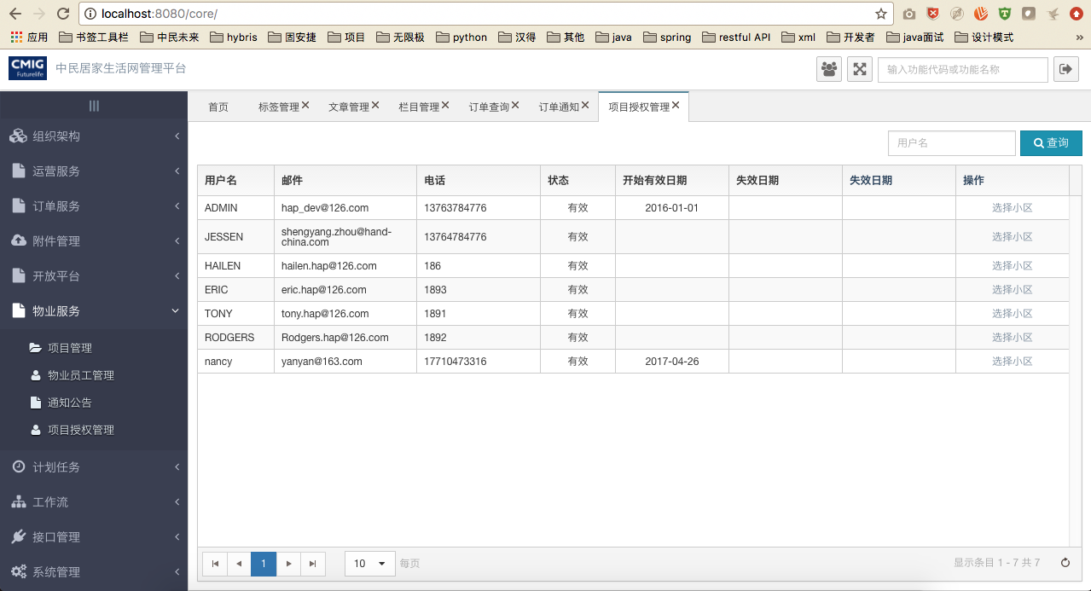

##### 文件清单

|  |  |
| --- | --- |
| **文件名** | **描述** |
| /include/head.html | 公用头部 |
| ljh_sys_user.html | 用户列表 |
| ljh_sys_user_community.html | 小区授权列表 |

##### 页面URL定义

|  |  |
| --- | --- |
| **URL名称** | 查询未授权的小区 |
| **URL** | /csp/ljh/sys/user/community/queryCommunitiesNoAuth |
| **URL名称** | 保存授权小区 |
| **URL** | /csp/ljh/sys/user/community/submit |
| **URL名称** | 删除小区 |
| **URL** | /csp/ljh/sys/user/community/remove |

##### 控制事件

| **对象名称** | **事件** | **动作** | **描述** |
| --- | --- | --- | --- |
| 选择小区 | onClick | SelectCommunity() | 选择小区 |
| 新增 | onClick | add() | 新增 |
| 删除 | onClick | delete(id) | 删除 |

#### 后台详细设计

##### Controller

###### 1.LjhSysUserCommunityController

|  |  |
| --- | --- |
| 类名：LjhSysUserCommunityController | |
| **method** | queryCommunitiesNoAuth |
| **mapping url** | csp/ljh/sys/user/community/queryCommunitiesNoAuth |
| **参数** | LjhSysUserCommunity dto  HttpServletRequest request  int page  int pageSize |
| **返回值** | ResponseData |
| **详细逻辑** | 调用service. queryCommunitiesNoAuth  并返回结果 |
| **method** | update |
| **mapping url** | /csp/ljh/sys/user/community/submit |
| **参数** | HttpServletRequest request  List<LjhSysUserCommunity> dto |
| **返回值** | ResponseData |
| **详细逻辑** | 调用service. saveUserCommunity并返回结果 |
| **method** | delete |
| **mapping url** | /csp/ljh/sys/user/community/remove |
| **参数** | HttpServletRequest request  List< LjhSysUserCommunity > dto |
| **返回值** | ResponseData |
| **详细逻辑** | 调用service. batchDelete并返回结果 |

##### Service

###### 1.ILjhSysUserCommunityService

|  |  |
| --- | --- |
| 类名：ILjhSysUserCommunityService | |
| **method** | saveUserCommunity |
| **参数** | IRequest request,  List<LjhSysUserCommunity> ljhSysUserCommunities |
| **返回值** | List<LjhSysUserCommunity> |
| **详细逻辑** | 调用*ILjhSysUserCommunityMapper*.saveUserCommunity并返回结果 |
| **method** | selectByUser |
| **参数** | IRequest requestContext,  LjhSysUserCommunity dto,  int page,  int pageSize |
| **返回值** | List<LjhSysUserCommunity> |
| **详细逻辑** | 根据userId查询授权小区 |
| **method** | queryCommunitiesNoAuth |
| **参数** | IRequest requestContext,  LjhSysUserCommunity dto,  int page,  int pageSize |
| **返回值** | List<LjhSysUserCommunity> |
| **详细逻辑** | 查询未授权的所有小区 |

##### Mapper

###### LjhSysUserCommunityMapper

|  |  |
| --- | --- |
| 类名：LjhSysUserCommunityMapper | |
| **method** | selectByUser |
| **参数** | LjhSysUserCommunity dto |
| **返回值** | List<LjhSysUserCommunity> |
| **method** | findListByUserId |
| **参数** | LjhSysUserCommunity dto |
| **返回值** | List<LjhSysUserCommunity> |
| **method** | queryCommunitiesNoAuth |
| **参数** | LjhSysUserCommunity dto |
| **返回值** | List<LjhSysUserCommunity> |

### 物业员工管理

#### 前端详细设计

##### UI设计

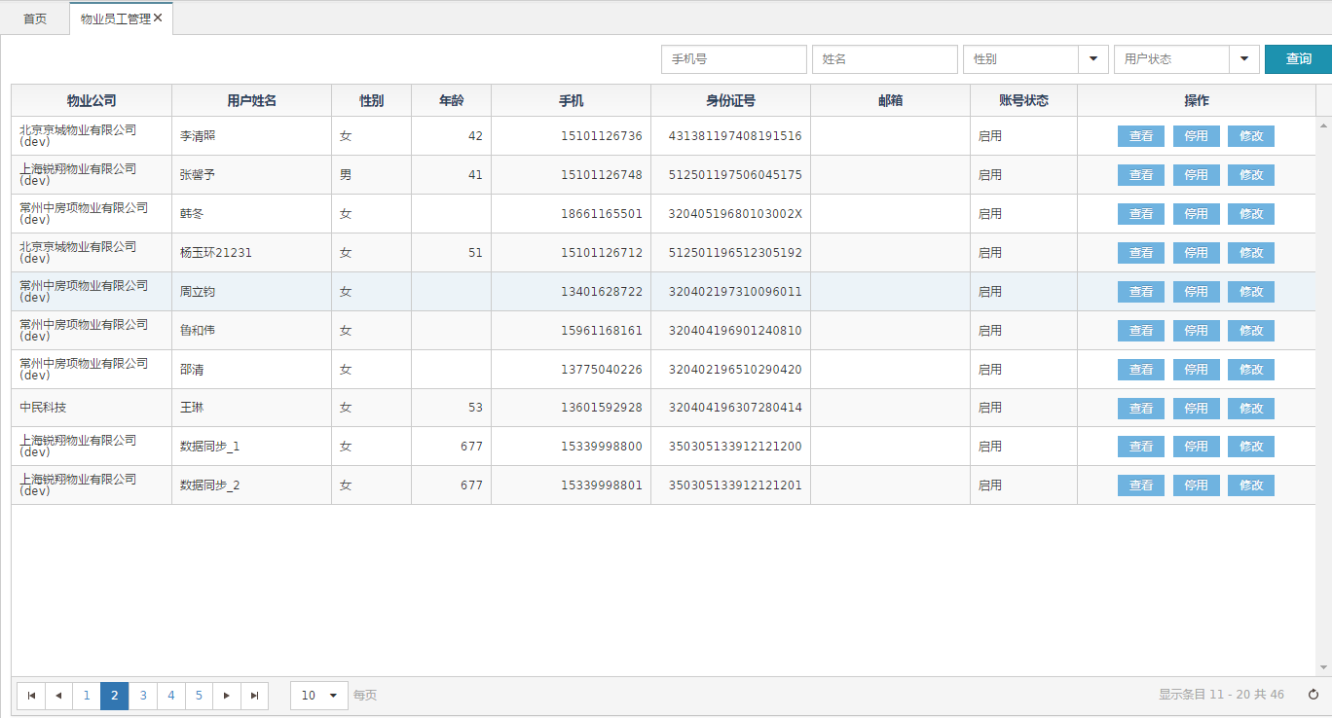

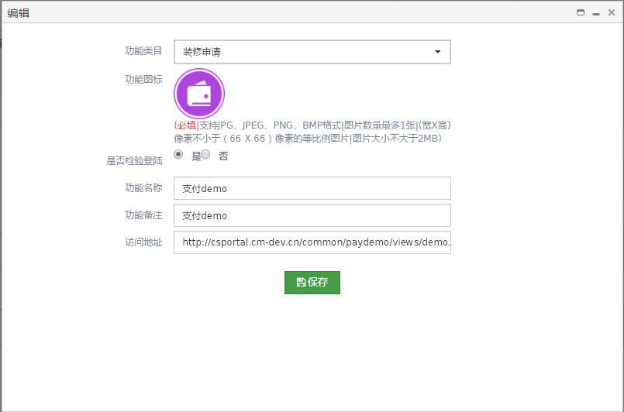

##### 文件清单

|  |  |
| --- | --- |
| **文件名** | **描述** |
| /include/head.html | 公用头部 |
| mgt_user.html | 物管用户列表界面 |
| mgtuser_detail.html | 物管用户详细界面 |
| mgtuser_edit.html | 物管用户修改界面 |

##### 页面URL定义

|  |  |
| --- | --- |
| **URL名称** | 查询物管用户列表 |
| **URL** | /ljh/mgt/user/query |

|  |  |
| --- | --- |
| **URL名称** | 查看物管用户的详细信息 |
| **URL** | /ljh/mgt/user/detail |

|  |  |
| --- | --- |
| **URL名称** | 更新物管用户 |
| **URL** | /ljh/mgt/user/update |

|  |  |
| --- | --- |
| **URL名称** | 停止物管用户的登陆状态 |
| **URL** | /ljh/mgt/user/stopLoginStatus |

|  |  |
| --- | --- |
| **URL名称** | 开启物管用户的登陆状态 |
| **URL** | /ljh/mgt/user/startLoginStatus |

##### 控制事件

| **对象名称** | **事件** | **动作** | **描述** |
| --- | --- | --- | --- |
| 查询按钮 | onClick | query() | 根据表单查询条件，将查询结果显示在表格中 |
| 查看-关闭 | onClick | detail(id) | 根据id查看该物管用户的详细信息 |
| 修改-保存 | onClick | editUser(id) | 根据id跳转到修改界面，进行修改用户的信息 |
| 停用 | onClick | stopstatus(id) | 根据id停用该物管用户的账号 |
| 启用 | onClick | startstatus(id) | 根据id开启该物管用户的账号 |

#### 后台详细设计

##### Controller

|  |  |
| --- | --- |
| 类名：com.cmig.future.csportal.module.properties.mgtuser.controllers.MgtUserController | |
| method | queryt |
| mapping url | /ljh/mgt/user/query |
| 参数 | HttpServletRequest request  MgtUser mgtUser  int page  int pagesize |
| 返回值 | ResponseData(List<MgtUser>) |
| 详细逻辑 | 调用mgtUserService.selectMgtUser  并返回结果 |
| method | detail |
| mapping url | /ljh/mgt/user/detail |
| 参数 | HttpServletRequest request  MgtUser dto |
| 返回值 | ResponseData(MgtUser dto) |
| 详细逻辑 | 调用mgtUserService.selectByPrimaryKey并返回修MgtUser对象 |
| method | update |
| mapping url | /ljh/mgt/user/update |
| 参数 | HttpServletRequest request  MgtUser mgtUser |
| 返回值 | ResponseData() |
| 详细逻辑 | 调用mgtUserService.updateByPrimaryKeySelective  执行更新 |
| method | stopLoginStatus |
| mapping url | /ljh/mgt/user/stopLoginStatus |
| 参数 | HttpServletRequest request, |
| 返回值 | ResponseData() |
| 详细逻辑 | 调用mgtUserService.updateByPrimaryKeySelective  关闭该用户的登陆状态 |
| method | startLoginStatus |
| Mapping url | /ljh/mgt/user/startLoginStatus |
| 参数 | HttpServletRequest request |
| 返回值 | ResponseData() |
| 详细逻辑 | 调用mgtUserService.updateByPrimaryKeySelective开启改用的登陆状态 |

##### Service

|  |  |
| --- | --- |
| 接口名：com.cmig.future.csportal.module.properties.mgtuser.service.IMgtUserService | |
| **method** | getUser |
| **参数** | String userId |
| **返回值** | MgtUser |
| **详细逻辑** | 调用mgtUserMapper.getMgtUserById返回MgtUser对像 |
| **method** | getUserByMobile |
| **参数** | String mobile |
| **返回值** | MgtUser |
| **详细逻辑** | 调用mgtUserMapper.getUserByMobile返回MgtUser对象 |
| **method** | getUserByEmail |
| **参数** | String email |
| **返回值** | MgtUser |
| **详细逻辑** | 调用mgtUserMapper.getUserByEmail返回MgtUser对象 |
| **method** | inertMgtUser |
| **参数** | MgtUser mgtUser |
| **返回值** | void |
| **详细逻辑** | 调用mgtUserMapper. insertSelective插入MgtUser对象，  调用mgtUserSynMapper mgtUserSyn插入对象 |
| **method** | update |
| **参数** | MgtUser mgtUser |
| **返回值** | void |
| **详细逻辑** | 调用mgtUserMapper.updateByprimaryKeySelective更新对象 |
| **method** | selectMgtUser |
| **参数** | IReqeust requestContext,  Int page  Int pagesize  MgtUser mgtUser |
| **返回值** | List<MgtUser> list |
| **详细逻辑** | 调用PageHelper.startPage(page,pageSize)方法进行分页  调用MgtUserMapper.selectMgtUser进行查询 |
| **method** | getMgtUserById |
| **参数** | String id |
| **返回值** | MgtUser |
| **详细逻辑** | 调用MgtUserMapper.getMgtUserById进行查询 |
| **method** | updateBathMgtUser |
| **参数** | Map<String,Object>map |
| **返回值** | void |
| **详细逻辑** | 调用MgtUserMapper.updateBathMgtUser进行批量更新 |

##### Mapper

|  |  |
| --- | --- |
| 类名：com.cmig.future.csportal.module.properties.mgtuser.mapper | |
| **method** | getUserByMobile |
| **参数** | MgtUser dto |
| **返回值** | MgtUser |
| **method** | getUserByEmail |
| **参数** | MgtUser dto |
| **返回值** | MgtUser |
| **method** | selectMgtUser |
| **参数** | MgtUser dto |
| **返回值** | List<MgtUser> |
| **method** | getMgtUserById |
| **参数** | MgtUser dto |
| **返回值** | MgtUser |
| **method** | updateBathMgtUser |
| **参数** | Map<String,Object>map |
| **返回值** | void |