csp详细技术设计

目录

1. 概述 3

1.1. 文档说明 3

2. 模块 3

2.1. 物业服务 3

2.1.1. 项目管理 3

2.1.2. 通知公告 11

2.2. 运营服务 22

2.2.1. 手动消息 22

2.2.2. 手动消息记录 26

# 概述

## 文档说明

本文档是三网详细技术设计---卜布负责的工作内容.

# 模块

## 物业服务

### 项目管理

#### 模块简介

对项目进行简单的增删改查操作

#### 前端详细设计

##### UI设计

项目管理主页

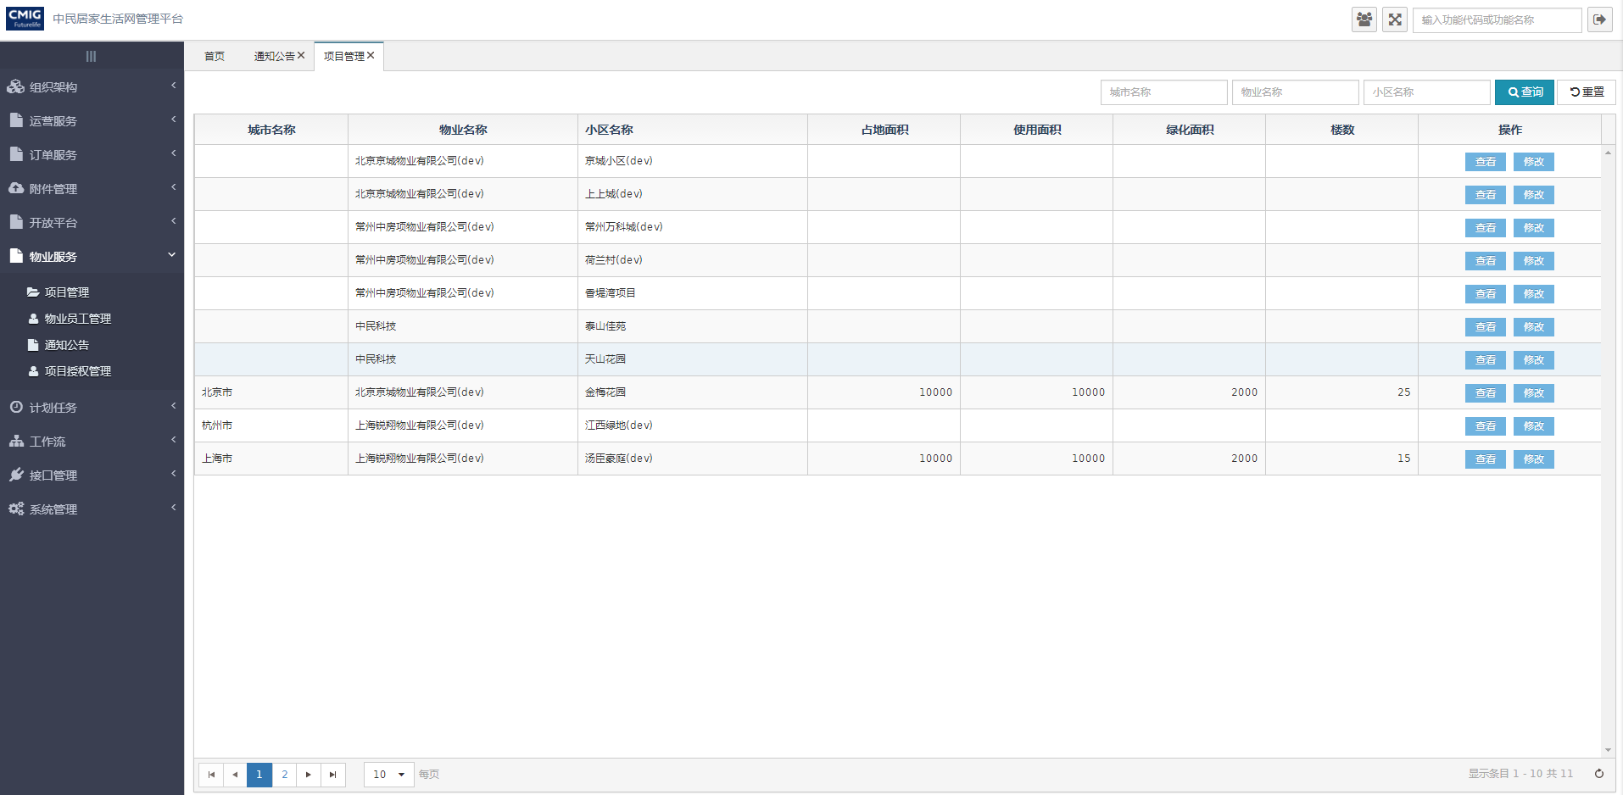

项目详情页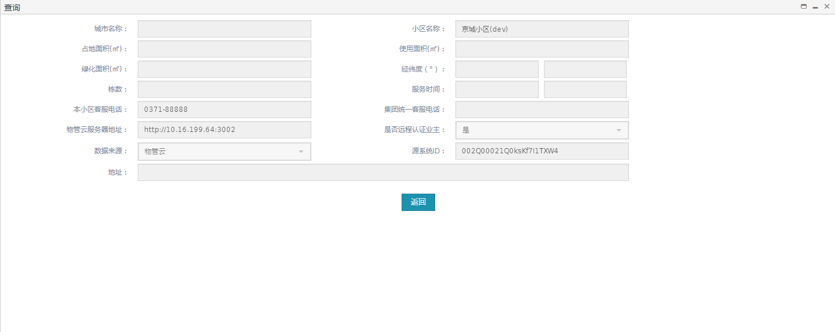项目修改页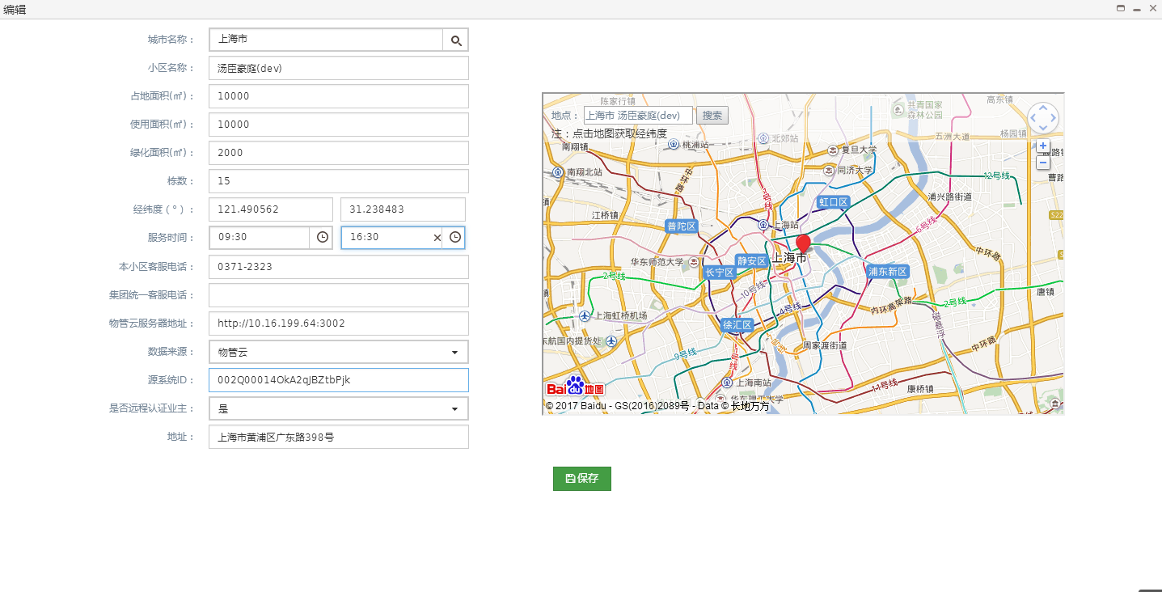

##### 文件清单

|  |  |
| --- | --- |
| **文件名** | **描述** |
| /include/head.html | 公用头部 |
| base_community.html | 项目管理页面 |
| base_community_detail.html | 项目详情页面 |
| base_community_edit.html | 项目修改页面 |

##### 页面URL定义

|  |  |
| --- | --- |
| **URL名称** | 查询项目信息 |
| **URL** | /ljh/base/community/query |
| **URL名称** | 修改项目信息 |
| **URL** | /ljh/base/community/update |
| **URL名称** | 根据id查询项目信息 |
| **URL** | /ljh/base/community/get |

##### 控制事件

| **对象名称** | **事件** | **动作** | **描述** |
| --- | --- | --- | --- |
| 查询按钮 | onClick | queryResource() | 根据表单查询条件，将查询结果显示在表格中 |
| 重置按钮 | onClick | reset() | 重置查询条件 |
| 查看按钮 | onClick | communityQuery(id) | 根据项目id查看项目信息 |
| 修改按钮 | onClick | communityEdit(id) | 根据项目id跳转修改页面 |
| 返回按钮 | onClick | back() | 返回项目管理页面 |
| 保存按钮 | onClick | save() | 保存项目信息 |

#### 后台详细设计

##### Controller

###### BaseCommunityController

|  |  |
| --- | --- |
| 类名：com.cmig.future.csportal.module.properties.community.controllers.BaseCommunityController | |
| **method** | query |
| **mapping url** | /ljh/base/community/query |
| **参数** | BaseCommunity dto  HttpServletRequest request  int page  int pageSize |
| **返回值** | ResponseData(List< BaseCommunity>) |
| **详细逻辑** | 调用baseCommunityService.selectCommunity  并返回结果 |
| **method** | get |
| **mapping url** | /ljh/base/community/get |
| **参数** | HttpServletRequest request  String id |
| **返回值** | ResponseData(BaseCommunity) |
| **详细逻辑** | 调用baseCommunityService.get并返回结果 |
| **method** | updateCommunity |
| **mapping url** | /ljh/base/community/update |
| **参数** | HttpServletRequest request  BaseCommunity dto |
| **返回值** | ResponseData(BaseCommunity) |
| **详细逻辑** | 调用ljhSysAreaService.queryCityNameById方法获得城市名称保存到BaseCommunity中,调用baseCommunityService.save方法返回结果 |

##### Service

###### IBaseCommunityService

|  |  |
| --- | --- |
| 类名：com.cmig.future.csportal.module.properties.community. service.IBaseCommunityService | |
| **method** | save |
| **参数** | BaseCommunity community |
| **返回值** | void |
| **详细逻辑** | 根据对象id是否为空判断,如果不为空调用baseCommunityMapper. updateByPrimaryKeySelective  更新,如果为空调用baseCommunityMapper.insertCommunity插入 |
| **method** | getBySourceSystemId |
| **参数** | BaseCommunity community |
| **返回值** | BaseCommunity |
| **详细逻辑** | 调用baseCommunityMapper.getBySourceSystemId并返回结果 |
| **method** | findByCommunityName |
| **参数** | BaseCommunity community |
| **返回值** | BaseCommunity |
| **详细逻辑** | 调用baseCommunityMapper.findByCommunityName并返回结果 |
| **method** | findCommunityListByName |
| **参数** | BaseCommunity community |
| **返回值** | List<BaseCommunity> |
| **详细逻辑** | 调用baseCommunityMapper.findCommunityListByName并返回结果 |
| **method** | delete |
| **参数** | BaseCommunity community |
| **返回值** | int |
| **详细逻辑** | 调用baseCommunityMapper.deleteCommunity并返回结果 |
| **method** | findUserCommunityList |
| **参数** | BaseCommunity community |
| **返回值** | List<BaseCommunity> |
| **详细逻辑** | 调用baseCommunityMapper.findUserCommunityList并返回结果 |
| **method** | get |
| **参数** | String communityId |
| **返回值** | BaseCommunity |
| **详细逻辑** | 调用baseCommunityMapper.getById并返回结果 |
| **method** | findCommunityByLikeCommunityName |
| **参数** | IRequest request  BaseCommunity community  int pageNum  int pageSize |
| **返回值** | List<BaseCommunity> |
| **详细逻辑** | 调用baseCommunityMapper. findCommunityByLikeCommunityName并返回结果 |
| **method** | findCommunityByLngLat |
| **参数** | BaseCommunity community |
| **返回值** | BaseCommunity |
| **详细逻辑** | 调用baseCommunityMapper. findCommunityByLngLat并返回结果 |
| **method** | selectCommunity |
| **参数** | IRequest request  BaseCommunity community  int pageNum  int pageSize |
| **返回值** | List<BaseCommunity> |
| **详细逻辑** | 调用baseCommunityMapper.selectCommunity并返回结果 |
| **method** | findList |
| **参数** | IRequest request  BaseCommunity community  int pageNum  int pageSize |
| **返回值** | List<BaseCommunity> |
| **详细逻辑** | 调用baseCommunityMapper.findList并返回结果 |

##### Mapper

###### BaseCommunityMapper

|  |  |
| --- | --- |
| 类名：com.cmig.future.csportal.module.properties.community. mapper.BaseCommunityMapper | |
| **method** | insertCommunity |
| **参数** | BaseCommunity community |
| **返回值** | int |
| **method** | updateCommunity |
| **参数** | BaseCommunity community |
| **返回值** | int |
| **method** | getBySourceSystemId |
| **参数** | BaseCommunity community |
| **返回值** | BaseCommunity |
| **method** | findByCommunityName |
| **参数** | BaseCommunity community |
| **返回值** | BaseCommunity |
| **method** | findCommunityListByName |
| **参数** | BaseCommunity community |
| **返回值** | List<BaseCommunity> |
| **method** | deleteCommunity |
| **参数** | BaseCommunity community |
| **返回值** | int |
| **详细逻辑** | 调用baseCommunityMapper.deleteCommunity并返回结果 |
| **method** | findUserCommunityList |
| **参数** | BaseCommunity community |
| **返回值** | List<BaseCommunity> |
| **method** | findCommunityByLikeCommunityName |
| **参数** | IRequest request  BaseCommunity community  int pageNum  int pageSize |
| **返回值** | List<BaseCommunity> |
| **详细逻辑** | 调用baseCommunityMapper. findCommunityByLikeCommunityName并返回结果 |
| **method** | findCommunityByLngLat |
| **参数** | BaseCommunity community |
| **返回值** | BaseCommunity |
| **method** | selectCommunity |
| **参数** | IRequest request  BaseCommunity community  int pageNum  int pageSize |
| **返回值** | List<BaseCommunity> |
| **method** | findList |
| **参数** | IRequest request  BaseCommunity community  int pageNum  int pageSize |
| **返回值** | List<BaseCommunity> |
| **method** | getById |
| **参数** | BaseCommunity community |
| **返回值** | BaseCommunity |

### 通知公告

#### 模块简介

能够对通知公告进行增删改查,通过极光推送平台,推送消息到勾选的人员或勾选的项目下的人员。推送是异步进行的,推送后可以查看是否推送成功,如果不成功,可以进行重新推送。

#### 前端详细设计

##### UI设计

通知公告主页

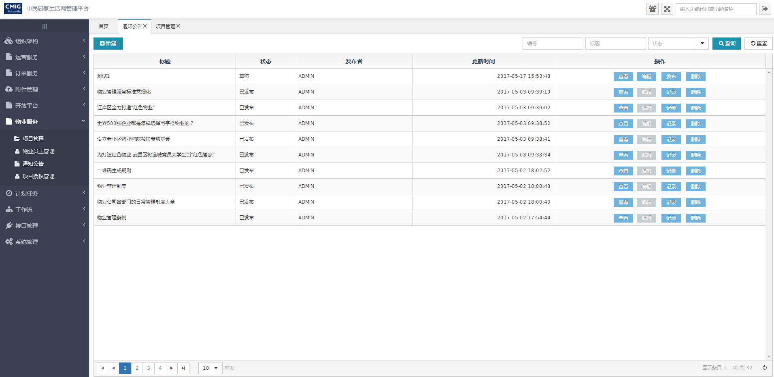

查看通知公告内容页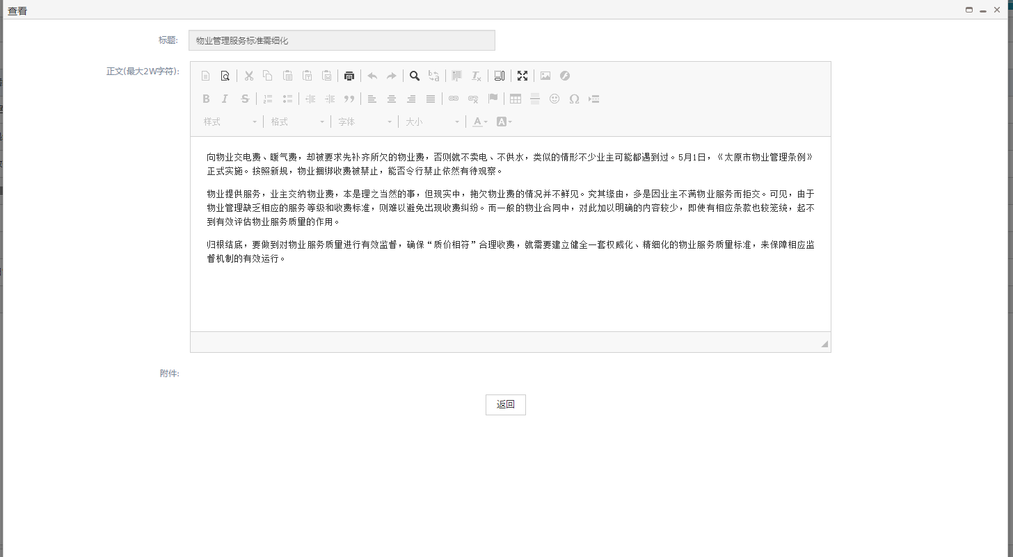通知公告编辑页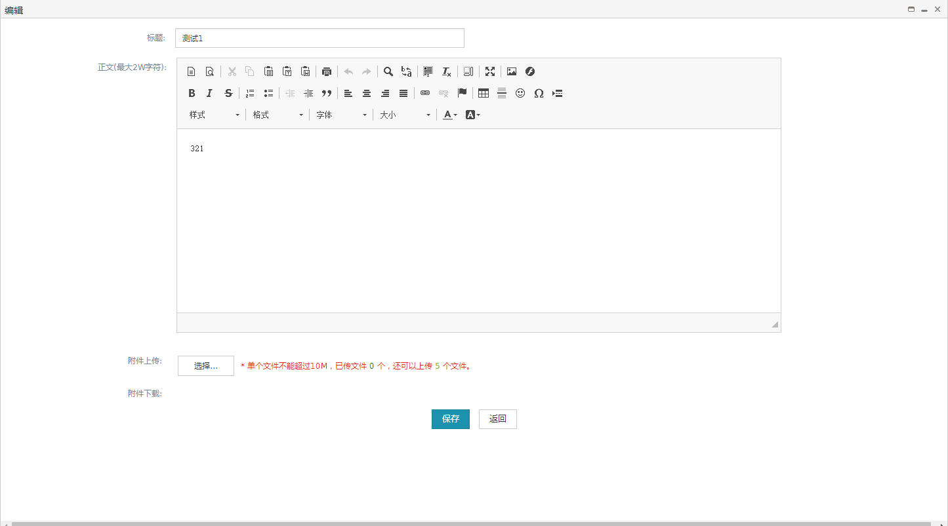通知公告发布页

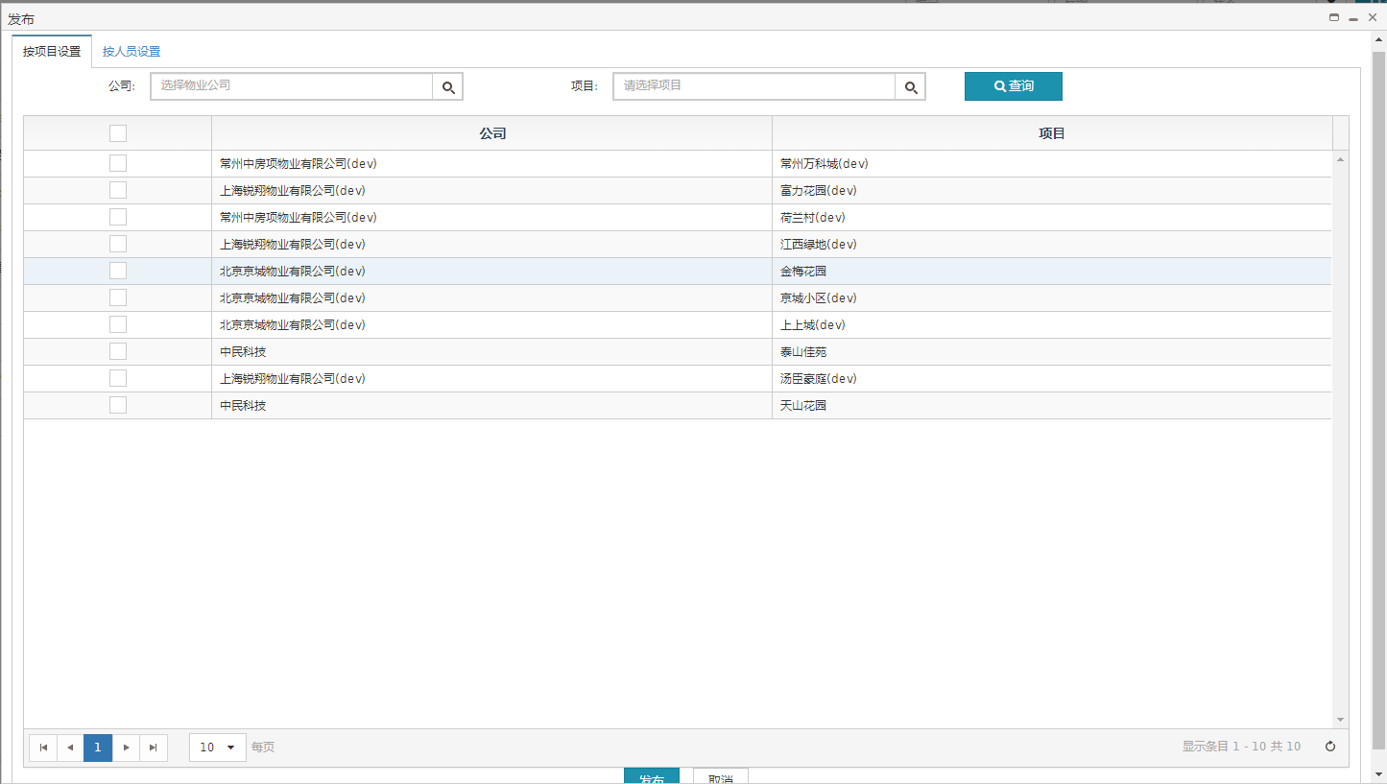

通知公告记录页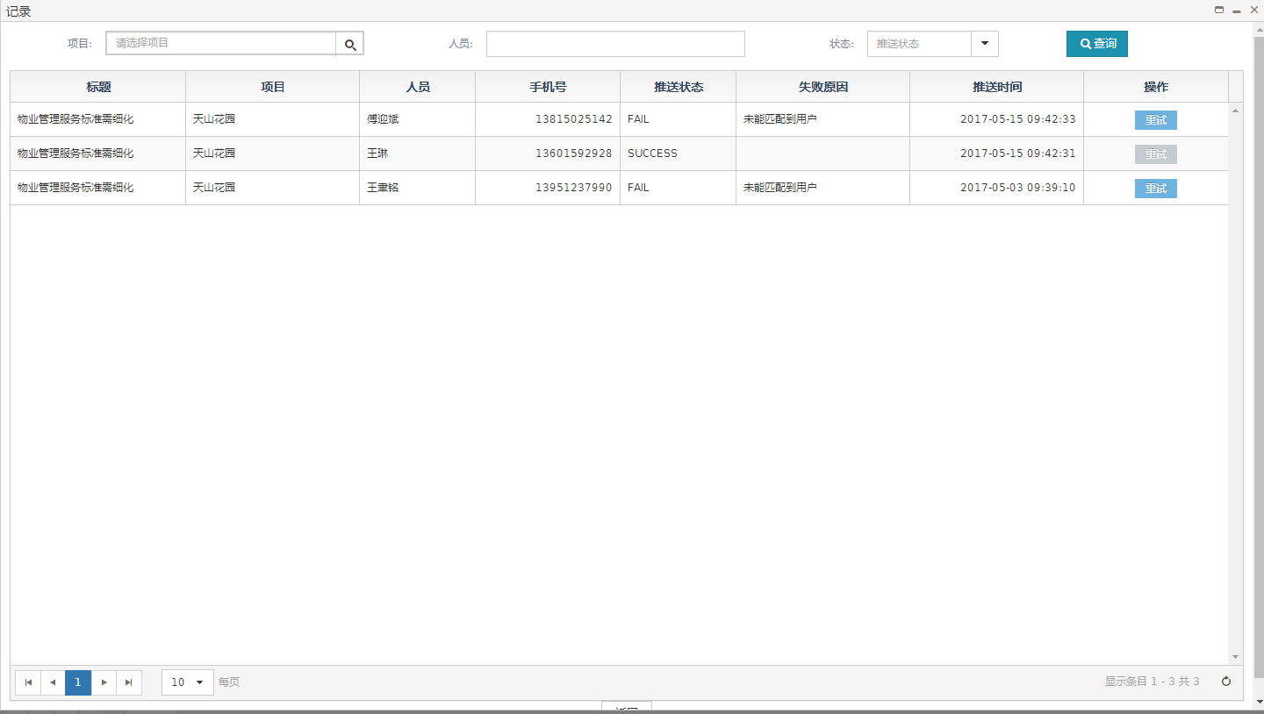

##### 文件清单

|  |  |
| --- | --- |
| **文件名** | **描述** |
| /include/head.html | 公用头部 |
| article_notify.html | 通知公告页面 |
| article_notify_detail.html | 查看通知公告内容页面 |
| article_notify_edit.html | 编辑通知公告页面 |
| article_notify_public.html | 通知公告发布页面 |
| article_notify_record.html | 通知公告记录页面 |

##### 页面URL定义

|  |  |
| --- | --- |
| **URL名称** | 根据id删除通知公告 |
| **URL** | /articleNotify/deleteArticleNotifyById |
| **URL名称** | 通知公告查询 |
| **URL** | /articleNotify/query |

##### 控制事件

| **对象名称** | **事件** | **动作** | **描述** |
| --- | --- | --- | --- |
| 查询按钮 | onClick | queryResource() | 根据表单查询条件，将查询结果显示在表格中 |
| 重置按钮 | onClick | reset() | 重置查询条件 |
| 查看按钮 | onClick | articleShow(id) | 根据通知公告id跳转查看页面 |
| 编辑按钮 | onClick | articleEdit(id) | 根据通知公告id跳转修改页面 |
| 发布按钮 | onClick | publish(id) | 根据通知公告id跳转发布页面 |
| 记录按钮 | onClick | articleRecord(id) | 根据通知公告id跳转记录页面 |
| 删除按钮 | onClick | articleDelete(id) | 根据通知公告id删除 |
| 返回按钮 | onClick | back() | 返回通知公告主页 |
| 保存按钮 | onClick | save() | 保存From表单中的信息 |
| 发布按钮 | onClick | public2() | 根据勾选对象发布通知公告 |
| 重试按钮 | onClick | repush(id) | 发送失败的通知公告重新发送 |

#### 后台详细设计

##### Controller

###### ArticleNotifyController

|  |  |
| --- | --- |
| 类名：com.cmig.future.csportal.module.operate.articleNotify.controllers.ArticleNotifyController | |
| **method** | query |
| **mapping url** | /articleNotify/query |
| **参数** | ArticleNotify dto  HttpServletRequest request  int page  int pageSize |
| **返回值** | ResponseData(List<ArticleNotify>) |
| **详细逻辑** | 调用articleNotifyService.selectArticleNotify  并返回结果 |
| **method** | update |
| **mapping url** | /articleNotify/submit |
| **参数** | HttpServletRequest request  List<ArticleNotify> dto |
| **返回值** | ResponseData(List<ArticleNotify>) |
| **详细逻辑** | 调用articleNotifyService.batchUpdate并返回结果 |
| **method** | delete |
| **mapping url** | /articleNotify/remove |
| **参数** | HttpServletRequest request  List<ArticleNotify> dto |
| **返回值** | ResponseData(List<ArticleNotify>) |
| **详细逻辑** | 调用articleNotifyService.batchDelete并返回结果 |
| **method** | saveOrUpdate |
| **mapping url** | /articleNotify/saveOrUpdate |
| **参数** | HttpServletRequest request  List<ArticleNotify> dto |
| **返回值** | ResponseData(List<ArticleNotify>) |
| **详细逻辑** | 调用articleNotifyService.saveOrUpdate并返回结果 |
| **method** | queryArticleNotifyById |
| **mapping url** | /articleNotify/queryArticleNotifyById |
| **参数** | HttpServletRequest request  String id |
| **返回值** | ResponseData(ArticleNotify) |
| **详细逻辑** | 调用articleNotifyService.queryArticleNotifyById并返回结果 |
| **method** | deleteArticleNotifyById |
| **mapping url** | /articleNotify/deleteArticleNotifyById |
| **参数** | HttpServletRequest request  String id |
| **返回值** | ResponseData(List<ArticleNotify>) |
| **详细逻辑** | 调用articleNotifyService.deleteArticleNotifyById并返回结果 |
| **method** | publishForCommunity |
| **mapping url** | /articleNotify/publishForCommunity |
| **参数** | HttpServletRequest request  MgtUserCommunity mgtUserCommunity  int page  int pageSize |
| **返回值** | ResponseData(List<MgtUserCommunity>) |
| **详细逻辑** | 调用articleNotifyService.findPublishCommunityList并返回结果 |
| **method** | publishForUser |
| **mapping url** | /articleNotify/publishForUser |
| **参数** | HttpServletRequest request  MgtUserCommunity mgtUserCommunity  int page  int pageSize |
| **返回值** | ResponseData(List<MgtUserCommunity>) |
| **详细逻辑** | 调用articleNotifyService.findPublishUserList并返回结果 |
| **method** | publishToCommunity |
| **mapping url** | /articleNotify/publishToCommunity |
| **参数** | HttpServletRequest request  String article  String selectIds |
| **返回值** | ResponseData(List<ArticleNotify>) |
| **详细逻辑** | 调用sysNotifyRecordService.publishToCommunity并返回结果 |
| **method** | publishToUser |
| **mapping url** | /articleNotify/publishToUser |
| **参数** | HttpServletRequest request  String article  String selectUserIds |
| **返回值** | ResponseData(List<ArticleNotify>) |
| **详细逻辑** | 调用sysNotifyRecordService.publishToUser并返回结果 |
| **method** | querySysAttachmentByObjectId |
| **mapping url** | /articleNotify/querySysAttachmentByObjectId |
| **参数** | HttpServletRequest request  SysAttachment sysAttachment |
| **返回值** | ResponseData(List<SysAttachment>) |
| **详细逻辑** | 调用sysAttachmentService.findList并返回结果 |

###### SysNotifyRecordController

|  |  |
| --- | --- |
| 类名：com.cmig.future.csportal.module.sys.notifyrecord.controllers.SysNotifyRecordController | |
| **method** | repush |
| **mapping url** | /ljh/sys/notify/record/repush |
| **参数** | SysNotifyRecord sysNotifyRecord  HttpServletRequest request |
| **返回值** | ResponseData(SysNotifyRecord) |
| **详细逻辑** | 调用JPushPmCloundUtils.pushAlertWithMessageSyn  并返回结果 |

##### Service

###### IArticleNotifyService

|  |  |
| --- | --- |
| 类名：com.cmig.future.csportal.module.operate.articleNotify.service.IArticleNotifyService | |
| **method** | selectArticleNotify |
| **参数** | IRequest requestContext  ArticleNotify articleNotify  int page  int pagesize |
| **返回值** | List<ArticleNotify> |
| **详细逻辑** | 调用articleNotifyMapper. selectArticleNotify并返回结果 |
| **method** | saveOrUpdate |
| **参数** | IRequest requestCtx  List<ArticleNotify> dto |
| **返回值** | List<ArticleNotify> |
| **详细逻辑** | 根据对象id是否为空判断,如果不为空调用articleNotifyMapper.updateByPrimaryKeySelective  更新,如果为空调用articleNotifyMapper.insertSelective插入 |
| **method** | queryArticleNotifyById |
| **参数** | String id |
| **返回值** | ArticleNotify |
| **详细逻辑** | 调用articleNotifyMapper.queryArticleNotifyById并返回结果 |
| **method** | deleteArticleNotifyById |
| **参数** | ArticleNotify articleNotify |
| **返回值** | int |
| **详细逻辑** | 调用articleNotifyMapper.deleteArticleNotifyById并返回结果 |

###### ISysNotifyRecordService

|  |  |
| --- | --- |
| 类名：com.cmig.future.csportal.module.sys.notifyrecord.service.ISysNotifyRecordService | |
| **method** | publishToCommunity |
| **参数** | IRequest request  String articleId  String content,  String selectIds |
| **返回值** | void |
| **详细逻辑** | 调用mgtUserCommunityMapper.findPublishUserList查询物业用户,调用sysNotifyRecordMapper.insertSelective保存信息,调用JPushPmCloundUtils.pushAlertWithMessage发送消息 |
| **method** | publishToUser |
| **参数** | IRequest request  String articleId  String content  String selectUserIds |
| **返回值** | void |
| **详细逻辑** | 调用mgtUserCommunityMapper.findPublishUserList查询物业用户,调用sysNotifyRecordMapper.insertSelective保存信息,调用JPushPmCloundUtils.pushAlertWithMessage发送消息 |

##### Mapper

###### ArticleNotifyMapper

|  |  |
| --- | --- |
| 类名：com.cmig.future.csportal.module.operate.articleNotify.mapper.ArticleNotifyMapper | |
| **method** | selectArticleNotify |
| **参数** | ArticleNotify articleNotify |
| **返回值** | List<ArticleNotify> |
| **method** | queryArticleNotifyById |
| **参数** | ArticleNotify articleNotify |
| **返回值** | ArticleNotify |
| **method** | deleteArticleNotifyById |
| **参数** | ArticleNotify articleNotify |
| **返回值** | int |

###### SysNotifyRecordMapper

|  |  |
| --- | --- |
| 类名：com.cmig.future.csportal.module.sys.notifyrecord.mapper.SysNotifyRecordMapper | |
| **method** | insertSelective |
| **参数** | SysNotifyRecord sysNotifyRecord |
| **返回值** | SysNotifyRecord |

## 运营服务

### 手动消息

#### 模块简介

编辑消息内容，根据消息方式,对勾选的人员进行对应的消息发送.

#### 前端详细设计

##### UI设计

手动消息主页

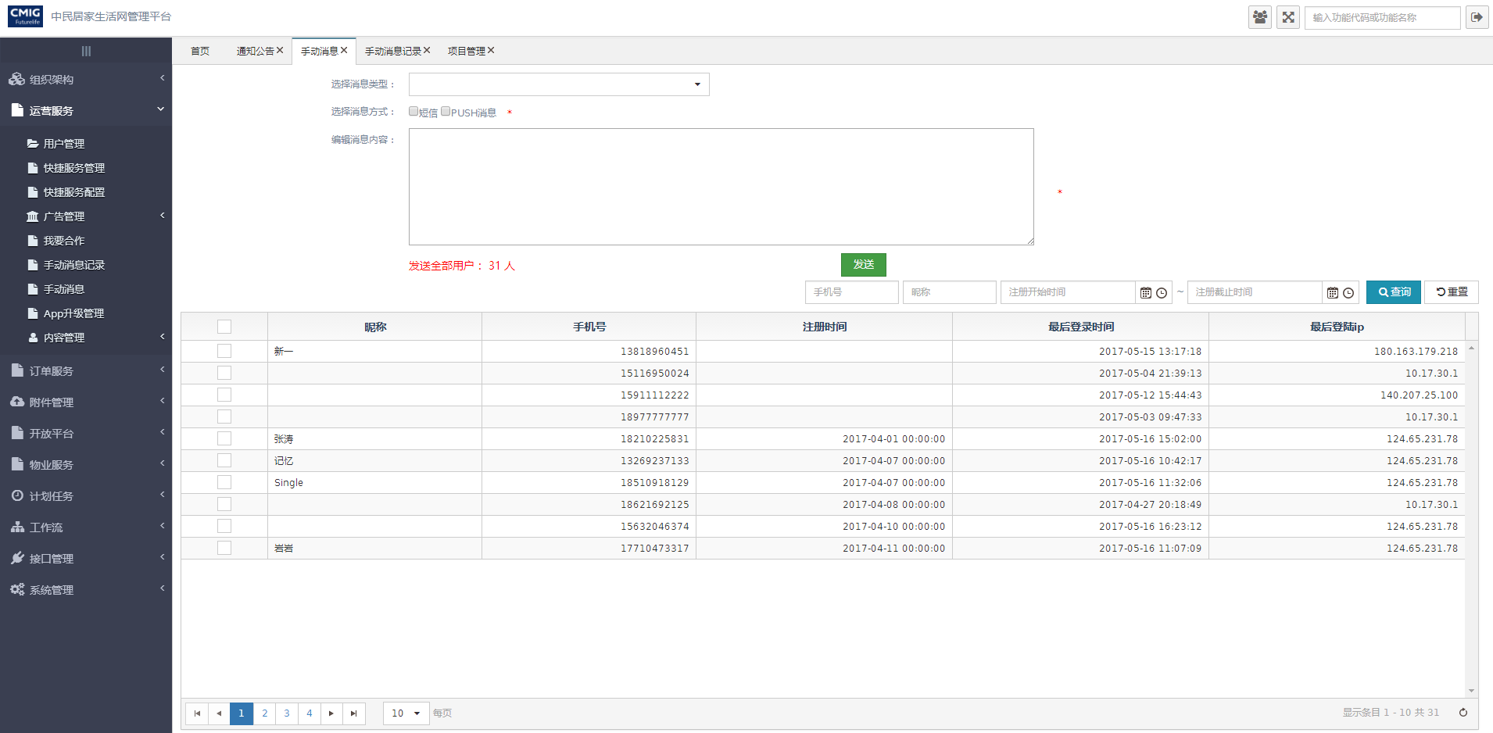

##### 文件清单

|  |  |
| --- | --- |
| **文件名** | **描述** |
| /include/head.html | 公用头部 |
| business_msg.html | 手动消息页面 |

##### 页面URL定义

|  |  |
| --- | --- |
| **URL名称** | 查询用户信息列表 |
| **URL** | /ljh/app/user/findList |
| **URL名称** | 发送信息 |
| **URL** | /businessMsg/publishToAppUser |
| **URL名称** | 查询用户列表,拼接用户手机号信息 |
| **URL** | /ljh/app/user/appUserList |

##### 控制事件

| **对象名称** | **事件** | **动作** | **描述** |
| --- | --- | --- | --- |
| 查询按钮 | onClick | queryResource() | 根据表单查询条件，将查询结果显示在表格中 |
| 重置按钮 | onClick | reset() | 重置查询条件 |
| 发送按钮 | onClick | saveGrid() | 根据勾选用户发送信息 |

#### 后台详细设计

##### Controller

###### BusinessMsgController

|  |  |
| --- | --- |
| 类名：com.cmig.future.csportal.module.operate.businessMsg.controllers.BusinessMsgController | |
| **method** | publishToAppUser |
| **mapping url** | /businessMsg/publishToAppUser |
| **参数** | HttpServletRequest request  List<SysNotifyRecord> list |
| **返回值** | ResponseData(List<SysNotifyRecord>) |
| **详细逻辑** | 如果发送消息方式选择短信,调用businessMsgService.smsToAppUser;如果发送消息方式选择push消息,调用businessMsgService.pushToAppUser  并返回结果 |

##### Service

###### IBusinessMsgService

|  |  |
| --- | --- |
| 类名：com.cmig.future.csportal.module.operate.businessMsg.service.IBusinessMsgService | |
| **method** | pushToAppUser |
| **参数** | IRequest requestCtx  String category  String content  String mobiles |
| **返回值** | void |
| **详细逻辑** | 调用appUserMapper.getByMobile根据电话查询用户,调用sysNotifyRecordMapper.insertSelective记录数据,调用JPushUtils.pushAlertWithMessage发送push消息 |
| **method** | smsToAppUser |
| **参数** | IRequest requestCtx  String category  String content  String mobiles |
| **返回值** | void |
| **详细逻辑** | 调用appUserMapper.getByMobile根据电话查询用户,调用sysNotifyRecordMapper.insertSelective记录数据,调用SmsUtil.sendSyne发送短信 |

###### IAppUserService

|  |  |
| --- | --- |
| 类名：com.cmig.future.csportal.module.user.appuser.service.IAppUserService | |
| **method** | getByMobile |
| **参数** | String mobile |
| **返回值** | AppUser |
| **详细逻辑** | 调用appUserMapper.getByMobile并返回结果 |
| **method** | findList |
| **参数** | IRequest request  AppUser appUser  int page  int pagesize |
| **返回值** | List<AppUser> |
| **详细逻辑** | 调用appUserMapper.findList并返回结果 |

##### Mapper

###### AppUserMapper

|  |  |
| --- | --- |
| 类名：com.cmig.future.csportal.module.user.appuser.mapper.AppUserMapper | |
| **method** | getByMobile |
| **参数** | String mobile |
| **返回值** | AppUser |
| **method** | findList |
| **参数** | AppUser appUser |
| **返回值** | List<AppUser> |

###### SysNotifyRecordMapper

|  |  |
| --- | --- |
| 类名：com.cmig.future.csportal.module.sys.notifyrecord.mapper.SysNotifyRecordMapper | |
| **method** | insertSelective |
| **参数** | SysNotifyRecord sysNotifyRecord |
| **返回值** | SysNotifyRecord |

### 手动消息记录

#### 模块简介

手动消息的发送记录,可以查看消息发送的对应人员

#### 前端详细设计

##### UI设计

手动消息记录主页

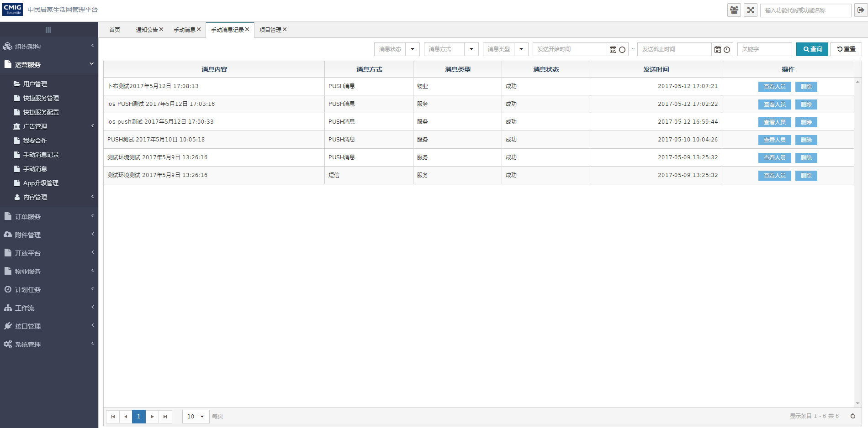

查看发送人员列表页面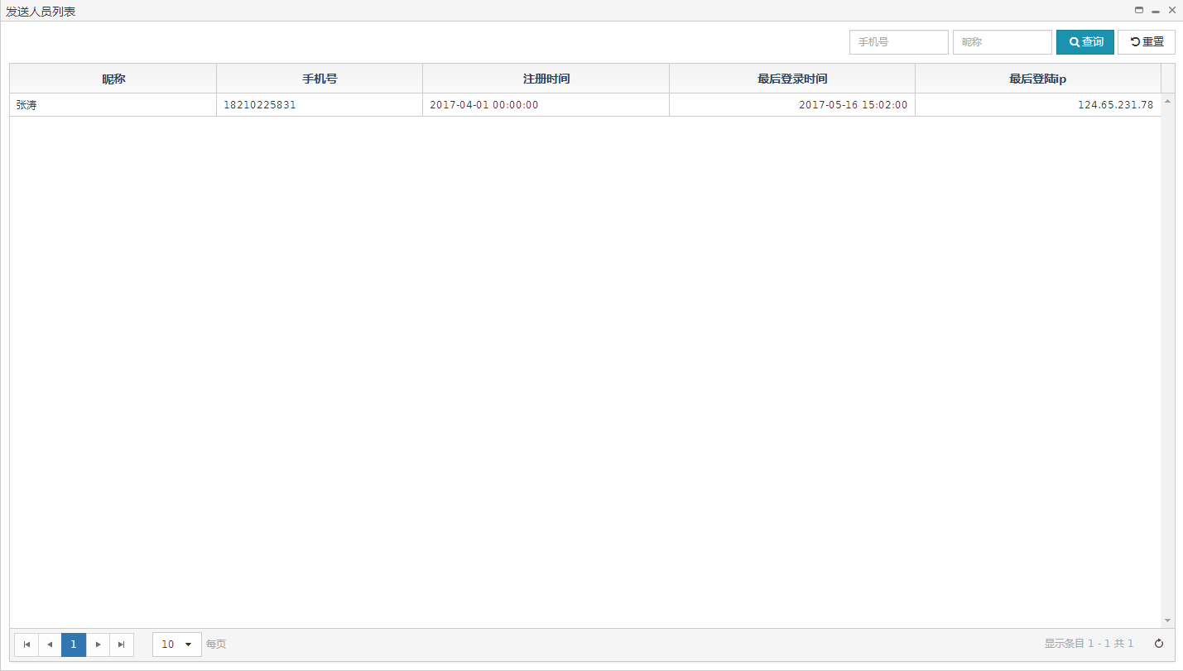

##### 文件清单

|  |  |
| --- | --- |
| **文件名** | **描述** |
| /include/head.html | 公用头部 |
| business_msg_list.html | 手动消息记录页面 |
| business_msg_userList.html | 查看发送人员列表页面 |

##### 页面URL定义

|  |  |
| --- | --- |
| **URL名称** | 查询手动消息列表 |
| **URL** | /businessMsg/query |
| **URL名称** | 删除信息记录 |
| **URL** | /businessMsg/delete |
| **URL名称** | 根据手动消息的类型、时间、种类分组的人员列表 |
| **URL** | /businessMsg/groupByTimeAndCateoryAndType |

##### 控制事件

| **对象名称** | **事件** | **动作** | **描述** |
| --- | --- | --- | --- |
| 查询按钮 | onClick | queryResource() | 根据表单查询条件，将查询结果显示在表格中 |
| 重置按钮 | onClick | reset() | 重置查询条件 |
| 查看人员按钮 | onClick | userInfoCard(id) | 根据id查看发送人员列表 |
| 删除按钮 | onClick | deleteRecor(id) | 根据id删除信息 |

#### 后台详细设计

##### Controller

###### BusinessMsgController

|  |  |
| --- | --- |
| 类名：com.cmig.future.csportal.module.operate.businessMsg.controllers.BusinessMsgController | |
| **method** | query |
| **mapping url** | /businessMsg/query |
| **参数** | SysNotifyRecord dto  int page  int pageSize  HttpServletRequest request |
| **返回值** | ResponseData(List<SysNotifyRecord>) |
| **详细逻辑** | 调用businessMsgService.findListByMsg  并返回结果 |
| **method** | delete |
| **mapping url** | /businessMsg/delete |
| **参数** | SysNotifyRecord dto  HttpServletRequest request |
| **返回值** | ResponseData(SysNotifyRecord) |
| **详细逻辑** | 调用businessMsgService.deleteByTimeAndCateoryAndType  并返回结果 |
| **method** | groupByTimeAndCateoryAndType |
| **mapping url** | /businessMsg/groupByTimeAndCateoryAndType |
| **参数** | SysNotifyRecord dto  int page  int pageSize  HttpServletRequest request |
| **返回值** | ResponseData(List<SysNotifyRecord>) |
| **详细逻辑** | 调用businessMsgService.groupByTimeAndCateoryAndType  并返回结果 |

##### Service

###### IBusinessMsgService

|  |  |
| --- | --- |
| 类名：com.cmig.future.csportal.module.operate.businessMsg.service.IBusinessMsgService | |
| **method** | groupByTimeAndCateoryAndType |
| **参数** | IRequest requestCtx  SysNotifyRecord dto  int page  int pageSize |
| **返回值** | List<SysNotifyRecord> |
| **详细逻辑** | 调用appUserMapper.groupByTimeAndCateoryAndType并返回结果 |
| **method** | deleteByTimeAndCateoryAndType |
| **参数** | SysNotifyRecord dto |
| **返回值** | int |
| **详细逻辑** | 调用sysNotifyRecordMapper.deleteByTimeAndCateoryAndType并返回结果 |

###### IAppUserService

|  |  |
| --- | --- |
| 类名：com.cmig.future.csportal.module.user.appuser.service.IAppUserService | |
| **method** | getByMobile |
| **参数** | String mobile |
| **返回值** | AppUser |
| **详细逻辑** | 调用appUserMapper.getByMobile并返回结果 |
| **method** | findList |
| **参数** | IRequest request  AppUser appUser  int page  int pagesize |
| **返回值** | List<AppUser> |
| **详细逻辑** | 调用appUserMapper.findList并返回结果 |

##### Mapper

###### AppUserMapper

|  |  |
| --- | --- |
| 类名：com.cmig.future.csportal.module.user.appuser.mapper.AppUserMapper | |
| **method** | groupByTimeAndCateoryAndType |
| **参数** | SysNotifyRecord dto |
| **返回值** | List<AppUser> |

###### SysNotifyRecordMapper

|  |  |
| --- | --- |
| 类名：com.cmig.future.csportal.module.sys.notifyrecord.mapper.SysNotifyRecordMapper | |
| **method** | deleteByTimeAndCateoryAndType |
| **参数** | SysNotifyRecord sysNotifyRecord |
| **返回值** | SysNotifyRecord |

## 物业管理平台

### 建筑结构版本

#### 模块简介

管理建筑结构版本的增删改查,建筑结构的增删改查导入

#### 前端详细设计

##### UI设计

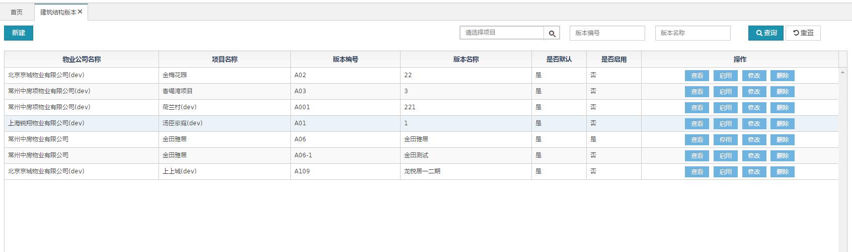

添加&修改

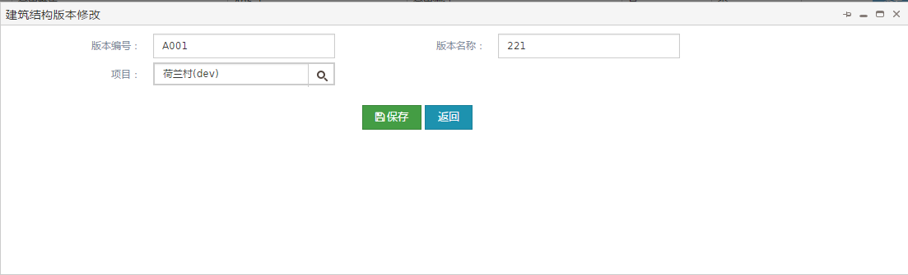

查看

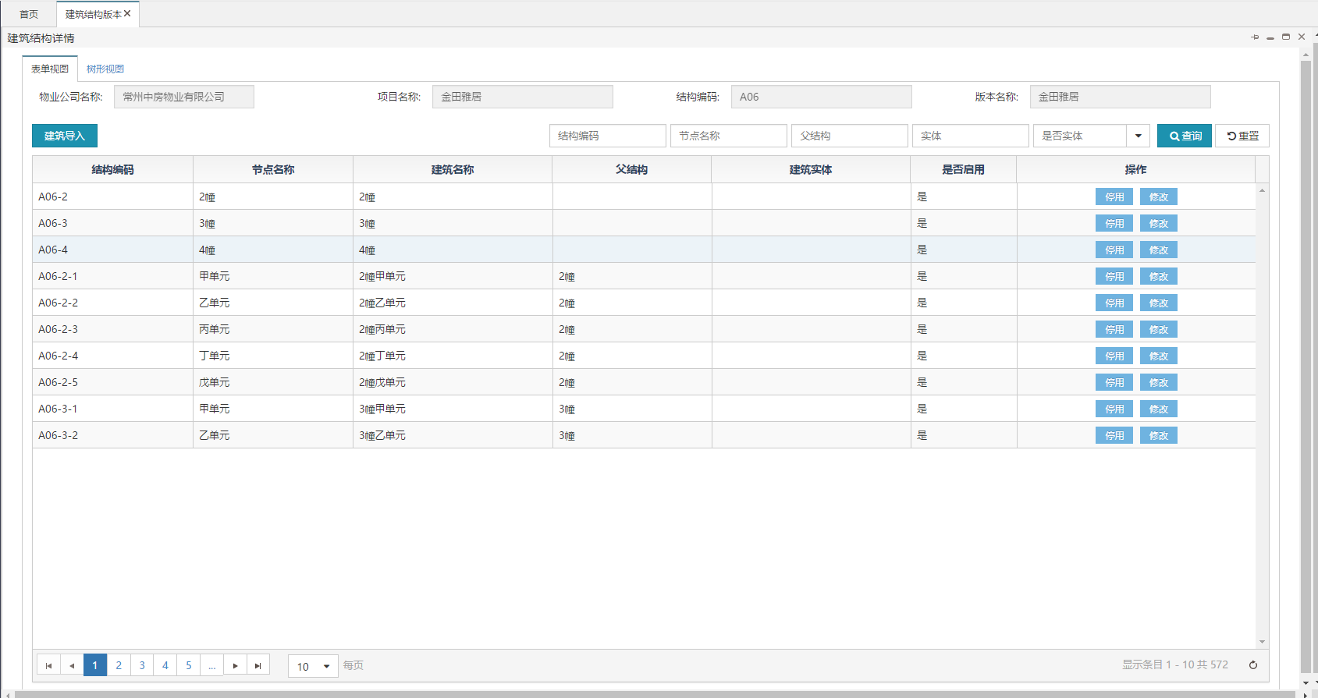

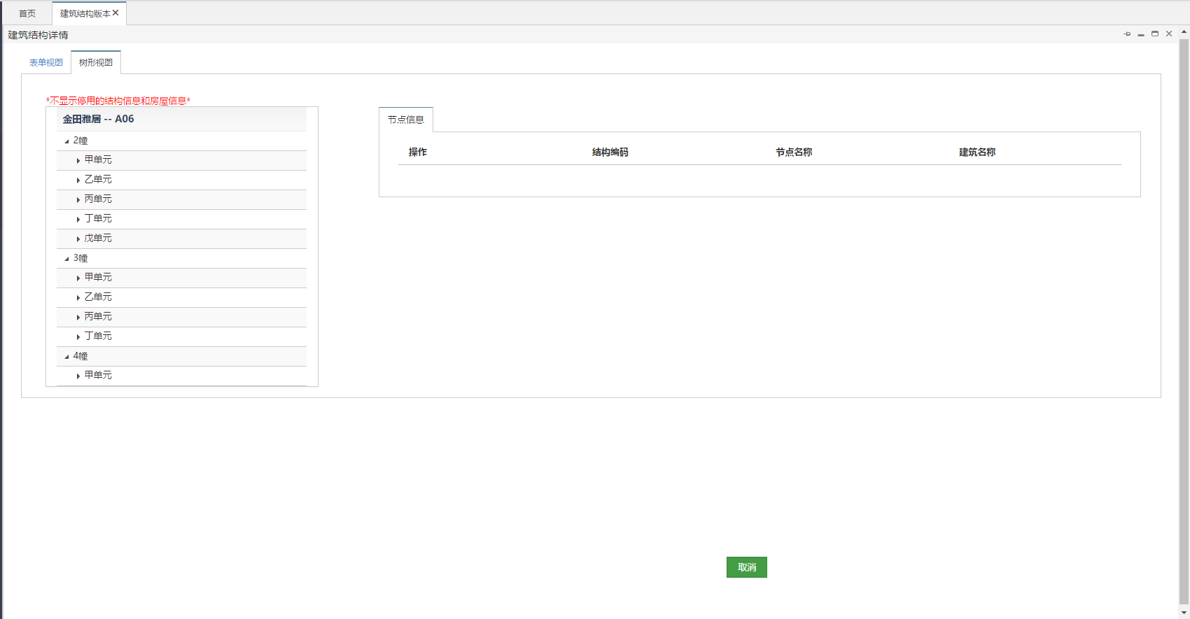

导入

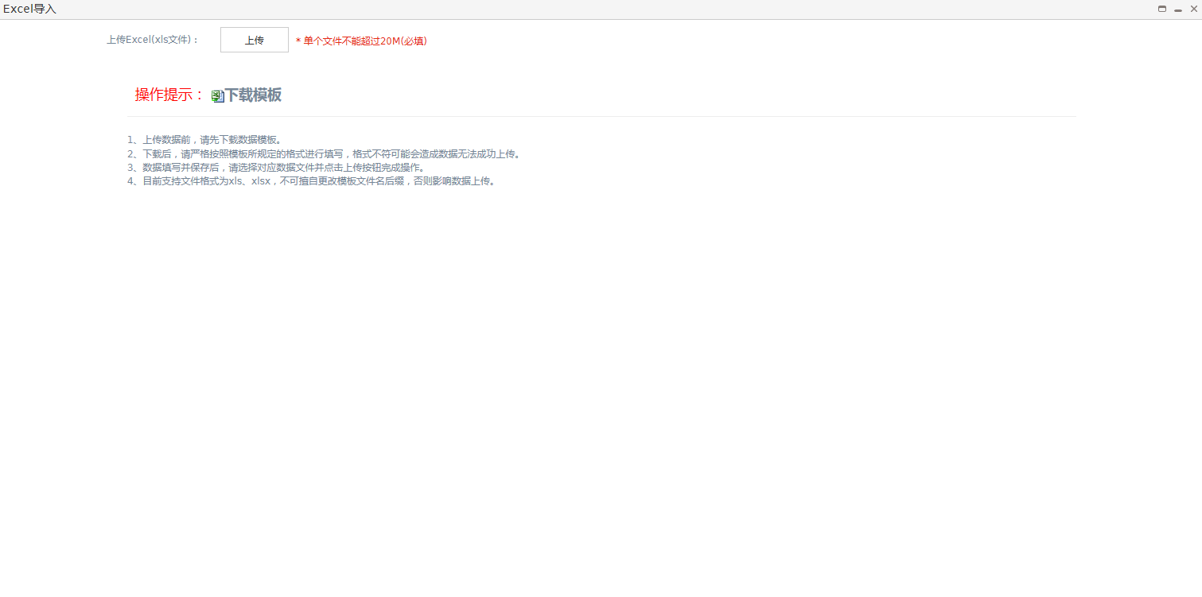

##### 文件清单

|  |  |
| --- | --- |
| **文件名** | **描述** |
| /include/head.html | 公用头部 |
| mgt_structure_version.html | 建筑版本页面 |
| mgt_structure_version_edit.html | 建筑版本新增&修改页面 |
| mgt_structure.html | 建筑结构页面 |
| mgt_structure_add.html | 建筑结构新增&页面 |
| mgt_structure_edit.html | 建筑结构修改&查看页面 |
| mgt_structure_importExcel.html | 建筑结构导入页面 |

##### 页面URL定义

|  |  |
| --- | --- |
| **URL名称** | 查询建筑版本列表 |
| **URL** | /csp/mgt/structure/version/query |
| **URL名称** | 删除建筑版本 |
| **URL** | /csp/mgt/structure/version/versionDel |
| **URL名称** | 建筑版本停用&启用 |
| **URL** | /csp/mgt/structure/version/unableUpdate |
| **URL名称** | 根据建筑版本id查询建筑版本 |
| **URL** | /csp/mgt/structure/version/queryByVersionId |
| **URL名称** | 更新&新增建筑版本 |
| **URL** | /csp/mgt/structure/version/saveOrUpdate |
| **URL名称** | 根据建筑版本id查询建筑结构与房屋 |
| **URL** | /csp/mgt/viewPojo/query |
| **URL名称** | 删除建筑结构与房屋间的映射关系 |
| **URL** | /csp/structure/building/map/deleteByStructureIdAndBuildIngId |
| **URL名称** | 根据建筑版本id展示建筑结构与房屋的树形结构 |
| **URL** | /csp/mgt/viewPojo/showTree |
| **URL名称** | 新增建筑结构 |
| **URL** | /csp/mgt/structure/saveOrUpdate |
| **URL名称** | 新增建筑结构与房屋实体的映射关系 |
| **URL** | /csp/structure/building/map/saveOrUpdate |
| **URL名称** | 根据建筑结构Id查询详情 |
| **URL** | /csp/mgt/structure/queryByStructureId |
| **URL名称** | 建筑结构Excel模版下载 |
| **URL** | /common/mgtStructure/excel/import/template |

##### 控制事件

| **对象名称** | **事件** | **动作** | **描述** |
| --- | --- | --- | --- |
| 查询按钮 | onClick | queryResource() | 根据表单查询条件，将查询结果显示在表格中 |
| 重置按钮 | onClick | reset() | 重置查询条件 |
| 版本新增按钮 | onClick | versionAdd () | 新建建筑版本 |
| 版本查询按钮 | onClick | versionQuery (id) | 根据id查询信息 |
| 版本停用&启用 | onClick | unable(id) | 根据id停用&启用 |
| 版本修改按钮 | onClick | versionEdit(id) | 根据id修改信息 |
| 版本删除按钮 | onClick | versionDel(id) | 根据id删除版本 |
| 保存按钮 | onClick | save() | 新增版本保存 |
| 表单视图按钮 | onClick | baseInfoTab() | 查看建筑版本下的建筑结构分页 |
| 树形视图按钮 | onClick | treeTab() | 查看建筑版本下的建筑结构树 |
| 结构修改按钮 | onClick | viewEdit(id) | 根据id修改结构 |
| 建筑导入按钮 | onClick | importExcel() | 导入建筑结构excel |

#### 后台详细设计

##### Controller

###### MgtStructureVersionController

|  |  |
| --- | --- |
| 类名：com.cmig.future.csportal.module.properties.base.version.controllers.MgtStructureVersionController | |
| **method** | query |
| **mapping url** | /csp/mgt/structure/version/query |
| **参数** | MgtStructureVersion dto  int page  int pageSize  HttpServletRequest request |
| **返回值** | ResponseData(List<MgtStructureVersion>) |
| **详细逻辑** | 调用mgtStructureVersionService.findList  并返回结果 |
| **method** | update |
| **mapping url** | /csp/mgt/structure/version/submit |
| **参数** | List<MgtStructureVersion> dto  HttpServletRequest request |
| **返回值** | ResponseData(List<MgtStructureVersion>) |
| **详细逻辑** | 调用mgtStructureVersionService.batchUpdate  并返回结果 |
| **method** | delete |
| **mapping url** | /csp/mgt/structure/version/remove |
| **参数** | List<MgtStructureVersion> dto  HttpServletRequest request |
| **返回值** | ResponseData() |
| **详细逻辑** | 调用mgtStructureVersionService.batchDelete  并返回结果 |
| **method** | saveOrUpdate |
| **mapping url** | /csp/mgt/structure/version/saveOrUpdate |
| **参数** | List<MgtStructureVersion> dto  HttpServletRequest request |
| **返回值** | ResponseData(List<MgtStructureVersion>) |
| **详细逻辑** | 调用mgtStructureVersionService.saveOrUpdate  并返回结果 |
| **method** | queryByVersionId |
| **mapping url** | /csp/mgt/structure/version/queryByVersionId |
| **参数** | MgtStructureVersion dto  HttpServletRequest request |
| **返回值** | ResponseData(MgtStructureVersion) |
| **详细逻辑** | 调用mgtStructureVersionService.queryByVersionId  并返回结果 |
| **method** | versionDel |
| **mapping url** | /csp/mgt/structure/version/versionDel |
| **参数** | MgtStructureVersion dto  HttpServletRequest request |
| **返回值** | ResponseData() |
| **详细逻辑** | 调用structureBuildingMapService.deleteByStructureVersionId  删除结构与房屋的管理关系,  mgtStructureService.deleteByVersionId删除结构,  mgtStructureVersionService.versionDel删除版本  并返回结果 |
| **method** | unableUpdate |
| **mapping url** | /csp/mgt/structure/version/unableUpdate |
| **参数** | MgtStructureVersion dto  HttpServletRequest request |
| **返回值** | ResponseData(MgtStructureVersion) |
| **详细逻辑** | 调用mgtStructureVersionService. updateByPrimaryKeySelective  并返回结果 |

###### MgtViewPojoController

|  |  |
| --- | --- |
| 类名：com.cmig.future.csportal.module.properties.base.view.controllers.MgtViewPojoController | |
| **method** | query |
| **mapping url** | /csp/mgt/viewPojo/query |
| **参数** | MgtViewPojo dto  int page  int pageSize  HttpServletRequest request |
| **返回值** | ResponseData(List<MgtViewPojo>) |
| **详细逻辑** | 调用mgtViewPojoService.findList  并返回结果 |
| **method** | showTree |
| **mapping url** | /csp/mgt/viewPojo/showTree |
| **参数** | MgtViewPojo dto  HttpServletRequest request |
| **返回值** | ResponseData(List<MgtStructureVersion>) |
| **详细逻辑** | 调用mgtViewPojoService.findList  并返回结果 |

###### MgtStructureController

|  |  |
| --- | --- |
| 类名：com.cmig.future.csportal.module.properties.base.structure.controllers.MgtStructureController | |
| **method** | query |
| **mapping url** | /csp/mgt/structure/query |
| **参数** | MgtStructure dto  int page  int pageSize  HttpServletRequest request |
| **返回值** | ResponseData(List<MgtStructure>) |
| **详细逻辑** | 调用mgtStructureService.select  并返回结果 |
| **method** | update |
| **mapping url** | /csp/mgt/structure/submit |
| **参数** | List<MgtStructure> dto  HttpServletRequest request |
| **返回值** | ResponseData(List<MgtStructure>) |
| **详细逻辑** | 调用mgtStructureService.batchUpdate  并返回结果 |
| **method** | delete |
| **mapping url** | /csp/mgt/structure/remove |
| **参数** | List< MgtStructure > dto  HttpServletRequest request |
| **返回值** | ResponseData() |
| **详细逻辑** | 调用mgtStructureService.batchDelete  并返回结果 |
| **method** | queryByStructureId |
| **mapping url** | /csp/mgt/structure/queryByStructureId |
| **参数** | List< MgtStructure > dto  HttpServletRequest request |
| **返回值** | ResponseData(List< MgtStructure >) |
| **详细逻辑** | 调用mgtStructureService.queryByStructureId  并返回结果 |
| **method** | saveOrUpdate |
| **mapping url** | /csp/mgt/structure/saveOrUpdate |
| **参数** | MgtStructure dto  HttpServletRequest request  String houseId |
| **返回值** | ResponseData(MgtStructureVersion) |
| **详细逻辑** | 调用mgtViewPojoService.findList判断房屋实体是否被使用,如果没有,则调用mgtStructureService.saveOrUpdate  并返回结果 |
| **method** | unableUpdate |
| **mapping url** | /csp/mgt/structure/unableUpdate |
| **参数** | MgtStructure dto  HttpServletRequest request |
| **返回值** | ResponseData(MgtStructure) |
| **详细逻辑** | 调用mgtStructureService.updateByPrimaryKeySelective并返回结果 |

###### StructureBuildingMapController

|  |  |
| --- | --- |
| 类名：com.cmig.future.csportal.module.properties.base.map.controllers.StructureBuildingMapController | |
| **method** | query |
| **mapping url** | /csp/structure/building/map/query |
| **参数** | StructureBuildingMap dto  int page  int pageSize  HttpServletRequest request |
| **返回值** | ResponseData(List< StructureBuildingMap >) |
| **详细逻辑** | 调用structureBuildingMapService.select  并返回结果 |
| **method** | update |
| **mapping url** | /csp/structure/building/map/submit |
| **参数** | List< StructureBuildingMap > dto  HttpServletRequest request |
| **返回值** | ResponseData(List< StructureBuildingMap >) |
| **详细逻辑** | 调用structureBuildingMapService.batchUpdate  并返回结果 |
| **method** | delete |
| **mapping url** | /csp/structure/building/map/remove |
| **参数** | List< StructureBuildingMap > dto  HttpServletRequest request |
| **返回值** | ResponseData() |
| **详细逻辑** | 调用structureBuildingMapService.batchDelete  并返回结果 |
| **method** | deleteByStructureIdAndBuildIngId |
| **mapping url** | /csp/structure/building/map/deleteByStructureIdAndBuildIngId |
| **参数** | StructureBuildingMap dto  HttpServletRequest request |
| **返回值** | ResponseData() |
| **详细逻辑** | 调用structureBuildingMapService.findByBuildingIdAndStructureId查询主键,根据主键调用structureBuildingMapService.deleteByPrimaryKey  并返回结果 |
| **method** | saveOrUpdate |
| **mapping url** | /csp/structure/building/map/saveOrUpdate |
| **参数** | StructureBuildingMap dto  HttpServletRequest request  String houseId |
| **返回值** | ResponseData(StructureBuildingMap) |
| **详细逻辑** | 调用mgtViewPojoService.findList判断房屋实体是否被使用,如果没有,则调用structureBuildingMapService.saveOrUpdate  并返回结果 |

###### ImportExcelController

|  |  |
| --- | --- |
| 类名：com.cmig.future.csportal.module.properties.base.view.controllers.MgtViewPojoController | |
| **method** | upload |
| **mapping url** | /common/mgtStructure/excel /import |
| **参数** | HttpServletRequest request,  HttpServletResponse response |
| **返回值** | ResponseData(RetApp) |
| **详细逻辑** | 调用mgtStructureService.validationImportData对excel进行校验,如果校验通过,则调用mgtStructureService.saveImportDate持久化数据  并返回结果 |
| **method** | delete |
| **mapping url** | /common/mgtStructure/excel /delete |
| **参数** | HttpServletRequest request,  HttpServletResponse response |
| **返回值** | ResponseData() |
| **详细逻辑** |  |
| **method** | importFileTemplate |
| **mapping url** | /common/mgtStructure/excel /import/template |
| **参数** | HttpServletRequest request,  HttpServletResponse response |
| **返回值** | null |
| **详细逻辑** |  |

##### Service

###### IMgtStructureVersionService

|  |  |
| --- | --- |
| 类名：com.cmig.future.csportal.module.properties.base.version.service.IMgtStructureVersionService | |
| **method** | findList |
| **参数** | IRequest requestCtx  MgtStructureVersion mgtStructureVersion  int page  int pageSize |
| **返回值** | List< MgtStructureVersion > |
| **详细逻辑** | 调用mgtStructureVersionMapper.findList并返回结果 |
| **method** | saveOrUpdate |
| **参数** | IRequest requestCtx  List<MgtStructureVersion> dto |
| **返回值** | List<MgtStructureVersion> |
| **详细逻辑** | 如果是新增调用mgtStructureVersionMapper.insertSelective,如果是更新调用mgtStructureVersionMapper.updateByPrimaryKeySelective并返回结果 |
| **method** | queryByVersionId |
| **参数** | MgtStructureVersion dto |
| **返回值** | MgtStructureVersion |
| **详细逻辑** | 调用mgtStructureVersionMapper.queryByVersionId并返回结果 |
| **method** | versionDel |
| **参数** | MgtStructureVersion dto |
| **返回值** | MgtStructureVersion |
| **详细逻辑** | 调用mgtStructureVersionMapper.versionDel并返回结果 |

###### IMgtViewPojoService

|  |  |
| --- | --- |
| 类名：com.cmig.future.csportal.module.properties.base.view.service.IMgtViewPojoService | |
| **method** | findList |
| **参数** | IRequest request  MgtViewPojo dto  int pageNum  int pageSize |
| **返回值** | List<MgtViewPojo> |
| **详细逻辑** | 调用mgtViewPojoMapper.findList并返回结果 |
| **method** | findList |
| **参数** | MgtViewPojo dto |
| **返回值** | List<MgtViewPojo> |
| **详细逻辑** | 调用mgtViewPojoMapper.findList并返回结果 |

###### IMgtStructureService

|  |  |
| --- | --- |
| 类名：com.cmig.future.csportal.module.properties.base.structure.service.IMgtStructureService | |
| **method** | validationImportData |
| **参数** | ImportExcel ei  List<MgtStructureImport> list  BaseCommunity baseCommunity  String communityId |
| **返回值** | void |
| **详细逻辑** | 校验excel数据 |
| **method** | saveImportDate |
| **参数** | List<MgtStructureImport> list  BaseCommunity baseCommunity  String versionId  String communityId |
| **返回值** | void |
| **详细逻辑** | 如果是结构调用mgtStructureMapper.insertSelective,如果是房屋调用mgtHouseMapper.insertSelective和structureBuildingMapMapper.insertSelective并返回结果 |
| **method** | findByStructureCode |
| **参数** | MgtStructure dto |
| **返回值** | MgtStructure |
| **详细逻辑** | 调用mgtStructureMapper.findByStructureCode并返回结果 |
| **method** | queryByStructureId |
| **参数** | MgtStructure dto |
| **返回值** | MgtStructure |
| **详细逻辑** | 调用mgtStructureMapper.queryByStructureId并返回结果 |
| **method** | saveOrUpdate |
| **参数** | IRequest requestCtx  MgtStructure dto  String houseId |
| **返回值** | MgtStructure |
| **详细逻辑** | 新增调用mgtStructureMapper.insertSelective，如果houseId不会空,继续调用structureBuildingMapMapper.insertSelective;更新调用mgtStructureMapper.updateByPrimaryKeySelective并返回结果 |
| **method** | deleteByVersionId |
| **参数** | MgtStructure dto |
| **返回值** | Int |
| **详细逻辑** | 调用mgtStructureMapper.deleteByVersionId并返回结果 |

###### IStructureBuildingMapService

|  |  |
| --- | --- |
| 类名：com.cmig.future.csportal.module.properties.base.map.service.IStructureBuildingMapService | |
| **method** | saveOrUpdate |
| **参数** | IRequest requestCtx  StructureBuildingMap dto |
| **返回值** | StructureBuildingMap |
| **详细逻辑** | 新增调用structureBuildingMapMapper.insertSelective,更新调用structureBuildingMapMapper.updateByPrimaryKeySelective并返回结果 |
| **method** | findByBuildingIdAndStructureId |
| **参数** | StructureBuildingMap dto |
| **返回值** | StructureBuildingMap |
| **详细逻辑** | 调用structureBuildingMapMapper.findByBuildingIdAndStructureId并返回结果 |
| **method** | deleteByStructureVersionId |
| **参数** | StructureBuildingMap dto |
| **返回值** | int |
| **详细逻辑** | 调用structureBuildingMapMapper.deleteByStructureVersionId并返回结果 |

##### Mapper

###### MgtStructureVersionMapper

|  |  |
| --- | --- |
| 类名：com.cmig.future.csportal.module.properties.base.version.mapper.MgtStructureVersionMapper | |
| **method** | findList |
| **参数** | MgtStructureVersion mgtStructureVersion |
| **返回值** | List<MgtStructureVersion> |
| **method** | queryByVersionId |
| **参数** | MgtStructureVersion mgtStructureVersion |
| **返回值** | MgtStructureVersion |
| **method** | versionDel |
| **参数** | MgtStructureVersion mgtStructureVersion |
| **返回值** | int |

###### MgtViewPojoMapper

|  |  |
| --- | --- |
| 类名：com.cmig.future.csportal.module.properties.base.view.mapper.MgtViewPojoMapper | |
| **method** | findList |
| **参数** | MgtViewPojo dto |
| **返回值** | List<MgtViewPojo> |

###### MgtStructureMapper

|  |  |
| --- | --- |
| 类名：com.cmig.future.csportal.module.properties.base.structure.mapper.MgtStructureMapper | |
| **method** | findByStructureCode |
| **参数** | MgtStructure dto |
| **返回值** | MgtStructure |
| **method** | getCountByStructureCode |
| **参数** | String structureCode |
| **返回值** | Int |
| **method** | queryByStructureId |
| **参数** | MgtStructure dto |
| **返回值** | MgtStructure |
| **method** | deleteByVersionId |
| **参数** | MgtStructure dto |
| **返回值** | Int |

###### StructureBuildingMapMapper

|  |  |
| --- | --- |
| 类名：com.cmig.future.csportal.module.properties.base.map.mapper.StructureBuildingMapMapper | |
| **method** | findByBuildingIdAndStructureId |
| **参数** | StructureBuildingMap dto |
| **返回值** | StructureBuildingMap |
| **method** | deleteByStructureVersionId |
| **参数** | StructureBuildingMap dto |
| **返回值** | int |

### 房屋信息

#### 模块简介

管理房屋的增删改查导入

#### 前端详细设计

##### UI设计

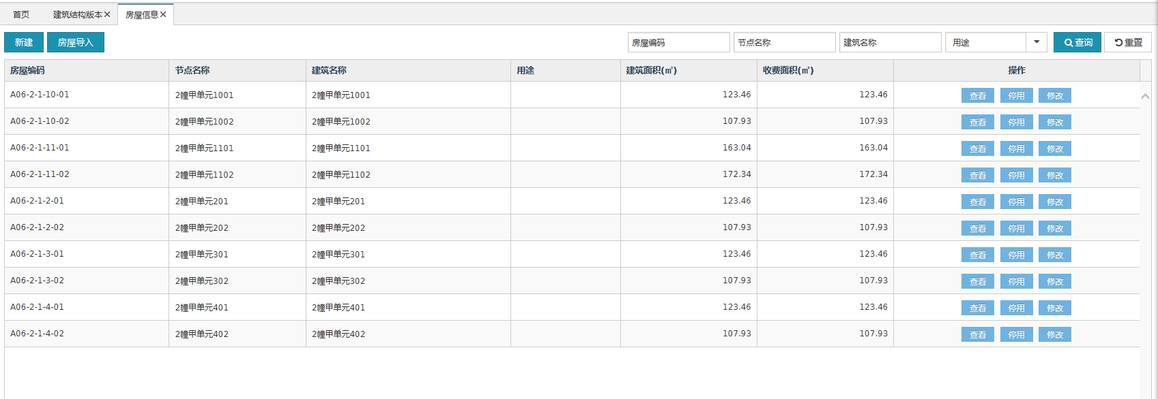

添加&修改

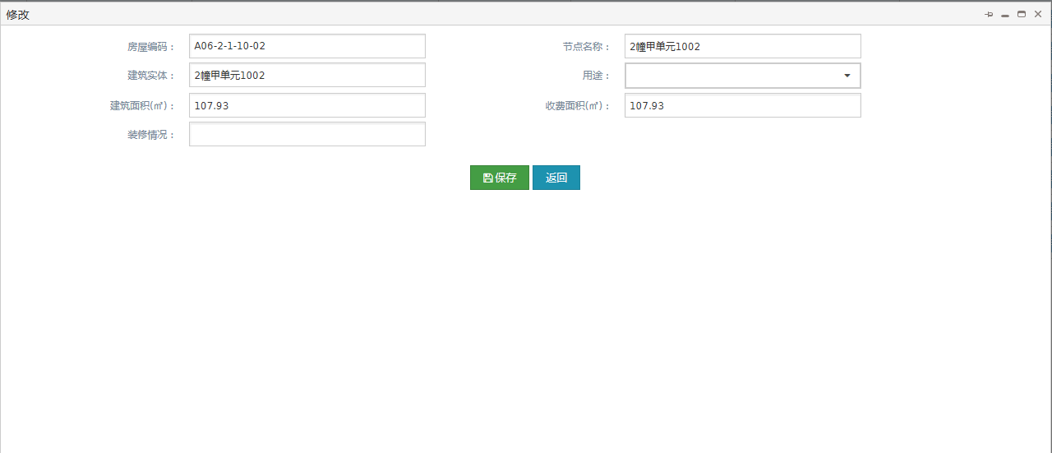

查看

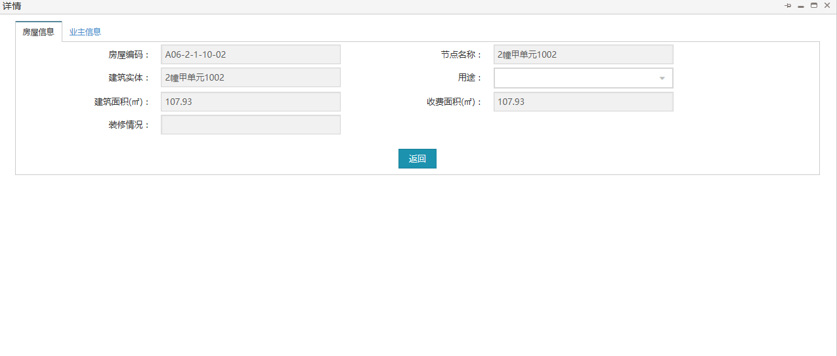 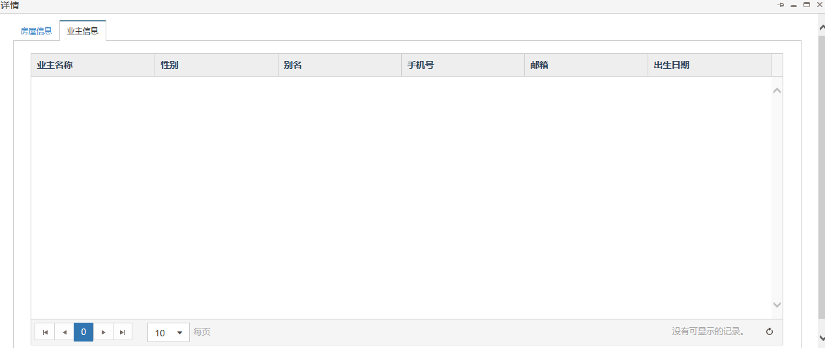

导入

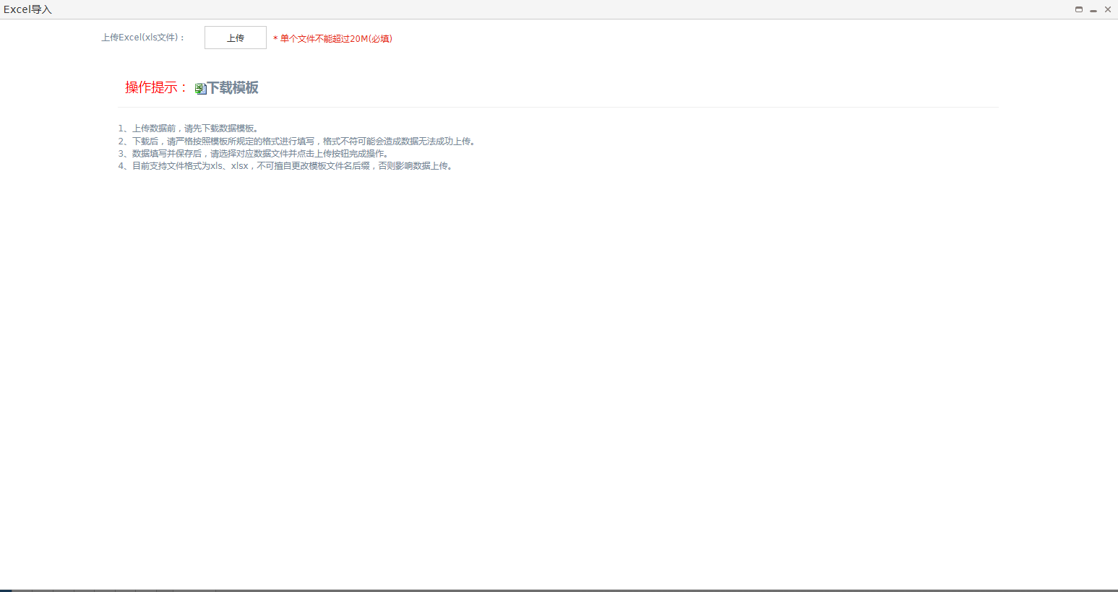

##### 文件清单

|  |  |
| --- | --- |
| **文件名** | **描述** |
| /include/head.html | 公用头部 |
| mgt_house.html | 房屋信息页面 |
| mgt_house_add.html | 房屋信息新增页面 |
| mgt_house_detail.html | 房屋信息详情页面 |
| mgt_house_edit.html | 房屋信息修改页面 |
| mgt_house_importExcel.html | 房屋信息导入页面 |

##### 页面URL定义

|  |  |
| --- | --- |
| **URL名称** | 查询房屋信息列表 |
| **URL** | /csp/mgt/house/query |
| **URL名称** | 房屋实体停用&启用 |
| **URL** | /csp/mgt/house/unableUpdate |
| **URL名称** | 房屋信息保存 |
| **URL** | /csp/mgt/house/saveOrUpdate |
| **URL名称** | 根据房屋信息id查询 |
| **URL** | /csp/mgt/house/queryByHouseId |
| **URL名称** | 查询房屋实体下的业主信息 |
| **URL** | /csp/bp/owner/findGeneralByBuildingId |
| **URL名称** | 建筑结构Excel模版下载 |
| **URL** | /common/house/excel/import/template |

##### 控制事件

| **对象名称** | **事件** | **动作** | **描述** |
| --- | --- | --- | --- |
| 查询按钮 | onClick | queryResource() | 根据表单查询条件，将查询结果显示在表格中 |
| 重置按钮 | onClick | reset() | 重置查询条件 |
| 房屋新增按钮 | onClick | houseAdd () | 新建房屋信息 |
| 房屋查询按钮 | onClick | houseQuery (id) | 根据id查询信息 |
| 版本停用&启用 | onClick | unable(id) | 根据id停用&启用 |
| 房屋修改按钮 | onClick | houseEdit (id) | 根据id修改信息 |
| 保存按钮 | onClick | save() | 新增房屋保存 |
| 房屋详情按钮 | onClick | baseInfoTab() | 查看房屋信息的详情 |
| 业主信息按钮 | onClick | ownerTab () | 查看房屋信息下的业主信息 |
| 建筑导入按钮 | onClick | importExcel() | 导入房屋信息excel |

#### 后台详细设计

##### Controller

###### MgtHouseController

|  |  |
| --- | --- |
| 类名：com.cmig.future.csportal.module.properties.base.house.controllers.MgtHouseController | |
| **method** | query |
| **mapping url** | /csp/mgt/house/query |
| **参数** | MgtHouse dto  int page  int pageSize  HttpServletRequest request |
| **返回值** | ResponseData(List<MgtHouse>) |
| **详细逻辑** | 调用mgtHouseService.select  并返回结果 |
| **method** | update |
| **mapping url** | /csp/mgt/house/submit |
| **参数** | List< MgtHouse > dto  HttpServletRequest request |
| **返回值** | ResponseData(List< MgtHouse >) |
| **详细逻辑** | 调用mgtHouseService.batchUpdate  并返回结果 |
| **method** | delete |
| **mapping url** | /csp/mgt/house /remove |
| **参数** | List< MgtHouse > dto  HttpServletRequest request |
| **返回值** | ResponseData() |
| **详细逻辑** | 调用mgtHouseService.batchDelete  并返回结果 |
| **method** | queryByHouseId |
| **mapping url** | /csp/mgt/house/queryByHouseId |
| **参数** | MgtHouse dto  HttpServletRequest request |
| **返回值** | ResponseData(MgtHouse) |
| **详细逻辑** | 调用mgtHouseService.queryByHouseId  并返回结果 |
| **method** | saveOrUpdate |
| **mapping url** | /csp/mgt/house/saveOrUpdate |
| **参数** | MgtHouse dto  HttpServletRequest request |
| **返回值** | ResponseData(MgtHouse) |
| **详细逻辑** | 调用mgtHouseService.saveOrUpdate  并返回结果 |
| **method** | unableUpdate |
| **mapping url** | /csp/mgt/house/unableUpdate |
| **参数** | MgtHouse dto  HttpServletRequest request |
| **返回值** | ResponseData(MgtHouse) |
| **详细逻辑** | 调用mgtHouseService.updateByPrimaryKeySelective  并返回结果 |

###### ImportExcelHouseController

|  |  |
| --- | --- |
| 类名：com.cmig.future.csportal.module.properties.base.house.controllers.ImportExcelHouseController | |
| **method** | upload |
| **mapping url** | /common/ house /excel /import |
| **参数** | HttpServletRequest request,  HttpServletResponse response |
| **返回值** | ResponseData(RetApp) |
| **详细逻辑** | 调用mgtHouseService.validationImportData对excel进行校验,如果校验通过,则调用mgtHouseService.saveImportDate持久化数据  并返回结果 |
| **method** | delete |
| **mapping url** | /common/ house /excel /delete |
| **参数** | HttpServletRequest request,  HttpServletResponse response |
| **返回值** | ResponseData() |
| **详细逻辑** |  |
| **method** | importFileTemplate |
| **mapping url** | /common/ house /excel /import/template |
| **参数** | HttpServletRequest request,  HttpServletResponse response |
| **返回值** | null |
| **详细逻辑** |  |

##### Service

###### IStructureBuildingMapService

|  |  |
| --- | --- |
| 类名：com.cmig.future.csportal.module.properties.base.map.service.IStructureBuildingMapService | |
| **method** | queryByHouseId |
| **参数** | MgtHouse dto |
| **返回值** | MgtHouse |
| **详细逻辑** | 调用mgtHouseMapper.queryByHouseId并返回结果 |
| **method** | saveOrUpdate |
| **参数** | IRequest requestCtx  MgtHouse dto |
| **返回值** | MgtStructureVersion |
| **详细逻辑** | 如果是新增调用mgtHouseMapper.insertSelective,如果有父id,调用structureBuildingMapMapper.insertSelective;如果是更新调用mgtHouseMapper.queryByHouseId如果父id修改,调用structureBuildingMapMapper.updateByPrimaryKeySelective并返回结果 |
| **method** | validationImportData |
| **参数** | ImportExcel ei  List<MgtHouseImport> list |
| **返回值** | Void |
| **详细逻辑** | 校验excel数据 |
| **method** | saveImportDate |
| **参数** | List<MgtHouseImport> list  BaseCommunity baseCommunity |
| **返回值** | Void |
| **详细逻辑** | 调用mgtHouseMapper.insertSelective并返回结果 |
| **method** | findBySourceHouseCodeAndSourceSystem |
| **参数** | MgtHouse dto |
| **返回值** | MgtHouse |
| **详细逻辑** | 调用mgtHouseMapper.findBySourceHouseCodeAndSourceSystem并返回结果 |

##### Mapper

###### MgtHouseMapper

|  |  |
| --- | --- |
| 类名：com.cmig.future.csportal.module.properties.base.house.mapper.MgtHouseMapper | |
| **method** | findByStructureCode |
| **参数** | MgtHouse dto |
| **返回值** | MgtHouse |
| **method** | queryByHouseId |
| **参数** | MgtHouse dto |
| **返回值** | MgtHouse |
| **method** | getCountByHouseCode |
| **参数** | String houseCode |
| **返回值** | int |
| **method** | findBySourceHouseCodeAndCid |
| **参数** | MgtHouse dto |
| **返回值** | MgtHouse |
| **method** | findBySourceHouseCodeAndSourceSystem |
| **参数** | MgtHouse dto |
| **返回值** | MgtHouse |

### 应收明细

#### 模块简介

应收明细的查询导入

#### 前端详细设计

##### UI设计

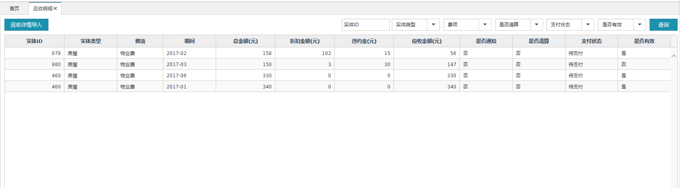

导入

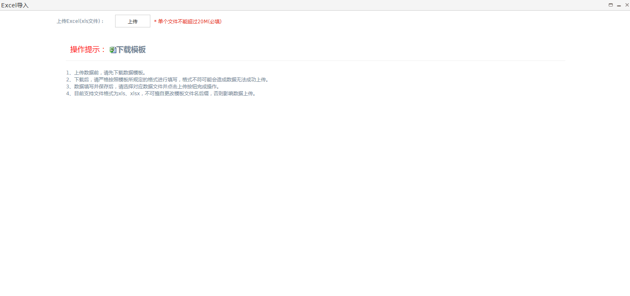

##### 文件清单

|  |  |
| --- | --- |
| **文件名** | **描述** |
| /include/head.html | 公用头部 |
| mgt_receivable.html | 应收明细页面 |
| mgt_receivable_importExcel.html | 应收明细导入页面 |

##### 页面URL定义

|  |  |
| --- | --- |
| **URL名称** | 查询应收明细列表 |
| **URL** | /csp/mgt/receivable/detail/query |
| **URL名称** | 建筑结构Excel模版下载 |
| **URL** | /common/mgtReceivable/excel/import/template |

##### 控制事件

| **对象名称** | **事件** | **动作** | **描述** |
| --- | --- | --- | --- |
| 查询按钮 | onClick | queryResource() | 根据表单查询条件，将查询结果显示在表格中 |
| 重置按钮 | onClick | reset() | 重置查询条件 |
| 明细导入按钮 | onClick | importExcel() | 导入应收明细excel |

#### 后台详细设计

##### Controller

###### MgtReceivableDetailController

|  |  |
| --- | --- |
| 类名：com.cmig.future.csportal.module.properties.payment.receivable.controllers.MgtReceivableDetailController | |
| **method** | query |
| **mapping url** | /csp/mgt/receivable/detail/query |
| **参数** | MgtReceivableDetaildto  int page  int pageSize  HttpServletRequest request |
| **返回值** | ResponseData(List< MgtReceivableDetail>) |
| **详细逻辑** | 调用mgtReceivableDetailService.select  并返回结果 |
| **method** | update |
| **mapping url** | /csp/mgt/receivable/detail /submit |
| **参数** | List< MgtReceivableDetail > dto  HttpServletRequest request |
| **返回值** | ResponseData(List< MgtReceivableDetail >) |
| **详细逻辑** | 调用mgtReceivableDetailService.batchUpdate  并返回结果 |
| **method** | delete |
| **mapping url** | /csp/mgt/receivable/detail /remove |
| **参数** | List< MgtReceivableDetail > dto  HttpServletRequest request |
| **返回值** | ResponseData() |
| **详细逻辑** | 调用mgtReceivableDetailService.batchDelete  并返回结果 |
| **method** | queryByHouseId |
| **mapping url** | /csp/mgt/house/queryByHouseId |
| **参数** | MgtHouse dto  HttpServletRequest request |
| **返回值** | ResponseData(MgtHouse) |
| **详细逻辑** | 调用mgtHouseService.queryByHouseId  并返回结果 |
| **method** | saveOrUpdate |
| **mapping url** | /csp/mgt/house/saveOrUpdate |
| **参数** | MgtHouse dto  HttpServletRequest request |
| **返回值** | ResponseData(MgtHouse) |
| **详细逻辑** | 调用mgtHouseService.saveOrUpdate  并返回结果 |
| **method** | unableUpdate |
| **mapping url** | /csp/mgt/house/unableUpdate |
| **参数** | MgtHouse dto  HttpServletRequest request |
| **返回值** | ResponseData(MgtHouse) |
| **详细逻辑** | 调用mgtHouseService.updateByPrimaryKeySelective  并返回结果 |

###### ImportExcelReceivableController

|  |  |
| --- | --- |
| 类名：com.cmig.future.csportal.module.properties.payment.receivable.controllers.ImportExcelReceivableController | |
| **method** | upload |
| **mapping url** | /common/ mgtReceivable /excel /import |
| **参数** | HttpServletRequest request,  HttpServletResponse response |
| **返回值** | ResponseData(RetApp) |
| **详细逻辑** | 调用mgtReceivableDetailService.validationImportData对excel进行校验,如果校验通过,则调用mgtReceivableDetailService.saveImportDate持久化数据  并返回结果 |
| **method** | delete |
| **mapping url** | /common/ mgtReceivable /excel /delete |
| **参数** | HttpServletRequest request,  HttpServletResponse response |
| **返回值** | ResponseData() |
| **详细逻辑** |  |
| **method** | importFileTemplate |
| **mapping url** | /common/ mgtReceivable /excel /import/template |
| **参数** | HttpServletRequest request,  HttpServletResponse response |
| **返回值** | null |
| **详细逻辑** |  |

##### Service

###### IMgtReceivableDetailService

|  |  |
| --- | --- |
| 类名：com.cmig.future.csportal.module.properties.payment.receivable.service.IMgtReceivableDetailService | |
| **method** | save |
| **参数** | MgtReceivableDetail dto |
| **返回值** | void |
| **详细逻辑** | 新增调用mgtReceivableDetailMapper.insertSelective;更新调用mgtReceivableDetailMapper.updateByPrimaryKeySelective并返回结果 |
| **method** | findBySourceReceivableIdAndSourceSystem |
| **参数** | MgtReceivableDetail dto |
| **返回值** | MgtReceivableDetail |
| **详细逻辑** | 调用mgtReceivableDetailMapper.findBySourceReceivableIdAndSourceSystem并返回结果 |
| **method** | validationImportData |
| **参数** | ImportExcel ei  List<MgtReceivableImport> list |
| **返回值** | Void |
| **详细逻辑** | 校验excel数据 |
| **method** | saveImportDate |
| **参数** | List<MgtReceivableImport> list |
| **返回值** | Void |
| **详细逻辑** | 调用mgtReceivableDetailMapper.insertSelective并返回结果 |

##### Mapper

###### MgtReceivableDetailMapper

|  |  |
| --- | --- |
| 类名：com.cmig.future.csportal.module.properties.payment.receivable.mapper.MgtReceivableDetailMapper | |
| **method** | findBySourceReceivableIdAndSourceSystem |
| **参数** | MgtReceivableDetail dto |
| **返回值** | MgtReceivableDetail |

# 接口

## 项目信息同步

### 项目信息修改

#### URL

POST:/common/syn/community/update

#### 参数

类名:BaseCommunitySynController

|  |  |  |  |
| --- | --- | --- | --- |
| **参数名** | **描述** | **类型** | **是否必填** |
| sourceSystemId | 源系统项目ID | String | 【Y】 |
| communityName | 项目名称 | String | 【Y】 |
| appid | 应用的唯一标识 | String | 【Y】乐家慧平台提供 |
| companyId | 物业公司ID | String | 【Y】 |
| companyName | 物业公司名称 | String | 【Y】 |

### 项目信息新增

#### URL

POST:/common/syn/community/add

#### 参数

类名:BaseCommunitySynController

## 关注社区

### 扫码小区id查询小区

#### URL

POST: /user/attentionCommunityUser/findCommunityByCommunityId

#### 参数

类名: AppAttentionCommunityUserController

|  |  |  |  |
| --- | --- | --- | --- |
| **参数名** | **描述** | **类型** | **是否必填** |
| id | 小区id | String | 【Y】 |
| token | 用户token | String | 【N】非必填,未登录状态不传 |

### 改变当前关注的小区

#### URL

POST: /user/attentionCommunityUser/findCommunityList

#### 参数

类名: AppAttentionCommunityUserController

|  |  |  |  |
| --- | --- | --- | --- |
| **参数名** | **描述** | **类型** | **是否必填** |
| pageSize | 显示条数 | number | 【N】默认10 |
| pageNo | 当前页 | number | 【N】默认1 |
| token | 用户token | String | 【N】未登录状态不传 |

### 查询所有小区

#### URL

POST: /user/st/attentionCommunityUser/updateAttention

#### 参数

类名: AppAttentionCommunityUserController

|  |  |  |  |
| --- | --- | --- | --- |
| **参数名** | **描述** | **类型** | **是否必填** |
| sourceSystemId | 源系统项目ID | String | 【Y】 |
| communityName | 项目名称 | String | 【Y】 |
| appid | 应用的唯一标识 | String | 【Y】乐家慧平台提供 |
| companyId | 物业公司ID | String | 【Y】 |
| companyName | 物业公司名称 | String | 【Y】 |

### 根据城市获取小区

#### URL

POST: /user/community/communityListByCity

#### 参数

类名: AppAttentionCommunityUserController

|  |  |  |  |
| --- | --- | --- | --- |
| **参数名** | **描述** | **类型** | **是否必填** |
| cityId | 城市ID | String | 【Y】数据来源于根据省获取市接口 |

### 根据小区名模糊查询

#### URL

POST: /user/attentionCommunityUser/findCommunityByLikeCommunityName

#### 参数

类名: AppAttentionCommunityUserController

|  |  |  |  |
| --- | --- | --- | --- |
| **参数名** | **描述** | **类型** | **是否必填** |
| communityName | 小区名称 | String | 【Y】 |
| token | 用户token | String | 【N】未登录状态不传 |

### 根据用户ID和小区ID取消关注

#### URL

POST: /user/st/attentionCommunityUser/cancelAttention

#### 参数

类名: AppAttentionCommunityUserController

|  |  |  |  |
| --- | --- | --- | --- |
| **参数名** | **描述** | **类型** | **是否必填** |
| communityId | 小区ID | String | 【Y】 |
| token | 用户token | String | 【Y】 |

### 根据用户token查询关注的小区

#### URL

POST: /user/st/attentionCommunityUser/findList

#### 参数

类名: AppAttentionCommunityUserController

|  |  |  |  |
| --- | --- | --- | --- |
| **参数名** | **描述** | **类型** | **是否必填** |
| token | 用户token | String | 【Y】 |

### 根据经纬度查询附近的小区

#### URL

POST: /user/attentionCommunityUser/nearbyCommunity

#### 参数

类名: AppAttentionCommunityUserController

|  |  |  |  |
| --- | --- | --- | --- |
| **参数名** | **描述** | **类型** | **是否必填** |
| longitude | 经度 | number | 【Y】BigDecimal类型 |
| latitude | 维度 | number | 【Y】BigDecimal类型 |
| token | 用户token | String | 【N】非必填,未登录状态不传 |

### 用户关注小区

#### URL

POST: /user/st/attentionCommunityUser/attentionCommunity

#### 参数

类名: AppAttentionCommunityUserController

|  |  |  |  |
| --- | --- | --- | --- |
| **参数名** | **描述** | **类型** | **是否必填** |
| token | 用户token | String | 【Y】 |
| communityId | 小区ID | String | 【Y】 |

### 用户登录后关联关注的小区

#### URL

POST: /user/st/attentionCommunityUser/attentionByLogin

#### 参数

类名: AppAttentionCommunityUserController

|  |  |  |  |
| --- | --- | --- | --- |
| **参数名** | **描述** | **类型** | **是否必填** |
| token | 用户token | String | 【Y】 |
| communityIds | 小区id | String | 【Y】 |

## 物业app消息模块

### app-查询消息列表

#### URL

POST: /mgt/notifyRecords/list

#### 参数

类名: MgtNotifyRecordsController

|  |  |  |  |
| --- | --- | --- | --- |
| **参数名** | **描述** | **类型** | **是否必填** |
| token | 用户令牌 | String | 【Y】 |
| communityId | 小区id | String | 【Y】 |
| page | 页码 | number | 【N】默认1 |
| pageSize | 每页条数 | number | 【N】默认10 |
| type | type | String | 【N】OTHER:非通知公告;NOTIFY:通知公告;READ_METER:抄表;REPAIR:报修;SECURITY:安防巡检;EQUIPMENT:设备巡检;DECORATION:装修巡检;不传则查询所有分类 |

### app-消息删除

#### URL

POST: /mgt/notifyRecords/delete

#### 参数

类名: MgtNotifyRecordsController

|  |  |  |  |
| --- | --- | --- | --- |
| **参数名** | **描述** | **类型** | **是否必填** |
| token | 用户token | String | 【Y】 |
| id | 消息主键 | String | 【Y】 |

### app-消息清空

#### URL

POST: /mgt/notifyRecords/clean

#### 参数

类名: MgtNotifyRecordsController

|  |  |  |  |
| --- | --- | --- | --- |
| **参数名** | **描述** | **类型** | **是否必填** |
| token | 用户token | String | 【Y】 |
| communityId | 小区id | String | 【Y】 |
| type | 消息分类 | String | 【N】OTHER:非通知公告;NOTIFY:通知公告;READ_METER:抄表;REPAIR:报修;SECURITY:安防巡检;EQUIPMENT:设备巡检;DECORATION:装修巡检;不传则清空所有分类 |

### app-阅读消息详情

#### URL

POST: /mgt/notifyRecords/read

#### 参数

类名: MgtNotifyRecordsController

|  |  |  |  |
| --- | --- | --- | --- |
| **参数名** | **描述** | **类型** | **是否必填** |
| token | 用户token | String | 【Y】 |
| id | 消息主键 | String | 【Y】 |

### 消息附件下载

#### URL

GET: /mgt/sys/attchment/download

#### 参数

类名: MgtAttachmentSynController

|  |  |  |  |
| --- | --- | --- | --- |
| **参数名** | **描述** | **类型** | **是否必填** |
| token | 用户token | String | 【Y】 |
| id | 附件id | String | 【Y】 |

## 用户消息

### app-查询未读消息数量

#### URL

POST: /user/st/notifyRecords/getNoReadCount

#### 参数

类名: UserNotifyRecordsController

|  |  |  |  |
| --- | --- | --- | --- |
| **参数名** | **描述** | **类型** | **是否必填** |
| token | 用户token | String | 【Y】 |
| id | 附件id | String | 【Y】 |
| type | type | String | 【N】OTHER:非通知公告;NOTIFY:通知公告;READ_METER:抄表;REPAIR:报修;SECURITY:安防巡检;EQUIPMENT:设备巡检;DECORATION:装修巡检;PROPERTY:物业,SERVICE:服务,SYSTEM:系统, 不传则查询所有分类 |

### app-查询消息列表

#### URL

POST: /user/st/notifyRecords/list

#### 参数

类名: UserNotifyRecordsController

|  |  |  |  |
| --- | --- | --- | --- |
| **参数名** | **描述** | **类型** | **是否必填** |
| token | 用户token | String | 【Y】 |
| communityId | 小区ID | String | 【Y】 |
| page | 页码 | number | 【N】默认1 |
| pageSize | 每页条数 | number | 【N】默认10 |
| type | 消息分类 | String | 【N】OTHER:非通知公告;NOTIFY:通知公告;READ_METER:抄表;REPAIR:报修;SECURITY:安防巡检;EQUIPMENT:设备巡检;DECORATION:装修巡检;PROPERTY:物业,SERVICE:服务,SYSTEM:系统, 不传则查询所有分类 |

### app-消息删除

#### URL

POST: /user/st/notifyRecords/delete

#### 参数

类名: UserNotifyRecordsController

|  |  |  |  |
| --- | --- | --- | --- |
| **参数名** | **描述** | **类型** | **是否必填** |
| token | 用户token | String | 【Y】 |
| id | 消息主键 | String | 【Y】 |

### app-消息清空

#### URL

POST: /user/st/notifyRecords/clean

#### 参数

类名: UserNotifyRecordsController

|  |  |  |  |
| --- | --- | --- | --- |
| **参数名** | **描述** | **类型** | **是否必填** |
| token | 用户token | String | 【Y】 |
| communityId | 小区id | String | 【Y】 |
| type | 消息分类 | String | 【N】OTHER:非通知公告;NOTIFY:通知公告;READ_METER:抄表;REPAIR:报修;SECURITY:安防巡检;EQUIPMENT:设备巡检;DECORATION:装修巡检;不传则清空所有分类 |

### app-阅读消息详情

#### URL

POST: /user/st/notifyRecords/read

#### 参数

类名: UserNotifyRecordsController

|  |  |  |  |
| --- | --- | --- | --- |
| **参数名** | **描述** | **类型** | **是否必填** |
| token | 用户token | String | 【Y】 |
| id | 消息主键 | String | 【Y】 |

### 消息附件下载

#### URL

GET: /user/st/sys/attchment/download

#### 参数

类名: UserAttachmentSynController

|  |  |  |  |
| --- | --- | --- | --- |
| **参数名** | **描述** | **类型** | **是否必填** |
| token | 用户令牌 | String | 【Y】 |
| id | 附件id | String | 【Y】 |
| appid | 应用的唯一标识 | String | 【Y】乐家慧平台提供 |

## 物管云消息模块

### 物管云-查询消息列表

#### URL

POST: /common/syn/notifyRecords/list

#### 参数

类名: NotifyRecordsController

|  |  |  |  |
| --- | --- | --- | --- |
| **参数名** | **描述** | **类型** | **是否必填** |
| appid | 乐家慧提供的appid | String | 【Y】 |
| sourceCommunityIds | 小区ID | String | 【Y】多个用逗号分隔 例如：1,2 |
| sourceSystemUserId | 员工id | String | 【N】不传该参数,则查询小区id下的所有员工 |
| type | 消息分类 | String | 【N】NOTIFY:通知公告;READ_METER:抄表;REPAIR:报修;SECURITY:安防巡检;EQUIPMENT:设备巡检;DECORATION:装修巡检;不传则查询所有分类 |
| page | 当前页码 | String | 【N】默认1 |
| pageSize | 每页条数 | String | 【N】默认10 |

### 物管云-读取消息

#### URL

POST: /common/syn/notifyRecords/read

#### 参数

类名: NotifyRecordsController

|  |  |  |  |
| --- | --- | --- | --- |
| **参数名** | **描述** | **类型** | **是否必填** |
| appid | 乐家慧提供的appid | String | 【Y】 |
| id | 消息主键 | String | 【Y】 |

### 附件下载

#### URL

GET: /common/sys/attchment/download

#### 参数

类名: AttachmentSynController

|  |  |  |  |
| --- | --- | --- | --- |
| **参数名** | **描述** | **类型** | **是否必填** |
| token | 用户令牌 | String | 【Y】 |
| id | 附件id | String | 【Y】 |
| appid | 应用的唯一标识 | String | 【Y】乐家慧平台提供 |

## 通用物业缴费

### 应收账单新增

#### URL

POST: /common/receivable/add

#### 参数

类名: NotifyRecordsController

|  |  |  |  |
| --- | --- | --- | --- |
| **参数名** | **描述** | **类型** | **是否必填** |
| appid | 应用的唯一标识 | String | 【Y】乐家慧平台提供 |
| sourceReceivableId | 源系统应收ID | String | 【Y】 |
| sourceBuildCode | 源系统建筑编码 | String | 【Y】 |
| expenditure | 费项 | String | 【Y】PROPERTY_FEE：物业费； |
| periodName | 期间（YYYY-MM） | String | 【Y】示例：2016-01 |
| totalAmount | 总金额（分） | number | 【Y】默认0 |
| discountAmount | 折扣金额（分） | number | 【N】默认0 |
| breakContractAmount | 违约金（分） | number | 【N】默认0 |
| backUrl | 支付成功通知地址 | String | 【Y】接收乐家慧异步通知，通知url必须为直接可访问的url，不能携带参数。 |
| description | 描述 | String | 【N】 |
| sign | 签名 | String | 【Y】 |
| buildingType | 建筑实体类型 | String | 【Y】HOUSE:房屋;PARKING:车位;SHOP:商铺 |

### 应收账单修改

#### URL

POST: /common/receivable/update

#### 参数

类名: MgtReceivableController

|  |  |  |  |  |  |  |
| --- | --- | --- | --- | --- | --- | --- |
| **参数名** | **描述** | | **类型** | | **是否必填** | |
| appid | | 应用的唯一标识 | | String | | 【Y】乐家慧平台提供 |
| sourceReceivableId | | 源系统应收ID | | String | | 【Y】 |
| periodName | | 期间（YYYY-MM） | | String | | 【Y】示例：2016-01 |
| totalAmount | | 总金额（分） | | number | | 【N】默认0 |
| discountAmount | | 折扣金额（分） | | number | | 【N】默认0 |
| breakContractAmount | | 违约金（分） | | number | | 【N】默认0 |
| backUrl | | 支付成功通知地址 | | String | | 【N】接收乐家慧异步通知，通知url必须为直接可访问的url，不能携带参数。 |
| description | | 描述 | | String | | 【N】 |
| sign | | 签名 | | String | | 【Y】 |

### 应收账单失效

#### URL

POST: /common/receivable/unable

#### 参数

类名: MgtReceivableController

|  |  |  |  |  |  |  |
| --- | --- | --- | --- | --- | --- | --- |
| **参数名** | **描述** | | **类型** | | **是否必填** | |
| appid | | 应用的唯一标识 | | String | | 【Y】乐家慧平台提供 |
| sourceReceivableId | | 源系统应收ID | | String | | 【Y】 |
| sign | | 签名 | | String | | 【Y】 |

### 查询应收账单状态

#### URL

POST: /common/receivable/queryStatus

#### 参数

类名: MgtReceivableController

|  |  |  |  |
| --- | --- | --- | --- |
| **参数名** | **描述** | **类型** | **是否必填** |
| appid | 应用的唯一标识 | String | 【Y】乐家慧平台提供 |
| sourceReceivableId | 源系统应收ID | String | 【Y】 |
| sign | 签名 | String | 【Y】 |

### 分页查询全部应收账单

#### URL

POST: /common/receivable/list

#### 参数

类名: MgtReceivableController

|  |  |  |  |
| --- | --- | --- | --- |
| **参数名** | **描述** | **类型** | **是否必填** |
| appid | 应用的唯一标识 | String | 【Y】乐家慧平台提供 |
| pageSize | 每页记录数 | number | 【Y】 |
| pageNo | 页码 | number | 【Y】 |
| sign | 签名 | String | 【Y】 |