# How to process the TM integrated into the file for translation.

A new mechanism “TM Hyperhub inline provider” (SoftTran.TM.Hyperhub.Inline.sdlplugin) was developed for SDL Studio. It allows to work with the TM directly in SDL Studio, keepeng the same characteristics as in Hyperhub.

Note: this plugin works only with the xlf files converter (Hyperhub File Type - SoftTran.FileType.Hyperhub.XLF.sdlplugin) under the version “1.0.0.1” or higher.

# How to proceed:

While converting the xlf file into sdlxlf, the Hyperhub (xlf) segment's “Suggestions” (if there are some) are also transported and saved in SDL Studio (sdlxlf).

If in the SDL Studio's project the new TM processing tool “TM Hyperhub inline provider” is activated. In this case SDL Studio will search for additional information from “Suggestions” in the xlf file while analyzing its statistics or editing the segment.

If there is such information, the tool “TM Hyperhub inline provider” will convert the TM data into suitable for SDL Studio TM format, keeping the same quantity of fuzzy matches as in the original Hyperhub (xlf) file.

Thus the problem of differences in statistics data is eliminated.

Apart of the “Suggestions”'s information, the “Inline tags” description is also applied while importing Hyperhub (xlf) file into SDL Stidion.

# Addon “TM Hyperhub inline provider” installtion

1. Install the “SoftTran.FileType.Hyperhub.XLF.sdlplugin”
2. Open the project settings window “Project Settings”
3. Open the settings window “Translation Memory and Automated Translation”  
   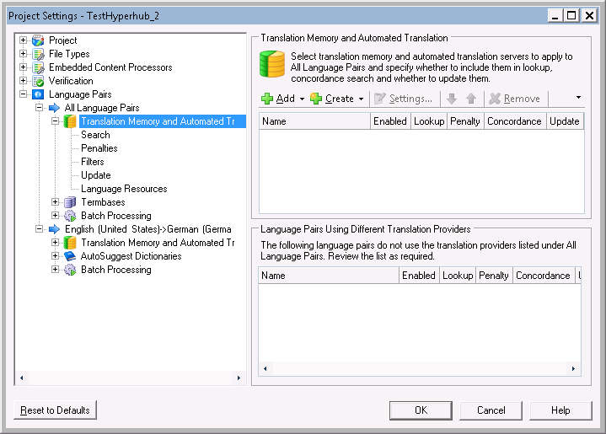
4. Add new TM conversion tool  
   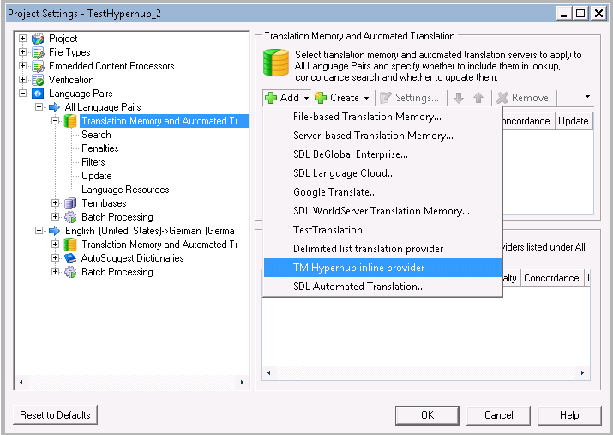  
   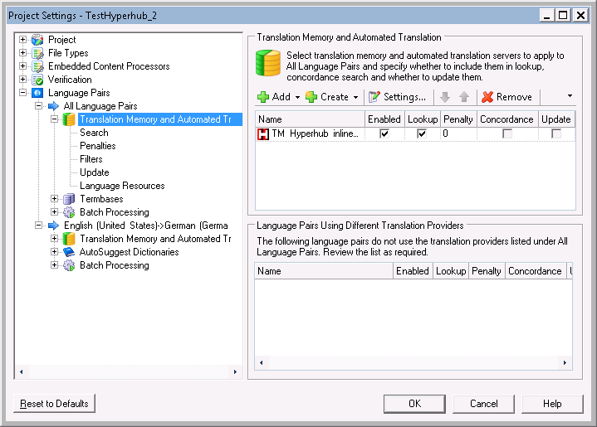
5. Done! Now start using the new awesome tool “TM Hyperhub inline provider”  
   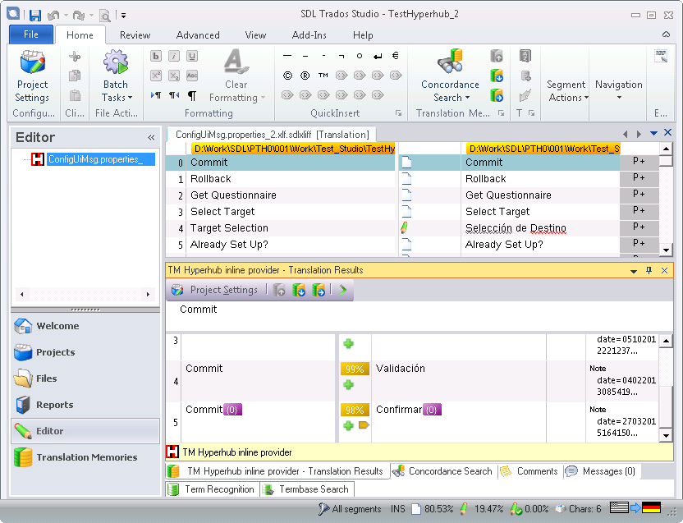
6. Additionally apart of the source and target text, the field “Comment” is displayed for each of “Suggestions”.  
   