西安交通大学城市学院
Java高级编程实验作业
班级： 计算机2405 学号： 24031257 姓名： 周钰杰
实验名称： 教学管理系统

报告正文

一、实验目的及要求
1、实验目的
掌握类、属性、方法的设计与实现
理解封装、继承等面向对象特性
熟练编写自定义异常并实现异常处理机制
完成学生、课程、成绩三大核心模块的业务逻辑实现
2、系统功能要求：
2.1类设计
Student：属性sid,sname,major；方法：输出学生基本信息；学生信息数据来源（本班任意四个学生）
Course： 属性cid,came,credit；方法：输出课程基本信息；课程信息数据来源（本学期所开设三门课程）
Score 属性：Student,Course,grade方法：输出所有学生选课信息；成绩任意输入。
Query：属性：无；方法：输出指定学生某一门课程的成绩。

自定义异常类
IdException：要求10位数字，否则出现异常。
CreditException：要求1—3之间，否则出现异常
ScoreException：成绩非法异常

二、实验内容、过程与结果
（1）源代码
package shiyan2;

public class IdException extends Exception{
public IdException(){
}
public IdException(String message){
super(message);
System.out.println(getMessage());
}

}
package shiyan2;

public class CreditException extends Exception{
public CreditException(){
}
public CreditException(String message){
super(message);
System.out.println(getMessage());
}

}
package shiyan2;

public class ScoreException extends Exception{
public ScoreException(){
}
public ScoreException(String message){
super(message);
System.out.println(getMessage());
}

}
package shiyan2;

public class Student {
private String sid;
private String sname;
private String major;
public Student(String sname, String major) {
super();
this.sname = sname;
this.major = major;
}
public String getSid() {
return sid;
}
public void setSid(String sid) throws IdException{
if(sid.length()==10)
this.sid = sid;
else
throw new IdException("学号的长度不符合要求");
}
public String getSname() {
return sname;
}
public void setSname(String sname) {
this.sname = sname;
}
public String getMajor() {
return major;
}
public void setMajor(String major) {
this.major = major;
}
@Override
public String toString() {
return "Student [sid=" + sid + ", sname=" + sname + ", major=" + major + "]";
}

}
package shiyan2;

public class Course {
private String cid;
private String came;
private int credit;
public Course(String cid, String came) {
super();
this.cid = cid;
this.came = came;
}
public String getCid() {
return cid;
}
public void setCid(String cid) {
this.cid = cid;
}
public String getCame() {
return came;
}
public void setCame(String came) {
this.came = came;
}
public int getCredit() {
return credit;
}
public void setCredit(int credit) throws CreditException{
if(credit>=1&&credit<=3)
this.credit = credit;
else
throw new CreditException("学分出现异常");
}
@Override
public String toString() {
return "Course [cid=" + cid + ", came=" + came + ", credit=" + credit + "]";
}

}
package shiyan2;

public class Score {
private String Student;
private Course Course;
private int grade;
public Score(String student, Course course) {
super();
Student = student;
Course = course;
}

public String getStudent() {
return Student;
}

public void setStudent(String student) {
Student = student;
}

public Course getCourse() {
return Course;
}

public void setCourse(Course course) {
Course = course;
}

public int getGrade() {
return grade;
}

public void setGrade(int grade) throws ScoreException{
if(grade<=100&&grade>=0)
this.grade = grade;
else
throw new ScoreException("成绩非法异常");
}

@Override
public String toString() {
return "Score [Student=" + Student + ", Course=" + Course + ", grade=" + grade + "]";
}

}
package shiyan2;

public class Test {
public static void main(String[] args) {
Student[] students = new Student[4];
students[0] = new Student("zhang", "compute");
students[1] = new Student("wang", "compute");
students[2] = new Student("zhao", "compute");
students[3] = new Student("liu", "compute");

try {
students[0].setSid("0001");
} catch (IdException e) {
System.out.println("异常捕获：" + e.getMessage());
}

try {
students[0].setSid("2024001001");
students[1].setSid("2024001002");
students[2].setSid("2024001003");
students[3].setSid("2024001004");

System.out.println("\n===== 学生信息 =====");
for (Student s : students) {
System.out.println(s);
}

Course c1 = new Course("2024000001", "Java程序设计");
Course c2 = new Course("2024000002", "数据库原理");
Course c3 = new Course("2024000003", "数据结构");

c1.setCredit(3);
c2.setCredit(2);
c3.setCredit(3);

System.out.println("\n===== 课程信息 =====");
System.out.println(c1);
System.out.println(c2);
System.out.println(c3);

Score s = new Score(students[0].getSid(), c1);
s.setGrade(90);

}catch (IdException | CreditException | ScoreException e) {
e.printStackTrace();
}
}
}

（2）结果截图
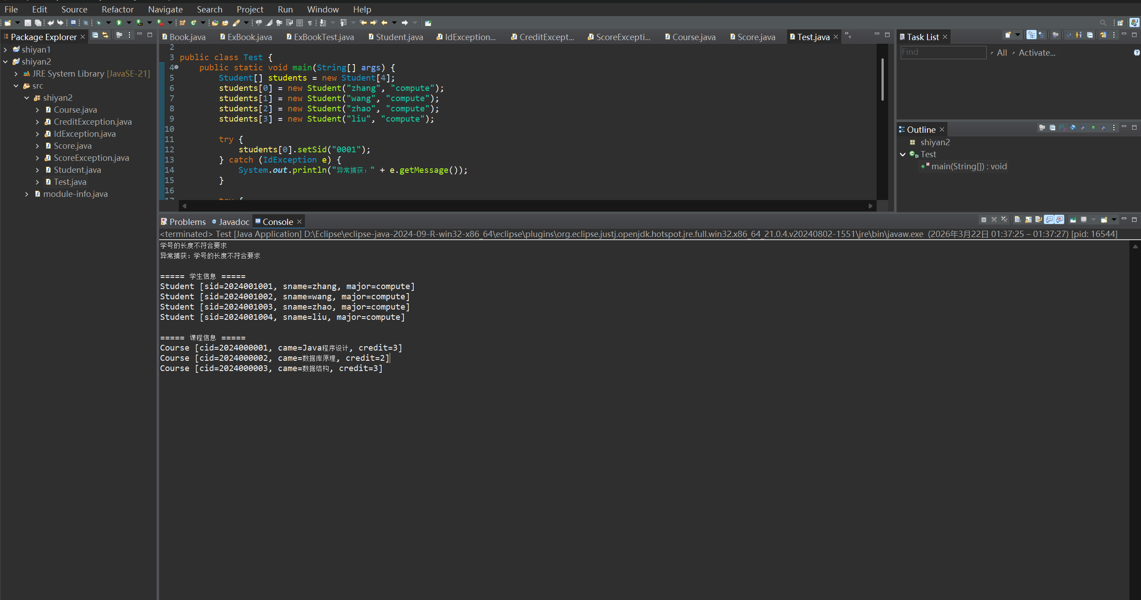
三、实验心得（代码出错原因及修改）
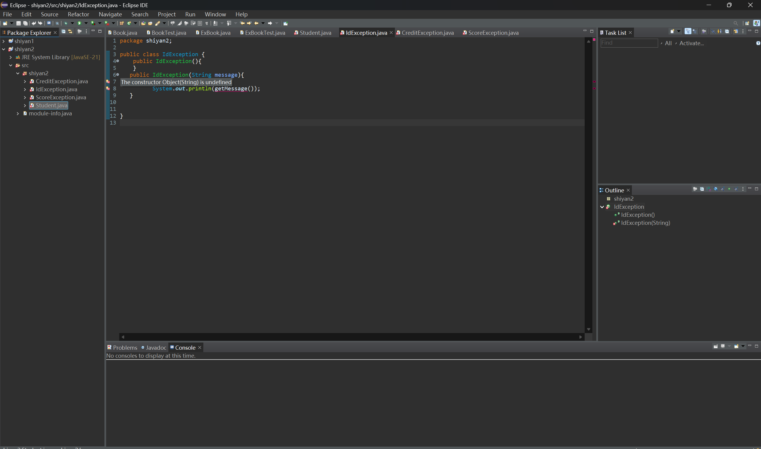
没写继承
public class IdException改为public class IdException extends Exception

