**ISCG6420 Internet & Website Development**

sTUDeNT ID: 1451757

Natalia zubko

**Contents**

Purpose 1

URL 1

Target Audience 1

Reference for content 1

Site Map 2

Homepage Layout 3

Places to Visit/Dine Page Layout 4

Accommodation Page Layout 5

Gallery Page Layout 6

Newsletter Page Layout 7

Explanation on where and how JavaScript was used 8

Explanation on where and how CSS was used 8

# **Purpose**

The purpose of the Queenstown site is to promote tourism in Queenstown and provide the necessary information for organizing the recreation for tourists. The site contains information about basic knowledge of the city, activities that tourist must do, places to visit, accommodation, places for dining, events of the year, image gallery.

# **URL**

# **Target Audience**

The main target audience is tourists visiting the Queenstown. However, the site can be useful for local people to help them organize their activities and entertainment as well.

# **Reference for content**

The resources of used information:

https://en.wikipedia.org/wiki/Queenstown,_New_Zealand

http://www.queenstownnz.co.nz/

# **Site Map**

A site map showing the navigational links between all the pages, and how the site is divided. Each page of the site has access to other pages from the navigation bar

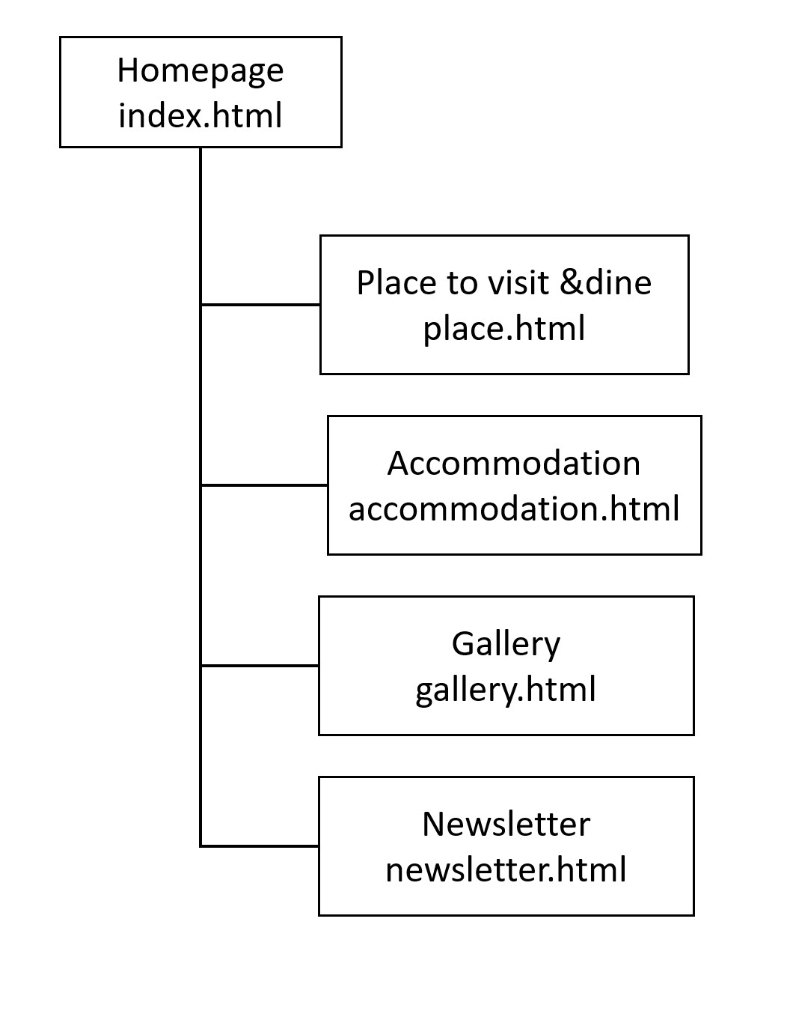

# **Homepage Layout**

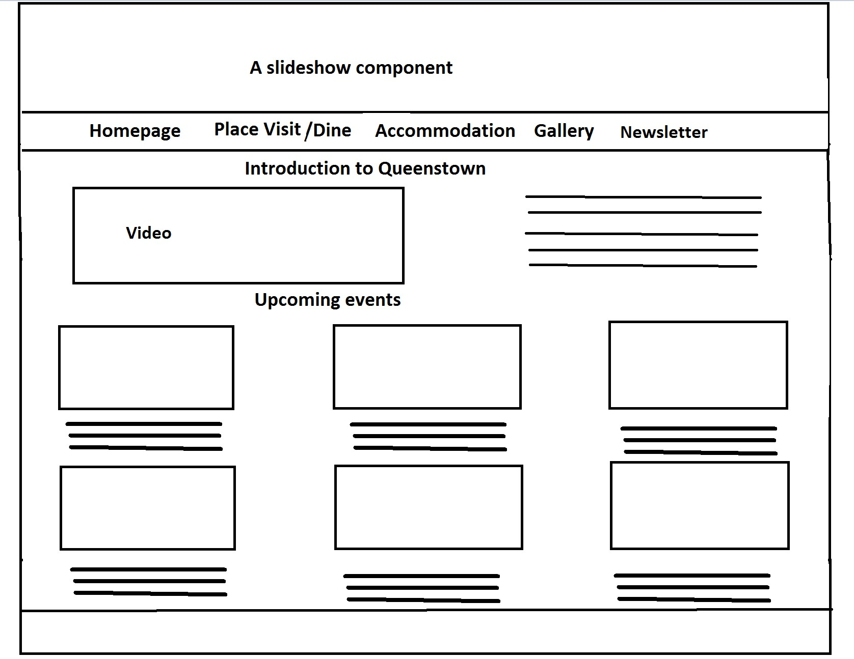

# **Places to Visit/Dine Page Layout**

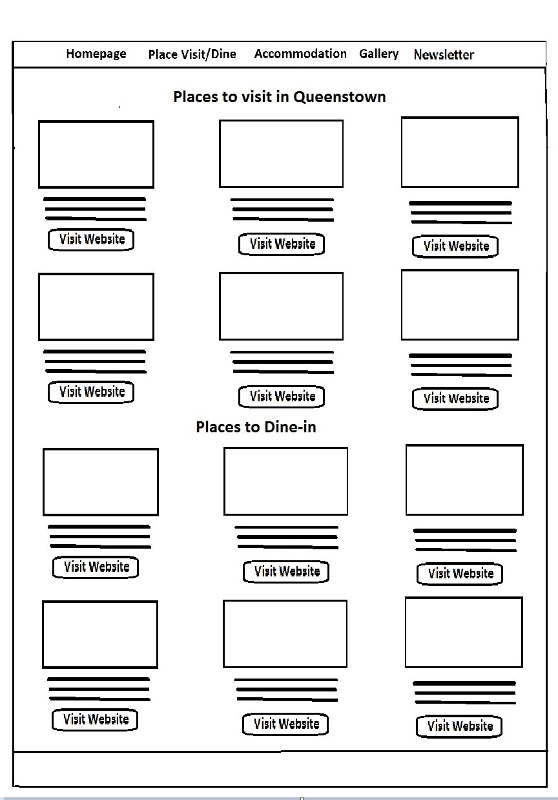

# **Accommodation Page Layout**

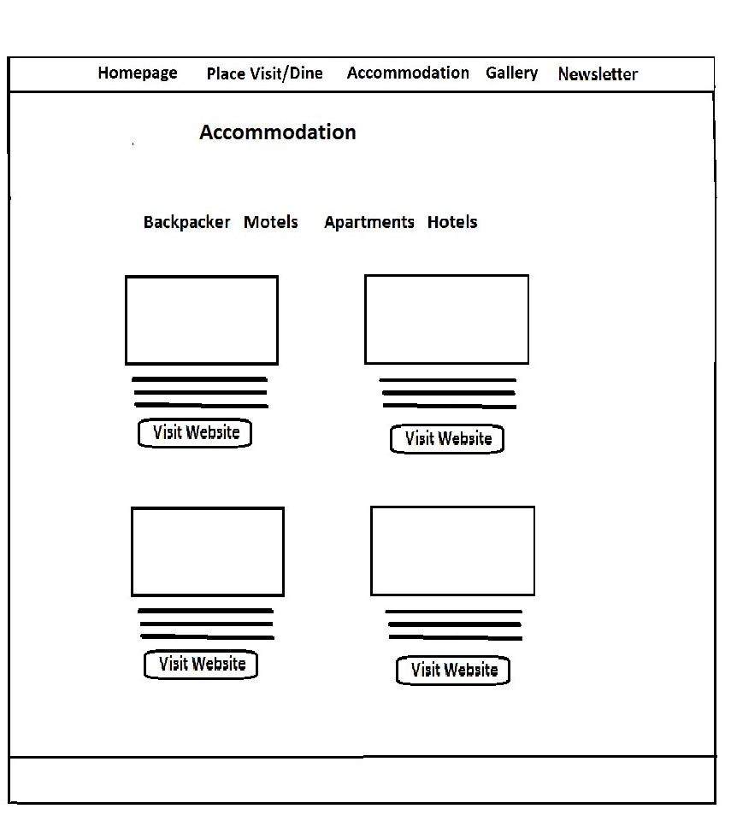

# **Gallery Page Layout**

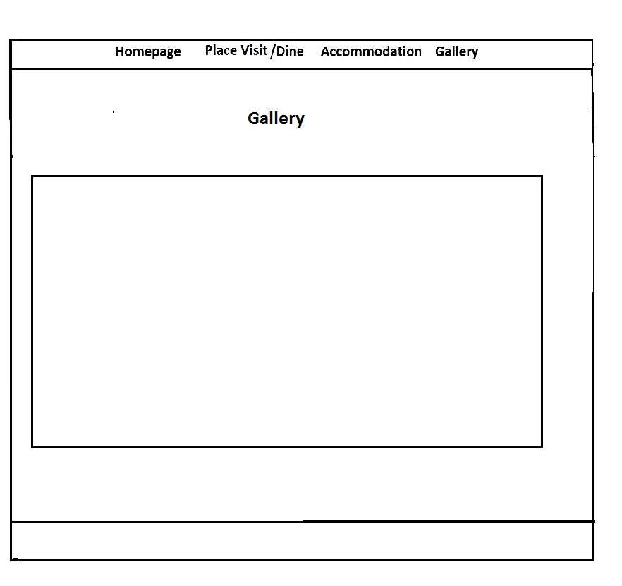

# **Newsletter Page Layout**

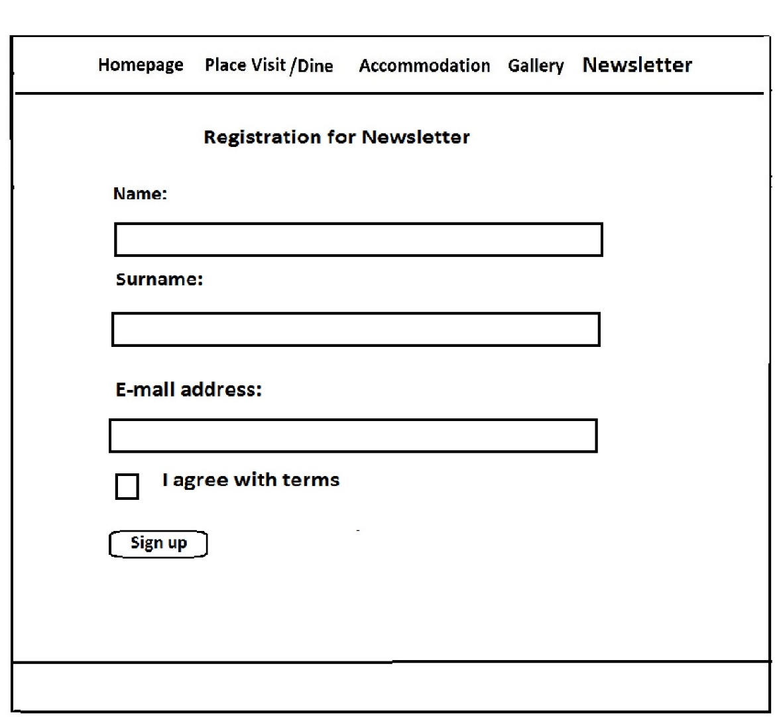

# **Explanation on where and how JavaScript was used**

1. site.js file locates in the js folder.

2. JS is used on the accommodation page to display information for each tab – backpacker, motels, apartments, hotels. It was done by creating 4 simple functions that show elements of chosen tab and hide elements of others.

3. JS is used on the gallery page. It was done by creating showImages() function where was displayed each element of the array. The array consists from 9 images. This function shows each element of the array every 5 second.

4. JS is used to check the data entered by user on the newsletter page. Each data of input is put into appropriate variable and checked needed conditions noticed in the task

# **Explanation on where and how CSS was used**

The site was developed with using Bootstrap framework that helped to create markup and to keep responsive design on mobile, tablet and desktop. CSS is used for stile of navigation bar in the header for each page. Also footer for every page was stylized.

The customized main.css file for the site is placed in the css folder.

Bootstrap img-responsive and text-center classes are used almost on the all pages of the site. img-responsive class adapt size of images for various screen resolution. text-center class aligns text to the center.

HTML and CSS files were checked using the following validators

HTML validator: https://validator.w3.org/

CSS validator: https://jigsaw.w3.org/css-validator/