East West University

Department of Computer Science and Engineering

# **Project Report**

**Project title:** Digital Speedometer using Arduino

**Course title:** Microcontroller and Microprocessor

**Course Code:** CSE442

**Section:** 01

**Semester:** Spring’2017

# **Group Members**

* Name: Al Muttakin

ID: 2013-2-60-005

* Name: Ummey Habiba Pinky

ID: 2013-2-60-057

* Name: Tanzin Tabanum Mim

ID: 2013-2-60-001

# **Instructor**

Md. Nawab Yousuf Ali

Associate Professor

Department of Computer Science and Engineering

East West University

***How does this work?***

In our project we measure the speed of any rotating object ( here a DC fan ) with the help of magnetic reed switch and Arduino board. A magnetic reed switch is connected with Arduino and set near to the rotating object. A nano magnet is fixed with the rotating object. When the magnet passes the magnetic reed switch, it senses the magnetic field and sent a signal to Arduino. Based on the time interval of the signal we calculate speed of the object in MPH.

***Name of the instruments used for this project:***

1. Magnetic reed switch
2. Arduino Uno R3
3. Bread Board
4. DC fan
5. 10 k register
6. Pot register 10k, 5K, 100K
7. Power supply, 9v and 12v
8. IRF 540 MOSFED
9. Slide switch
10. Wire

***Circuit Diagram:***

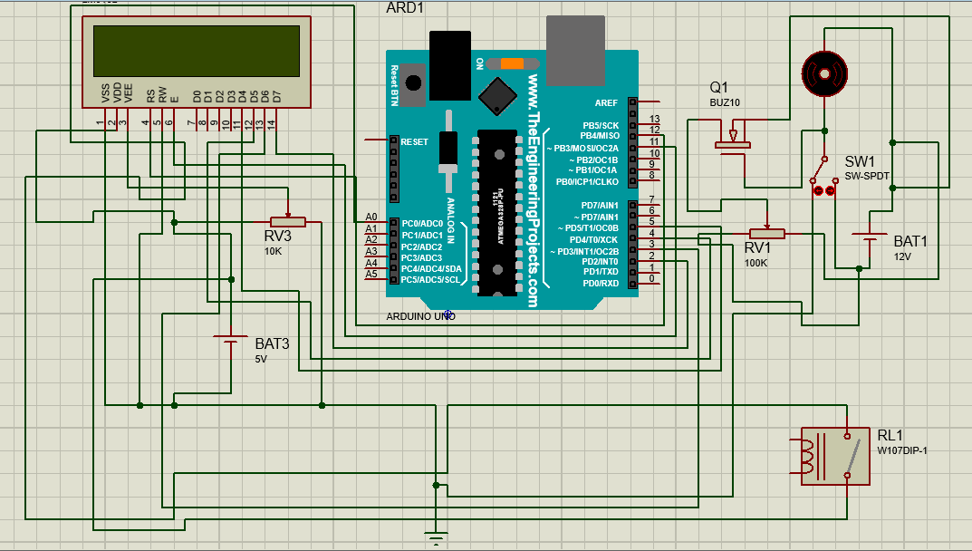

***PROGRAM CODE:***

#include <LiquidCrystal.h>

#define reed A0

LiquidCrystal lcd(12, 11, 5, 4, 3, 2);

float radius = 5.1;

int reedVal;

long timer = 0;

float mph = 0.00;

float circumference;

int maxReedCounter = 100;

int reedCounter;

void setup()

{

lcd.begin(16, 2);

reedCounter = maxReedCounter;

circumference = 2*3.14*radius;

pinMode(reed, INPUT);

cli();

TCCR1A = 0;

TCCR1B = 0;

TCNT1 = 0;

OCR1A = 1999;

TCCR1B |= (1 << WGM12);

TCCR1B |= (1 << CS11);

TIMSK1 |= (1 << OCIE1A);

sei();

}

ISR(TIMER1_COMPA_vect)

{

reedVal = digitalRead(reed);

if (reedVal)

{

if (reedCounter == 0)

{

mph = (56.8*float(circumference))/float(timer);

timer = 0;

reedCounter = maxReedCounter;

}

else{

if (reedCounter > 0)

{

reedCounter -= 1;

}

}

}

else

{

if (reedCounter > 0)

{

reedCounter -= 1;//decrement reedCounter

}

}

if (timer > 1500)

{

mph = 0;//if no new pulses from reed switch- tire is still, set mph to 0

}

else

{

timer += 1;//increment timer

}

}

void displayMPH()

{

lcd.setCursor(0,1);

lcd.print(mph);

}

void loop()

{

lcd.print("Speed...");

lcd.setCursor(8,1);

lcd.print("mph");

displayMPH();

delay(10);

lcd.clear();

}