**Brick Wall Patterns**

If we want to build a brick wall out of the usual size of brick which has a length twice as long as its height, and if our wall is to be two units tall, we can make our wall in a number of patterns, depending on how long we want it. From the figure one observe that:

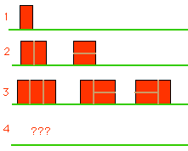

* There is just one wall pattern which is 1 unit wide - made by putting the brick on its end.
* There are 2 patterns for a wall of length 2: two side-ways bricks laid on top of each other and two bricks long-ways up put next to each other.
* There are three patterns for walls of length 3.

How many patterns can you find for a wall of length 4? And, for a wall of length 5?

**Problem**

Your task is to write a program that given the length of a wall, determines how many patterns there may be for a wall of that length.

**Intput**

Your program receives a sequence of positive integers, one per line, each representing the length of a wall. The maximum value for the wall is length 50. The input terminates with a 0.

**Output**

For each wall length given in the input, your program must output the corresponding number of different patterns for such a wall in a separate line.

**Sample Intput**

1

2

3

0

**Sample Output**

1

2

3

*Fernando Silva, CPUP'2003 Round 1  
Concurso de Programa��o da Universidade do Porto*