SMALL LANGUAGE MODEL CHALLENGE
Parameter-Matched SwiGLU with Capacity Scaling and Dropout
Course: DASE7506
Student ID: 3036781272
Name: Li Zhoutong

1. Summary
I first reproduced the supplied causal language-model baseline and then changed one component at a time. My main modification replaces the GELU feed-forward sublayer with a parameter-matched SwiGLU gate. At the same training budget, validation BPB improved from 2.071083 to 2.010852. I then trained a wider, deeper SwiGLU model with dropout for longer. The frozen final model reached 1.567424 validation BPB and 1.589531 CPU FP32 test BPB, which is 24.35% lower than the reproduced baseline test result. I use the matched run to analyse the architectural change and the larger run as the final quality-cost trade-off.
Final test BPB | CPU score time | Peak RAM | Inference assets
1.589531 | 42.99 s (3.19x) | 1.4972 GiB | 20.46 MiB total

2. Task and baseline
The task is next-token prediction on the supplied WikiText-2 benchmark, a corpus introduced by Merity et al. [3], using the fixed training-fitted BPE-2048 tokenizer and evaluator supplied by the course [1]. Evaluation uses independent causal windows of 256 targets and reports summed negative log probability in bits divided by the raw UTF-8 byte count. Lower BPB is better. I used validation for development and model selection and evaluated test only after freezing the final predictor.
The baseline is a small decoder-only Transformer in the general architecture of Vaswani et al. [4]. It has four pre-LayerNorm blocks, width 128, four attention heads, learned absolute positions, residual connections, tied token/output embeddings and a 4x GELU MLP. It contains 1,088,256 parameters and is trained from random initialization for 1,200 updates with batch size 32, corresponding to 9,830,400 processed targets. Importantly, the supplied attention is already multi-head and causally masked; changing it to 'multi-head masked attention' would therefore not create a new mechanism.
I reproduced the baseline on Windows 11, Python 3.12.13 and PyTorch 2.7.1+cpu using four threads on an AMD Ryzen 7 4800HS. Training took 769.99 s; validation BPB was 2.071083 and test BPB was 2.101260. This matches the staff reference of approximately 2.10 BPB.

2.1 Baseline components and possible improvements
I divided the baseline into five parts before choosing a modification: embeddings and positions, causal attention, the feed-forward sublayer, normalisation/residual connections, and the training configuration. This made it easier to distinguish an architectural change from simply using more parameters or more updates.
Embeddings and positions. The learned absolute position table could be replaced by a relative or rotary scheme, but the evaluator fixes the context to 256 tokens, so long-context extrapolation is not the main limitation in this project.
Causal attention. Head count, model width and the attention implementation can be changed. However, the existing model already uses scaled dot-product multi-head attention with a causal mask. A more complicated attention change would require additional controls and was harder to isolate within the time available.
Feed-forward sublayer. This sublayer applies the same nonlinear feature transformation independently at every token and accounts for a substantial part of each block's parameters. Its activation and hidden-width allocation can be changed without touching tokenisation, causal masking or evaluation. This made it the most practical component for a controlled first experiment.
Normalisation, residuals and training. Alternatives such as RMSNorm, different regularisation, learning-rate schedules, model width, depth and training duration may also improve BPB. These choices interact with optimisation, so I kept them fixed in the mechanism experiment and changed capacity and duration only after selecting SwiGLU on validation.

3. Method

3.1 Controlled mechanism: parameter-matched SwiGLU
I chose SwiGLU because it was a small change that I could explain and test with a fair ablation. Shazeer [2] reports that GLU variants can improve Transformer feed-forward sublayers. My expectation was that a learned gate could decide which candidate features to pass for each token, whereas the baseline GELU MLP transforms only one projected path. I did not assume that the published result would automatically transfer to this much smaller model, so the parameter-matched run was necessary.
The baseline MLP has one nonlinear feature path:
GELU MLP(x) = W2 GELU(W1 x + b1) + b2
I replace it with a gated path:
SwiGLU(x) = Wo [SiLU(Wg x + bg) * (Wv x + bv)] + bo
The gate branch can suppress or pass each candidate value feature at every token position. Directly retaining hidden width 512 would add many parameters because SwiGLU has gate, value and output projections. I therefore used hidden width 341. The matched student has 1,088,424 parameters, only 168 (0.015%) more than baseline. Attention, LayerNorm, positions, residual layout, initialisation, optimiser, seed and sampling are held fixed. The original GELU model is therefore the removal ablation for the gate. This setup follows the SwiGLU form described in [2], adapted to the supplied model interface.

3.2 Final quality/cost candidate
After the controlled SwiGLU model improved validation, I froze the mechanism choice and allocated additional capacity and regularisation to the final candidate: width 256, eight heads, six blocks, SwiGLU hidden width 688 and dropout 0.1. It has 5,355,584 parameters and trains for 12,000 updates (98,304,000 targets). Training used a local GPU for speed, but the ranked result was measured on CPU FP32. This model intentionally changes width, depth, dropout and training duration, so it is a final quality/cost optimization rather than evidence that isolates SwiGLU.

4. Experimental design
Run | Width / heads | Steps | Targets | Parameters | Purpose
GELU baseline | 128 / 4 | 1,200 | 9,830,400 | 1,088,256 | Ablation / reference
Matched SwiGLU | 128 / 4 | 1,200 | 9,830,400 | 1,088,424 | Mechanism test
Final SwiGLU + dropout | 256 / 8 | 12,000 | 98,304,000 | 5,355,584 | Frozen score
All runs use seed 17, context 256, AdamW with the supplied schedule, gradient clipping and only the supplied training text. The fixed evaluator and tokenizer are unchanged. The 1,200-step pair is the required same-target comparison and key-mechanism ablation. The final model is selected solely because its 1.567424 validation BPB is lower than the earlier candidates.

5. Results
Method | Val BPB | Test BPB | Train time | CPU test | Checkpoint fingerprint  (short SHA-256)
GELU baseline | 2.071083 | 2.101260 | 769.99 s | 13.46 s | 7d869d...6d3f
Matched SwiGLU | 2.010852 | Not run | 724.22 s | Not run | a555a3...3c94
Final SwiGLU + dropout | 1.567424 | 1.589531 | 2,207.84 s GPU | 42.99 s CPU | 90163a...7802
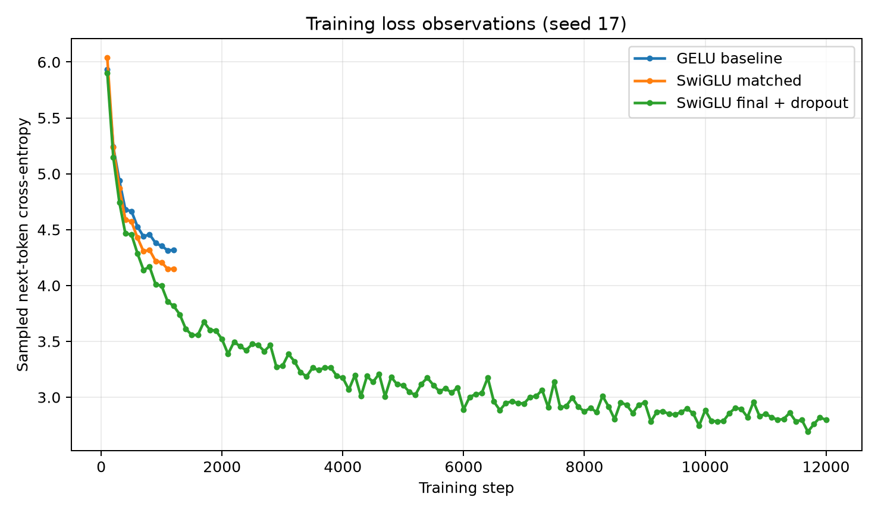
Figure 1. Logged training losses. The matched pair shares the same 1,200-step budget; the final dropout run continues to 12,000 updates.
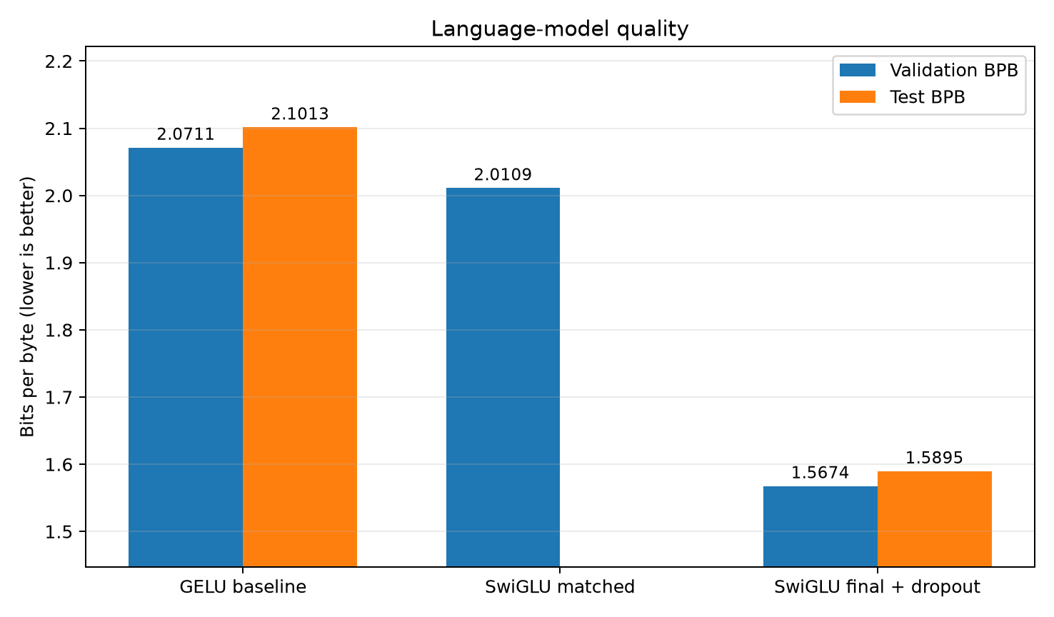
Figure 2. Validation and frozen test BPB. Lower is better; unselected models were not evaluated on test.
The matched experiment is the clearest evidence for the proposed mechanism. Both models see exactly 9,830,400 targets, and their parameter counts differ by only 0.015%. The 0.060232 validation-BPB reduction therefore cannot be explained by a larger training set or a meaningfully larger model. The matched model was not evaluated on test because it was a validation-only ablation, not the frozen submission candidate.
The final model improves validation by 0.503660 BPB (24.32%) and test by 0.511730 BPB (24.35%) relative to baseline. It uses 4.92x parameters, 10x processed targets and 2,207.84 s of GPU training. The final CPU FP32 test took 42.99 s, or 3.19x the locally reproduced baseline. Peak process-tree working set was 1.4972 GiB, and all required inference assets total 20.46 MiB. The model passes the 5x time, 4 GiB RAM and 64 MiB asset limits; the quality gain comes with a substantial training cost.

6. Analysis and trade-offs

6.1 What the controlled comparison establishes
At the same 9,830,400 targets, validation BPB decreases by 0.060232 (2.91% relative) when GELU is replaced by parameter-matched SwiGLU. In the logged training curves, the two runs are close early in training; the SwiGLU loss becomes consistently lower after roughly 300 updates and stays lower through step 1,200. Because the final validation score agrees with the direction of the training curves, I interpret this as evidence that gating used the same feed-forward parameter budget more effectively in this run.
What this comparison does not establish is equally important: it uses only one seed and one small model, and it does not compare SwiGLU with every other possible activation or training schedule. The result supports this design choice for the submitted setting rather than a universal claim that SwiGLU always improves language models.
The matched run took 724.22 s versus 769.99 s for baseline, but this single local timing should not be interpreted as an inherent SwiGLU speed advantage; background load and kernel variation were not controlled across repetitions.

6.2 Final score versus cost
The final model improves validation by 0.503660 BPB (24.32%) and test by 0.511730 BPB (24.35%) relative to baseline. It uses 4.92x parameters and 10x processed targets. CPU FP32 scoring took 42.99 s, or 3.19x baseline, below the 5x time limit. Peak process-tree working set was 1.4972 GiB. The checkpoint, student implementation and configuration total 20.46 MiB. These measurements remain below the 4 GiB RAM and 64 MiB asset limits.
Constraint | Limit | Measured | Status
CPU scoring | <= 5x baseline | 3.19x | Pass
Peak evaluation RAM | <= 4 GiB | 1.4972 GiB | Pass
Inference assets | <= 64 MiB | 20.46 MiB total | Pass

6.3 Limitations
The main limitation is that I ran one seed for each complete experiment, so I cannot estimate run-to-run variance. The matched evidence is also limited to one small scale and one corpus. For the final model, width and training duration change together, so their individual contributions are unknown. Given more time, I would repeat the matched pair with additional seeds and add separate width-only and training-duration-only controls. I also did not run the matched candidate on test, because development and selection were restricted to validation by design.

7. Reproducibility
From the code directory, install the pinned dependencies and run the contract tests before training:
python -m pip install torch==2.7.1 --index-url https://download.pytorch.org/whl/cpu
python -m pip install -r requirements.txt
python -m unittest discover -s tests -v
Controlled SwiGLU training:
python train.py --implementation student --config configs/swiglu_128.json --device cpu --precision fp32 --threads 4 --seed 17 --steps 1200 --batch-size 32 --run-dir runs/swiglu128-fair-s17
Final training and frozen evaluation:
python train.py --implementation student --config configs/swiglu_256x6_dropout.json --device cuda --precision fp32 --threads 4 --seed 17 --steps 12000 --batch-size 32 --eval-every 2000 --run-dir runs/swiglu256x6-dropout10-final12000-s17
python evaluate.py --checkpoint runs/swiglu256x6-dropout10-final12000-s17/checkpoint.pt --device cpu --precision fp32 --threads 4 --split test
SHA-256 is a file fingerprint, not an accuracy score. If even one byte of a checkpoint changes, its SHA-256 value changes. Recording the fingerprint lets the evaluator check that the downloaded file is exactly the checkpoint used for the reported result. The results table shortens each value for readability: 7d869d...6d3f identifies the baseline checkpoint, a555a3...3c94 identifies the matched validation-only checkpoint, 373b88...7dcc identifies the earlier frozen checkpoint, and 90163a...7802 identifies the current frozen checkpoint.
The complete current frozen-final checkpoint SHA-256 is 90163aed08c92f1affce1830907e63a62ef0b01ec32327c82a71088f8c747802. The current supporting student_model.py is included in the repository and checkpoint bundle.

8. Conclusion
The controlled experiment answers my main question: at nearly the same parameter count and exactly the same target budget, the SwiGLU version achieved lower validation BPB than the supplied GELU MLP. The wider, longer-trained and regularised version then reached 1.589531 CPU FP32 test BPB while remaining below the 5x scoring-time and 64 MiB asset limits. The experiments do not show that gating alone caused the entire final improvement, but they separate the evidence for the gate from the later decision to spend more model and training capacity.

References
[1] DASE7506. MP1 Small Language Model Challenge starter package and evaluation protocol, 2026.
[2] N. Shazeer. GLU Variants Improve Transformer. arXiv:2002.05202, 2020. https://arxiv.org/abs/2002.05202
[3] S. Merity, C. Xiong, J. Bradbury, and R. Socher. Pointer Sentinel Mixture Models. arXiv:1609.07843, 2016. https://arxiv.org/abs/1609.07843
[4] A. Vaswani et al. Attention Is All You Need. arXiv:1706.03762, 2017. https://arxiv.org/abs/1706.03762

