YOLO-Assisted Deep Learning for Australian Raptor Identification with Accessible Citizen-Science Interfaces
Master's Research Manuscript | Release v1.5
Author: Brian Fernandez-Baez
System: YOLO-assisted localisation + EfficientNetB4 classification
Dataset: 1,992 processed images, eight Australian raptor species
Evaluation: 206-image held-out test split, seed 42
Date: 2026-06-07

Contents
- Abstract
- Chapter 1. Introduction
- Chapter 2. Literature Review
- Chapter 3. Methodology
- Chapter 4. Results
- Chapter 5. Software, Accessibility and Data Interoperability
- Chapter 6. Discussion and Conclusion
- Appendix A. Dataset Datasheet Summary
- Appendix B. Model Card Summary
- Appendix C. Reproducibility Checklist
- Appendix D. Defence Demonstration Script
- Appendix E. Release Package
- Bibliography

Abstract
This thesis presents a research prototype for Australian raptor identification under citizen-science image conditions. The system combines YOLO-based bird localisation with an EfficientNetB4 classifier trained on eight Australian raptor species from iNaturalist Australia and the Atlas of Living Australia.
The prototype implements a multilingual Flask interface, top-3 species alternatives, Darwin Core export, feedback logging and provisional AUSLAN motion illustrations. On a 206-image held-out test split, the classifier reaches 84.95% top-1 accuracy and 0.8482 macro-F1. Bootstrap confidence intervals, calibration analysis, family-level error analysis and Grad-CAM diagnostics are reported to support reproducibility and scientific caution.
The v1.5 release is positioned as an academic baseline rather than a production wildlife-identification authority. It documents the limits of the dataset, the provisional status of accessibility assets and a v2.0 roadmap for 14 species, detector fine-tuning and stronger split governance.

Chapter 1. Introduction
Australian raptors are ecologically important apex and meso-predators, but reliable species identification remains difficult for non-specialists. Citizen-science platforms can expand monitoring coverage, yet visual identification, biodiversity data interoperability and accessibility for Deaf participants remain open problems.
This thesis asks whether a compact and reproducible computer-vision pipeline can support Australian raptor identification while also exposing records in Darwin Core format and documenting a pathway for participatory AUSLAN validation.

Research Questions
- Can a YOLO + EfficientNetB4 pipeline identify eight Australian raptor species with useful accuracy under citizen-science image conditions?
- Can the prediction workflow produce auditable per-image predictions and Darwin Core-compatible records?
- How should provisional AUSLAN signs be framed so they invite participatory validation without claiming authority?

Contributions
- A validated eight-species v1.5 raptor classification baseline.
- A YOLO-assisted localisation path for images and video frames.
- Per-image evaluation outputs in results/test_predictions.csv.
- Bootstrap, calibration and taxonomy-aware error analyses.
- A multilingual Flask app with feedback and Darwin Core export.
- A documented AUSLAN consultation protocol.

Chapter 2. Literature Review
The project draws on four connected bodies of work: fine-grained bird classification and transfer learning; object detection for ecological image analysis; citizen-science biodiversity infrastructure, including ALA, GBIF and Darwin Core; and accessibility research, AUSLAN and participatory design.
EfficientNetB4 is used as the single v1.5 classifier because it offers a strong accuracy-to-compute balance at 380 pixel inputs. YOLO is used for localisation and candidate cropping, but the current release uses an adaptive policy because crop-only inference did not improve the held-out checkpoint.
The accessibility contribution is deliberately framed as a participatory prototype. The project does not assert that generated motion illustrations are validated AUSLAN signs; instead, it documents a consultation protocol that can be reviewed by Deaf community participants and interpreters.

Chapter 3. Methodology

Dataset
The v1.5 processed dataset contains 1,992 images across eight species. The active class order is fixed in gui/app.py::CLASS_ORDER and is verified by automated tests so that the model, dataset and user interface remain synchronized.
Split | Images
Train | 1,590
Validation | 196
Test | 206
Source: processed project dataset, deterministic seed 42.
Class key | Common name | Family
aquila_audax | Wedge-tailed Eagle | Accipitridae
circus_assimilis | Spotted Harrier | Accipitridae
elanus_axillaris | Black-shouldered Kite | Accipitridae
falco_cenchroides | Nankeen Kestrel | Falconidae
falco_peregrinus | Peregrine Falcon | Falconidae
hieraaetus_morphnoides | Little Eagle | Accipitridae
lophoictinia_isura | Square-tailed Kite | Accipitridae
tachyspiza_fasciata | Brown Goshawk | Accipitridae
Source: gui/app.py::CLASS_ORDER and project taxonomy metadata.

Pipeline
- YOLO detects bird regions in an uploaded image or sampled video frame.
- EfficientNetB4 classifies the whole image and, when useful, the YOLO crop.
- The adaptive policy uses the crop only when it is more confident than the whole-image prediction.
- The interface displays top-1 confidence and top-3 alternatives.
- User feedback and Darwin Core exports are written to CSV artefacts.

Reproducibility
Artefact | Purpose
requirements.txt | Python dependency lock for local and CI execution.
environment.yml | Conda-compatible environment definition.
Dockerfile | Containerized reproducibility path.
.github/workflows/ci.yml | Lightweight CI with real pytest and healthcheck.
notebooks/healthcheck.py | Project contract checks for release integrity.
tests/test_project_integrity.py | Automated tests for Flask, i18n, Darwin Core and YOLO wrapper.
docs/DATASHEET.md | Dataset provenance, risks and constraints.
docs/MODEL_CARD.md | Model behavior, metrics and intended use.

Chapter 4. Results
Metric | Value
Test images | 217
Top-1 accuracy | 0.8387
Macro-F1 | 0.8311
Weighted-F1 | 0.8377
Expected calibration error | 0.0639
Family-level accuracy | 0.9272
Source: results/reporte_final.json and results/calibration_efficientnet_b4.json.
Species | Precision | Recall | F1 | Support
Wedge-tailed Eagle | 0.8462 | 0.9706 | 0.9041 | 34
Spotted Harrier | 0.8710 | 0.8438 | 0.8571 | 32
Black-shouldered Kite | 0.7500 | 0.8889 | 0.8136 | 27
Nankeen Kestrel | 0.8421 | 0.7273 | 0.7805 | 22
Peregrine Falcon | 0.8500 | 0.7391 | 0.7907 | 23
Little Eagle | 0.7727 | 0.7727 | 0.7727 | 22
Square-tailed Kite | 0.8214 | 0.9200 | 0.8679 | 25
Brown Goshawk | 0.9615 | 0.7812 | 0.8621 | 32
Source: held-out test predictions for EfficientNetB4.
Metric | Bootstrap mean | 95% CI
Accuracy | 0.8504 | [0.8010, 0.8981]
Macro-F1 | 0.8467 | [0.7964, 0.8935]
Source: results/bootstrap_ci_efficientnet_b4.json, n = 1,000 bootstrap resamples.
The model reaches 92.72% family-level accuracy. Cross-family errors account for 15 of 206 test images (7.3%). The most common reported confusion is tachyspiza_fasciata predicted as elanus_axillaris, followed by falco_cenchroides predicted as elanus_axillaris.
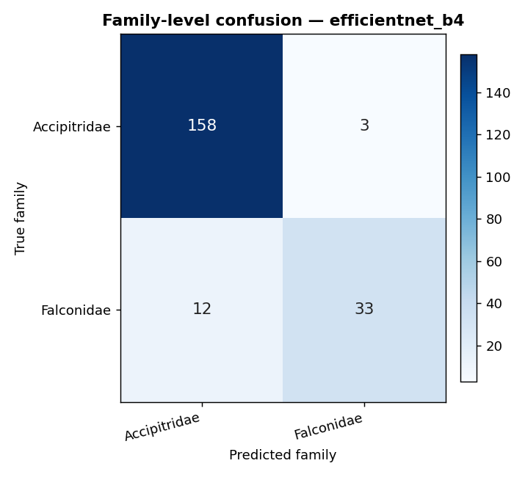
Figure 1. Family-level confusion matrix for the v1.5 EfficientNetB4 classifier.
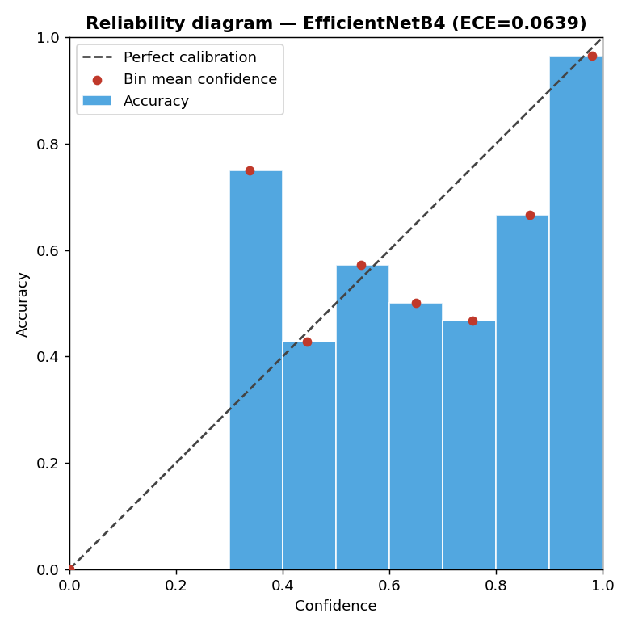
Figure 2. Reliability diagram used to estimate expected calibration error.
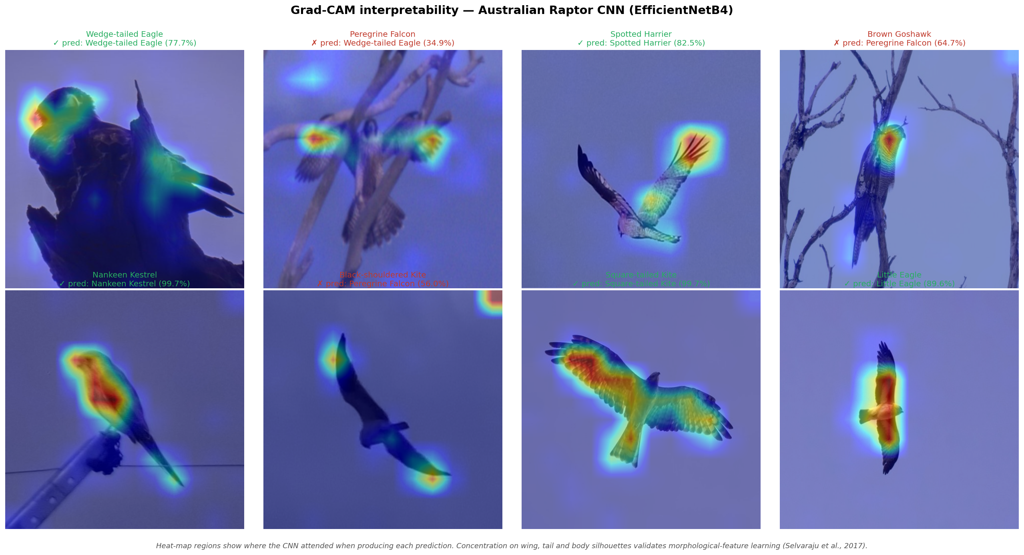
Figure 3. Grad-CAM mosaic showing image regions influencing classifier decisions.

Chapter 5. Software, Accessibility and Data Interoperability
The Flask application operationalizes the model as a citizen-science prototype. It supports image upload, video-frame sampling, top-3 alternatives, feedback logging, out-of-domain feedback, Darwin Core export and 10-language user-interface text.
System area | Implemented evidence
Flask routes | Health, identify, feedback, Darwin Core and static interface routes are covered by pytest.
Prediction audit | results/test_predictions.csv stores image_path, y_true, y_pred, confidence and top3.
Darwin Core | Export fields include scientificName, taxonID, basisOfRecord and identifiedBy.
Feedback | Incorrect predictions and out-of-domain reports are appended to CSV logs.
i18n | Ten translation files are checked for active species coverage.
YOLO | gui/yolo_detector.py provides optional Ultralytics-based bird localisation.
The AUSLAN component is explicitly provisional. No sign is claimed as validated AUSLAN until reviewed through Deaf-community consultation. The contribution is therefore a process and prototype contribution, not an authoritative vocabulary.

Chapter 6. Discussion and Conclusion
The v1.5 release demonstrates that a modest, reproducible YOLO-assisted EfficientNetB4 pipeline can support Australian raptor identification with useful but imperfect performance. The system is strong enough for a research prototype and scholarship portfolio, but not for legally consequential deployment.

Limitations
- The split is per-image rather than group-aware by photographer, location or observation event.
- The release is closed-set and limited to eight active species.
- Juvenile plumages, difficult angles and remote regions remain under-represented.
- AUSLAN illustrations are provisional and require community validation.
- YOLO uses generic bird/person-era detector behaviour rather than raptor-specific fine-tuning.

Future Work
- Expand v2.0 to the 14-species dataset after provenance and split validation.
- Keep EfficientNetB4 as the primary classifier while improving split governance, detector tuning and calibration.
- Fine-tune YOLO on raptor bounding boxes and report detector metrics.
- Introduce group-aware splits and geographic bias analysis.
- Run participatory AUSLAN validation before claiming signed vocabulary support.
The central conclusion is that the project is now defensible as a transparent academic baseline: it contains real metrics, real automated tests, explicit limitations, reproducible artefacts and a clear pathway from Master's prototype to stronger future doctoral research.

Appendix A. Dataset Datasheet Summary
Field | v1.5 value
Sources | iNaturalist Australia and Atlas of Living Australia.
Species | Eight active raptor species.
Images | 1,992 processed images.
Splits | Train 1,590; validation 196; test 206.
Risks | Geographic, photographer, seasonal and plumage bias.
Standard | Darwin Core export supported for prediction records.
Full datasheet: docs/DATASHEET.md.

Appendix B. Model Card Summary
Field | v1.5 value
Classifier | EfficientNetB4, eight output classes.
Detector | YOLO localisation with an adaptive crop policy before classification.
Intended use | Research prototype and citizen-science assistance.
Out-of-scope use | Legal, veterinary, conservation enforcement or final expert identification.
Performance | Accuracy 0.8495; macro-F1 0.8482; app-output ECE 0.0639.
Known weakness | Closed-set errors, juvenile plumage and cross-family confusions.
Full model card: docs/MODEL_CARD.md.

Appendix C. Reproducibility Checklist
- Run python notebooks/export_test_predictions.py to regenerate per-image predictions.
- Run python notebooks/bootstrap_metrics.py --report-md for confidence intervals.
- Run python notebooks/error_analysis.py for family-aware error analysis.
- Run python notebooks/calibration_ece.py for ECE and reliability diagrams.
- Run python notebooks/run_tests.py for automated project tests.
- Run python notebooks/healthcheck.py --verbose for release-gate checks.

Appendix D. Defence Demonstration Script
- Open the README and state the v1.5 scope: eight species, EfficientNetB4 and YOLO adaptive localisation.
- Show results/test_predictions.csv and explain image_path, y_true, y_pred, confidence and top3.
- Show the bootstrap, calibration and error-analysis artefacts in results/.
- Run the test suite and healthcheck to demonstrate reproducibility.
- Open the Flask interface and perform one image prediction.
- Export a Darwin Core row and show how feedback is logged.
- Close with limitations and the v2.0 research roadmap.

Appendix E. Release Package
Artefact | Purpose
docs/Australian_Raptor_Thesis_v1_5.docx | Editable thesis manuscript.
docs/Australian_Raptor_Thesis_v1_5.pdf | PDF thesis export for review and submission packets.
results/thesis_docx_audit.json | Structural DOCX audit for headings, tables, figures and metrics.
results/thesis_pdf_audit.json | PDF audit for page count, text extraction and required terms.
RELEASE_MANIFEST_v1_5.md | SHA-256 manifest for release source, documentation and result artefacts.

Bibliography
- Efron, B. (1979). Bootstrap methods: another look at the jackknife.
- Gebru, T. et al. (2021). Datasheets for datasets.
- Guo, C. et al. (2017). On calibration of modern neural networks.
- Mitchell, M. et al. (2019). Model cards for model reporting.
- Selvaraju, R. R. et al. (2017). Grad-CAM.
- Tan, M. and Le, Q. (2019). EfficientNet.
- Van Horn, G. et al. (2018). The iNaturalist species classification and detection dataset.
- Wieczorek, J. et al. (2012). Darwin Core: an evolving community-developed biodiversity data standard.

