互对比标定使用说明

殷振平

武汉大学遥感信息工程学院

# 整体介绍

根据激光雷达对比标定软件的整体功能（如图 1所示），可以将程序的运行逻辑分为“数据转换→自对比/互对比→输出结果”三个部分。三个部分的流程均通过配置文件（config file）控制，其中配置文件为[YAML](https://yaml.org/)标记语言格式。

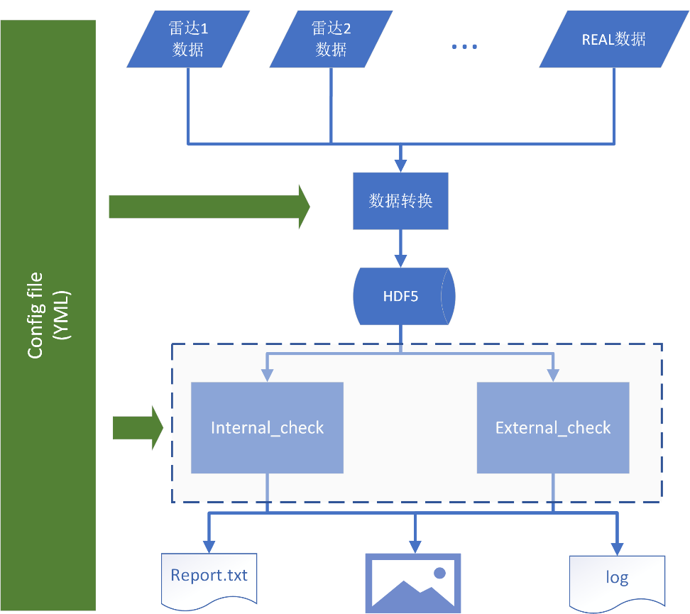

图 1 激光雷达对比标定软件整体架构图

# 数据准备

因为Matlab对中文路径识别存在问题，因此需要讲所有的数据放在英文路径下。

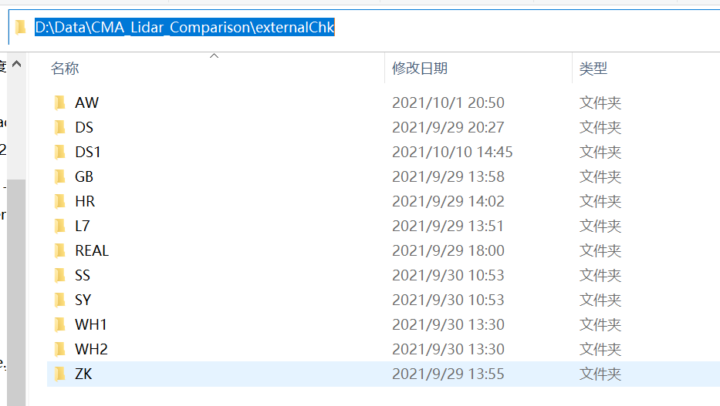

图 2 2021年9月南郊对比实验互对比数据存储样例。图中每个文件夹代表一个厂家的雷达系统互对比数据

# 数据读取配置

在进行互对比时，我们需要将进行对比的数据从原始格式转换成统一的[HDF5](https://www.hdfgroup.org/solutions/hdf5/)格式，因此在配置读取数据时需要配置多个雷达的读取设置，如下为读取2021年09月北京南郊对比标定雷达的设置（配置文件路径为configBkp/Beijing/external_check_config.yml）：

################################################################################

# data loader configuration

# Load lidar data to a specified directory (defined by `dataSavePath`)

################################################################################

dataLoaderCfg:

  lidarList: ['AW', 'SY', 'L7', 'DS', 'DS1', 'SS', 'GB', 'ZK', 'WH1', 'WH2', 'REAL', 'HR']

  AW:   # Ai wo si

    dataPath: D:\Data\CMA_Lidar_Comparison\externalChk\AW

    dataFilenamePattern: .*Lidar.*   # all files

    dataFormat: 3

    chTag: ['532p', '532s']

    nMaxBin: 1800   # number of bins

    flagFilenameTime: true

  SY:   # Shan yi suo

    dataPath: D:\Data\CMA_Lidar_Comparison\externalChk\SY

    dataFilenamePattern: .*Lidar.*   # all files

    dataFormat: 3

    chTag: ['532p', '532s', '355e', '607', '1064e']

    nMaxBin: 1600   # number of bins

    flagFilenameTime: true

  L7:   # 704

    dataPath: D:\Data\CMA_Lidar_Comparison\externalChk\L7

    dataFilenamePattern: .*Lidar.*   # all files

    dataFormat: 3

    chTag: ['355p', '355s', '532p', '532s', '387', '407', '607', '1064e']

    nMaxBin: 1800   # number of bins

    flagFilenameTime: true

  DS:   # Dasun

    dataPath: D:\Data\CMA_Lidar_Comparison\externalChk\DS

    dataFilenamePattern: .*Lidar.*

    dataFormat: 3

    chTag: ['1064p', '1064s']

    nMaxBin: 1250

  DS1:   # Dasun1

    dataPath: D:\Data\CMA_Lidar_Comparison\externalChk\DS1

    dataFilenamePattern: .*Lidar.*

    dataFormat: 3

    chTag: ['1064e']

    nMaxBin: 1250

    flagFilenameTime: true

  SS:   # Qianhai

    dataPath: D:\Data\CMA_Lidar_Comparison\externalChk\SS

    dataFilenamePattern: .*Lidar.*

    dataFormat: 3

    chTag: ['532p', '532s']

    nMaxBin: 1000

    nBin: 8000

  GB:   # Zhongke Guang bo

    dataPath: D:\Data\CMA_Lidar_Comparison\externalChk\GB

    dataFilenamePattern: .*Lidar.*

    chTag: ['532p', '532s']

    dataFormat: 3

    nMaxBin: 2000

  ZK:   # Wu xi zhong ke

    dataPath: D:\Data\CMA_Lidar_Comparison\externalChk\ZK

    dataFilenamePattern: .*Lidar.*

    dataFormat: 3

    chTag: ['532p', '532s']

    nMaxBin: 2000

  WH1:

    dataPath: D:\Data\CMA_Lidar_Comparison\externalChk\WH1

    dataFilenamePattern: .*   # all files

    dataFormat: 1

    chTag: ['1064e']

    nMaxBin: 2048   # number of bins

  WH2:

    dataPath: D:\Data\CMA_Lidar_Comparison\externalChk\WH2

    dataFilenamePattern: .*   # all files

    dataFormat: 2

    chTag: ['1064e']

    nMaxBin: 1300   # number of bins

  REAL:

    dataPath: D:\Data\CMA_Lidar_Comparison\externalChk\REAL

    dataFilenamePattern: .*   # all files

    dataFormat: 5

    chTag: ['532sh', '532ph', '532sl', '532pl', '607l', '607h']

    nMaxBin: 2300   # number of bgBins

  HR:

    dataPath: D:\Data\CMA_Lidar_Comparison\externalChk\HR

    dataFilenamePattern: .*

    dataFormat: 3

    chTag: ['532p', '532s']

    nMaxBin: 1900

设置完配置文件后，可以在Matlab命令行中运行读取数据的命令将雷达数据转换成[HDF5](https://www.hdfgroup.org/solutions/hdf5/)格式。首先打开Matlab，然后将当前目录导航到代码目录中，如图 3所示

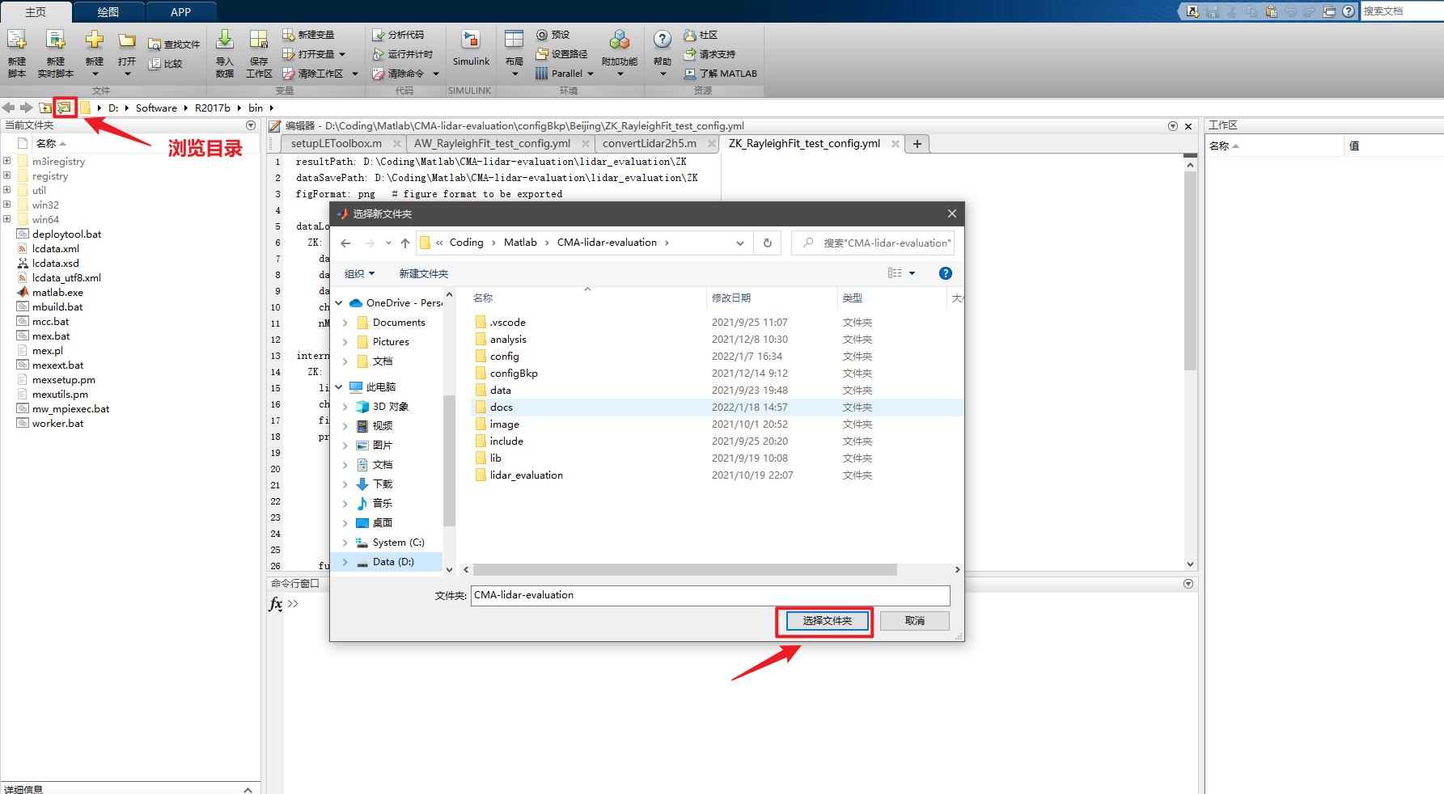

图 3 Matlab中修改当前工作目录到对比软件代码目录中

然后在命令行中输入”setupLEToolbox”装载对比软件（或者点击setupLEToolbox.m文件打开，并单击运行），这里需要注意Matlab命令行大小写敏感，因此需要注意大小写一致。

装载完对比软件后，可以在命令行中看到一些输出结果。接下来可以运行如下指令转换多台雷达数据

LEMain('D:\Coding\Matlab\CMA-lidar-evaluation\configBkp\Beijing\external_check_test.yml', 'flagReadData', true)

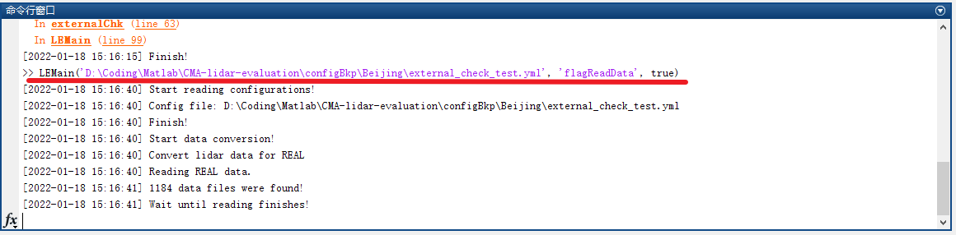

图 4 转换雷达数据

等待运行完成后，多台激光雷达数据会以.h5格式的文件保存在dataSavePath中。

# 互对比距离修正信号

在读取完数据后，接下来可以通过设置互对比配置来完成互对比相关内容，这里以距离修正信号为例。

针对每台雷达需要先设置好雷达的预处理参数修正雷达的系统效应，预处理参数设置如下所示（配置文件路径为configBkp/Beijing/external_check_config.yml，参考文件最后的内容）

################################################################################

#

#                             external-check

#

#  Below is the struct of `externalChkCfg`, which was used to inter-compare lidars.

#

################################################################################

externalChkCfg:

  WH1:

    lidarNo: 12   # lidar number. (see ./docs/lidarList.md)

    chTag: ['1064e']

    fullOverlapHeight: 400   # minimum height with complete overlap. (m)

    overlapFile: ''

    hOffset: 0   # height offset. (m)

    tOffset: 0   # time offset. (min)

    deadTime: []   # deadtime (ns). If it's empty, deadtime correction is disabled.

    bgBins: [1500, 2000]   # [start index, stop index] for background correction

    nPretrigger: 15   # if nPretrigger < 0, move signal up

    bgCorFile: ''   # data file of dark measurement results

  WH2:

    lidarNo: 13   # lidar number. (see ./docs/lidarList.md)

    chTag: ['1064e']

    fullOverlapHeight: 200   # minimum height with complete overlap. (m)

    overlapFile: ''

    hOffset: 0   # height offset. (m)

    tOffset: 0   # time offset. (min)

    deadTime: []   # deadtime (ns). If it's empty, deadtime correction is disabled.

    bgBins: [1100, 1250]   # [start index, stop index] for background correction

    nPretrigger: 0   # if nPretrigger < 0, move signal up

    bgCorFile: ''   # data file of dark measurement results

  REAL:

    lidarNo: 11   # lidar number. (see ./docs/lidarList.md)

    chTag: ['532sh', '532ph', '532sl', '532pl', '607l', '607h']

    fullOverlapHeight: 400   # minimum height with complete overlap. (m)

    hOffset: 0   # height offset. (m)

    tOffset: 0   # time offset. (min)

    deadTime: [3.5, 3.5, 3.5, 3.5, 3.5, 30.4]   # deadtime (ns). If it's empty, deadtime correction is disabled.

    bgBins: [1700, 2000]   # [start index, stop index] for background correction

    nPretrigger: 55   # if nPretrigger < 0, move signal up

    bgCorFile: ''   # data file of dark measurement results

    overlapFile: ''

  DS:

    lidarNo: 9   # lidar number. (see ./docs/lidarList.md)

    chTag: ['1064p', '1064s']

    fullOverlapHeight: 400   # minimum height with complete overlap. (m)

    hOffset: 0   # height offset. (m)

    tOffset: 0   # time offset. (min)

    deadTime: []   # deadtime (ns). If it's empty, deadtime correction is disabled.

    bgBins: [1100, 1200]   # [start index, stop index] for background correction

    nPretrigger: 0   # if nPretrigger < 0, move signal up

    bgCorFile: ''   # data file of dark measurement results

    overlapFile: ''

  DS1:

    lidarNo: 6   # lidar number. (see ./docs/lidarList.md)

    chTag: ['1064e']

    fullOverlapHeight: 400   # minimum height with complete overlap. (m)

    hOffset: 0   # height offset. (m)

    tOffset: 0   # time offset. (min)

    deadTime: []   # deadtime (ns). If it's empty, deadtime correction is disabled.

    bgBins: [1150, 1250]   # [start index, stop index] for background correction

    nPretrigger: 0   # if nPretrigger < 0, move signal up

    bgCorFile: ''   # data file of dark measurement results

    overlapFile: ''

  AW:

    lidarNo: 7   # lidar number. (see ./docs/lidarList.md)

    chTag: ['532p', '532s']

    fullOverlapHeight: 400   # minimum height with complete overlap. (m)

    hOffset: 0   # height offset. (m)

    tOffset: 0   # time offset. (min)

    deadTime: []   # deadtime (ns). If it's empty, deadtime correction is disabled.

    bgBins: [1600, 1700]   # [start index, stop index] for background correction

    nPretrigger: 0   # if nPretrigger < 0, move signal up

    bgCorFile: ''   # data file of dark measurement results

    overlapFile: ''

  ZK:

    lidarNo: 2   # lidar number. (see ./docs/lidarList.md)

    chTag: ['532p', '532s']

    fullOverlapHeight: 400   # minimum height with complete overlap. (m)

    hOffset: 0   # height offset. (m)

    tOffset: 0   # time offset. (min)

    deadTime: []   # deadtime (ns). If it's empty, deadtime correction is disabled.

    bgBins: [1800, 1900]   # [start index, stop index] for background correction

    nPretrigger: 0   # if nPretrigger < 0, move signal up

    bgCorFile: ''   # data file of dark measurement results

    overlapFile: ''

  GB:

    lidarNo: 8   # lidar number. (see ./docs/lidarList.md)

    chTag: ['532p', '532s']

    fullOverlapHeight: 400   # minimum height with complete overlap. (m)

    hOffset: 0   # height offset. (m)

    tOffset: 0   # time offset. (min)

    deadTime: []   # deadtime (ns). If it's empty, deadtime correction is disabled.

    bgBins: [1200, 1300]   # [start index, stop index] for background correction

    nPretrigger: 0   # if nPretrigger < 0, move signal up

    bgCorFile: ''   # data file of dark measurement results

    overlapFile: ''

  SY:

    lidarNo: 14   # lidar number. (see ./docs/lidarList.md)

    chTag: ['532p', '532s', '355e', '607', '1064e']

    fullOverlapHeight: 400   # minimum height with complete overlap. (m)

    hOffset: 0   # height offset. (m)

    tOffset: 0   # time offset. (min)

    deadTime: []   # deadtime (ns). If it's empty, deadtime correction is disabled.

    bgBins: [1400, 1500]   # [start index, stop index] for background correction

    nPretrigger: 0   # if nPretrigger < 0, move signal up

    bgCorFile: ''   # data file of dark measurement results

    overlapFile: ''

  SS:

    lidarNo: 7   # lidar number. (see ./docs/lidarList.md)

    chTag: ['532p', '532s']

    fullOverlapHeight: 400   # minimum height with complete overlap. (m)

    hOffset: 0   # height offset. (m)

    tOffset: 0   # time offset. (min)

    deadTime: []   # deadtime (ns). If it's empty, deadtime correction is disabled.

    bgBins: [900, 950]   # [start index, stop index] for background correction

    nPretrigger: 0   # if nPretrigger < 0, move signal up

    bgCorFile: ''   # data file of dark measurement results

    overlapFile: ''

  L7:

    lidarNo: 9   # lidar number. (see ./docs/lidarList.md)

    chTag: ['355p', '355s', '532p', '532s', '387', '407', '607', '1064e']

    fullOverlapHeight: 400   # minimum height with complete overlap. (m)

    hOffset: 0   # height offset. (m)

    tOffset: 0   # time offset. (min)

    deadTime: []   # deadtime (ns). If it's empty, deadtime correction is disabled.

    bgBins: [1500, 1600]   # [start index, stop index] for background correction

    nPretrigger: 0   # if nPretrigger < 0, move signal up

    bgCorFile: ''   # data file of dark measurement results

overlapFile: ''

每个配置参数的说明可以参考<配置文件说明.pdf>。

接下来可以配置互对比中的距离修正信号对比的相关配置，这些配置主要包括使用哪些雷达，如何从不同通道数据中组合弹性信号，并且控制输出图形的横纵坐标范围

  figVisible: 'on'   # whether display figures

  flagRangeCmp: false

  flagRCSCmp: true

  flagVDRCmp: false

  flagFernaldCmp: false

  flagRamanCmp: false

  RCSCmpCfg:   # 532 p

    LidarList: ['REAL', 'SY', 'L7', 'SS', 'ZK', 'GB', 'AW']

    sigCompose:

      - [0, 1, 0, 0, 0, 0]   # first lidar

      - [1, 0, 0, 0, 0]   # second lidar

      - [0, 0, 1, 0, 0, 0, 0, 0]   # second lidar

      - [0, 1]   # second lidar

      - [1, 0]   # second lidar

      - [1, 0]   # second lidar

      - [1, 0]   # second lidar

    tRange: '2021-09-27 19:00:00 ~ 2021-09-27 19:30:00'

    normRange: [3500, 4500]

    hChkRange:

      - [500, 2000]

      - [2000, 5000]

    maxDev:

      - 10

      - 20

    smoothwindow:

      - [0, 1000, 100]   # Piecewise smoothing: [bottom height, top height, window length]

      - [1000, 10000, 300]

      - [10000, 20000, 600]

    hRange: [0, 14000]

    sigRange: [1e10, 1e15]

其中flagRangeCmp代表距离测量精度对比，flagRCSCmp代表距离修正信号对比，flagVDRCmp代表体退偏结果对比，flagFernaldCmp代表Fernald反演结果对比，flagRamanCmp代表Raman反演结果对比。距离修正信号对比的配置参数在RCSCmpCfg对应的列表下，其中LidarList代表需要进行互对比的雷达列表。sigCompose表示每台雷达如何组合成对应的距离修正信号，这里每条对应通道信号组合时的系数，比如[0, 1]表示第一个通道信号的系数为0，第二个通道信号的系数为1。tRange表示选取的信号时间段。normRange表示信号归一化的高度范围，单位为米。hChkRange表示信号偏移评估的高度范围，以上示例中的高度范围为激光雷达标定标准建议的范围。maxDev表示每个评估高度范围内允许的最大偏差。Smoothwindow为分段平滑窗，每条信息为一个滑动平滑窗，第一个数值为滑动平滑窗的起始高度。第二个为滑动平滑窗的终止高度，最后一个为滑动平滑窗的窗长。hRange为显示结果的高度范围。sigRange为信号的显示范围。