# 代码规范

## 接口例子

@Controller  
**@Api(description = "修改历史数据处理控制器") 《--必须声明类注释**  
@RequestMapping(value = **"/dataHandling"**, produces = MediaType.***APPLICATION_JSON_UTF8_VALUE***)  
**public class** DataHandlingController **extends** BaseController {  
  
 @RequestMapping(value = **"/testSwagger"**, method = RequestMethod.***GET***)  
 @ResponseBody  
 **@ApiOperation("测试swagger")<---必须声明方法注释 说明改接口是做什么用的** **public** SimpleResult<TestSwagger> testSwagger(  
  **@ApiParam(name = "username", value = "账号", required = true) <---必须声明参数注释 说明改参数做什么用的（时间格式必须注释 时间格式）**  
 @RequestParam(value = **"username"**) String username) {  
  
  
 **return new** SimpleResult<>(**new** TestSwagger());  
 }  
}

## 实体例子

@ApiModel(description = **"获取单个实体信息返回"**)  
**public class** SimpleResult<T> **extends** BaseResponse {  
  
 @ApiModelProperty(**"内容"**)  
 **private** T **data**;  
  
 **public** T getData() {  
 **return data**;  
 }  
  
 **public** SimpleResult(T data) {  
 **this**.**data** = data;  
 }  
  
 **public void** setData(T data) {  
 **this**.**data** = data;  
 }  
}

@ApiModel( description = **"测试swagger生成"**)  
**public class** TestSwagger {  
  
 @ApiModelProperty(**"姓名"**)  
 **private** String **name**;  
  
 @ApiModelProperty(**"年龄"**)  
 **private** Integer **age**;  
  
 **public** String getName() {  
 **return name**;  
 }  
  
 **public void** setName(String name) {  
 **this**.**name** = name;  
 }  
  
 **public** Integer getAge() {  
 **return age**;  
 }  
  
 **public void** setAge(Integer age) {  
 **this**.**age** = age;  
 }  
}

# 生成swagger文档

## 1.maven添加相关依赖

### Maven包

<**dependency**>  
 <**groupId**>io.springfox</**groupId**>  
 <**artifactId**>springfox-swagger2</**artifactId**>  
 <**version**>2.7.0</**version**>  
</**dependency**>  
*<!--activemq start-->*<**dependency**>  
 <**groupId**>io.springfox</**groupId**>  
 <**artifactId**>springfox-swagger-ui</**artifactId**>  
 <**version**>2.7.0</**version**>  
</**dependency**>  
  
<**dependency**>  
 <**groupId**>io.springfox</**groupId**>  
 <**artifactId**>springfox-staticdocs</**artifactId**>  
 <**version**>2.6.1</**version**>  
</**dependency**>  
<**dependency**>  
 <**groupId**>io.github.swagger2markup</**groupId**>  
 <**artifactId**>swagger2markup</**artifactId**>  
 <**version**>1.3.2</**version**>  
</**dependency**>  
<**dependency**>  
 <**groupId**>org.apache.commons</**groupId**>  
 <**artifactId**>commons-lang3</**artifactId**>  
 <**version**>3.3.2</**version**>  
</**dependency**>

### Maven插件

<**plugin**>  
 <**groupId**>org.asciidoctor</**groupId**>  
 <**artifactId**>asciidoctor-maven-plugin</**artifactId**>  
 <**version**>${asciidoctor.maven.plugin.version}</**version**>  
 <**configuration**>  
 <**sourceDirectory**>build</**sourceDirectory**>  
 <**outputDirectory**>build/asciidoc/${project.version}</**outputDirectory**>  
 <**headerFooter**>true</**headerFooter**>  
 <**doctype**>book</**doctype**>  
 <**sourceHighlighter**>coderay</**sourceHighlighter**>  
 <**attributes**>  
 <**toc**>left</**toc**>  
 <**toclevels**>3</**toclevels**>  
 <**sectnums**>true</**sectnums**>  
 <**revnumber**>${project.version}</**revnumber**>  
 <**revdate**>${maven.build.timestamp}</**revdate**>  
 <**organization**>厦门健康之路</**organization**>  
 <**sourcedir**>${project.build.sourceDirectory}</**sourcedir**>  
 </**attributes**>  
 </**configuration**>  
 <**executions**>  
 <**execution**>  
 <**id**>output-html</**id**>  
 <**phase**>generate-resources</**phase**>  
 <**goals**>  
 <**goal**>process-asciidoc</**goal**>  
 </**goals**>  
 <**configuration**>  
 <**backend**>html5</**backend**>  
 </**configuration**>  
 </**execution**>  
 <**execution**>  
 <**id**>output-docbook</**id**>  
 <**phase**>generate-resources</**phase**>  
 <**goals**>  
 <**goal**>process-asciidoc</**goal**>  
 </**goals**>  
 <**configuration**>  
 <**backend**>docbook</**backend**>  
 </**configuration**>  
 </**execution**>  
 </**executions**>  
</**plugin**>

## 2.Swagger代码 添加main函数

*/**  
 * 生成html文章专用  
 *  
 private static final String Doctor_API = "doctor";  
 private static final String Patient_API = "patient";  
 private static final String Other_API = "other";  
 private static final String GateWay_API = "gateway";  
 \** ***@param args*** *\** ***@throws*** *Exception  
 */***public static void** main(String[] args) **throws** Exception {  
 String groupName=**"doctor"**;  
 *//String groupName="patient";  
 //String groupName="other";  
 // String groupName="gateway";* **URL remoteSwaggerFile = new URL("http://127.0.0.1:8080//v2/api-docs?group="+groupName);//项目的swagger-ui地址**  
 Path outputFile = Paths.*get*(**"patient-co/patient-co-wlyy/build/"**+groupName); //文档输出地址  
  
 Swagger2MarkupConfig config = **new** Swagger2MarkupConfigBuilder()  
 .withMarkupLanguage(MarkupLanguage.***ASCIIDOC***)  
 .withOutputLanguage(Language.***ZH***)  
 .withPathsGroupedBy(GroupBy.***TAGS***)  
 .withGeneratedExamples()  
 .withoutInlineSchema()  
 .withBasePathPrefix()  
 .build();  
  
 Swagger2MarkupConverter converter = Swagger2MarkupConverter.*from*(remoteSwaggerFile)  
 .withConfig(config)  
 .build();  
  
 converter.toFile(outputFile);  
}

## 启动项目

确定swagger可以访问

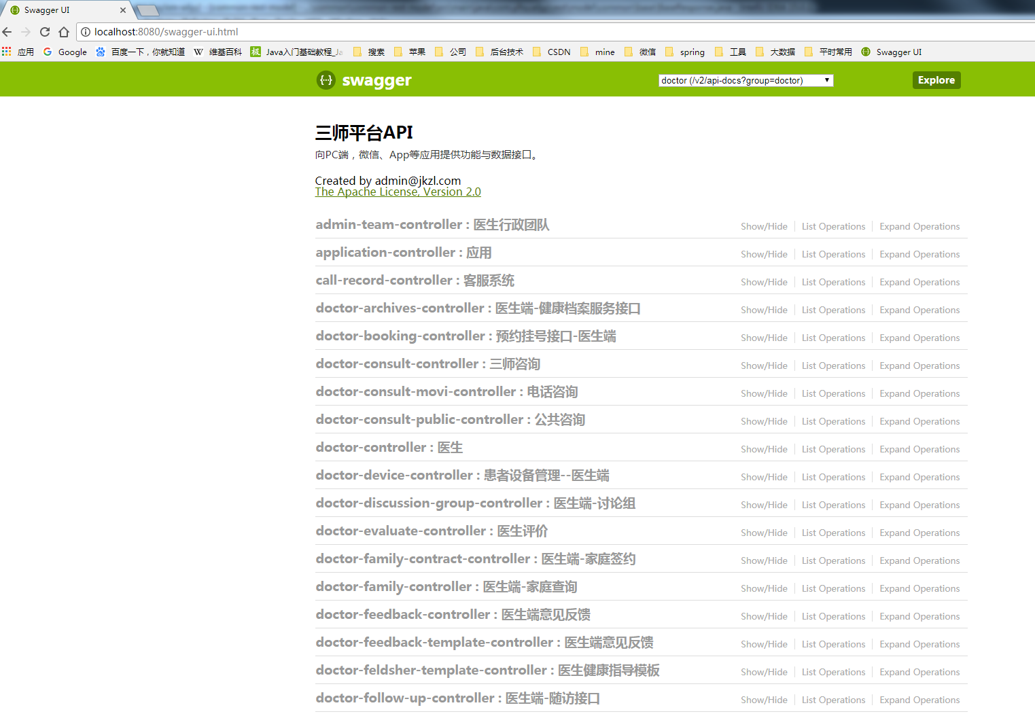

## 生成adoc文件

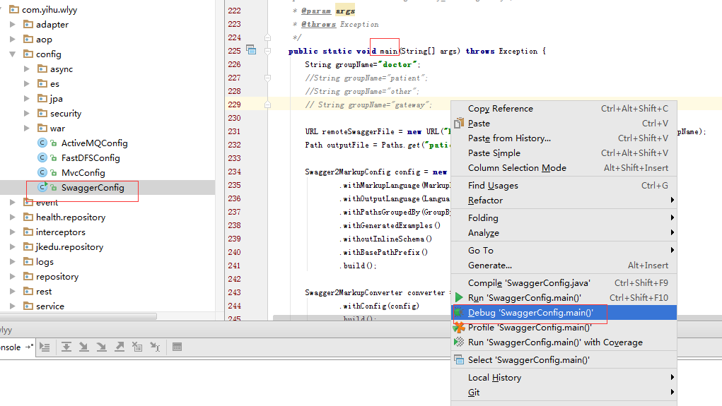

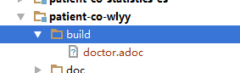

## 生成html

