


本科毕业设计说明书（论文）
Undergraduate International Students’ Graduation Project Report (Thesis)

基于机器学习的AI文本检测分析系统的设计与开发
DESIGN AND DEVELOPMENT OF AI TEXT DETECTION AND ANALYSIS SYSTEM BASED ON MACHINE LEARNING

学 院： 计算机科学与技术学院、软件学院
专 业： 软件工程（中外合作办学）
班 级： 2022软件工程（中外合作办学）02
学 号： 202203340212
学生姓名： 刘靖杰
指导老师： 陈久军
提交日期： 2026年6月

摘 要
随着 ChatGPT、GPT-4 等大语言模型的快速发展，人工智能已经能够生成大量自然、流畅且具有较强逻辑性的文本内容。在提高内容生产效率的同时，AI生成文本也逐渐被用于论文写作、作业生成、新闻撰写以及网络内容生产等场景，这给学术诚信、内容审核以及信息真实性带来了新的挑战。由于当前生成模型的文本质量越来越高，仅依靠人工已经很难准确区分人类文本与AI生成文本，因此，研究一种可靠的AI文本检测方法具有重要意义。
本文围绕AI文本检测任务，设计并实现了一套基于机器学习的AI文本检测分析系统。针对传统检测方法在未知数据集和未知生成模型下泛化能力不足的问题，本文结合对比学习与向量检索思想，提出了一种基于监督式对比学习的AI文本检测框架。系统采用 SimCSE-RoBERTa 作为文本编码器，将文本映射到语义向量空间中，并通过监督式对比学习优化不同类别文本之间的距离关系，使AI生成文本与人类文本在嵌入空间中能够形成更加明显的区分。本文分别实现了两种检测策略：一种是传统的神经网络二分类器，另一种是基于 FAISS 的 K近邻（KNN）向量检索方法。其中，KNN检索方法通过比较输入文本与向量库中已有文本的相似度，利用邻居投票完成检测，相比普通分类器能够更好地适应不同数据分布下的文本变化。本文在 MAGE 数据集上完成模型训练，并在 HC3、CHEAT 以及多个 Kaggle 数据集上进行了跨领域测试。同时，本文还对不同嵌入模型、不同K值以及不同检测策略进行了实验分析。实验结果表明，基于向量检索的检测方法在跨领域场景下表现更加稳定，在准确率、F1-score 以及泛化能力方面均优于传统分类方法，尤其是在面对未知文本风格和未知语言模型时具有更好的鲁棒性。
本文进一步开发了一套完整的AI文本检测分析系统。系统后端采用 FastAPI 搭建模型推理服务，前端使用 Streamlit 实现交互界面，支持文本输入、检测结果可视化、数据集评测以及后台任务管理等功能。用户可以直接输入待检测文本，查看不同粒度下的检测结果和AI概率分析，同时还能够对数据集进行批量评测和模型性能分析。

关键词： AI文本检测，文本嵌入，Transformer，机器学习，对比学习

ABSTRACT
With the rapid development of large language models such as ChatGPT and GPT-4, artificial intelligence is now capable of generating natural and fluent text that is increasingly difficult to distinguish from human writing. While these technologies improve content generation efficiency, they also introduce challenges related to academic integrity, content authenticity, and online information reliability. Therefore, developing effective AI text detection methods has become an important research topic in natural language processing.
This thesis designs and implements an AI text detection and analysis system based on machine learning techniques. To address the limited generalization ability of traditional detectors under unseen datasets and unseen language models, this work combines contrastive learning with vector retrieval techniques and proposes an AI text detection framework based on supervised contrastive learning. The system adopts SimCSE-RoBERTa as the text encoder to map texts into semantic embedding space, where supervised contrastive learning is used to improve the separability between AI-generated and human-written texts.Two detection strategies are implemented in this work: a neural network binary classifier and a FAISS-based K-Nearest Neighbor (KNN) retrieval method. The model is trained on the MAGE dataset and evaluated on multiple external datasets including HC3, CHEAT, and Kaggle datasets. Experimental results show that the retrieval-based method achieves better robustness and cross-domain generalization performance than traditional classification methods, especially under unseen text distributions and unseen language models.
Based on the proposed framework, a complete AI text detection and analysis system is further developed. The backend service is implemented using FastAPI, while the frontend interface is built with Streamlit. The system supports text detection, result visualization, dataset evaluation, and model performance analysis, providing a practical platform for AI-generated text detection tasks.
Keywords: AI Text Detection; Contrastive Learning; Transformer; Text Embedding; Machine Learning

CONTENT
摘 要 I
ABSTRACT II
CHAPTER 1: INTRODUCTION 1
1.1 Background 1
1.2 The Purpose and Significance of Project 2
1.3 About system 3
1.4 The Organization of This Article 3
1.5 Chapter Summary 4
CHAPTER 2: RELATED WORK 5
2.1 Research Status of AI Text Detection 5
2.1.1 Statistical Feature-Based Methods 5
2.1.2 Fine-tuned Transformer Classifiers 5
2.1.3 Contrastive Learning-Based Detection Methods 6
2.1.4 Adversarial Training and Robust Detection 7
2.2 Related Techniques on Project 8
2.3 Chapter Summary 13
CHAPTER 3: DESIGN OF AI TEXT DETECTION METHOD 15
3.1 Overall Framework of the Proposed Method 15
3.2 SimCSE-based Text Embedding Model 16
3.2.1 SimCSE Framework 16
3.2.2 RoBERTa Encoder 17
3.2.3 Sentence Embedding Generation 17
3.2.4 Embedding Normalization 18
3.3 Supervised Contrastive Learning Framework 18
3.3.1 Sentence Embedding Representation 18
3.3.2 Similarity Matrix Construction and Temperature Scaling 19
3.3.3 Positive/Negative Construction and Loss 19
3.4 Detection Methods at Inference Time 20
3.4.1 Neural Binary Classifier 21
3.4.2 k-Nearest-Neighbour Retrieval in Embedding Space 21
3.5 Experiments and Analysis 22
3.5.1 Dataset 22
3.5.2 Evaluation Criteria 23
3.5.3 Experiments of Structural Parameters 25
3.5.4 Comparison of Different Detection Strategies 27
3.5.5 Cross-domain Generalization Analysis 28
3.6 Chapter Summary 30
CHAPTER 4: SYSTEM DESIGN AND DEVELOPMENT 32
4.1 Requirement Analysis 32
4.1.1 Functional requirements 32
4.1.2 Non-functional requirements 32
4.2 System Context 33
4.2.1 Users 33
4.2.2 System Feature 34
4.3 System Interface 36
4.3.1 Interface Generalization 36
4.3.2 Main Interface 36
4.3.3 Function Module Interface 37
4.4 Chapter Summary 41
CHAPTER 5: CONCLUSION AND FEATURE WORK 43
5.1 Conclusion 43
5.2 Feature Work 44
Reference 46
Acknowledgment 48

CHAPTER 1: INTRODUCTION

1.1 Background
In recent years, the rapid advancement of large language models (LLMs), such as the GPT series and other foundation models, has significantly transformed the field of natural language processing. These models are capable of generating fluent, coherent, and contextually rich text, greatly lowering the barrier for content creation across domains including education, journalism, scientific research, and software development [1][2]. While such capabilities improve productivity and provide intelligent assistance, they also introduce serious challenges related to academic integrity, misinformation dissemination, and authorship attribution [1][2].
The widespread availability of AI-generated text has made it increasingly difficult to distinguish between human-written and machine-generated content. This issue is particularly critical in academic environments, where misuse of AI tools may undermine originality and fairness, as well as in online platforms where synthetic content can contribute to the spread of misleading or low-quality information. Consequently, AI text detection has emerged as an important research problem, aiming to accurately identify whether a given piece of text is generated by humans or machines under realistic and often adversarial conditions [1][3].
Early approaches to AI text detection primarily relied on statistical features and language model-based metrics, such as perplexity and burstiness [1][4][5][6]. These methods attempt to capture differences in predictability and structural variability between human-written and machine-generated text. Although they are computationally efficient and easy to implement, they suffer from limited generalization ability [3]. With the rapid evolution of LLMs, modern generated text increasingly resembles human writing, rendering such surface-level features less effective. Moreover, these methods are highly sensitive to domain shifts and can be easily bypassed through paraphrasing or minor human editing [3][7].
To address these limitations, recent research has shifted toward machine learning-based detection methods, particularly those built on pre-trained Transformer architectures such as BERT, RoBERTa, and DistilBERT [8][9][10][11][12]. These models leverage deep contextual embeddings to capture subtle semantic and stylistic differences between human and AI-generated text, achieving strong performance on benchmark datasets [8][10]. However, these approaches often exhibit overfitting to specific generators or datasets, leading to significant performance degradation when applied to unseen models or new domains [13][14].
More recently, advanced techniques such as contrastive representation learning and adversarial training have been proposed to improve generalization and robustness [7][15][16][17]. Contrastive learning-based methods, exemplified by frameworks like DeTeCtive, aim to learn generator-invariant representations by distinguishing writing styles across different “authors” in an embedding space [15]. These approaches have demonstrated strong zero-shot performance on unseen LLMs [15][16]. Meanwhile, adversarial training methods simulate real-world evasion strategies, such as paraphrasing, to enhance the robustness of detection systems against attacks [7][18].
Despite these advancements, several challenges remain unresolved. Current detection methods still struggle with cross-domain generalization, robustness against sophisticated adversarial attacks, and fairness issues, particularly for non-native language users [1][7][13]. These limitations highlight the complexity of the problem and the need for more robust and adaptable detection systems.
Therefore, developing an AI text detection and analysis system that is accurate, generalizable, and resilient to real-world challenges has become both necessary and timely. This project aims to address these issues by leveraging state-of-the-art machine learning techniques, with a focus on contrastive learning-based approaches, to build a practical and reliable AI text detection system.

1.2 The Purpose and Significance of Project
AI-generated text has brought new challenges to academic integrity, content authenticity, and information reliability. Existing AI text detection methods often suffer from poor generalization when facing unseen language models or paraphrased text, which limits their effectiveness in real-world applications. Therefore, it is necessary to develop a more robust and practical AI text detection system.
The purpose of this project is to design and develop an AI text detection and analysis system based on machine learning techniques. This project mainly focuses on contrastive learning-based methods, especially the DeTeCtive framework, to improve the model’s ability to distinguish between human-written and AI-generated text under different domains and generation scenarios. The system will provide users with detection results and confidence scores through a complete frontend and backend platform.
This project has both academic and practical significance. From an academic perspective, the project explores the application of contrastive learning in AI text detection and studies how to improve the robustness and generalization ability of detection models. From a practical perspective, the system can assist educational institutions, online platforms, and content reviewers in identifying AI-generated text and reducing the risks caused by synthetic content. In addition, the project combines machine learning algorithms with software system development, demonstrating the practical application of artificial intelligence technologies in modern software engineering.

1.3 About system
Back-end Language: Python
Back-end Framework: fastapi
Front-end Framework: Streamlit
Deep learning Framework: pytroch
IDE: Pycharm, Cursor
GPU: GeForce GTX 5070Ti

1.4 The Organization of This Article
Chapter 1: mainly introduces the background of research, purpose, and significance of the project. It also presents the overall objectives and basic organization of the thesis.
Chapter 2: reviews the current research status of AI-generated text detection and summarizes related machine learning methods, datasets, evaluation metrics, and existing challenges. In addition, the related technologies used in this project are introduced.
Chapter 3: presents the proposed AI text detection method based on the DeTeCtive framework. This chapter mainly introduces the overall architecture of the model, contrastive learning strategy, embedding retrieval mechanism, and the implementation details of the detection framework.
Chapter 4: focuses on experiments and performance evaluation. Comparative experiments are conducted on multiple datasets to analyze the effectiveness, robustness, and generalization ability of the proposed method.
Chapter 5: mainly introduces the design and development of the AI text detection system, including requirement analysis, system architecture, backend and frontend implementation, and database design.
Chapter 6: presents the implementation results and user interface of the system. The main functional modules and interaction process of the system are also demonstrated.
Chapter 7: summarizes the work completed in this project, discusses the limitations of the current system, and proposes possible directions for future research and improvement.

1.5 Chapter Summary
This chapter mainly introduced the research background, purpose, and significance of the AI text detection project. The challenges brought by AI-generated text and the necessity of developing reliable detection methods were discussed. In addition, the overall objectives of the project and the main technologies used in the system were briefly presented. Finally, the organization and structure of the whole thesis were introduced to provide an overview of the subsequent chapters.

CHAPTER 2: RELATED WORK

2.1 Research Status of AI Text Detection
The rapid development of large language models (LLMs) has significantly improved the quality of AI-generated text, making it increasingly difficult to distinguish machine-generated content from human-written text. As a result, AI text detection has become an important research topic in natural language processing. Existing detection methods can generally be divided into three categories: statistical feature-based methods, fine-tuned Transformer classifiers, and advanced robust detection approaches such as contrastive learning and adversarial training.

2.1.1 Statistical Feature-Based Methods
Early AI text detection methods mainly relied on statistical characteristics and language model-based metrics. Common approaches include perplexity, burstiness, and stylometric analysis [1][4][5][6]. Perplexity measures how predictable a text is to a language model, while burstiness evaluates the variation of sentence structures and word distributions. Human-written text usually contains more diverse sentence patterns, whereas AI-generated text tends to be more statistically regular.
These methods are computationally efficient and easy to implement. Some studies also combined statistical features with traditional machine learning classifiers such as Support Vector Machines (SVM), Random Forests, and Logistic Regression to improve performance. However, as modern LLMs continue to improve, the differences between human and AI-generated text become increasingly subtle. Consequently, statistical feature-based methods suffer from poor generalization and are highly vulnerable to paraphrasing and domain shifts [3]. Therefore, their effectiveness in real-world scenarios is limited.

2.1.2 Fine-tuned Transformer Classifiers
To overcome the limitations of statistical methods, researchers have increasingly adopted fine-tuned Transformer-based classifiers. Models such as BERT, DistilBERT, and RoBERTa have become mainstream approaches for AI text detection [8][9][10][11][12].
Unlike traditional methods, Transformer classifiers use contextual embeddings to capture semantic, syntactic, and stylistic differences between human-written and AI-generated text. DistilBERT and RoBERTa have shown strong performance on benchmark datasets such as HC3 and CHEAT. Some studies reported F1-scores above 0.90 and high AUC performance on GPT-generated text detection tasks [8][10].
Although Transformer-based detectors achieve excellent results on in-distribution datasets, they often overfit to specific generators or training domains. Their performance may significantly decrease when evaluated on unseen LLMs or paraphrased text [13][14]. In addition, large Transformer models usually require considerable computational resources during training and inference.

2.1.3 Contrastive Learning-Based Detection Methods
To improve generalization ability, contrastive representation learning has recently attracted increasing attention in AI text detection research [15][16][17]. Unlike traditional classifiers that directly predict labels, contrastive learning methods aim to learn style representations in an embedding space by distinguishing different “authors,” including humans and various LLMs.
The representative framework DeTeCtive adopts a multi-author contrastive learning strategy, treating different LLMs and human writers as separate style classes [15]. During training, the model pulls samples from the same author closer while pushing different authors apart in embedding space. Instead of relying on a traditional softmax classifier, DeTeCtive performs detection through k-nearest neighbor retrieval on a style embedding database.
Experimental results demonstrate that contrastive learning methods achieve stronger zero-shot performance and better cross-generator generalization than traditional Transformer classifiers [15][16]. However, these methods require additional embedding retrieval operations and large style databases, which increase computational complexity.
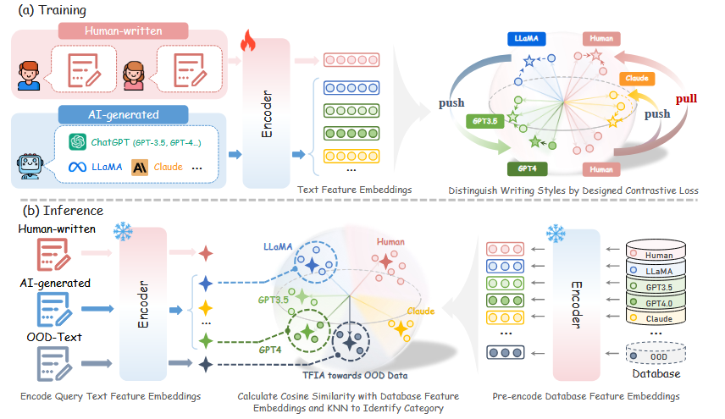
Figure 2-1: Overview of DeTeCtive from [15].

2.1.4 Adversarial Training and Robust Detection
Adversarial attacks, especially paraphrasing, present major challenges for AI text detection systems. To improve robustness, adversarial training methods have been proposed [7][18].
RADAR is one of the representative adversarial detection frameworks [7]. It jointly trains a paraphraser and a detector through adversarial learning. The paraphraser attempts to rewrite AI-generated text to evade detection, while the detector learns to recognize both original and paraphrased AI-generated content. This training strategy significantly improves robustness against rewriting attacks.
Other methods, such as SCRN, focus on token-level and character-level perturbations [18]. These approaches further improve detection robustness under synonym replacement, back-translation, and style transfer attacks. Although adversarial training improves practical reliability, it also increases training complexity and computational cost.
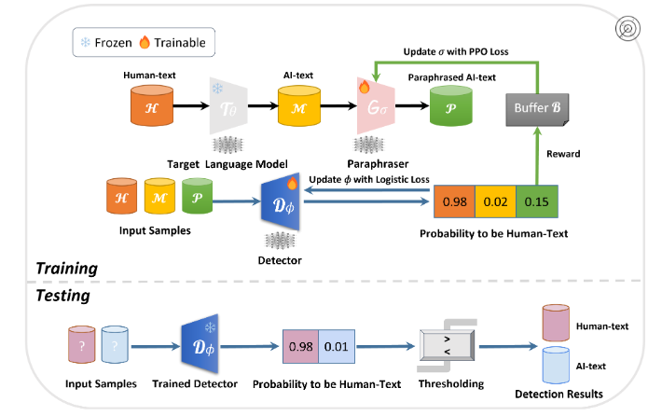
Figure 2-2: Overview of RADAR from [7].

2.2 Related Techniques on Project
2.2.1 FastAPI
FastAPI is a modern Python web framework designed for building high-performance APIs. It is based on standard Python type hints and supports asynchronous programming, which enables efficient request processing and fast response speed. Compared with traditional backend frameworks, FastAPI provides automatic API documentation generation and data validation, making backend development more efficient and maintainable.
In this project, FastAPI is used to build the backend service of the AI text detection system. The trained detection model is deployed as an API service, allowing users to send text requests through HTTP interfaces and receive prediction results and confidence scores. FastAPI also supports modular system design, which improves the scalability and maintainability of the system.
2.2.2 streamlit and EChart
Streamlit is a lightweight Python framework for rapidly developing interactive web applications for machine learning and data science projects. It allows developers to build user interfaces directly using Python code without requiring traditional frontend technologies such as JavaScript or HTML.
In this project, Streamlit is used to implement the frontend interface of the AI text detection system. Users can input text, upload files, and visualize detection results through an interactive web interface. Streamlit simplifies the deployment process and improves development efficiency.
ECharts is a powerful data visualization library that supports dynamic charts and interactive visual analysis. It provides multiple chart types such as line charts, bar charts, and pie charts. In this project, ECharts is used to visualize model performance metrics, detection statistics, and experimental results, helping users better understand the behavior and effectiveness of the detection system.
2.2.3 Deep Learning Framework: PyTroch
PyTorch is one of the most widely used deep learning frameworks in artificial intelligence research and development. It provides dynamic computation graphs, automatic differentiation, GPU acceleration, and flexible neural network construction tools, making it highly suitable for machine learning experiments and model training.
This project uses PyTorch to implement and train the AI text detection models. Transformer-based architectures such as DistilBERT and contrastive learning frameworks are developed using PyTorch and the HuggingFace Transformers library. PyTorch also supports efficient tensor operations and distributed training, which improves training efficiency and model scalability.
2.2.4 FAISS
FAISS (Facebook AI Similarity Search) is a high-performance similarity search library developed by Meta AI. It is designed for efficient nearest neighbor search and large-scale vector retrieval. FAISS supports GPU acceleration and multiple indexing strategies, enabling fast similarity matching in high-dimensional embedding spaces.
In this project, FAISS is used to build the embedding retrieval database for the DeTeCtive framework. After generating text embeddings through the contrastive learning model, FAISS performs k-nearest neighbor (KNN) retrieval to identify the most similar writing styles in the embedding space. Compared with traditional linear search methods, FAISS significantly improves retrieval speed and system efficiency, especially when processing large-scale text datasets.
2.2.5 Transformer-based Neural Network Architecture
Deep learning models have become the core technology in modern natural language processing tasks. Unlike traditional machine learning methods that rely heavily on manually designed features, neural networks can automatically learn semantic and contextual representations from large-scale text data. In recent years, Transformer-based architectures have achieved remarkable success in various NLP tasks due to their strong representation learning capability and parallel computation efficiency.
(1) Transformer Architecture
The Transformer architecture mainly relies on the self-attention mechanism to model relationships between words in a sentence[19]. Unlike recurrent neural networks (RNNs), Transformer models process all tokens simultaneously, which significantly improves training efficiency and enables better long-range dependency modeling. The self-attention mechanism calculates the similarity between tokens and dynamically assigns different attention weights to capture contextual information.
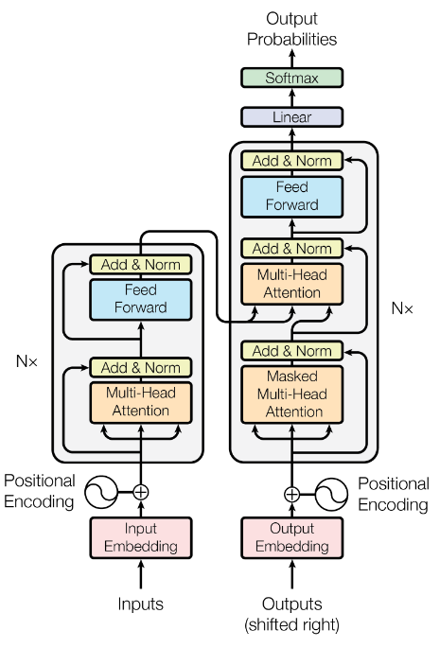
Figure 2-3 The Transformer - model architecture from [19]
(2) Pre-trained Language Models
In this project, pre-trained Transformer models are used as the text feature extraction backbone. The system supports multiple pre-trained models, including RoBERT[20], DistilBERT[21], BGE[22], and T5-based[23] encoders. These models are implemented using the HuggingFace Transformers library. After tokenization, the input text is encoded into contextual embeddings through the Transformer encoder.
Compared with traditional neural network models, pre-trained language models can learn rich semantic information from large-scale corpora and significantly improve downstream task performance. Therefore, they are widely used in AI-generated text detection tasks.
(3) Sentence Embedding and Pooling Strategy
The generated token embeddings are further transformed into sentence-level embeddings through a pooling strategy. Two pooling methods are mainly used in this project: average pooling and CLS pooling. Average pooling calculates the mean representation of all tokens, while CLS pooling directly uses the embedding of the special classification token.
After pooling, the embedding vectors are normalized before being used for downstream tasks such as contrastive learning and vector retrieval. Sentence embeddings provide compact semantic representations for measuring text similarity and performing classification tasks.
(4) Cosine Similarity
Cosine similarity is used in this project to measure semantic similarity between embedding vectors. The cosine similarity between two embeddings can be calculated as follows:
$$\begin{aligned}sim\left(q,k\right)=\frac{q∙k}{\left\|q\right\|\left\|k\right\|}\#\left(2-1\right)\end{aligned}$$
where q and k represent two embedding vectors. Higher cosine similarity indicates stronger semantic similarity between texts.
Compared with traditional neural network structures, Transformer-based models provide stronger contextual understanding and better semantic representation capability, making them highly suitable for AI-generated text detection tasks.
(5) inner product
The inner product similarity is defined as:
$$\begin{aligned}sim\left(q,k\right)=q∙k\#\left(2-2\right)\end{aligned}$$
Inner product directly measures the projection relationship between two embedding vectors. Unlike cosine similarity, inner product additionally preserves embedding magnitude information, which may contain useful semantic features learned during contrastive training.
(6) inner product
Euclidean distance measures the geometric distance between two embeddings in vector space and can be calculated as follows:
$$\begin{aligned}d\left(q,k\right)=\sqrt{\sum_{i=1}^{n}{{\left(q_{i}-k_{i}\right)}^{2}}}\#\left(2-3\right)\end{aligned}$$
Smaller Euclidean distance indicates that two embeddings are closer in the semantic space. Compared with cosine similarity, Euclidean distance simultaneously considers both vector direction and vector magnitude, allowing the retrieval process to better preserve the geometric structure of the embedding space.
2.2.5 Contrastive Learning and Classification Structure
To improve the generalization ability and robustness of AI text detection models, this project adopts a contrastive learning-based training strategy. Contrastive learning aims to learn discriminative embedding representations by reducing the distance between similar samples while increasing the distance between dissimilar samples in the embedding space.
(1) Contrastive Learning
Contrastive learning is a representation learning method that constructs positive and negative sample pairs to optimize embedding distributions. Positive samples are encouraged to stay closer in the embedding space, while negative samples are pushed farther apart.
In this project, contrastive learning is applied to distinguish writing styles between human-written and AI-generated text. Different language models and datasets are treated as different style categories, allowing the model to learn generator-invariant representations.
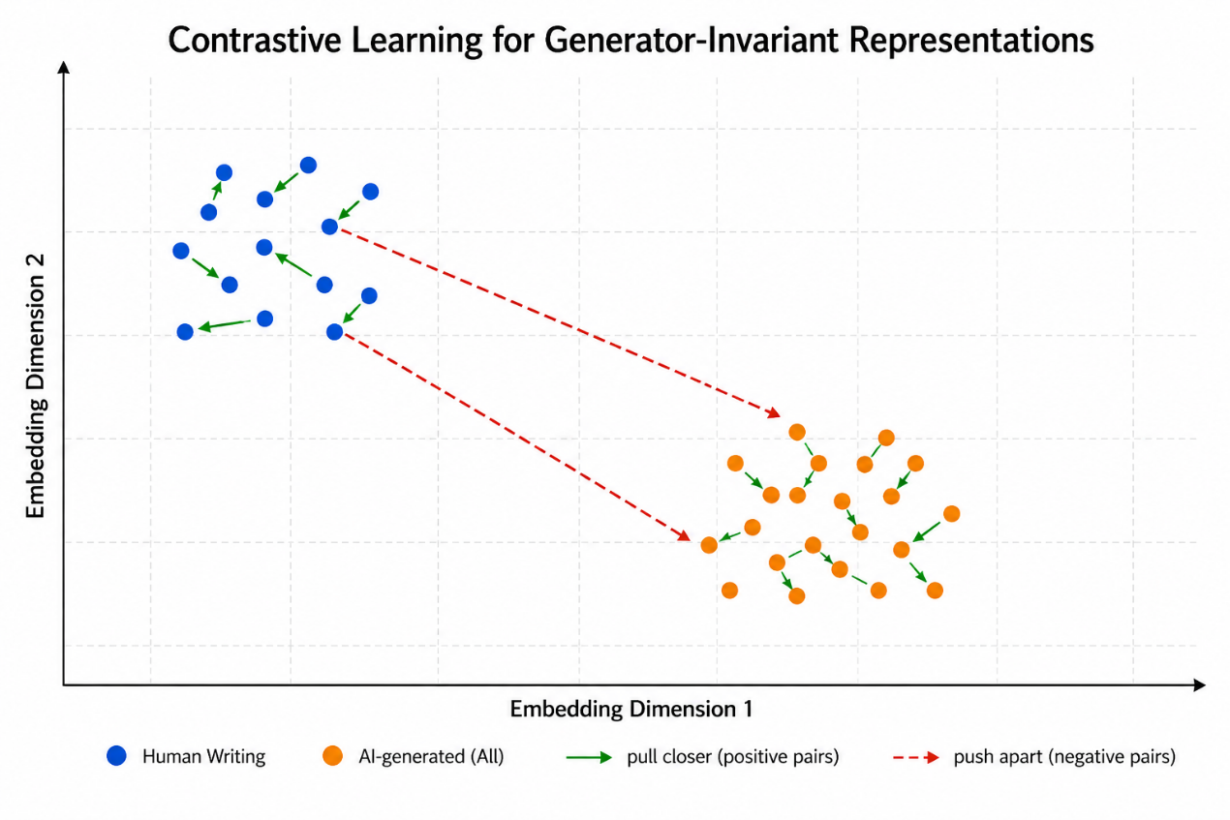
Figure 2-4 Contrastive learning in the embedding space for generator-invariant text representations
(2) Temperature Scaling
The similarity score between embeddings is scaled by a temperature parameter before calculating the contrastive loss. The temperature-scaled similarity is defined as follows:
$$\begin{aligned}logits=\frac{sim\left(q,k\right)}{τ}\#\left(2-4\right)\end{aligned}$$
where τ represents the temperature hyperparameter. Temperature scaling controls the smoothness of similarity distributions and improves training stability.
(3) Multi-level Contrastive Objective
This project constructs multiple contrastive objectives according to different relationships between samples, including model-level similarity, dataset-level similarity, and label-level similarity. Positive samples from the same category are pulled closer, while unrelated samples are separated in the embedding space.
This multi-level contrastive learning strategy improves the robustness and generalization capability of the model, especially when detecting texts generated by unseen language models.
(4) Classification Head
In addition to contrastive learning, the project also includes a supervised classification branch. The classification head adopts a multi-layer perceptron (MLP) structure consisting of multiple fully connected layers and Tanh activation functions.
The overall classification structure is shown below:
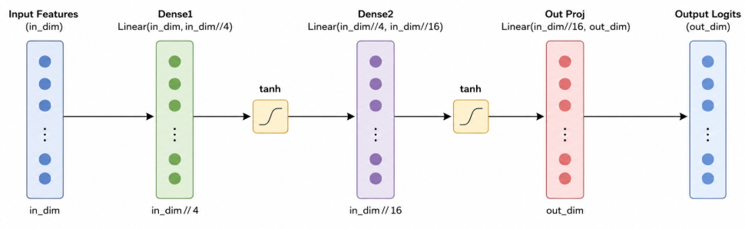
Figure 2-5 Classification Head Architecture
The classification branch predicts whether the input text is human-written or AI-generated based on the generated sentence embedding.
(5) FAISS-based Vector Retrieval
After embedding generation, the project uses FAISS to perform efficient nearest neighbor retrieval in high-dimensional embedding space. By comparing the similarity between query embeddings and stored embeddings, the system can identify the most similar writing styles for AI text detection.
Compared with traditional classification-only methods, the combination of contrastive learning and retrieval-based detection improves model robustness and generalization performance under cross-domain and adversarial scenarios.

2.3 Chapter Summary
This chapter mainly introduced the related work and key technologies used in the AI text detection system. Existing AI-generated text detection methods, including statistical approaches, Transformer-based classifiers, and contrastive learning methods, were reviewed and analyzed. In addition, several important development technologies used in the project, such as FastAPI, Streamlit, PyTorch, and FAISS, were introduced.
Furthermore, the neural network structures adopted in this project were discussed in detail, including Transformer-based language models, sentence embedding methods, contrastive learning strategies, classification structures, and vector retrieval mechanisms. These techniques provide the theoretical foundation and technical support for the design and implementation of the proposed AI text detection system in the following chapters.

CHAPTER 3: DESIGN OF AI TEXT DETECTION METHOD

3.1 Overall Framework of the Proposed Method
This chapter introduces the core AI text detection method used in this project. The proposed system is mainly based on the DeTeCtive[15] framework, which combines Transformer-based text representation learning, contrastive learning, and vector retrieval techniques to improve the robustness and generalization ability of AI-generated text detection.
Different from traditional binary classification methods that directly predict whether a text is human-written or AI-generated, this project implements two different detection strategies:
- A supervised binary classification model based on Transformer embeddings;
- A retrieval-based detection method using embedding vectors and K-Nearest Neighbor (KNN) voting.
The overall framework of the proposed system is shown below:
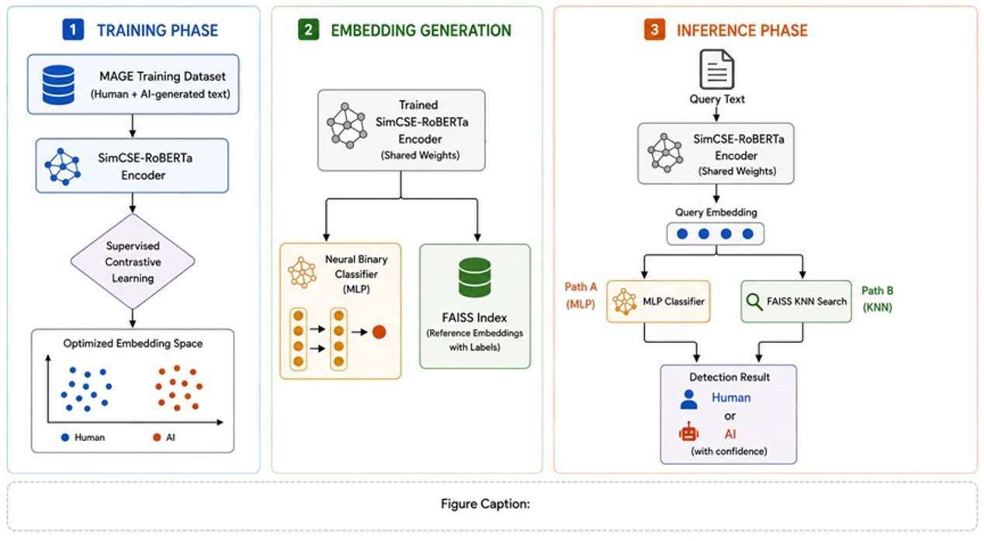
Figure 3-1: Overall framework of the proposed AI text detection method.
The classification-based method directly predicts text labels through a neural network classifier, while the retrieval-based method determines the result according to the similarity between the input embedding and stored embeddings in the vector database.

3.2 SimCSE-based Text Embedding Model
The text embedding model is the core component of the proposed detection framework. This work adopts the publicly available pretrained sentence encoder princeton-nlp/unsup-simcse-roberta-base. The backbone follows the RoBERTa Transformer architecture; the checkpoint is optimized at pretraining time using the unsupervised SimCSE objective. In our downstream detection training, we fine-tune this encoder jointly with the objectives described in Section 3.3 (rather than repeating unsupervised SimCSE training from scratch).
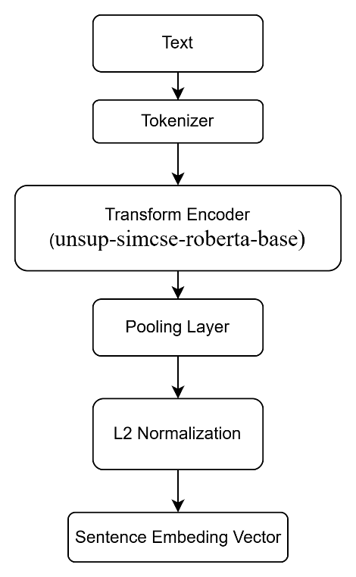
Figure 3-2: Text embedding model

3.2.1 SimCSE Framework
SimCSE[24] is a contrastive learning framework designed for sentence representation learning. Unlike traditional classification models, SimCSE learns semantically meaningful sentence embeddings by maximizing the similarity between positive sentence pairs while minimizing the similarity between negative pairs.
The unsupervised SimCSE framework generates positive samples through dropout noise during training. This strategy enables the model to learn robust sentence-level semantic representations without requiring manually labeled positive pairs.
Compared with traditional sentence embedding methods, SimCSE achieves better semantic representation ability and stronger generalization performance.
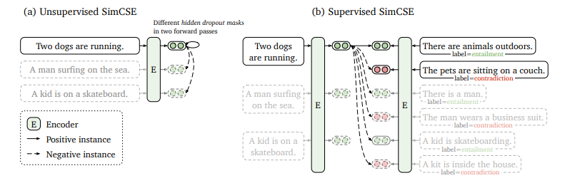
Figure 3-3: from [24] (a) Unsupervised SimCSE predicts the input sentence itself from in-batch negatives, with different hidden dropout masks applied. (b) Supervised SimCSE leverages the NLI datasets and takes the entailment (premisehypothesis) pairs as positives, and contradiction pairs as well as other in-batch instances as negatives.

3.2.2 RoBERTa Encoder
The backbone of the embedding model is RoBERTa[20], which is a Transformer-based pre-trained language model. RoBERTa improves upon BERT by using larger training datasets, dynamic masking strategies, and optimized training procedures.
The Transformer encoder mainly relies on the self-attention mechanism to capture contextual relationships between tokens. Compared with recurrent neural networks, Transformer models provide stronger contextual representation ability and higher parallel computation efficiency.
After tokenization, the input text is converted into contextual token embeddings through the RoBERTa encoder.

3.2.3 Sentence Embedding Generation
Because the Transformer outputs token-level hidden states, a pooling operator is required to obtain a sentence-level vector $h∈R^{d}$. In this project, we primarily use:
(1) Masked average pooling
Let$x_{1},…,x_{n}$be token vectors and $m∈{\{0,1\}}^{n}$the attention mask. The pooled representation is:
$$\begin{aligned}h=\frac{\sum_{i = 1}^{n}{m_{i}x_{i}}}{\sum_{i = 1}^{n}{m_{i}}}\#\left(3-1\right)\end{aligned}$$
(2) CLS Pooling
For selected encoder families (e.g., certain BGE/MXBai-style checkpoints), we use the hidden state of the [CLS] token as h.
Different pooling choices can affect compatibility with the pretrained objective and downstream similarity behavior; we select pooling according to the encoder’s recommended usage.

3.2.4 Embedding Normalization
After pooling, the embedding vectors are normalized using L2 normalization:
$$\begin{aligned}z=\frac{h}{{\left\|h\right\|}_{2}}\#\left(3-2\right)\end{aligned}$$
Normalization maps representations onto a hypersphere, which stabilizes optimization and makes dot products equivalent to cosine similarity when comparing $z_{i}$and $z_{j}$.

3.3 Supervised Contrastive Learning Framework
To improve embedding discriminability for AI-generated text detection, we adopt a joint training scheme that combines (i) a label-supervised contrastive scoring loss operating on normalized embeddings and (ii) a lightweight MLP classifier on the same embeddings. This differs from training a standalone binary classifier only: the contrastive term explicitly shapes the geometry of the embedding space using human vs. machine supervision.
In this project, the contrastive learning framework only considers two semantic categories:
- human-written text;
- AI-generated text.
Texts belonging to the same category are treated as positive pairs, while texts belonging to different categories are treated as negative pairs.
Compared with ordinary binary classification methods, supervised contrastive learning improves the semantic distribution of embeddings and enhances model robustness under unseen domains and different language model generators.

3.3.1 Sentence Embedding Representation
Given an input sentence x, the SimCSE-RoBERTa encoder generates its sentence embedding representation:
$$\begin{aligned}h=f_{0}\left(x\right)\#\left(3-3\right)\end{aligned}$$
where:
- x represents the input text;
- $f_{0}$represents the SimCSE-RoBERTa encoder;
- h represents the generated sentence embedding.
After pooling, the embedding vector is normalized using L2 normalization:
$$\begin{aligned}z=\frac{h}{{\left\|h\right\|}_{2}}\#\left(3-4\right)\end{aligned}$$
where z represents the normalized embedding vector.
Embedding normalization constrains all vectors onto a unit hypersphere and improves the stability of similarity computation during contrastive learning.

3.3.2 Similarity Matrix Construction and Temperature Scaling
For a minibatch of size$N$, let $\{z_{i}\}_{i=1..N}$ be the normalized query embeddings. To increase the effective number of comparisons, we additionally form a key set by aggregating representations across devices (e.g., via all-gather in distributed training), denoted as $\{z_{j}^{\left(k\right)}\}_{j=1..M}$, where $M ≥ N$. In our implementation, keys are derived from the encoder outputs with stopped gradients through the key branch to stabilize training while still providing a large set of similarity targets for queries.
Since $z_{i}$and $z_{j}^{\left(k\right)}$ are L2-normalized, cosine similarity equals the inner product:
$$\begin{aligned}sim\left(z_{i},z_{j}^{\left(k\right)}\right)=z_{i}^{T}z_{j}^{\left(k\right)}\#\left(3-5\right)\end{aligned}$$
We apply a temperature τ > 0 to obtain scaled scores:
$$\begin{aligned}S_{ij}=\frac{sim\left(z_{i},z_{j}^{\left(k\right)}\right)}{τ}\#\left(3-6\right)\end{aligned}$$
Smallerτsharpens the score distribution, increasing separation pressure between high- and low-similarity pairs.

3.3.3 Positive/Negative Construction and Loss
Let $y_{i}∈\{0,1\}$ be the label for sample i (e.g., human vs. AI). For each query$i$, we define a same-label mask $M_{ij}^{+}=I\left[y_{i}=y_{j}\right]$ over keys$j$.
Positive channel (aggregated same-label score). Instead of enumerating every positive pair as a separate term in a classical multi-positive InfoNCE formulation, we aggregate all same-label similarities into one positive logit per anchor:
$$\begin{aligned}l_{i}^{+}=\frac{\sum_{j}^{ }{{M^{+}}_{ij}S_{ij}}}{max\left(\sum_{j}^{ }{{M^{+}}_{ij}},ε\right)}\#\left(3-7\right)\end{aligned}$$
where $ε$ is a small constant for numerical stability.
Negative channels (cross-label scores). For each key j with different label from i, we treat the corresponding scaled similarity as a negative logit:
$$\begin{aligned}l_{ij}^{-}=S_{ij}⋅I\left[y_{i}≠y_{j}\right]\#\left(3-8\right)\end{aligned}$$
Contrastive classification over similarity channels. We concatenate the positive scalar with all negative scalars into a vector$ϕ_{i}=\left[l_{i}^{+},\{l_{ij}^{-}\}_{j:y_{i}≠y_{j}}\right]$ and optimize a cross-entropy objective that assigns probability mass to the positive channel index (i.e., encouraging $l_{i}^{+}$​ to dominate over all cross-label$S_{ij}$). This yields a label-consistent similarity learning objective in the spirit of temperature-scaled contrastive training, while being aligned with our codebase’s exact logits construction.
Joint objective with the detection classifier. In parallel, an MLP classification head maps $z_{i}$(equivalently the pre-normalized pooled features used in implementation) to class logits for standard cross-entropy supervision. The overall training loss is a weighted sum
$$\begin{aligned}L=αL_{contrast}+δL_{cls}\#\left(3-8\right)\end{aligned}$$
where $α$ and $δ$ are hyperparameters. If the contrastive term is disabled in training configuration, optimization reduces to classification-only fine-tuning.

3.4 Detection Methods at Inference Time
Section 3.3 describes how the encoder is trained together with a supervised contrastive term and a parametric classification head. At inference, the system supports two alternative detectors that map an input passage to a machine-generated probability (or an equivalent binary decision). Both detectors share the same sentence encoder backbone (SimCSE-initialised RoBERTa with pooling and $l_{2}$normalisation of embeddings where applicable), but they differ in how decision boundaries are realised: (i) a learned two-way softmax classifier on top of the query embedding, and (ii) a non-parametric k-nearest-neighbour rule in the embedding space against a pre-built reference bank.
Unless otherwise stated, both methods consume tokenised text under a fixed maximum length and return a soft score for the AI class, which can be thresholded for hard decisions or used for ranking in evaluation protocols.

3.4.1 Neural Binary Classifier
The first detector is a standard supervised classifier defined on the sentence embedding $z$ produced by the encoder. Concretely, the same architecture used during training applies a bottleneck MLP head (two$tanh$layers with progressive width reduction followed by a linear map) to map $z$ to two logits corresponding to human-written and AI-generated classes. At inference, the softmax transformation yields class probabilities; the AI-generated posterior is taken as the second dimension of the softmax vector and serves as the detection score.
(1) This pathway is fully parametric: all information about the decision boundary is encoded in the head weights (and, if not frozen, the encoder weights) estimated during training. (2) It is amortised: each query requires one forward pass through the Transformer and the MLP, which is attractive for low-latency deployment. (3) For long documents, the implementation may apply a windowing or aggregation strategy over multiple segments; the core score remains the classifier’s softmax output on each segment or its aggregate, depending on the deployment configuration.

3.4.2 k-Nearest-Neighbour Retrieval in Embedding Space
The second detector is instance-based rather than parametric. Given a query passage, the encoder produces an embedding vector, which is $l_{2}$-normalised so that Euclidean inner products coincide with cosine similarity between unit vectors. A reference library of previously embedded passages—each annotated with a binary human/machine label—is stored in a FAISS index with inner-product geometry (IndexFlatIP), i.e., maximum inner product search over normalised vectors.
For each query, the index retrieves the top-K nearest neighbours in embedding space. Neighbour identities are mapped back to stored labels; a majority vote over these $K$ labels yields a discrete prediction, and the fraction of neighbours labelled as machine-generated is used as a continuous AI score in $\left[0,1\right]$(equivalently, the empirical frequency of the AI label among the K retrieved references).
The KNN pathway separates representation learning from the decision rule: the encoder may be shared with the contrastive training pipeline, while the reference bank constitutes a non-parametric memory of typical human and machine patterns. (2) Computational cost scales with index size and K, but the query-time forward pass through the encoder remains single-pass per segment. (3) Performance depends critically on bank composition (domain coverage, label noise, balance) and on K.

3.5 Experiments and Analysis

3.5.1 Dataset
Evaluation protocol. Following a strict corpus-level separation between training and evaluation, optimisation is performed exclusively on MAGE[25], a multi-domain benchmark that aggregates human-authored text and machine-generated text from several large language models, designed to approximate realistic “in-the-wild” deployment. Held-out testing and cross-domain analysis are conducted on four additional resources: HC3[26], CHEAT[27], and two Kaggle-hosted benchmarks referred to herein as Kaggle [28] and Kaggle2[29], which we preprocess into the same binary detection formulation as the other corpora. This design deliberately induces domain, style, and generator shift at test time relative to MAGE.
Unified task formulation. All corpora are reduced to sentence- or passage-level binary classification: the positive class denotes machine-generated text and the negative class human-written text (or human-authored controls under the same task definition). Instances are represented by plain text and a discrete label, enabling a common training and evaluation pipeline across datasets without task-specific architectural changes.
MAGE (training). MAGE is drawn from the public release yaful/MAGE and comprises on the order of 4.4×10⁵ instances in total (official documentation). It combines heterogeneous human sources with LLM-generated counterparts and provides standard training, validation, and test partitions; in our experiments, only the training portion of MAGE is used for parameter estimation, while validation data, when employed, serve hyper-parameter and model selection without accessing any of the external evaluation corpora listed below.
HC3 (evaluation). HC3 is a human–ChatGPT comparison corpus collected under matched prompts across multiple topical domains (e.g., open QA and encyclopaedic-style content in the English split). It is widely used to study ChatGPT-style generation under question–answering and open-domain conditions. After standard shuffling and partitioning into training, development, and test subsets at an 8:1:1 ratio for analysis purposes, the resulting HC3 material amounts to approximately 1.0×10⁵ labelled instances in aggregate and is used only for evaluation, not for gradient updates.
CHEAT (evaluation). CHEAT targets scientific abstract generation: human-written IEEE-style abstracts are contrasted with ChatGPT-authored abstracts derived from the same underlying articles. In the configuration adopted here, evaluation focuses on the initial human abstracts versus first-pass ChatGPT “generation” abstracts, yielding tens of thousands of paired abstracts per class at full scale; this setting provides a formal, domain-specific stress test complementary to the broader coverage of MAGE and the conversational style of HC3.
Kaggle1 (evaluation). The first Kaggle resource is a large-scale student–machine text collection in which human responses correspond to authentic student writing and machine responses correspond to automatically generated continuations under the same prompt regime. After filtering and random 8:1:1 partitioning into training, development, and test subsets for reporting consistency, the benchmark remains large-scale (on the order of 10⁶–10⁷ tokens or 10⁶-level instances, depending on release and filtering), offering a strong length and register shift relative to short QA corpora.
Kaggle2 (evaluation).The second Kaggle resource is comparatively compact (on the order of 10³ instances in total after the same partitioning protocol), contrasting informal, conversational human snippets with formal, encyclopaedic machine-generated passages. Its primary role is to probe style mismatch and extreme brevity rather than to estimate asymptotic performance with high statistical precision.
Table 3-1 Dataset Overview
Dataset | Type | train | dev | test | Total
MAGE | Multi-domain; multi-LLM; mixed length | 319071 | 56792 | 60743 | 436606
HC3 | QA-style; human–ChatGPT paired | 48185 | 38546 | 4818 | 4821
CHEAT | Scientific abstracts; IEEE-style | 24632 | 3079 | 3079 | 30790
Kaggle1 | Student essays; human vs machine (same prompt setting) | 389783 | 48723 | 48723 | 487229
Kaggle2 | Short informal vs formal; style-contrastive | 881 | 110 | 111 | 1102

3.5.2 Evaluation Criteria
AI-generated text detection is formulated as binary classification. Each instance has a ground-truth label$y∈\{0,1\}$, where 0 denotes human-written text and 1 denotes machine-generated text. The detector outputs a score $s∈[0,1]$, interpreted as the AI-ness of the passage (e.g., the softmax probability of the AI class). Unless stated otherwise, a hard label is obtained by the default threshold
$$\begin{aligned}y=\left\{\begin{aligned}1,s>0.5, \\ 0,s≤0.5\end{aligned}\right.​\#\left(3-9\right)\end{aligned}$$
which matches the evaluation pipeline in the implementation (binarisation before accuracy / F1 / confusion-matrix computation). AUROC is computed from the continuous scores ss and is therefore not tied to the 0.5 cut-off.
Confusion counts and accuracy
Before defining performance criteria, we need to define a few very common terms (TP, TN, FP, FN), Table 3-2 shown the definition of those four terms.
Table 3-2: Definition of TP, TN, FP and FN
Predicted label  True Label | AI | Huamn
AI | TP | FN
Human | FP | TN

Accuracy is the overall fraction of correct decisions:
$$\begin{aligned}ACC=\frac{\left(TP+TN\right)}{\left(TP+FP+FN+TN\right)}\#\left(3-10\right)\end{aligned}$$
Precision, recall, and F1
For the AI class (positive class y=1), precision answers “among all predicted AI, how many are truly AI?”, recall answers “among all true AI, how many are detected?”, and F1 is their harmonic mean:
$$\begin{aligned}P_{AI}=\frac{TP}{\left(TP+FP\right)},R_{AI}=\frac{TP}{\left(TP+FN\right)},F_{1-AI}=\frac{2×\left(P_{AI}×P_{AI}\right)}{\left(P_{AI}+P_{AI}\right)}\#\left(3-11\right)\end{aligned}$$
For the human class (y=0), the analogous quantities are:
$$\begin{aligned}P_{Hum}=\frac{TN}{\left(TN+FN\right)},R_{AI}=\frac{TN}{\left(TN+FP\right)},F_{1-Hum}=\frac{2×\left(P_{Hum}×P_{Hum}\right)}{\left(P_{Hum}+P_{Hum}\right)}\#\left(3-12\right)\end{aligned}$$
ROC curve and AUROC
The ROC curve describes the relationship between the True Positive Rate (TPR) and False Positive Rate (FPR) under different decision thresholds. Unlike accuracy and F1-score, ROC analysis evaluates the ranking ability of the detector over all possible thresholds instead of relying on a fixed threshold value.
The True Positive Rate is defined as:
$$\begin{aligned}TPR=\frac{TP}{\left(TP+FN\right)}\#\left(3-13\right)\end{aligned}$$
where TPR represents the proportion of correctly detected AI-generated texts among all actual AI-generated samples.
The False Positive Rate is defined as:
$$\begin{aligned}FPR=\frac{FP}{\left(FP+TN\right)}\#\left(3-14\right)\end{aligned}$$
where FPR represents the proportion of human-written texts incorrectly classified as AI-generated texts.
By continuously adjusting the classification threshold from 0 to 1, different pairs of (TPR,FPR) can be obtained to construct the ROC curve. A detector with better discrimination capability generally produces a ROC curve closer to the upper-left corner of the coordinate system.
The Area Under the ROC Curve (AUROC) is used to quantitatively measure the overall discrimination capability of the detector. AUROC can be interpreted as the probability that a randomly selected AI-generated sample receives a higher prediction score than a randomly selected human-written sample.
The AUROC value ranges from 0 to 1:
- AUROC = 1 indicates perfect classification performance;
- AUROC = 0.5 indicates random guessing performance;
- Higher AUROC values indicate stronger discrimination capability.
Mathematically, AUROC can be expressed as:
$$\begin{aligned}AUROC=\int_{0}^{1}{TPR\left(FPR\right)d\left(FPR\right)}\#\left(3-15\right)\end{aligned}$$
In this project, AUROC is calculated directly from the continuous prediction scores produced by the detector instead of the binarized prediction labels. Therefore, AUROC is independent of the default threshold value of 0.5 and provides a more comprehensive evaluation of model performance under different operating conditions.
Compared with accuracy alone, AUROC is more suitable for evaluating AI-generated text detection systems because it reflects the global ranking capability of the model and is less sensitive to class imbalance and threshold selection.

3.5.3 Experiments of Structural Parameters
(1) Effect of Similarity Metrics
The retrieval-based detector determines nearest neighbors according to similarity relationships in the embedding space. Therefore, the choice of similarity metric directly affects the retrieval quality and final detection performance.
To evaluate the influence of different similarity metrics, three commonly used distance calculation methods were compared in the KNN retrieval process:
- Cosine Similarity;
- Inner Product;
- Euclidean Distance.
All experiments were conducted under the same setting with K=5. The experimental results are shown in Table 3-4.
Table 3-4 Effect of Different Similarity Metrics.
Similarity Metric | ACC | AI Recall | Human Recall | F_{1-AI}
Cosine Similarity | 90.73% | 94.73% | 86.69% | 0.9111
Inner Product | 89.28% | 96.28% | 82.23% | 0.9001
Euclidean Distance | 92.26% | 94.63% | 89.88% | 0.9247
As shown in Table 3-7, different similarity metrics produce noticeable differences in retrieval performance. Among the evaluated methods, Euclidean distance achieves the best overall accuracy and F1-score, while cosine similarity obtains the lowest performance.
The results indicate that embedding magnitude information still contains useful discriminative signals in the learned representation space. Cosine similarity only considers angular similarity between embeddings and removes the influence of vector magnitude, which may weaken part of the semantic discrimination capability learned during supervised contrastive training.
In contrast, Euclidean distance simultaneously considers both vector direction and embedding magnitude, allowing the retrieval process to better preserve the geometric structure of the embedding space. This leads to more balanced performance between human-written and AI-generated samples.
Inner product similarity also achieves competitive performance and slightly improves AI recall compared with cosine similarity. However, its overall performance remains slightly lower than Euclidean distance.
Overall, the experimental results demonstrate that the choice of similarity metric has a measurable impact on retrieval-based AI text detection. Among the evaluated methods, Euclidean distance provides the most effective retrieval behavior under the current embedding framework and is therefore adopted in the final system configuration.
(2) Effect of K in KNN Retrieval
The retrieval-based detector determines the prediction result through K-nearest-neighbor voting in the embedding space. Therefore, the value of K directly affects the robustness and stability of the retrieval process.
Different values of K were tested in the experiments with MAGE dataset, and the results are shown in Table 3-3.
Table 3-3: Effect of Different K Values in Retrieval
K | ACC | AI Recall | Human Recall | F_{1-AI}
1 | 92.14% | 94.47% | 89.79% | 0.9234
3 | 92.29% | 94.65% | 89.93% | 0.9250
5 | 92.27% | 94.63% | 89.89% | 0.9247
7 | 92.24% | 94.82% | 89.84% | 0.9247
10 | 90.08% | 94.64% | 89.32% | 0.9232
As shown in Table 3-3, the overall performance remains relatively stable across different values of K, indicating that the proposed embedding space has good semantic consistency and retrieval robustness.
When K is relatively small, such as K=1, the detector becomes more sensitive to noisy neighbors and local embedding variations. Increasing K slightly improves the overall performance because the voting process becomes more stable and less affected by individual outlier samples.
The best overall accuracy is achieved when K=3, while the highest AI recall is obtained at K=7. However, the performance differences among K=3, K=5, and K=7 remain relatively small, suggesting that the learned embedding space maintains stable neighborhood structures under different voting settings.
When K further increases to K=10, both accuracy and human recall begin to decrease slightly. This phenomenon indicates that excessively large K values may introduce semantically less relevant neighbors into the voting process, which weakens the discriminative capability of the retrieval-based detector.
In addition, the gradual decrease in human recall under larger K values suggests that the detector becomes slightly more biased toward predicting the AI class during majority voting. As more neighbors participate in the retrieval process, ambiguous human-written samples are more likely to be influenced by nearby AI-generated embeddings.
Overall, the experimental results demonstrate that the retrieval-based detector is relatively insensitive to moderate changes in K, reflecting the robustness of the proposed embedding framework.

3.5.4 Comparison of Different Detection Strategies
To further evaluate the effectiveness of different inference mechanisms in the proposed framework, this section compares two detection strategies built upon the same embedding backbone:
- Neural Binary Classifier;
- KNN Retrieval-based Detector.
Both methods use the same contrastive-learning-based embedding encoder trained on the MAGE dataset. The binary classifier directly predicts the probability of AI-generated text through a supervised classification head, while the retrieval-based detector performs K-nearest-neighbor voting in the embedding space using a FAISS index.
The experimental results are shown in Table 3-4.
Table 3-4: Comparison Between Different Detection Strategies
Detection Strategy | ACC | Human Recall | AI Recall | F_{1-AI}
Neural Binary Classifier | 87.68% | 78.89% | 96.40% | 0.8870
KNN Retrieval Detector | 92.27% | 89.89% | 94.63% | 0.9247
As shown in Table 3-10, the retrieval-based detector achieves better overall accuracy and F1-score than the neural binary classifier. Although the classifier-based method obtains slightly higher AI recall, its human recall is significantly lower, indicating that the classifier tends to over-predict the AI class.
In contrast, the KNN retrieval-based detector achieves a more balanced performance between human-written and AI-generated samples. By performing nearest-neighbor voting in the embedding space, the retrieval-based method can better utilize the semantic structure learned through supervised contrastive learning, which improves robustness and reduces overfitting to a fixed classification boundary.
Interestingly, both methods achieve very similar AUROC performance, indicating that the two detectors have comparable ranking capability on continuous prediction scores. However, the retrieval-based detector achieves better hard-label classification performance after thresholding, which suggests that embedding-space voting produces more stable final predictions under cross-domain evaluation settings.
In addition, the retrieval-based detector demonstrates stronger interpretability because the prediction result can be explained through the retrieved nearest-neighbor examples in the embedding space. This property is particularly useful for practical AI text detection systems where interpretability and robustness are important considerations.
Overall, the experimental results indicate that the retrieval-based detection strategy is more suitable for cross-domain AI-generated text detection tasks and better leverages the semantic representation capability of the proposed contrastive-learning framework.

3.5.5 Cross-domain Generalization Analysis
One of the major challenges in AI-generated text detection is maintaining robust performance under unseen domains and unseen language models. Detection models trained on a specific dataset often experience performance degradation when evaluated on datasets with different writing styles, prompts, or generation distributions.
To investigate the cross-domain robustness of different inference strategies, this experiment evaluates two detection methods built upon the same contrastive-learning embedding framework:
- Neural Binary Classifier;
- KNN Retrieval-based Detector.
Both methods use the same embedding encoder trained on the MAGE dataset. During evaluation, the models were directly tested on multiple external datasets without additional fine-tuning. The evaluated datasets include:
- HC3;
- CHEAT;
- Kaggle1;
- Kaggle2.
The experimental results are shown in Table 3-5.

Table 3-5: Cross-domain Generalization Performance
Dataset | Method | ACC | Human Recall | AI Recall | F_{1-AI} | AUROC
MAGE (test) | Binary Classifier | 87.68% | 78.89% | 96.40% | 0.8870 | 0.9580
 | KNN Retrieval | 92.27% | 89.89% | 94.63% | 0.9247 | —
HC3 | Binary Classifier | 83.21% | 67.33% | 99.40% | 0.8543 | 0.9746
 | KNN Retrieval | 88.24% | 77.53% | 99.15% | 0.8931 | —
CHEAT | Binary Classifier | 85.27% | 70.59% | 99.95% | 0.8716 | 0.9812
 | KNN Retrieval | 92.15% | 84.70% | 99.60% | 0.9270 | —
Kaggle1 | Binary Classifier | 83.91% | 82.03% | 87.07% | 0.8012 | 0.9162
 | KNN Retrieval | 88.08% | 90.32% | 84.31% | 0.8404 | —
Kaggle2 | Binary Classifier | 89.84% | 82.18% | 97.46% | 0.9057 | 0.9716
 | KNN Retrieval | 96.73% | 98.00% | 94.47% | 0.9669 | —
As shown in Table 3-5, the KNN retrieval-based detector consistently achieves better overall accuracy and F1-score across all evaluation datasets. The improvement is particularly noticeable on the CHEAT and Kaggle2 datasets, where the text distributions differ substantially from the MAGE training corpus.
The binary classifier achieves extremely high AI recall on HC3 and CHEAT, exceeding 99% on both datasets. However, its human recall is significantly lower, indicating that the classifier tends to over-predict the AI class under domain shifts. As a result, a considerable number of human-written samples are incorrectly classified as AI-generated text.
In contrast, the retrieval-based detector achieves a more balanced performance between human-written and AI-generated samples. By performing nearest-neighbor voting in the embedding space, the KNN-based method better utilizes the semantic structure learned through supervised contrastive learning and reduces over-reliance on a fixed classification boundary.
The improvement on the Kaggle2 dataset is particularly significant. Compared with the binary classifier, the KNN retrieval detector improves the overall accuracy from 89.84% to 96.01%, while simultaneously maintaining high recall for both classes. This result demonstrates that embedding-space retrieval provides stronger robustness under unseen text distributions and unseen generation styles.
Overall, the experimental results indicate that retrieval-based inference achieves stronger cross-domain robustness than classifier-based inference under the same embedding framework. The findings suggest that embedding-space retrieval is more suitable for practical AI-generated text detection scenarios where text distributions continuously evolve across different datasets and language models.

3.6 Chapter Summary
This chapter presents the experimental evaluation and analysis of the proposed AI-generated text detection framework. Multiple experiments were conducted to evaluate the effectiveness, robustness, and generalization capability of the proposed contrastive-learning-based embedding framework and retrieval-based detection strategy.
First, the influence of different retrieval parameters was investigated through KNN ablation experiments. The results demonstrate that the proposed embedding space maintains stable semantic neighborhood structures under different values of K, indicating strong robustness and consistency in retrieval-based inference.
Next, different similarity metrics were evaluated in the retrieval process, including cosine similarity, inner product similarity, and Euclidean distance. Experimental results show that Euclidean distance achieves the best overall performance, suggesting that embedding magnitude information provides additional discriminative capability for AI-generated text detection.
The chapter further compares two inference strategies built upon the same embedding framework: the neural binary classifier and the KNN retrieval-based detector. The results indicate that the retrieval-based method achieves more balanced classification performance and better overall robustness than the classifier-based approach.
To further evaluate practical applicability, cross-domain generalization experiments were conducted on multiple external datasets, including HC3, CHEAT, and Kaggle2. Without additional fine-tuning, the retrieval-based detector consistently outperformed the classifier-based method across different domains and generation distributions. The results demonstrate that embedding-space retrieval can better adapt to unseen text styles and unseen language model outputs.
Overall, the experimental results verify the effectiveness of the proposed contrastive-learning embedding framework and demonstrate the advantages of retrieval-based inference for cross-domain AI-generated text detection tasks. The proposed method achieves strong robustness, balanced classification performance, and improved generalization capability under different evaluation settings.

CHAPTER 4: SYSTEM DESIGN AND DEVELOPMENT

4.1 Requirement Analysis
In order to ground the system in realistic use and guide the subsequent design, this chapter analyses the project requirements before presenting the architecture and implementation. The analysis is organised into functional requirements and non-functional requirement.

4.1.1 Functional requirements
1) The user shall be able to paste or type plain text (including long documents) and obtain an AI vs human–oriented assessment at configurable granularity (e.g. paragraph, sentence, or finer segments), with results shown as per-fragment scores, labels, and visual highlighting rather than a single opaque verdict.
2) The user shall be able to choose between at least two detection strategies where the backend supports them (e.g. a learned classifier and an embedding-based KNN path), and to inspect summary charts (e.g. distribution of outcomes and severity) so that the model behaviour is easier to interpret at a glance.
3) The user shall be able to browse local CSV datasets, inspect basic metadata and label statistics, and submit batch evaluation jobs over a selected split and text column; the system shall report task progress and allow cancellation of long-running jobs when supported by the API.

4.1.2 Non-functional requirements
1) The overall interface shall be simple, coherent, and visually clear, so that users can complete detection and dataset tasks without reading internal code or deployment manuals beyond short on-screen hints.
2) The interactive detection path shall feel responsive: long inputs shall be handled via batch requests where possible to limit waiting time from excessive network round-trips; dataset jobs may be long-running but shall remain observable (progress indication) rather than silent.
3) The interface shall provide adequate interactivity and feedback—for example, loading or progress indicators during API calls, visible error messages on failure, and controls whose purpose is explained in brief help text—so that each major user action produces a discernible system response.

4.2 System Context
In order to better analyze the structure of the whole system, a context diagram of the system was drawn, as shown in Figure 4-1. This diagram includes AI detect system, users and external systems.
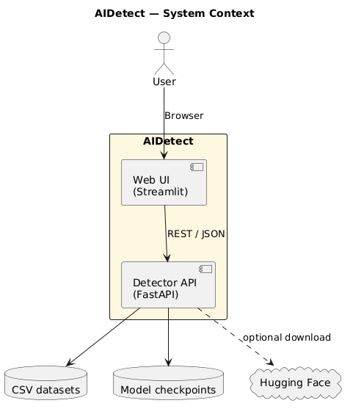
Figure 4-1: Context diagram of system.

4.2.1 Users
The intended users of this system are not split into clinical roles; instead, they are grouped by how they use the workbench: general users who need quick, interpretable screening of text, research-oriented users who work with labelled corpora and aggregate metric.
A general user (for example a student, instructor, or content reviewer) can paste or type plain text—including long passages—on the AI Detector page, choose segmentation granularity (paragraph, sentence, or finer units) and a detection method where available, and obtain per-fragment scores, labels, and visual highlighting together with summary charts. This supports everyday questions such as whether a submission reads like machine-generated prose, without requiring the user to run scripts or manage model files.
Research-oriented users (for example the author of this thesis or other experimenters) mainly use the Datasets area: they browse local CSV datasets, inspect column and label statistics, and submit batch evaluation jobs over a chosen split and text column. When a job completes, they can read accuracy, confusion matrix, ROC-related summaries, and related fields returned by the backend, which is appropriate for reporting model quality and comparing configurations (e.g. classifier versus KNN) under the same data conditions.

4.2.2 System Feature
The system is an AI-generated text detection workbench built for this graduation project. It is organised into three main feature groups, implemented as separate functional modules in the Streamlit application: interactive text detection, dataset-scale evaluation with background jobs, and supporting information modules (evaluation help, system overview, and the home landing page). Figure 4-2 gives a use case diagram summarising these features and their main actors (user, front end, inference API, and stored data).
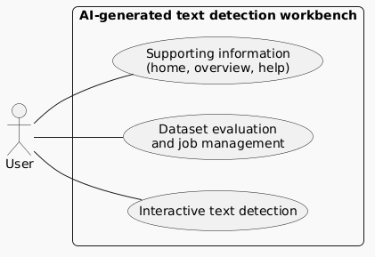
Figure 4-2: Use case diagram to show the feature of the system
(1) Interactive text detection
Interactive text detection is the core feature. It is backed by the detection models and APIs described elsewhere in this thesis (SimCLR-based classifier and, when enabled, a KNN-over-embeddings path). The user pastes or types plain text, selects segmentation granularity (e.g. paragraph or sentence) and detection method, and submits the request. The front end splits the document, calls the /v1/detect/batch endpoint, receives per-fragment labels, probabilities, and severity fields, and renders highlighted text and charts. Figure 4-3 shows a sequence diagram of this end-to-end flow (user → Streamlit UI → FastAPI backend → model inference → response → visualisation).
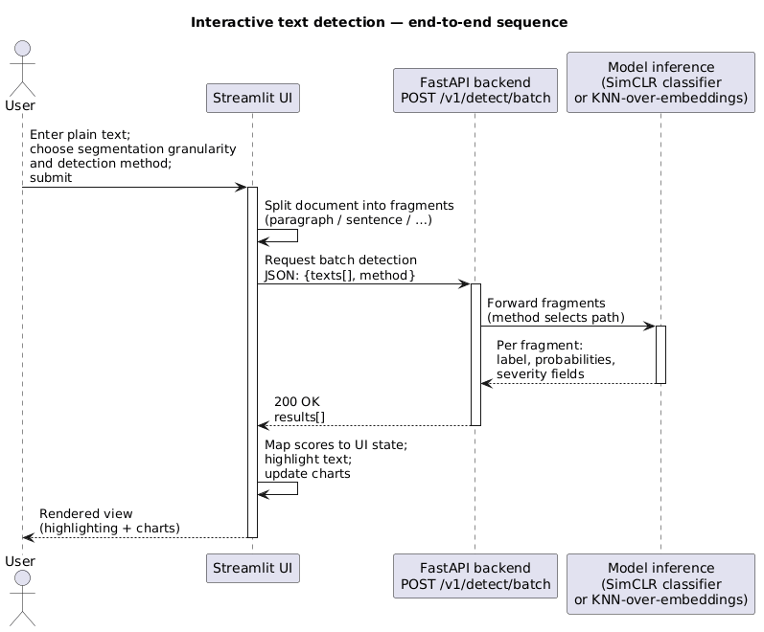
Figure 4-3: Sequence diagram of Interactive text detection
(2) Dataset evaluation and job management
This module supports batch evaluation over local CSV datasets. The user selects a dataset, split (e.g. train/test), and text column, then starts a job through /v1/dataset/run. When the backend returns a job identifier, the UI polls job status and may cancel a long run. Upon completion, the user inspects aggregate metrics (e.g. accuracy, confusion matrix, ROC-related summaries, depending on the returned payload) in the Datasets workflow. Figure 4-4 presents the sequence diagram for submitting a job, polling, and retrieving results.
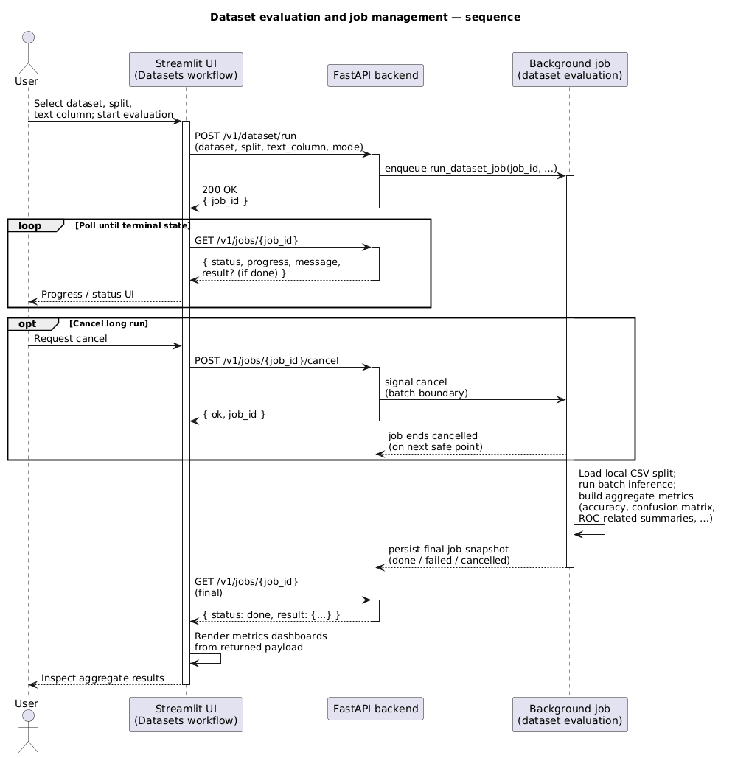
Figure 4-4: Sequence diagram of Dataset evaluation and job management

4.3 System Interface

4.3.1 Interface Generalization
The client is implemented with Streamlit, so the interface is web-based and runs in a browser. Interaction follows Streamlit’s rerun-on-action model: each control change or button press triggers a script rerun, and the active page is selected through a persistent left sidebar. Controls are grouped with headings, captions, and expanders so that infrequently used information (for example API environment hints) does not clutter the main workflow. The layout uses a wide page configuration to accommodate text areas, side-by-side controls, and charts. Colour highlighting in detection results is rendered through HTML snippets embedded in the page, while summary distributions use ECharts widgets.

4.3.2 Main Interface
This prototype does not implement a login screen or a personal account centre. After launching the application, the user enters the Home page by default, while a left navigation menu remains visible for switching modules.
The main entry experience can be described in four conceptual areas, aligned with what is shown on the Home page together with the global chrome:
- Hero and introduction — a top banner presents the project title and positioning, with light visual styling to improve readability and first impressions.
- Capability cards — a grid of cards summarises the main capabilities of the workbench (interactive detection, visualisation, and dataset-scale jobs).
- Step-by-step usage — a short sequence of steps explains how to open AI Detector or Datasets through the sidebar.
- Technical strip — a compact strip lists key technologies or commands for reproducibility, and points readers to the System Overview page for fuller deployment detail.
Global chrome includes the sidebar option menu (module switcher) and, when a dataset job is active, a top banner for job progress that can remain visible while the user navigates between pages. Figure 4-5 should capture the Home page together with the sidebar, as the primary entry view of the system.

Figure 4-5: Overview of the main entry interface (Home + sidebar navigation).

4.3.3 Function Module Interface
(1) AI Detector interface
This module is the core function. The user provides plain text (no file upload is required for the default workflow). The interface is organised so that a typical user can complete a run with minimal prior training: paste text, choose options, press Start detection, and read the coloured output.
The workflow can be documented in three screenshots:
Input and configuration — a large text area for the full document; radio buttons for annotation granularity; a slider for red-intensity threshold; a number input for merging overly short fragments; radio for detection method (classifier vs KNN); and a primary Start detection button (Figure 4-6).
Submission and loading — after the button is pressed, the client prepares fragments and calls the batch API; a progress indicator may appear while results are pending (Figure 4-7). If the progress state is very short in practice, Figure 4-7 may be a cropped detail of the same page.
Results presentation — highlighted text by severity, summary metrics, pie charts, and an expandable per-fragment table (Figure 4-8 – Figure 4-10).

Figure 4-6: AI Detector — input and configuration.

Figure 4-7: AI Detector — detection in progress.
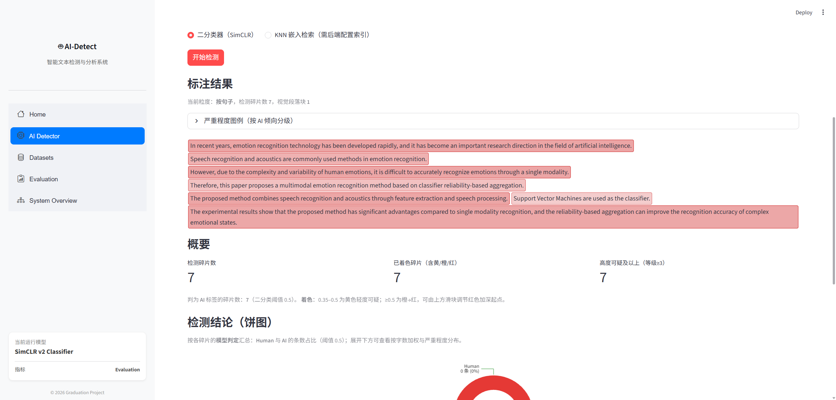
Figure 4-8: AI Detector — results and charts.
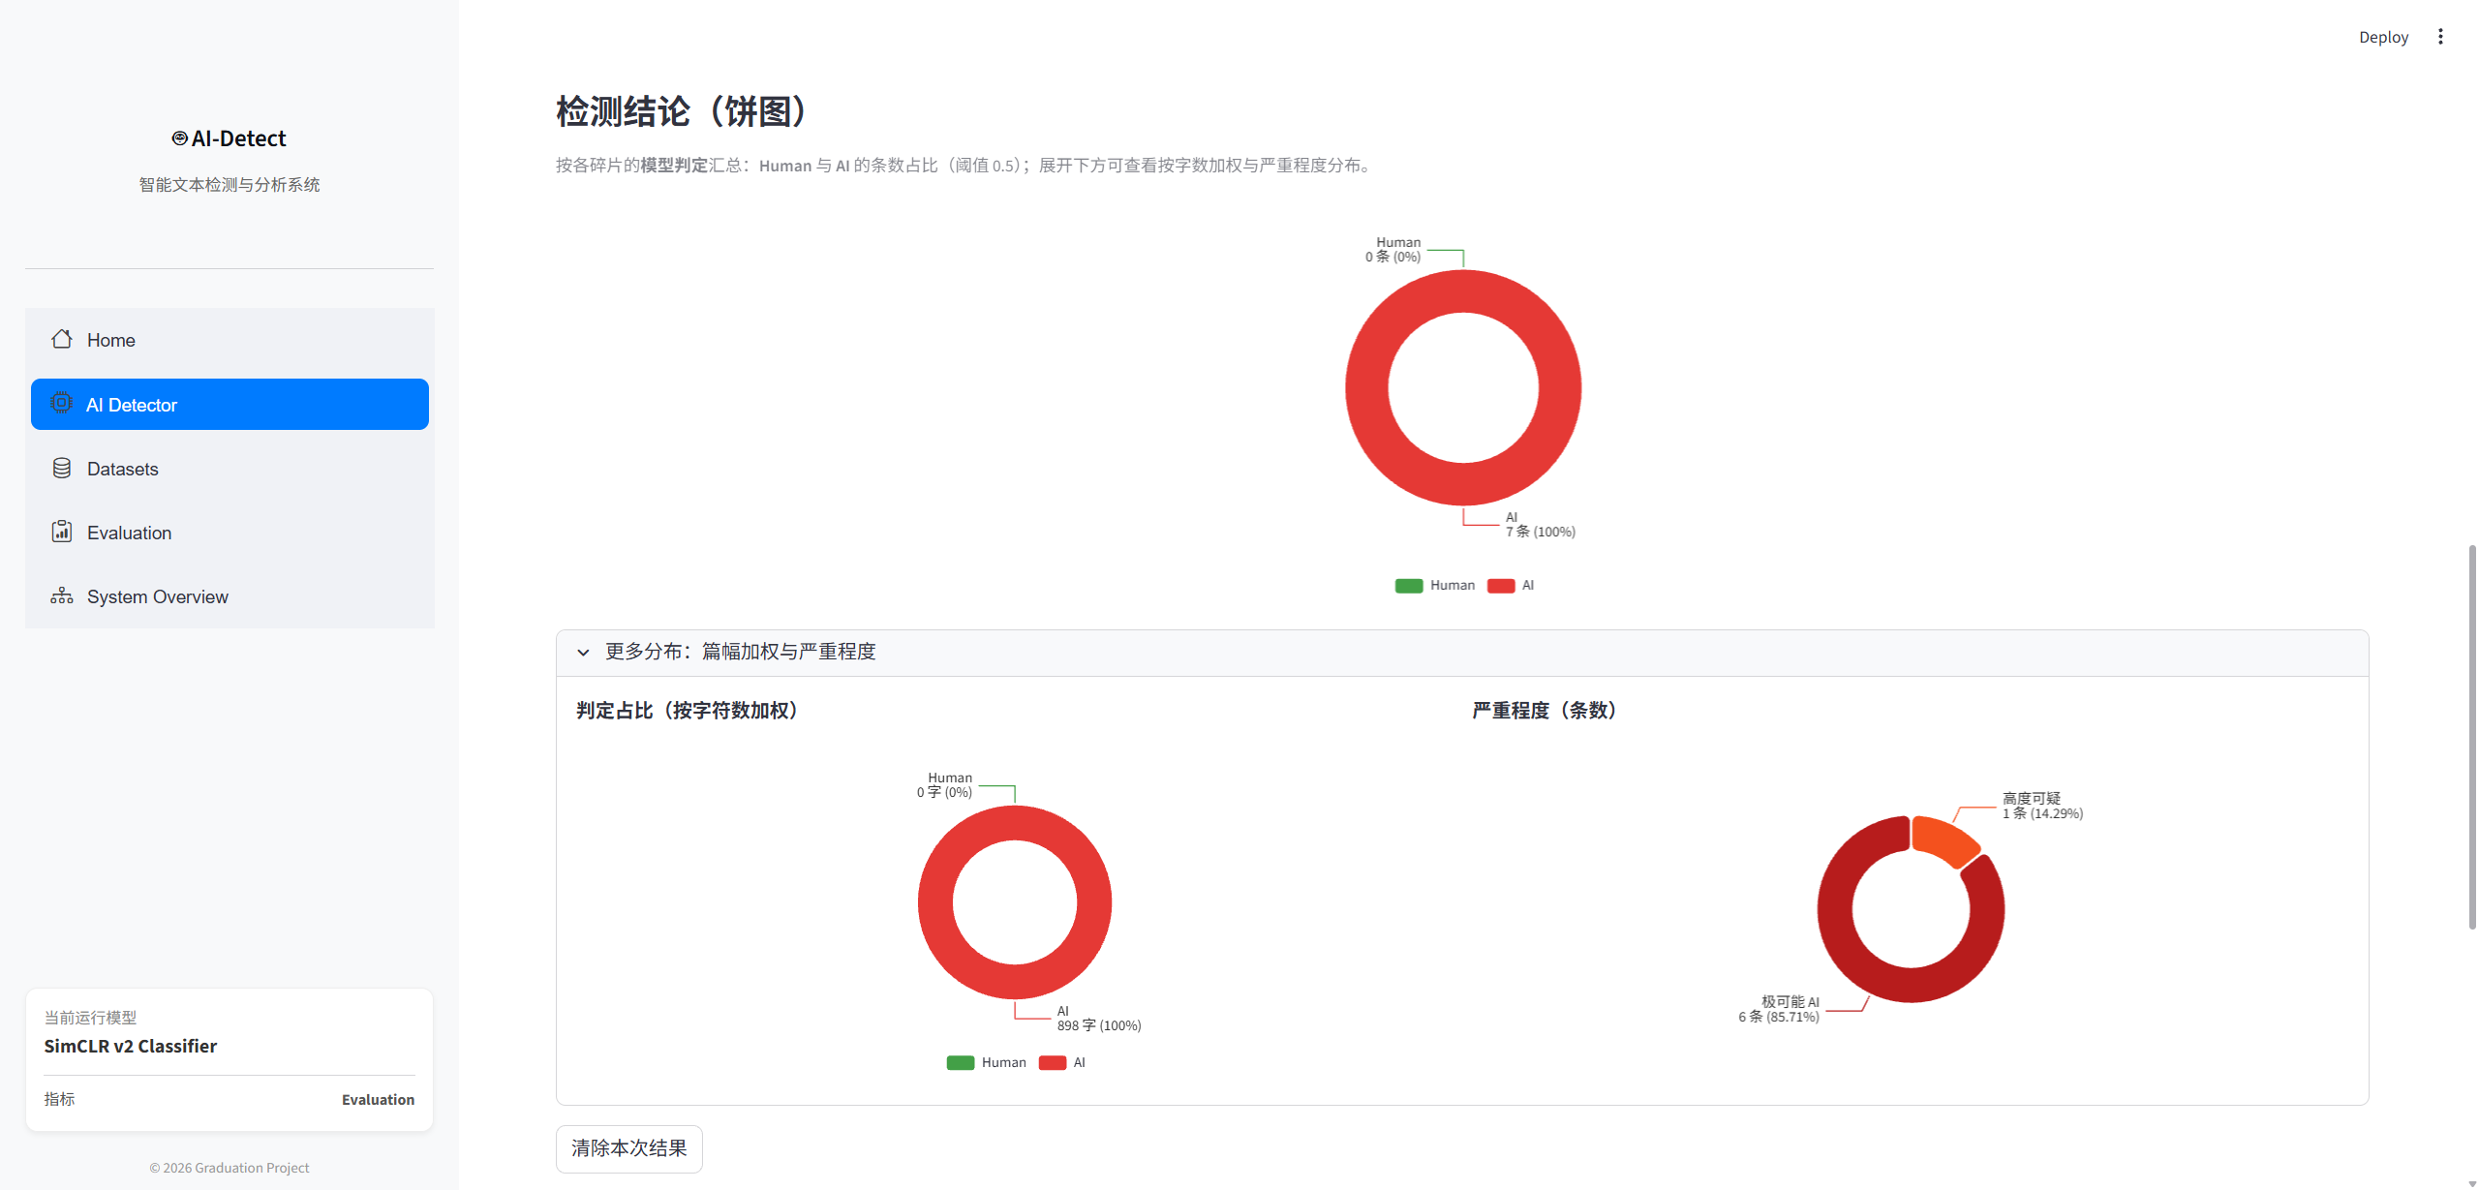
Figure 4-9: AI Detector — results and charts.
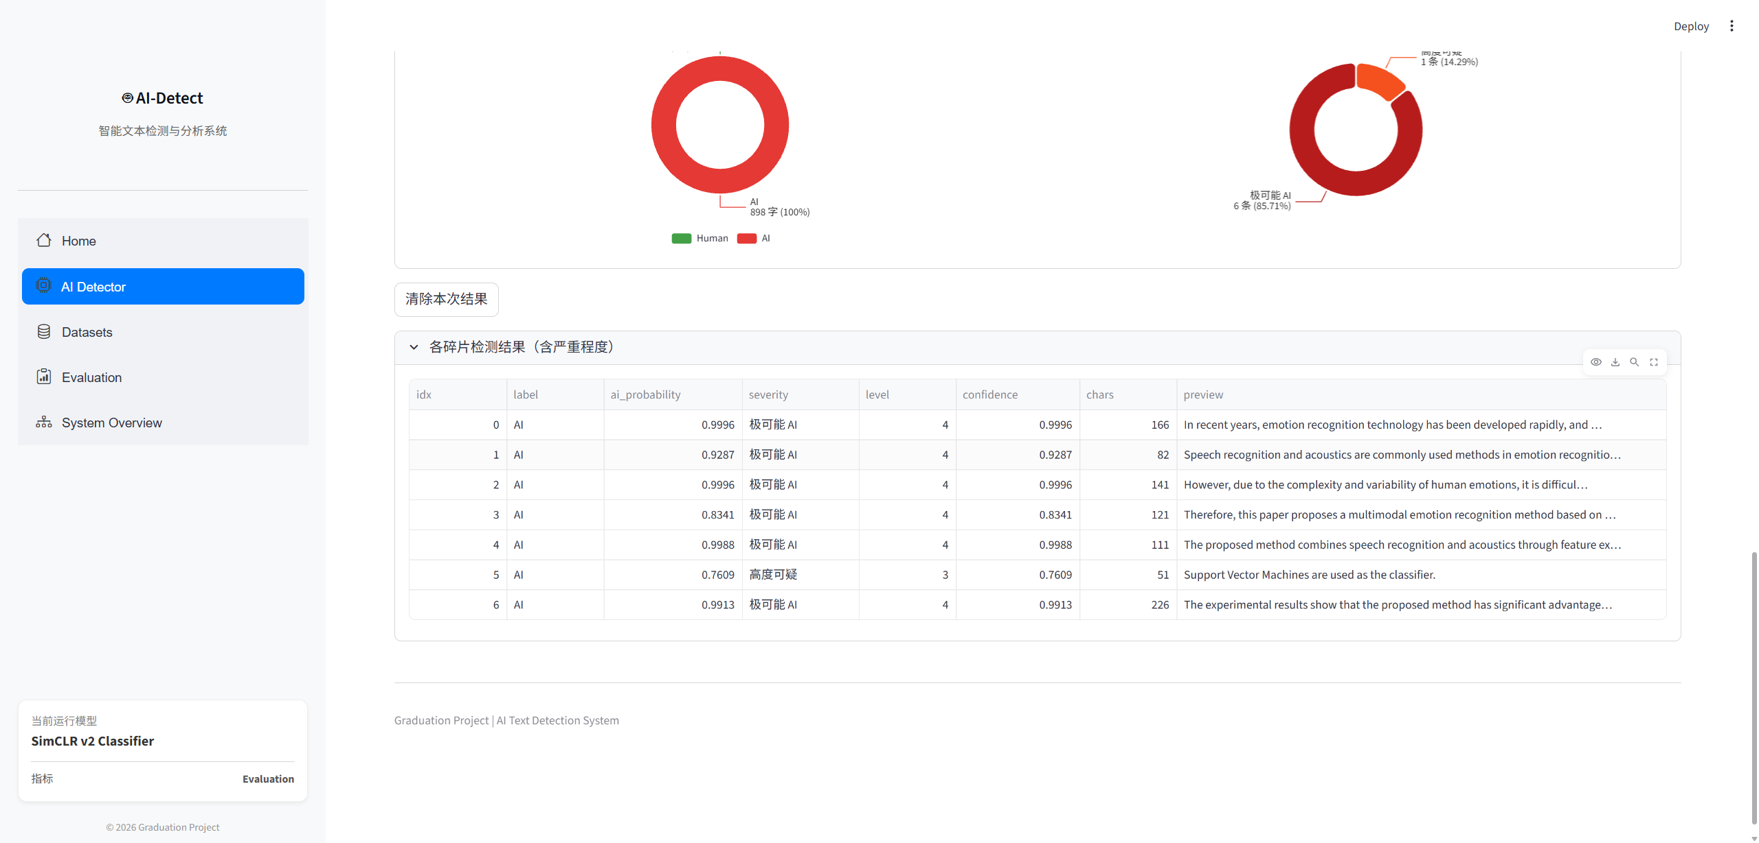
Figure 4-10: AI Detector — results and charts.
(2) Datasets interface
This module supports dataset browsing and job-oriented evaluation. It naturally splits into two interface states:
- Dataset exploration — select a dataset, inspect splits, columns, label distribution, and sampled rows (Figure 4-11,Figure 4-12, Figure 4-13).
- Job submission and outcomes — configure parameters, start a backend job, observe progress, optionally cancel, and read returned metrics and tables when finished (Figure 4-14).
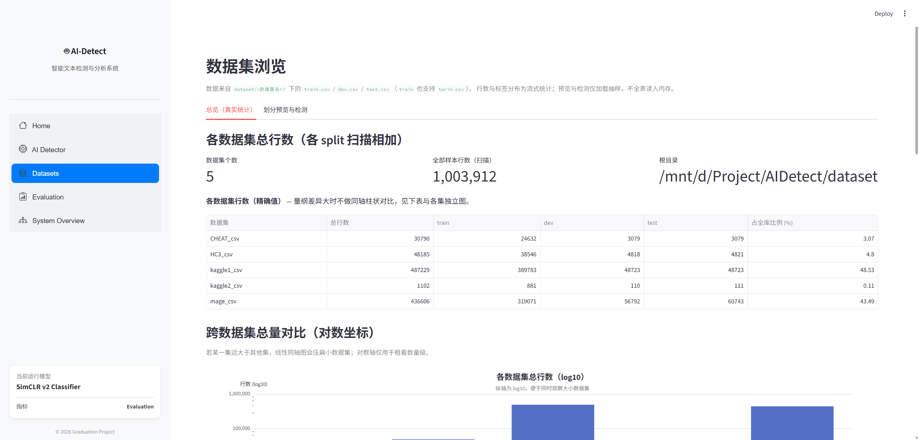
Figure 4-11: Datasets — exploration and statistics.
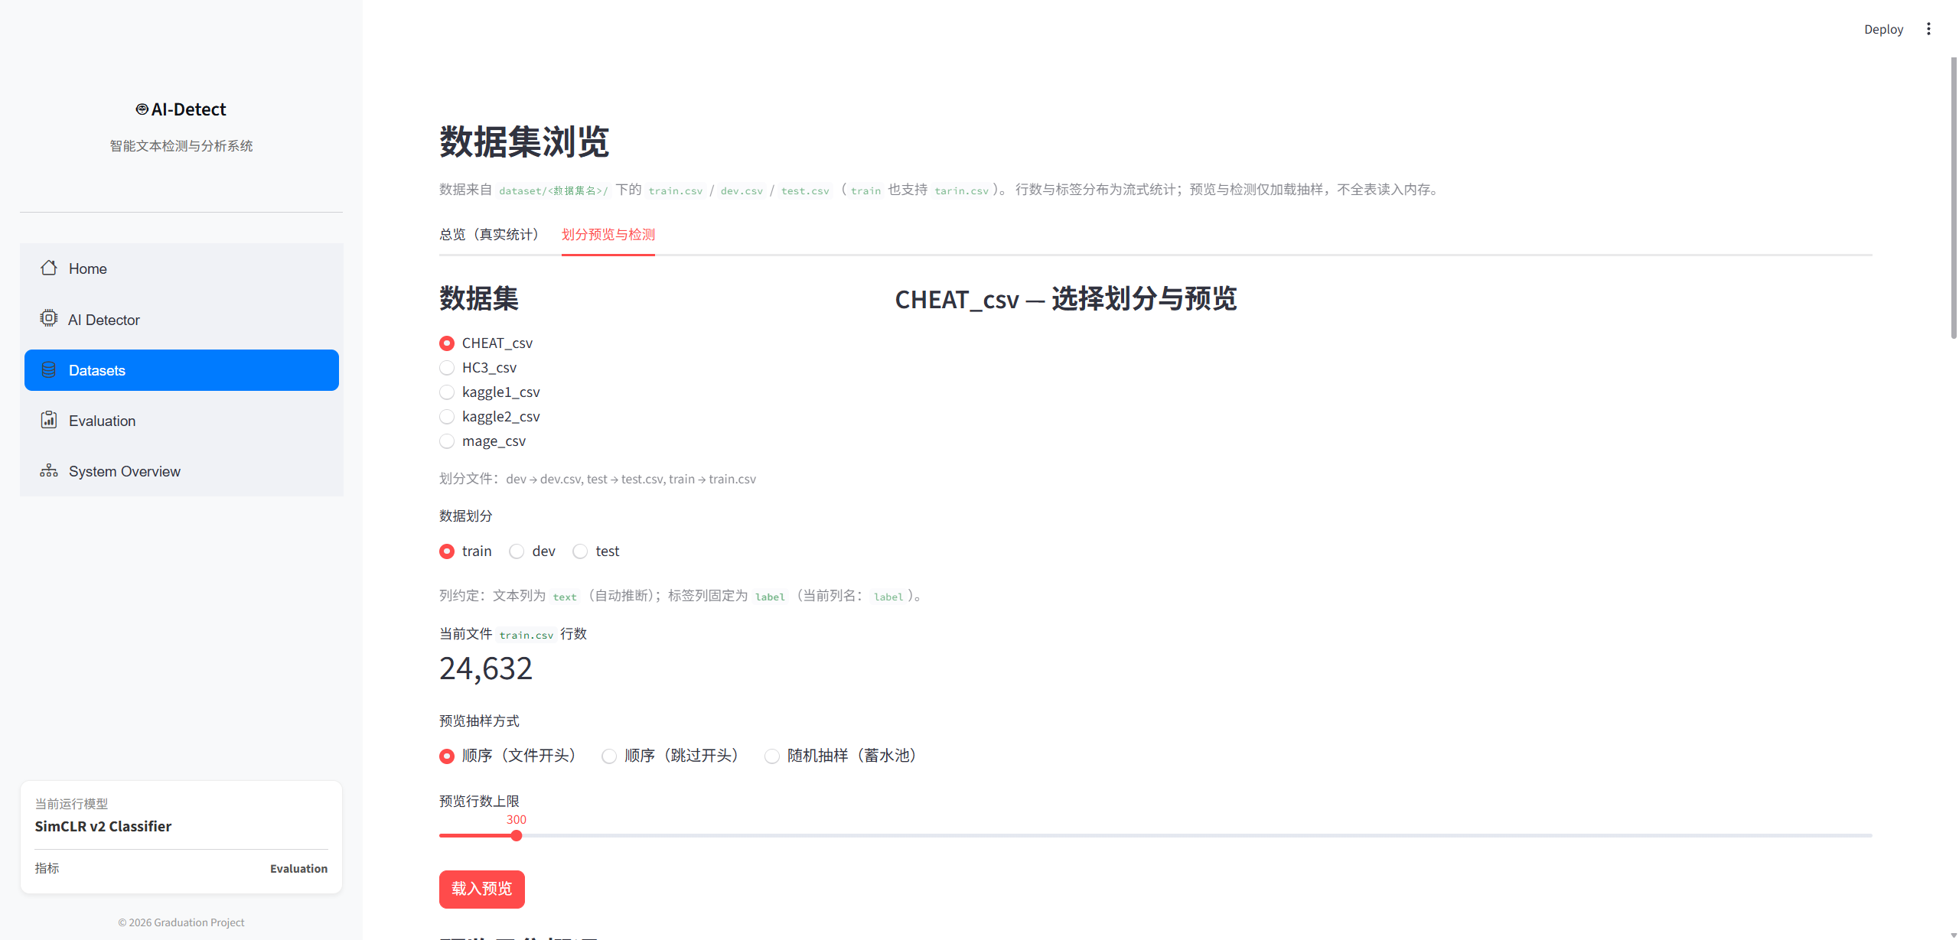
Figure 4-12: Datasets — exploration and statistics.
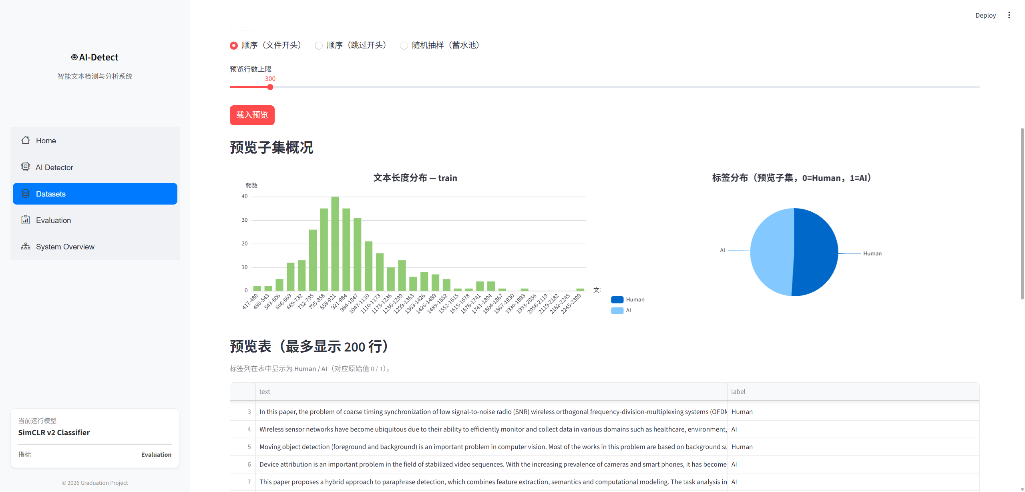
Figure 4-13: Datasets — exploration and statistics.
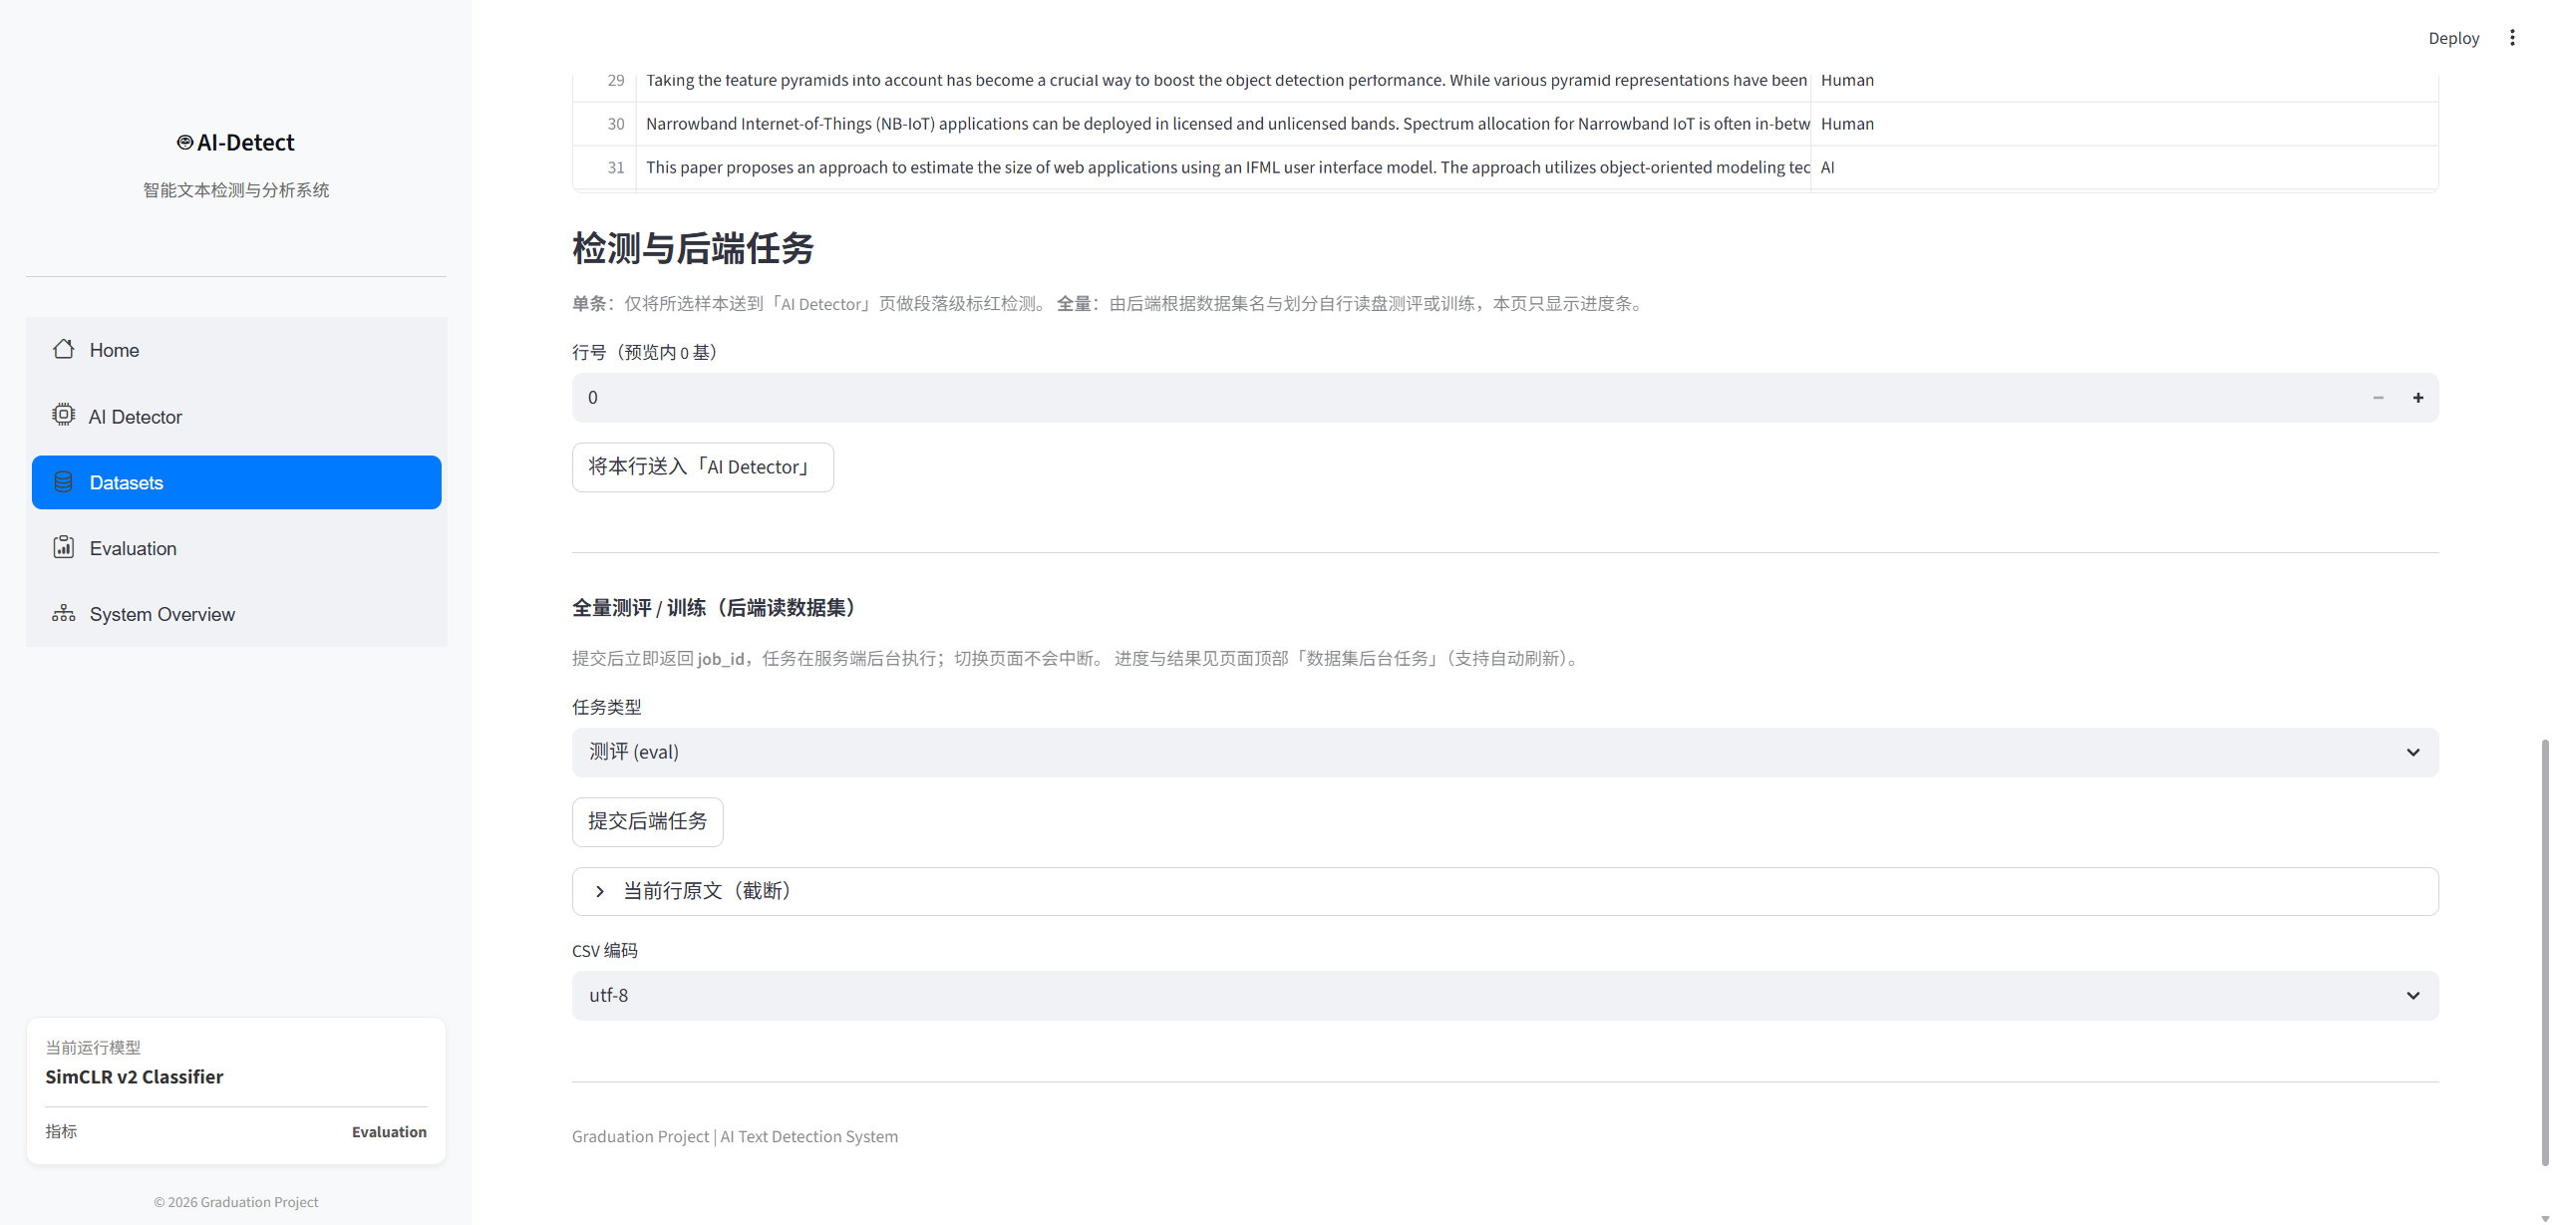
Figure 4-14: Datasets — job submission, progress, and results.
(3) Evaluation help interface
This module is documentation-oriented. It explains common evaluation statistics (for example accuracy, precision/recall/F1, AUC, confusion matrix) in the context of dataset jobs, and states that reportable numbers come from completed jobs on the Datasets page (Figure 4-15).
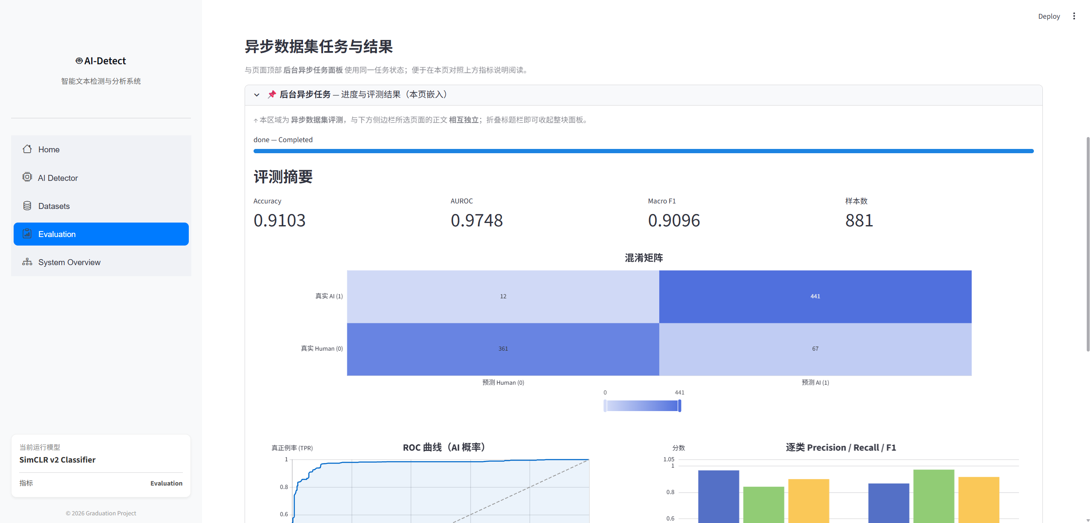
Figure 4-15: Evaluation — metric definitions and usage guidance.

4.4 Chapter Summary
This chapter mainly introduced the design and development of the AI text detection and analysis system. First, the functional requirements and non-functional requirements of the system were analyzed, including interactive AI text detection, dataset-scale evaluation, visualization support, usability, responsiveness, and system interactivity.
Next, the system context and overall functional architecture were presented. The system was divided into several major functional modules, including the interactive AI Detector module, the Datasets evaluation module, and the Evaluation Help module. The roles of different users and the interaction process between the frontend interface, backend API service, and detection models were also discussed through use case diagrams and sequence diagrams.
In addition, this chapter introduced the implementation and interface design of the system in detail. The frontend system was developed using Streamlit, while the backend inference service was implemented using FastAPI. The system supports multiple detection strategies, visualization of prediction results, background dataset evaluation tasks, and interactive statistical analysis. Several interface screenshots and workflow descriptions were provided to demonstrate the usability and functionality of the system.
Overall, this chapter completed the system-level design and implementation description of the proposed AI text detection platform, providing a practical deployment environment for the detection framework proposed in Chapter 3 and demonstrating the practical application value of the research work.

CHAPTER 5: CONCLUSION AND FEATURE WORK

5.1 Conclusion
This project designed and developed an AI text detection and analysis system based on machine learning techniques. With the rapid advancement of large language models, AI-generated text has become increasingly difficult to distinguish from human-written content, which introduces serious challenges in areas such as academic integrity, online content authenticity, and information reliability. Therefore, building a robust and practical AI text detection framework has important academic and practical significance.
In this thesis, a contrastive learning-based AI text detection framework was proposed and implemented. Different from traditional statistical methods and ordinary binary classifiers, the proposed framework combines Transformer-based sentence embedding models, supervised contrastive learning, and embedding-space retrieval mechanisms to improve the robustness and generalization capability of AI-generated text detection.
First, the project reviewed existing AI text detection methods, including statistical feature-based approaches, Transformer-based classifiers, contrastive learning methods, and adversarially robust detection frameworks. The advantages and limitations of different methods were analyzed in detail. Based on these analyses, the DeTeCtive framework was selected as the foundation of the proposed method.
Second, this thesis introduced the overall architecture of the proposed detection framework. A SimCSE-RoBERTa encoder was adopted to generate sentence embeddings, while supervised contrastive learning was used to optimize semantic representation distributions in the embedding space. Two different inference strategies were implemented:
· a neural binary classification detector;
· a FAISS-based KNN retrieval detector.
Experimental results on multiple benchmark datasets demonstrated that the retrieval-based detection strategy achieved stronger cross-domain robustness and more balanced performance than the traditional classifier-based approach. In particular, the KNN retrieval detector achieved better accuracy and F1-score on external datasets such as HC3, CHEAT, and Kaggle datasets, indicating that embedding-space retrieval can effectively reduce overfitting to fixed decision boundaries and improve generalization under unseen domains and unseen language models.
In addition to the detection framework itself, a complete AI text detection and analysis system was also developed in this project. The backend system was implemented using FastAPI, while the frontend interface was developed using Streamlit. The system supports interactive text detection, visualization of detection results, dataset-scale evaluation, background task management, and model performance analysis. Users can conveniently input text, select detection methods, visualize prediction results, and evaluate datasets through an interactive web interface.
Overall, this project successfully combined machine learning algorithms with practical software engineering technologies to build an end-to-end AI text detection platform. The proposed framework achieved strong detection performance and demonstrated good robustness and practical applicability under cross-domain evaluation settings.

5.2 Feature Work
Although the proposed system achieved promising results in AI-generated text detection, several limitations still exist. Future work will mainly focus on improving robustness, scalability, efficiency, and interpretability of the detection framework.
(1) Improve Robustness Against Adversarial Attacks
One important challenge in AI text detection is adversarial paraphrasing[30]. Modern large language models can rewrite AI-generated text into more human-like expressions, which significantly reduces the effectiveness of many existing detectors.
Although the proposed retrieval-based framework demonstrates stronger robustness than ordinary binary classifiers, the system still experiences performance degradation under heavy paraphrasing and style-transfer attacks. Therefore, future work will further explore adversarial training methods, paraphrase augmentation strategies, and robustness-oriented contrastive learning frameworks to improve detection stability under real-world adversarial conditions.
(2) Improve Cross-domain Generalization Ability
Current AI-generated text detectors are often highly dependent on training datasets and specific language models. When evaluated on unseen domains or newly released LLMs, performance degradation may still occur.
Future work will focus on improving the generalization capability of the embedding space. More diverse datasets and additional generator types will be introduced during training. Domain adaptation techniques and self-supervised representation learning strategies may also be explored to improve robustness across different writing styles, topics, and generation distributions.
(3) Explore More Advanced Embedding Models
This project mainly adopts SimCSE-RoBERTa as the sentence embedding backbone. Although it achieves strong performance, recent large embedding models and instruction-tuned encoders may provide stronger semantic representation capability.
Future work may evaluate additional embedding architectures such as:
· BGE series embedding models;
· E5 embedding models;
· Instructor-based embedding models;
· T5-style encoder frameworks.
The influence of different pooling strategies, embedding dimensions, and normalization methods may also be further studied.
(4) Improve Retrieval Efficiency and Scalability
The retrieval-based detection framework relies on FAISS nearest-neighbor search over embedding databases. As the scale of the reference corpus increases, retrieval cost and memory consumption may become important practical issues.[31]
Future work will investigate more efficient vector indexing structures and approximate nearest-neighbor retrieval algorithms to improve scalability. Distributed retrieval systems and hybrid retrieval-classification frameworks may also be explored to support large-scale industrial deployment scenarios.
(5) Improve Interpretability of Detection Results
Although the retrieval-based detector already provides better interpretability than ordinary classifiers through nearest-neighbor examples, the current system still lacks detailed explanations about why a text is classified as AI-generated.
Future work may incorporate:
· attention visualization;
· token-level contribution analysis;
· semantic similarity explanation;
· retrieval example comparison;
· explainable AI techniques.
These methods can help users better understand the reasoning process of the detector and improve trustworthiness in practical applications.

Reference
- Wu J, Yang S, Zhan R, et al. A survey on LLM-generated text detection: necessity, methods, and future directions[J]. Computational Linguistics, 2025, 51(1): 275-338.
- Xiang L, Li N, Liu Y, et al. AI-Generated Text Detection: A Comprehensive Review of Active and Passive Approaches[J]. Computers, Materials & Continua, 2026, 86(3).
- Sadasivan V S, Kumar A, Balasubramanian S, et al. Can AI-Generated Text be Reliably Detected?[A]. arXiv, 2025.
- Liu X, Kong L. AI Text Detection Method Based on Perplexity Features with Strided Sliding Window[C]//FAGGIOLI G, FERRO N, GALUŠČÁKOVÁ P, et al. Working Notes of the Conference and Labs of the Evaluation Forum (CLEF 2024): Vol. 3740. Grenoble, France: CEUR, 2024: 2755-2760.
- Alikhanov A, Amangeldi A, Demeubay D, et al. AI Generated Text Detection[A]. arXiv, 2026.
- Habibzadeh F. GPTZero Performance in Identifying Artificial Intelligence-Generated Medical Texts: A Preliminary Study[J]. Journal of Korean Medical Science, 2023, 38(38).
- Hu X, Chen P Y, Ho T Y. RADAR: robust AI-text detection via adversarial learning[J]. Advances in Neural Information Processing Systems, 2023, 36: 15077-15095.
- Yadagiri A, Shree L, Parween S, et al. Detecting AI-Generated Text with Pre-Trained Models Using Linguistic Features[C]//LALITHA DEVI S, ARORA K. Proceedings of the 21st International Conference on Natural Language Processing (ICON). AU-KBC Research Centre, Chennai, India: NLP Association of India (NLPAI), 2024: 188-196.
- Sundararaj J, Maruthavanan D, Jayabalan D, et al. Robust detection of LLM-generated text through transfer learning with pre-trained Distilled BERT model[J]. European Journal of Computer Science and Information Technology, 2024, 12(9): 61-74.
- Khan H U, Naz A, Alarfaj F K, et al. Identifying artificial intelligence-generated content using the DistilBERT transformer and NLP techniques[J]. Scientific Reports, 2025, 15(1): 20366.
- Gakpetor J M, Doe M, Damoah M Y S, et al. AI-generated and human-written text detection using DistilBERT[C]//2024 IEEE SmartBlock4Africa. 2024: 1-7.
- Bafna J, Mittal H, Sethia S, et al. Mast kalandar at SemEval-2024 task 8: on the trail of textual origins: RoBERTa-BiLSTM approach to detect AI-generated text[C]//OJHA A Kr, DOĞRUÖZ A S, TAYYAR MADABUSHI H, et al. Proceedings of the 18th International Workshop on Semantic Evaluation (SemEval-2024). Mexico City, Mexico: Association for Computational Linguistics, 2024: 1627-1633.
- Doughman J, Mohammed Afzal O, Toyin H O, et al. Exploring the limitations of detecting machine-generated text[C]//RAMBOW O, WANNER L, APIDIANAKI M, et al. Proceedings of the 31st International Conference on Computational Linguistics. Abu Dhabi, UAE: Association for Computational Linguistics, 2025: 4274-4281..
- THORAT S, YANG T. Which LLMs are difficult to detect? A detailed analysis of potential factors contributing to difficulties in LLM text detection[C]//Neurips Safe Generative AI Workshop 2024. 2024.
- Guo X, Zhang S, He Y, et al. DeTeCtive: detecting AI-generated text via multi-level contrastive learning[J]. Advances in Neural Information Processing Systems, 2024, 37: 88320-88347..
- Cava L L, Costa D, Tagarelli A. Is contrasting all you need? Contrastive learning for the detection and attribution of AI-generated text[M]. 2024.
- Bhattacharjee A, Kumarage T, Moraffah R, et al. ConDA: contrastive domain adaptation for AI-generated text detection[C]//PARK J C, ARASE Y, HU B, et al. Proceedings of the 13th International Joint Conference on Natural Language Processing and the 3rd Conference of the Asia-Pacific Chapter of the Association for Computational Linguistics (Volume 1: Long Papers). Nusa Dua, Bali: Association for Computational Linguistics, 2023: 598-610.
- Huang G, Zhang Y, Li Z, et al. Are AI-generated text detectors robust to adversarial perturbations?[C]//KU L W, MARTINS A, SRIKUMAR V. Proceedings of the 62nd Annual Meeting of the Association for Computational Linguistics (Volume 1: Long Papers). Bangkok, Thailand: Association for Computational Linguistics, 2024: 6005-6024.
- Vaswani A, Shazeer N, Parmar N, et al. Attention is all you need[C]//Advances in Neural Information Processing Systems: Vol. 30. Curran Associates, Inc., 2017.
- [1] LIU Y, OTT M, GOYAL N, et al. RoBERTa: a robustly optimized BERT pretraining approach[C]//ICLR 2020. 2019..
- Sanh V, Debut L, Chaumond J, et al. DistilBERT, a distilled version of BERT: smaller, faster, cheaper and lighter[A]. arXiv, 2020.
- Xiao S, Liu Z, Zhang P, et al. C-pack: packed resources for general chinese embeddings[C]//Proceedings of the 47th International ACM SIGIR Conference on Research and Development in Information Retrieval. New York, NY, USA: Association for Computing Machinery, 2024: 641-649.
- Raffel C, Shazeer N, Roberts A, et al. Exploring the limits of transfer learning with a unified text-to-text transformer[J]. J. Mach. Learn. Res., 2020, 21(1): 140:5485-140:5551.
- Gao T, Yao X, Chen D. SimCSE: simple contrastive learning of sentence embeddings[A]. arXiv, 2022.
- Li Y, Li Q, Cui L, et al. MAGE: machine-generated text detection in the wild[EB/OL]. (2023-05-22)[2026-05-14]. https://arxiv.org/abs/2305.13242v3.
- Su Z, Wu X, Zhou W, et al. HC3 plus: a semantic-invariant human ChatGPT comparison corpus[A]. arXiv, 2024.
- Yu P, Chen J, Feng X, et al. CHEAT: a large-scale dataset for detecting ChatGPT-writtEn AbsTracts[A]. arXiv, 2024.
- https://www.kaggle.com/datasets/shanegerami/ai-vs-human-text/data
- https://www.kaggle.com/datasets/prajwaldongre/llm-detect-ai-generated-vs-student-generated-text/data
- Yang Y, Yih W tau, Meek C. WikiQA: a challenge dataset for open-domain question answering[C]//MÀRQUEZ L, CALLISON-BURCH C, SU J. Proceedings of the 2015 Conference on Empirical Methods in Natural Language Processing. Lisbon, Portugal: Association for Computational Linguistics, 2015: 2013-2018.
- Krishna K, Song Y, Karpinska M, et al. Paraphrasing evades detectors of AI-generated text, but retrieval is an effective defense[C]//Thirty-seventh Conference on Neural Information Processing Systems. 2023.

Acknowledgment
感谢大学期间帮助我的老师同学，也感谢大学努力的自己。

