


本科毕业设计说明书（论文）
Undergraduate International Students’ Graduation Project Report (Thesis)

通道选择性融合的时间序列预测方法
CHANNEL SELECTIVE FUSION FOR TIME SERIES FORECASTING

学 院： 计算机科学与技术学院、软件学院
专 业： 软件工程（中外合作办学）
班 级： 2022软件工程（中外合作办学）02
学 号： 202203340222
学生姓名： 徐升翔
指导老师： 景宸琛
提交日期： 2026年6月

摘 要
多变量时间序列预测在气象预测、电力系统及交通分析等领域具有重要应用价值。然而，由于时间序列数据通常具有长时间依赖关系以及变量之间复杂的耦合特性，传统方法难以同时有效建模时间维度和通道维度的信息交互。
近年来，基于状态空间模型的 Mamba 网络在长序列建模方面展现出较强的能力，但其在多变量通道建模方面仍存在不足。针对该问题，本文在 Mamba 模型的基础上，提出一种基于通道选择性融合的多变量时间序列预测方法。该方法首先利用 Mamba 模型对时间序列进行高效建模，然后通过计算不同通道之间的相关性，筛选出与目标变量相关性较高的 Top-K 通道，并进行加权融合，从而增强关键变量信息并抑制冗余噪声。
为了验证所提出方法的有效性，本文在 ETTh1 和 Weather 等公开数据集上进行了实验，并对模型参数设置进行了分析，同时与基础模型进行了对比。实验结果表明，所提出的通道选择性融合方法在均方误差（MSE）和平均绝对误差（MAE）等指标上均取得了更优的性能，验证了该方法在多变量时间序列预测任务中的有效性。
综上所述，本文提出的基于通道选择性融合的 Mamba 模型能够有效提升多变量时间序列预测精度，为相关领域提供了一种可行且高效的解决方案。

关键词： 时间序列预测；Mamba；通道融合；多变量预测；深度学习

ABSTRACT
Multivariate time series forecasting plays an important role in various fields such as weather prediction, power systems, and traffic analysis. However, due to the existence of long-term temporal dependencies and complex interactions among multiple variables, traditional methods often struggle to effectively model both temporal dynamics and inter-channel relationships.
Recently, the Mamba model based on state space modeling has demonstrated strong capability in handling long-sequence dependencies. However, it still has limitations in modeling relationships among multiple channels. To address this issue, this paper proposes a channel-selective fusion method based on the Mamba framework for multivariate time series forecasting. Specifically, the proposed method first utilizes the Mamba model to capture temporal dependencies efficiently. Then, by calculating the correlations among different channels, the Top-K most relevant channels are selected and fused with weighted aggregation, which enhances informative features while suppressing redundant noise.
To validate the effectiveness of the proposed method, experiments are conducted on public datasets including ETTh1 and Weather. The performance of different parameter settings is analyzed, and comparisons are made with baseline models. Experimental results show that the proposed method achieves better performance in terms of Mean Squared Error (MSE) and Mean Absolute Error (MAE), demonstrating its effectiveness in multivariate time series forecasting tasks.
In conclusion, the proposed channel-selective fusion Mamba model effectively improves prediction accuracy and provides a practical and efficient solution for multivariate time series forecasting.

Keywords: Multivariate time series forecasting; Mamba; channel fusion; deep learning; time series prediction

CONTENT

目录
摘 要 I
ABSTRACT I
CONTENT III
CHAPTER 1: INTRODUCTION 1
1.1 Background 1
1.2 The Purpose and Significance of Project 2
1.3 About system 3
1.4 The Organization of This Article 3
1.5 Chapter Summary 4
CHAPTER 2: RELATED WORK 5
2.1 Methods on Time Series Forecasting 5
2.1.1 Traditional Machine Learning Methods 5
2.1.2 Deep Learning Methods 5
2.1.3 Research Status and Development Trend Analysis 6
2.2 Related Techniques on Project 7
2.2.1 Deep learning framework ( PyTorch ) 7
2.2.2 State space model and Mamba 7
2.2.3 Channel modeling and fusion technology 8
2.2.4 Time series data preprocessing method 9
2.3 Chapter Summary 10
CHAPTER 3: Multivariate time series prediction method design and experimental analysis 11
3.1 Overall Idea 11
3.2 Problem Formulation 12
3.3 Data Preprocessing 13
3.3.1 Removing the Time Column 13
3.3.2 Data Standardization 14
3.3.3 Dataset Splitting 14
3.3.4 Sliding Window Construction 14
3.4 Channel Selective Fusion Module 15
3.4.1 Channel Correlation Calculation 15
3.4.2 Top-K Channel Selection 16
3.4.3 Weighted Residual Fusion 17
3.5 Mamba-based Temporal Modeling Module 17
3.5.1 Input Projection 18
3.5.2 Gated Temporal Feature Extraction 18
3.5.3 Bidirectional Temporal Modeling 19
3.6 Forecasting Output Module 19
3.7 Overall Algorithm Process 20
3.8 Model Training Process 23
3.9 Model Characteristics 24
3.10 Chapter Summary 24
CHAPTER 4: EXPERIMENTS AND ANALYSIS 25
4.1Introduction 25
4.2 Dataset Description 26
4.3 Evaluation Metrics 27
4.3.1 Mean Squared Error 27
4.3.2 Mean Absolute Error 28
4.3.3 Root Mean Squared Error 28
4.3.4 Mean Absolute Percentage Error 28
4.4 Experimental Environment and Parameter Settings 28
4.4.1 Experimental Environment 28
4.4.2 Main Parameter Settings 29
4.5 Main Comparison Experiments 29
4.5.1 Experimental Design 29
4.5.2 Results on ETTh1 30
4.5.3 Results on ETTh2 30
4.5.4 Results on ETTm1 31
4.5.5 Results on ETTm2 31
4.5.6 Results on Weather 32
4.6 Overall Comparison and Analysis 32
4.7 Parameter Discussion and Analysis 34
4.7.1 Influence of Input Sequence Length 34
4.7.2 Influence of Top-K Channel Selection 35
4.7.3 Influence of Fusion Weight 36
4.8 Additional Structural Analysis 36
4.8.1 Analysis of DCS Module 36
4.8.2 Analysis of Positive Correlation Filtering 37
4.9 Discussion 37
4.10 Chapter Summary 38
CHAPTER 5: CONCLUSION AND FUTURE WORK 39
5.1 Conclusion 39
5.2 Future Work 40
5.3 Chapter Summary 41
Reference 42
Acknowledgment 45

CHAPTER 1: INTRODUCTION

1.1 Background
With the rapid development of information technology and data acquisition technology, a large number of multivariate time series data are generated in various application scenarios, such as meteorological monitoring, power load forecasting, traffic flow analysis and industrial control systems. These data usually have time continuity and multivariate coupling, which is of great significance for accurate prediction of future trends [1].
The core task of multivariate time series prediction is to predict multiple variables over a period of time in the future based on a given historical observation data. However, time series data often have long-term dependencies, nonlinear dynamic changes, and complex correlations between variables, making the prediction task more challenging. Traditional statistical methods ( such as ARIMA model ) are usually based on linear assumptions, which are difficult to effectively deal with high-dimensional complex data [2]. Although deep learning-based methods ( such as recurrent neural networks and Transformer models ) have improved prediction performance to a certain extent, there are still problems with high computational complexity or difficulty in efficiently modeling long sequence dependencies [3].
In recent years, Mamba networks based on State Space Model ( SSM ) [16] have shown good performance in long sequence modeling [4]. The model achieves effective modeling of long-term dependence through linear complexity, and has strong potential in time series prediction tasks. However, the existing Mamba-based methods mainly focus on the information modeling of the time dimension, and lack of modeling of the channel relationship between multiple variables. They usually adopt a unified channel processing method, ignoring the difference in the importance of different variables in the prediction task.
In fact, in multivariate time series, the contribution of different channels to the prediction target is often uneven [5]. Some variables have a strong correlation with the target, while others may contain redundant or even interference information. If the key variables can be effectively identified and utilized, it will help to improve the prediction performance of the model. Therefore, how to further enhance the information expression ability of the channel dimension while maintaining the time modeling ability has become an important research direction in the current multivariate time series prediction.
In view of the above problems, this paper introduces a channel selective fusion mechanism based on the Mamba model. By calculating the correlation between variables, the most relevant channels are selected for information fusion, so as to improve the model 's ability to capture key features and reduce the interference of irrelevant information.

1.2 The Purpose and Significance of Project
Multivariate time series prediction has important application value in the fields of meteorological prediction, power system, traffic management and industrial production. With the continuous growth of data scale and the increasingly complex relationship between variables, traditional methods face great challenges in dealing with high-dimensional nonlinear time series data. Therefore, it is of great theoretical significance and practical application value to study efficient and accurate multivariate time series prediction methods. From a theoretical point of view, although the existing time series prediction methods based on deep learning have made some progress in time dimension modeling, there are still some shortcomings in channel dimension modeling. The contribution of different variables to the prediction results is different. If all channels are processed uniformly, it is easy to introduce redundant information or even noise interference. In order to solve the above problems, this paper introduces a channel selective fusion mechanism based on the Mamba model. By calculating the correlation between channels, the Top-K channels that contribute more to the prediction task are selected, and weighted fusion is performed to enhance the expression ability of key features and suppress irrelevant information interference. In practical applications, this method helps to improve the accuracy of tasks such as weather forecasting and power load forecasting. At the same time, it has low computational complexity and good scalability, and can meet the needs of large-scale time series data processing.
Based on the above research significance, this paper focuses on the channel modeling problem in multivariate time series prediction [6]. The main objectives include : analyzing the correlation characteristics between different channels and exploring the influence of channel selection mechanism on prediction performance ; based on the Mamba model, the channel selective fusion module is designed. By screening the Top-K high correlation channels and performing weighted fusion, the model 's ability to use key variable information is improved. A complete time series prediction model is constructed and verified on public data sets such as ETTh1 and Weather. The improvement of the proposed method in terms of prediction accuracy and model performance was evaluated by comparative experiments and ablation experiments. At the same time, the influence of key parameters ( such as batch size, top-k, etc. ) on the prediction results is analyzed to provide a reference for model optimization.

1.3 About system
Back-end Language: Python
Deep Learning Framework: Python
Data Processing Library: NumPy、Pandas
Visualization Tool: Matplotlib
Operating System: Windows 11
IDE: Pycharm
GPU: NVIDIA GeForce RTX 3060 Laptop GPU (6 GB)

1.4 The Organization of This Article
Chapter 1: Mainly introduces the research background, significance, and objectives of the project. It also briefly describes the development environment and system configuration used in this study.
Chapter 2: Reviews the related work on time series forecasting, including traditional statistical methods, deep learning-based approaches, and recent Mamba-based models. A summary of existing methods and their limitations is also provided.
Chapter 3: Presents the proposed method, which is the core of this paper. It introduces the overall architecture of the Mamba-based model and describes the channel-selective fusion mechanism in detail, including its design and implementation.
Chapter 4: Describes the experimental setup and presents the experimental results. Comparative experiments and ablation studies are conducted to evaluate the effectiveness of the proposed method and analyze the impact of different parameters.
Chapter 5: Concludes the paper by summarizing the main contributions and findings. It also discusses the limitations of the current work and outlines possible directions for future research.

1.5 Chapter Summary
This chapter mainly introduces the research background, research significance and research objectives of this paper, analyzes the key problems in multivariate time series prediction, and expounds the necessity of carrying out this research. On this basis, the development environment and experimental platform used in this paper are explained, and the technical framework and hardware conditions on which the model implementation depends are clarified. At the same time, the overall structure of the paper is summarized, which lays the foundation for the subsequent chapters.It should be noted that the experiment in this paper uses public time series data sets ( such as ETTh1 and Weather ) to ensure the repeatability and fairness of the experimental results. Finally, this chapter gives an overall organizational description of the full text, which provides a clear logical structure for the follow-up related work review and method design.

CHAPTER 2: RELATED WORK

2.1 Methods on Time Series Forecasting
Time series prediction refers to the use of historical time series data to predict the trend of data change in the next period of time [6]. It has important application value in the fields of meteorological prediction, power load prediction, traffic flow analysis and so on. With the continuous growth of data scale and the improvement of application requirements, time series prediction methods are also developing and evolving.

2.1.1 Traditional Machine Learning Methods
Traditional machine learning methods are a class of methods used earlier in the field of time series prediction, including autoregressive model ( AR ), moving average model ( MA ), autoregressive integrated moving average model ( ARIMA ) and support vector regression ( SVR ) [7]. Such methods are usually based on statistical principles and achieve prediction by modeling time series data.
Among them, the ARIMA model makes the data meet the stationarity hypothesis by differential processing of the sequence, so as to establish a linear regression relationship ; the SVR model maps the data to a high-dimensional space through a kernel function to achieve nonlinear fitting. These methods have certain advantages in scenarios where the data scale is small and the change rule is relatively simple.
However, traditional methods generally rely on artificial feature extraction, and it is difficult to automatically learn deep features in complex data. At the same time, when dealing with multivariate time series data, such methods are difficult to effectively model the complex relationship between variables, and the prediction performance is limited.

2.1.2 Deep Learning Methods
With the development of deep learning technology, neural network-based time series forecasting methods have gradually become the mainstream. Typical recurrent models include Recurrent Neural Network (RNN), Long Short-Term Memory (LSTM), and Gated Recurrent Unit (GRU). RNN is one of the earliest neural network structures used for sequential data modeling, which processes the input sequence step by step and uses hidden states to store historical information [8]. However, traditional RNNs may suffer from gradient vanishing or gradient explosion when modeling long sequences.
To address the difficulty of long-term dependency modeling, LSTM introduces memory cells and gate mechanisms to control the information flow in recurrent networks [9]. Compared with standard RNN, LSTM can better preserve useful historical information and reduce the influence of irrelevant information. GRU further simplifies the gating structure by combining some gates in LSTM, which reduces the number of parameters while maintaining effective sequence modeling ability [10]. These recurrent models have been widely used in time series forecasting tasks, but their sequential computation makes them less efficient when dealing with very long sequences.
On this basis, the Transformer model has been introduced into time series forecasting tasks. Transformer uses the self-attention mechanism to model relationships between different time steps in a sequence [11]. Compared with recurrent models, Transformer has stronger parallel computing ability and can capture long-range dependencies more directly. Informer further improves Transformer-based long sequence forecasting by introducing ProbSparse self-attention, which reduces the computational cost of attention calculation [3].
After Informer, many improved Transformer-based forecasting models have been proposed. Autoformer introduces a decomposition architecture and an auto-correlation mechanism to capture long-term dependencies more effectively [12]. FEDformer further combines seasonal-trend decomposition with frequency-domain representation to improve long-term forecasting performance [13]. PatchTST divides time series into patches and applies Transformer to long-term forecasting, reducing the input length and improving representation ability [14]. TimesNet transforms one-dimensional time series into two-dimensional representations to model complex temporal variations [15]. These methods show that Transformer-based structures have strong modeling ability in long-term forecasting tasks, but they may still face high computational cost when the input sequence becomes very long.
In recent years, research based on State Space Models (SSMs) has gradually emerged. Structured state space models provide an efficient way to model long sequences with lower computational complexity [16]. Mamba further introduces a selective state update mechanism, which allows the model to dynamically select useful information according to the input sequence [4]. Compared with standard Transformer-based models, Mamba has advantages in computational efficiency and long-sequence modeling, making it a promising model for time series forecasting.
To more clearly compare the development of different time series forecasting methods, Figure 2-1 summarizes several typical model families, including traditional statistical models, machine learning models, deep learning models, and state space models.
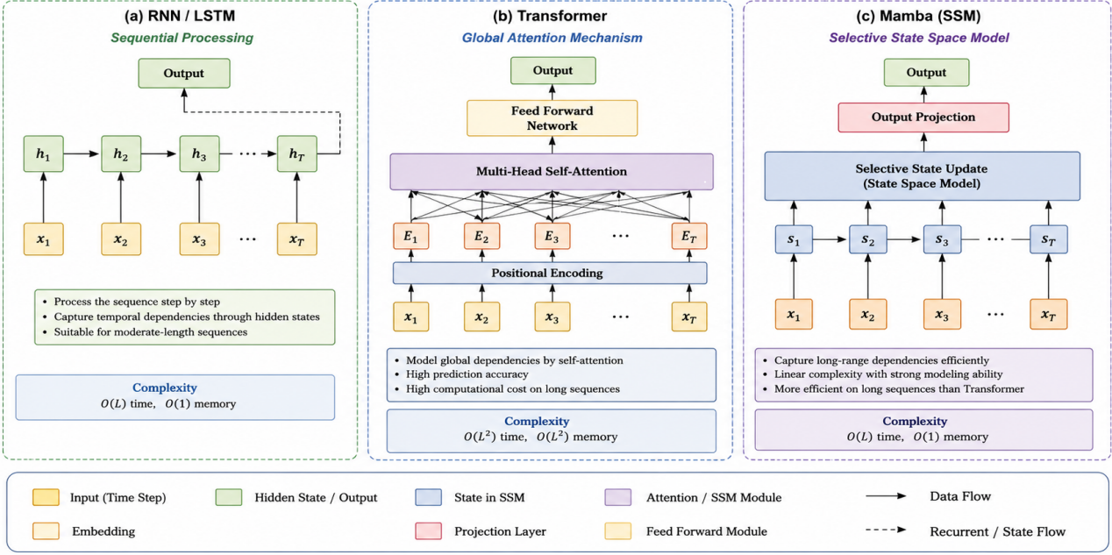
Figure 2-1 Comparison of Typical Time Series Models，adapted from [1]

2.1.3 Research Status and Development Trend Analysis
Through the analysis of the above methods, it can be seen that time series forecasting models have developed from traditional statistical methods to deep learning methods. Traditional methods such as ARIMA and SVR have simple structures and good interpretability, but they usually rely on manual feature design and linear assumptions. Deep learning models can automatically extract temporal features from data, but they still face challenges such as high model complexity, long-sequence modeling difficulty, and insufficient utilization of multivariate channel information.
For multivariate time series forecasting, one important research direction is to improve the model’s ability to capture cross-variable dependencies. Crossformer uses cross-dimension dependency modeling to enhance multivariate time series forecasting [17]. SOFTS further studies efficient multivariate forecasting with series-core fusion, showing that the interaction among variables plays an important role in forecasting performance [18]. These studies indicate that modeling the relationship between variables is an important direction for improving multivariate forecasting models.
In addition to Transformer-based methods, some recent studies explore efficient non-Transformer architectures for time series forecasting. TSMixer uses an all-MLP architecture to mix temporal and feature information [19]. TiDE designs a dense encoder-decoder structure for long-term time series forecasting [20]. SCINet models temporal dependencies through sample convolution and interaction [21]. TimeMixer introduces decomposable multiscale mixing for time series forecasting [22]. ModernTCN revisits pure convolution structures and shows that convolution-based models can still be effective for general time series analysis [23]. These studies show that the design of efficient forecasting architectures is still an active research topic.
With the development of large-scale models, time series forecasting has also begun to explore foundation-model-style methods. Chronos formulates time series forecasting as a language modeling problem and applies pretrained sequence models to forecasting tasks [24]. MOMENT provides a family of open time-series foundation models and explores general-purpose time series representation learning [25]. These studies indicate that time series forecasting is developing toward more general and scalable modeling frameworks.
Overall, the current development trends of time series forecasting mainly include three aspects. First, models need to improve long-sequence modeling ability while reducing computational complexity. Second, multivariate forecasting models should better capture channel relationships and cross-variable dependencies. Third, forecasting models should improve their generalization ability across different datasets and prediction horizons. Based on the above analysis, this paper chooses Mamba as the temporal modeling backbone and introduces a channel selective fusion mechanism to improve multivariate channel modeling ability.

2.2 Related Techniques on Project
In order to realize the multivariate time series prediction model proposed in this paper, a variety of key technologies need to be combined, including deep learning framework, state space model and channel fusion mechanism.

2.2.1 Deep learning framework ( PyTorch )
This project uses PyTorch as the main development framework. PyTorch is a deep learning framework based on dynamic computational graphs. It has the advantages of flexible structure and convenient debugging, and is widely used in academic research and engineering practice.
Through PyTorch, complex neural network models can be easily constructed and GPU-accelerated computing can be supported, thereby significantly improving model training efficiency. At the same time, its rich function library provides good support for model design and experimental analysis.

2.2.2 State space model and Mamba
The state space model is a mathematical model used to describe the dynamic system, and the system is modeled by state variables. In the time series prediction task, the state space model can be used to describe the dynamic change process of the sequence.
The Mamba model is a sequence modeling method developed on the basis of the traditional state space model. By introducing a selectivity mechanism, the model can dynamically adjust the state update process according to the input, thereby improving the expression ability of the model.
Compared to Transformer, Mamba has the following advantages [26] :
- Lower computational complexity ( linear complexity ) ;
- More suitable for processing long sequence data ;
- Improve computational efficiency while maintaining modeling capabilities.
Recently, Mamba-based models have also been explored in time series forecasting.Bi-Mamba4TS introduces bidirectional Mamba for time series forecasting [27]. TimeMachine investigates Mamba-based structures for long-term forecasting [28]. MambaTS improves selective state space models for long-term time series forecasting [29].
To illustrate the basic structure of the Mamba model, Figure 2-2 shows a simplified Mamba block, including linear projection, convolution, selective state space modeling, gating, and output projection.
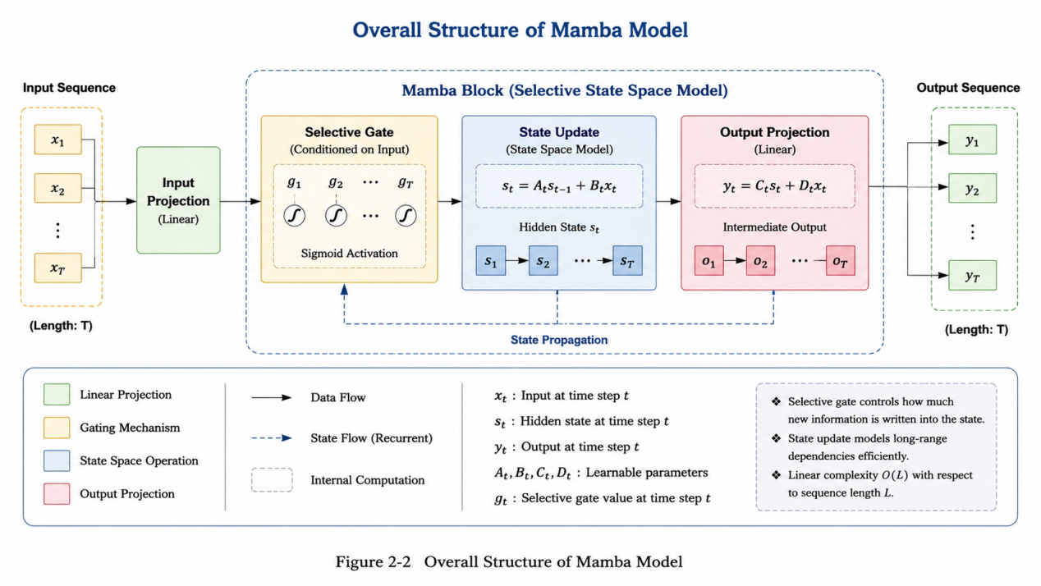
Figure 2-2 Overall Structure of Mamba Model，adapted from [4]

2.2.3 Channel modeling and fusion technology
In multivariate time series, there are usually complex correlations between different variables. Traditional methods often process all channels in a unified way, which is easy to introduce redundant information and even reduce the performance of the model.
In order to improve the model 's ability to use key information, this paper uses channel selective fusion method. The specific process includes :
- Calculate the correlation between the channels ;
- Select the Top-K important channel ;
- Weighted fusion is performed on the selected channels.
This method can highlight the information of key variables, reduce the interference of irrelevant channels, and improve the prediction accuracy of the model.
Recent research also shows that introducing channel correlation into state space models can improve the representation ability of multivariate time series forecasting models [30].
The basic idea of channel-selective fusion is illustrated in Figure 2-3. The model first calculates channel correlations, then selects highly related channels, and finally performs weighted residual fusion.
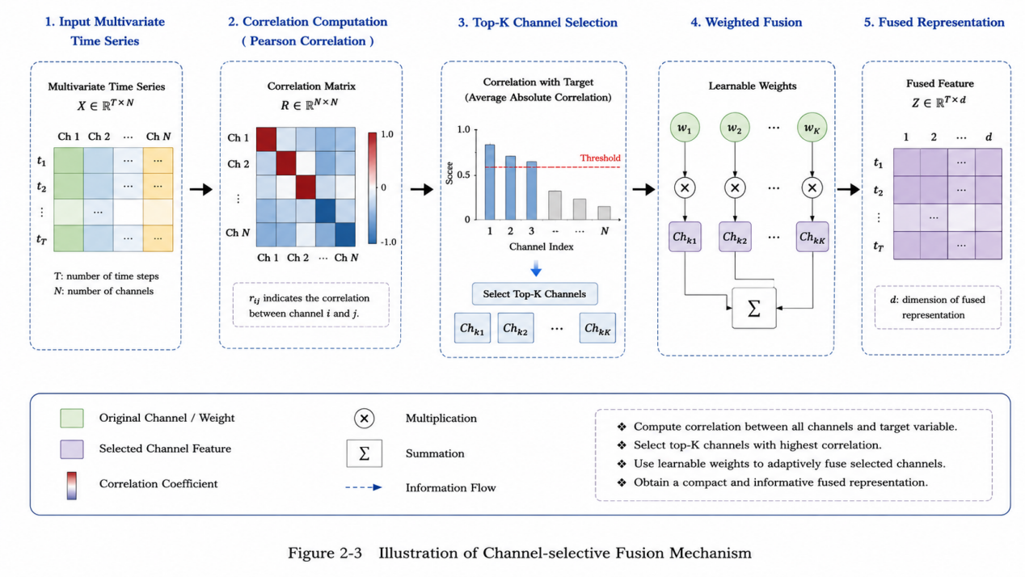
Figure 2-3Illustration of Channel-selective Fusion Mechanism，adapted from [5]

2.2.4 Time series data preprocessing method
Before the model training, the original data needs to be preprocessed to improve the training effect and stability of the model. Common data preprocessing methods include :
- Data normalization processing ;
- Missing value processing ;
- Sliding window partition ;
- The training set and the test set are divided.
Among them, the sliding window method divides the time series into multiple input-output pairs, so that the model can learn the local variation of the sequence, thereby improving the prediction performance.
The overall preprocessing procedure used in this paper is shown in Figure 2-4. The raw time series data are processed through time column removal, standardization, chronological dataset splitting, and sliding window construction.
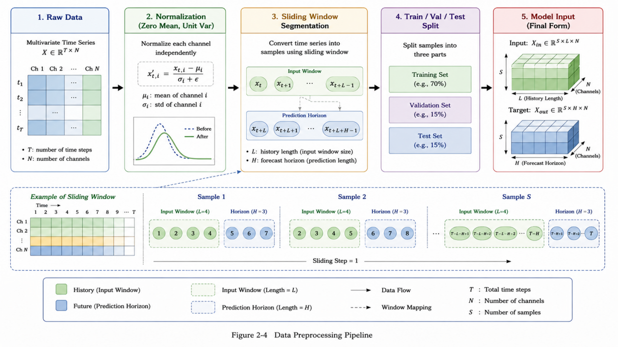
Figure 2-4Data Preprocessing Pipeline

2.3 Chapter Summary
This chapter summarizes the research on time series prediction, focuses on the traditional machine learning methods and methods based on deep learning, and analyzes the development trend of current research. At the same time, the key technologies involved in this paper are introduced, including PyTorch framework, Mamba model and channel selective fusion method.
Through analysis, it can be seen that channel modeling is still an important but not yet fully solved problem in multivariate time series prediction tasks. Therefore, this paper introduces a channel selective fusion mechanism based on the Mamba model to improve the performance of the model. The next chapter will introduce the method proposed in this paper and its implementation process in detail.

CHAPTER 3: Multivariate time series prediction method design and experimental analysis

3.1 Overall Idea
This chapter mainly introduces the Mamba multivariate time series prediction method based on channel selective fusion proposed in this paper. The core goal of this method is to further enhance the ability of the model to utilize the correlation between multivariate channels on the basis of maintaining the long sequence modeling ability of the Mamba model, so as to improve the prediction accuracy.
In multivariate time series prediction tasks, the input data is usually composed of multiple variables, and each variable can be regarded as an independent channel. For example, in the power transformer temperature prediction task, there may be correlations between variables such as oil temperature, load, and power consumption ; in meteorological prediction tasks, there are also complex interactions between variables such as temperature, humidity, air pressure, and wind speed. If the model only focuses on the time change within a single channel and ignores the relationship between different channels, it is difficult to make full use of the effective information in multivariate time series.
In recent years, the Mamba model has shown strong ability in long sequence modeling tasks due to its structure based on selective state space model. Compared with the Transformer model, Mamba has lower computational complexity when the sequence length increases, and is more suitable for processing long-time span prediction tasks [31]. CMMamba related research also pointed out that Mamba can be used to efficiently model long sequences and enhance multivariate prediction capabilities in combination with channel mixing mechanisms.
However, the basic Mamba model mainly focuses on the dependence relationship in the time dimension, and the modeling of the channel relationship between multiple variables is insufficient. If all channel information is directly processed or simply fused, it may introduce noise information that is weakly correlated or even unrelated to the target channel, which will affect the prediction performance of the model. Therefore, this paper proposes a channel selective fusion Mamba model. The model first calculates the correlation between different channels, then selects Top-K channels with high correlation for each target channel, and uses the weighted residual method for fusion. Finally, the fused sequence is sent to the bidirectional Mamba time modeling module for extracting long-term dependency features.
The overall framework of the proposed model is shown in Figure 3-1. The figure highlights the channel selective fusion module, which is the core component of this paper, and shows how the fused sequence is further processed by the bidirectional Mamba temporal modeling module.

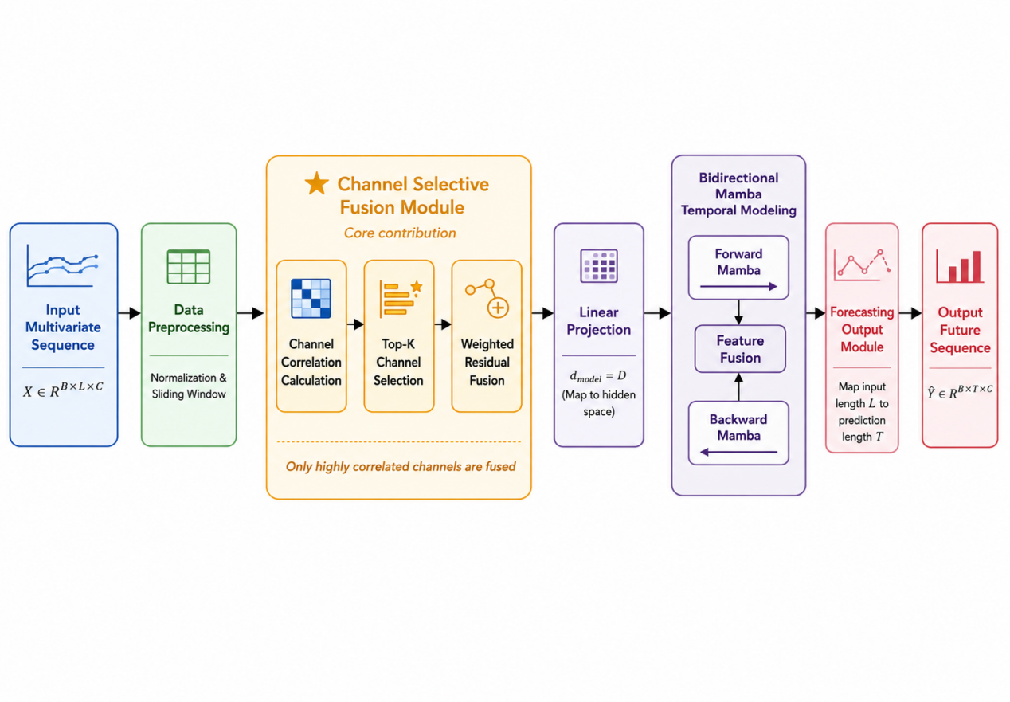
Figure 3-1: Overall Framework of the Proposed Model
The overall process of this method includes four parts : data preprocessing module, channel selective fusion module, bidirectional Mamba time modeling module and prediction output module. The key idea of this method is not to fuse all channels indiscriminately, but to select a small number of highly correlated channels to participate in the fusion according to the channel correlation. In this way, the model can not only retain the time characteristics of the target channel itself, but also introduce auxiliary information of other related channels.

3.2 Problem Formulation
Multivariate time series forecasting aims to predict the future values of multiple variables based on their historical observations. Let the historical multivariate time series be:
$$X=\left\{x_{1},x_{2},…,x_{L}\right\}∈R^{L×C}$$
where L denotes the input sequence length, and C denotes the number of variables, also called the number of channels. Each time step x contains the observations of C variables.
The objective of the model is to predict the future sequence of T time steps:
$$Y=\left\{x_{L+1},x_{L+2},…,x_{L+T}\right\}∈R^{T×C}$$
where T denotes the prediction length.
Therefore, the forecasting task can be formulated as learning a mapping function
$$\hat{Y}=F(X)$$
where$F(⋅)$represents the proposed forecasting model, and $\hat{Y}$ represents the predicted future sequence.
During model training, the parameters of $F(⋅)$are optimized by minimizing the difference between the predicted sequence and the ground truth sequence. In this paper, Mean Squared Error (MSE) is used as the training loss function:
$$Loss=\frac{1}{N}\sum_{i=1}^{N}{{\left({\hat{y}}_{i}−y_{i}\right)}^{2}}$$
$where N denotes the total number of predicted values, {\hat{y}}_{i}$ $denotes the predicted value, and y_{i}$ $denotes the real value.$
The purpose of the model is to learn both temporal dependencies and channel relationships from historical observations, so that the prediction error can be reduced.

3.3 Data Preprocessing
Before training the forecasting model, the original time series data need to be transformed into a suitable input format. The preprocessing process mainly includes removing the time column, standardization, dataset splitting, and sliding window construction.
The data preprocessing process is illustrated in Figure 3-2. It converts the raw time series data into normalized input-output samples that can be used for model training.
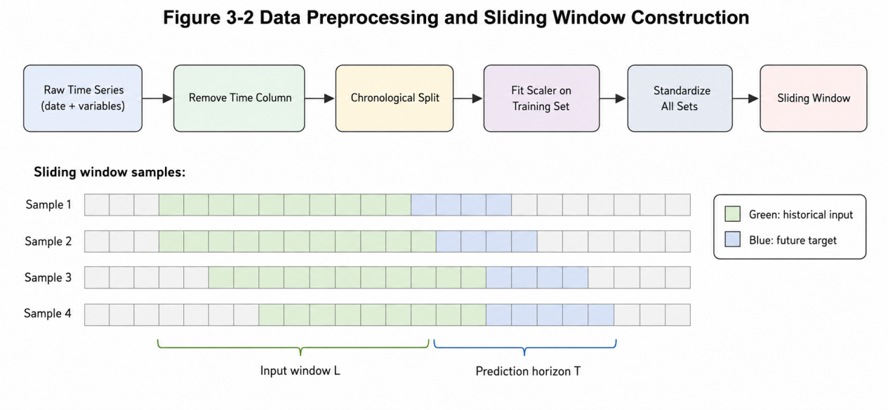
Figure 3-2 Data Preprocessing And Sliding Window Construction

3.3.1 Removing the Time Column
Most public time series datasets contain a date or time column. This column records the sampling time of each observation. Since the proposed model mainly uses numerical variables as input features, the time column is not directly used in the model.
When reading the dataset, the first column is checked. If it is a non-numerical column, it is regarded as a time column and removed. The remaining numerical columns are used as the multivariate time series input.
After removing the time column, the raw data can be represented as:
$$X_{raw}∈R^{N×C}$$
$$where N denotes the total length of the time series and C denotes the number of variables.$$

3.3.2 Data Standardization
Different variables in multivariate time series may have different units and value ranges. For example, temperature, humidity, and pressure have different physical meanings and numerical scales. If the raw values are directly used for training, variables with larger scales may dominate the optimization process.
To reduce the influence of scale differences, standardization is applied:
$$x^{′}=\frac{x−μ}{σ}$$
where x is the original value, μ is the mean of the training set, and σ is the standard deviation of the training set.
To avoid data leakage, the scaler is fitted only on the training set. The validation set and test set are transformed using the same mean and standard deviation obtained from the training set.

3.3.3 Dataset Splitting
The original time series is divided into training set, validation set, and test set. The training set is used to update model parameters, the validation set is used to select the best model during training, and the test set is used to evaluate the final forecasting performance.
In the implementation of this project, the dataset is divided according to chronological order. This is important for time series forecasting because future information should not be used to train a model that predicts the future. Random splitting is not used, since it may break the temporal order and cause information leakage.

3.3.4 Sliding Window Construction
To transform the time series into supervised learning samples, the sliding window method is used. Given input length L and prediction length T, each sample is constructed as follows:
$$X_{i}=\left[x_{i},x_{i+1},…,x_{i+L−1}\right]$$
$$Y_{i}=\left[x_{i+L},x_{i+L+1},…,x_{i+L+T−1}\right]$$
where${ X}_{i}$is the input sequence and${ Y}_{i}$is the corresponding prediction target.
By moving the window along the time dimension, multiple training samples can be generated from the original sequence. This method allows the model to learn the mapping relationship between historical observations and future values.

3.4 Channel Selective Fusion Module
The channel selective fusion module is the core component of the proposed method. Its purpose is to identify highly related channels and use them to enhance the representation of the target channel [32].
In multivariate time series forecasting, different variables usually have different levels of relevance. Some variables may provide useful information for prediction, while others may contain redundant or noisy information. If all channels are fused equally, the model may be affected by irrelevant variables. Therefore, this paper proposes to select only the most relevant channels for fusion.
The channel selective fusion module includes three steps:
- Channel correlation calculation;
- Top-K channel selection;
- Weighted residual fusion.
The structure of the channel selective fusion module is shown in Figure 3-3. This module first calculates channel correlations, then selects the Top-K related channels, and finally performs weighted residual fusion.
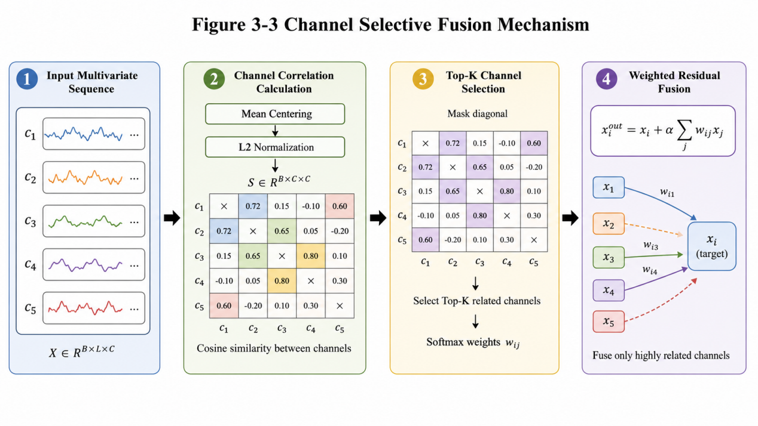
Figure 3-3 Channel Selective Fusion Mechanism

3.4.1 Channel Correlation Calculation
Let the input sequence be: $X∈R^{B×L×C}$ where B is the batch size, L is the input length, and C is the number of channels.
First, the input is transposed into channel-first form: $X_{c}∈R^{B×C×L}$. For each channel sequence, mean centering is performed: ${\bar{x}}_{i}=x_{i}−mean\left(x_{i}\right)$. Then L₂ normalization is applied: ${\tilde{x}}_{i}=\frac{{\bar{x}}_{i}}{||{\bar{x}}_{i}||_{2}+ε}$ where $ε$ is a small constant to avoid division by zero.The cosine similarity between channel i and channel j is computed as: $s_{i,j}={\tilde{x}}_{i}⋅{\tilde{x}}_{j}$. After calculating all pairwise channel similarities, a channel similarity matrix is obtained: $S∈R^{B×C×C}$ where${ s}_{i,j}$indicates the similarity score between channel i and channel j.
The similarity matrix reflects the relationship between variables in each batch. A higher similarity score means that two channels have more similar temporal patterns within the input window.

3.4.2 Top-K Channel Selection
After obtaining the channel similarity matrix, the model selects the Top-K most relevant channels for each target channel [33].
Since the similarity between a channel and itself is usually the largest, the diagonal elements of the similarity matrix are masked before Top-K selection. This operation prevents the model from selecting the target channel itself as an additional fusion source.
For target channel $i$, the selected channel set is:
$$N_{i}=TopK\left(S_{i,1},S_{i,2},…,S_{i,C}\right)$$
where${ N}_{i }$denotes the set of selected channels for target channel i.
Then, Softmax normalization is applied to the selected similarity scores:
$$w_{i,j}=\frac{exp\left(s_{i,j}\right)}{\sum_{k∈N_{i}}{e}xp\left(s_{i,k}\right)},j∈N_{i}$$
where $w_{i,j}$ is the fusion weight from source channel $j$ to target channel $i$.

3.4.3 Weighted Residual Fusion
The selected channel features are aggregated by weighted summation:
$$x_{i}^{fused}=\sum_{j∈N_{i}}{w_{i,j}}x_{j}$$
To avoid destroying the original information of the target channel, residual fusion is used:
$$x_{i}^{out}=x_{i}+αx_{i}^{fused}$$
where $α$ is the channel fusion weight. It controls the strength of cross-channel information fusion.
If $α$ is too small, the model may not fully use useful channel information. If $α$ is too large, the original target channel information may be weakened. Therefore, $α$ is an important hyperparameter.
The output of the channel selective fusion module can be written as:
$$X^{out}=\left[x_{1}^{out},x_{2}^{out},…,x_{C}^{out}\right]$$
where${ X}^{out}∈R^{B×L×C}$.
This module improves the model in two aspects. First, it introduces explicit channel relationship modeling. Second, it avoids unnecessary fusion of all variables by selecting only a small number of highly related channels.

3.5 Mamba-based Temporal Modeling Module
After channel selective fusion, the fused sequence is sent into the temporal modeling module. The purpose of this module is to extract temporal dependencies from the input sequence.
Mamba is a sequence modeling method based on selective state space models. It is designed to capture long-range dependencies efficiently. Compared with traditional recurrent structures, Mamba has better efficiency in long-sequence modeling. Compared with Transformer-based models, Mamba avoids the quadratic complexity caused by the self-attention mechanism [34].
In this project, a Mamba-like compatible module is used to simulate the selective sequence modeling mechanism. The module mainly consists of linear projection, depthwise convolution, activation function, and gating mechanism.
The temporal modeling structure used in this paper is shown in Figure 3-4. It contains input projection, gated temporal feature extraction, bidirectional Mamba modeling, residual connection, and layer normalization.
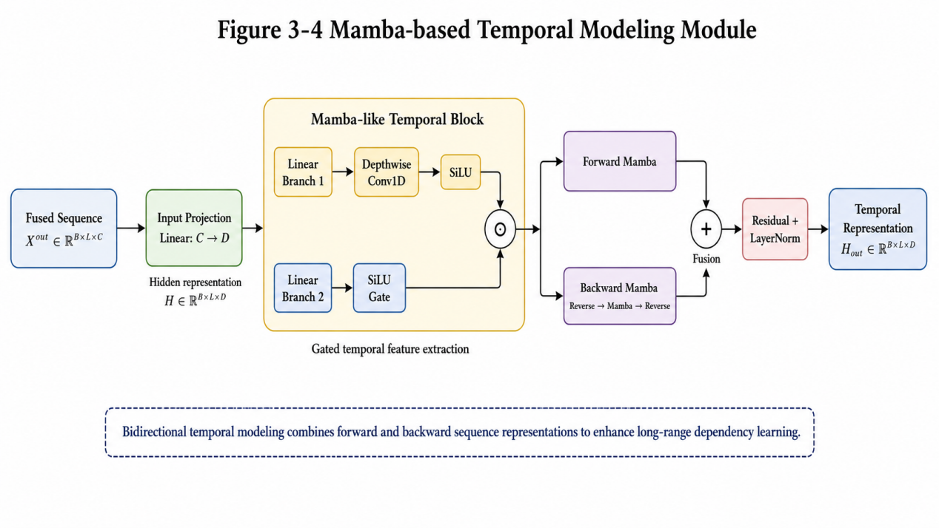
Figure 3-4 Mamba-based Temporal Modeling Module

3.5.1 Input Projection
The fused sequence is:
$$X^{out}∈R^{B×L×C}$$
Before being sent into the temporal modeling module, the sequence is mapped into a hidden feature space:
$$H=Linear\left(X^{out}\right)$$
where:
$$H∈R^{B×L×D}$$
and D denotes the hidden feature dimension.
The input projection layer transforms the original multivariate sequence into a higher-dimensional representation, which improves the feature extraction ability of the model.

3.5.2 Gated Temporal Feature Extraction
Given the hidden representation HHH, it is first projected into two branches:
$$H_{1},H_{2}=Split(Linear(H))$$
The first branch is used for temporal feature extraction:
$$H_{1}^{′}=SiLU\left(Conv1D\left(H_{1}\right)\right)$$
The depthwise one-dimensional convolution captures local temporal patterns within the sequence. The SiLU activation function introduces nonlinearity and improves the expressive ability of the module.
The second branch is used as a gate:
$$G=SiLU\left(H_{2}\right)$$
Then the two branches are multiplied element by element:
$$Z=H_{1}^{′}⊙G$$
where ⊙ denotes element-wise multiplication.
This gating mechanism allows the model to selectively pass useful temporal information and suppress less important information.
Finally, the output is projected back to the hidden dimension:
$$H^{′}=Linear(Z)$$

3.5.3 Bidirectional Temporal Modeling
A unidirectional sequence model only processes the sequence in one temporal direction. However, when extracting historical features, both forward and reverse temporal patterns may provide useful information. Therefore, this paper adopts a bidirectional temporal modeling structure.
The forward branch processes the sequence in the original order:
$$H_{f}=Mamba(H)$$
The backward branch first reverses the input sequence along the temporal dimension, then processes it using another Mamba module, and finally reverses the output back:
$$H_{b}=Reverse\left(Mamba\left(Reverse(H)\right)\right)$$
The forward and backward outputs are combined:
$$H_{bi}=H_{f}+H_{b}$$
Then residual connection and layer normalization are applied:
$$H_{out}=LayerNorm\left(H+Dropout\left(H_{bi}\right)\right)$$
where $H_{out}$ is the final temporal representation.
The bidirectional structure enables the model to extract richer temporal features. It also improves training stability through residual connection and normalization.

3.6 Forecasting Output Module
After temporal modeling, the hidden representation is mapped to the future prediction horizon. The output of the bidirectional Mamba module is:
$$H_{out}∈R^{B×L×D}$$
where L is the input sequence length and D is the hidden feature dimension.
The forecasting module first transposes the hidden representation:
$$H_{out}^{T}∈R^{B×D×L}$$
Then, a linear prediction layer maps the input length L to the prediction length T:
$$H_{pred}=Linear\left(H_{out}^{T}\right)$$
where:
$$H_{pred}∈R^{B×D×T}$$
After that, the representation is transposed back:
$$H_{pred}∈R^{B×T×D}$$
Finally, an output projection layer maps the hidden dimension to the original number of channels:
$$\hat{Y}=Linear\left(H_{pred}\right)$$
where:
$$\hat{Y}∈R^{B×T×C}$$
The output $\hat{Y }$is the final prediction of the model.
Figure 3-5 presents the forecasting output module. This module maps the temporal hidden representation from the input sequence length to the prediction length and finally projects it back to the original channel dimension.
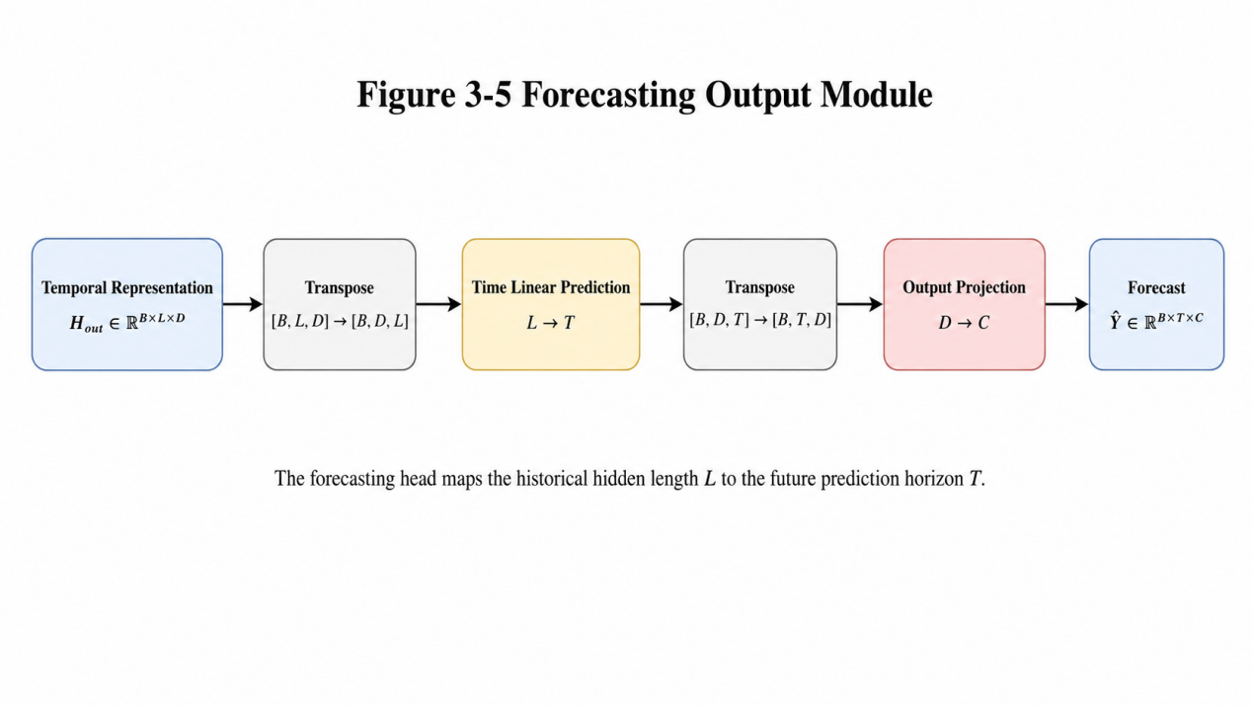
Figure 3-5 Forecasting Output Module

3.7 Overall Algorithm Process
The overall forecasting process of the proposed model is shown in Algorithm 3-1.
Algorithm 3-1 Channel Selective Fusion Mamba Forecasting Algorithm
Input: Multivariate time series X ∈ R^{B×L×C}, selected channel number K, fusion weight α
Output: Predicted sequence Ŷ ∈ R^{B×T×C}

1: Apply data preprocessing to the raw time series
2: Construct input-output samples using sliding windows
3: Apply normalization to the input sequence X
4: Transform X into channel-first form [B, C, L]
5: Perform mean centering and L2 normalization for each channel sequence
6: Calculate the cosine similarity matrix S
7: Mask the diagonal elements of S to remove self-correlation
8: Select Top-K highly correlated channels for each target channel
9: Apply Softmax to selected similarity scores and obtain fusion weights
10: Perform weighted channel fusion
11: Use residual fusion to obtain X_out = X + αX_fused
12: Project X_out into the hidden feature space
13: Extract temporal features using the bidirectional Mamba module
14: Map the input length L to the prediction length T
15: Generate the prediction result Ŷ through the output projection layer
16: Return Ŷ
To provide a more intuitive understanding of the complete forecasting procedure, Figure 3-6 shows the overall algorithm flowchart from input preprocessing to final prediction output.

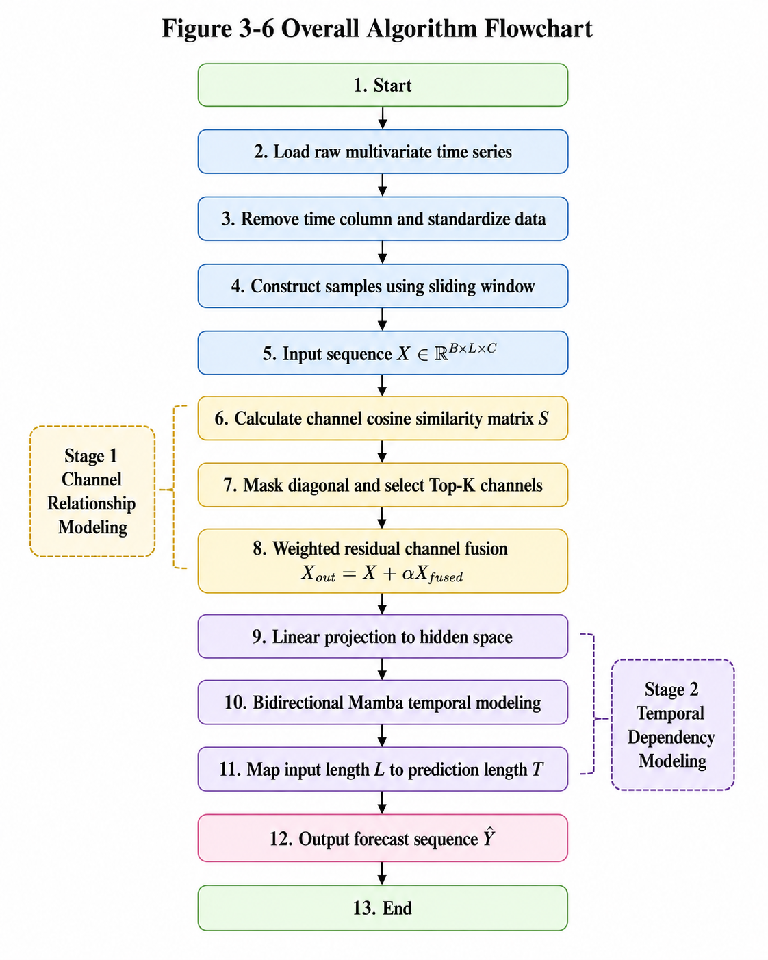
Figure 3-6 Overall Algorithm Flowchart
The algorithm can be divided into two major stages. The first stage is channel relationship modeling, where the model calculates channel correlations and performs selective fusion. The second stage is temporal dependency modeling, where the fused sequence is processed by the bidirectional Mamba module and mapped to the forecasting horizon.
This design allows the model to consider both cross-channel information and temporal dependency information.

3.8 Model Training Process
The proposed model is trained in an end-to-end manner. During training, the input sequence and prediction target are first obtained from the dataset through the sliding window method. Then, the input sequence is fed into the model, and the model outputs the predicted future sequence.
The loss between the prediction result and the ground truth is calculated using MSE. Then, the model parameters are updated through backpropagation.
Adam optimizer is used for model training. During training, the model is evaluated on the validation set after each epoch. The model parameters with the lowest validation loss are saved as the best model. Finally, the best model is evaluated on the test set.
The training process is shown in Algorithm 3-2.
Algorithm 3-2 Model Training Process
Input: Training dataset D, validation dataset V, learning rate lr, epoch number E
Output: Best trained model parameters θ*

1: Initialize model parameters θ
2: Set best validation loss to infinity
3: for epoch = 1 to E do
4: Set model to training mode
5: for each batch data (X, Y) in D do
6: Feed X into the model
7: Obtain prediction result Ŷ
8: Calculate MSE loss between Ŷ and Y
9: Perform backpropagation
10: Update model parameters using Adam optimizer
11: end for
12: Set model to evaluation mode
13: Evaluate model on validation dataset V
14: if validation loss is lower than best validation loss then
15: Save current model parameters as θ*
16: end if
17: end for
18: Return best model parameters θ*
The use of validation loss can reduce the risk of overfitting. It also ensures that the final test result is obtained from the model with the best validation performance rather than the last training epoch.

3.9 Model Characteristics
The proposed model has the following characteristics.
First, it explicitly models channel relationships. Before temporal feature extraction, the model calculates the similarity between channels. This makes the channel dependency modeling process more interpretable.
Second, it adopts a selective fusion strategy. Instead of mixing all variables, the model selects only the Top-K most relevant channels for each target channel. This can reduce the interference of low-relevance channels.
Third, it uses residual fusion. The original target channel information is preserved, and related channel information is added with a controllable weight. This design helps balance channel independence and channel interaction.
Fourth, it uses bidirectional temporal modeling. The forward and backward Mamba branches extract temporal information from two directions, providing richer sequence representations.
Fifth, the model structure is relatively lightweight. It does not rely on complex attention mechanisms, so it is suitable for long input windows in time series forecasting tasks.3.10 Chapter Summary
This chapter introduces the proposed Mamba-based multivariate time series forecasting method with channel selective fusion. First, the overall idea of the method is described. The proposed model aims to improve forecasting accuracy by combining selective channel fusion and efficient temporal modeling.
Then, the multivariate time series forecasting problem is formulated. The input sequence, prediction target, mapping function, and training loss function are defined. After that, the data preprocessing process is introduced, including removing the time column, standardization, chronological dataset splitting, and sliding window construction.
The core part of this chapter is the channel selective fusion module. This module calculates cosine similarity between channels, selects the Top-K related channels for each target channel, and performs weighted residual fusion. In this way, the model can use useful information from related variables while preserving the original information of the target channel.
The Mamba-based temporal modeling module is also described in detail. It uses linear projection, depthwise convolution, gating mechanism, and bidirectional temporal modeling to extract long-range temporal dependencies. The forecasting output module maps the hidden representation to the future prediction horizon.
Finally, the overall algorithm process and training procedure are presented through pseudo-code. The proposed method provides a complete solution for multivariate time series forecasting by combining channel relationship modeling and temporal dependency modeling.
The experimental settings, datasets, evaluation metrics, parameter discussion, and comparative analysis will be presented in Chapter 4.

CHAPTER 4: EXPERIMENTS AND ANALYSIS

4.1Introduction
This chapter presents the experimental evaluation of the proposed Channel Selective Fusion Mamba model. Since this project focuses on algorithm design and forecasting performance rather than system development, the fourth chapter is organized as the experimental analysis chapter.
The main purpose of this chapter is to verify whether the proposed channel selective fusion mechanism can improve multivariate time series forecasting performance. To achieve this goal, experiments are conducted on several public benchmark datasets, including ETTh1, ETTh2, ETTm1, ETTm2 and Weather. These datasets are widely used in long-term time series forecasting tasks and contain different sampling frequencies, variable numbers and temporal patterns.
In the experiments, the proposed model with channel selective fusion is compared with the same model without channel fusion. The model without channel fusion is used as the baseline, while the model with Top-K channel selection and weighted residual fusion is used as the proposed model. By comparing these two settings, the effectiveness of the channel selective fusion mechanism can be evaluated directly.
This chapter mainly includes the following parts:
- Dataset description;
- Evaluation metrics;
- Experimental environment and parameter settings;
- Main comparison experiments;
- Parameter discussion and analysis;
- Additional structural analysis;
- Summary of experimental results.

4.2 Dataset Description
To evaluate the effectiveness of the proposed method, five public multivariate time series datasets are used in this paper: ETTh1, ETTh2, ETTm1, ETTm2 and Weather.
The ETT datasets are widely used benchmarks in long-term time series forecasting. They contain data collected from electricity transformers. ETTh1 and ETTh2 are sampled hourly, while ETTm1 and ETTm2 are sampled every 15 minutes. Each ETT subset contains 7 variables related to electricity transformers, such as load and oil temperature. Weather contains 21 meteorological indicators, such as temperature, humidity and air pressure, and is sampled every 10 minutes. These datasets are commonly used to evaluate multivariate long-horizon forecasting models.
The details of the datasets used in this paper are shown in Table 4-1.
Dataset | Domain | Channels | Sampling Frequency | Prediction Length
ETTh1 | Electricity transformer | 7 | 1 hour | 96 / 192 / 336 / 720
ETTh2 | Electricity transformer | 7 | 1 hour | 96 / 192 / 336 / 720
ETTm1 | Electricity transformer | 7 | 15 minutes | 96 / 192 / 336 / 720
ETTm2 | Electricity transformer | 7 | 15 minutes | 96 / 192 / 336 / 720
Weather | Meteorology | 21 | 10 minutes | 96 / 192 / 336 / 720
Table 4-1 Dataset Description
In this paper, the input sequence length is set to 336 for all datasets. The prediction lengths are set to 96, 192, 336 and 720. These prediction lengths are used to evaluate the model performance under different forecasting horizons.
The ETT datasets are suitable for evaluating forecasting models in the energy domain. Since the variables are collected from electricity transformers, there are potential correlations between different channels. The Weather dataset contains more variables than the ETT datasets, which makes it useful for evaluating whether channel selective fusion can handle datasets with more complex inter-variable relationships.

4.3 Evaluation Metrics
To evaluate the forecasting performance of the proposed model, four commonly used metrics are adopted: Mean Squared Error (MSE), Mean Absolute Error (MAE), Root Mean Squared Error (RMSE), and Mean Absolute Percentage Error (MAPE). Among them, MSE and MAE are the main evaluation metrics in this paper. Related time series forecasting studies also commonly use MSE and MAE to measure forecasting performance.

4.3.1 Mean Squared Error
Mean Squared Error measures the average squared difference between the predicted values and the true values. It is defined as:
$$MSE=\frac{1}{N}\sum_{i=1}^{N}{{\left({\hat{y}}_{i}−y_{i}\right)}^{2}}$$
MAE is more intuitive than MSE because it directly reflects the average prediction error magnitude. A smaller MAE means that the prediction is closer to the true value.

4.3.2 Mean Absolute Error
Mean Absolute Error measures the average absolute difference between predictions and true values. It is defined as:
$$MAE=\frac{1}{N}\sum_{i=1}^{N}{\left|{\hat{y}}_{i}−y_{i}\right|}$$
MAE is more intuitive than MSE because it directly reflects the average prediction error magnitude. A smaller MAE means that the prediction is closer to the true value.

4.3.3 Root Mean Squared Error
Root Mean Squared Error is the square root of MSE:
$$RMSE=\sqrt{MSE}$$
RMSE has the same unit as the original data and can be used to measure the overall error magnitude.

4.3.4 Mean Absolute Percentage Error
Mean Absolute Percentage Error measures the relative prediction error:
$$MAPE=\frac{1}{N}\sum_{i=1}^{N}{\left|\frac{{\hat{y}}_{i}−y_{i}}{y_{i}}\right|}$$
MAPE reflects the prediction error in percentage form. However, when the true value is close to zero, MAPE may become unstable. Therefore, this paper mainly uses MSE and MAE for model comparison.

4.4 Experimental Environment and Parameter Settings

4.4.1 Experimental Environment
The experiments are implemented using Python and PyTorch. The hardware and software environment is shown in Table 4-2.
Item | Configuration
Programming Language | Python
Deep Learning Framework | PyTorch
Data Processing Libraries | NumPy, Pandas
Visualization Tool | Matplotlib
Operating System | Windows 11
IDE | PyCharm
GPU | NVIDIA GeForce RTX 3060 Laptop GPU 6GB
Table 4-2 Experimental Environment

4.4.2 Main Parameter Settings
The main parameter settings used in the experiments are shown in Table 4-3.
Parameter | Value | Description
seq_len | 336 | Input sequence length
pred_len | 96 / 192 / 336 / 720 | Prediction length
d_model | 64 | Hidden feature dimension
e_layers | 2 | Number of Mamba layers
batch_size | 32 | Batch size
learning_rate | 0.001 | Learning rate
dropout | 0.1 | Dropout ratio
d_state | 16 | State dimension
d_conv | 4 | Convolution kernel size
expand | 2 | Expansion factor
train_epochs | 100 | Maximum number of training epochs
Table 4-3 Main Experimental Parameters
The input sequence length is set to 336, which allows the model to use longer historical information. The hidden dimension d_modeld is set to 64 to balance model representation ability and computational cost. The number of Mamba layers is set to 2. Adam optimizer is used for training, and the learning rate is set to 0.001.
For the channel selective fusion module, different values of top_k and α are tested. In the no-fusion baseline, top_k=0 and α=0 , which means that no cross-channel fusion is performed.

4.5 Main Comparison Experiments

4.5.1 Experimental Design
The purpose of the main comparison experiment is to verify whether the proposed channel selective fusion mechanism can improve prediction performance.
Two model settings are compared:
1.Without channel fusion: the channel selective fusion module is removed. The model only uses the temporal modeling module for forecasting.
2.With channel selective fusion: the proposed Top-K channel selection and weighted residual fusion mechanism is added.
The comparison is conducted on five datasets: ETTh1, ETTh2, ETTm1, ETTm2 and Weather. Each dataset is evaluated under four prediction lengths: 96, 192, 336 and 720.

4.5.2 Results on ETTh1
The experimental results on ETTh1 are shown in Table 4-4.
pred_len | MSE without Fusion | MSE with Fusion | MAE without Fusion | MAE with Fusion
96 | 0.441650 | 0.411059 | 0.480879 | 0.462657
192 | 0.602643 | 0.483747 | 0.569675 | 0.514833
336 | 0.605667 | 0.612681 | 0.575091 | 0.583475
720 | 0.737590 | 0.700669 | 0.660701 | 0.640296
Table 4-4 Experimental Results on ETTh1
As shown in Table 4-4, the proposed channel selective fusion model outperforms the no-fusion baseline in three out of four prediction lengths. The improvement is especially obvious when the prediction length is 192. The MSE decreases from 0.602643 to 0.483747, which indicates that channel correlation information is useful for medium-range forecasting.
However, when the prediction length is 336, the fusion model performs slightly worse than the baseline. This suggests that fixed channel selection may not always be optimal for all prediction horizons.
To more intuitively compare the forecasting performance on ETTh1, Figure 4-1 shows the MSE results of the no-fusion baseline and the proposed fusion model under different prediction lengths.
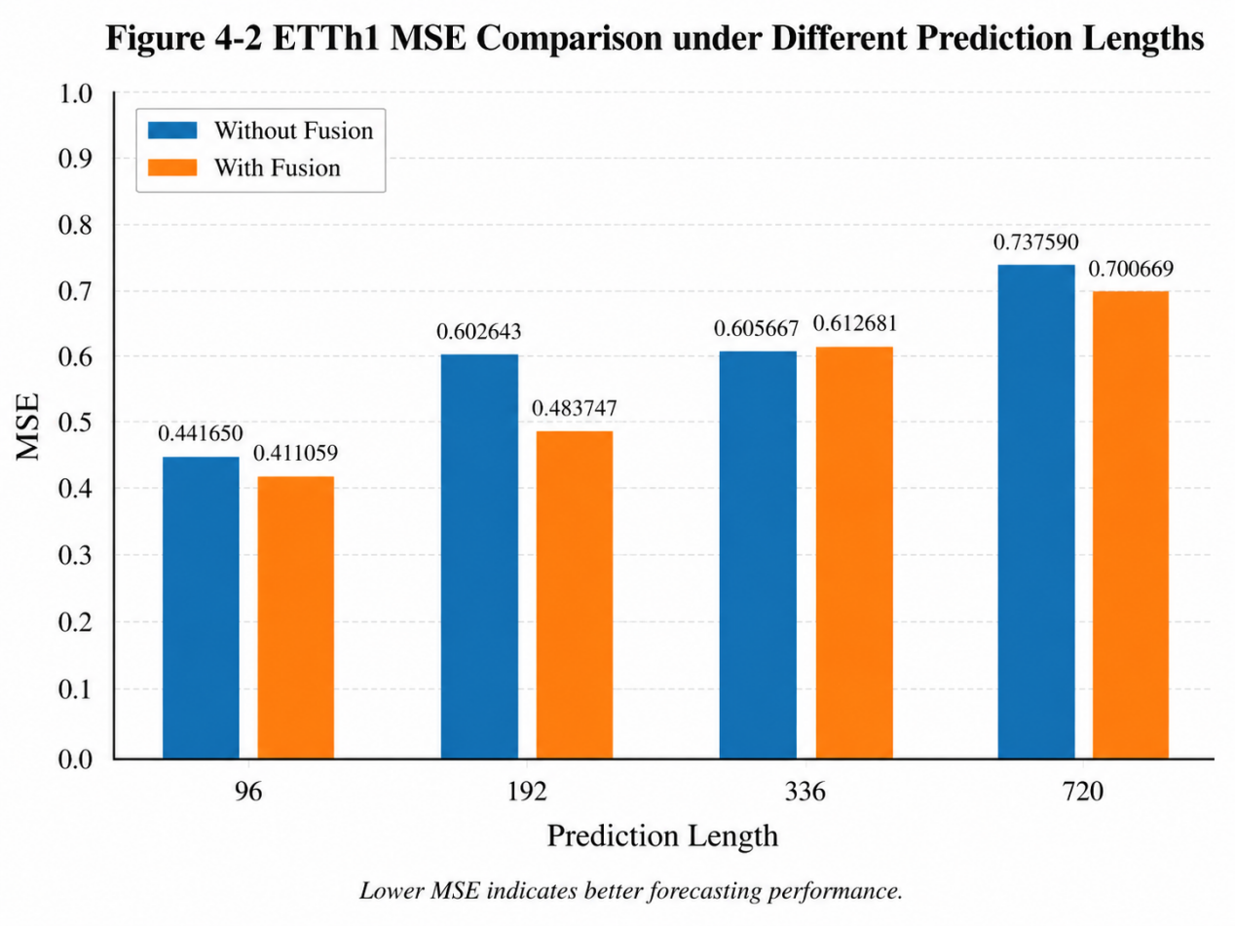
Figure 4-1 ETTh1 MSE Comparison Under Different Prediction Lengths

4.5.3 Results on ETTh2
The experimental results on ETTh2 are shown in Table 4-5.
pred_len | MSE without Fusion | MSE with Fusion | MAE without Fusion | MAE with Fusion
96 | 0.133662 | 0.127984 | 0.264917 | 0.258710
192 | 0.179040 | 0.172877 | 0.309274 | 0.299603
336 | 0.218269 | 0.209347 | 0.335193 | 0.336496
720 | 0.310770 | 0.261703 | 0.406177 | 0.371178
Table 4-5 Experimental Results on ETTh2
The ETTh2 results show that the proposed model improves MSE under all four prediction lengths. In particular, when the prediction length is 720, the MSE decreases from 0.310770 to 0.261703. This demonstrates that the channel selective fusion mechanism is effective on ETTh2. The recorded experimental log also shows the corresponding MAE, RMSE and MAPE results for ETTh2 under both fusion and no-fusion settings.
This result indicates that the channels in ETTh2 may contain useful correlated information. Selecting related channels can help the model obtain more effective representations for forecasting.

4.5.4 Results on ETTm1
The experimental results on ETTm1 are shown in Table 4-6.
pred_len | MSE without Fusion | MSE with Fusion | MAE without Fusion | MAE with Fusion
96 | 0.133662 | 0.127984 | 0.264917 | 0.258710
192 | 0.179040 | 0.172877 | 0.309274 | 0.299603
336 | 0.218269 | 0.209347 | 0.335193 | 0.336496
720 | 0.310770 | 0.261703 | 0.406177 | 0.371178
Table 4-6 Experimental Results on ETTm1
On ETTm1, the proposed method improves performance under prediction lengths of 192, 336 and 720. However, it performs slightly worse than the baseline when the prediction length is 96. This means that channel fusion is not always beneficial for very short-term forecasting on this dataset.
One possible reason is that the short-term prediction of ETTm1 relies more on the target channel’s own recent temporal pattern, while introducing information from other channels may slightly disturb the original representation.

4.5.5 Results on ETTm2
The experimental results on ETTm2 are shown in Table 4-7.
pred_len | MSE without Fusion | MSE with Fusion | MAE without Fusion | MAE with Fusion
96 | 0.082293 | 0.083333 | 0.203469 | 0.205213
192 | 0.120398 | 0.102274 | 0.248847 | 0.228474
336 | 0.139496 | 0.146284 | 0.265607 | 0.273585
720 | 0.171033 | 0.207487 | 0.297988 | 0.323046
Table 4-7 Experimental Results on ETTm2
The results on ETTm2 are less stable. The proposed fusion model performs better only when the prediction length is 192. For the other three prediction lengths, the no-fusion baseline performs better.
This result shows that channel selective fusion may not be suitable for all datasets. In ETTm2, the channel relationships may change more strongly over time, and fixed Top-K channel selection may introduce less useful information in some forecasting horizons. This result also indicates that future work should consider dynamic channel selection or adaptive fusion weights.

4.5.6 Results on Weather
The experimental results on Weather are shown in Table 4-8.
pred_len | MSE without Fusion | MSE with Fusion | MAE without Fusion | MAE with Fusion
96 | 0.245024 | 0.186154 | 0.266553 | 0.218355
192 | 0.334849 | 0.332907 | 0.306318 | 0.306024
336 | 0.358064 | 0.371935 | 0.331436 | 0.345153
720 | 0.377574 | 0.364809 | 0.340442 | 0.322916
Table 4-8 Experimental Results on Weather
Weather contains 21 variables, which is more than the ETT datasets. The results show that the proposed method obtains clear improvement when the prediction length is 96. The MSE decreases from 0.245024 to 0.186154. This indicates that channel selective fusion can help the model select useful variables from a larger number of channels.
However, the prediction length 336 shows a decrease in performance. This again suggests that fixed channel selection may not be optimal for all prediction lengths.

4.6 Overall Comparison and Analysis
To provide a clearer overall comparison, the MSE results of all datasets are summarized in Table 4-9.
Dataset | pred_len | MSE without Fusion | MSE with Fusion | Improvement
ETTh1 | 96 | 0.441650 | 0.411059 | 6.93%
 | 192 | 0.602643 | 0.483747 | 19.73%
 | 336 | 0.605667 | 0.612681 | -1.16%
 | 720 | 0.737590 | 0.700669 | 5.01%
ETTh2 | 96 | 0.133662 | 0.127984 | 4.25%
 | 192 | 0.179040 | 0.172877 | 3.44%
 | 336 | 0.218269 | 0.209347 | 4.09%
 | 720 | 0.310770 | 0.261703 | 15.79%
ETTm1 | 96 | 0.410143 | 0.420485 | -2.52%
 | 192 | 0.459306 | 0.455137 | 0.91%
 | 336 | 0.543100 | 0.526368 | 3.08%
 | 720 | 0.578391 | 0.557665 | 3.58%
ETTm2 | 96 | 0.082293 | 0.083333 | -1.26%
 | 192 | 0.120398 | 0.102274 | 15.05%
 | 336 | 0.139496 | 0.146284 | -4.87%
 | 720 | 0.171033 | 0.207487 | -21.31%
Weather | 96 | 0.245024 | 0.186154 | 24.03%
 | 192 | 0.334849 | 0.332907 | 0.58%
 | 336 | 0.358064 | 0.371935 | -3.87%
 | 720 | 0.377574 | 0.364809 | 3.38%
Table 4-9 Overall MSE Comparison
From Table 4-9, the proposed method achieves better MSE in 14 out of 20 experimental settings. The strongest improvements appear on Weather with prediction length 96, ETTh1 with prediction length 192, ETTh2 with prediction length 720, and ETTm2 with prediction length 192.
The average MSE of the no-fusion baseline across all settings is about 0.3524, while the average MSE of the proposed model is about 0.3367. This means that the proposed channel selective fusion mechanism reduces the average MSE by about 4.45%.
Based on the overall MSE comparison in Table 4-9, Figure 4-2 further visualizes the average MSE performance of different datasets, making the overall effect of channel selective fusion clearer.
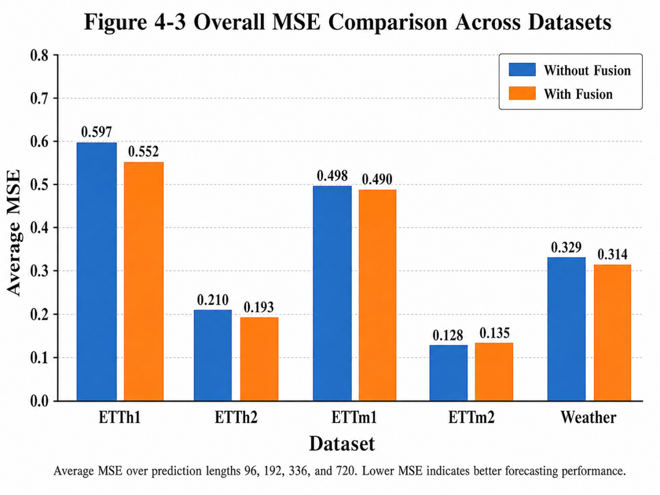
Figure 4-2 Overall MSE Comparison Across Datasets
The results show that selective channel fusion is generally effective, but its effect depends on the dataset and prediction length. For datasets such as ETTh2 and Weather, channel correlation information is especially useful. For ETTm2, the fixed fusion strategy is less stable, which indicates that the channel relationships in this dataset may be more complex.

4.7 Parameter Discussion and Analysis

4.7.1 Influence of Input Sequence Length
In the early experiments, the model was tested with different input sequence lengths. When the input sequence length was 96, the model achieved MSE 0.448873 and MAE 0.482606 on ETTh1 with prediction length 96. After increasing the input length to 336, the model achieved MSE 0.415769 and MAE 0.460998.
This result indicates that a longer input sequence can provide more historical context for the model. Since Mamba is suitable for long-sequence modeling, increasing the input length helps the model capture more useful temporal dependency information.
Therefore, the input length is fixed to 336 in the main experiments.
To show the influence of input sequence length more clearly, Figure 4-3 compares the MSE and MAE results under different input lengths.

seq_len | pred_len | MSE | MAE
96 | 96 | 0.448873 | 0.482606
336 | 96 | 0.415769 | 0.460998
Table 4-10 Influence of Input Sequence Length on ETTh1
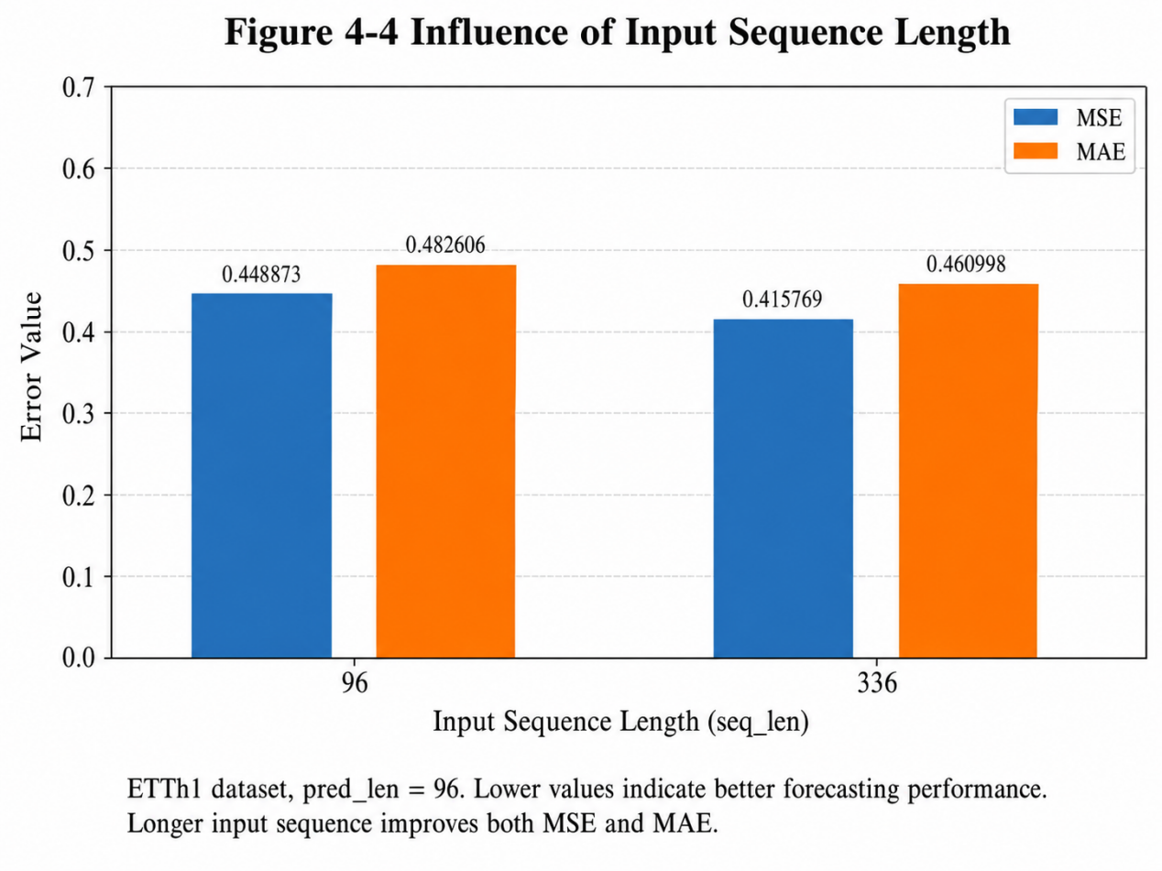
Figure 4-3 Influence Of Input Sequence Length

4.7.2 Influence of Top-K Channel Selection
To analyze the influence of channel selection strength, several Top-K related experiments were conducted on ETTh1. The results are shown in Table 4-11.
Fusion Setting | MSE | MAE | RMSE | MAPE
No channel fusion | 0.441650 | 0.480879 | 0.664568 | 3.059533
Low selective fusion | 0.425759 | 0.469569 | 0.652502 | 2.927265
Medium selective fusion | 0.416941 | 0.467986 | 0.645710 | 2.925848
Strong selective fusion | 0.411059 | 0.462657 | 0.641139 | 2.803888
Top-3 experiment | 0.424603 | 0.471945 | 0.651616 | 3.121767
Top-4 experiment | 0.477911 | 0.521286 | 0.691311 | 3.087353
Table 4-11 Influence of Channel Selection Strength
The results show that appropriate channel fusion improves prediction performance. Compared with no channel fusion, low, medium and strong selective fusion all reduce the prediction error. The best result is obtained by strong selective fusion, where the MSE is reduced to 0.411059.
However, when the number of selected channels becomes too large, the performance decreases. In the Top-4 experiment, the MSE increases to 0.477911, which is even worse than the no-fusion baseline. This means that channel fusion is not always better when more channels are selected. Too many channels may introduce irrelevant information and weaken the original features of the target channel.
The influence of different channel selection settings is shown in Figure 4-4. This figure illustrates that proper channel fusion can improve forecasting performance, while selecting too many channels may introduce noise.
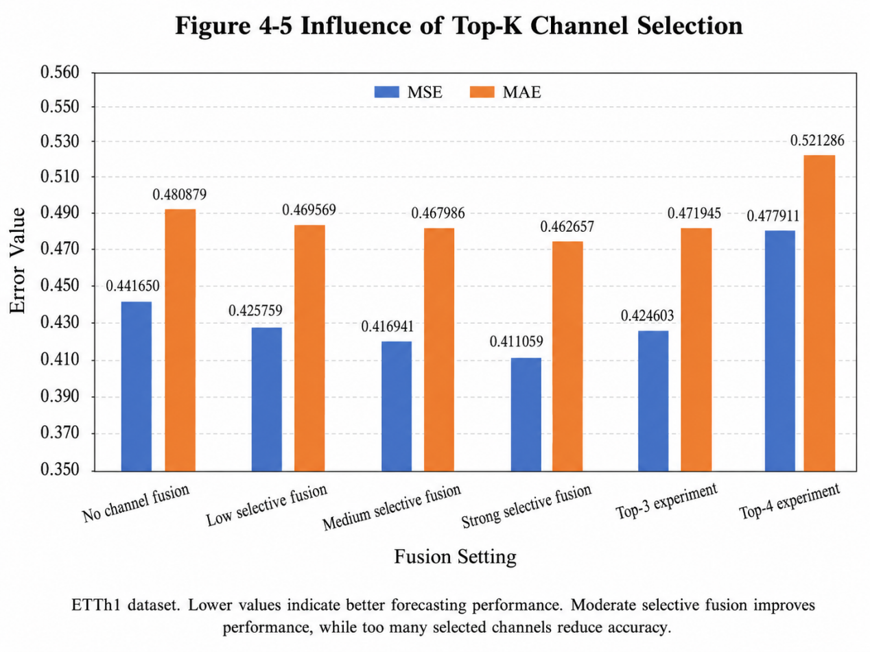
Figure 4-4 Influence Of Top-K Channel Selection

4.7.3 Influence of Fusion Weight
The fusion weight α controls the amount of information introduced from related channels. If α is too small, the model may not fully use useful channel information. If α is too large, the model may overemphasize other channels and weaken the target channel’s own information.
In this project, the experiments show that moderate fusion strength performs better. For ETTh1, stronger but controlled fusion achieves the best result. However, when the fusion scope becomes too large, the performance decreases. This shows that both top_k and α should be carefully selected.
The parameter analysis also supports the main idea of this paper: channel fusion should be selective and controlled rather than unlimited.

4.8 Additional Structural Analysis

4.8.1 Analysis of DCS Module
During model development, an additional DCS module was tested after the bidirectional Mamba module. The purpose of this module was to further extract local temporal features through convolution. However, the experimental result showed that adding this simplified DCS module did not improve performance.
The comparison is shown in Table 4-12.
Model Structure | MSE | MAE
Without DCS | 0.415769 | 0.460998
With DCS | 0.443367 | 0.480253
Table 4-12 Influence of DCS Module on ETTh1
The result shows that the simplified DCS module increases the prediction error. One possible reason is that the DCS module introduces additional convolutional transformations, which may disturb the hidden representation learned by the bidirectional Mamba module. Therefore, the final model does not use the DCS module.

4.8.2 Analysis of Positive Correlation Filtering
A positive correlation filtering strategy was also tested. This strategy only kept channels with positive correlation scores during fusion. The purpose was to reduce the interference of negatively related channels.
However, the experimental results showed that this modification did not bring stable improvement. For example, on ETTm2 with prediction length 336, the MSE increased to 0.176417, which was worse than both the original fusion model and the no-fusion baseline. On Weather with prediction length 336, the result was close to the baseline but still did not show clear improvement.
Therefore, the final model keeps the original Top-K channel selective fusion strategy rather than using positive correlation filtering.
Dataset | pred_len | No Fusion MSE | Original Fusion MSE | Positive Filtering MSE
ETTm2 | 336 | 0.139496 | 0.146284 | 0.176417
ETTm2 | 720 | 0.171033 | 0.207487 | 0.192512
Weather | 336 | 0.358064 | 0.371935 | 0.358313
ETTm1 | 96 | 0.410143 | 0.420485 | 0.424990
Table 4-13 Analysis of Positive Correlation Filtering
This result indicates that simply filtering negative correlations may remove some useful information. Therefore, the original softmax-based Top-K fusion is more stable in this project.

4.9 Discussion
The experimental results show that the proposed channel selective fusion mechanism is effective in most forecasting settings. Across five datasets and four prediction lengths, the proposed method improves MSE in 14 out of 20 settings.
The method performs especially well on ETTh2. The MSE is reduced under all four prediction lengths. This suggests that the variables in ETTh2 contain useful cross-channel relationships, and the proposed fusion mechanism can effectively utilize this information.
On Weather, the improvement at prediction length 96 is significant. Since Weather contains 21 variables, this result shows that selective channel fusion can help the model select useful information from many variables and reduce redundant information.
However, the results on ETTm2 are unstable. In long-horizon forecasting, the no-fusion baseline performs better. This may be because the correlations between variables in ETTm2 are more dynamic. A fixed Top-K selection strategy may not always select the most useful channels for different time periods and prediction lengths.
Overall, the experiments demonstrate that channel fusion is useful, but it needs to be carefully controlled. Selecting too many channels or using unsuitable fusion weights may reduce performance. Therefore, future work can consider dynamic Top-K selection, adaptive fusion weights, or learnable channel attention mechanisms.

4.10 Chapter Summary
This chapter presents the experimental evaluation of the proposed Channel Selective Fusion Mamba model. First, the datasets used in the experiments are introduced, including ETTh1, ETTh2, ETTm1, ETTm2 and Weather. Then, the evaluation metrics are described, including MSE, MAE, RMSE and MAPE. The experimental environment and parameter settings are also provided.
The main comparison experiments are conducted between the no-fusion baseline and the proposed channel selective fusion model. The results show that the proposed model achieves lower MSE in 14 out of 20 experimental settings. The improvement is especially clear on ETTh2 and Weather. These results demonstrate that selecting highly related channels can effectively improve multivariate time series forecasting performance.
Parameter analysis shows that the number of selected channels has a significant influence on forecasting accuracy. Proper channel fusion can improve performance, but selecting too many channels may introduce noise and reduce accuracy. Additional structural experiments show that the simplified DCS module and positive correlation filtering strategy do not bring stable improvement, so they are not used in the final model.
In summary, the experiments verify the effectiveness of the proposed channel selective fusion mechanism. At the same time, the results also show that fixed Top-K channel selection has limitations. Future work can further improve the model by designing dynamic channel selection and adaptive fusion weight mechanisms.

CHAPTER 5: CONCLUSION AND FUTURE WORK

5.1 Conclusion
This paper studies the problem of multivariate time series forecasting and proposes a Channel Selective Fusion Mamba model. The proposed method aims to improve forecasting performance by combining Mamba-based temporal dependency modeling with selective channel relationship modeling.
In the proposed model, channel correlations are first calculated according to the historical input sequence. Then, the Top-K most relevant channels are selected for each target channel, and weighted residual fusion is performed to introduce useful cross-channel information while preserving the original target channel features. After that, the fused sequence is processed by the bidirectional Mamba-based temporal modeling module to generate future predictions.
Experiments are conducted on several public multivariate time series datasets, including ETTh1, ETTh2, ETTm1, ETTm2 and Weather. The experimental results show that the proposed channel selective fusion mechanism improves forecasting performance in most settings compared with the no-fusion baseline. The ablation experiments also show that appropriate channel selection is helpful for improving prediction accuracy, while excessive channel fusion may introduce noise and reduce model performance.
In summary, the proposed method provides a simple and effective way to utilize channel relationships in multivariate time series forecasting. It verifies the effectiveness of combining selective channel fusion with Mamba-based temporal modeling.

5.2 Future Work
Although the proposed method achieves certain improvements, there is still room for further research. In future work, the channel selection strategy can be made more adaptive, so that the model can better adjust to different datasets, prediction horizons and temporal patterns.
In addition, more flexible channel relationship modeling methods can be explored. For example, learnable fusion mechanisms or attention-based methods may be introduced to capture more complex relationships among variables.
Furthermore, the proposed method can be evaluated on more real-world datasets and application scenarios. Future studies can also analyze the efficiency, stability and generalization ability of the model more comprehensively.
Overall, future work will focus on improving the adaptability and robustness of the proposed method, so that it can be better applied to practical multivariate time series forecasting tasks.

5.3 Chapter Summary
This chapter summarizes the main work and contributions of this paper. A Channel Selective Fusion Mamba model is proposed for multivariate time series forecasting. The model combines channel relationship modeling and Mamba-based temporal dependency modeling. Experimental results show that the proposed method can improve prediction performance in most cases.
At the same time, this chapter also discusses the limitations of the current work and points out several future research directions, including dynamic Top-K selection, adaptive fusion weight learning, nonlinear channel relationship modeling and the use of the complete Mamba implementation.These directions provide possible improvements for future multivariate time series forecasting research.

Reference
[1] 毛远宏,孙晨晨,徐璐瑶,刘曦,柴波,何鹏超. 基于深度学习的时间序列预测方法综述[J].微电子学与计算机, 2023. DOI: 10.19304/J.ISSN1000-7180.2022.0725.
[2] G. E. P. Box, G. M. Jenkins, G. C. Reinsel, and G. M. Ljung, Time Series Analysis: Forecasting and Control, 5th ed. Wiley, 2015.
[3] H. Zhou, S. Zhang, J. Peng, S. Zhang, J. Li, H. Xiong, and W. Zhang, “Informer: Beyond Efficient Transformer for Long Sequence Time-Series Forecasting,” Proceedings of the AAAI Conference on Artificial Intelligence, 2021.
[4] A. Gu and T. Dao, “Mamba: Linear-Time Sequence Modeling with Selective State Spaces,” International Conference on Learning Representations, 2024.
[5] Q. Li, J. Qin, D. Cui, D. Sun, and D. Wang, “CMMamba: Channel Mixing Mamba for Time Series Forecasting,” Journal of Big Data, vol. 11, no. 153, 2024.
[6] Y. Liu, T. Hu, H. Zhang, H. Wu, S. Wang, L. Ma, and M. Long, “iTransformer: Inverted Transformers Are Effective for Time Series Forecasting,” International Conference on Learning Representations, 2024.
[7] C. Cortes and V. Vapnik, “Support-Vector Networks,” Machine Learning, vol. 20, pp. 273–297, 1995.
[8] J. L. Elman, “Finding Structure in Time,” Cognitive Science, vol. 14, no. 2, pp. 179–211, 1990.
[9] S. Hochreiter and J. Schmidhuber, “Long Short-Term Memory,” Neural Computation, vol. 9, no. 8, pp. 1735–1780, 1997.
[10] K. Cho, B. van Merrienboer, C. Gulcehre, D. Bahdanau, F. Bougares, H. Schwenk, and Y. Bengio, “Learning Phrase Representations using RNN Encoder-Decoder for Statistical Machine Translation,” Proceedings of the Conference on Empirical Methods in Natural Language Processing, 2014.
[11] A. Vaswani, N. Shazeer, N. Parmar, J. Uszkoreit, L. Jones, A. N. Gomez, L. Kaiser, and I. Polosukhin, “Attention Is All You Need,” Advances in Neural Information Processing Systems, 2017.
[12] H. Wu, J. Xu, J. Wang, and M. Long, “Autoformer: Decomposition Transformers with Auto-Correlation for Long-Term Series Forecasting,” Advances in Neural Information Processing Systems, 2021.
[13] T. Zhou, Z. Ma, Q. Wen, X. Wang, L. Sun, and R. Jin, “FEDformer: Frequency Enhanced Decomposed Transformer for Long-term Series Forecasting,” Proceedings of the International Conference on Machine Learning, 2022.
[14] Y. Nie, N. H. Nguyen, P. Sinthong, and J. Kalagnanam, “A Time Series is Worth 64 Words: Long-term Forecasting with Transformers,” International Conference on Learning Representations, 2023.
[15] H. Wu, T. Hu, Y. Liu, H. Zhou, J. Wang, and M. Long, “TimesNet: Temporal 2D-Variation Modeling for General Time Series Analysis,” International Conference on Learning Representations, 2023.
[16] A. Gu, K. Goel, and C. Ré, “Efficiently Modeling Long Sequences with Structured State Spaces,” International Conference on Learning Representations, 2022.
[17] Y. Zhang and J. Yan, “Crossformer: Transformer Utilizing Cross-Dimension Dependency for Multivariate Time Series Forecasting,” International Conference on Learning Representations, 2023.
[18] C. Liu, C. Li, G. Chen, and Z. Liu, “SOFTS: Efficient Multivariate Time Series Forecasting with Series-Core Fusion,” Advances in Neural Information Processing Systems, 2024.
[19] S.-A. Chen, C.-L. Li, N. Yoder, S. O. Arik, and T. Pfister, “TSMixer: An All-MLP Architecture for Time Series Forecasting,” Transactions on Machine Learning Research, 2023.
[20] A. Das, W. Kong, A. Leach, S. Mathur, R. Sen, and R. Yu, “Long-term Forecasting with TiDE: Time-series Dense Encoder,” Transactions on Machine Learning Research, 2023.
[21] M. Liu, A. Zeng, M. Chen, Z. Xu, Q. Lai, L. Ma, and Q. Xu, “SCINet: Time Series Modeling and Forecasting with Sample Convolution and Interaction,” Advances in Neural Information Processing Systems, 2022.
[22] S. Wang, H. Wu, X. Shi, T. Hu, H. Luo, L. Ma, J. Y. Zhang, and J. Zhou, “TimeMixer: Decomposable Multiscale Mixing for Time Series Forecasting,” International Conference on Learning Representations, 2024.
[23] D. Luo and X. Wang, “ModernTCN: A Modern Pure Convolution Structure for General Time Series Analysis,” International Conference on Learning Representations, 2024.
[24] A. F. Ansari, L. Stella, C. Turkmen, X. Zhang, P. Mercado, H. Shen, O. Shchur, S. S. Rangapuram, S. P. Arango, S. Kapoor, J. Zschiegner, D. C. Maddix, H. Wang, M. W. Mahoney, K. Torkkola, A. G. Wilson, M. Bohlke-Schneider, and Y. Wang, “Chronos: Learning the Language of Time Series,” arXiv preprint arXiv:2403.07815, 2024.
[25] M. Goswami, K. Szafer, A. Choudhry, Y. Cai, S. Li, and A. Dubrawski, “MOMENT: A Family of Open Time-series Foundation Models,” Proceedings of the International Conference on Machine Learning, 2024.
[26] T. Dao and A. Gu, “Transformers are SSMs: Generalized Models and Efficient Algorithms Through Structured State Space Duality,” Proceedings of the International Conference on Machine Learning, 2024.
[27] D. Liang, X. Jiang, and Y. Liu, “Bi-Mamba4TS: Bidirectional Mamba for Time Series Forecasting,” arXiv preprint arXiv:2404.15772, 2024.
[28] M. A. Ahamed and Q. Cheng, “TimeMachine: A Time Series is Worth 4 Mambas for Long-term Forecasting,” arXiv preprint arXiv:2403.09898, 2024.
[29] X. Cai, Y. Zhu, X. Wang, and Y. Yao, “MambaTS: Improved Selective State Space Models for Long-term Time Series Forecasting,” arXiv preprint, 2024.
[30] C. Zeng, Z. Liu, G. Zheng, and L. Kong, “CMamba: Channel Correlation Enhanced State Space Models for Multivariate Time Series Forecasting,” arXiv preprint arXiv:2406.05316, 2024.
[31] Z. Wang et al.,“Is Mamba Effective for Time Series Forecasting?” Neurocomputing, 2025.
[32] C. Zeng et al.,“CMamba: Channel Correlation Enhanced State Space Models for Multivariate Time Series Forecasting,”arXiv preprint arXiv:2406.05316, 2024.
[33] Y. Wang et al., “TimeXer: Empowering Transformers for Time Series Forecasting with Exogenous Variables,”Advances in Neural Information Processing Systems, 2024.
[34] M. A. Ahamed and Q. Cheng,“TimeMachine: A Time Series is Worth 4 Mambas for Long-term Forecasting,”arXiv preprint arXiv:2403.09898, 2024.

Acknowledgment
First of all, I would like to express my sincere gratitude to my supervisor, for the patient guidance, valuable suggestions, and continuous encouragement throughout the process of completing this graduation thesis. From topic selection to model design, experiment analysis, and thesis revision, the teacher gave me many helpful suggestions, which enabled me to gradually improve this work.
I would also like to thank all the teachers in the School of Computer Science and Technology for their instruction and support during my undergraduate study. The knowledge and training I received in these courses provided an important foundation for this thesis.
In addition, I am grateful to my classmates and friends for their help and encouragement during the writing and experiment process. Finally, I would like to thank my family for their understanding, support, and companionship. Their encouragement gave me confidence and motivation to complete this work.
This graduation project is not only a summary of my undergraduate study, but also an important experience in independent learning and research. I sincerely thank everyone who has helped me during this period.

