## 安装

<https://blog.csdn.net/m0_60416282/article/details/126040435>

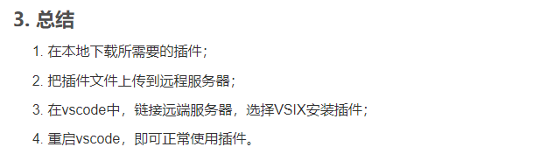

* 下载插件

<https://marketplace.visualstudio.com/items?itemName=ms-vscode.cpptools>

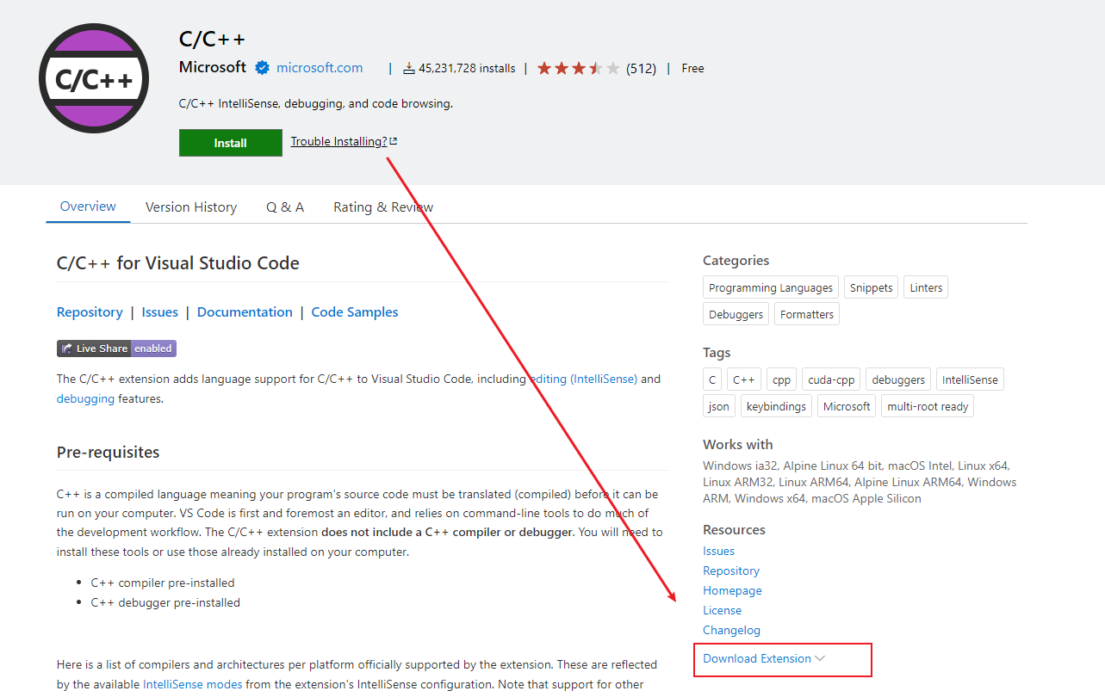

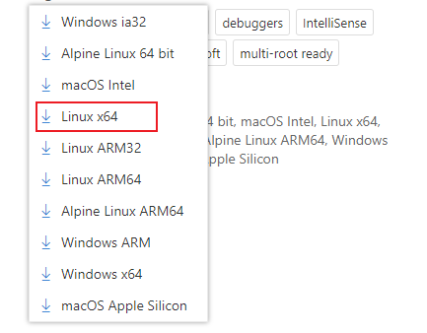

<https://marketplace.visualstudio.com/items?itemName=ms-vscode.cpptools-extension-pack>

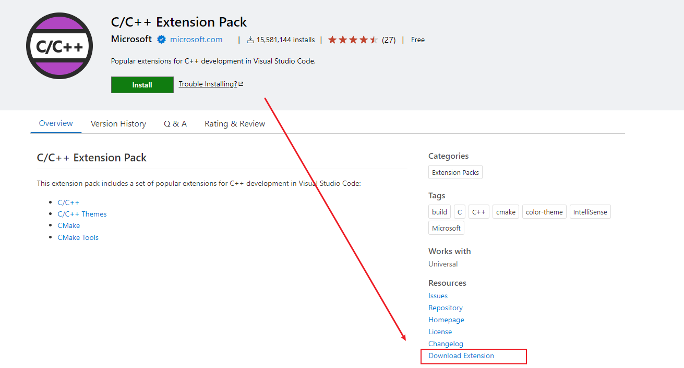

<https://marketplace.visualstudio.com/items?itemName=ms-vscode.cpptools-themes>

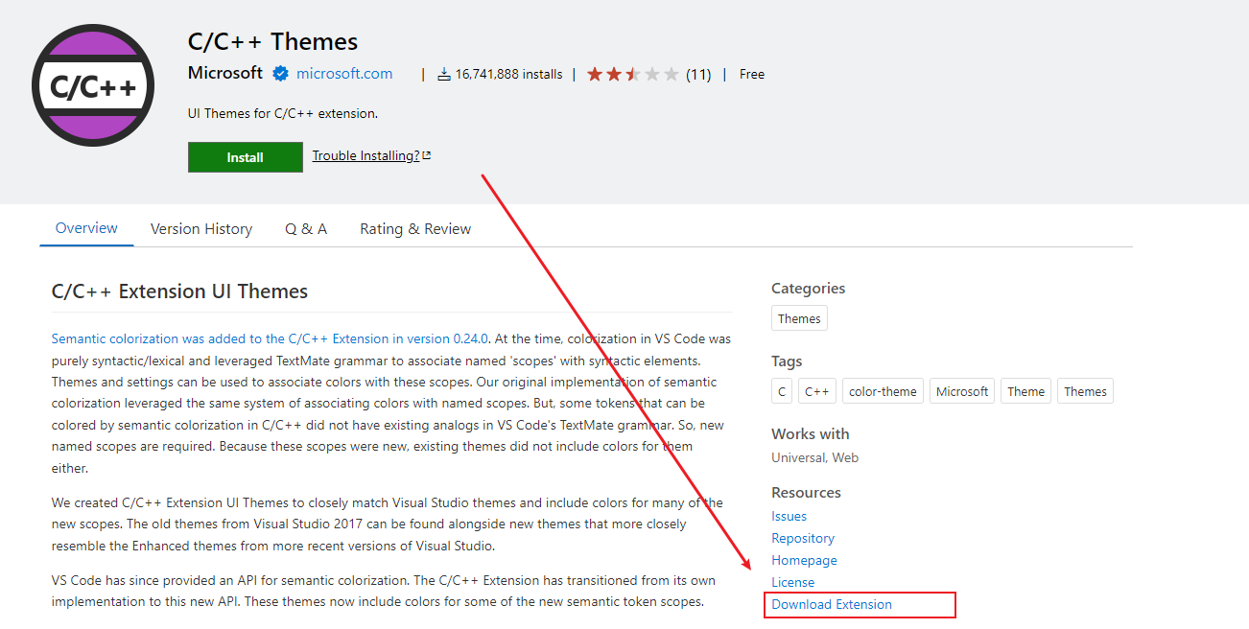

<https://marketplace.visualstudio.com/items?itemName=amiralizadeh9480.cpp-helper>

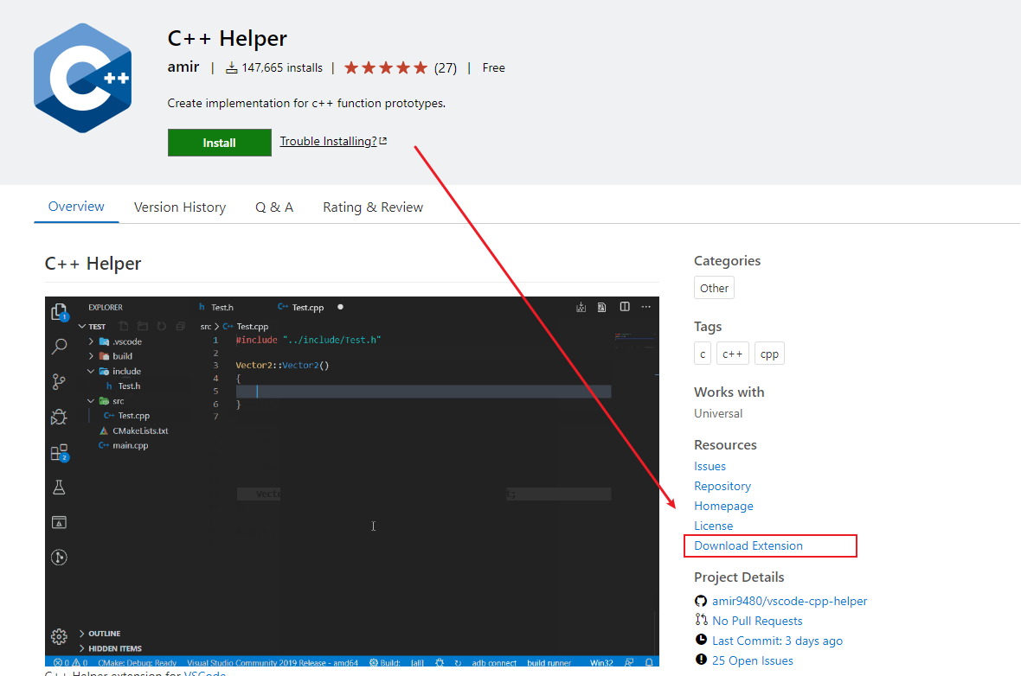

<https://marketplace.visualstudio.com/items?itemName=xaver.clang-format>

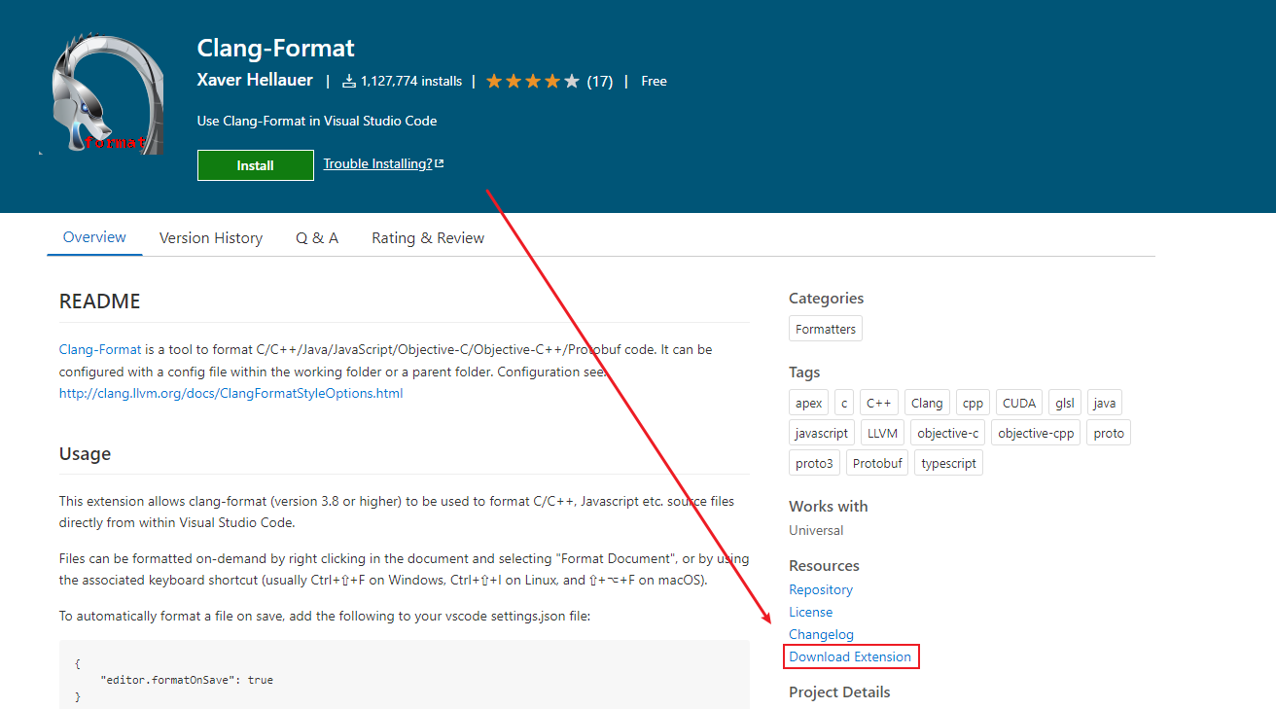

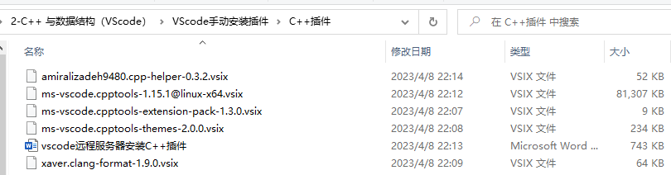

* 在VScode中，~/zqc/中新建一个文件夹thirdpart，用于存放插件安装文件

ssh [ubuntu@43.142.243.134](mailto:ubuntu@43.142.243.134:/home/ubuntu/zqc/thridpart)

密码Ljm_990725

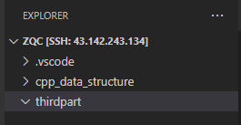

拖动vsix文件到里面

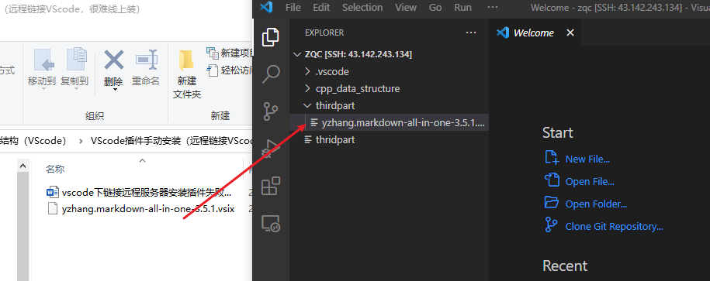

* 在windows下打开vscode，并链接远端，进行安装

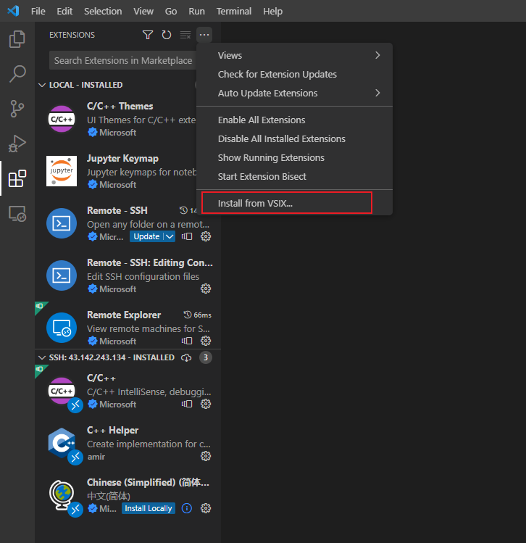

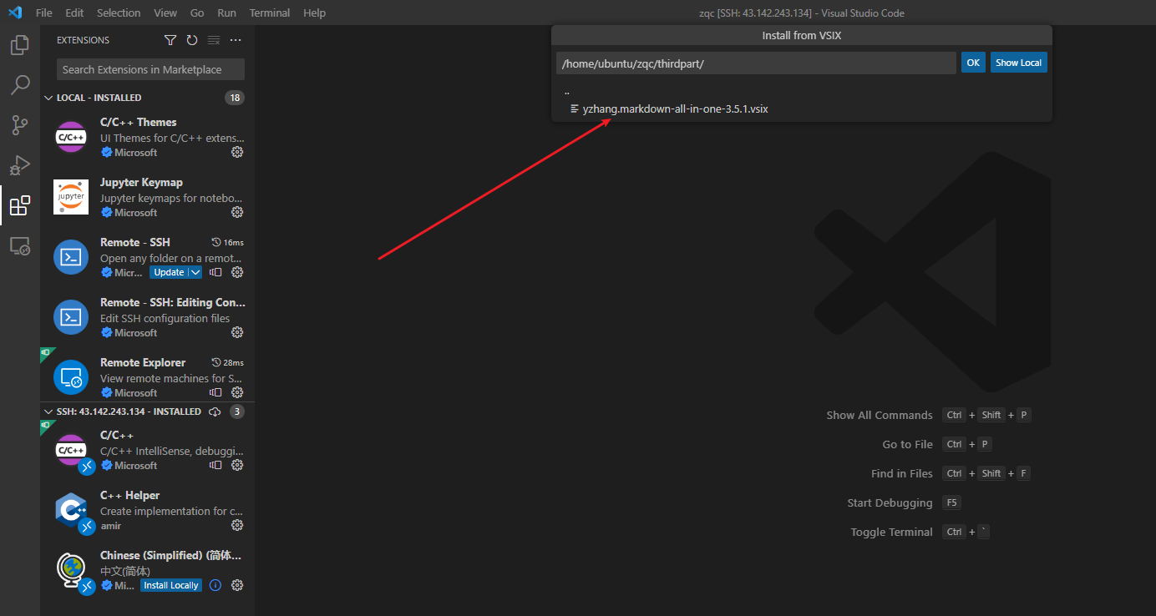

重启VScode

