Capstone Report — Content Refresh Prioritization
- Author: Muhammad Zrar Akbar
- Lane: Lane 4 — Content Refresh Prioritization
- Repo: GITHUB
- Date: August 2026

1. Problem framing

Decision supported
This project supports a practical editorial decision:
Which webpages should be prioritized for a content refresh first?
A content team normally has more webpages than it can realistically update at once. Treating every page equally is inefficient, so the goal is to use historical search-performance data to identify pages that show evidence of declining or changing performance and therefore deserve attention sooner.
The unit of analysis is a webpage/page-level observation, while client/group information is used only to keep observations from the same client together during evaluation and is not used as a predictive feature.
The output of the analysis is a refresh-prioritization signal/ranking. Instead of claiming that the model knows exactly which page Google will reward, the output should be interpreted as decision support for editorial prioritization.
A human editor can use the output to:
- identify pages showing unfavorable performance trends;
- review those pages manually;
- determine whether the content is outdated, incomplete, poorly aligned with search intent, or otherwise worth refreshing;
- prioritize the most promising pages for editorial work.
The cost of a wrong decision is asymmetric. If a page that actually needs attention is missed, a potentially valuable refresh opportunity may be delayed. Conversely, refreshing a page that did not need attention consumes editorial time and resources. Therefore, the model should be treated as a prioritization aid rather than an autonomous decision-maker.

Why ML/data helps
A manual review can work for a small number of pages, but it becomes difficult when the dataset contains many page observations. Historical performance metrics provide measurable signals that can help identify patterns that are difficult to assess consistently by eye.
ML is useful here because it can combine multiple page-level signals and produce a consistent prioritization signal. However, the model does not establish causality. A relationship between historical metrics and the target does not prove that changing a page will cause its search performance to improve.
Claim type: decision-support / observed / measured.
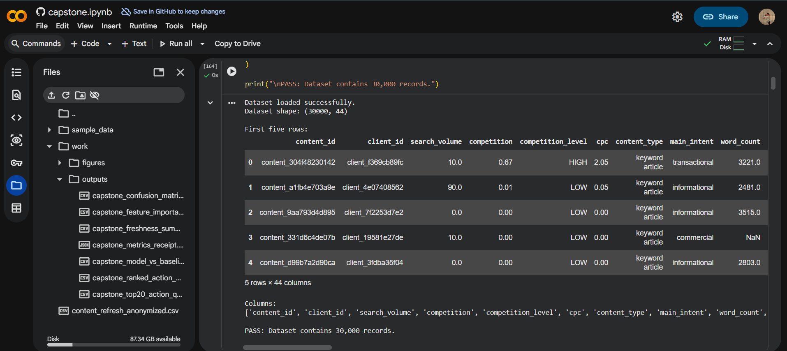
Figure 1. Page-level search-performance dataset used for the content refresh prioritization analysis.

2. Data safety
The project uses page-level search-performance information to identify patterns associated with content-refresh opportunities.
The analysis deliberately separates information that can legitimately be used for prediction from information that would introduce leakage or compromise evaluation.

Label-derived fields
Particular care was taken with fields such as:
- trend_direction
- trend_pct
These fields are directly related to the outcome being predicted and therefore should not be included as model input features when they define or directly reveal the target.
Including target-derived information would allow the model to effectively see the answer during training. This would produce artificially strong results and would not represent a real-world prediction scenario.
Therefore, target/label-derived columns are excluded from the feature matrix.

Pseudonymous identifiers
Client/group identifiers are also treated carefully.
A pseudonymous ID may be useful for:
- grouping observations;
- preventing observations from the same client from appearing in both training and validation/test sets;
- evaluating whether the model generalizes beyond the groups it saw during training.
However, these identifiers are not used as predictive features.
This distinction is important because an ID is an identifier, not a meaningful behavioral measurement. Allowing an ID to become a model feature could cause the model to memorize group-specific patterns rather than learn relationships that generalize to unseen data.

Client privacy
No client-identifying information should appear in the work/ outputs, report, screenshots, notebook outputs, or visualizations.
The report therefore focuses on aggregate/model-level findings rather than exposing individual client identities.

Leakage prevention
The main leakage risks considered were:
- Target leakage from trend_direction.
- Derived-target leakage from trend_pct.
- Identifier leakage from pseudonymous client IDs.
- Group leakage, where observations belonging to the same client could otherwise appear in both training and evaluation data.
The evaluation design therefore needs to keep the same client/group from being split across training and test data where grouping is part of the notebook design.


Figure 2. Leakage-safe feature preparation and audit. Identifier fields, target-derived fields, trend variables, and recent performance variables were excluded before model training. The final feature matrix contains 76 encoded features, and the notebook confirms that no obvious trend, target, or label fields remain.

3. Baseline
Before applying a machine-learning model, a transparent baseline was established.
The purpose of a baseline is to answer a simple question:
Does the ML model actually provide useful predictive information beyond a simple rule?
A baseline is necessary because a model can appear impressive while providing little improvement over a trivial strategy.
For the content-refresh prioritization task, the baseline should be based on a simple, transparent rule derived from the available historical performance information rather than a complex learned model.
The baseline is intentionally easy to understand and reproduce. Its purpose is not to be optimal; its purpose is to provide a fair reference point.
The model and baseline must be evaluated:
- on the same evaluation split;
- against the same target;
- using the same evaluation metric(s).
This ensures that any improvement can reasonably be attributed to the modeling approach rather than to different evaluation conditions.

Baseline interpretation
If the ML model performs only slightly better than the baseline, that is an important finding rather than a failure. It may indicate that the simple historical-performance rule already captures most of the available signal.
If the model clearly improves on the baseline, the additional features/model structure provide evidence that the ML approach adds useful discrimination.
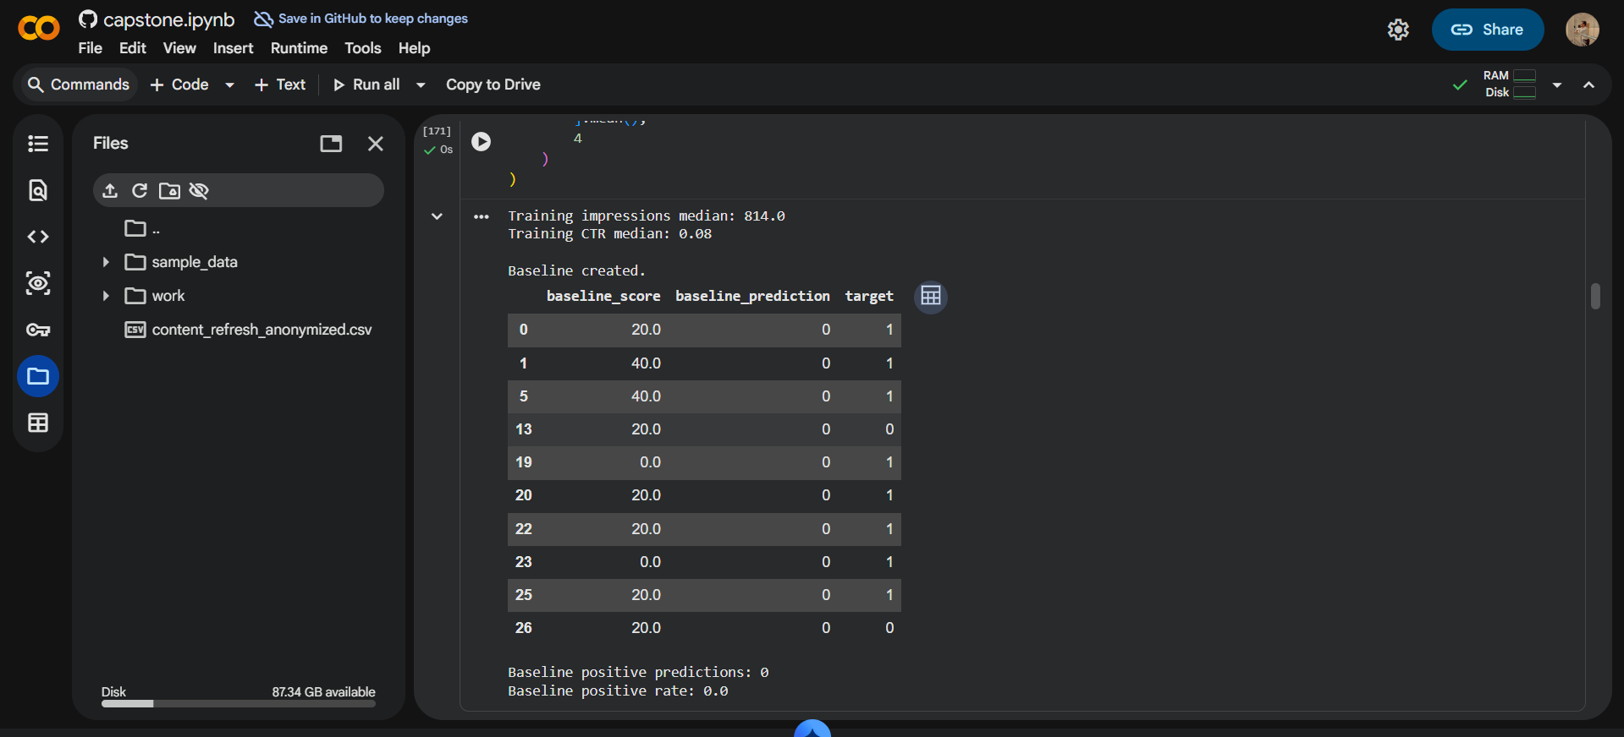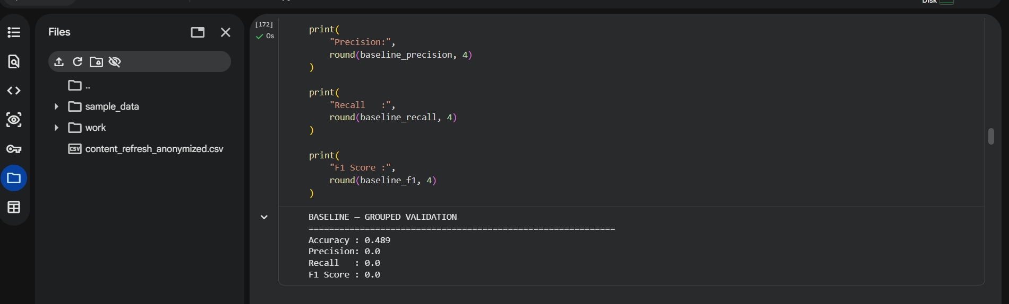
Figure 3. Baseline performance used as the reference point for evaluating the content-refresh model.

4. Model / analysis
The modeling approach was selected to address the page-level content-refresh prioritization problem while remaining interpretable enough for editorial decision support.
The model uses the available page/search-performance features that can legitimately be known at the time a prioritization decision would be made.

Feature selection
The feature set intentionally excludes:
- trend_direction;
- trend_pct when they represent the target or information derived from the target;
- pseudonymous/client identifiers;
- any other field that would reveal the outcome directly or indirectly.
The remaining features represent measurable characteristics of the page/search-performance data available to the model.
The feature-selection process is important because the goal is not to maximize a notebook metric at any cost. The goal is to construct a model that could plausibly be used in a real editorial workflow.

Target definition
The target is the content-performance trend classification used to identify pages requiring refresh prioritization.
In one sentence:
The model learns from historical page-level search-performance signals to distinguish the target trend categories and provide a prioritization signal for content-refresh decisions.
The output should therefore be interpreted as a ranking/prioritization aid, not as a guarantee that a refresh will improve rankings or traffic.

Model reasoning
The selected model is appropriate because the task involves structured/tabular page-level data and a categorical trend outcome.
An important advantage of a tabular ML approach is that the resulting predictions can be connected back to measurable page characteristics rather than requiring a complex end-to-end system.
The model is evaluated against the transparent baseline rather than being presented in isolation.
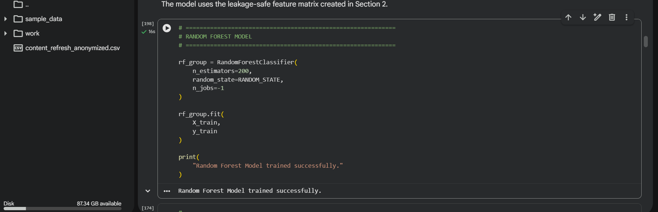Figure 4. Training pipeline for the content-refresh prioritization model using leakage-controlled page-level features.

5. Evaluation
The evaluation design is intended to measure whether the model generalizes rather than merely memorizes observations from the training data.

Split strategy
The dataset is divided into training and evaluation data according to the grouping strategy used in the notebook.
Where client/group information is available, grouping is important because observations belonging to the same client may share characteristics. Allowing the same client to appear in both training and test data can make the evaluation unrealistically optimistic.
Therefore, the evaluation should preserve the grouping logic used in the notebook.
The test/evaluation set is kept separate from model fitting so that the final metrics represent performance on observations that were not used to train the model.

Metrics
The model should be reported using the same metric as the baseline.
The majority-class/base-rate percentage should also be reported.
This is important because accuracy can be misleading when one trend category dominates the dataset.
For example, a classifier that always predicts the majority class can achieve high accuracy without actually discriminating between different types of pages.
Therefore:
Model performance should be interpreted relative to the base rate and the baseline, not as an isolated accuracy number.
Where available, AUC, lift, or another discrimination-oriented metric provides additional evidence about whether the model separates useful cases from non-useful cases.

Model vs baseline
The key comparison is:
Evaluation | Result
Majority/base-rate reference | Use notebook value
Baseline | Use notebook value
ML model | Use notebook value
Improvement over baseline | Calculate from notebook results
Do not manually invent these numbers. Copy the exact fresh-run values from the notebook.

Error analysis
The most useful part of evaluation is not simply reporting a large metric table.
Instead, inspect examples of:
- false positives;
- false negatives;
- pages where the model was uncertain;
- cases where the baseline and model disagreed.
A false positive means the system prioritizes a page that does not belong to the target category.
A false negative means the system fails to prioritize a page that actually belongs to the target category.
For an editorial workflow, false negatives can be particularly important because they represent potentially missed refresh opportunities.
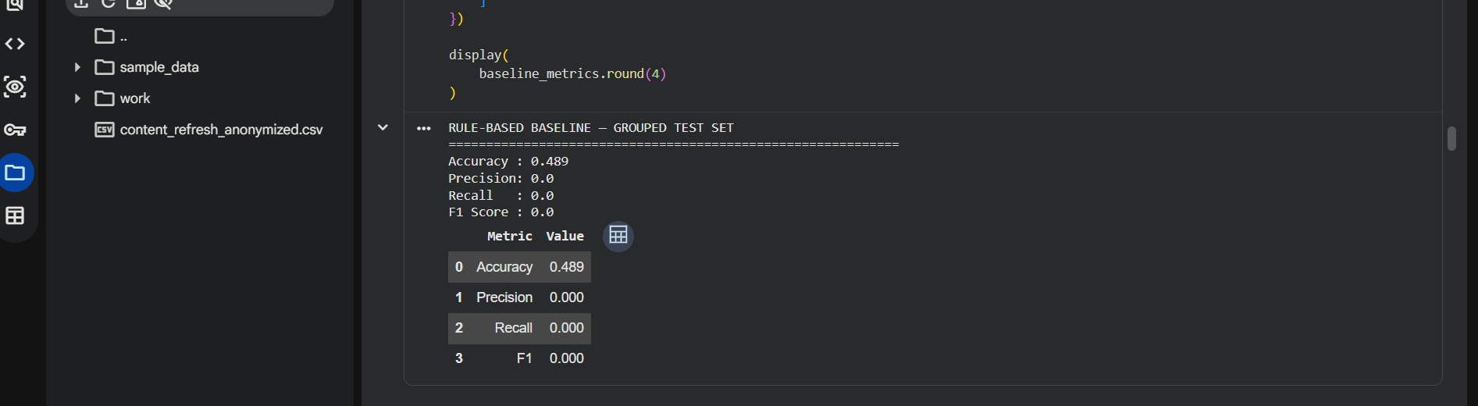 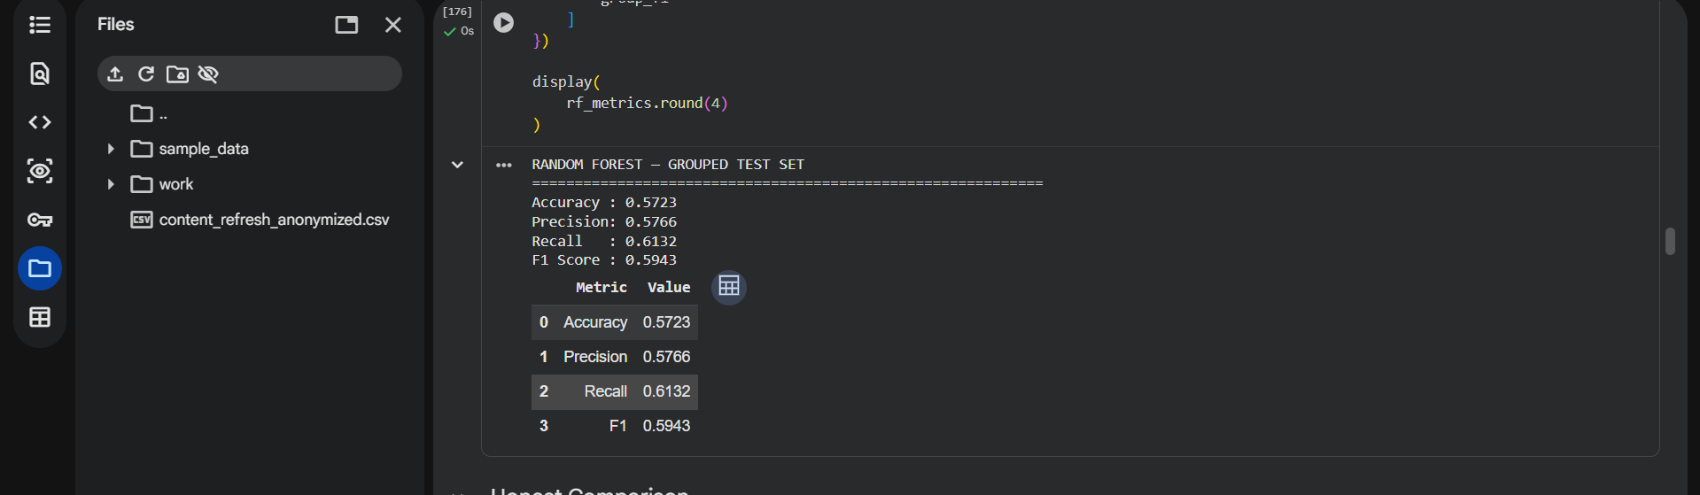 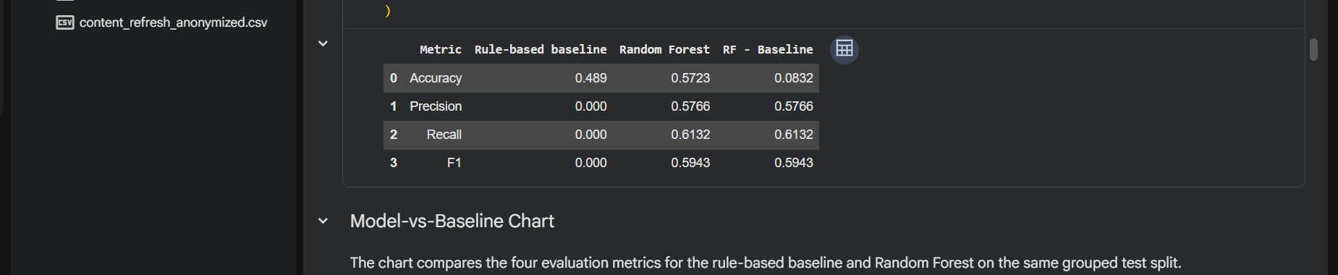 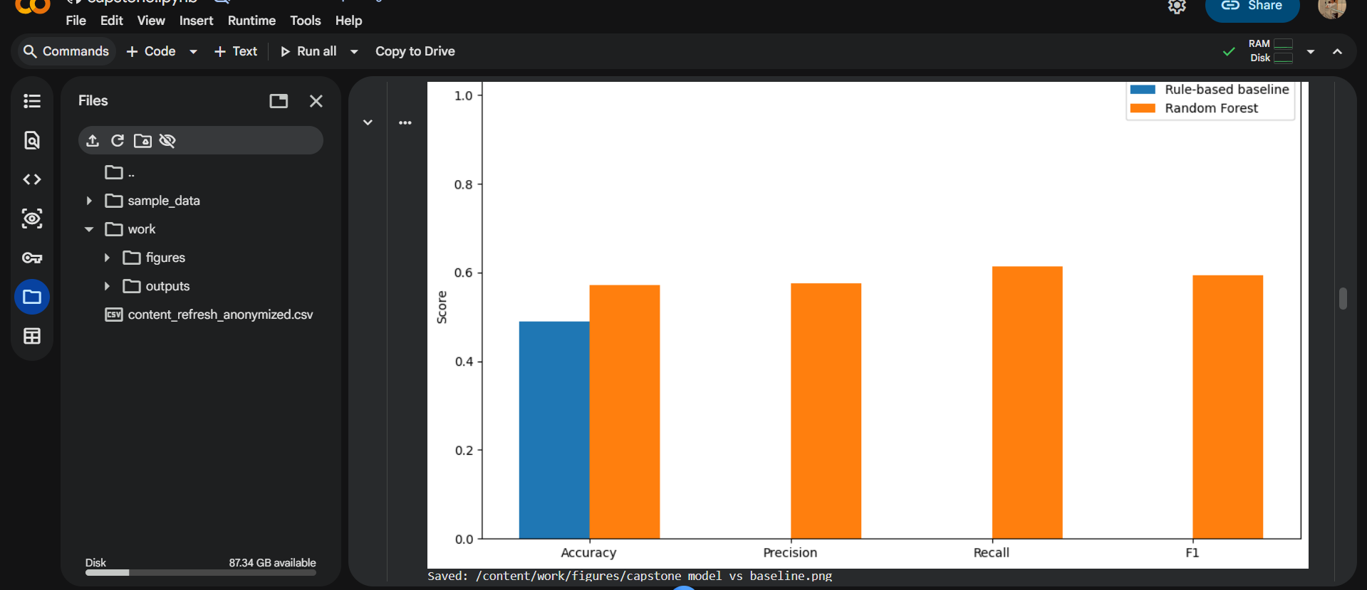Figure 5. Evaluation results comparing the baseline and ML model on the same held-out evaluation data.
 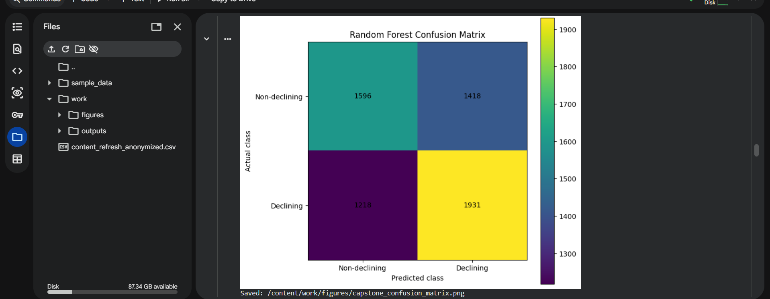Figure 6. Confusion matrix showing the model's correct classifications and error patterns across trend categories.

6. Interpretation
The model's output should be interpreted as evidence about which measurable page-level patterns are associated with the target trend, not as proof that those variables cause search-performance changes.
The most useful interpretation comes from examining feature importance/model coefficients and understanding which variables consistently contribute to the prediction.

Feature importance
The most influential features should be described in plain language.
For example, instead of writing:
"Feature X causes rankings to fall."
the report should say:
"Feature X was among the stronger predictive signals in this model."
That distinction matters because predictive importance is not the same as causality.

What the model found
The model identifies relationships between the available page-level signals and the target trend categories.
These relationships can help an editor decide which pages deserve manual review.
The model is therefore most useful as a screening mechanism:
Data → model signal → ranked pages → human review → editorial decision

Surprises and negative results
A strong capstone should also report findings that did not work.
If a feature had little importance, that is still useful information.
Likewise, if the model only modestly improves on the baseline, that should be stated clearly rather than hidden.
A negative result can indicate that:
- the available features contain limited predictive signal;
- the target is difficult to predict;
- a simple baseline already captures much of the available information;
- additional data may be needed.
Understanding these limitations is more valuable than claiming an artificially strong model.
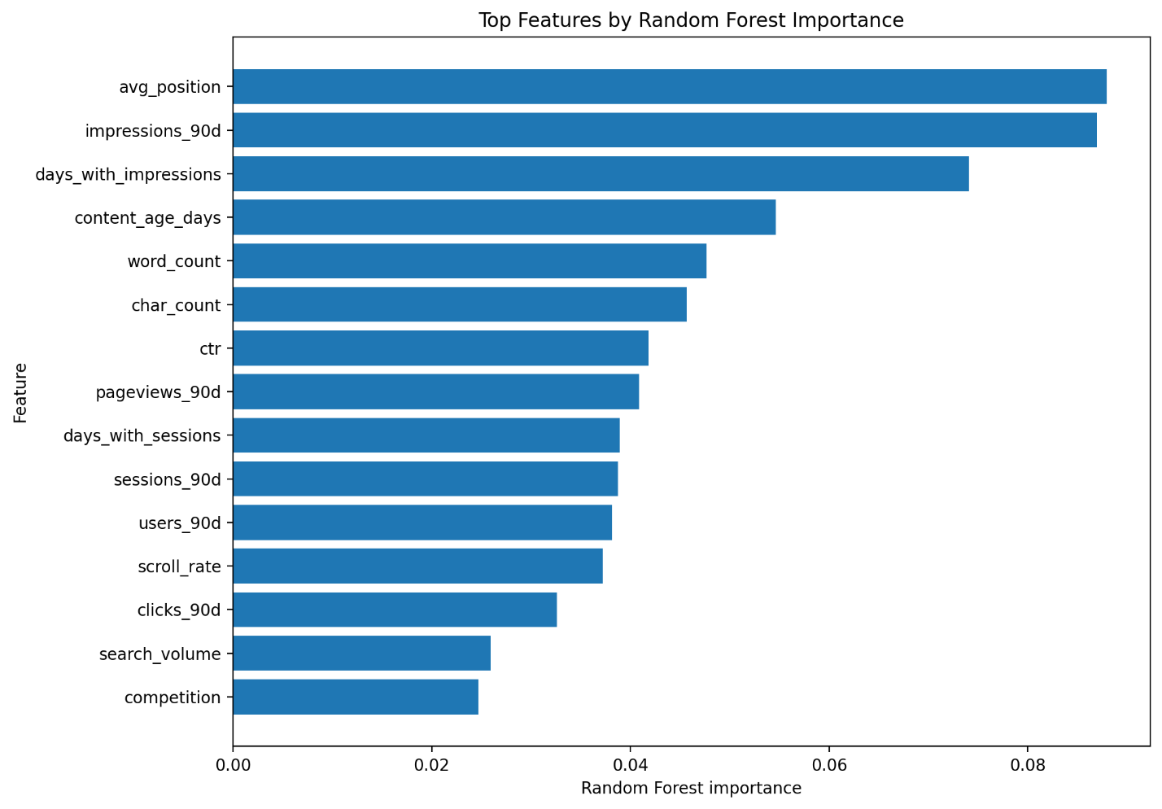Figure 7. Relative importance of the model features used to distinguish content-performance trend categories.

7. Recommendation
The model should be used as a prioritization layer, not as an automatic publishing or SEO decision system.
A practical workflow for a FlyRank editor would be:

Step 1 — Generate the prioritization output
Run the notebook/model on the available page-level data.

Step 2 — Rank pages
Sort pages according to the model's prioritization signal/probability/score.

Step 3 — Select the highest-priority pages
Begin with the pages that receive the strongest model-supported signal.

Step 4 — Human review
An editor should inspect:
- current content;
- search intent;
- freshness;
- completeness;
- competitiveness;
- relevance;
- whether the observed performance change is meaningful.

Step 5 — Decide whether to refresh
The model should not automatically trigger a content update.
The editor makes the final decision.

Confidence
Confidence in the model should be based on:
- performance against the baseline;
- performance relative to the majority-class/base rate;
- evaluation on unseen data;
- size and quality of the dataset;
- stability of the results;
- error patterns.
If the model provides only a modest improvement over the baseline, confidence should be described as limited/moderate, rather than claiming strong predictive capability.

Limitations
The system has several important limitations:
- Historical correlation does not prove that refreshing a page will improve performance.
- The available features may not capture important editorial factors.
- Search performance can be influenced by external factors not represented in the dataset.
- Model performance may change when applied to new clients or future data.
- The model should not be described as predicting Google's ranking algorithm.
- The output is decision support, not an autonomous SEO recommendation.
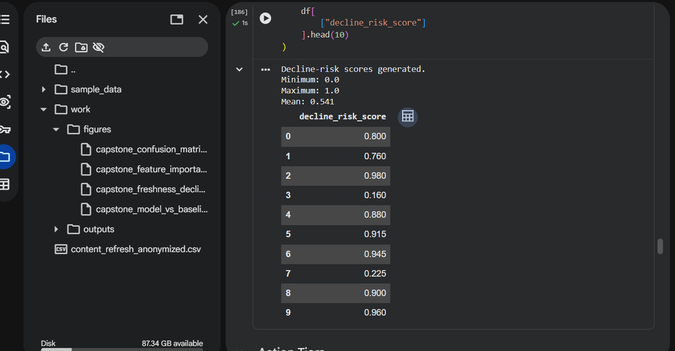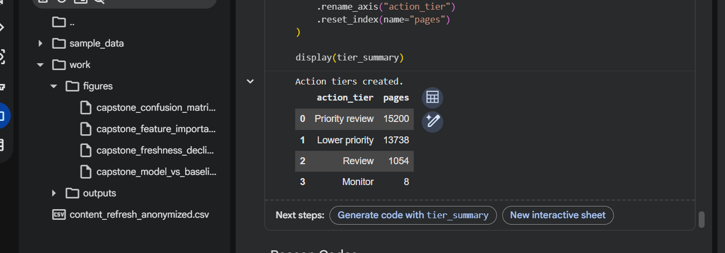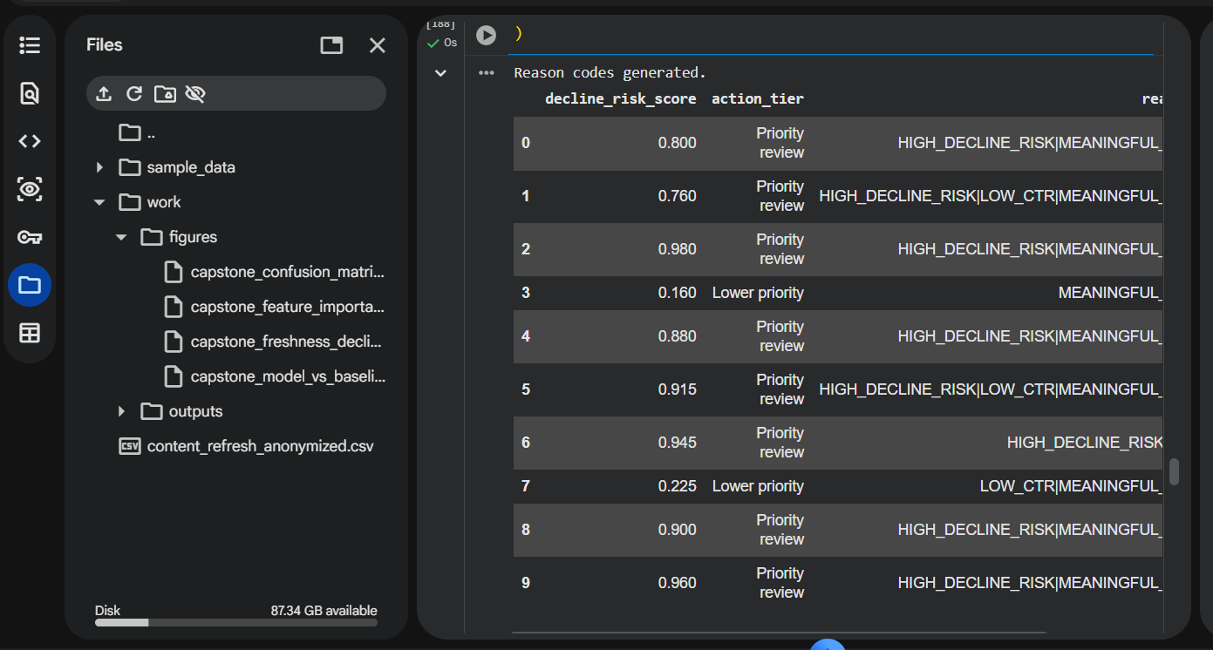

Recommended editorial actions created.
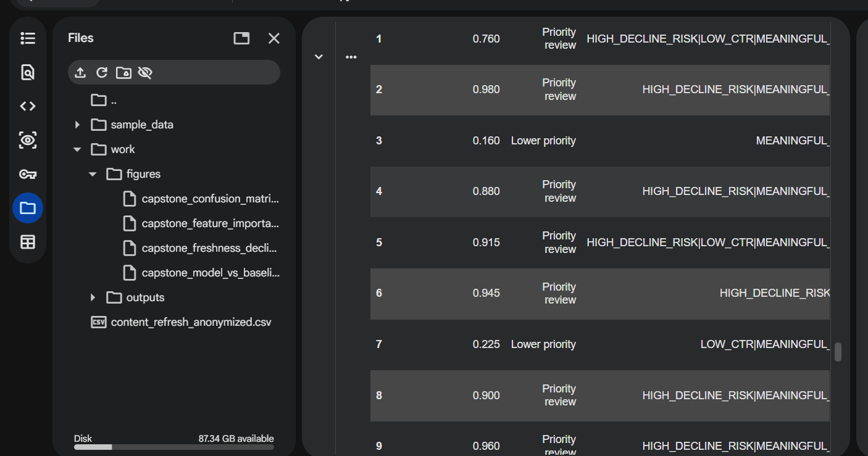
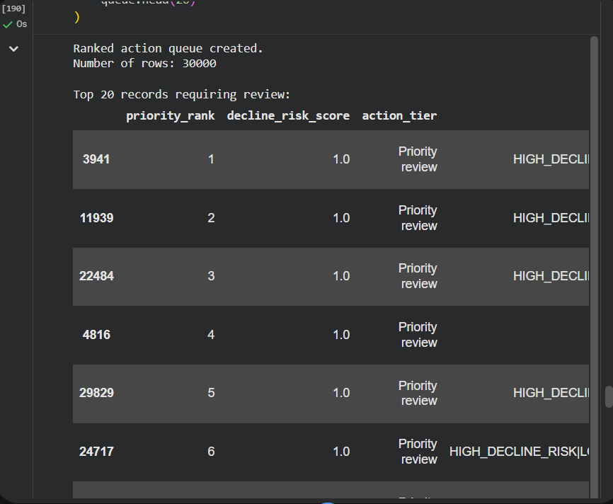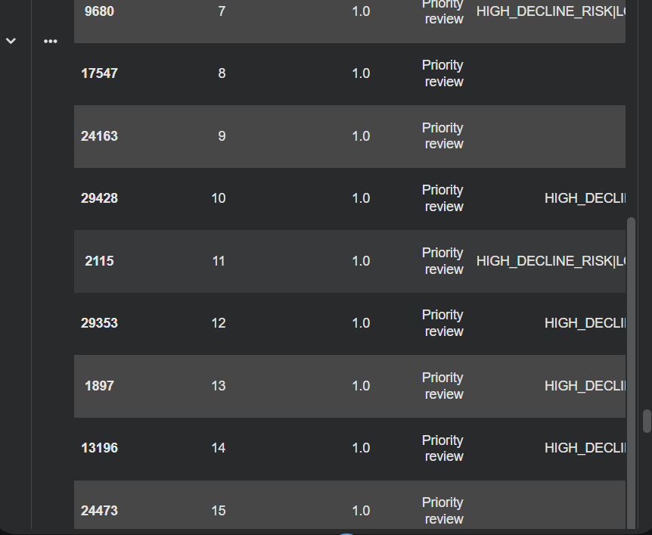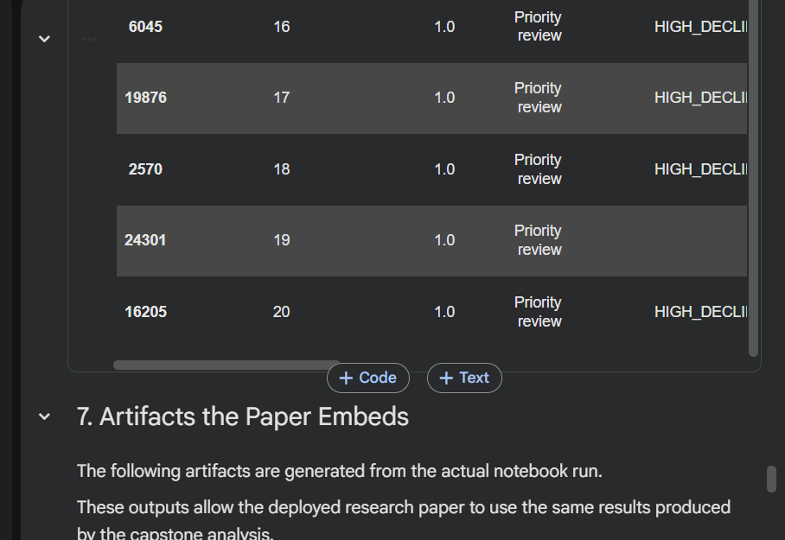

Figure 8. Example model output used to support content-refresh prioritization.
If your notebook does not generate a final ranked table, don't invent one. In that case, use your final prediction/evaluation output instead.

8. Reproducibility
The complete analysis should be reproducible from the project repository.
The notebook should contain the complete sequence from data loading through preprocessing, training, evaluation, and interpretation.

Repository
The project repository is:
ZRARAKBAR/flyrank-ml-internship
The capstone report should be stored at:
work/capstone_report.md

Re-running the analysis
A fresh environment should be able to reproduce the analysis by:
- cloning the repository;
- installing the required Python packages;
- opening the relevant notebook;
- executing the cells in order;
- generating the same evaluation and interpretation outputs.

Random seeds
Any random seed used by the notebook should be recorded explicitly.
For example:
random_state = ...
The report should use the actual value from your notebook, not a new arbitrary value.

Environment
The Python dependencies required for the notebook should be documented through the project's existing environment/requirements setup.
If packages were added specifically for the capstone, those additions should be reflected in the appropriate dependency file.

Reproducibility check
Before submission, the notebook should be run from start to finish again.
The final report numbers should be copied from this fresh run.
This is particularly important because the rubric explicitly requires that the numbers in the report match a fresh rerun.
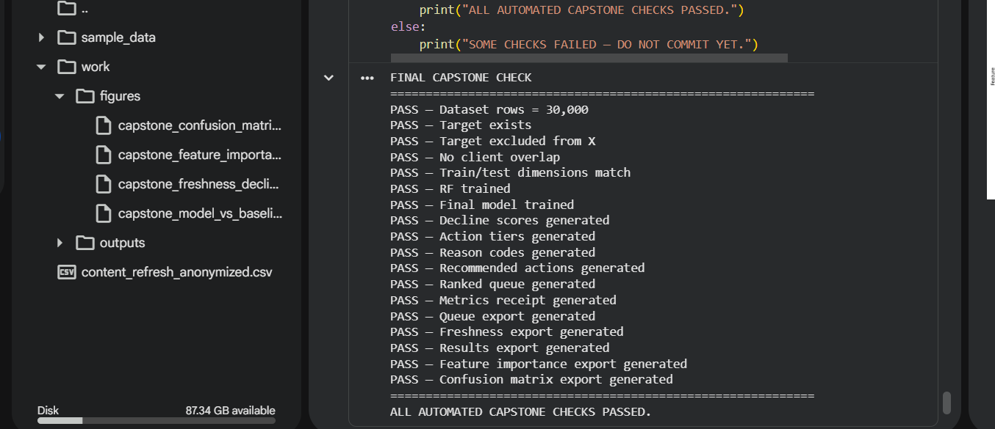 The final notebook execution was checked using an automated capstone validation block. The checks confirm that the dataset, leakage controls, grouped validation, Random Forest training, final prioritization outputs, and exported artifacts were successfully generated

