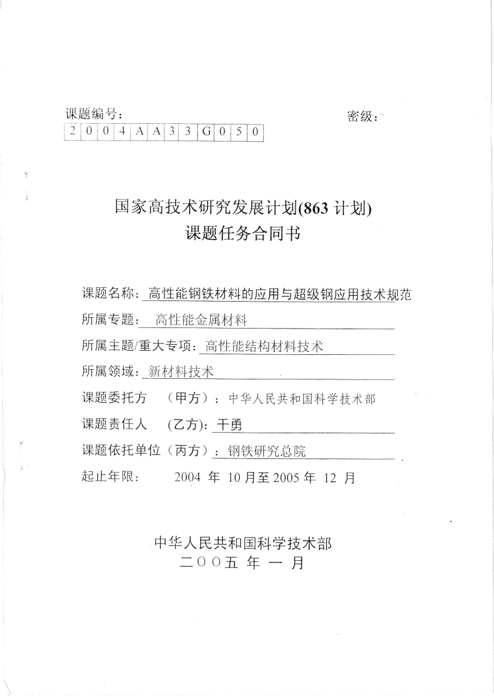

{{a}}

{{b}}

{{c}}