SAIMON,MD.ZILLUR RAHMAN (17-34006-1)

1. Write a shell script to generate the series of even number from 0 to n. 0 2 4 n
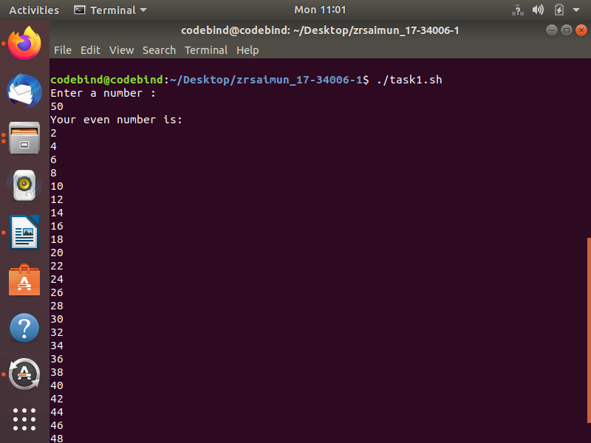
#!/bin/bash
echo "Enter a number : "
read num
echo "Your even number is: "
for((i=1;i<=num;i++))
do
out=$(( $i % 2 ))
if [ $out -eq 0 ]
then
echo $i
fi
done

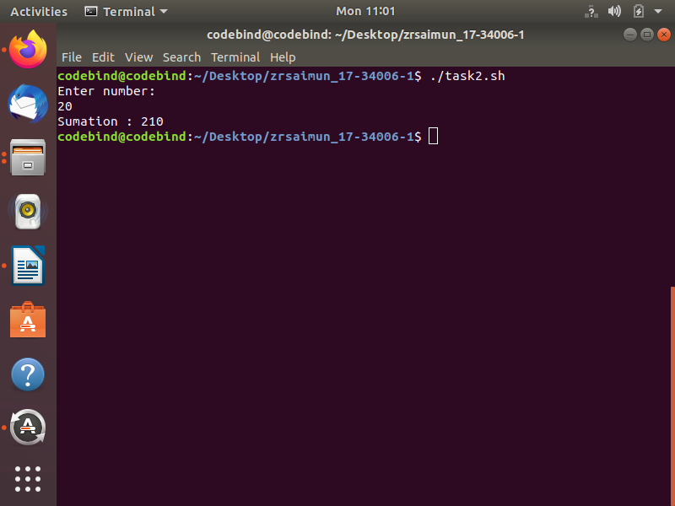
2. Write a shell script to find out the sum of series 1+2+3+.............n, where n is input by the
user.

#!/bin/bash
echo "Enter number: "
read num
sum=0
for ((i=1;i<=num;i++))
do
sum=$((sum+i))
done
echo "Sumation : $sum"

3. Write a shell script to print the characters of an input string into reverse order.
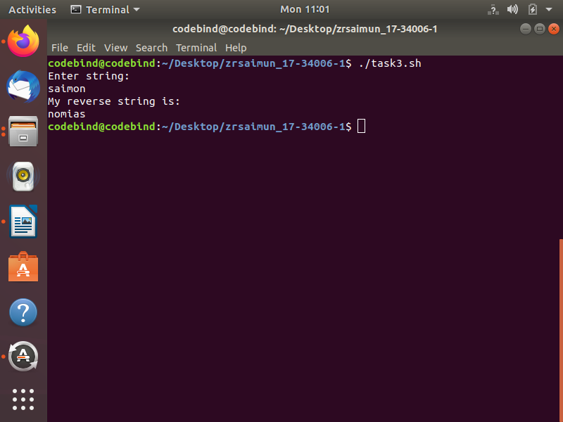
#!/bin/bash
echo "Enter string: "
read str
echo "My reverse string is: "
echo $str | rev

4. Write a shell script to count the number of characters, words, spaces in a given text.

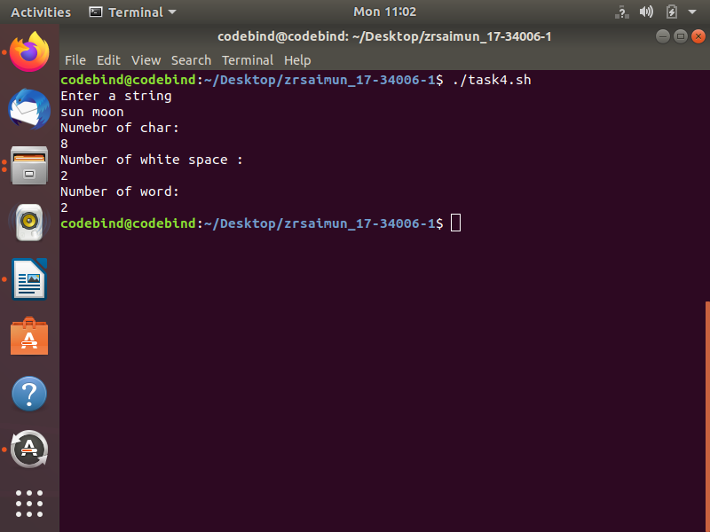
#!/bin/bash
echo "Enter a string"
read str
echo "Numebr of char: "
echo -n $str | wc -c
echo "Number of white space : "
echo grep -o "" <<< $str | wc -w
echo "Number of word: "
echo -n $str | wc -w

5. The marks obtained by a student in two different subjects are input through the keyboard.
The student gets a division as per the following rules. (Using elif clause). If percentage
greater than or equal to 60 get First division if percentage greater than or equal to 50 or less
than 60 get Second division if percentage greater than or equal to 40 or less than 50 get
Third division if percentage less than 40 Fail
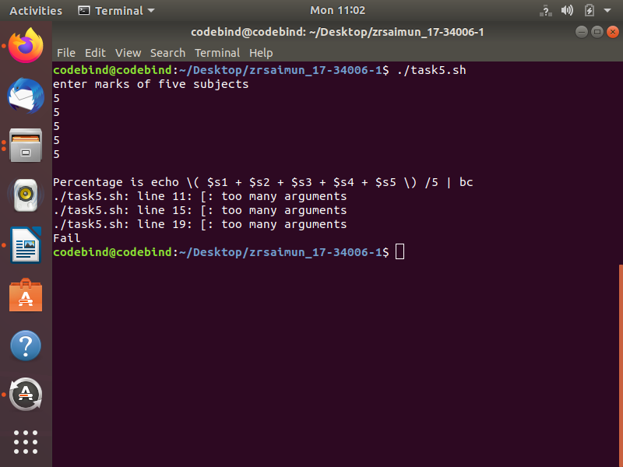
#!/bin/bash
echo enter marks of five subjects
read s1
read s2
read s3
read s4
read s5
per='echo \( $s1 + $s2 + $s3 + $s4 + $s5 \) /5 | bc'
echo
echo Percentage is $per
if [ $per –ge 60 ]
then
echo First division

elif [ $per –ge 50 –a -$per –lt 60 ]
then
echo Second division

elif [ $per –ge 40 –a $per –lt 50 ]
then
echo Third division
else
echo Fail
fi

6. Write a shell script to search a file in current directory.

1)Shell comand using grep
2)ls *.txt ( search all txt file in folder)
3)find . -maxdepth 1 -type f

7. Run All grep command

-c : This prints only a count of the lines that match a pattern
-h : Display the matched lines, but do not display the filenames.
-i : Ignores, case for matching
-l : Displays list of a filenames only.
-n : Display the matched lines and their line numbers.
-v : This prints out all the lines that do not matches the pattern
-e exp : Specifies expression with this option. Can use multiple times.
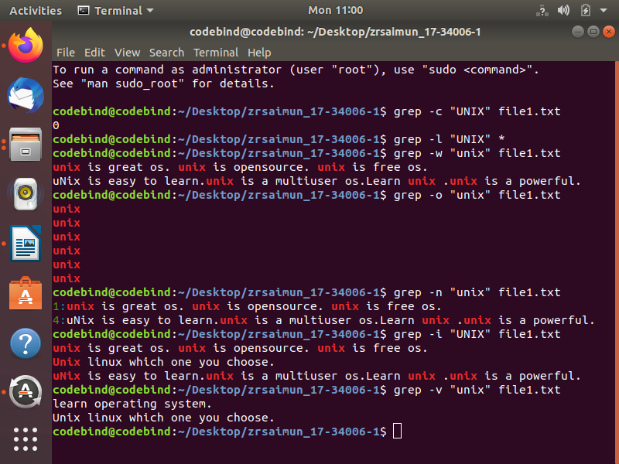
-f file : Takes patterns from file, one per line.
-E : Treats pattern as an extended regular expression (ERE)
-w : Match whole word
-o : Print only the matched parts of a matching line,
with each such part on a separate output line.

