--------------------------------------------------------  
OUTPUT OF LINUX COMMANDS ON KALI LINUX  
--------------------------------------------------------

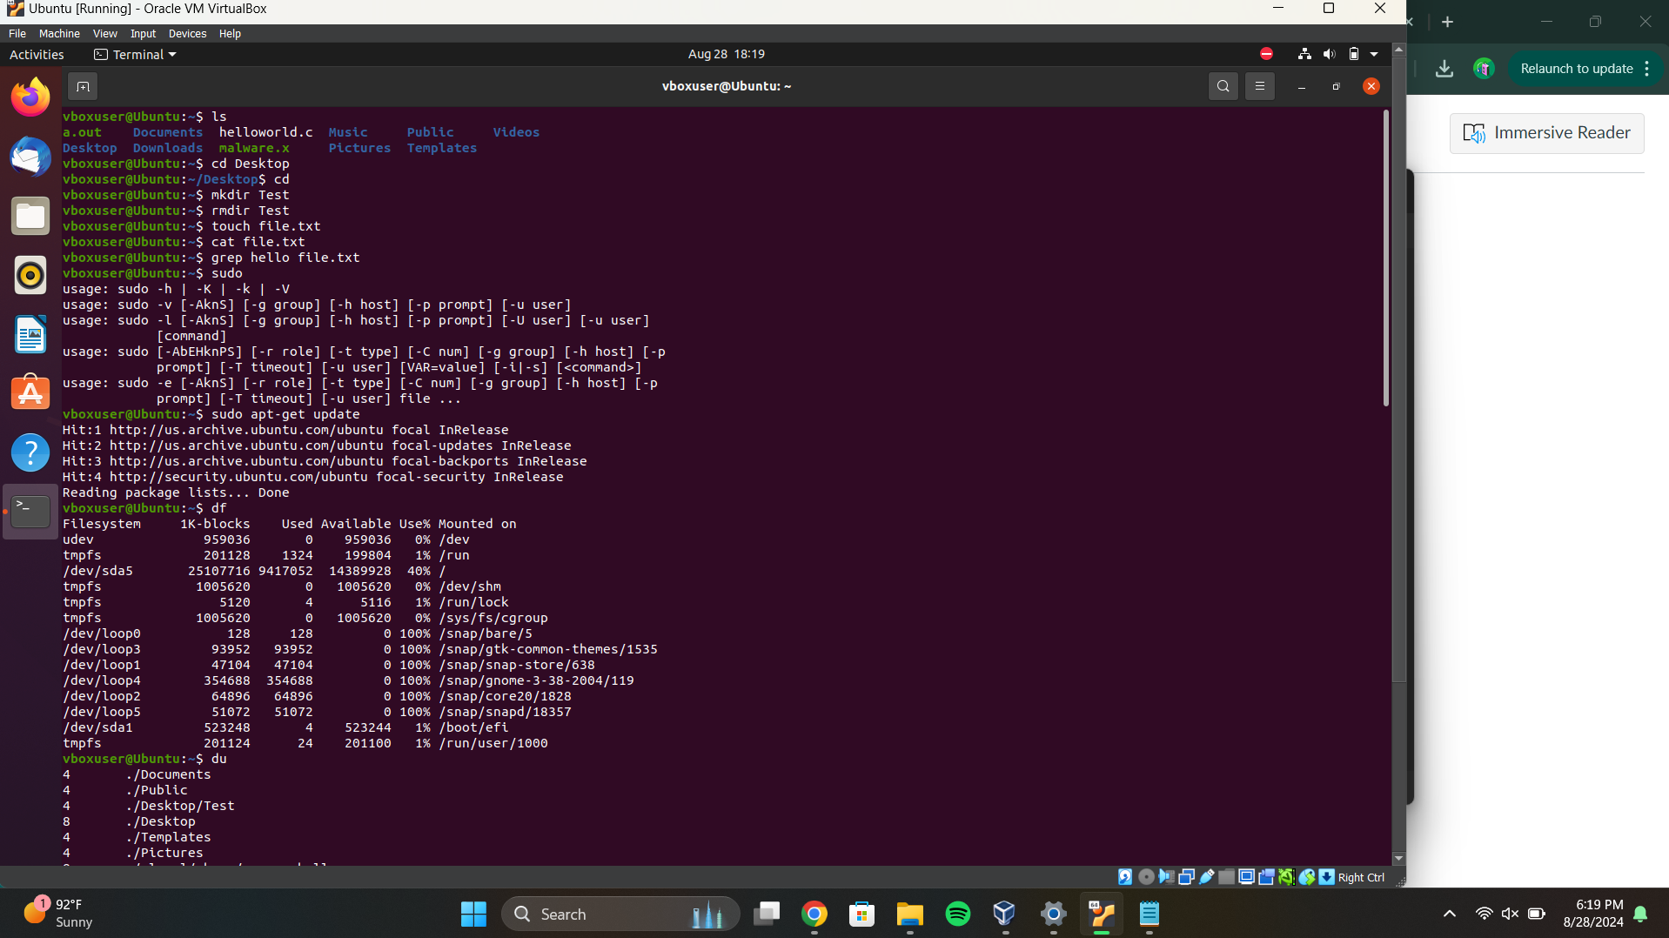

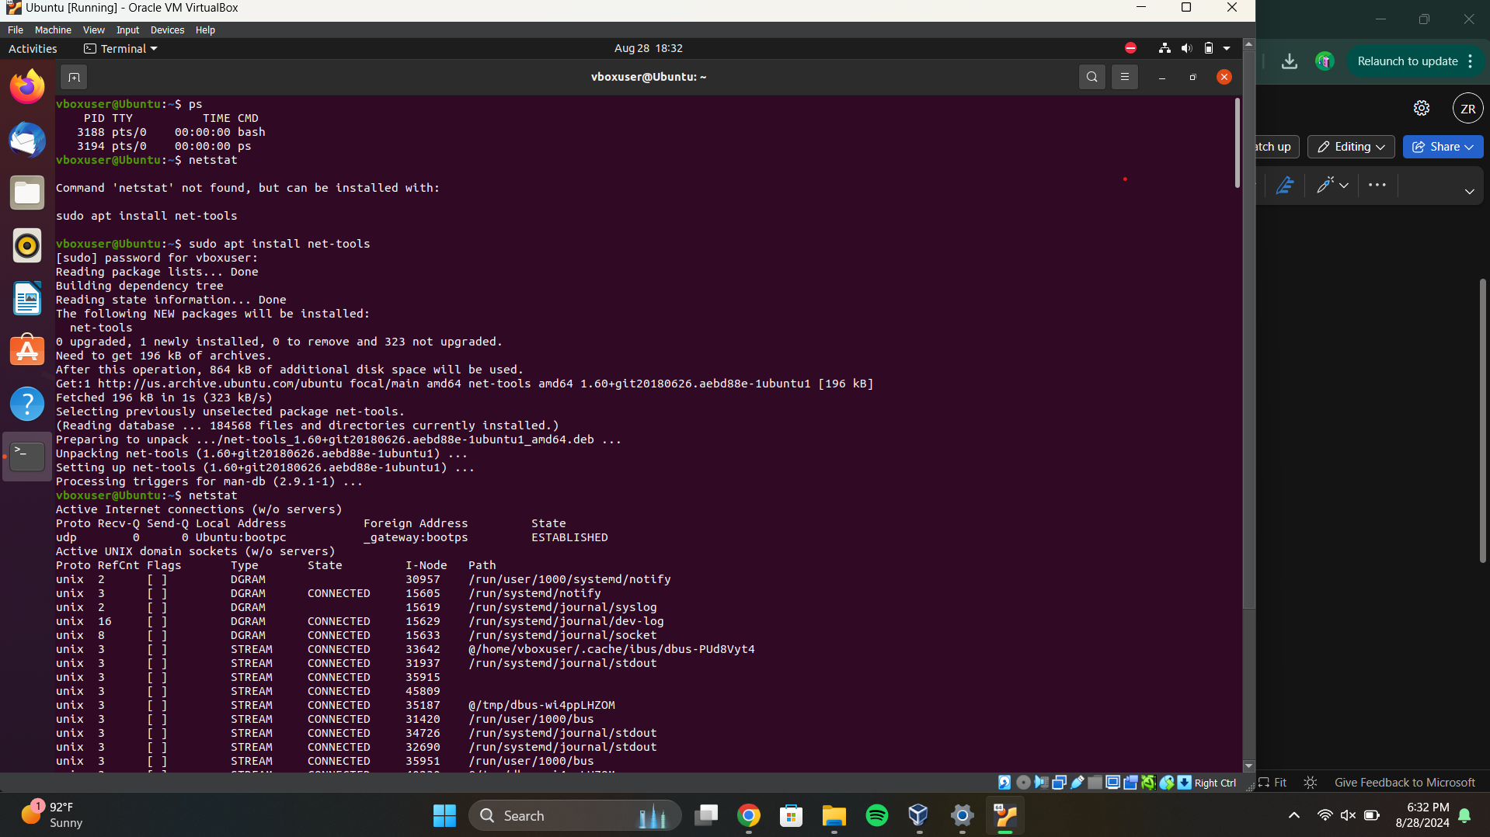

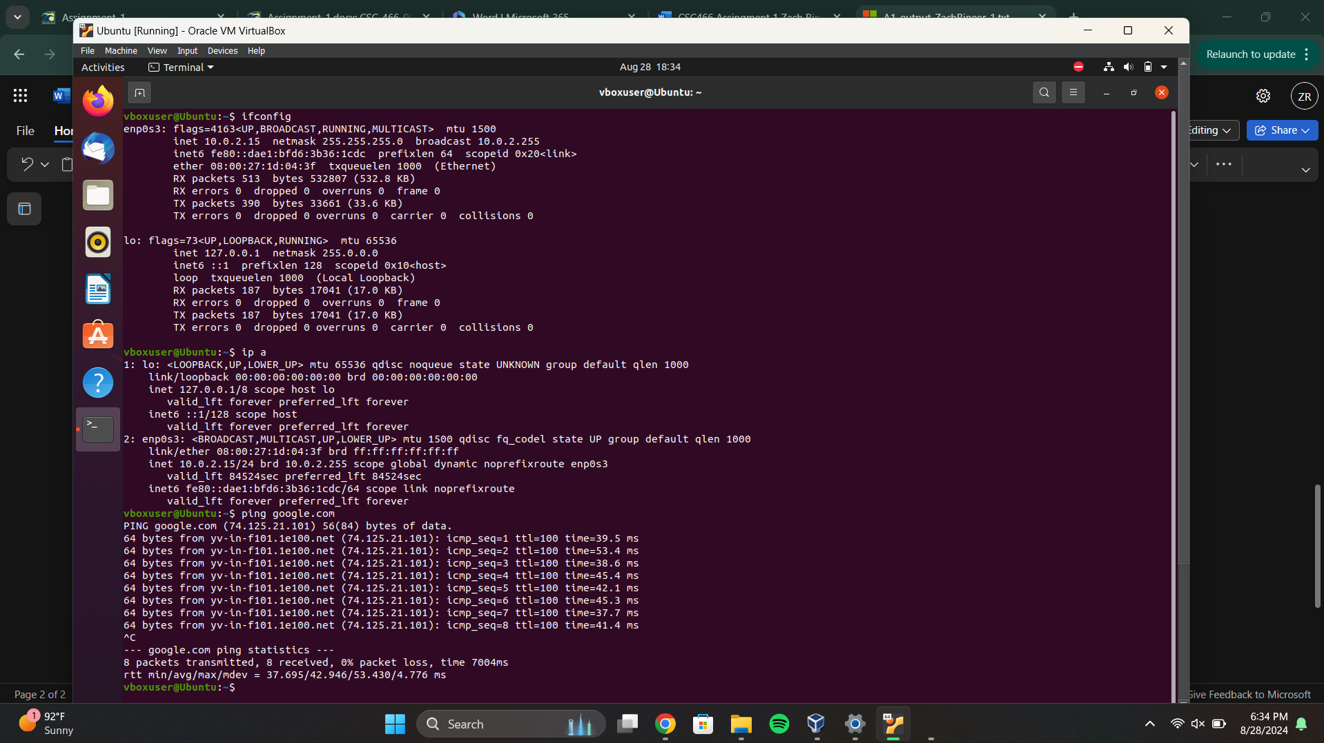

--------------------------------------------------------  
OUTPUT OF LINUX COMMANDS ON KALI LINUX  
--------------------------------------------------------