**Problem #1**: 51

**Problem #2**: The error with the given pseudocode is the location of the first line, “*area = width*length*.” For the program to multiply the values of *width* and *length* together and assign the result to the *area* variable, the variables *length* and *width* must first be initialized. Moving the statement “*area = width * length*” to just after the line “*Input length*” will allow the multiplication to work because both *length* and *width* will have values input by the user at that point.

**Problem #3**:

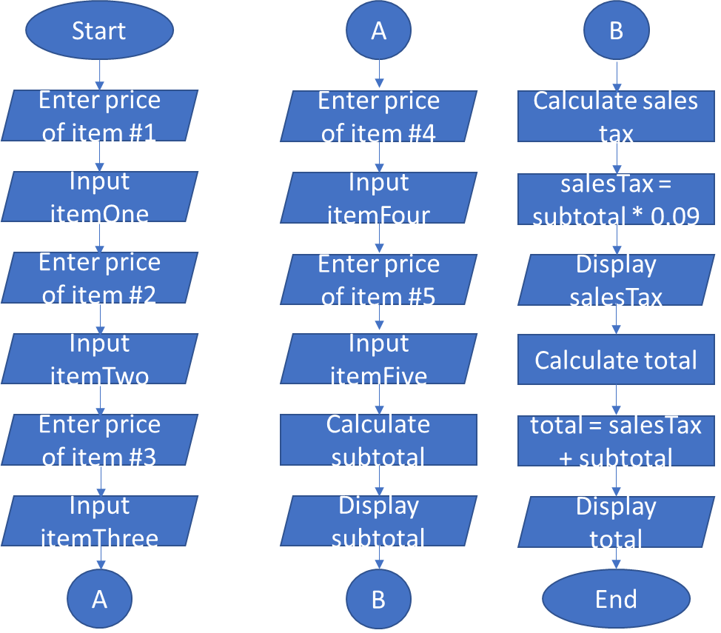

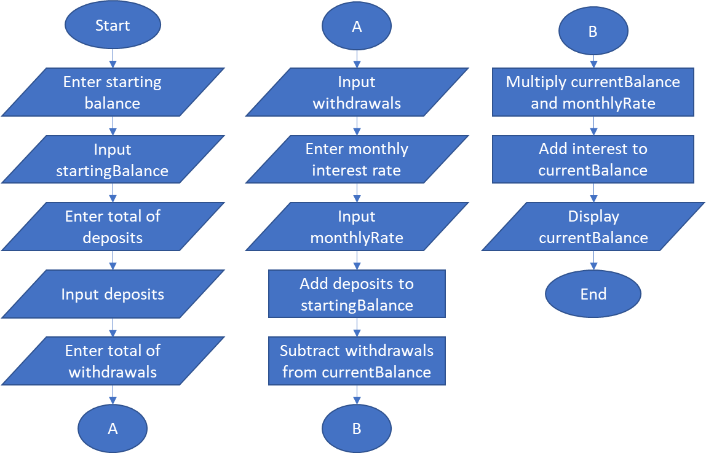**Problem #4**:

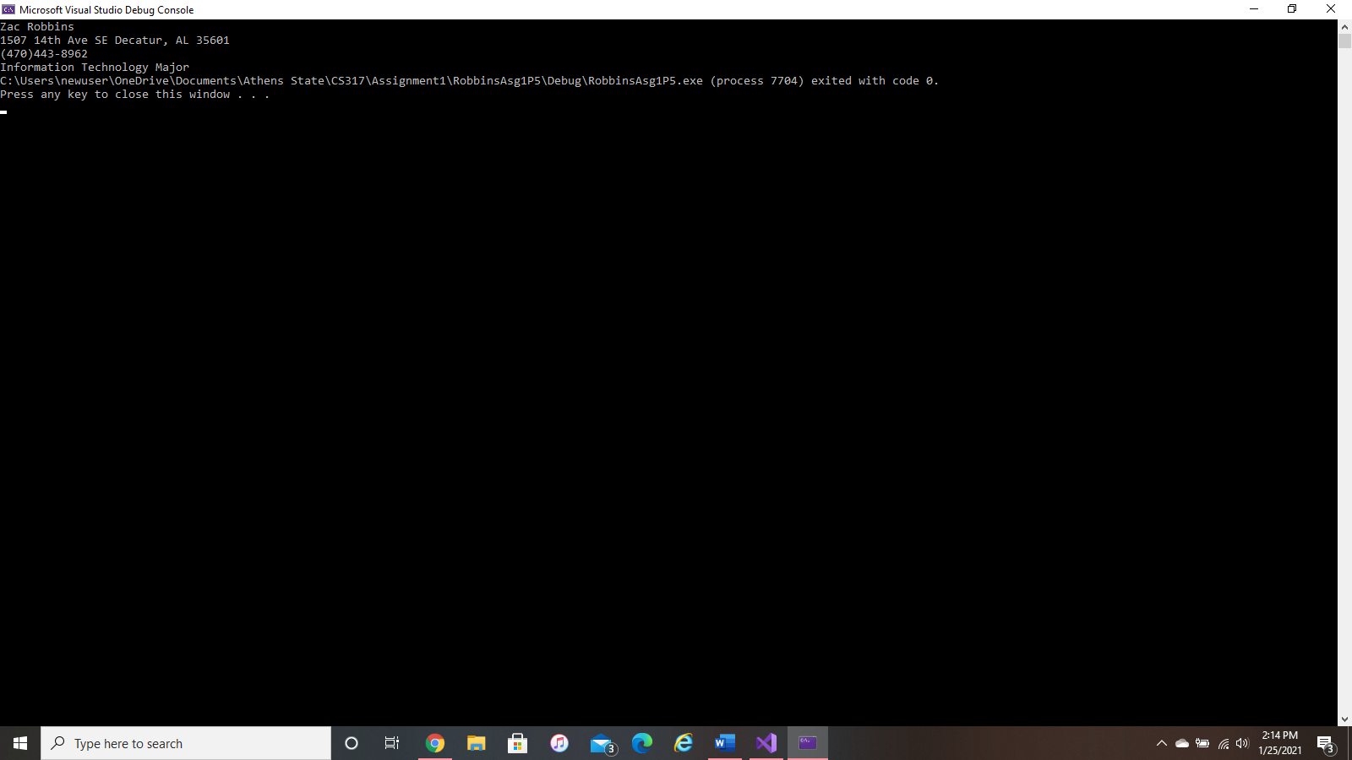**Problem #5**:

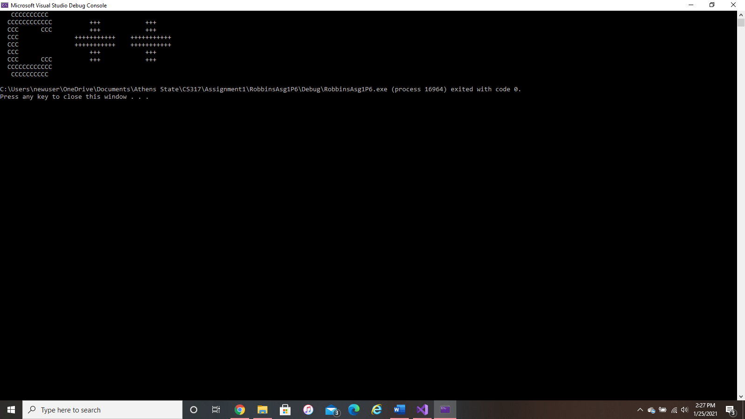**Problem #6**:

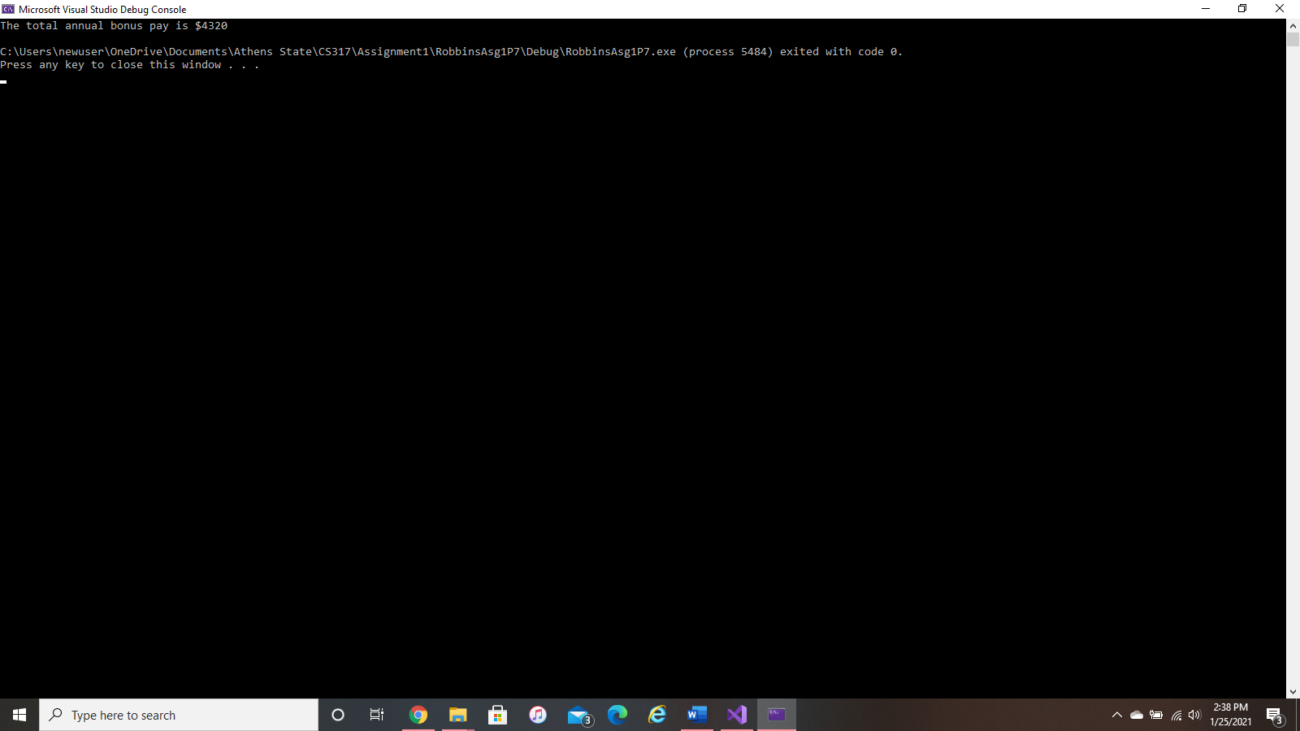**Problem #7**: