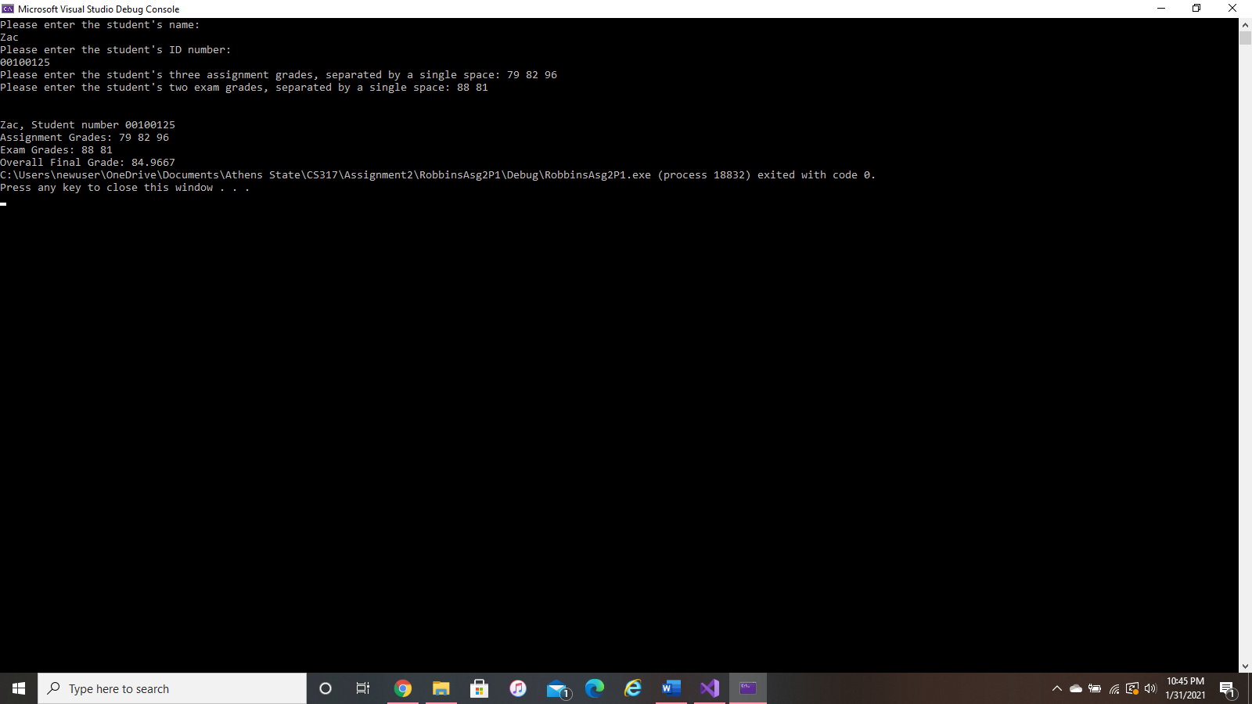Problem #1:

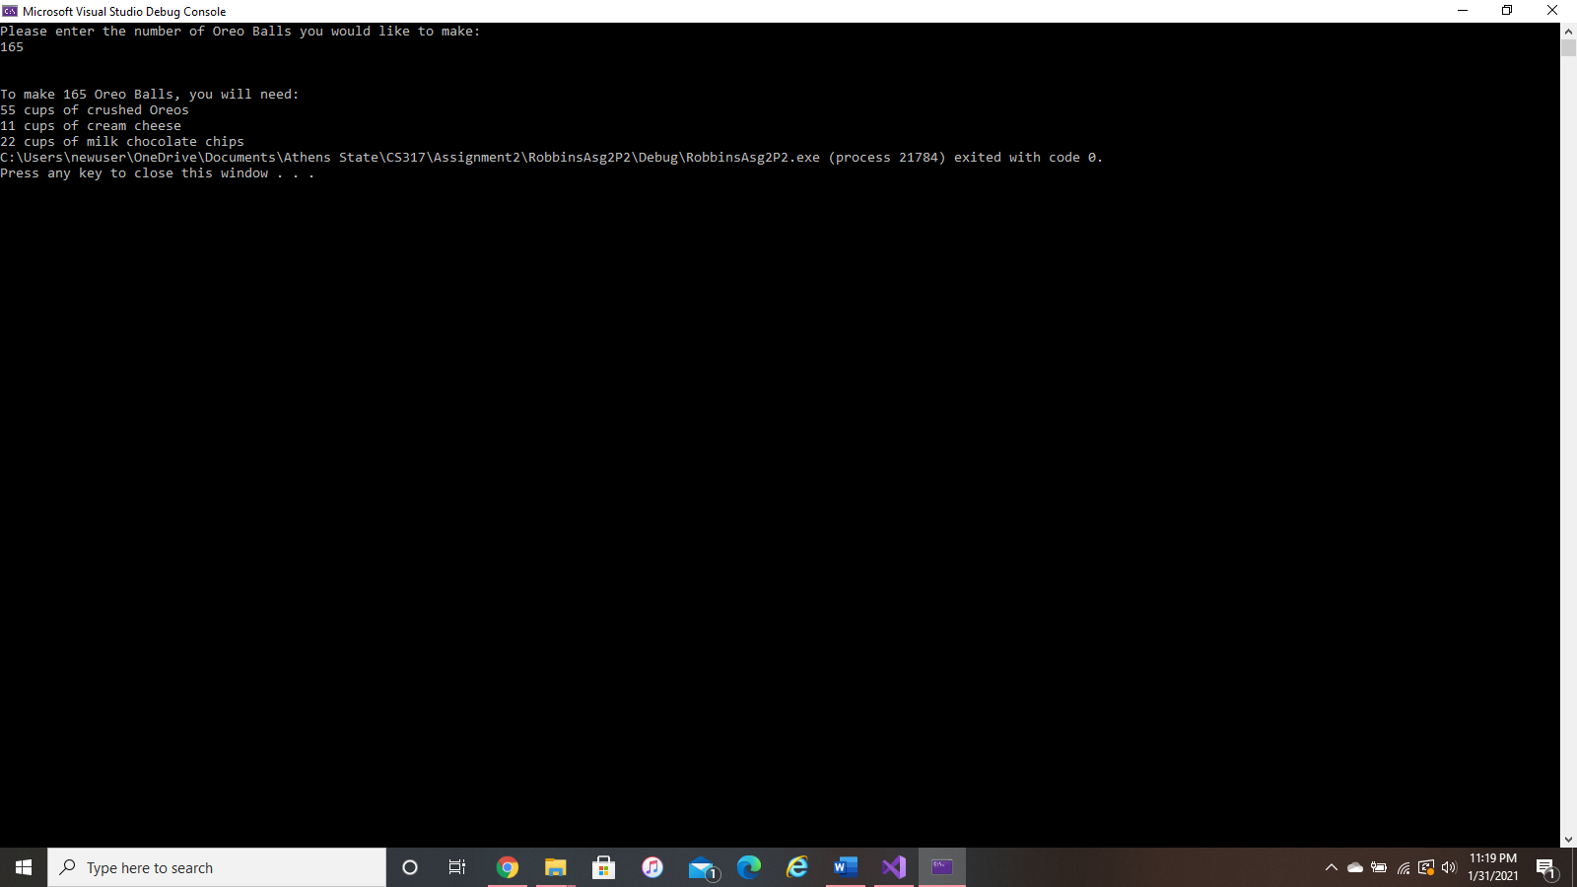Problem #2:

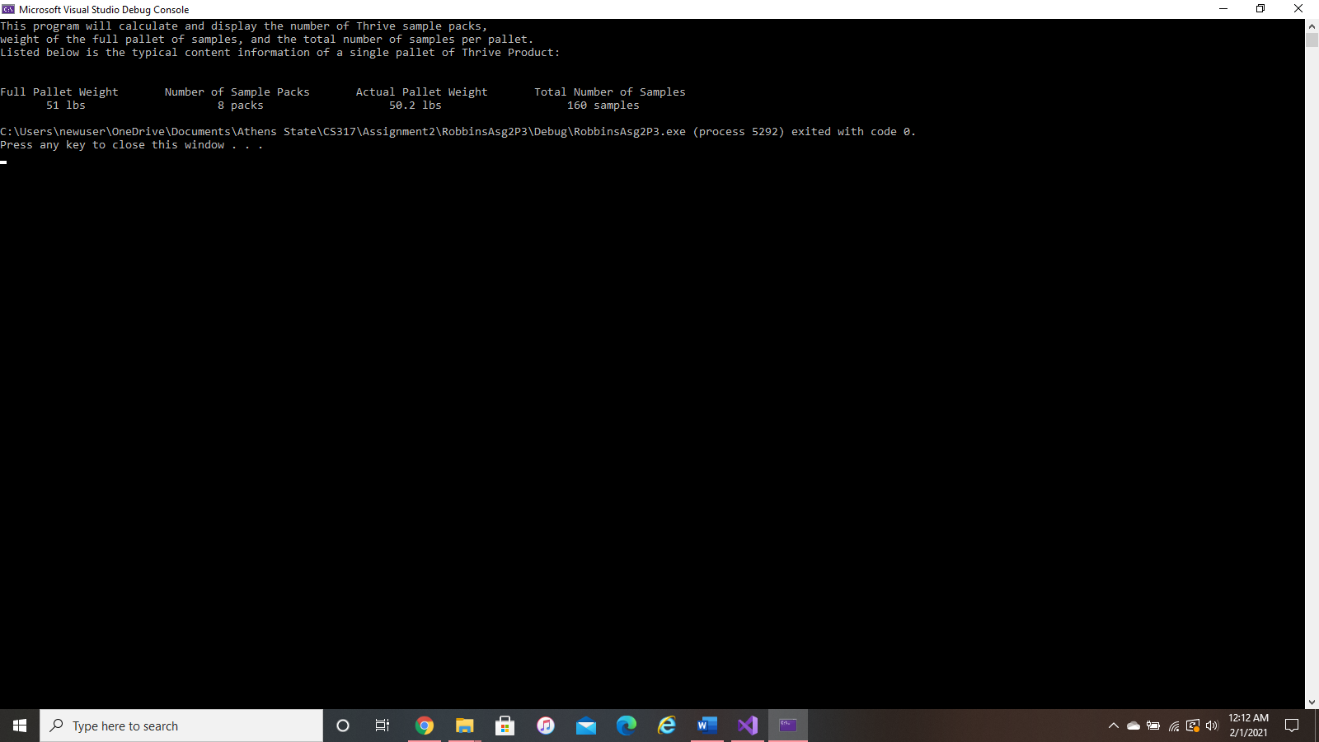Problem #3:

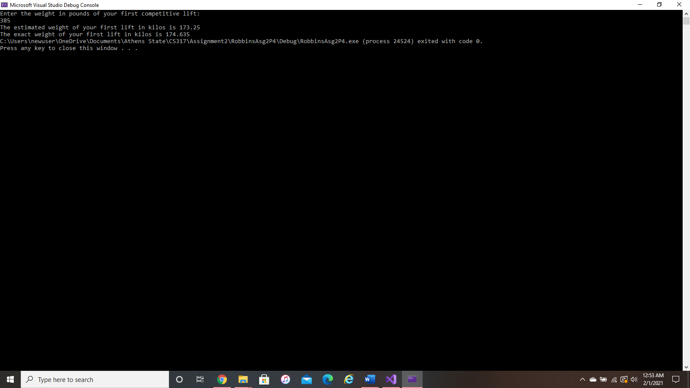Problem #4:

Problem #5:

|  |  |  |
| --- | --- | --- |
| 1. Add 6 to x | x = x +6 | x += 6 |
| 1. Subtract 10 from *grade* | *grade* = *grade* – 10 | *grade* -= 10 |
| 1. Multiply *discount* by *percent* times 2 | *discount* = *discount* * (*percent* * 2) | *discount* *= (*percent* * 2) |
| 1. Divide *loan* by *months’* minus 2500 | *loan* = *loan* / (*months’* – 2500) | *loan* /= (*months’* – 2500) |
| 1. Divide *TotalGrades* by *students* | *TotalGrades* = *TotalGrades* / *students* | *TotalGrades* /= *students* |
| 1. Store in *money* the remainder of *money* divided by *expense* | *money* = *money* % *expense* | *money* %= *expense* |
| 1. Multiply *number1* by 6 | *number1* = *number1* *6 | *number1* *= 6 |
| 1. Subtract *number2* *4 from *total* | *total* = *total* – (*number2* * 4) | *total* -= (*number2* *4) |