Problem 1 – Time Calculator

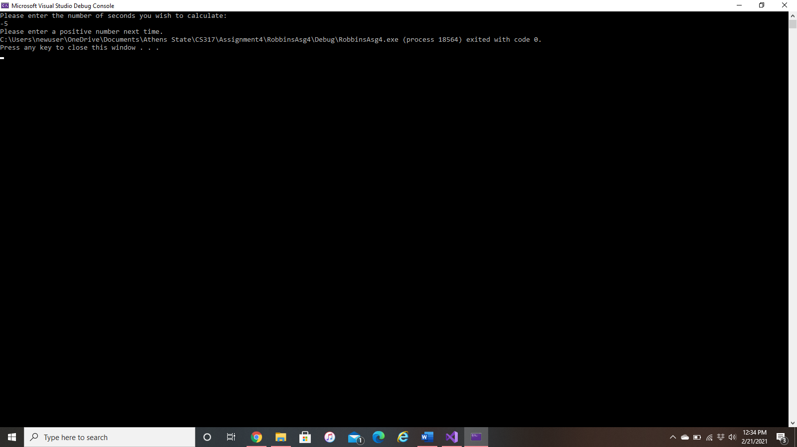Negative Input:

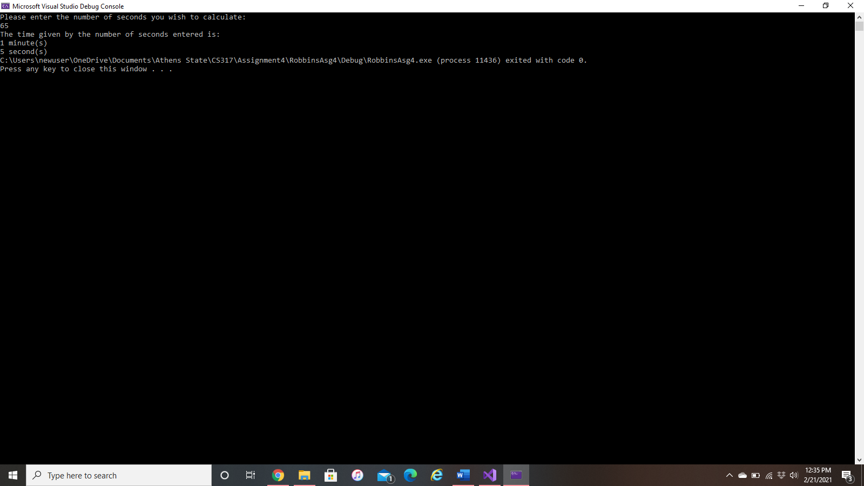Minutes:

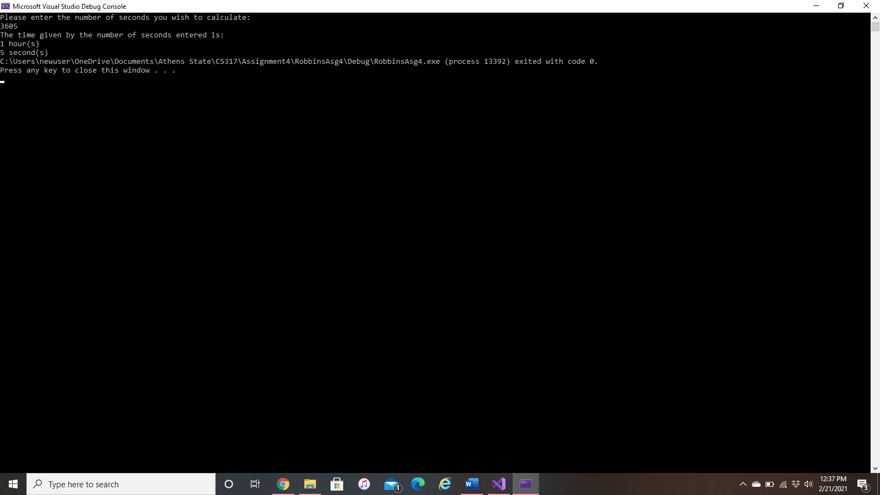Hours:

Days:

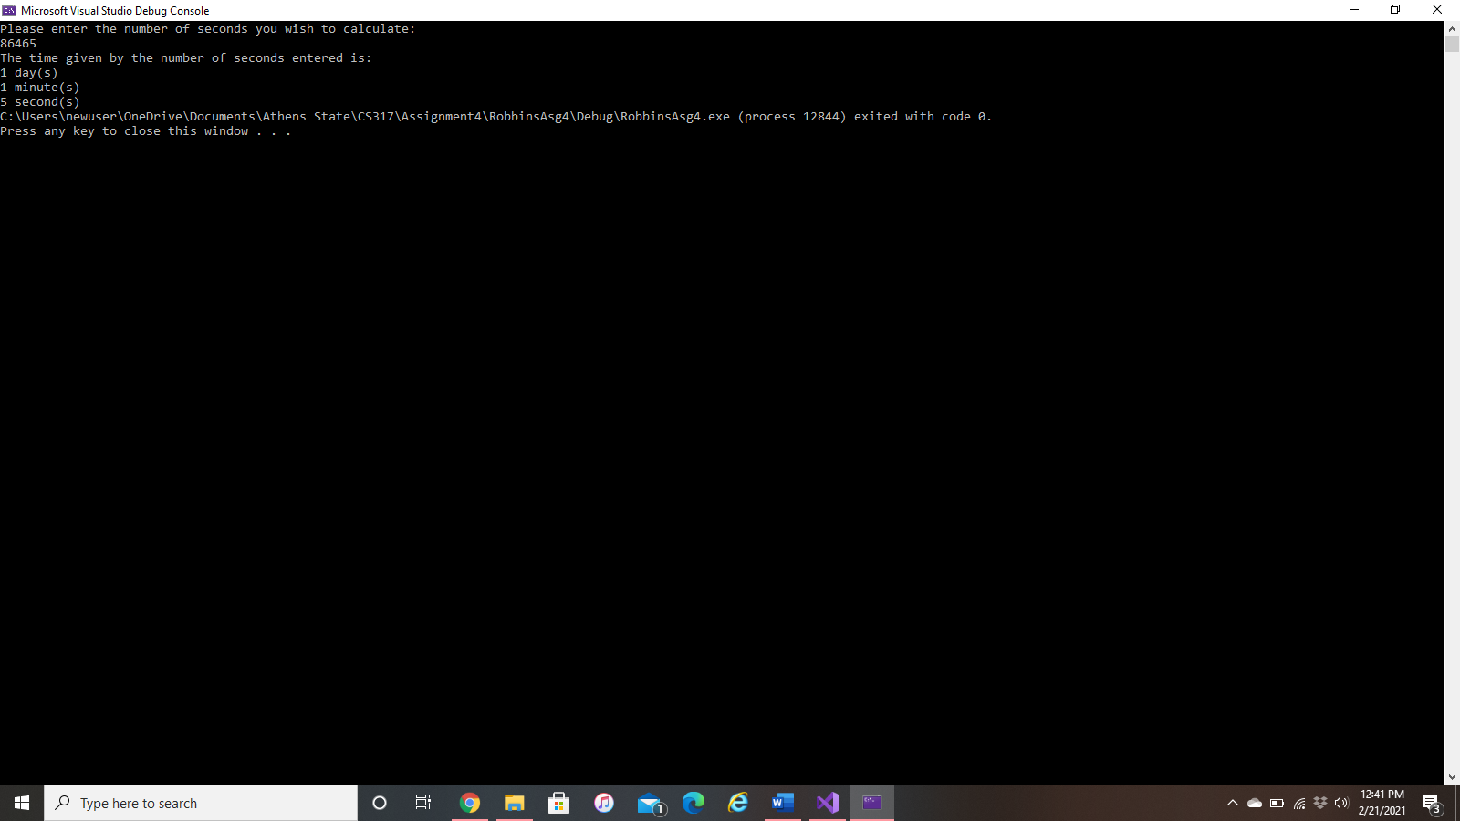

Problem 2: Vibe 5K Color Run

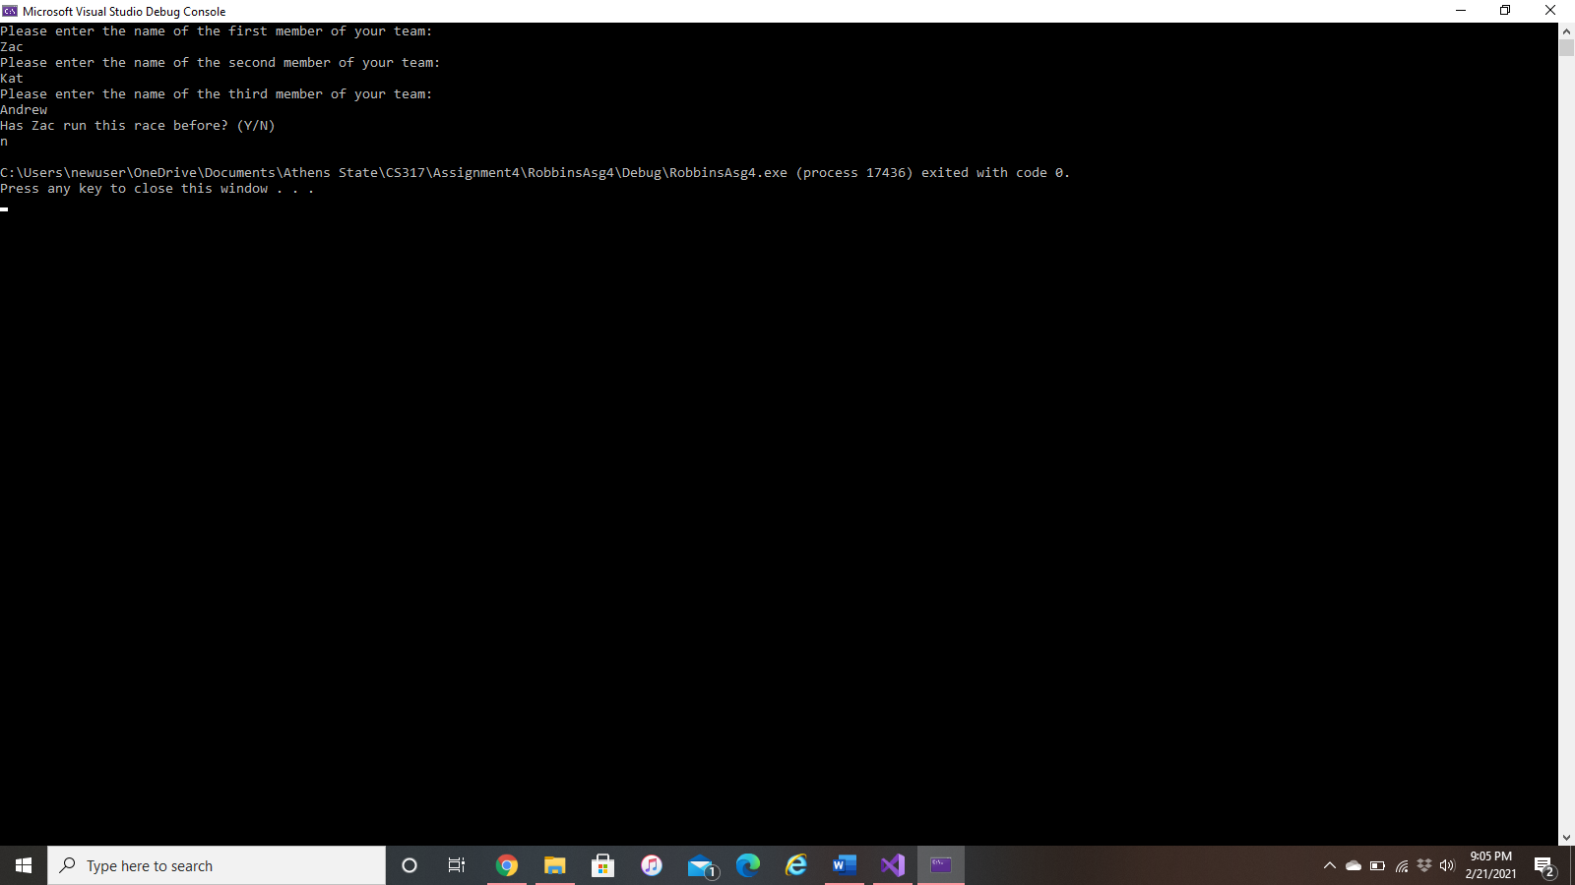Display #1:

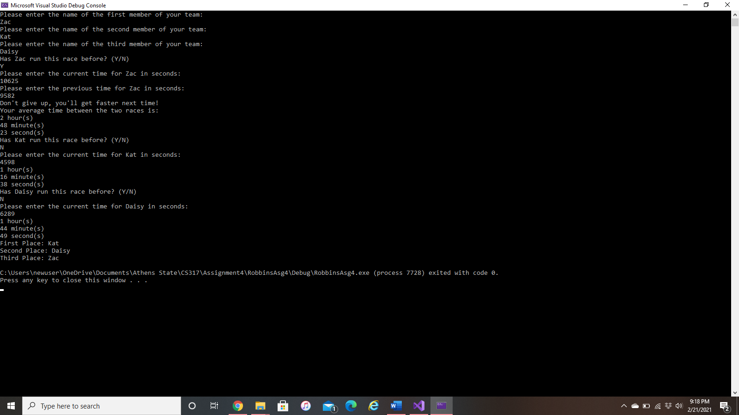Display #2:

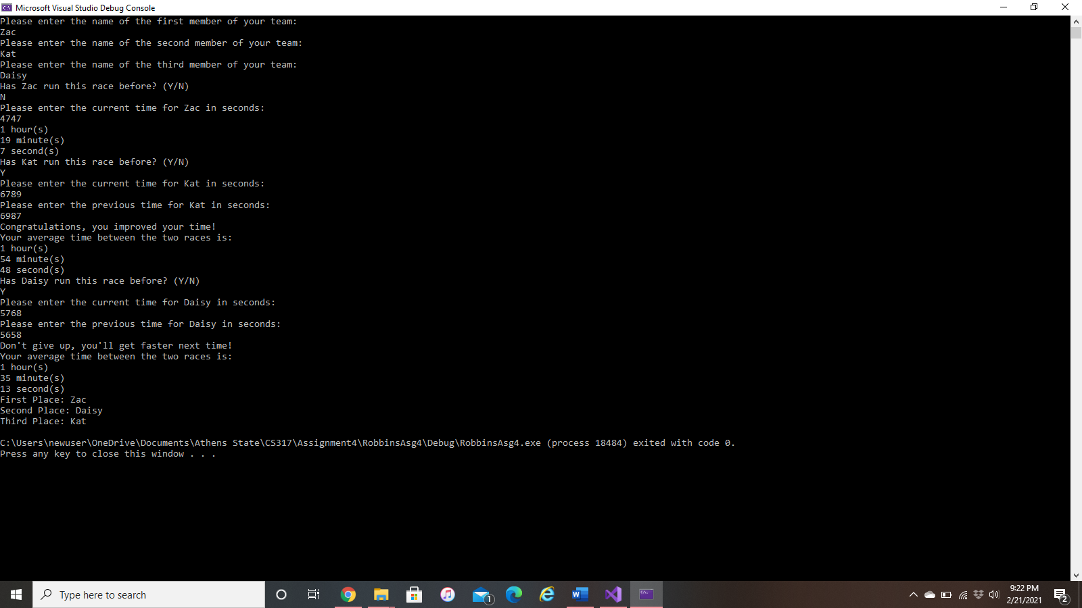Display #3:

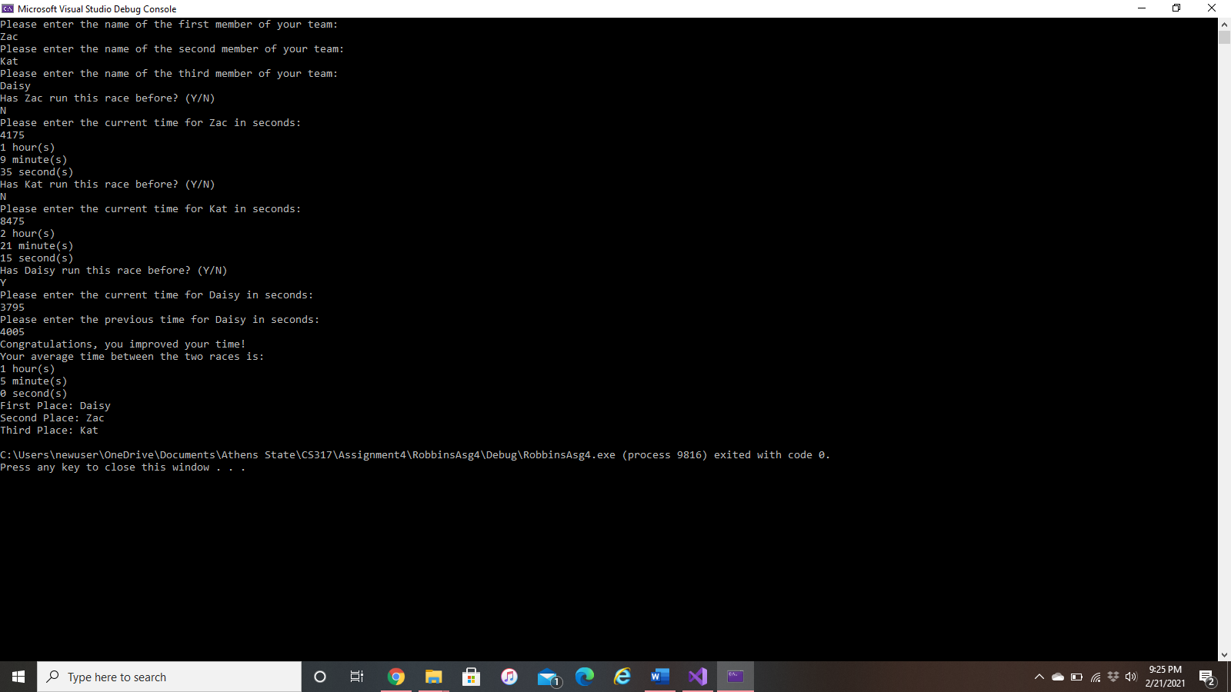Display #4:

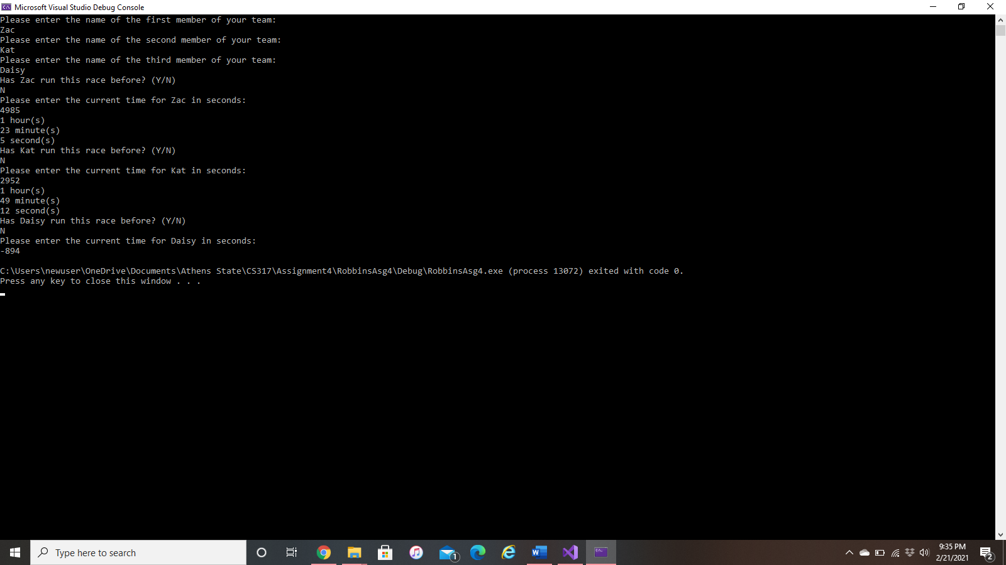Display #5:

Problem 3: Combined Assignment Operators

1. For line 21-22 (the last “else if” statement) to work, the lines need to be placed before the trailing else statement on line 19.
2. The “cout” statement that starts at the end of line 8 and continues in line 9 needs to just be moved to entirely be on line 9. With the statement separated, an error occurs that requires a quotation and semicolon at the end of line 8 and a new, separate cout statement for the rest of line 9.