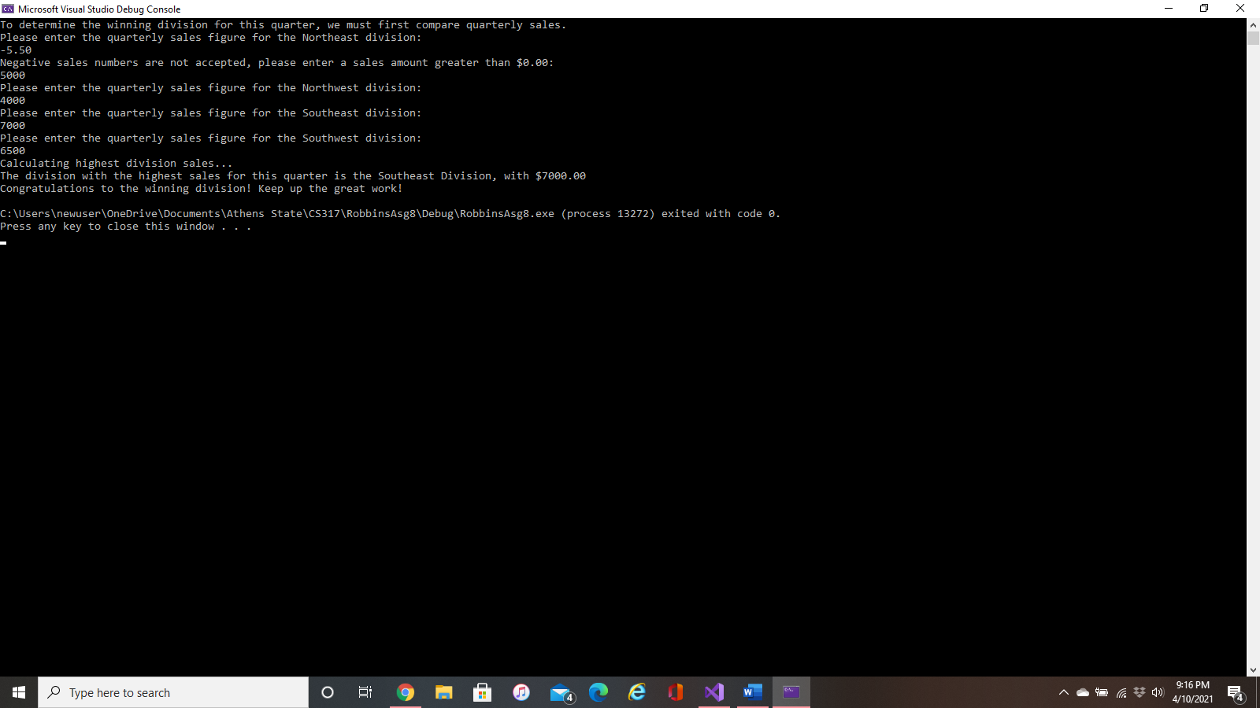**Problem 1**:

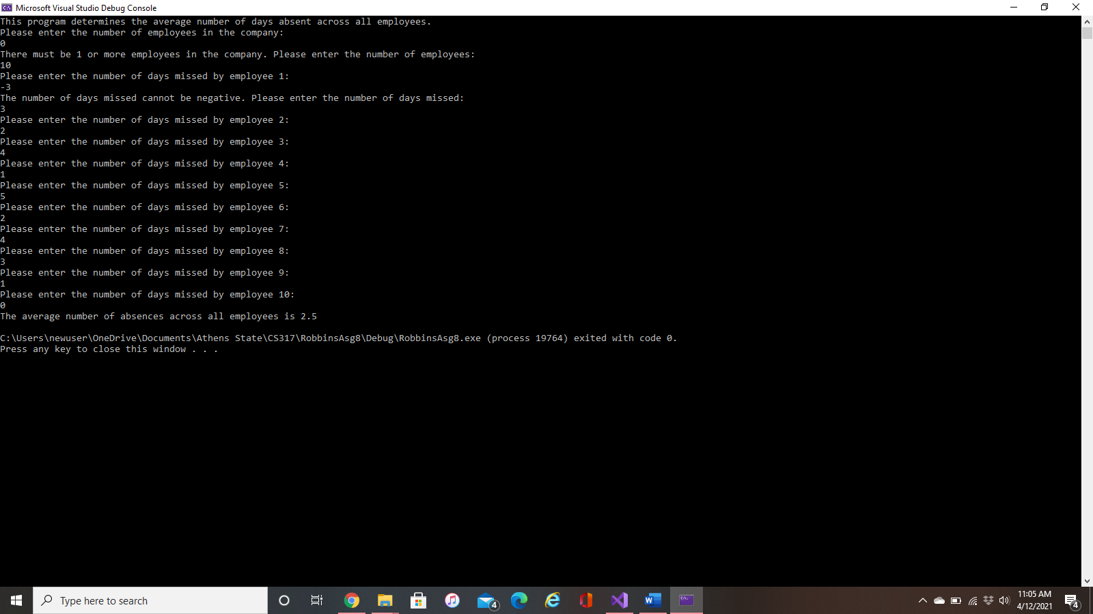**Problem 2**:

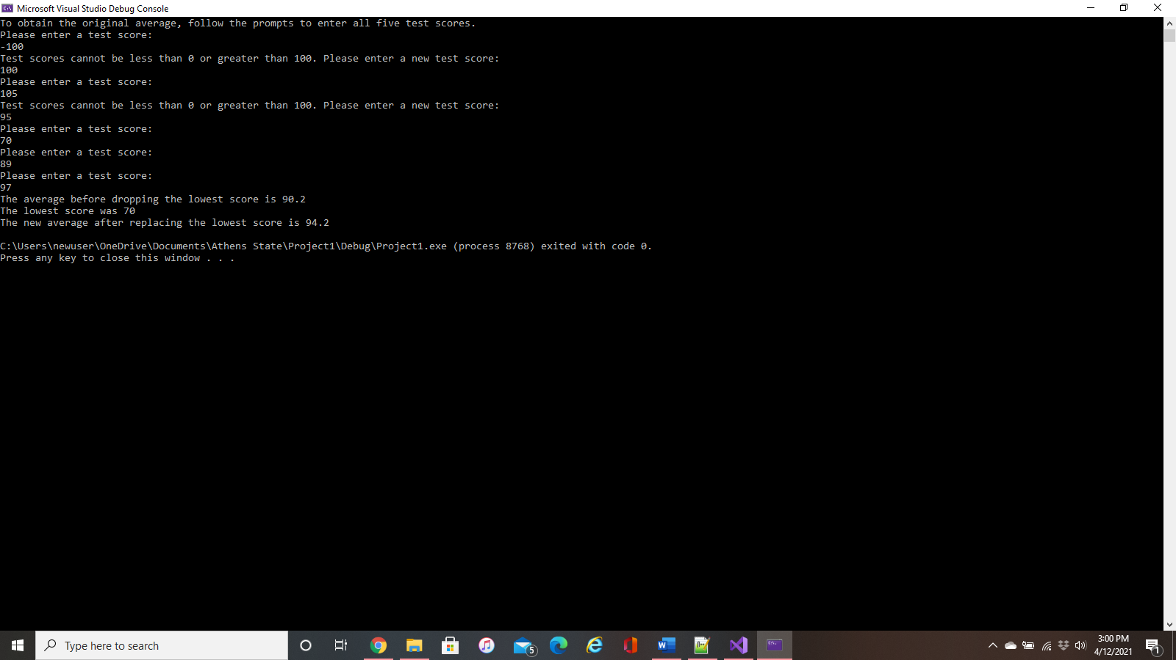**Problem 3**:

Problem 4:

**Problem 6**:

1. The “void total” function parameters are not all defined, value2 and value3 both need “int” type declarations.
2. The “void total” function is also trying to return a value but cannot unless the return type is changed to an “int total” function.
3. The average function is truncating the decimal and performing integer division, so it needs parenthesis and a “static_cast<double>(value1 + value2 + value3)”.
4. The “void area” function is also trying to return a value but cannot unless the return type is changed to an “int area” function.
5. The parameter list of the “area” function also needs a default value for “width” since “length” has a default value and is placed before it.