**Flowchart**:

Start

Declare voltage constants

Declare Euler’s Number Constant

Declare Time-Constant Constants

Declare Resistance Constants

A

A

Declare current doubles

Declare time doubles

Input timeOne

Ask user for time values

B

Input timeTwo

C

B

Input timeThree

Input timeFive

Input timeFour

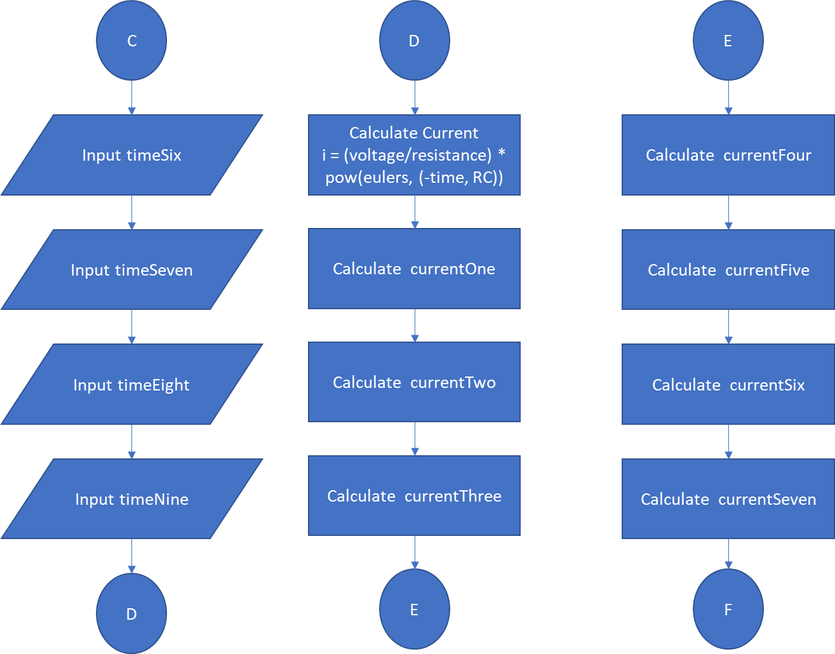**Flowchart Continued:**

**Flowchart Continued:**

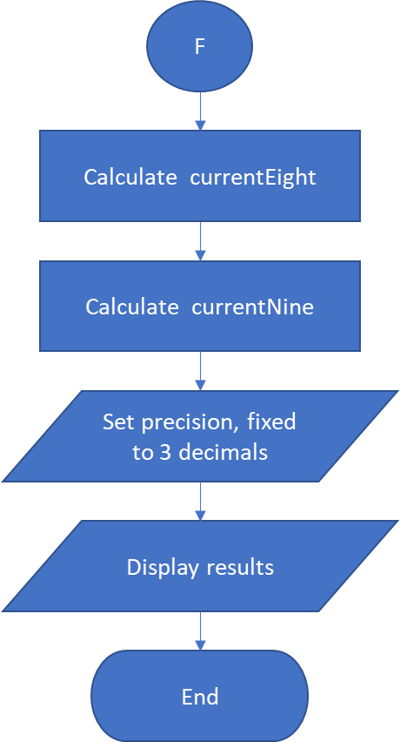

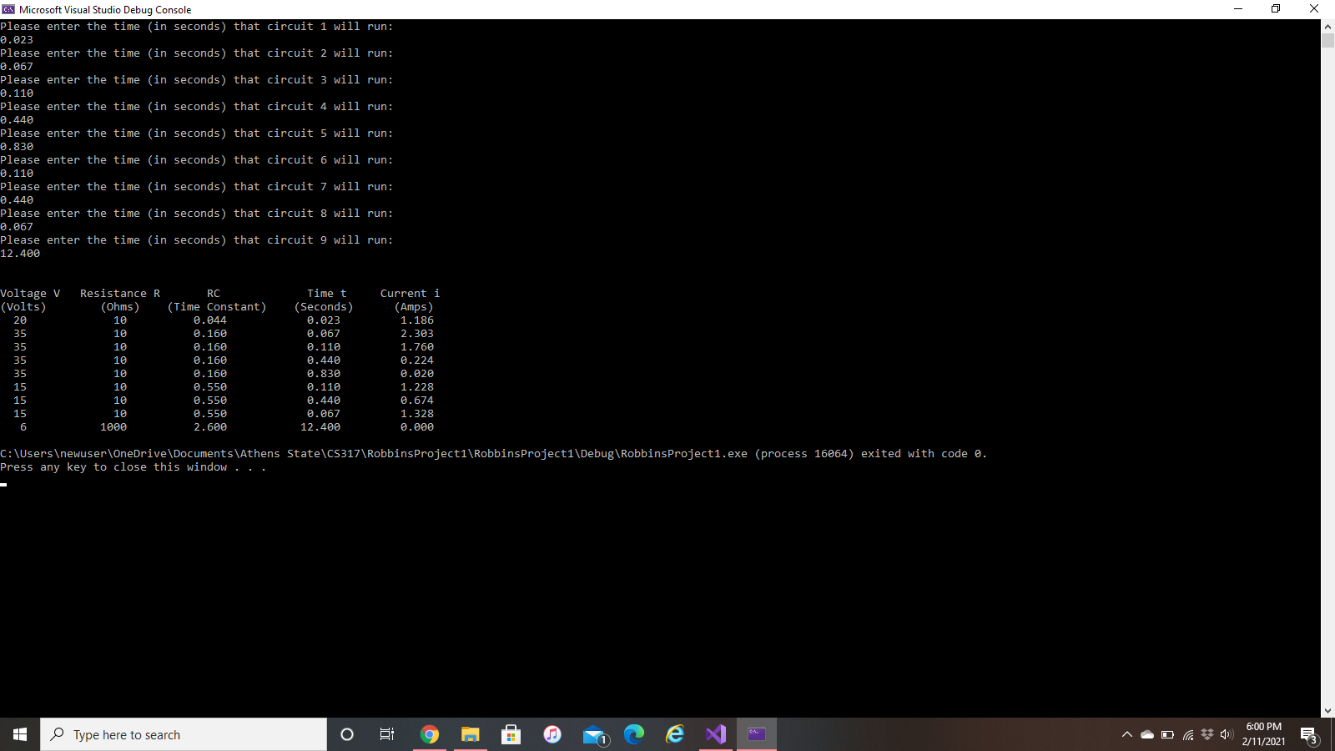**Program Screenshot**: