Problem 1

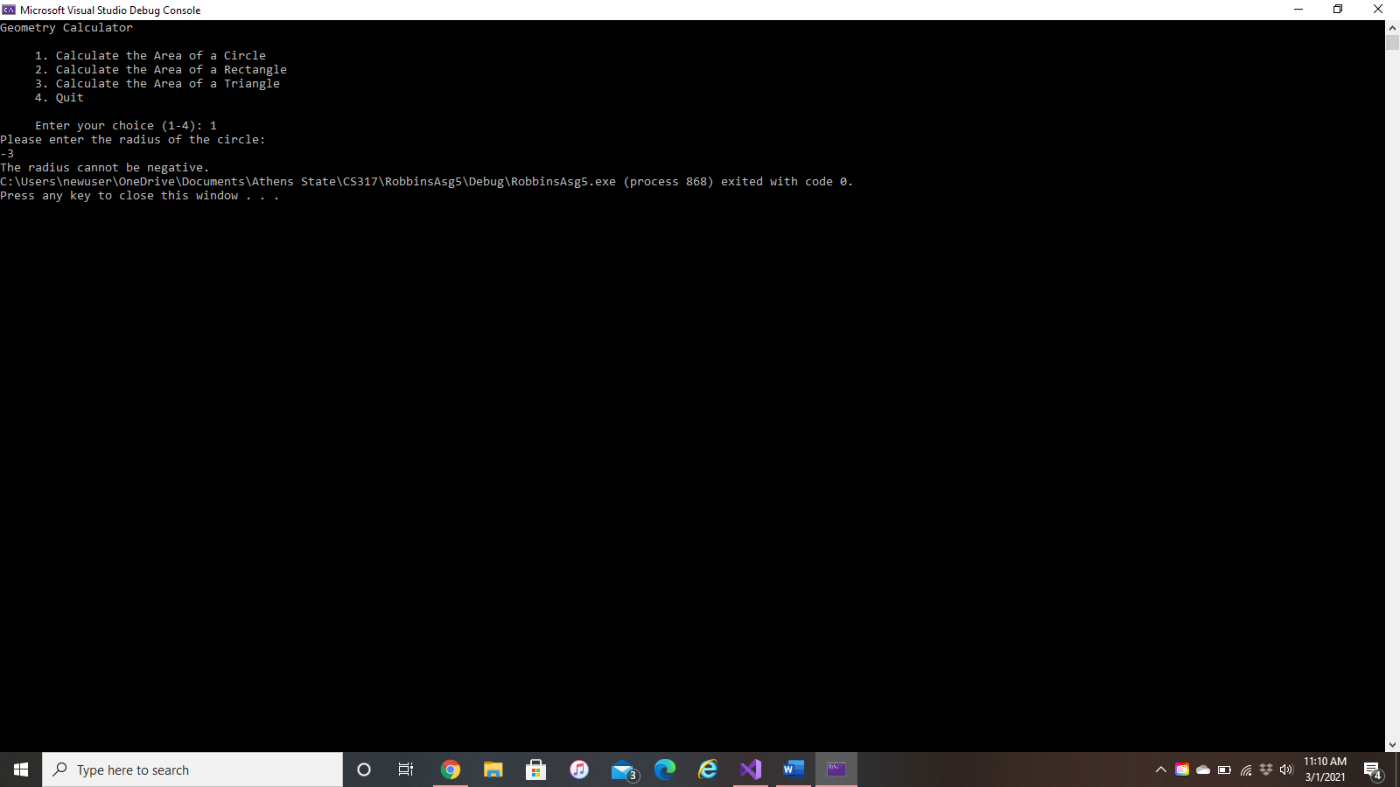Negative Radius:

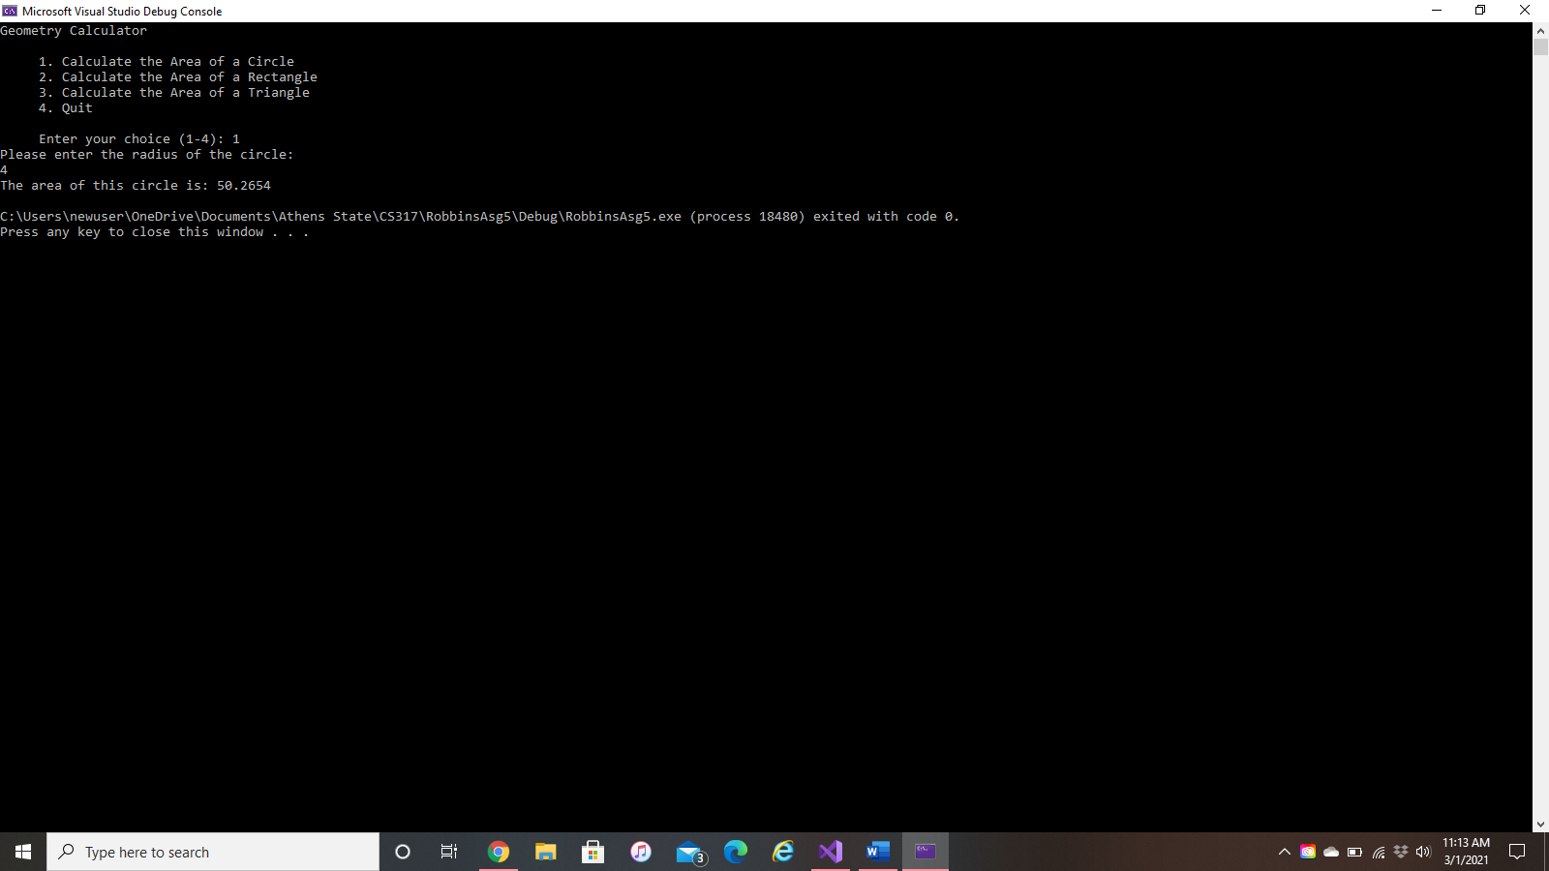Correct radius:

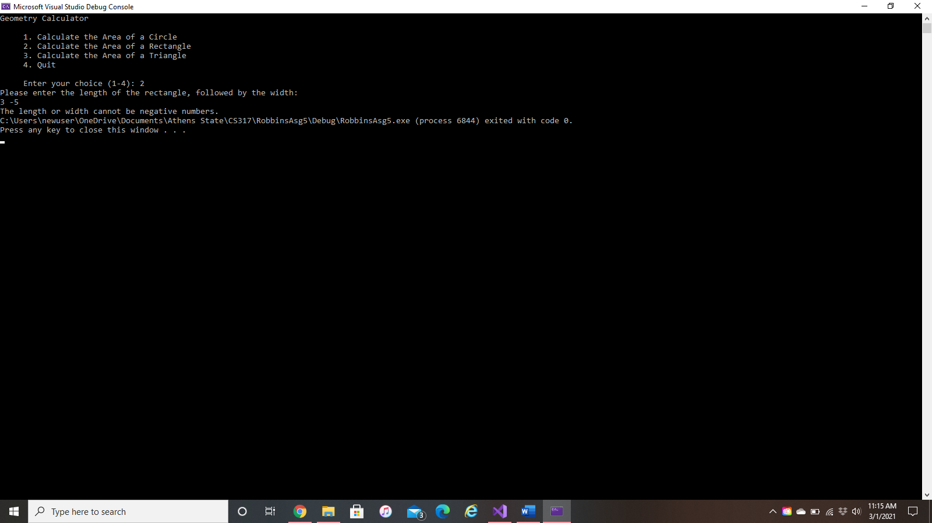Negative Length or Width:

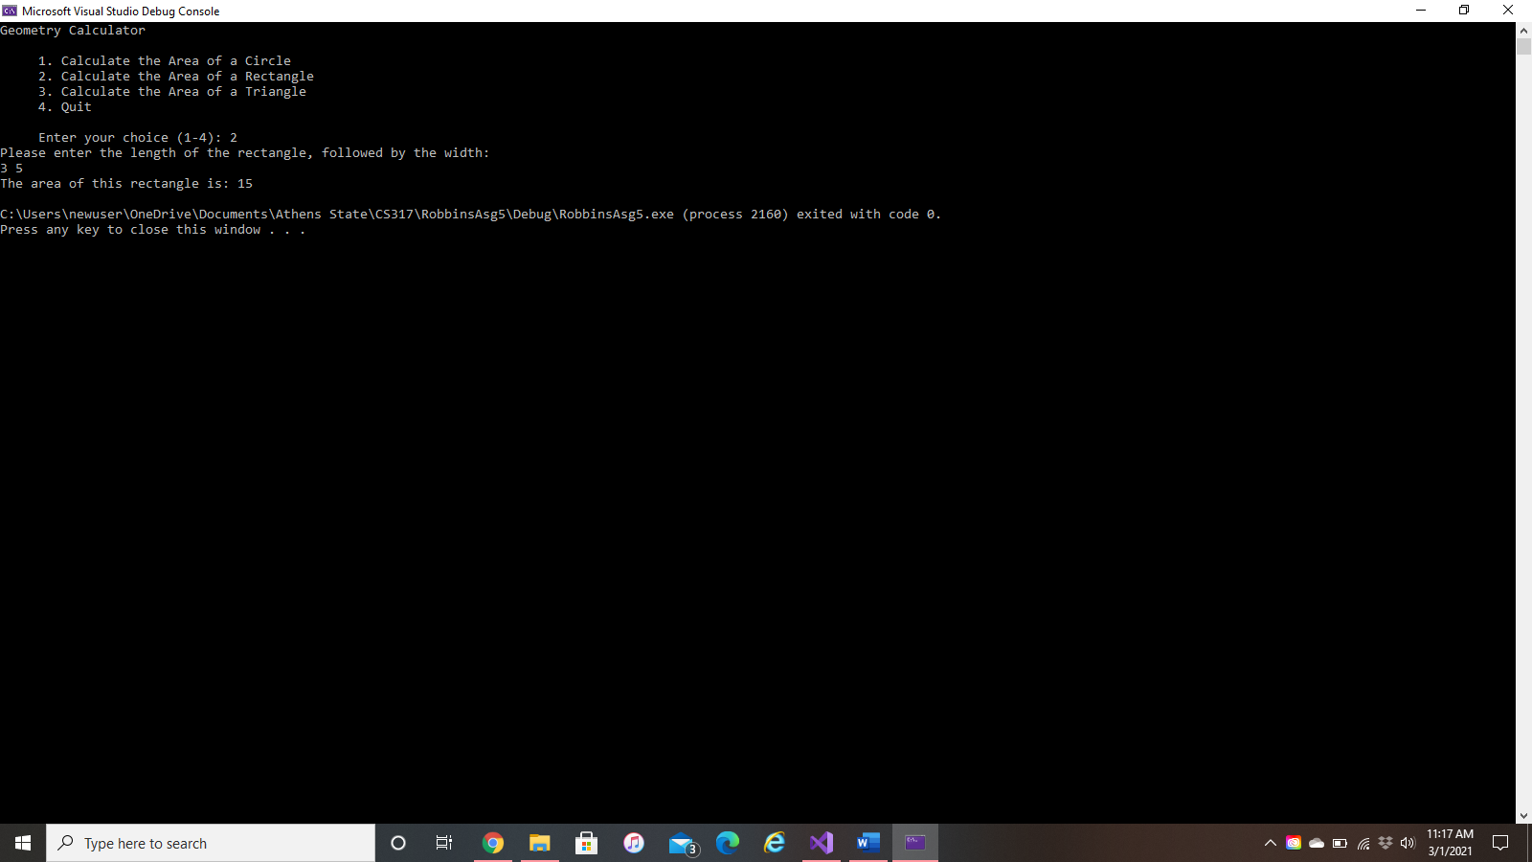Correct Length and Width:

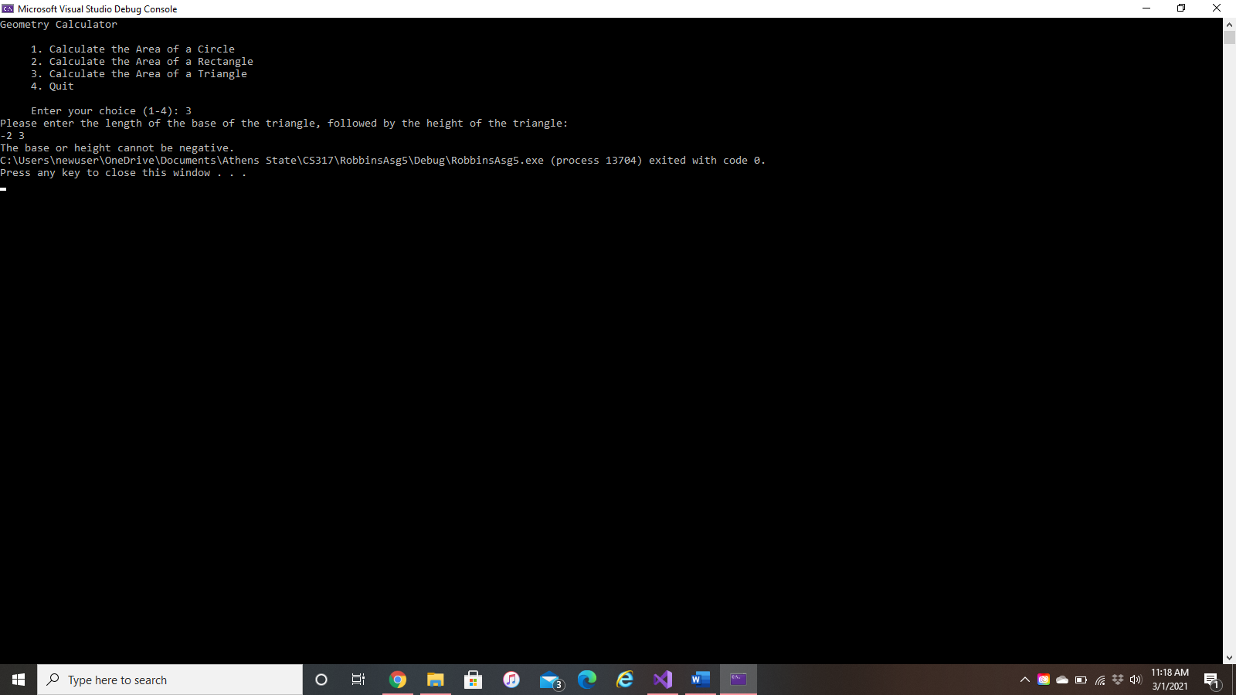Negative Base or Height:

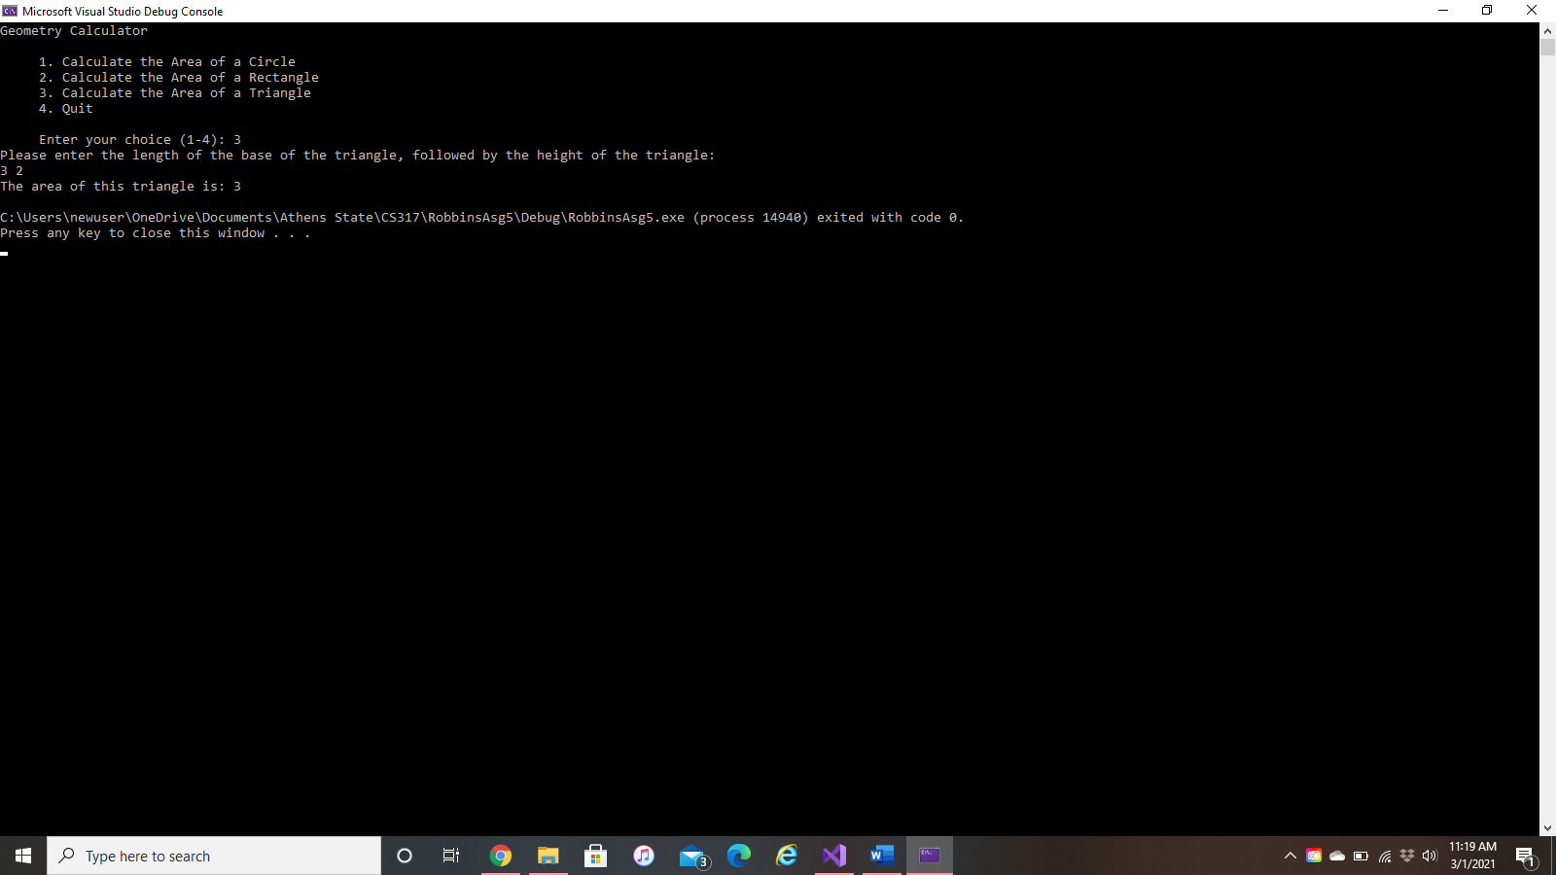Correct Base and Height:

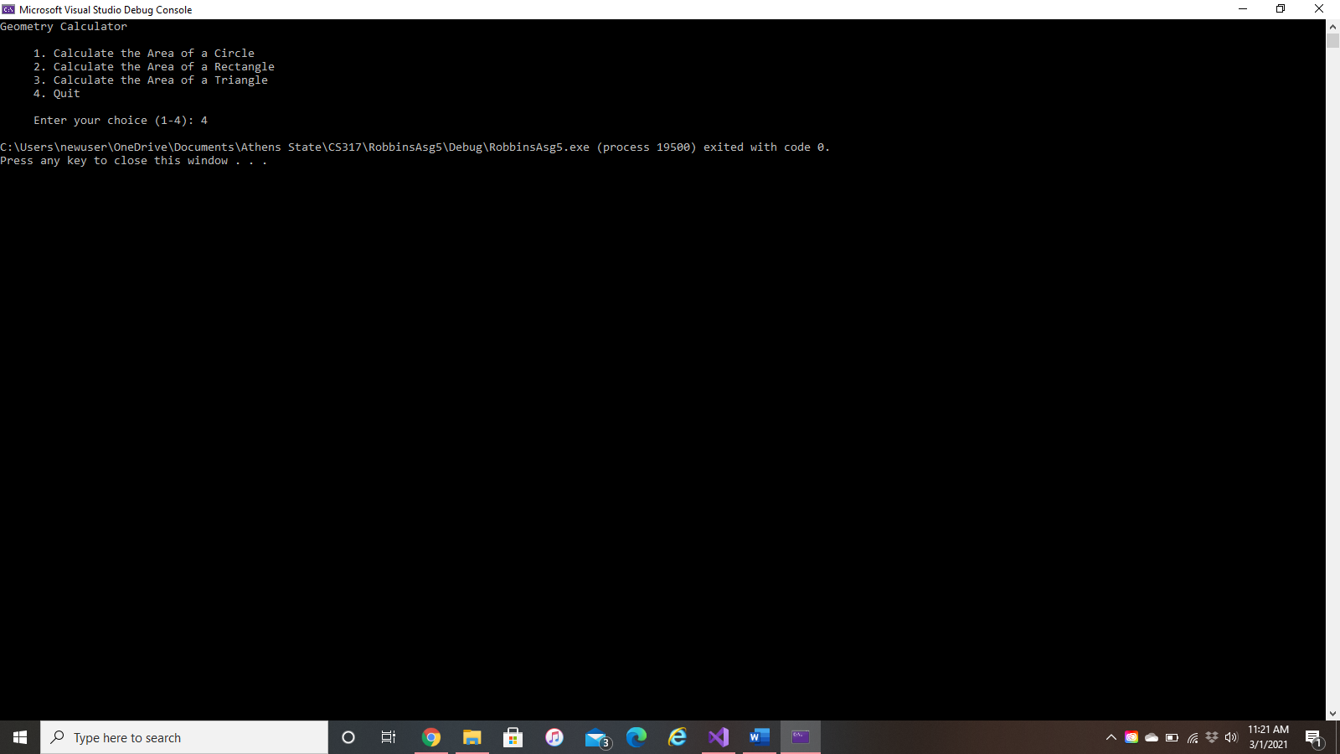Choice 4:

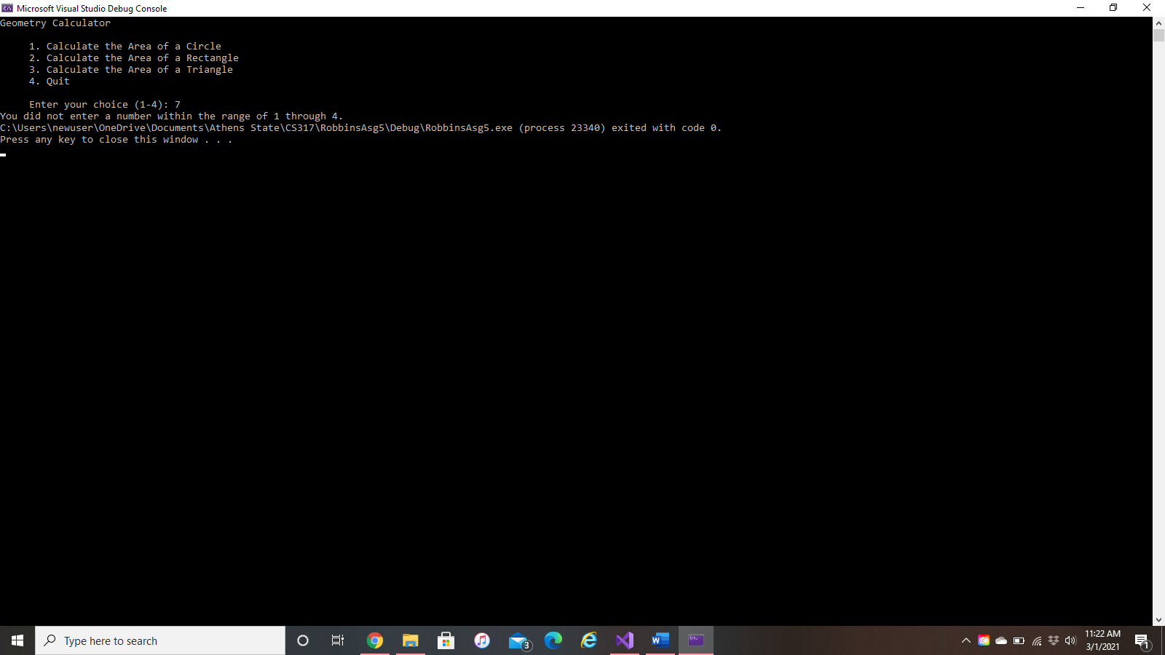Invalid Menu Choice:

Problem 2

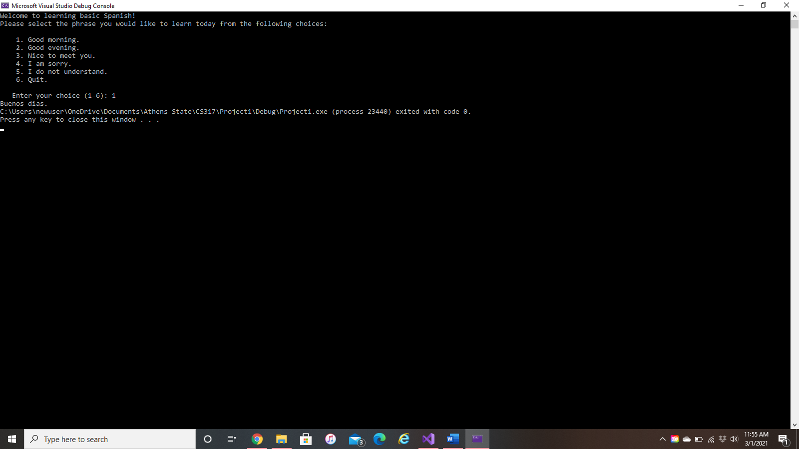Option 1:

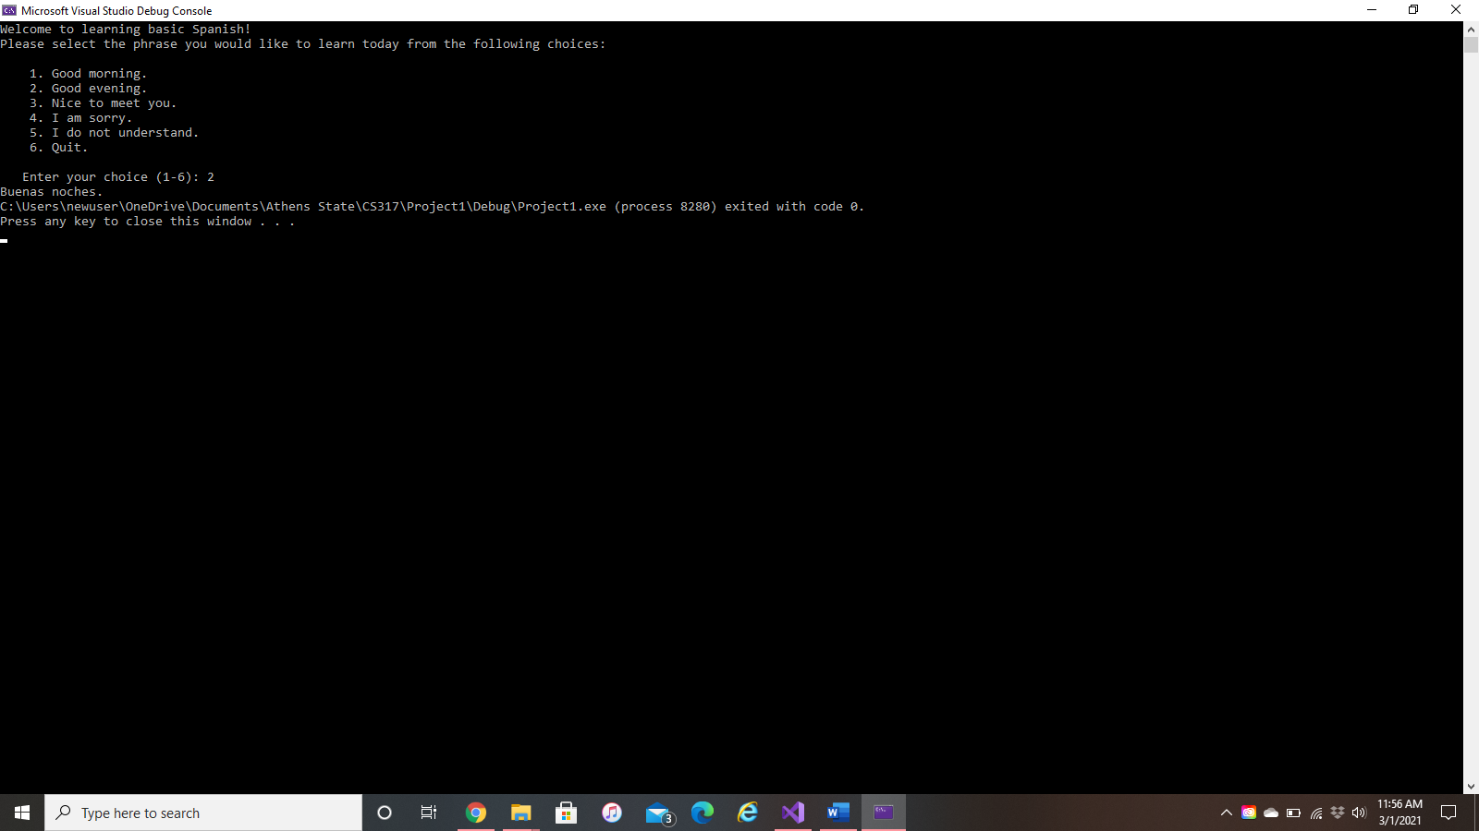Option 2:

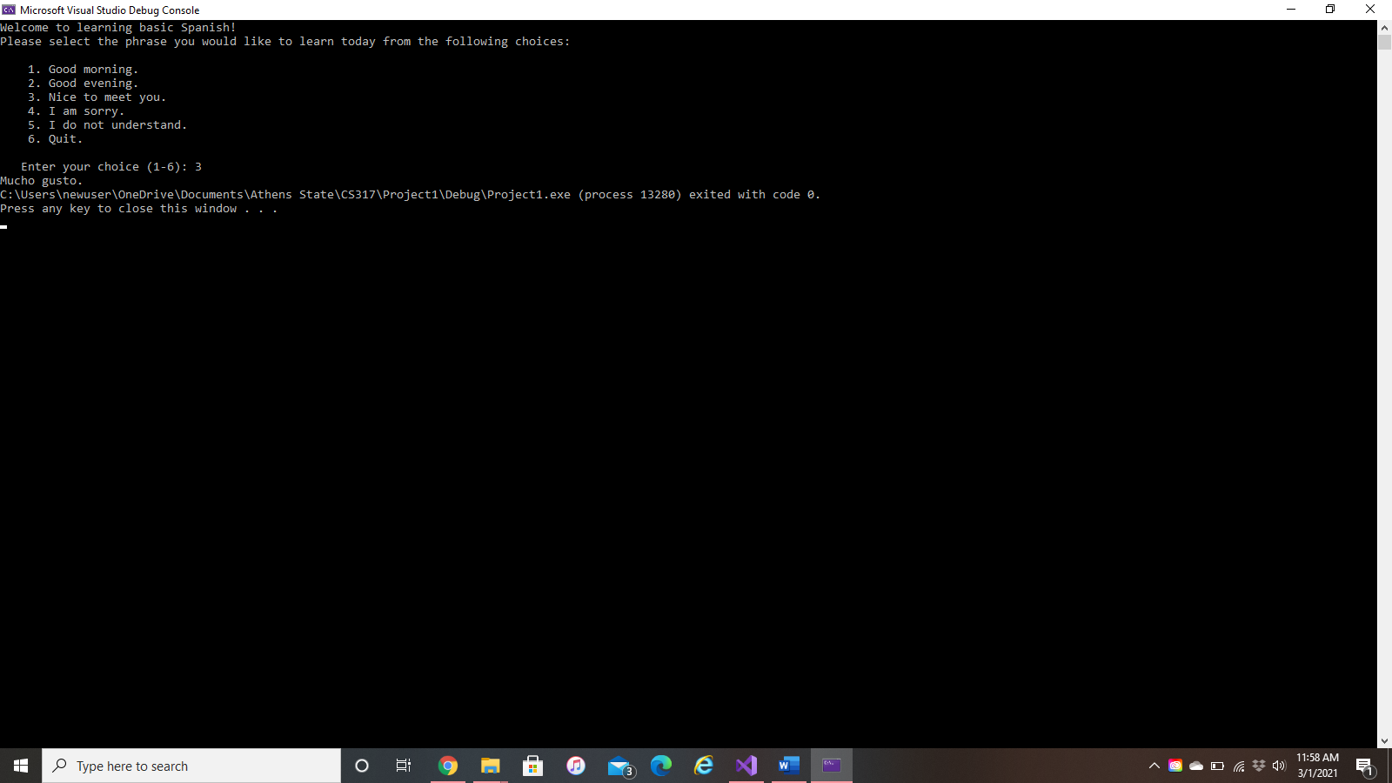Option 3:

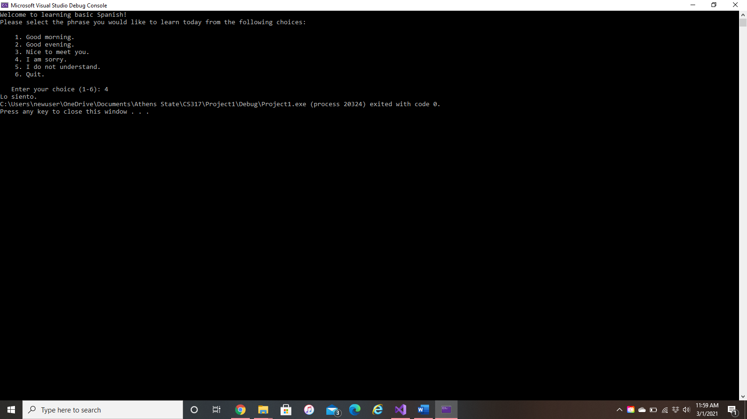Option 4:

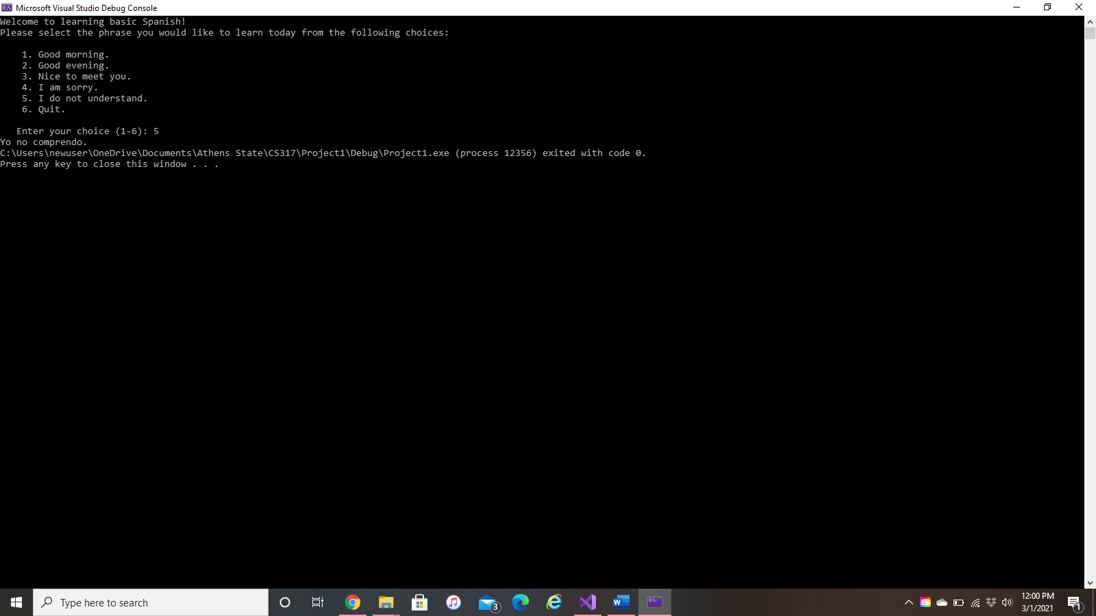Option 5:

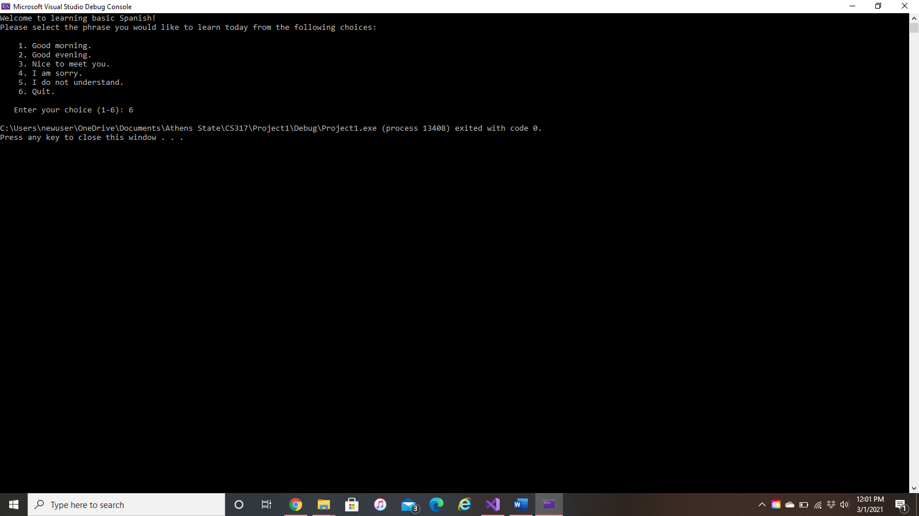Option 6:

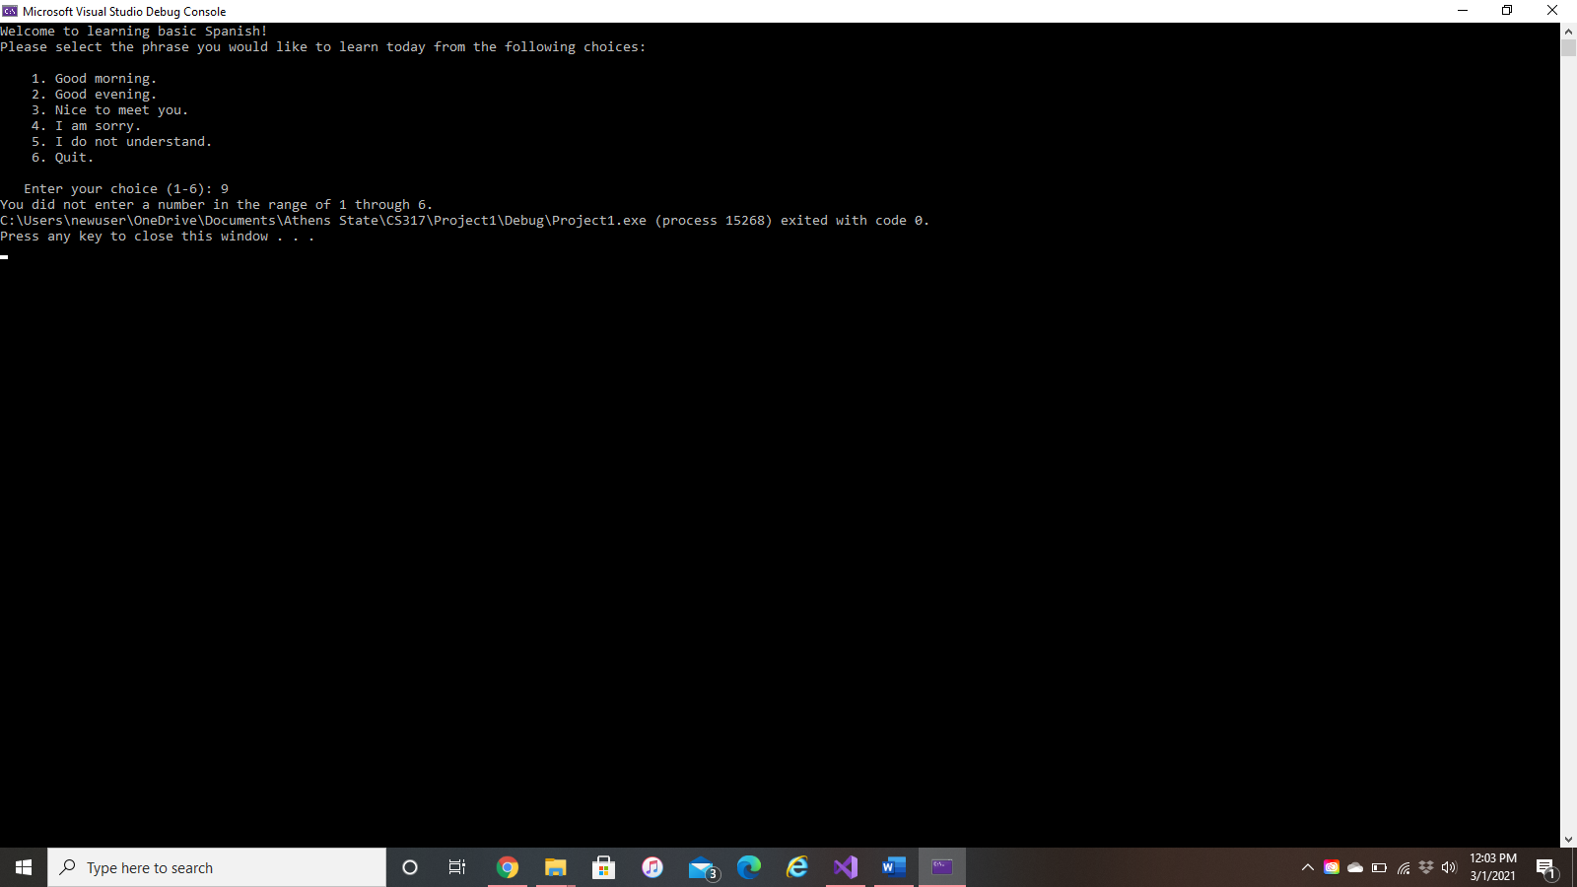Incorrect Menu Option:

Problem 3

The problem with the given code is that the *testScore* variable is a double. Switch statements can only be used on variables with an integer data type or an expression with an integer value.

The case statements are also incorrect because case statements cannot contain a variable or a variable expression. They must instead contain an integer literal or a constant.