Student ID 2022280000

Harbin Engineering University
Undergraduate Students Individual Project Report

Study on the wave parameter reconstruction
based on machine-learning

College: Southampton Ocean Engineering Joint Institute
Program Title: XXX Engineering
Student Name: San （名）Zhang（姓）
Supervisor: Wei Meng Associate Prof./Blair Thornton Prof.
Word count: 9188（南安要求不能超过1万词）

Harbin Engineering University
May, 2026

学 号 2022280000
密 级 公开

哈尔滨工程大学本科生毕业论文

基于机器学习的波浪参数重构研究

学 院 名 称：南安普顿海洋工程联合学院
专 业 名 称：船舶与海洋工程
学 生 姓 名：张三
指 导 教 师：孟巍副教授/Blair Thornton 教授

哈尔滨工程大学
2026 年 5 月
书脊
Study on the wave parameter reconstruction based on machine-learning San Zhang Harbin Engineering University

Student ID: 202028XXXX

Study on the wave parameter reconstruction
based on machine-learning

Student’s name | ：San Zhang
College | ：Southampton Ocean Engineering Joint Institute
Program | ：**Engineering
Supervisor | ：Wei Meng /Blair Thornton
Supervisor’s Title | ：Associate professor/Professor
University | ：Harbin Engineering University
Submission Date | ：May 2026
Oral Defense Date | ：May 2026
Degree award | ：Harbin Engineering University

学 号：202028XXXX
密 级： 公开

基于机器学习的波浪参数重构研究

学生姓名 | ：张三
所在学院 | ：南安普顿海洋工程联合学院
所在专业 | ：船舶与海洋工程
指导教师 | ：孟巍/Blair Thornton
职称 | ：副教授/教授
所在单位 | ：哈尔滨工程大学
论文提交日期 | ：2026年5月
论文答辩日期 | ：2026年5月
学位授予单位 | ：哈尔滨工程大学
Preparation and study of XXXXX（IP Title
）

哈尔滨工程大学
学位论文原创性声明

本人郑重声明：本论文的所有工作，是在导师的指导下，由作者本人独立完成的。有关观点、方法、数据和文献的引用已在文中指出，并与参考文献相对应。除文中已注明引用的内容外，本论文不包含任何其他个人或集体已经公开发表的作品成果。对本文的研究做出重要贡献的个人和集体，均已在文中以明确方式标明。本人完全意识 到本声明的法律结果由本人承担。

作者（签字）：(电子签放上)
日期：2026 年 5 月 1 日

Harbin Engineering University
Declaration of Originality

I solemnly declare: All the work in this thesis was completed independently by me, the author, under the guidance of my supervisor. The references to the viewpoints, methods, data, and literature in this thesis have been indicated in the text and correspond to the Works Cited. Except for the content cited in the text, this thesis does not contain any other individual or collective work that has been published. Individuals and organisations who have made significant contributions to this study have been clearly indicated. I am fully aware of the legal consequences of this declaration and bear all responsibilities.
Author (Signature):(电子签放上)
Date: 2026/5/1

哈尔滨工程大学
学位论文原创性声明

本人完全了解学校保护知识产权的有关规定，即在校攻读学位期间论文工作的知识产权属于哈尔滨工程大学。哈尔滨工程大学有权保留并向国家有关部门或机构送交论文的复印件。本人允许哈尔滨工程大学将论文的部分或全部内容编入有关数据库进行检索，可采用影印、缩印或扫描等复制手段保存和汇编本学位论文，可以公布论文的全部内容。同时本人保证毕业后结合学位论文研究课题再撰写的论文一律注明作者第一署名单位为哈尔滨工程大学。涉密学位论文待解密后适用本声明。
本论文（□在授予学位后即可 □在授予学位 12 个月后 □解密后）由哈尔滨工程大学送交有关部门进行保存、汇编等。

作者（签字）：(电子签放上) 导师（签字）：(电子签放上)

日期： 2026年5月 1 日 2026年5月1日

Harbin Engineering University
Thesis Authorization Statement

I fully understand the regulations of the university regarding the protection of intellectual property rights, that is, the intellectual property rights of the thesis work during the period of pursuing a degree at the university belong to Harbin Engineering University. Harbin Engineering University has the right to retain and submit copies of the thesis to relevant national departments or institutions. I allow Harbin Engineering University to include part or all of the content of the thesis in relevant databases for retrieval, and to use photocopying, microfilming, scanning, or other means of reproduction to preserve and compile this thesis. The full content of the thesis can be made available to the public. At the same time, I guarantee that any papers written after graduation based on the research topic of this degree thesis will indicate that the author's first affiliation is Harbin Engineering University. This statement is applicable to confidential theses after they are declassified.
This thesis can be submitted to relevant departments for preservation and compilation by Harbin Engineering University (□ immediately after the degree is granted □ 12 months after the degree is granted □ after declassification).

Author (Signature):(电子签放上) Supervisor (Signature):(电子签放)

Date: 2026.5.1 Date:2026.5.1

ABSTRACT
The study of wave propagation characteristics near the ocean bottom is a prominent field in oceanography.
The thesis XXX.
Keywords: Water wave; Ground wave; ship collision

摘 要
海洋声传播研究长期以来一直是海洋声学学科中的热门领域，尤其是在海底附近的水波和地波传播特性方面，如时域波形和传播损失等。尽管目前在此领域取得了一定进展，但对于水波和地波的分离研究甚少。这些问题的解决不仅对海洋声场分析有重要意义，还对海洋资源开发和海底地震灾害预测具有实用价值。
在这一背景下，本文探讨了XXXX。
结果表明，XXXX。

关键词：水波；底波；模态频散；谱元法；水波分离

Contents（自动生成）
ABSTRACT I
摘 要 II
I Introduction 1
1.1 Background and significance 1
1.2 Ground waves and water waves 1
1.3 Project aim and objectives 1
1.3.1 Project aim 1
1.3.2 Project objectives 1
1.4 Research contents 1
II Literature Review 2
2.1 Review of water wave and ground wave 2
2.2 Review of Spectral Element Method 2
III Brief Theory and Model 3
3.1 Normal mode theory 3
3.2 Ground/water waves and Airy waves theory 3
3.3 Spectral Element Method Model based on SPECFEM2D 4
3.3.1 SPECFEM2D program configuration 4
3.3.2 Simulation environment establishment 5
3.4 Chapter Summary 5
IV Numerical study of Ground/ Water waves 6
4.1 Numerical methods and parameter settings 6
4.2 Separation of ground and water waves 6
4.2.1 Time-domain characteristics analysis 6
4.2.2 τ-p transformation analysis 8
4.2.3 Ground/water wave separation 8
4.3 Transmission Loss Analysis 10
4.4 Chapter summary 10
V Shallow water experiment analysis 11
5.1 Experiment Overview 11
5.2 Data Processing and Analysis 11
5.3 Chapter Summary 14
VI Conclusion 15
Reference 16
致谢 17
Acknowledgement 18
Published papers and research achievements during the pursuit of bachelor's degree 19
Appendix 20

I Introduction

1.1 Background and significance
Oceans cover more than seventy percent of the Earth's surface, serving as the cradle of life, nurturing countless species and abundant energy resources.
（图片和表格注释参考南安普顿书写要求，查找路径：钉钉全院文件夹——22级毕设——IP 辅导PPT资料——2022级IP 辅导资料）

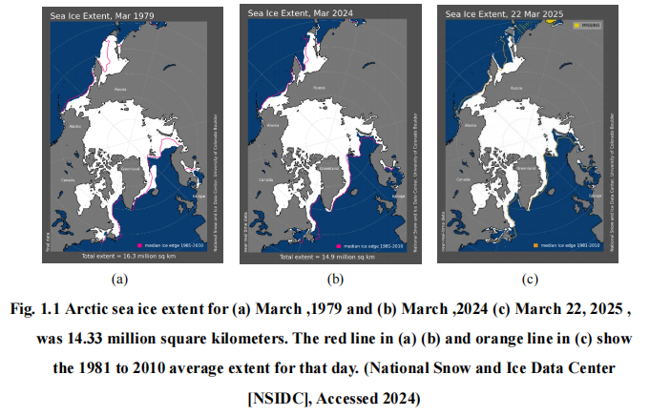

1.2 Ground waves and water waves
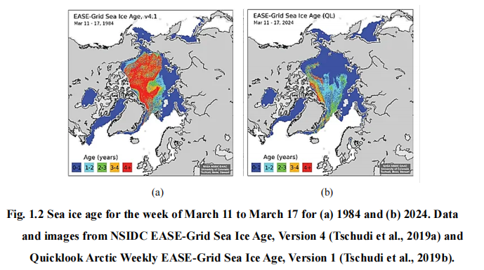
In shallow water environments, the propagation of sound waves is determined by the unique physical properties of the environment, exhibiting distinct propagation characteristics (Pekeris 17).

1.3 Project aim and objectives

1.3.1 Project aim
The project focuses on the acoustic propagation characteristics of broadband sound sources in shallow water, aiming to study theoretically and experimentally the method of separating the ground wave from water wave and analyse the transmission efficiency.

1.3.2 Project objectives
To comprehensively understand and simulate the interaction between ground and water waves, the research has established the following specific objectives:

1.4 Research contents
This thesis analyses water and ground waves near the ocean bottom from numerical simulation and experimental data processing perspectives.

II Literature Review

2.1 Review of water wave and ground wave
As early as 1948, Pekeris proposed a method for solving the normal mode acoustic field in the context of exploring shallow water waveguide problems composed of a uniform fluid layer and a semi-infinite liquid ocean bottom layer (Pekeris 43).

2.2 Review of Spectral Element Method
The spectral element method, as a type of generalised finite element method, combines the flexible handling capability of the finite element method with the high-speed convergence characteristics of the pseudo-spectral method, providing an efficient solution for the numerical simulation of sound wave propagation (TANG 65–75).

III Brief Theory and Model
In studying sound propagation in shallow waters, broadband point sources are taken into consideration.

3.1 Normal mode theory
The normal mode theory was first developed by Pekeris as a simple two-layer fluid ocean model (Jensen et al. 102–33).

3.2 Ground/water waves and Airy waves theory
The Pekeris waveguide, proposed by Pekeris, is a waveguide environment consisting of a uniform seawater layer and a liquid semi-infinite space beneath it (Pekeris 1–116)
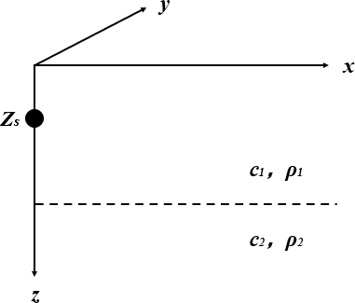
Fig. 3.2 Pekeris waveguide environment
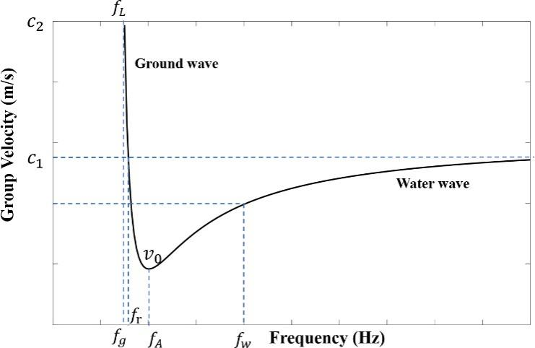
Fig. 3.3 First-Order Mode Group Velocity-Frequency Relationship
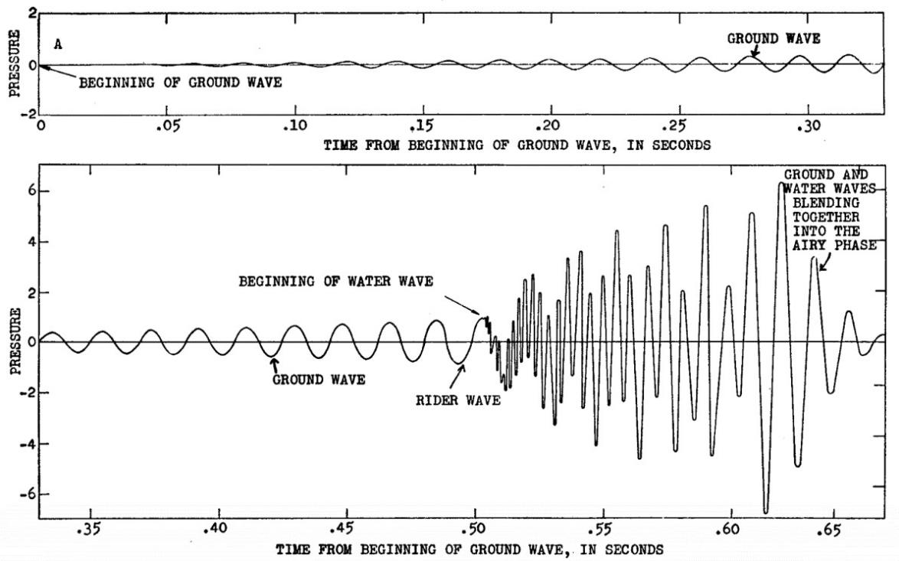
Fig. 3.4 Theoretical contribution of the first mode to the disturbance, from Chaim Leib Pekeris, "Theory of Propagation of Explosive Sound in Shallow Water" (1948 94).

3.3 Spectral Element Method Model based on SPECFEM2D
The core idea of the Spectral Element Method is to first divide the entire computational area into a finite number of elements and then apply the Pseudospectral Method, distributing non-uniform nodes within each element.

3.3.1 SPECFEM2D program configuration
SPECFEM2D is a Spectral Element Method program designed for computations on Linux systems.
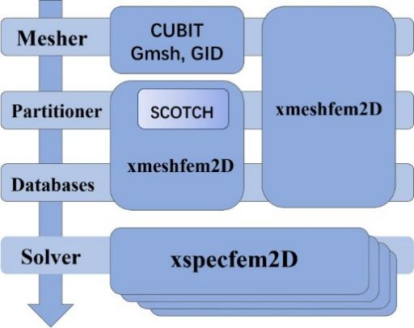
Fig. 3.5 SPECFEM2D Simulation Flowchart

3.3.2 Simulation environment establishment
When conducting ocean acoustic field modelling, it is necessary to determine parameters such as sound speed and density.
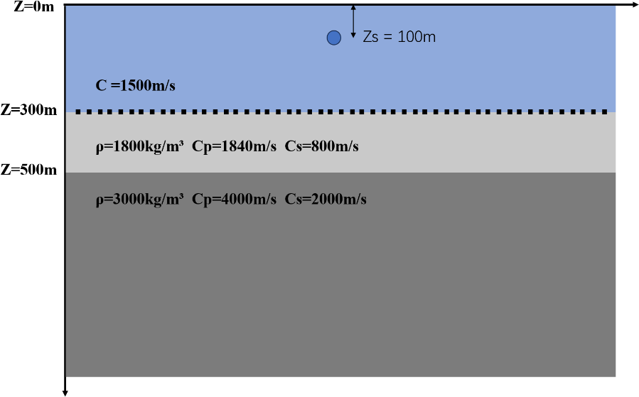
Fig. 3.6 Shallow water wave guide model

3.4 Chapter Summary
This chapter primarily conducts theoretical analyses on the following three aspects:

IV Numerical study of Ground/ Water waves
In order to measure the transmission efficiency of the water wave-ground wave channel, the study utilises the water layer, elastic sedimentary layer, and semi-infinite ocean bottom layer model created in Section 3.3 using the spectral element method.

4.1 Numerical methods and parameter settings
The separation of water waves from ground waves first necessitates the modal resolution of water and ground wave signals, achieved through domain transformation of signals received by the horizontal array stations.

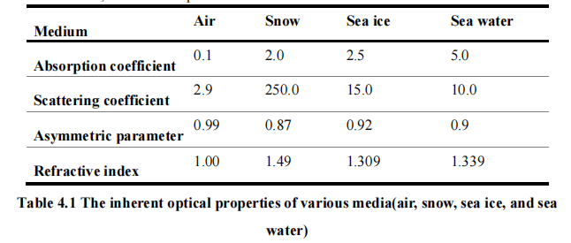

4.2 Separation of ground and water waves

4.2.1 Time-domain characteristics analysis

4.2.2 τ-p transformation analysis
The method of t - p transformation involves stacking signals in the xt- domain according to different intercepts t and slopes p (Zhou and Greenhalgh 1133–49).

4.3 Transmission Loss Analysis
As shown in Fig. 4.12, sound waves exhibit significant attenuation characteristics near the source area.
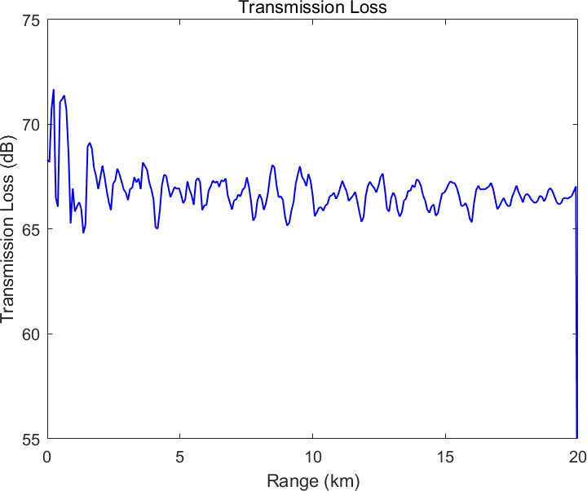
Fig. 4.12 Transmission Loss

4.4 Chapter summary
This chapter aims to improve the comprehension of how sound waves propagate in the horizontally stratified waveguides by utilising the SPECFEM2D for sound field modelling.

V Shallow water experiment analysis
As shown in Chapter 4, it presents a simulation of a three-layer horizontally stratified ocean bottom using the two-dimensional Spectral Element Method.

5.1 Experiment Overview
The College of Underwater Acoustic Engineering at Harbin Engineering University conducted a comprehensive marine experiment in a specific sea area.

5.2 Data Processing and Analysis
Similar to numerical studies, the processing of experimental data primarily relies on the water-ground modal separation technique based on the time-frequency characteristics of signals from horizontal arrays at the ocean bottom interface.

5.3 Chapter Summary
This chapter focuses on the processing and analysis of experimental data, with the aim of separating the ground waves and water waves.

VI Conclusion
The aim of the study is to separate the ground waves and water waves in a horizontally stratified environment.

Reference

参考文献写作规范参考哈佛大学写作规范（查找路径：钉钉全院文件夹——22级毕设——论文模板）

致谢

Acknowledgement

Published papers and research achievements during the pursuit of bachelor's degree

Appendix

