Zachary St. John (40131286)

Professor E. Shaw

Programming for Geospatial Technologies (Geog 464)

27 April 2022

**Low Income in Montreal and Access to Green Space - Final Project**

**Introduction**

There are copious amounts of research linking a multitude of benefits (economic, physical, mental, ecological, etc.) to access to green space (Cicea & Pîrlogea, 2011). However, since industrialization there has been an increase of urbanization in many cities and a great decrease in green spaces as a result (Nazarnia et al., 2016). Unfortunately, many studies have concluded that the distribution of green spaces in cities is disproportionate, with green spaces appearing mostly in and around White and affluent communities. This creates an environmental justice issue, as this causes low-income communities to lack the benefits that can be derived from green spaces such as physical activity, socialization in a safe space, and psychological restoration (Wolch et al., 2014; Lee et al., 2015).

This paper sought to explore socio-economic status and the availability and access to green space on the Island of Montreal. Based on previous finding of Astell-Burt and colleagues (2014), this project hypothesised that those with low economic status will have less access to close green space in cities.

**Methods**

This study focused on the Island of Montreal located at about -74° longitude and 45° latitude, it is one of the largest population centers in Canada and the island is almost entirely urbanized. This paper used Dissemination area data to break up the Island of Montreal, as these areas are generally small enough to provide a good representation of the population that lives in its bounds. The spatial dissemination area data for Montreal was provided by professor E. Shaw from Concordia University for use in Programming for Geospatial Technologies (Geog 464, Winter 2022 semester), as a shape file containing all of the dissemination areas of the 2016 census. The income data that was used was retrieved from The Canadian Census Analyser, specifically retrieving “One-person Median Household Income After-tax” and “Two-person Median Household Income After-tax” dissemination area data from the 2016 census. This paper chose to investigate the connections between low-income status and green space availability based on findings in a paper by Astell-Burt (Astell-Burt et al., 2014). To measure access to green space and amount of green space, this paper used the intersection between the DAs and green spaces, and then determined the area of the over lapped green spaces. The one- and two-person median household income after-tax was chosen as the indicator for economic status based on an article by CTV news that reported that the IRIS indicated that the 2020 poverty line in Montreal for one and two person households was $27,948 and $61,009, respectively. The final data that was needed for this project was the major parks and green spaces on the Island of Montreal. This was retrieved from the city of Montreal’s open data website “donnees.montreal.ca” as a geojson file that was last updated in 2022.

**Inputs**

Once the data was acquired the data management, processing and visualization was completely done in a Python Jupyter Notebook, with the following packages imported, pandas, geopandas and matplotlib.pyplot.

The first important step of the data processing was to ensure that the crs of the spatial data all matched.

In = parks_df.crs == Mtl_poly.crs   
Out = True

Next there needed to be a merge between the dissemination area shape file and the income data. To do so there needed to be a column in each that had the same identification data in order to link the income data to the shape file data. Since these were both data based on dissemination areas the related columns were renamed ‘UID’ in order to merge.

In = Merged_census_poly = pd.merge(Mtl_poly,Census_data,on=['UID'])

This resulted in data that contained both the geometry of the shape file and the income data of the census data.

Next to isolate the income groups based on the low-income threshold that was identified the following code was used. This code was used for both the one and two person households just replacing the one-person threshold value with the two-person value.

In = one_person_lowInc = Merged_census_poly.loc[Merged_census_poly['Median after-tax income of one-person households'] < 27950]

one_person_notlowinc = Merged_census_poly.loc[Merged_census_poly['Median after-tax income of one-person households'] > 27950]

one_person_lowInc = one_person_lowInc.loc[one_person_lowInc['Median after-tax income of one-person households'] > 0]

This code produces data frames that are spatially linked to the DAs of Montreal and only show the low income and not low-income status DAs.

The next part was to create the link between the green space and the income group DA data frames. To do this a spatial join was used, resulting in a data frame that had rows of DAs that had been spatially linked to the green spaces that they intersect. Again, this code was identical to the code used for the two-person data, just changing the data frame input to make sure it was using the two-person data.

In = oneperson_sjoin_lowinc = one_person_lowInc.sjoin(parks_df, how ='left')

oneperson_sjoin_notlowinc = one_person_notlowinc.sjoin(parks_df, how ='left')

This data was then further processed to show only low-income DAs which did and did not intersect with green space, as well as not low-income DAs which intersected with green spaces.

A quick function was written to calculate the area of the greenspace that was represented in each income group.

In = def whatisArea(data):

AreaC = input('Area column name is: ')

datafix = data.drop_duplicates(subset= AreaC, keep='first', inplace=False)

dataArea = datafix[AreaC].sum()

return dataArea

**Results**

The results of the data processing in python are shown using maps 1-4 (Appendix A), and tables 1 and 2.Maps 1 and 3 show the distribution of low-income households throughout Montreal, and their proximity to green spaces. Most low-income status one- and two-person households are in the north-eastern and south-central ends of Montreal. There are few of these areas that intersect with green spaces, and those that do are with comparatively small green spaces. In contrast, Maps 2 and 4 show the not low-income DAs, these can be seen to intersect with and surround most of the available green space in Montreal. Figure 1, presents these 4 maps in a more digestible and comparable manner

Table 1 shows the number of dissemination areas identified per income group, and how the count increases with higher incomes, also, it shows that there are more DAs which do not intersect with green space than do. Table 2 shows the area (hectares) of green space which intersects with the income groups. This also shows that as the income increases there is more green space area available.

 *Table 1.*

 *Table 2.*

**Conclusion**

The hypothesis of the paper was there would be a negative correlation between socio-economic status and green space access. Based on the results of this paper this hypothesis does appear to be correct.

References

Astell-Burt, T., Feng, X., Mavoa, S., Badland, H. M., & Giles-Corti, B. (2014). Do low-income neighbourhoods have the least green space? a cross-sectional study of australia's most populous cities. *Bmc Public Health*, *14*, 292–292. <https://doi.org/10.1186/1471-2458-14-292>

Cicea, C. & Pîrlogea, C. (2011). Green spaces and public health in urban areas. *Theoretical and Empirical Researches in Urban Management*, *6*(1), 83–92.

*How much income does it take to avoid poverty in Quebec in 2020?* Montreal. (2020, May 6). Retrieved April 21, 2022, from https://montreal.ctvnews.ca/how-much-income-does-it-take-to-avoid-poverty-in-quebec-in-2020-1.4927106

Lee, A., Jordan, H., & Horsley, J. (2015). Value of urban green spaces in promoting healthy living and wellbeing: prospects for planning. *Risk Management and Healthcare Policy*, *131*, 131–131. [https://doi.org/10.2147/RMHP.S61654](https://can01.safelinks.protection.outlook.com/?url=https%3A%2F%2Fdoi.org%2F10.2147%2FRMHP.S61654&data=05%7C01%7Czachary.stjohn%40mail.concordia.ca%7C424e2ba4fe034f11310908da2a5e3f2e%7C5569f185d22f4e139850ce5b1abcd2e8%7C0%7C0%7C637868881802075430%7CUnknown%7CTWFpbGZsb3d8eyJWIjoiMC4wLjAwMDAiLCJQIjoiV2luMzIiLCJBTiI6Ik1haWwiLCJXVCI6Mn0%3D%7C3000%7C%7C%7C&sdata=HWgi%2BL6r51SC%2FUgQflloyBuZRUyUQBqbAwT6BSa9xtg%3D&reserved=0)

Wolch, J. R., Byrne, J., & Newell, J. P. (2014). Urban green space, public health, and environmental justice: the challenge of making cities ‘just green enough.’ *Landscape and Urban Planning*, *125*, 234–244. [https://doi.org/10.1016/j.landurbplan.2014.01.017](https://can01.safelinks.protection.outlook.com/?url=https%3A%2F%2Fdoi.org%2F10.1016%2Fj.landurbplan.2014.01.017&data=05%7C01%7Czachary.stjohn%40mail.concordia.ca%7C424e2ba4fe034f11310908da2a5e3f2e%7C5569f185d22f4e139850ce5b1abcd2e8%7C0%7C0%7C637868881802075430%7CUnknown%7CTWFpbGZsb3d8eyJWIjoiMC4wLjAwMDAiLCJQIjoiV2luMzIiLCJBTiI6Ik1haWwiLCJXVCI6Mn0%3D%7C3000%7C%7C%7C&sdata=oSHk3Vs2r6M%2BS1YsnscFPTfuCg3cwi2lXZEA1n3WdUI%3D&reserved=0)

Data Sources

Datopian. (n.d.). *Grands Parcs, parcs d'arrondissements et espaces publics*. City of Montreal. Retrieved April 21, 2022, from https://donnees.montreal.ca/ville-de-montreal/grands-parcs-parcs-d-arrondissements-et-espaces-publics

Technology, A. K. through. (n.d.). Canadian census analyser / analyseur de recensement Canadien. Retrieved April 21, 2022, from http://datacentre.chass.utoronto.ca.lib-ezproxy.concordia.ca/cgi-bin/census/2016/displayCensus.cgi?year=2016&geo=da

Appendix A

*Map 1.*

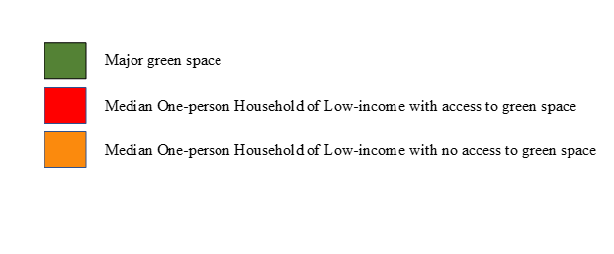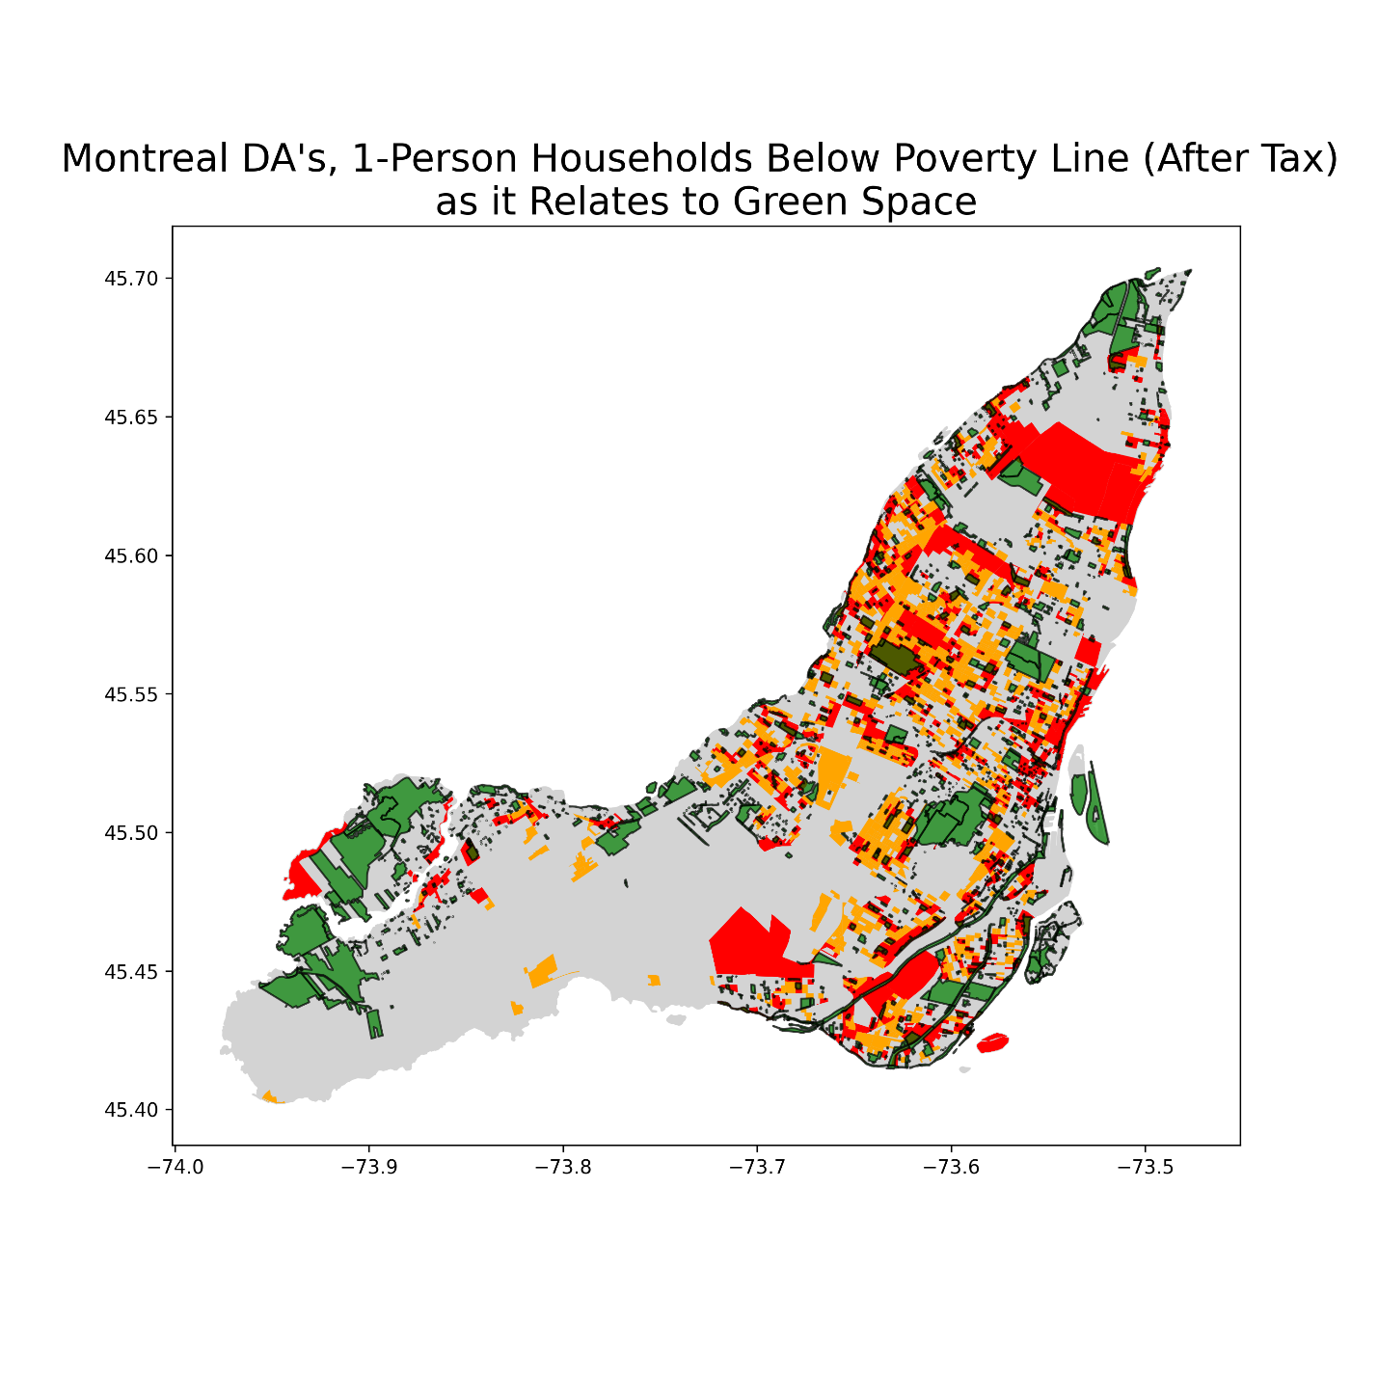

*Map 2.*

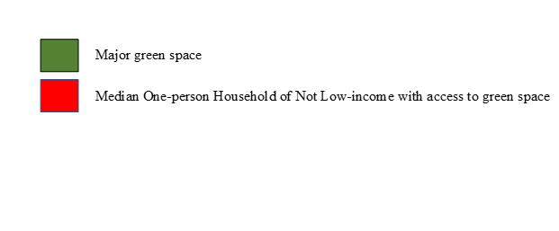

*Map 3.*

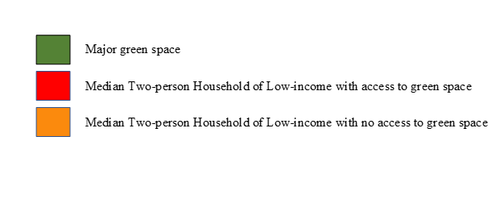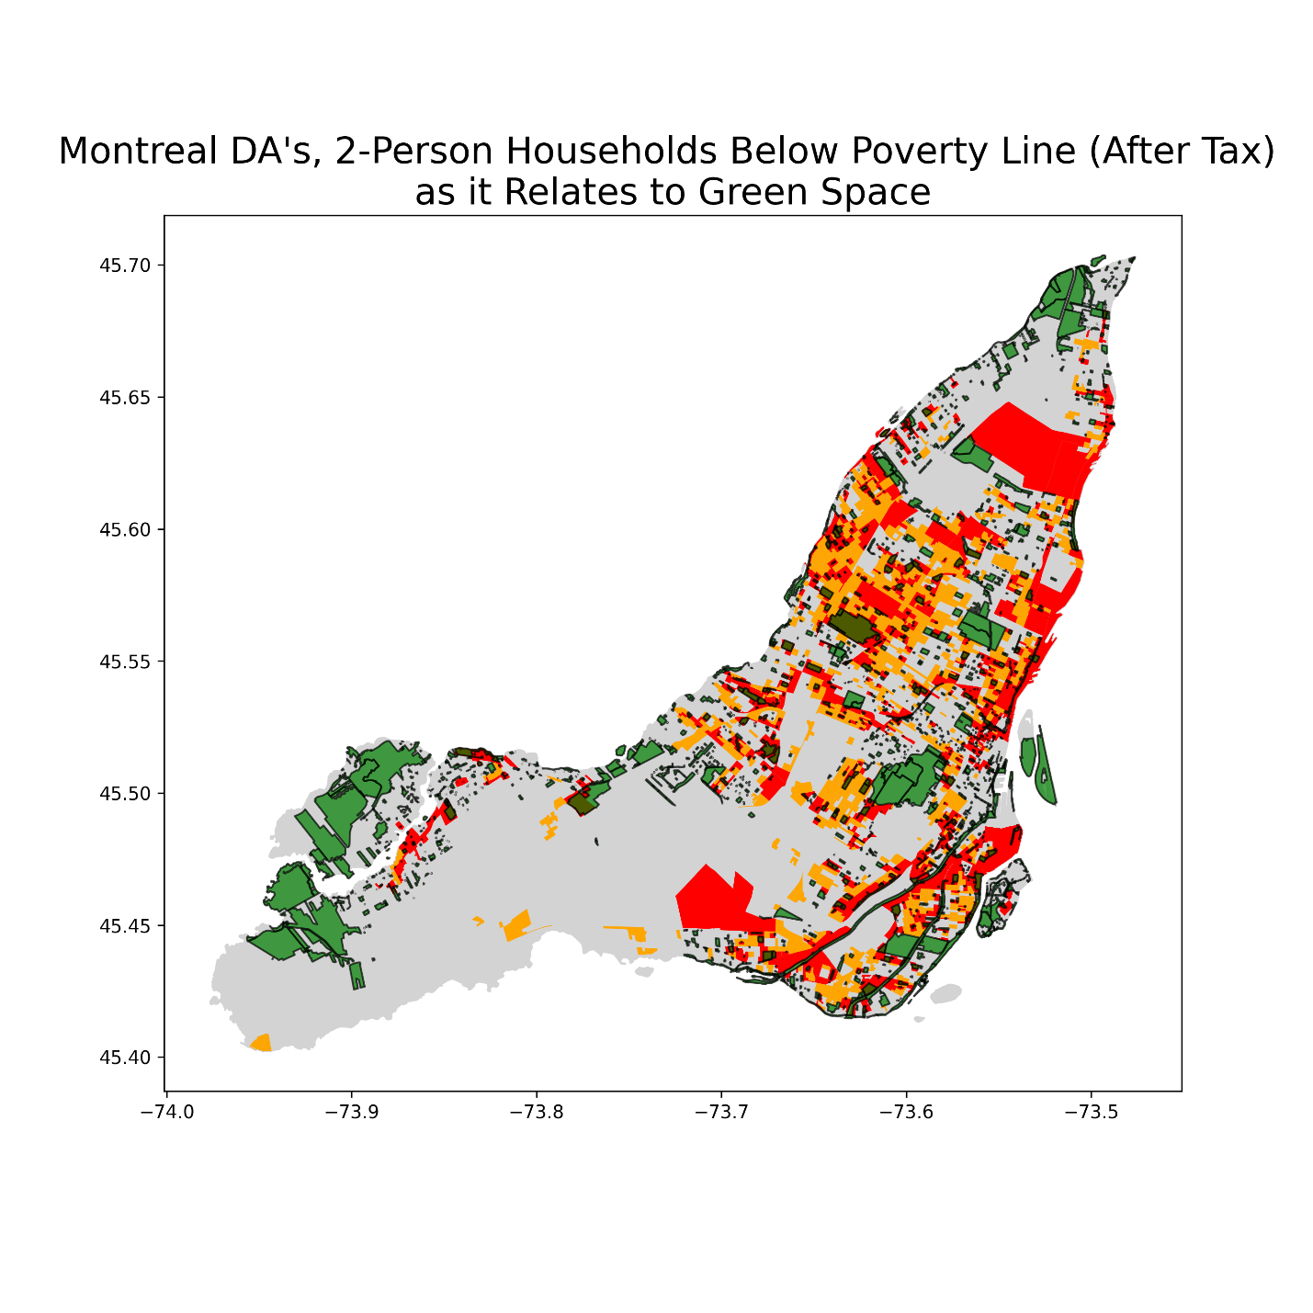

*Map 4.*

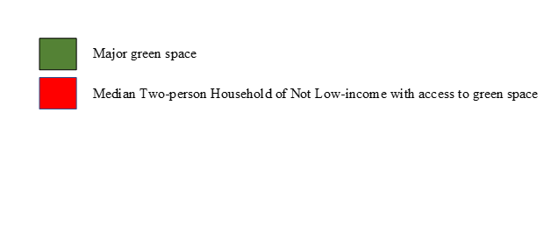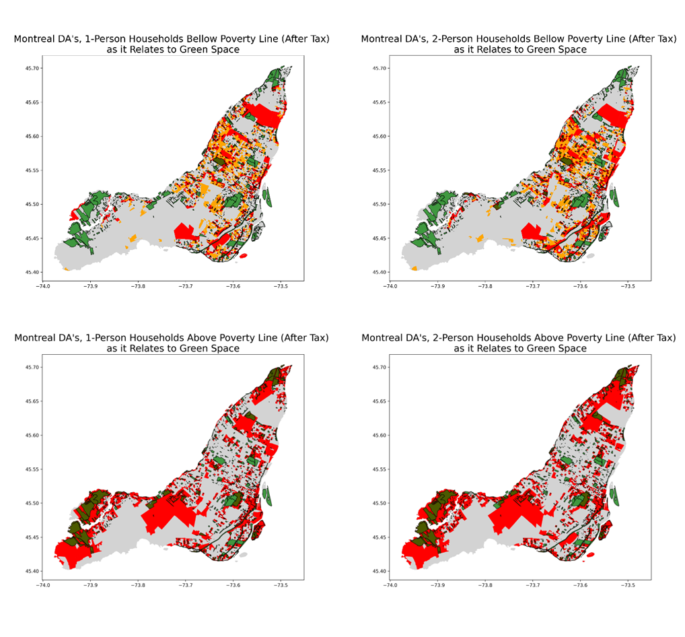 *Figure 1. Maps 1,2,3,4 for comparison.*