Project Iteration 1
Activity 3
User-Centric Computing II
COMP4600
Spring 2025
Project Name: Water Front Tourism
Team Name: King Wasabi
Trello board URL: https://trello.com/b/uAlpxaFN/water-front-tourism
Github repo URL: https://github.com/ZSeals/King-Wasabi

Member information
# | Name
1 | Zachary Seals
2
3
4

All the project iteration 1, activity 2 items
Zachary Seals
Survey Monkey Survey
I am conducting research for a website that highlights lesser-known waterfront destinations. This short survey asks about your travel habits, preferences, and what information you find most helpful when planning a trip.
https://www.surveymonkey.com/results/SM-DwnIUm_2BWNWO8JAtVBTz8TA_3D_3D/
Interview users
Age of the individual | 57
Gender of the individual | Female
Interview questions and answers
When planning a waterfront vacation, what matters most to you? | I want realistic photos, honest reviews, and clear pricing before I even consider booking.
How do you usually research travel destinations? | I compare multiple websites, read user reviews carefully, and look at photos to make sure the location looks safe and peaceful.
What frustrates you about current travel websites? | Too many ads, unrealistic edited photos, and hidden fees that show up later.
How important is safety and accuracy in your travel planning? | Very important. I need to feel confident that what I see online matches the real experience.
What would make you trust a travel website more? | Clear pricing, real pictures, verified reviews, and simple navigation without clutter.
User Need Statements (list 5 statements)
Users need realistic photos to build trust in a destination.
Users need transparent pricing to avoid hidden costs.
Users need credible reviews to feel confident before booking.
Users need a simple, clutter-free website experience.
Users need accurate information about safety and accessibility.

Final List of User Need Statements
User Need Statements – final list
Users need trustworthy visuals and honest reviews to feel confident in choosing a waterfront destination.
Users need clear, transparent pricing information to avoid unexpected costs.
Users need a simple and organised website layout that reduces stress during trip planning.

User Personas
Member 1 User Persona
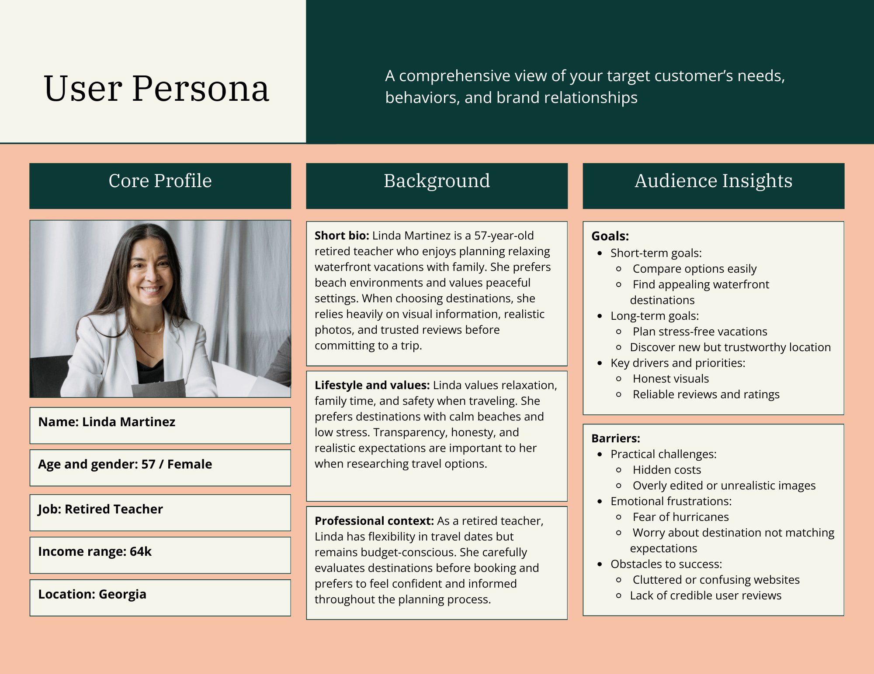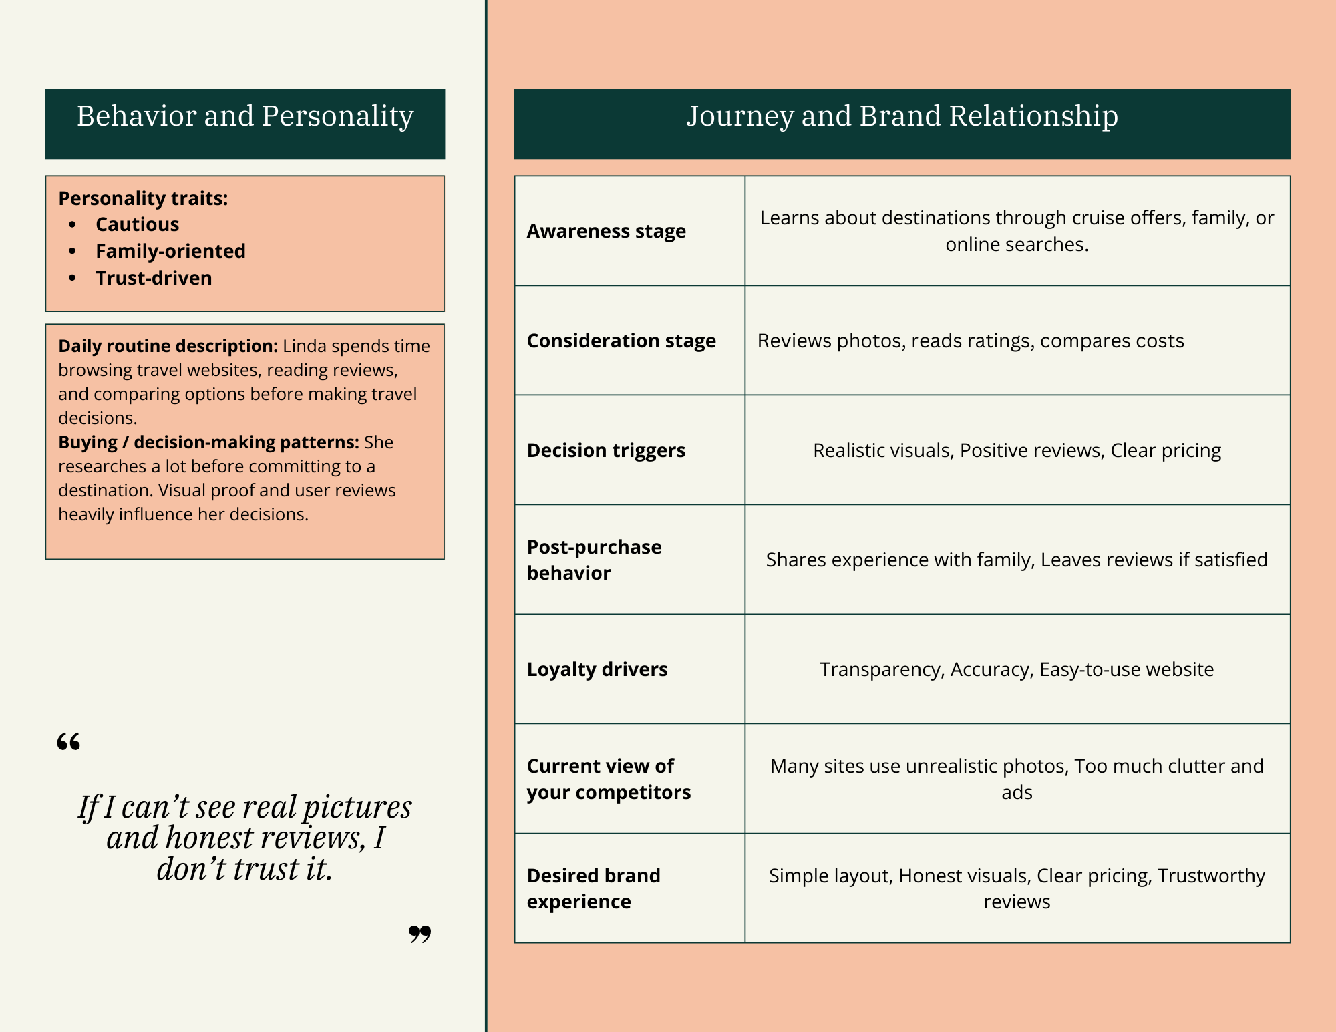

User Flows
Member 1 User Flow
Users need trustworthy visuals and honest reviews to feel confident in choosing a waterfront destination.
