Project Iteration 2
Activity 2
User-Centric Computing II
COMP4600
Spring 2025
Usability Test 2
Project Name: Water Front Tourism
Team Name: King Wasabi
Team’s Project Trello board URL: https://trello.com/b/uAlpxaFN/water-front-tourism
Tream’s Project Github repo URL: https://github.com/ZSeals/King-Wasabi-Website
Website URL: Waterfront Tourism | Home Waterfront Tourism | Home
Team members
# | Name
1 | Zachary Seals
2 | Jacob Seals
3 | Quentin Robinson
4

Usability tests ran by all members
Member Name | Zachary Seals
Participant age | 25
Participant gender | Female
Test Date | 04-29-2026
Test Time | 7:45 PM
Total time taken | ~7 minutes
Test Introduction script
Hi, my name is Zachary, and I’m testing a website I created for a class project. I’m going to ask you to complete a few tasks on the site so I can see how easy it is to use. This is not a test of you. You’re helping me test the website, not being tested yourself. The session should take around 5–10 minutes. I won’t guide you unless you get stuck, because I want to see how the site works naturally.

The 10 Tasks users must complete and your observations
Task 1 (Go to the homepage) | Completed successfully: yes  Time taken: 8 seconds  Facial expressions: Neutral  Any noises made: None  Any other gestures made: None
Task 2 (Navigate to Destination 1) | Completed successfully: yes  Time taken: 12 seconds  Facial expressions: Focused  Any noises made: “okay”  Any other gestures made: Slight pause before clicking
Task 3 (Return to homepage) | Completed successfully: yes  Time taken: 7 seconds  Facial expressions: Neutral  Any noises made: None  Any other gestures made: Quick click
Task 4 (Go to Favorite Locations) | Completed successfully: yes  Time taken: 10 seconds  Facial expressions: Neutral  Any noises made: None  Any other gestures made: Quick click
Task 5 (Go to Things-to-Do page) | Completed successfully: yes  Time taken: 9 seconds  Facial expressions: Neutral  Any noises made: None  Any other gestures made: None
Task 6 (Find one activity) | Completed successfully: yes  Time taken: 11 seconds  Facial expressions: Interested  Any noises made:  Any other gestures made: “that’s cool”
Task 7 (Navigate to Destination 2) | Completed successfully: yes  Time taken: 15 seconds  Facial expressions: Slight confusion  Any noises made: “hmm…”  Any other gestures made: None
Task 8 (Find attractions section) | Completed successfully: yes  Time taken: 17 seconds  Facial expressions: Focused  Any noises made: None  Any other gestures made: None
Task 9 (Return to homepage) | Completed successfully: yes  Time taken: 8 seconds  Facial expressions: None  Any noises made: None  Any other gestures made: None
Task 10 (Identify top destinations) | Completed successfully: yes  Time taken: 13 seconds  Facial expressions: None  Any noises made: None  Any other gestures made: None
User’s opinions/comments/suggestions about the site
What they liked:
- Clean and simple layout
- Easy navigation
- Images looked nice
- Pages were easy to understand

What they didn’t like:
- Wanted more interactive features

Suggestions:
- Add more descriptions
- Add a map or location feature
- Add small animations or buttons

The “Thank You” note to conclude the test
Thank you for taking the time to test my website. I really appreciate your feedback and suggestions.
Your experience, assessment of the Usability Test
The usability test went well overall. The participant was able to complete all tasks successfully, showing that the navigation and structure of the website are clear.

Member Name | Jane Doe
Participant age | Input age here
Participant gender | Input gender here
Test Date | Test date here
Test Time | Test time here
Total time taken | Total test time here
Test Introduction script
Insert here the introductory speech you gave to the participant to put her at ease and inform him/her about what is expected. You know from our Usability Testing lectures, and videos that an introduction is necessary.
The following items must be present here -
- Your formal introduction
  - Your name
  - What you do
  - And so on
- The purpose of the session and the time it might take
- Put the users at ease by ensuring that they are not being tested in any way, but rather they are helping us by testing a product for us!
- Explain about your website – do not give them too many details, we want them to explore and find out.
- Explain how the participant is helping you by participating.
  - Explain what you expect to find
    - Do not tell them exact results that you hope to find, you will bias them that way
    - Explain to them that you are trying to get a general understanding of the site’s usability, what works and what does not for a user.
- Now point them to the website that they will have to test by giving them the URL.
The 10 Tasks users must complete and your observations
Here you will ask the user to be at ease and complete the tasks listed below
You must observe and collect/note necessary information on the left
Task 1 (description of the task) | Completed successfully: yes/no  Time taken: in seconds  Facial expressions:  Any noises made:  Any other gestures made:
Task 2 (description of the task) | Completed successfully: yes/no  Time taken: in seconds  Facial expressions:  Any noises made:  Any other gestures made:
Task 3 (description of the task) | Completed successfully: yes/no  Time taken: in seconds  Facial expressions:  Any noises made:  Any other gestures made:
Task 4 (description of the task) | Completed successfully: yes/no  Time taken: in seconds  Facial expressions:  Any noises made:  Any other gestures made:
Task 5 (description of the task) | Completed successfully: yes/no  Time taken: in seconds  Facial expressions:  Any noises made:  Any other gestures made:
Task 6 (description of the task) | Completed successfully: yes/no  Time taken: in seconds  Facial expressions:  Any noises made:  Any other gestures made:
Task 7 (description of the task) | Completed successfully: yes/no  Time taken: in seconds  Facial expressions:  Any noises made:  Any other gestures made:
Task 8 (description of the task) | Completed successfully: yes/no  Time taken: in seconds  Facial expressions:  Any noises made:  Any other gestures made:
Task 9 (description of the task) | Completed successfully: yes/no  Time taken: in seconds  Facial expressions:  Any noises made:  Any other gestures made:
Task 10 (description of the task) | Completed successfully: yes/no  Time taken: in seconds  Facial expressions:  Any noises made:  Any other gestures made:
User’s opinions/comments/suggestions about the site
Ask the users about the site and insert their answers here.
Questions that you must ask are below, but you are more than welcome ask them other questions you deem necessary -
- what they liked
- what they didn’t like
- what suggestions they can provide to make the site better for users
The “Thank You” note to conclude the test
Insert the closing remarks with your Thank You speech here.
Your experience, assessment of the Usability Test
Insert your own assessments of the test, your experience here, if there is anything you would do differently next time, if anything else needs to be added to this document, and so on.

Member Name | John Doe
Participant age | Input age here
Participant gender | Input gender here
Test Date | Test date here
Test Time | Test time here
Total time taken | Total test time here
Test Introduction script
Insert here the introductory speech you gave to the participant to put her at ease and inform him/her about what is expected. You know from our Usability Testing lectures, and videos that an introduction is necessary.
The following items must be present here -
- Your formal introduction
  - Your name
  - What you do
  - And so on
- The purpose of the session and the time it might take
- Put the users at ease by ensuring that they are not being tested in any way, but rather they are helping us by testing a product for us!
- Explain about your website – do not give them too many details, we want them to explore and find out.
- Explain how the participant is helping you by participating.
  - Explain what you expect to find
    - Do not tell them exact results that you hope to find, you will bias them that way
    - Explain to them that you are trying to get a general understanding of the site’s usability, what works and what does not for a user.
- Now point them to the website that they will have to test by giving them the URL.
The 10 Tasks users must complete and your observations
Here you will ask the user to be at ease and complete the tasks listed below
You must observe and collect/note necessary information on the left
Task 1 (description of the task) | Completed successfully: yes/no  Time taken: in seconds  Facial expressions:  Any noises made:  Any other gestures made:
Task 2 (description of the task) | Completed successfully: yes/no  Time taken: in seconds  Facial expressions:  Any noises made:  Any other gestures made:
Task 3 (description of the task) | Completed successfully: yes/no  Time taken: in seconds  Facial expressions:  Any noises made:  Any other gestures made:
Task 4 (description of the task) | Completed successfully: yes/no  Time taken: in seconds  Facial expressions:  Any noises made:  Any other gestures made:
Task 5 (description of the task) | Completed successfully: yes/no  Time taken: in seconds  Facial expressions:  Any noises made:  Any other gestures made:
Task 6 (description of the task) | Completed successfully: yes/no  Time taken: in seconds  Facial expressions:  Any noises made:  Any other gestures made:
Task 7 (description of the task) | Completed successfully: yes/no  Time taken: in seconds  Facial expressions:  Any noises made:  Any other gestures made:
Task 8 (description of the task) | Completed successfully: yes/no  Time taken: in seconds  Facial expressions:  Any noises made:  Any other gestures made:
Task 9 (description of the task) | Completed successfully: yes/no  Time taken: in seconds  Facial expressions:  Any noises made:  Any other gestures made:
Task 10 (description of the task) | Completed successfully: yes/no  Time taken: in seconds  Facial expressions:  Any noises made:  Any other gestures made:
User’s opinions/comments/suggestions about the site
Ask the users about the site and insert their answers here.
Questions that you must ask are below, but you are more than welcome ask them other questions you deem necessary -
- what they liked
- what they didn’t like
- what suggestions they can provide to make the site better for users
The “Thank You” note to conclude the test
Insert the closing remarks with your Thank You speech here.
Your experience, assessment of the Usability Test
Insert your own assessments of the test, your experience here, if there is anything you would do differently next time, if anything else needs to be added to this document, and so on.

Accessibility tests and Markup validation
Zachary Seals
Accessibility test screenshots here
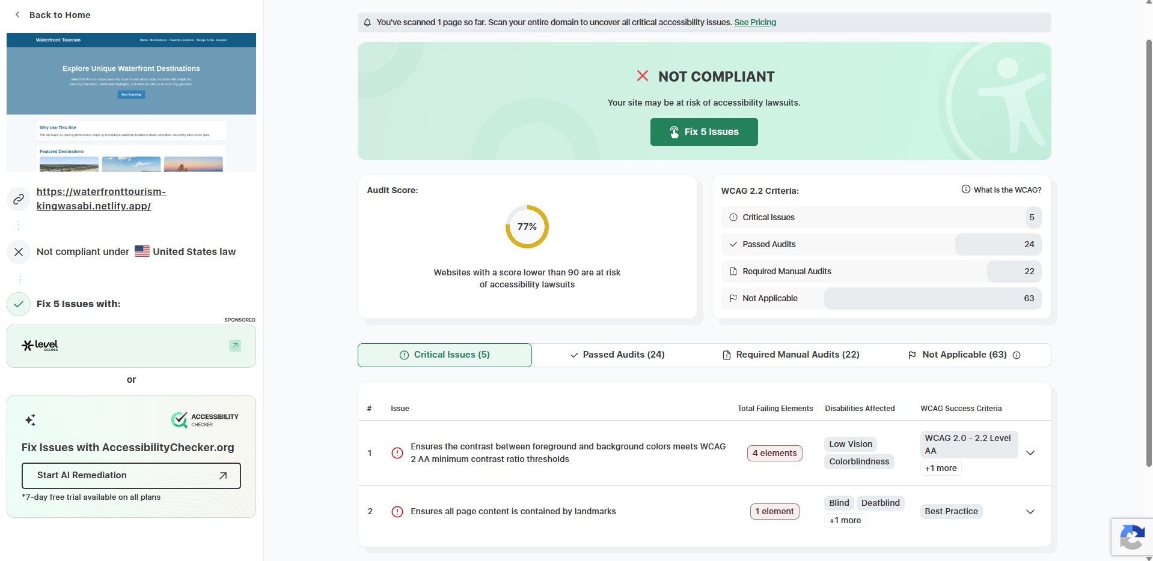
- Ensures the contrast between foreground and background colors meets WCAG 2 AA minimum contrast ratio thresholds
- Ensures all page content is contained by landmarks
HTML validation screenshots here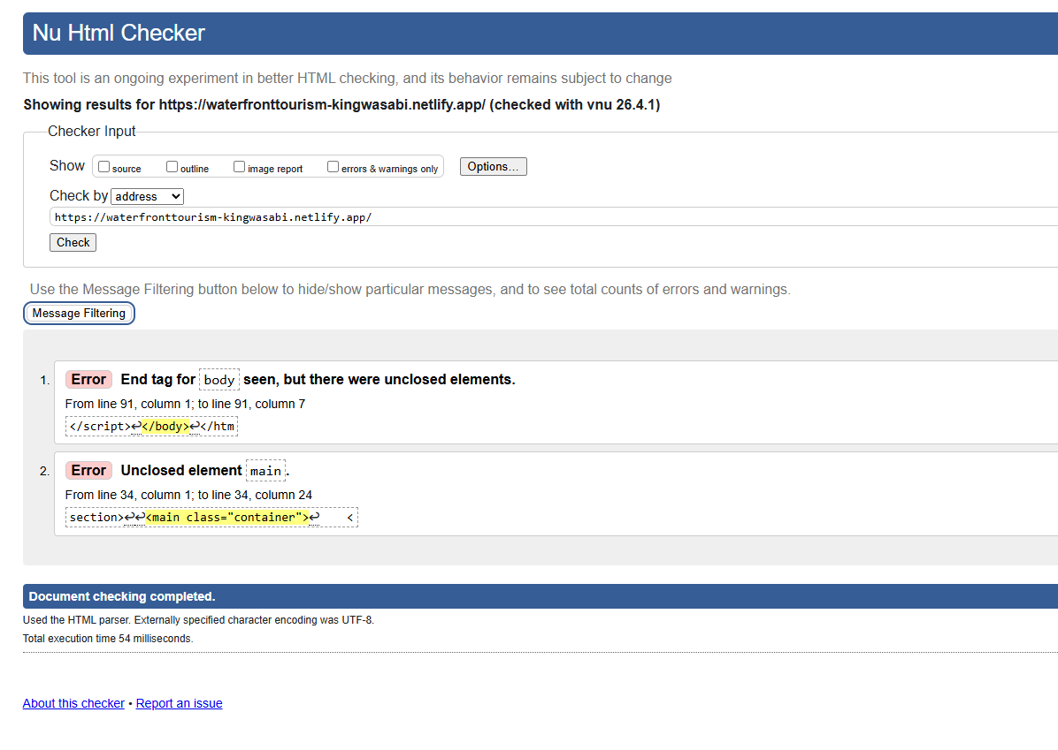
- End tag for body seen, but there were unclosed elements.
- Unclosed element main.
Jacob Seals
Insert the Accessibility test screenshots here
List the issues found here
Insert the HTML validation screenshots here
List the Markup issues found here
Quentin Robinson
Insert the Accessibility test screenshots here
List the issues found here
Insert the HTML validation screenshots here
List the Markup issues found here

Team’s assessments
Usability test results, discussions, analysis
Insert team discussions and analysis of all the usability test results. The following must be included here -
  - summary and analysis of all the results from each member’s usability test
  - The future enhancements that can be made on the site based on analysis above.

Accessibility issues
List any accessibility issues your team has found and the steps your team will take to remedy them.
HTML Markup issues
List any markup issues your team has found and the steps your team will take to remedy them.

