Project Iteration 1
Activity 3
User-Centric Computing II
COMP4600
Spring 2026
Project Name: Water Front Tourism
Team Name: King Wasabi
Trello board URL: https://trello.com/b/uAlpxaFN/water-front-tourism
Github repo URL: https://github.com/ZSeals/King-Wasabi

Member information
# | Name
1 | Jacob Seals
2
3
4

Jacob Seals
Survey Monkey Survey
Create a user research survey to help me design a website that highlights lesserknown waterfront travel destinations. The website will feature a Top 10 list format and provide information, visuals, and insights to help users discover, plan, and feel confident about visiting these locations. The target users include individuals, families, and companies interested in leisure travel, family vacations, or group retreats. The survey should collect information that will help me create user personas and user need statements. Include questions about travel habits, how users currently find travel destinations, interest in overlooked or lesser-known waterfront locations, the importance of visuals and simplicity when planning trips, frustrations with existing travel websites, and features users would expect from a travel planning website. Use a mix of multiple-choice, rating scale, and open-ended questions.
https://www.surveymonkey.com/r/X9WM92L
Interview users
Age of the individual | 45
Gender of the individual | Male
Interview questions and answers
What is important to you with a website? | Simplicity in finding what I’m looking for without having to dig for it.
Do you like when websites make you create an account? | Absolutely not.
Do you enjoy traveling to waterfront locations? | Yes, I was in the coast guard, so I do 100%.
When traveling, how do you choose a destination. | I just go to places that stick out or that I’ve been to before.
What is your least favorite part about traveling. | Dealing with booking a place to stay and figuring out different amenities at the locations.
User Need Statements
Users need a website that minimizes frustration and complexity so they can focus on planning their trip rather than figuring out how the site works.
Users need a way to compare different waterfront destinations so they can choose the best option for their needs.
Users need concise and organized information about each destination so they can quickly understand what the location offers.
Users need clear visuals (photos and images) of waterfront destinations so they can decide if the location interests them.
Users need recommendations that highlight unique or standout waterfront locations so they can find places worth visiting.

Final List of User Need Statements
User Need Statements – final list
Users need a way to compare different waterfront destinations so they can choose the best option for their needs.
Users need clear visuals (photos and images) of waterfront destinations so they can decide if the location interests them.
Insert statement 3 here
Insert statement 4 here
Insert statement 5 here (add more rows if needed)

Jacob Seals User Persona 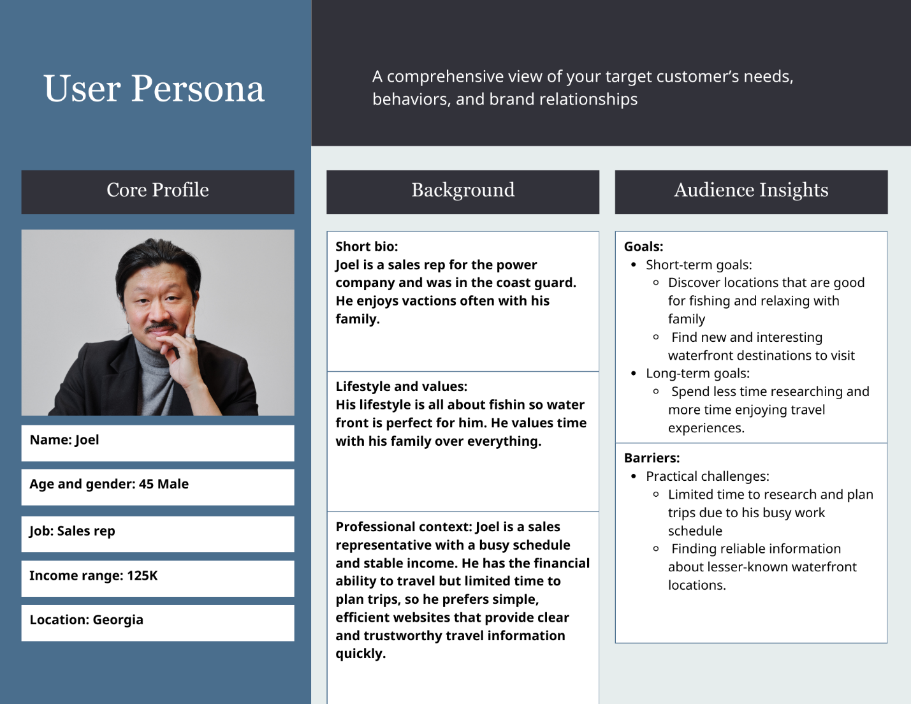
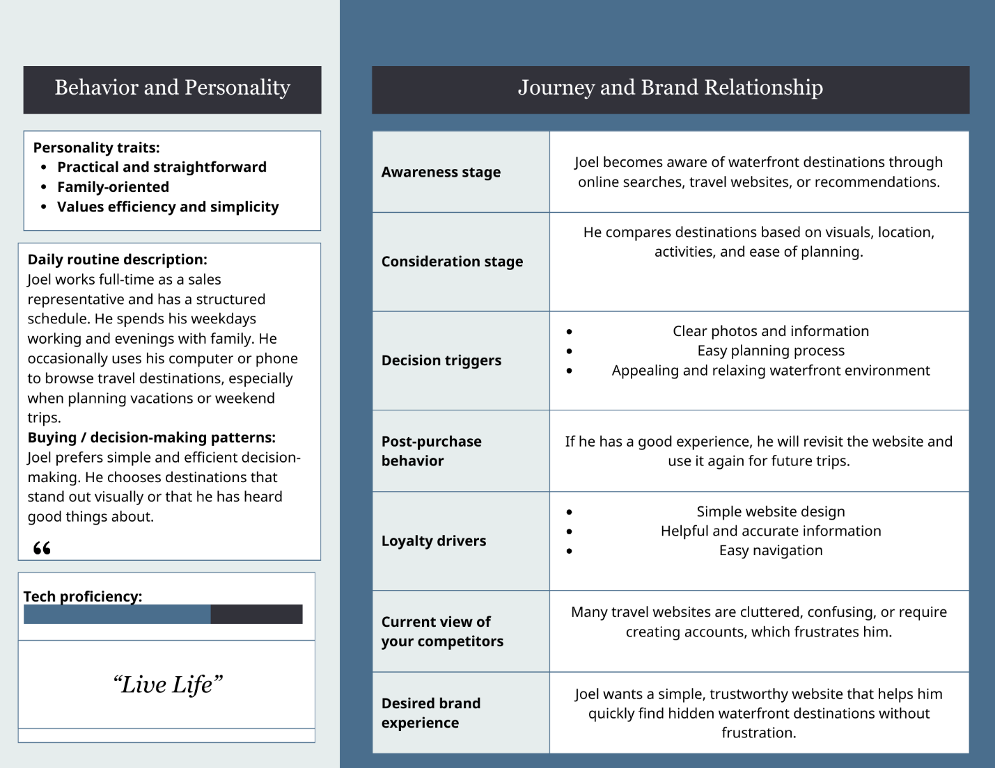

Jacob User Flow
Users need clear visuals (photos and images) of waterfront destinations so they can decide if the location interests them.
