Project Iteration 1
Activity 3
User-Centric Computing II
COMP4600
Spring 2025
Project Name: Water Front Tourism Site
Team Name: King Wasabi
Trello board URL: Water Front Tourism | Trello
Github repo URL: ZSeals/King-Wasabi: The team website for King-Wasabi

Member information
# | Name
1 | Quentin Robinson
2
3
4

All the project iteration 1, activity 2 items from all members
Member 1 name here
Survey Monkey Survey
This survey is being created to help guide the design of a waterfront tourism website that makes it easier for users to quickly plan trips to lesser-known locations. The goal is to understand how people currently look for travel destinations, what slows them down during the planning process, and what information helps them make decisions faster.
The survey will also collect information about how users compare destinations, how budget and trip length affect their choices, and what features they expect from a travel website. It will identify what makes users stay on a site, what makes them leave, and what tools would make trip planning more simple and less time-consuming.
The data collected will be used to develop user personas and user need statements that will directly influence the structure and functionality of the website.
https://www.surveymonkey.com/r/8Z8WRJQ
Interview users
Age of the individual | 21
Gender of the individual | Male
Interview questions and answers
How do you usually decide where to travel? | I usually go for stuff that I can get too quickly and doesn’t take too long to plan.
What is the most frustrating part of planning a trip? | When I have to go through a bunch of different pages and websites just to get information I am looking for.
How much time do you usually spend planning a trip? | Usually spend a day or two and no longer than a week or ill start to lose interest.
What would make a travel website seem more useful to you? | If the site had a way to search and filter so I could find things quickly and had actual working links to take me to the direct place to book things or get information.
What makes you leave a travel website? | When I can’t find what I am looking for quickly or when the site feels like it has more fluff than it needs to have.
User Need Statements (list 5 statements)
Users need filtering options so they can quickly narrow down destinations based on trip length, travel time, and budget.
Users need one place that shows the key trip details, so they do not have to search across multiple websites.
Users need direct and reliable links for booking and additional information so they can move from browsing to planning without extra steps.
Users need a fast way to compare a few relevant destinations so they can make a decision before losing interest.
Users need a streamlined planning process so they can organize a short trip within a limited amount of time.

Member 2 name here
Survey Monkey Survey
Insert the prompt you used to generate the survey at SurveyMonkey website
Insert the link to the survey here
Interview users
Age of the individual | Insert the age here
Gender of the individual | Insert the age of the individual
Interview questions and answers
Insert question 1 here | Insert answer to question 1 here
Insert question 2 here | Insert answer to question 2 here
Insert question 3 here | Insert answer to question 3 here
Insert question 4 here | Insert answer to question 4 here
Insert question 5 here | Insert answer to question 5 here
User Need Statements (list 5 statements)
Insert statement 1 here
Insert statement 2 here
Insert statement 3 here
Insert statement 4 here
Insert statement 5 here

Final List of User Need Statements
User Need Statements – final list
Insert statement 1 here
Insert statement 2 here
Insert statement 3 here
Insert statement 4 here
Insert statement 5 here (add more rows if needed)

Summary of discussion on the effectiveness of the survey and interview questions
Insert the summary here

User Personas
Member 1 User Persona
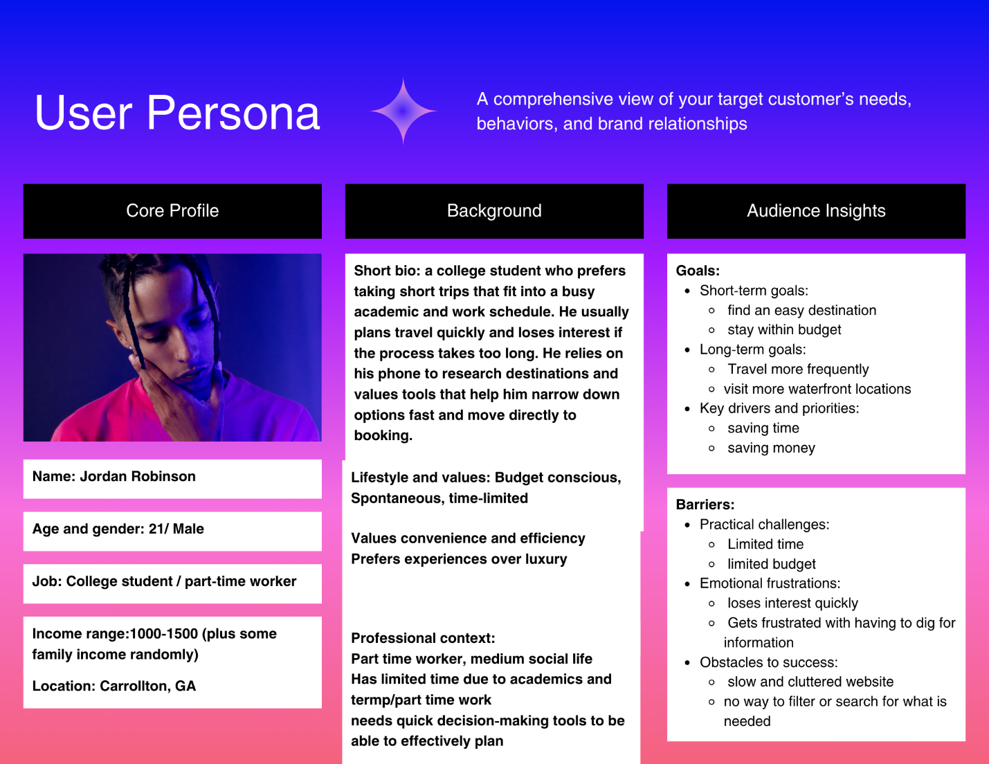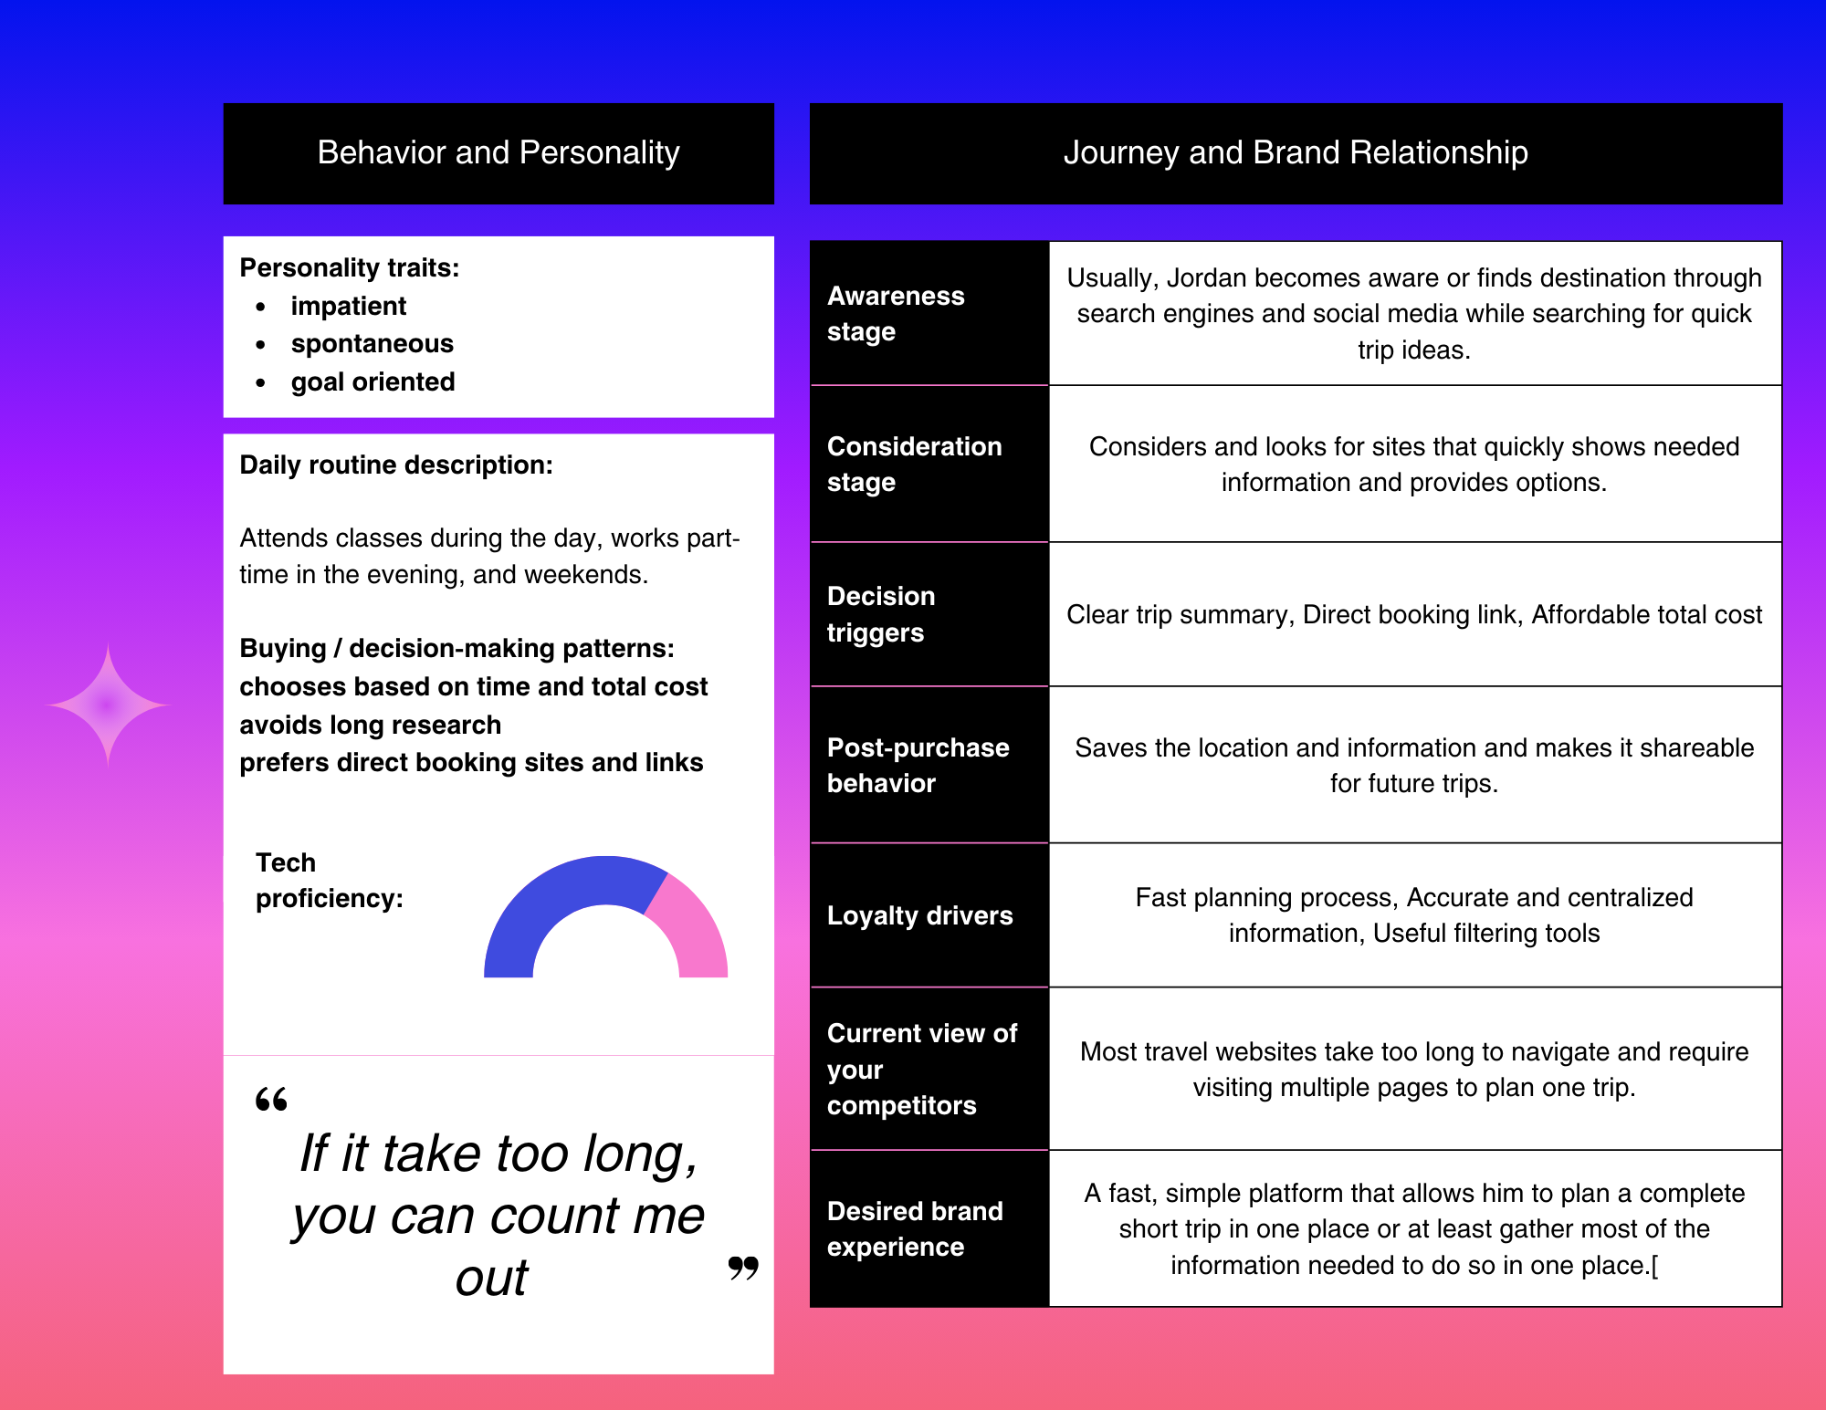
Member 2 User Persona
Insert user persona here
Combined User Persona
Insert the final user persona here

User Flows
Member 1 User Flow
User need: Users need filtering options so they can quickly narrow down destinations based on trip length, travel time, and budget.
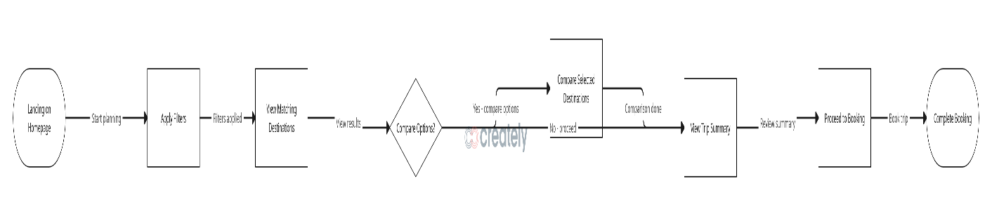
Member 2 User Flow
Mention the User Need statement the flow is for here
Insert the User flow diagram here

