**Notation or Meaning standard keyboard symbol**

**运算符号**

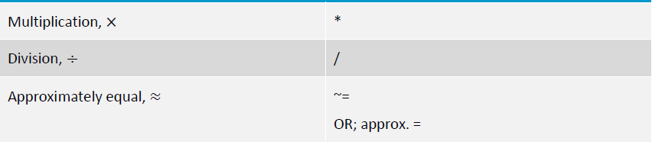

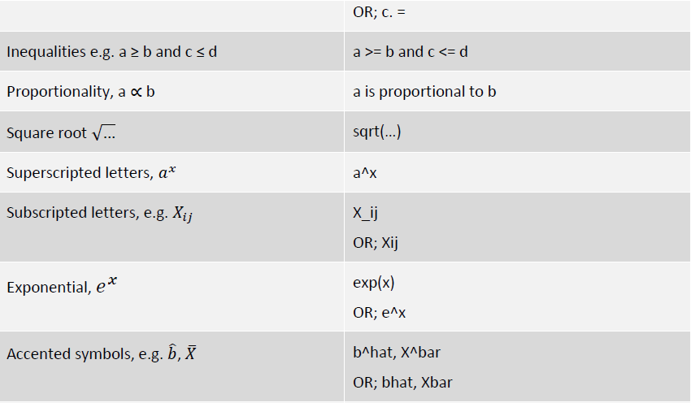

乘法 *

除法 /

约等于 ~= OR; approx.= OR; c.=

不等于 >= OR; <=

正比于 a is proportional to b

开根号 sqrt(…)

上标 a^x

下标 X_ij OR; Xij

指数 exp(x) OR; e^x

头标 b^hat, X^bar OR; bhat Xbar

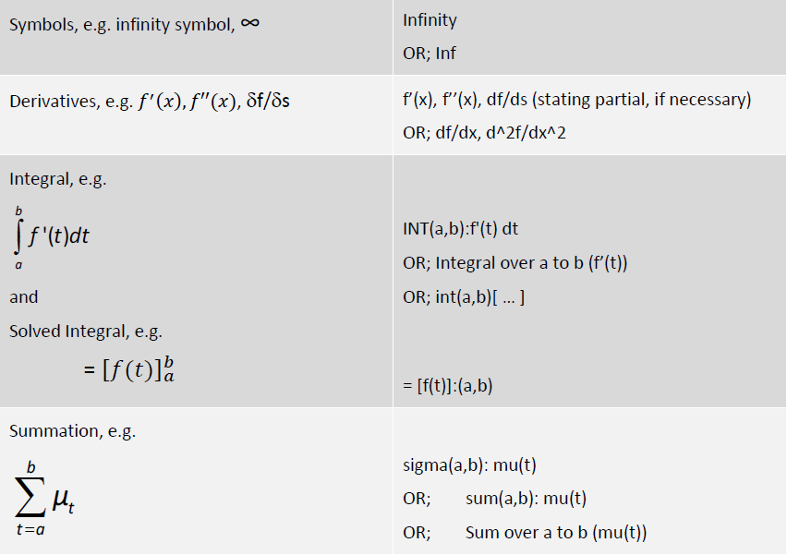

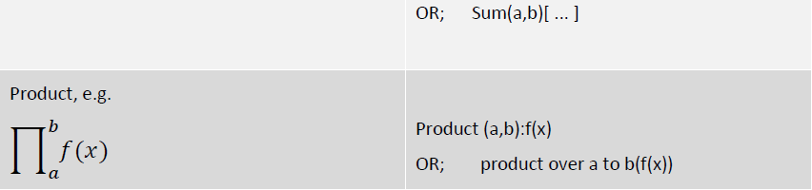无穷 Infinity OR; Inf

求导 f'(x), f''(x), df/ds (stating partial, if necessary)

OR; df/dx, d^2f/dx^2

积分 INT(a, b):f'(t)dt

OR; Integral over a to b (f'(t))

积分后上下限 int(a, b)[…] = [f(t)]:(a, b)

求和 sigma(a: b):mu(t)

OR; sum(a, b):mu(t)

OR; Sum over a to b (mu(t))

连乘 Product (a, b): f(x)

OR; product over a to b(f(x))

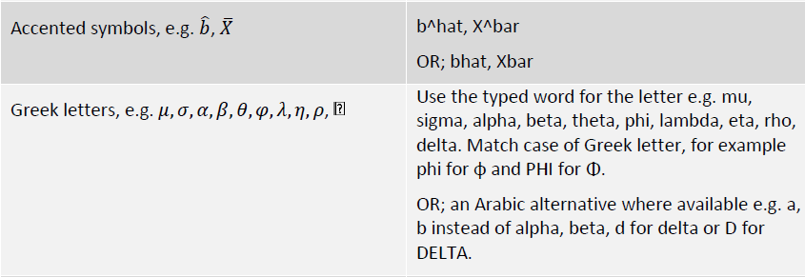

𝜇 𝜎 𝛼 𝛽 𝜃 𝜑 𝜆 𝜂 𝜌 δ

mu sigma alpha beta theta phi lambda eta rho delta

**统计符号**

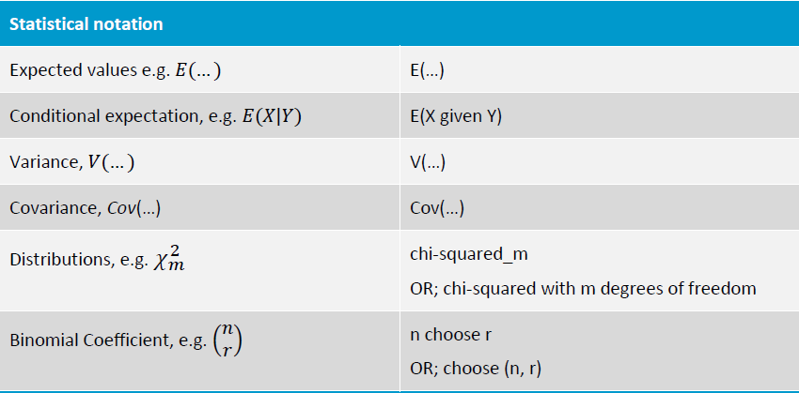

期望 E(…)

条件期望 E(Y given X)

方差 V(…)

协方差 Cov(…)

分布 chi-squared_m

OR; chi-square with m degrees of freedom

二项分布系数 n choose r;

OR; choose (n, r)