

|  |
| --- |
| ***Ahsanullah University of Science & Technology***  Department of Computer Science & Engineering  **FALL 2021** |
| Orphanage Management System |
| CSE 3104: Project Report |
| Submitted By: |

|  |  |
| --- | --- |
| **ID** | **NAME** |
| 190204002 | Mr. D M Raffin |
| 190204003 | Ms. Nura Zabin |
| 190204012 | Mr. Farhan Abid |
| 190204021 | Mr. Md. Abir Hossain Bony |

Table of Contents

1. Motivation of the project: 3
2. Project Goal 3
3. Project Cost Calculation 3
4. Potential Customers/Product Market 3
5. Requirement Analysis 4
6. Entity Relationship Attributes 5
7. Schema/Tables 7
8. Project Risk 7
9. SQL 8
10. Contribution 10
11. Conclusion 11

# Motivation of the Project

Recently we have visited an orphanage where we saw they maintain age old document sheets to keep record of children. Some of them were torn apart which can be at times very problematic to manage. So, we decided to create an efficient management system for this noble organizations and also other organizations may get help from it. It will help them to manage the organization proficiently and reduce paperwork and reduce human labor.

# Project Goal

The purpose of our management system will be to help orphanage by keeping the track of entries and by helping to allocate them to new foster homes and thus pave the way for them to lead a happy life. Our orphanage management system will also manage budgets, expenses, list of workers, and will calculate revenue in form of donations. Information will be secured, sorted, easy to access.

# Project Cost Calculation

The cost estimation of the project can be divided into many criteria.

Total time required: 7 weeks.

Total 4 people working on this project for 7 weeks, two days per week: Salary of the developer team = 12,000 BDT (Approximately) monthly. Payment for the team for each working day = 600 BDT

So, payment for the development for 7 weeks will be = 8,400 BDT

Utilities such as internet, transportation, snacks and others cost will be around 1000 BDT

For selling the software, the estimated starting price will be

* 1,000 BDT/month
* 10,000 BDT/year (Saves 6% per month)

# Potential Customers/Product Market

The interested customers of the project will be

* + - Orphanage Managing Non profitable organizations
    - Individual who manages Orphanage

# Requirement Analysis

Features of the software:

* + - Login: User will login to the software using the username and password provided.
    - Children Information: Children information name, age, gender, blood group, previous foster home, date brought into will be seen.
    - Room allocations: In an orphanage a child will be allocated to which room, how many children will stay in one room, which rooms are vacant. It can be easily distributed.
    - Admin Panel: Admin will access any data of the orphanage. Children information can be added, updated and deleted in this section. Budget and expenses info will be accessed and updated.
    - Visiting information: Our system will keep a record of all the visitor that have visited the orphanage. Will also keep track of the reason of the visits, time of visiting the visitors' information.
    - Adoption: Adopter information will be added in this section, he/she will be check whether the child is currently in a foster home or not.
    - View all records: This option will enable the user to view all the information such as orphans' information, adopters' information, visitors' information all at once in an organized manner.
    - Expenses: Expenses will help the orphanage manage and keep track of their expenses. Will also display per month total cost.

Software requirements:

* + - Front End: NetBeans IDE 8.2
    - Back end: SQL Server Management Studio
  1. Entity Relationship Attributes

Project possible Entity, Relationship and Attributes

## Possible Entities:

1. Orphanage
2. Orphan
3. Room
4. Expenditure
5. Budget
6. Admin
7. Adopter
8. Visitor

## Possible Relationships:

1. Helps

2. Admits

3. Allocates

4. Expends

5. Donates

6. Adopts

7. Visits

## Possible Attributes:

1. Orphanage: Branch Id (Primary key), Branch name, Locality, Capacity, Orphan Id (Foreign key), Visitors Id (Foreign Key), Adopter Id (Foreign Key), Donor Id (Primary key)
2. Orphan: Orphan Id (Primary key), First Name, Last Name, Orphan Age, Orphan Date of Birth, Orphan Gender, Blood Group, Allocated Room, Adoption Status
3. Room: Room Id, Room Name, Block No, Building No, Occupied, Orphan Id (Foreign key)
4. Budget: Budget Allocated to Sectors, Increase from Previous Year (In Percentage), Savings
5. Expenditure: Sectors ID (primary key), Sector Name, Increase from Previous year (Percentage), Per sector accumulated cost
6. Admin: Admin Login, Admin Password
7. Adopter: Adopter Id (Primary Key), Adopter Name, Locality, Phone Number, Adoption Date, Orphan Id (Foreign Key)
8. Visitors: Visitors Id (Primary Key), Visitor Name, Visited Purpose, Phone number, Locality, Email
9. Expenses: Sector ID (Primary Key), months, food, clothes, health, education, miscellaneous.
10. Schema/Tables

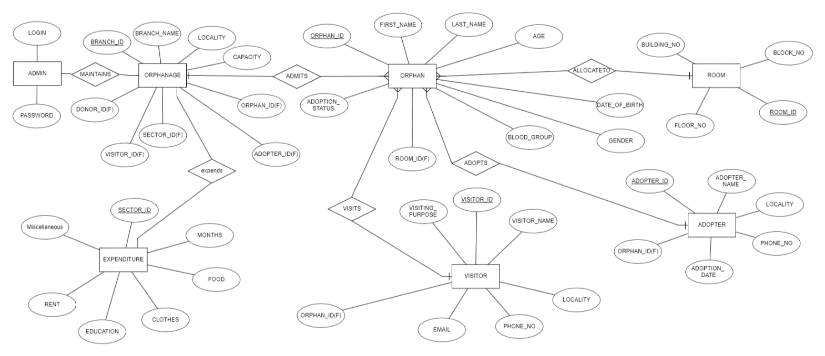ER Diagram:

1. Project Risk
   * As our project has a lot of features, there is possibility that some of the stated features above may not act properly at first.
   * Asking sell price may not meet the expectation of the buyers so it may be needed to adjust manually.
2. SQL

Table Create:

CREATE DATABASE FarhanTest;

USE FarhanTest;

CREATE TABLE room

(

roomID INT PRIMARY KEY NOT NULL,

floorno INT NOT NULL,

buildingno INT NOT NULL,

block VARCHAR NOT NULL

)

CREATE TABLE orphan

(

orphanID INT IDENTITY(10000,1) PRIMARY KEY,

firstname VARCHAR(50) NOT NULL,

lastname VARCHAR(50)NOT NULL,

age INT NOT NULL,

dateofbirth DATE NOT NULL,

gender VARCHAR(50) NOT NULL,

bloodgroup VARCHAR(50) NULL,

adoptionstatus VARCHAR(50) NOT NULL DEFAULT 'Not Adopted',

);

CREATE TABLE adopter

(

adopterID INT IDENTITY(50000, 1) PRIMARY KEY,

adoptername VARCHAR(50) NOT NULL,

locality VARCHAR(50) NOT NULL,

phoneno VARCHAR(50) NOT NULL,

email VARCHAR(50),

adoptiondate DATE NULL,

orphanID INT FOREIGN KEY REFERENCES orphan(orphanID) NULL

);

CREATE TABLE visitor

(

visitorID INT IDENTITY(100, 1) PRIMARY KEY,

visitorname VARCHAR(50) NOT NULL,

locality VARCHAR(50) NOT NULL,

phoneno VARCHAR(50) NOT NULL,

email VARCHAR(50),

orphanID INT FOREIGN KEY REFERENCES orphan(orphanID) NULL,

visitingpurpose VARCHAR(max)

);

CREATE TABLE ex

(

sectorID INT IDENTITY(1,1) PRIMARY KEY,

months VARCHAR(50),

food INT,

clothes INT,

education INT,

rent INT,

miscellaneous INT,

);

CREATE TABLE orphanage

(

branchID INT IDENTITY(1,1) PRIMARY KEY,

branchname VARCHAR(50) NOT NULL,

locality VARCHAR(50)NOT NULL,

capacity VARCHAR(50) NOT NULL,

orphanID INT FOREIGN KEY REFERENCES orphan(orphanID) NOT NULL,

visitorID INT FOREIGN KEY REFERENCES visitor(visitorID) NOT NULL,

adopterID INT FOREIGN KEY REFERENCES adopter(adopterID) NOT NULL,

sectorID INT FOREIGN KEY REFERENCES ex(sectorID) NOT NULL,

);

Expense Calculate Query:

select months,(select SUM(costs) from ( values (food),(clothes),(health),(education),(miscellaneous)) As sum(costs)) as totalcostofmonth from ex

View Adoption Records Query :

select O.orphanID, O.firstname, O.age, O.adoptionstatus, A.adopterID, A.adoptername, A.phoneno from orphan O left join adopter A on O.orphanID=A.orphanID

1. Contribution
   * DM Raffin (190204002) – 25%
     + ERD
     + Database Creation
     + Orphan (Backend)
     + Expense, Adopter (Backend)
     + Error Handling
   * Nura Zabin (190204003) – 25%

* ERD
* Adoption (Backend)
* Visitor (Backend)
* Admin (Backend & Frontend)
* Error Handling
  + Farhan Abid (190204012) – 25%
* ERD
* UI Design (Home, Visitor, Adoption, Orphan, Adopter, Expense)
* Adoption (Backend)
* Visitor (Backend)
* Error Handling
  + Md. Abir Hossain Bony (190204021) – 25%
    - ERD
    - Database Creation
    - Orphan, Adopter, All Records (Backend)
    - UI Design (All Records)
    - Error Handling

11. Conclusion

There are not many orphanage management systems in our country. Most of our NGO and other non-profit organization rely on sheet of papers as documents which can be very restless and at a times a lot unorganized to manage. Our target is to provide a working, reliable, affordable and efficient database management system for those orphanages and non-profit organizations.