**CST-361 - Design Report Template**

|  |  |  |
| --- | --- | --- |
| **Topic:** | *Milestone 4* | |
| **Date:** | *1/24/20* | |
| **Revision:** | *1.0* | |
| **Team:** | 1. *John Harrison.* | |
| 1. *Zachary Swoveland.* | |
|  | |
|  | |
| **Weekly Team Status Summary:** | |  |  |  |  | | --- | --- | --- | --- | | **User Story** | **Team**  **Member** | **Hours**  **Worked** | **Hours Remaining** | | *DAO* | *John Harrison* |  |  | |  |  |  |  | |  |  |  |  | |  |  |  |  | |  |  |  |  | |  |  |  |  | |  |  |  |  | |  |  |  |  | |  |  |  |  | |  |  |  |  | |  |  |  |  | |  |  |  |  | |  |  |  |  | | |
| **GIT URL:** | *https://github.com/ZSwoveland/CST361Group/tree/master* | |
| **Peer Review:** | *Y* | We acknowledge that our team has reviewed this report and we agree to the approach we are all taking. |

**Planning Documentation**

**Agile Scrum Product Backlog:**

*https://github.com/ZSwoveland/CST361Group/tree/main/Scrum.*

**Agile Scrum Sprint Backlog:**

**N/A**

**Agile Scrum Burn Down Chart:**

<https://github.com/ZSwoveland/CST361Group/blob/main/Scrum/CST361-SprintBurnDown%20Milestone%204.xlsx>

**Agile Retrospective Results:**

*The following table should be completed after each Retrospective on Things That Went Well (Keep Doing). An alternative to the following table is to use a Mind Mapping tool such as Coggle. If you use a Mind Mapping tool you must include a URL or Image File.*

|  |
| --- |
| **What Went Well** |
|  |
|  |
|  |

*The following table should be completed after each Retrospective on Things That Didn’t Go Well (Stop Doing) and What Would Be Done Differently Next Time with an Action Plan to Improve (Try Doing and Continuous Improvement). An alternative to the following table is to use a Mind Mapping tool such as Coggle. If you use a Mind Mapping tool, you must include a URL or Image File.*

|  |  |  |
| --- | --- | --- |
| **What Did Not Go Well** | **Action Plan** | **Due Date** |
|  |  |  |
|  |  |  |
|  |  |  |

**Design Documentation**

**Install Instructions:**

*Clone the current version from link:* [*https://github.com/ZSwoveland/CST361Group/tree/main/Code*](https://github.com/ZSwoveland/CST361Group/tree/main/Code) *. You will need to be using Wildfly 13.0 and Java 8 JDK to have it run. You will also need Eclipse Java EE edition to run the application.*

**General Technical Approach:**

*We took a simple approach in the design and brainstorming setting times we are available and what is needed to get the project done. We plan to have a home page for the user that will populate the data of the Raspberry PI motion sensor stating what time the sensor was activated on what date. This will be sent to the user via Text or Email and updated in the log portion on the website.*

**Key Technical Design Decisions:**

*There is no final design pick out for the website. We know we will need the UI to be clean and professional with all data easy to access by having easy to understand navigation bars.*

**Known Issues:**

*On Zach’s environment is having issues with Javax imports usage and having some server issues.*

**Risks:**

*There are no known risks at this time.*

**ER Diagram:**

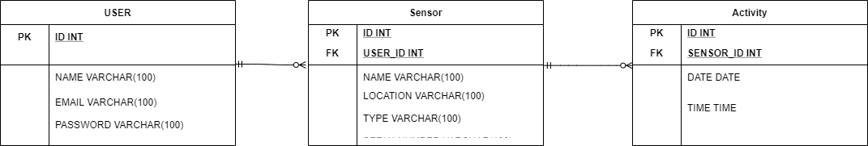

**DDL Scripts:**

*N/A*

**Flow Charts:**

*N/A*

**Sitemap Diagram/ User Interface Diagrams:**

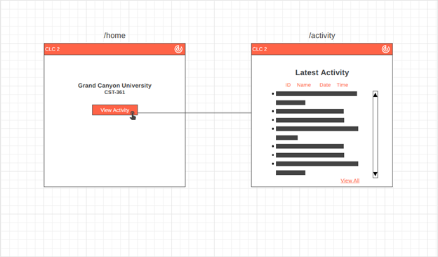

**Class Diagrams:**

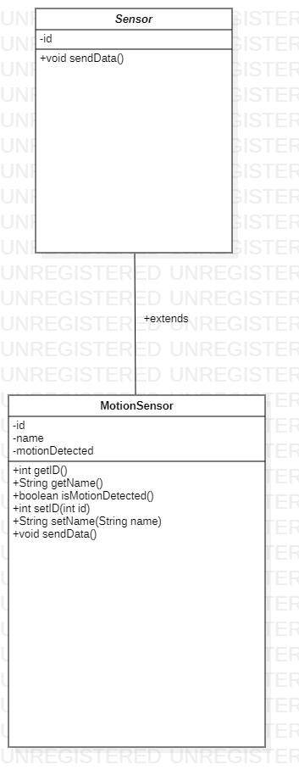

**Service API Design:**

*N/A*

**Security Design:**

*We plan on using a Secure login for user to add and remove their own sensors from their account.*

**Pseudo Code:**

*N/A*

**Other Documentation:**

*Component Diagram:*

<https://github.com/ZSwoveland/CST361Group/blob/main/Diagrams/CLC%202%20Diagrams/CLC%202%20-%20Component%20Diagram.png>

*Deployment Diagram:*

<https://github.com/ZSwoveland/CST361Group/blob/main/Diagrams/CLC%202%20Diagrams/CLC%202%20-%20Deployment%20Diagram.png>

*Use Case Diagram:*

<https://github.com/ZSwoveland/CST361Group/blob/main/Diagrams/CLC%202%20Diagrams/CLC%202%20-%20Use%20Case%20Diagram.png>

*Initial Database Diagram:*

[*https://github.com/ZSwoveland/CST361Group/blob/main/Diagrams/CLC%202%20Diagrams/CLC%202%20-%20Initial%20Database%20Design.png*](https://github.com/ZSwoveland/CST361Group/blob/main/Diagrams/CLC%202%20Diagrams/CLC%202%20-%20Initial%20Database%20Design.png)

*Wireframe Design Diagram:*

[*https://github.com/ZSwoveland/CST361Group/blob/main/Diagrams/CLC%202%20Diagrams/CLC%202%20-%20Wireframe.png*](https://github.com/ZSwoveland/CST361Group/blob/main/Diagrams/CLC%202%20Diagrams/CLC%202%20-%20Wireframe.png)

*EER Diagram:*

*https://github.com/ZSwoveland/CST361Group/blob/main/Diagrams/CLC%204%20Diagrams/EER%20Diagram.png*