Marvel Champions Hit Points Counter

Zachary Swoveland

CST-451 Senior Project 1

Grand Canyon University

Instructor: Professor Michael Landreth

Revision: 3

Date: 6/20/21

**ABSTRACT**

This project is a health point (HP) counter for the game Marvel Champions. In this document we have finalized all portion of the application. We will focus on getting 1 player’s HP and Villains HP working for this project the rest will follow. This application will include all possible playable heroes and villains from the Marvel Champions the Card Game. Its purpose is to keep table clutter down when playing this game and/or make it feasible to play over zoom.

**Technical Requirements**

|  |  |  |
| --- | --- | --- |
| **Requirements** | **Description** | **Tech Requirements** |
| **Needs to looks similar to out of box dial** | **It is a turn dial that has numbers representing their HP** | **PHP and an IDE** |
| **Ability to add multiple Players HP to a view** | **To keep track of the board state** | **PHP and an IDE** |
| **Select a Hero and it auto fills HP information** | **Heroes have varied HP levels to start the game with** | **PHP, IDE, Database and Server** |
| **Save the Game in Progress** | **Games can vary in time to 30 minutes to 2 hours** | **PHP, IDE, Database and Server** |
| **Modify HP of Hero and Villains** | **It is necessary in the game to be able to modify the HP** | **PHP and an IDE** |
| **Login Page** | **To Sign In users and get their games back** | **PHP, IDE, Database and Server** |
| **Register Page** | **To add users** | **PHP, IDE, Database and Server** |
| **Ability to select a Villain** | **Makes it easier to set up the game** | **PHP, IDE, Database and Server** |
| **Select Difficulty level of Villain** | **Makes it easier to set up the game** | **PHP, IDE, Database and Server** |
| **Select How Many Players will be playing** | **Makes it easier to set up villain HP** | **PHP, IDE, Database and Server** |
| **Villain and Heroes be on the same view** | **Makes it easier to play** | **PHP and an IDE** |
| **Show the Hero names and Villain names** | **Cosmetic appeasing** | **PHP and an IDE** |
| **Customize background** | **Cosmetic appeasing** | **PHP and an IDE** |
| **Status effects if Hero or Villain gets toughness on them** | **Makes sure the user does not damage unless removed** | **PHP and an IDE** |
| **Show the Scheme limit** | **Lose Condition for Heroes** | **PHP and an IDE** |

Anything highlighted in red are not going to be ready on release but will be planned for the next patches

|  |  |
| --- | --- |
| **Technology or Tool** | **Justification** |
| **PHP Programming Language** | **Language to write the logic of the program** |
| **HTML and Bootstrap** | **Front end language and tool to make the website/application look appealing** |
| **XAMMP/MAMP** | **Locally host database** |
| **Draw.io** | **To design GUI and other diagrams** |
| **Monday.com/Jira** | **To help keep team on track** |

**Design Planning Summary**

The problem this project is solving is cleaning up the table from the hit point dials the game comes with. It is providing a technology way of playing with friends and family members. The tabletop gets cluttered with cards and tokens that it is hard to keep your hit point dial in one place with limited table space. The solutions are getting a tray to attach to the hero card to have HP tokens on or getting a HP app to track your HP. This will eventually help players with limited time as well to drive and hangout together in one space. Most people are zoom calling today and cannot play together in person. This will solve that by giving access to use technology to help track what is going on with the board state. I would like to have everything automated in the future of the project such as scheme management and virtual villain decks. This will take time to do. For now, we are focusing on the HP portion of the game and slowly going to incorporate the other aspects to this web app.

**Overview of Design Concepts**

The user is the main purpose and drive behind the application the only logic it will have will be algorithms such as health calculations, hero select, villain select, login, registration, create game, and start game.

Logical System Design

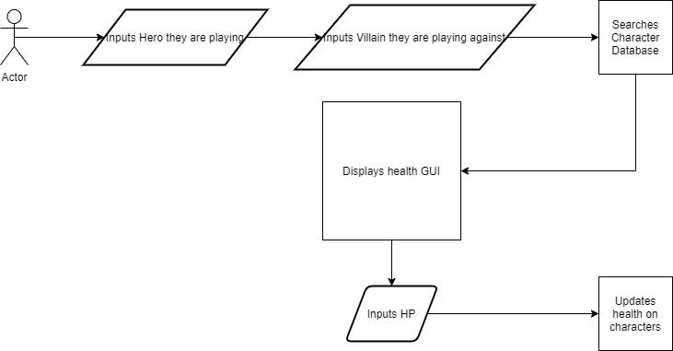

Figure 1 represents a typical 4 player set-up for Marvel Champions. We are going to remove the HP dials that are bulky to move to the web application for others to use. This will clear up minion and side scheme area to make it a little easier to focus on the game instead of managing table space.

Figure 1 Marvel Champions Typical Game State:

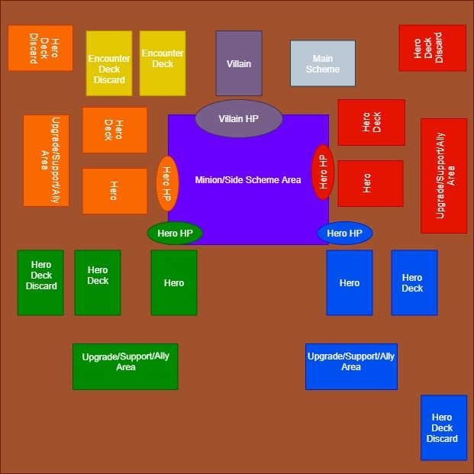

The proposed User Interfaces are follows figure 2 Home/Login Page, figure 3 Registration Page, figure 4 Player Select, figure 5 Hero Select, figure 6 Villain Select, figure 7 HP dials View.

Sitemap:

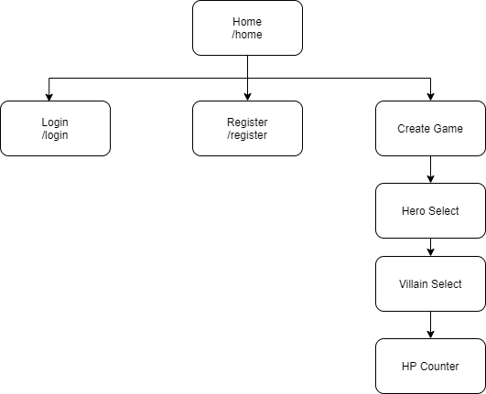

Figure 2 Login/Home:

This is just a basic Login Page that will allow the user to login via username and email with only one password.

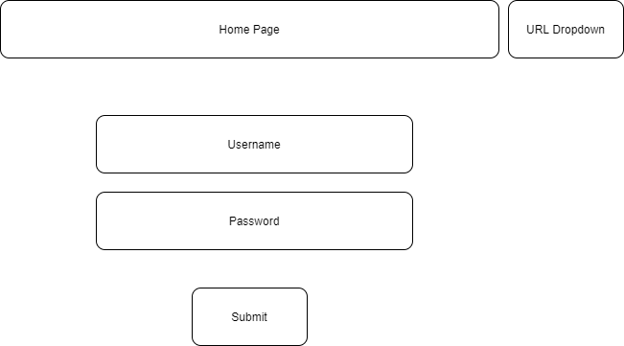

Figure 3 Register:

This a basic register page that will allow us to store only their email address, username, and password. This is all we want at this time until we add more like their name and or age to have some policies met when this goes live.

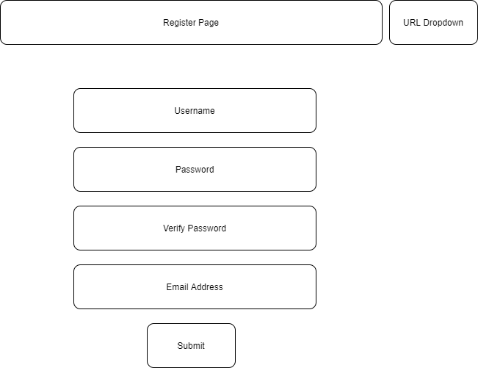

Figure 4 Create Game/Player Select:

This will all the players to get started in creating a game and selecting how many are playing at their table. This will make a difference when calculating the Villains health later since it is based on how many players.

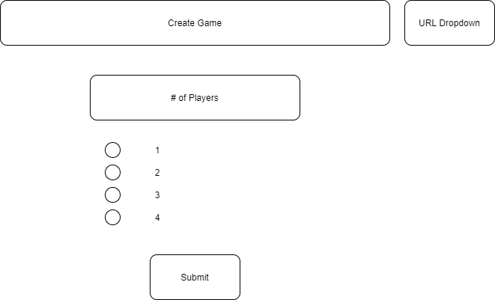

Figure 5 Hero Select GUI:

The players will then select which hero they are going to play as and then press the submit button this will take them to villain select.

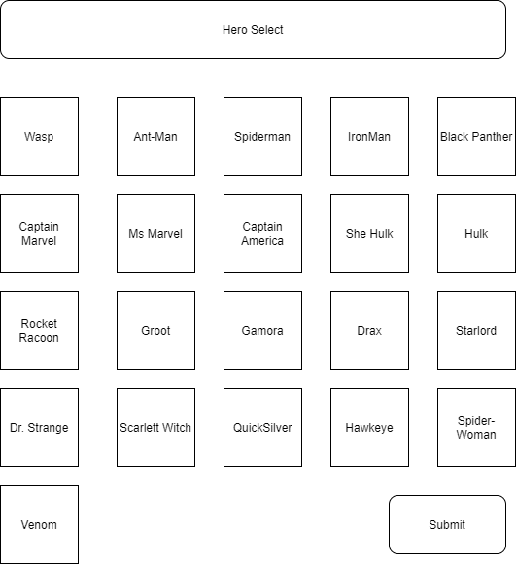

Figure 6 Villain Select GUI:

They will then select the villain that they choose to set up on the table and what difficulty they are facing them as.

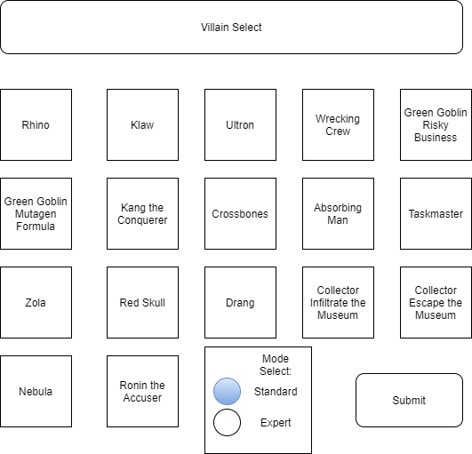

The grid layout made it easier for players to find their villain and hero for hero selection. It is not in alphabetical order which we did consider. It is in release order or campaign order depending on expansion you are playing with.

Figure 7 HP GUI:

This will be the final product on how it will look for a 1 hero vs the villain.

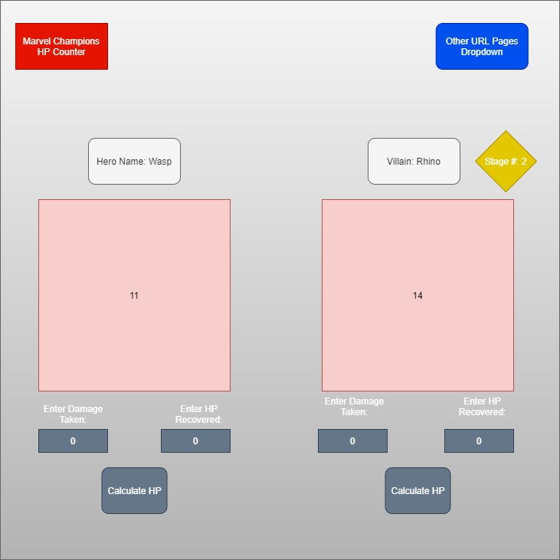We want to keep it as organized as possible with giving just enough information that it won’t overwhelm an individual player. This goes for all the other views and GUIs the point is to get enough information to the player that they can play. They will also need a way to manipulate which could be entered and we also tried just adding and subtracting signs on push to see which one was better. Most players take more than 1 HP damage per attack so entering it all at once was the better option.

Figure 8 Hero Turn Logic:

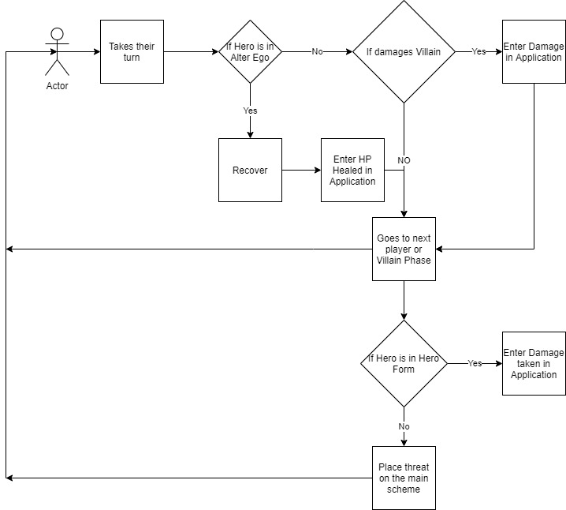

Some minions or villains have a trait called retaliate which will do 1 damage to the hero when they attack them. That is one way they can be attacked on the hero phase of the game otherwise it will be special cards in the villain's deck causing them to do more damage to the heroes

Figure 9 Update Create Game Page:

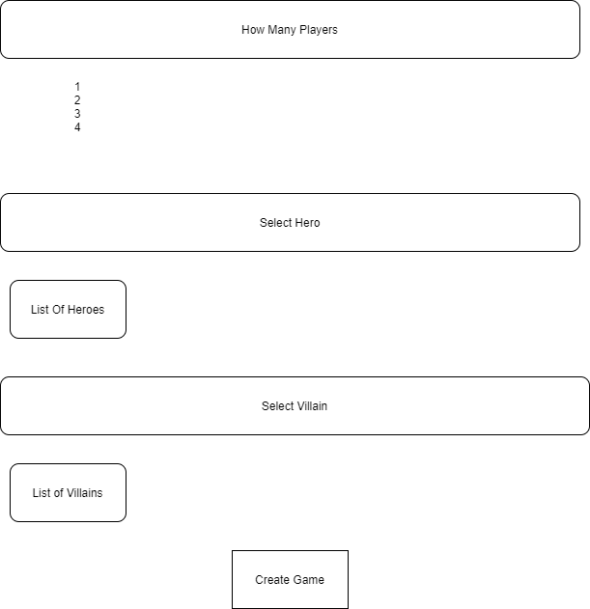

The difficulty is going to be defaulted to Standard as the bugs are worked.

**Detailed Solution Architecture**

**Classes:**

Classes needed:

* Hero and Villain
  + HP
  + Name
* User
  + First Name
  + Last Name
  + Date of Birth
  + Email Address
  + Username
  + Password
  + Country

**Views/UI:**

*Please refer to the diagrams in figures 1 – 7*

* Login page
* Register page
* Create game page
* User update page
* Hero Select page //Being merged with Create Game Page
* Villain Select page //Being merged with Create Game Page
* Health Point page
* Home page

Make sure all views have a banner to go back to the main pages Login/Home, Register, and Create Game.

**Algorithms:**

Health Calculation Algorithm:

This logic will be based on Figure 7 text boxes it will only take integer values and calculate the current HP displayed and either add or subtract it based on if it was entered in take damage or recover. This will take at least 3 to 4 methods on getting the logic down with an if statement checking if either Hero or Villain HP are at zero.

Login Algorithm:

Will check base off the Database for stored users' information to verify if that is them and login them in.

Register Algorithm:

Will take the information from the register page and save it to the Users database.

Villain/Hero Select Algorithm:

Will take a grid of the buttons to check which one is pressed and pull from the databased to find it based on the hero/villain's name and calculate per player if needed.

**Databases:**

Needs a user table able to store: First Name, Last Name, Email address, Username, Password, Date of Birth, and Country.

Needs a Hero database able to store: Hero Name, Hero Health Points, and Hero Hand Size

Needs a Villain database able to store: Villain Name, Villain Health Points, and Villain Main Scheme information

**Required Technologies:**

PHP and MySQL Database

Revision and Signoff Sheet

**Change Record**

|  |  |  |
| --- | --- | --- |
| **Date** | **Editor** | **Revision Notes** |
|  |  | Initial draft for review/discussion |
|  |  |  |
|  |  |  |

Project Demonstration:

[Capstone Presentation Marvel Champions](https://youtu.be/jOxue6SPaYk)



Project Portfolio:

Under ReadMe File in GitHub

Code:

<https://github.com/ZSwoveland/CapStone>

Traceability:

In Zip Folder Traceability Version 3

Test Cases:

In Zip Folder Test Case Version 3