APPENDICES

**APPENDIX A**

**System Flow Chart**

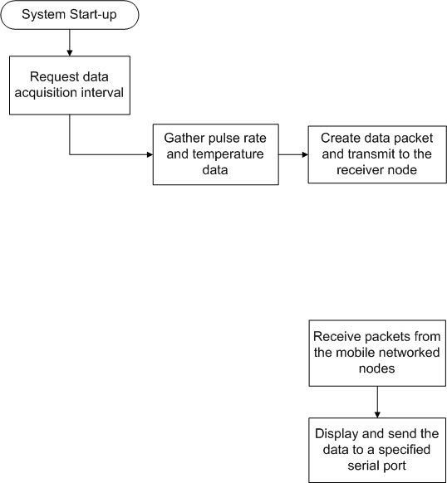

**Sensor Node**

**Receiver Node**

**Wireless**

**APPENDIX B**

**System Block Diagram**

Pulse Rate Module

Temperature

Module

MCU

ATmega

328P

CC1101

TRx

433 Mhz

Laptop / Desktop

CC1101

RF TRx

433 Mhz

Arduino

UNO

Pulse Rate Module

Temperature

Module

MCU

ATmega

328P

CC1101

TRx

433 Mhz

**APPENDIX C**

**Circuit Connections**

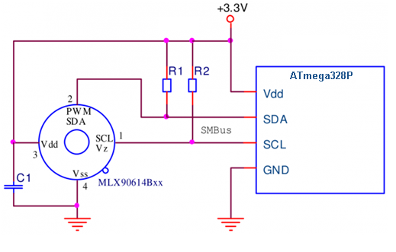

**MLX90614 to ATmega328P** (Elechouse, 2016)

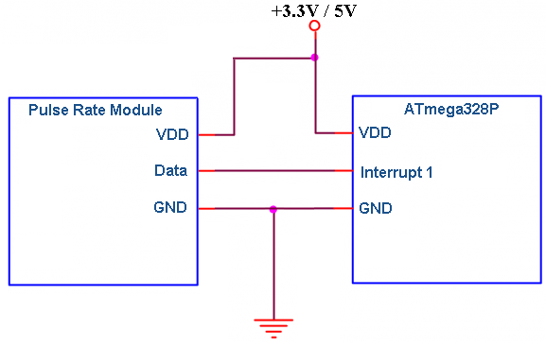

**Grove Pulse Rate Sensor to ATmega328P**

(Grove - Ear - clip Heart Rate Sensor, 2015)

**APPENDIX D**

**Power Sources**

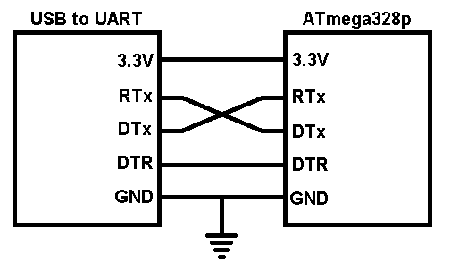

UART to ATmega328P connection

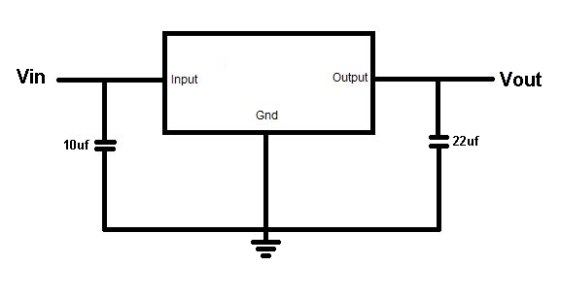

3.3V voltage regulator circuit

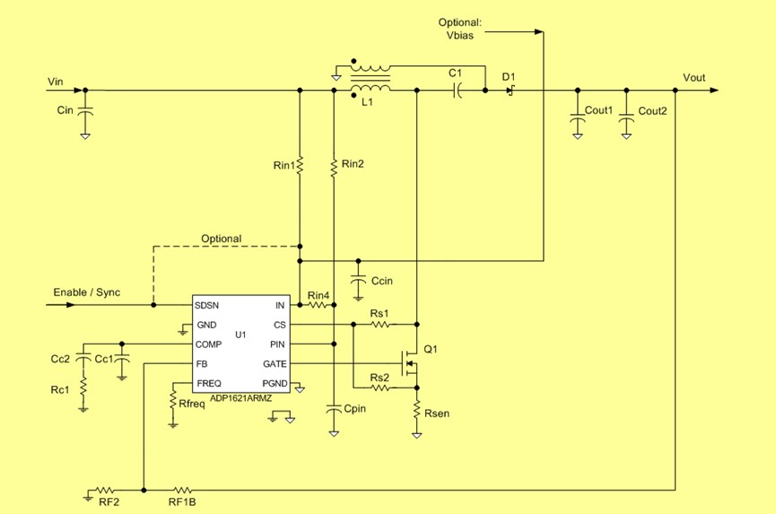

Schematic design of the ADP1621 SEPIC converter

|  |  |  |  |  |
| --- | --- | --- | --- | --- |
| Des | Component Specs | Part Number | Pkg | Qty |
| U1 | Integrated Switching Regulator | ADP1621ARMZ-R7 | MSOP-10 | 1 |
| L1 | 2.4uH, 18mΩ, 15Apk | 744870002 | 12.5mm x 12.5mm x 8.5mm | 1 |
| Q1 | 6.1 mΩ, 1.5 Vth,30 V | FDMC8651 | PP8-3x3 | 1 |
| D1 | 2 A, 30 V | DFLS230LH | DI-123 | 1 |
| Rsen | 0.015Ω | RL1220T-R015-J | 0805 | 1 |
| Cout1 | 47µF, 6.3V, 5mΩ | JMK212 BJ476MG-T | 0805 | 2 |
| Cout2 |  | No Pop |  |  |
| Cin | 47uF, 6.3V, 5mΩ | JMK212 BJ476MG-T | 0805 | 1 |
| C1 | 10uF, 10V, 2mΩ | GRM21BR61A106K | 0805 | 1 |
| Rs1 |  | No Pop |  |  |
| Rs2 | 243 Ohms | 5% tolerance | 0805 | 1 |
| Rfreq | 18.2 kOhms | 1% tolerance | 0805 | 1 |
| Rc1 | 4.32 kOhms | 5% tolerance | 0805 | 1 |
| Cc1 | 1000 pF | 10% tolerance | 0805 | 1 |
| Cc2 | 12 nF | 10% tolerance | 0805 | 1 |
| RF1B | 35.7 kOhms | 1% tolerance | 0805 | 1 |
| RF2 | 21 kOhms | 1% tolerance | 0805 | 1 |
| Ccin | 1uF,10V,X5R | GRM188R61A105K | 0603 | 1 |
| Cpin | 1uF,10V,X5R | GRM188R61A105K | 0603 | 1 |
| Rin1 | 1 Ohms | 5% tolerance | 0805 | 1 |
| Rin2 | 1 Ohms | 5% tolerance | 0805 | 1 |
| Rin4 |  | No Pop |  |  |

ADP1621 SEPIC Converter Parts List

**APPENDIX E**

**PBC Floor Plan**

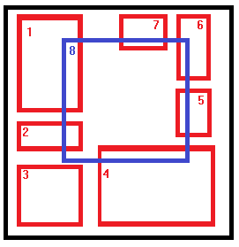

|  |  |
| --- | --- |
| **Number** | **Function** |
| 1 | On-board CC1101 RF Transceiver |
| 2 | Break-out CC1101 RF Transceiver |
| 3 | 3.3 Volts Regulator |
| 4 | ADP1621 Sepic Converter |
| 5 | Grove Pulse Rate Sensor |
| 6 | UART programming pins |
| 7 | MLX90614 Temperature Thermometer |
| 8 | ATmega328p circuit |

**APPENDIX F**

**PCB Layout**

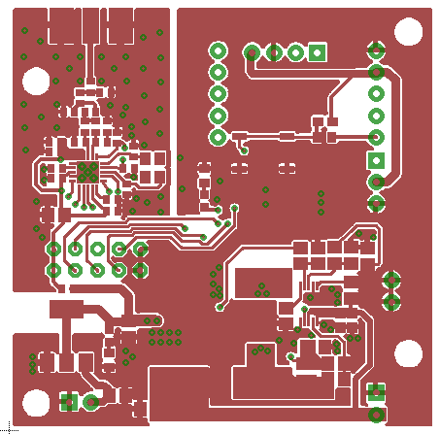

1. Sensor Node Top Layer

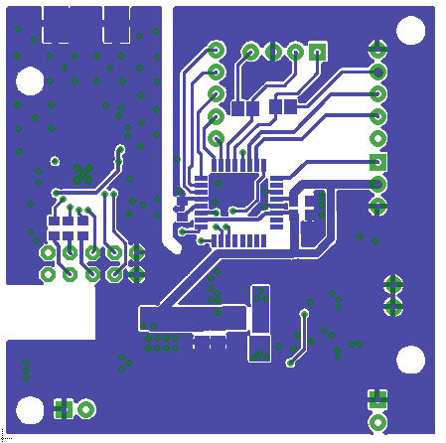

1. Sensor Node Bottom Layer

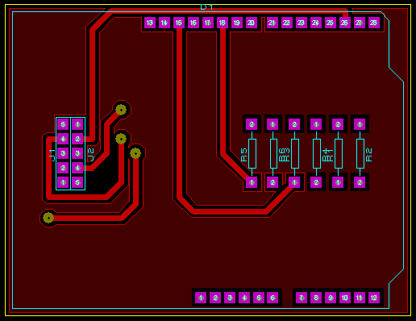

1. Receiver Node Top Layer

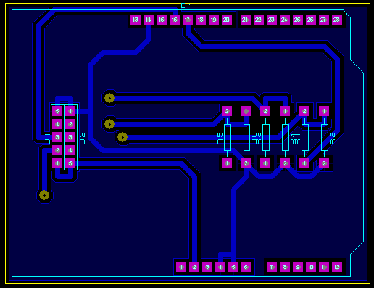

1. Receiver Node Bottom Layer

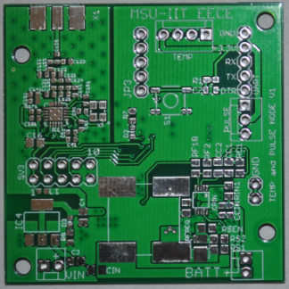

1. Fabricated PCB Sensor Node Top Layer

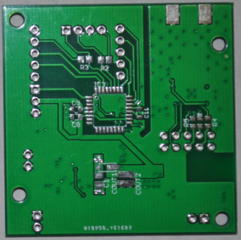

1. Fabricated PCB Sensor Node Bottom Layer

**APPENDIX G**

**Prototype**

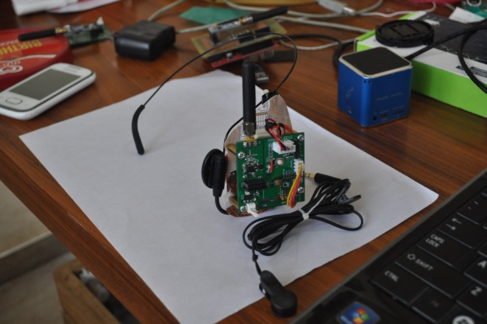

1. Sensor Node Protoype

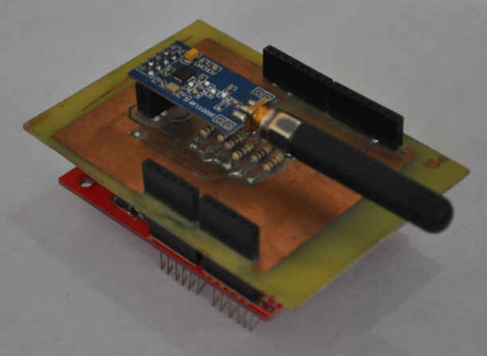

1. Receiver Node Prototype

**APPENDIX H**

**COMPILATIONS OF CODES**