**白盒测试用例**

基本路径覆盖图

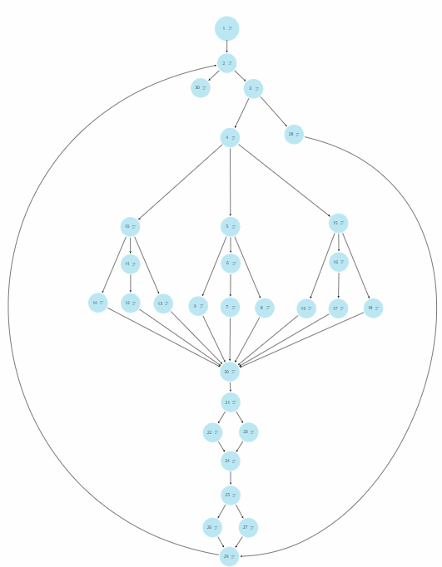

PDL描述：

输入当前播放器的状态，是播放/暂停，还是下一首歌或上一首歌，还有播放歌曲模式：0对应顺序播放，1对应随机播放，2对应循环播放

Play = 0 or 1

Next = 0 or 1

Prev = 0 or 1

CurMode = 0 or 1 or 2

提前准备好音乐列表，音乐资源，音乐图片，音乐歌词以及音乐评论的数据

url_music = ${music1}

url_music_png = ${music_png}

url_music_comment = ${music_comment}

url_music_lyric = ${ music_lyric }

1:ClickToPlayPage()

Success = 0

2:DO WHILE GetUrlMusic(url_music)

Success = 1

3: IF GetUrlMusicPage(url_music_png)

4: THEN printf(“已加载音乐资源”)

5: IF CurMode == 0

6: IF Play == 1

7: THEN PlayMusic(url_music)

Printf(“音乐播放成功”)

ENDIF

8: ESIF Next == 1

THEN url_music = ${music2}

Printf(“音乐切换下一首成功”)

Play = 1

Next = 0

ENDIF

9: ESIF Prev == 1

THEN url_music = ${music0}

Printf(“音乐切换上一首成功”)

Play = 1

Prev = 0

ENDIF

10: ESIF CurMode == 1

11: IF Play == 1

12: THEN PlayMusic(url_music)

Printf(“音乐播放成功”)

ENDIF

13: ESIF Next == 1

THEN url_music = ${music2 }

Printf(“音乐随机下一首成功”)

Play = 1

Next = 0

ENDIF

14: ESIF Prev == 1

THEN url_music = ${music1}

Printf(“音乐随机上一首成功”)

Play = 1

Prev = 0

ENDIF

15: ESIF CurMode == 2

16: IF Play == 1

17: THEN PlayMusic(url_music)

Printf(“音乐播放成功”)

ENDIF

18: ESIF Next == 1

THEN url_music = ${music1}

Printf(“音乐单曲循环成功”)

ENDIF

19: ESIF Prev == 1

THEN url_music = ${music1}

Printf(“音乐单曲循环成功”)

ENDIF

20: ENDIF

21: IF GetLyric(url_music_lyric)

22: THEN Printf(“获取歌词成功”)

23: ELSE Printf(“获取歌词失败”)

24： ENDIF

25: IF GetComment(url_music_comment)

26: THEN Printf(“获取评论成功”)

ENDIF

27: ELSE Printf(“获取评论失败”)

ENDIF

28: ELSE printf(“加载音乐资源成功，但找不到对应图片”)

29:ENDDO

30:IF Success == 0

THEN printf(“加载音乐资源失败”)

ENDIF

|  |  |  |  |
| --- | --- | --- | --- |
|  | 输入数据 | 测试路径 | 预期输出 |
| 测试用例1 | Play = 1,Next = 0,Prev = 0, CurMode = 0,  url_music = ${SondId1},  url_music_png = ${PicUrl1},  url_music_comment = ${SondId1},  url_music_lyric = ${SondId1} | P(1,2,3,4,5,6,7,20,21,22,24,25,26,29) | 已加载音乐资源  音乐播放成功  获取歌词成功  获取评论成功 |
| 测试用例2 | Play = 1,Next = 0,Prev = 0, CurMode = 0,  url_music = null,  url_music_png = ${PicUrl1},  url_music_comment = ${SondId1},  url_music_lyric = ${SondId1} | P(1,2,30) | 加载音乐资源失败 |
| 测试用例3 | Play = 1,Next = 0,Prev = 0,CurMode = 0,url_music = ${SondId1}  url_music_png = null  url_music_comment = ${SondId1}  url_music_lyric = ${SondId1} | P(1,2,3,28,29) | 加载音乐资源成功，但找不到对应图片 |
| 测试用例4 | Play = 1,Next = 0,Prev = 0, CurMode = 0,url_music = ${SondId1}  url_music_png = ${PicUrl1}  url_music_comment = null  url_music_lyric = ${SondId1} | P(1,2,3,4,5,6,7,20,21,22,24,25,27,29) | 已加载音乐资源  音乐播放成功  获取歌词成功  获取评论失败 |
| 测试用例5 | Play = 1,Next = 0,Prev = 0,CurMode = 0,url_music = ${SondId1}  url_music_png = ${PicUrl1}  url_music_comment = ${SondId1}  url_music_lyric = null | P(1,2,3,4,5,6,7,20,21,23,24,25,26,29) | 已加载音乐资源  音乐播放成功  获取歌词失败  获取评论成功 |
| 测试用例6 | Play = 1,Next = 0,Prev = 0, CurMode = 0,url_music = ${SondId1}  url_music_png = ${PicUrl1}  url_music_comment = null  url_music_lyric = null | P(1,2,3,4,5,6,7,20,21,23,24,25,26,29) | 已加载音乐资源  音乐播放成功  获取歌词失败  获取评论失败 |
| 测试用例7 | Play = 0,Next = 1,Prev = 0, CurMode = 0,url_music = ${SondId1}  url_music_png = ${PicUrl1}  url_music_comment = ${SondId1}  url_music_lyric = ${SondId1} | P(1,2,3,4,5,8,20,21,22,24,25,26,29) | 已加载音乐资源  音乐切换下一首成功  获取歌词成功  获取评论成功 |
| 测试用例8 | Play = 0,Next = 0,Prev = 1, CurMode = 0,url_music = ${SondId1}  url_music_png = ${PicUrl1}  url_music_comment = ${SondId1}  url_music_lyric = ${SondId1} | P(1,2,3,4,5,9,20,21,22,24,25,26,29) | 已加载音乐资源  音乐切换上一首成功  获取歌词成功  获取评论成功 |
| 测试用例9 | Play = 1,Next = 0,Prev = 0, CurMode = 1,url_music = ${SondId1}  url_music_png = ${PicUrl1}  url_music_comment = ${SondId1}  url_music_lyric = ${SondId1} | P(1,2,3,4,10,11,12,20,21,22,24,25,26,29) | 已加载音乐资源  音乐播放成功  获取歌词成功  获取评论成功 |
| 测试用例10 | Play = 0,Next = 1,Prev = 0, CurMode = 1,url_music = ${SondId1}  url_music_png = ${PicUrl1}  url_music_comment = ${SondId1}  url_music_lyric = ${SondId1} | P(1,2,3,4,10,13,20,21,22,24,25,26,29) | 已加载音乐资源  音乐随机下一首成功  获取歌词成功  获取评论成功 |
| 测试用例11 | Play = 0,Next = 0,Prev = 1, CurMode = 1,url_music = ${SondId1}  url_music_png = ${PicUrl1}  url_music_comment = ${SondId1}  url_music_lyric = ${SondId1} | P(1,2,3,4,10,14,20,21,22,24,25,26,29) | 已加载音乐资源  音乐随机上一首成功  获取歌词成功  获取评论成功 |
| 测试用例12 | Play = 1,Next = 0,Prev = 0, CurMode = 2,url_music = ${SondId1}  url_music_png = ${PicUrl1}  url_music_comment = ${SondId1}  url_music_lyric = ${SondId1} | P(1,2,3,4,15,16,17,20,21,22,24,25,26,29) | 已加载音乐资源  音乐播放成功  获取歌词成功  获取评论成功 |
| 测试用例13 | Play = 0,Next = 1,Prev = 0, CurMode = 2,url_music = ${SondId1}  url_music_png = ${PicUrl1}  url_music_comment = ${SondId1}  url_music_lyric = ${SondId1} | P(1,2,3,4,15,18,20,21,22,24,25,26,29) | 已加载音乐资源  音乐单曲循环成功  获取歌词成功  获取评论成功 |
| 测试用例14 | Play = 0,Next = 0,Prev = 1, CurMode = 2,url_music = ${SondId1}  url_music_png = ${PicUrl1}  url_music_comment = ${SondId1}  url_music_lyric = ${SondId1} | P(1,2,3,4,15,19,20,21,22,24,25,26,29) | 已加载音乐资源  音乐单曲循环成功  获取歌词成功  获取评论成功 |
| 测试用例15 | Play = 0,Next = 1,Prev = 0, CurMode = 1,url_music = ${SondId1}  url_music_png = ${PicUrl1}  url_music_comment = ${SondId1}  url_music_lyric = ${SondId1} | P(1,2,3,4,10,13,20,21,22,24,25,26,29,2,3,4,10,11,12,20,21,22,24,25,26,29) | 已加载音乐资源  音乐随机下一首成功  获取歌词成功  获取评论成功  已加载音乐资源  音乐播放成功  获取歌词成功  获取评论成功 |
| 测试用例16 | Play = 0,Next = 0,Prev = 1, CurMode = 1,url_music = ${SondId1}  url_music_png = ${PicUrl1}  url_music_comment = ${SondId1}  url_music_lyric = ${SondId1} | P(1,2,3,4,10,14,20,21,22,24,25,26,29,2,……) | 已加载音乐资源  音乐随机上一首成功  获取歌词成功  获取评论成功  已加载音乐资源  音乐播放成功  获取歌词成功  获取评论成功 |
| 测试用例17 | Play = 0,Next = 1,Prev = 0, CurMode = 0,url_music = ${SondId1}  url_music_png = ${PicUrl1}  url_music_comment = ${SondId1}  url_music_lyric = ${SondId1} | P(1,2,3,4,5,9,20,21,22,24,25,26,29,2,3,4,5,6,7,20,21,22,24,25,26,29) | 已加载音乐资源  音乐下一首成功  获取歌词成功  获取评论成功  已加载音乐资源  音乐播放成功  获取歌词成功  获取评论成功 |
| 测试用例18 | Play = 0,Next = 0,Prev = 1, CurMode = 0,url_music = ${SondId1}  url_music_png = ${PicUrl1}  url_music_comment = ${SondId1}  url_music_lyric = ${SondId1} | P(1,2,3,4,5,9,20,21,22,24,25,26,29,2,……) | 已加载音乐资源  音乐上一首成功  获取歌词成功  获取评论成功  已加载音乐资源  音乐播放成功  获取歌词成功  获取评论成功 |

环形复杂度为：V（G） = E（边） – N（节点） + 2 = 38 – 30 + 2 = 10