

实 验（实训）报 告

项 目 名 称 实验2 层次数据和网络数据绘制
所属课程名称 数据可视化
项 目 类 型 验 证 性
实验(实训)日期 2019

班 级 18软件工程2班
学 号 180110910603
姓 名 陈 彬 捷
指导教师 刘 玉 华

浙江财经大学教务处制
一、实验（实训）概述：
【实验目的】
1．熟悉和掌握d3.js关于绘制层次数据和网络数据的接口。
【实验要求】
1．正确建立项目开发环境，能正确地把项目文件保存在指定的位置；
2．实现数据的输入和绘制。
【基本原理】
见d3.js官网
【实施环境】（使用的材料、设备、软件）
火狐或者谷歌浏览器、文本编辑器
注意：所有回答的内容请用蓝色字体标出！
二、实验（实训）内容：
第1题
【项目内容】
从json或者csv文件读取层次数据，用点线链接式的方法进行绘制。
【方案设计】
提示：请在此粘贴你的完整程序。
HTML文件:
<!--/*
* @Author: ChenShan
* @Date: 2019-08-11 22:45:02
* @Last Modified by: ChenShan
* @Last Modified time: 2019-08-11 22:46:38
*/-->

<!DOCTYPE html>
<html>
<head>
<meta charset="utf-8">
<script src="https://d3js.org/d3.v4.min.js"></script>
<script src="https://d3js.org/d3.v3.min.js"></script>
<title>树图 2019/10</title>
<link rel="stylesheet" href="../css/h3.css">
</head>
<body>
<script src="../js/h3.js"></script>
<!-- <script src="newcl.js"></script> -->
<div id="showTree"></div>
</body>
</html>
CSS文件：
/*
* @Author: ChenShan
* @Date: 2019-11-02 23:41:16
* @Last Modified by: ChenShan
* @Last Modified time: 2019-11-02 23:41:16
*/

.node circle{
stroke:steelblue;
stroke-width: 1.5px;
}
.node{
font: 12px sans-serif;
}
.link{
fill:none;
stroke:#ccc;
stroke-width: 1.5px;
}
JSON文件：
/*
* @Author: ChenShan
* @Date: 2019-08-11 22:45:09
* @Last Modified by: ChenShan
* @Last Modified time: 2019-10-29 20:44:43
*/

var width = 680,
height = 680;

var cluster = d3.layout.cluster()
.size([width, height - 200]);

var diagonal = d3.svg.diagonal()
.projection(function(d) { return [d.y, d.x]; });

var svg = d3.select("body").append("svg")
.attr("width", width)
.attr("height", height)
.append("g")
.attr("transform", "translate(100,0)");

d3.json("../data/h3.json", function(error, root) {

var nodes = cluster.nodes(root);
var links = cluster.links(nodes);

// console.log(nodes);
// console.log(links);

var link = svg.selectAll(".link")
.data(links)
.enter()
.append("path")
.attr("class", "link")
.attr("d", diagonal);

var node = svg.selectAll(".node")
.data(nodes)
.enter()
.append("g")
.attr("class", "node")
.attr("transform", function(d) { return "translate(" + d.y + "," + d.x + ")"; })

node.append("circle")
.attr("r", 4.5);

//为节点添加圆形标记,如果有子节点为红色，否则绿色
node.append("circle")
.attr("fill",function(d){return d.children==null?"#0FF":"pink";})
.attr("r", 5);

node.append("text")
.attr("dx", function(d) { return d.children ? -8 : 8; })
.attr("dy", 3)
.style("text-anchor", function(d) { return d.children ? "end" : "start"; })
.text(function(d) { return d.name; });
});
【结论】（结果、分析）
回答： 绘制的树状图，用点线链接式方法可视化数据效果如下：
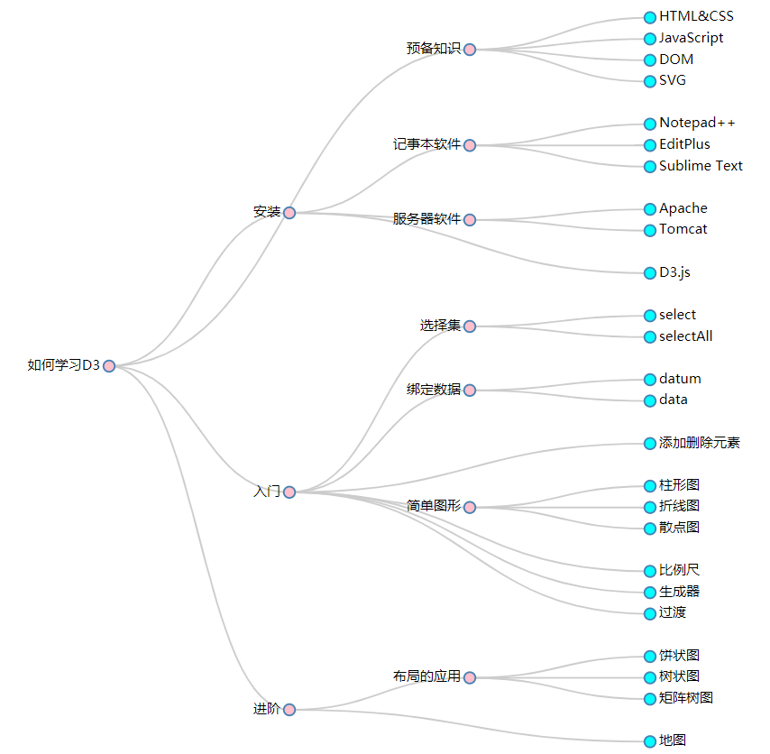

第2题
【项目内容】
从json或者csv文件读取层次数据，用空间填充式的方法进行绘制。。
【方案设计】
提示：请在此粘贴你的完整程序。
HTML文件：
<!DOCTYPE html>
<html>
<head>
<meta charset="utf-8">
<!-- <script src="https://d3js.org/d3.v3.min.js"></script> -->
<!-- <script src="https://d3js.org/d3.v4.min.js"></script> -->
<script type="text/javascript" src="http://d3js.org/d3.v5.min.js"></script>

<link rel="stylesheet" href="../css/h5.css">
<title>矩阵树图</title>
</head>
<body>
<div id='svgContainer' style="">
<div class="every">
<h3>矩形树图</h3>
<div class="svg" id="treemap"></div>
<script src="../js/h5.js"></script>
</body>
</html>
CSS文件：
/*
* @Author: ChenShan
* @Date: 2019-11-08 00:11:41
* @Last Modified by: ChenShan
* @Last Modified time: 2019-11-10 18:27:59
*/
#svgContainer{
width: 100%;
height: 100%;
}
.every{
width: 400px;
height: 425px;
margin: 15px;
float: left;
}
#svgContainer .every h3{
margin:0;
}
#svgContainer .every .button{
float: right;
margin-right: 20px;
font-size: 14px;
cursor: pointer;
padding: 2px 8px;
border:1px solid #ccc;
background: yellowgreen;
border-radius: 4px;
}
#svgContainer .every .svg{
width: 400px;
height: 400px;
}
JSON文件：
/*
* @Author: ChenShan
* @Date: 2019-11-07 23:58:11
* @Last Modified by: ChenShan
* @Last Modified time: 2019-11-10 18:25:38
*/

const width = 500
const height = 400

const treeData = {
'name': '中国',
'children': [
{
'name': '浙江',
'children':
[
{'name': '杭州', 'gdp': 1234},
{'name': '宁波', 'gdp': 3334},
{'name': '温州', 'gdp': 2000},
{'name': '绍兴', 'gdp': 1002}
]
},
{
'name': '广西',
'children': [
{
'name': '桂林',
'children':
[
{'name': '秀峰区', 'gdp': 2131},
{'name': '叠彩区', 'gdp': 2015},
{'name': '象山区', 'gdp': 988},
{'name': '七星区', 'gdp': 756}
]
},
{'name': '南宁', 'gdp': 3699},
{'name': '柳州', 'gdp': 4511},
{'name': '防城港', 'gdp': 2325}
]
},
{
'name': '黑龙江',
'children': [
{'name': '哈尔滨', 'gdp': 784},
{'name': '齐齐哈尔', 'gdp': 885},
{'name': '牡丹江', 'gdp': 1254},
{'name': '大庆', 'gdp': 3240}
]
},
{
'name': '新疆',
'children':
[
{'name': '乌鲁木齐', 'gdp': 2456},
{'name': '克拉玛依', 'gdp': 1015},
{'name': '吐鲁番', 'gdp': 998},
{'name': '哈密', 'gdp': 654}
]
}
]
}

const color = d3.scaleOrdinal(d3.schemeCategory10)

// 数据转化
const treemap = d3.treemap().size([width, height])
const root = d3.hierarchy(treeData).sum((d) => d.gdp)
const tree = treemap(root) // 获取treemap结构树
const leaves = tree.leaves() // 将生成的树形结构转化成叶子节点数组

// 用叶子节点数组绘图
const svg = d3.select('#treemap')
.append('svg')
.attr('width', width)
.attr('height', height)
const g = svg.selectAll('.rects')
.data(leaves)
.enter()
.append('g')
.attr('class', 'rects')

// 添加矩阵
g.append('rect')
.attr('x', (d) => d.x0)
.attr('y', (d) => d.y0)
.attr('width', (d) => (d.x1 - d.x0))
.attr('height', (d) => (d.y1 - d.y0))
.style('fill', (d) => color(d.parent.data.name))
.style('stroke', '#cccccc')

// 添加描述
g.append('text')
.attr('x', (d) => (d.x1 - d.x0) / 2 + d.x0)
.attr('y', (d) => (d.y1 - d.y0) / 2 + d.y0)
.attr('dx', (d) => { return -d.data.name.length / 2 + 'em' })
.attr('dy', (d) => { return '-0.5em' })
.text((d) => { return d.data.name })
.attr('font-size', (d) => { return 14 - d.depth + 'px' })
.attr('fill', '#f0f0f0')

g.append('text')
.attr('x', (d) => (d.x1 - d.x0) / 2 + d.x0)
.attr('y', (d) => (d.y1 - d.y0) / 2 + d.y0)
.attr('dx', (d) => { return -(d.value.toString().length + 2) / 4 + 'em' })
.attr('dy', (d) => { return '1em' })
.text((d) => { return '(' + d.value + ')' })
.attr('font-size', (d) => { return 14 - d.depth + 'px' })
.attr('fill', '#ffffff')

【结论】（结果、分析）
回答：用空间填充式的方法呈现层次数据，所绘制的矩阵树图效果如下：
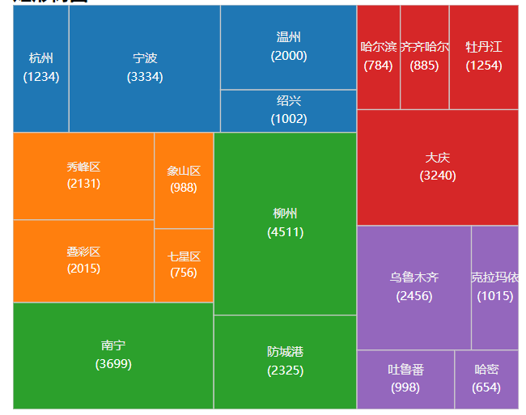
第3题
【项目内容】
从json或者csv文件读取网络图数据，用点线链接式的方法进行绘制。
【方案设计】
提示：请在此粘贴你的完整程序。
HTML文件：
<!DOCTYPE html>
<html>
<head>
<meta charset="utf-8">
<script type="text/javascript" src="http://d3js.org/d3.v5.min.js"></script>
<title>力导图 2019/11</title>
</head>
<body>
<script src="../js/h4.js"></script>
</body>
</html>
JSON文件：
/*
* @Author: ChenShan
* @Date: 2019-11-01 12:37:31
* @Last Modified by: ChenShan
* @Last Modified time: 2019-11-01 13:14:05
*/

var width = 800;
var height = 800;
var svg = d3.select("body")
.append("svg")
.attr("width",width)
.attr("height",height);

var marge = {top:10,bottom:10,left:10,right:10}

var g = svg.append("g")
.attr("transform","translate("+marge.top+","+marge.left+")");

var nodes = [
{name:"浙江省",group:2.5},
{name:"杭州",group:2},
{name:"宁波",group:2},
{name:"温州",group:2},
{name:"绍兴",group:2},
{name:"湖州",group:2},
{name:"嘉兴",group:2},
{name:"金华",group:2},
{name:"衢州",group:2},
{name:"台州",group:2},
{name:"丽水",group:2},
{name:"舟山",group:2},
{name:"上城区",group:1.5},
{name:"下城区",group:1.5},
{name:"江干区",group:1.5},
{name:"拱墅区",group:1.5},
{name:"西湖区",group:1.5},
{name:"滨江区",group:1.5},
{name:"余杭区",group:1.5},
{name:"萧山区",group:1.5},
{name:"富阳区",group:1.5},
{name:"临安区",group:1.5},
{name:"建德市",group:1.5},
{name:"桐庐县",group:1.5},
{name:"淳安县",group:1.5},
{name:"鹿城区",group:1.5},
{name:"龙湾区",group:1.5},
{name:"瓯海区",group:1.5},
{name:"洞头区",group:1.5},
{name:"瑞安市",group:1.5},
{name:"乐清市",group:1.5},
{name:"永嘉县",group:1.5},
{name:"平阳县",group:1.5},
{name:"苍南县",group:1.5},
{name:"文成县",group:1.5},
{name:"泰顺县",group:1.5},
{name:"龙港市",group:1.5},
{name:"安阳街道",group:1},
{name:"玉海街道",group:1},
{name:"锦湖街道",group:1},
{name:"潘岱街道",group:1},
{name:"东山街道",group:1},
{name:"上望街道",group:1},
{name:"莘塍街道",group:1},
{name:"汀田街道",group:1},
{name:"飞云街道",group:1},
{name:"云舟街道",group:1},
{name:"仙降街道",group:1},
{name:"南滨街道",group:1},
{name:"芳庄乡",group:1},
{name:"北麂乡",group:1},
{name:"塘下镇",group:1},
{name:"陶山镇",group:1},
{name:"桐浦镇",group:1},
{name:"湖岭镇",group:1},
{name:"林川镇",group:1},
{name:"马屿镇",group:1},
{name:"曹村镇",group:1},

{name:"高楼镇",group:1},
{name:"平阳坑镇",group:1},
];
var edges = [
{source:0,target:1,value:2},
{source:0,target:2,value:2},
{source:0,target:3,value:2},
{source:0,target:4,value:2},
{source:0,target:5,value:2},
{source:0,target:6,value:2},
{source:0,target:7,value:2},
{source:0,target:8,value:2},
{source:0,target:9,value:2},
{source:0,target:10,value:2},
{source:0,target:11,value:2},
{source:1,target:12,value:1.5},
{source:1,target:13,value:1.5},
{source:1,target:14,value:1.5},
{source:1,target:15,value:1.5},
{source:1,target:16,value:1.5},
{source:1,target:17,value:1.5},
{source:1,target:18,value:1.5},
{source:1,target:19,value:1.5},
{source:1,target:20,value:1.5},
{source:1,target:21,value:1.5},
{source:1,target:22,value:1.5},
{source:1,target:23,value:1.5},
{source:1,target:24,value:1.5},
{source:3,target:25,value:1.5},
{source:3,target:26,value:1.5},
{source:3,target:27,value:1.5},
{source:3,target:28,value:1.5},
{source:3,target:29,value:1.5},
{source:3,target:30,value:1.5},
{source:3,target:31,value:1.5},
{source:3,target:32,value:1.5},
{source:3,target:33,value:1.5},
{source:3,target:34,value:1.5},
{source:3,target:35,value:1.5},
{source:3,target:36,value:1.5},
{source:29,target:37,value:1},
{source:29,target:38,value:1},
{source:29,target:39,value:1},
{source:29,target:40,value:1},
{source:29,target:41,value:1},
{source:29,target:42,value:1},
{source:29,target:43,value:1},
{source:29,target:44,value:1},
{source:29,target:45,value:1},
{source:29,target:46,value:1},
{source:29,target:47,value:1},
{source:29,target:48,value:1},
{source:29,target:49,value:1},
{source:29,target:50,value:1},
{source:29,target:51,value:1},
{source:29,target:52,value:1},
{source:29,target:53,value:1},
{source:29,target:54,value:1},
{source:29,target:55,value:1},
{source:29,target:56,value:1},
{source:29,target:57,value:1},
{source:29,target:58,value:1},
{source:29,target:59,value:1},

];

var colorScale = d3.scaleOrdinal()
.domain(d3.range(nodes.length))
.range(d3.schemeCategory10);

var forceSimulation = d3.forceSimulation()
.force("link",d3.forceLink())
.force("charge",d3.forceManyBody())
.force("center",d3.forceCenter());

forceSimulation.nodes(nodes)
.on("tick",ticked);

forceSimulation.force("link")
.links(edges)
.distance(function(d){
return d.value*100;
})

forceSimulation.force("center")
.x(width/2)
.y(height/2);

console.log(nodes);
console.log(edges);

var links = g.append("g")
.selectAll("line")
.data(edges)
.enter()
.append("line")
.attr("stroke",function(d,i){
return colorScale(d.value);
})
.attr("stroke-width",1);

var linksText = g.append("g")
.selectAll("text")
.data(edges)
.enter()
.append("text")
.text(function(d){
return d.relation;
})

var gs = g.selectAll(".circleText")
.data(nodes)
.enter()
.append("g")
.attr("transform",function(d,i){
var cirX = d.x;
var cirY = d.y;
return "translate("+cirX+","+cirY+")";
})
.call(d3.drag()
.on("start",started)
.on("drag",dragged)
.on("end",ended)
);

gs.append("circle")
.attr("r",function (d,i) {
return d.group*15;
})
.attr("fill",function(d,i){
return colorScale(d.group);
})

gs.append("text")
.attr("x",-25)
.attr("y",-5)
.attr("dy",10)
.text(function(d){
return d.name;
})
function ticked(){
links
.attr("x1",function(d){return d.source.x;})
.attr("y1",function(d){return d.source.y;})
.attr("x2",function(d){return d.target.x;})
.attr("y2",function(d){return d.target.y;});

linksText
.attr("x",function(d){
return (d.source.x+d.target.x)/2;
})
.attr("y",function(d){
return (d.source.y+d.target.y)/2;
});

gs
.attr("transform",function(d) { return "translate(" + d.x + "," + d.y + ")"; });
}

function started(d){
if(!d3.event.active){
forceSimulation.alphaTarget(0.8).restart();
}
d.fx = d.x;
d.fy = d.y;
}
function dragged(d){
d.fx = d3.event.x;
d.fy = d3.event.y;
}
function ended(d){
if(!d3.event.active){
forceSimulation.alphaTarget(0);
}
d.fx = null;
d.fy = null;
}
【结论】（结果、分析）
回答：用点线链接式的方法呈现网络图数据，所绘制的网络图效果如下：
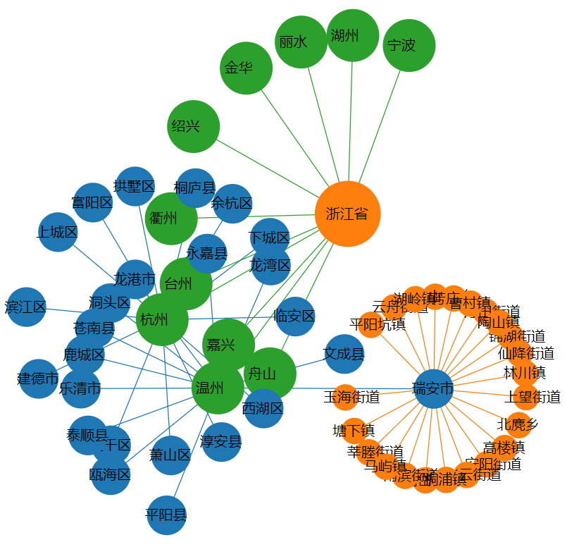

三、指导教师评语及成绩：
评语：

成绩： 指导教师签名：
批阅日期：

