Mustang project developer documentation
Jochen Stärk
For Mustangproject 1.4.0, 2017-05-18
http://www.mustangproject.org
Inhaltsverzeichnis
Mustang project developer documentation 1
New build 1
Release 2
After the release 3

New build

A section in Maven's settings.xml is needed, in Linux (and MacOS) that's at ~/.m2/settings.xml
As „servers“, enter the following
<servers>
<server>
<id>github</id>
<password>GITHUB-TOKEN</password>
</server>
</servers>
The password is generated on github.
See the following screenshot:

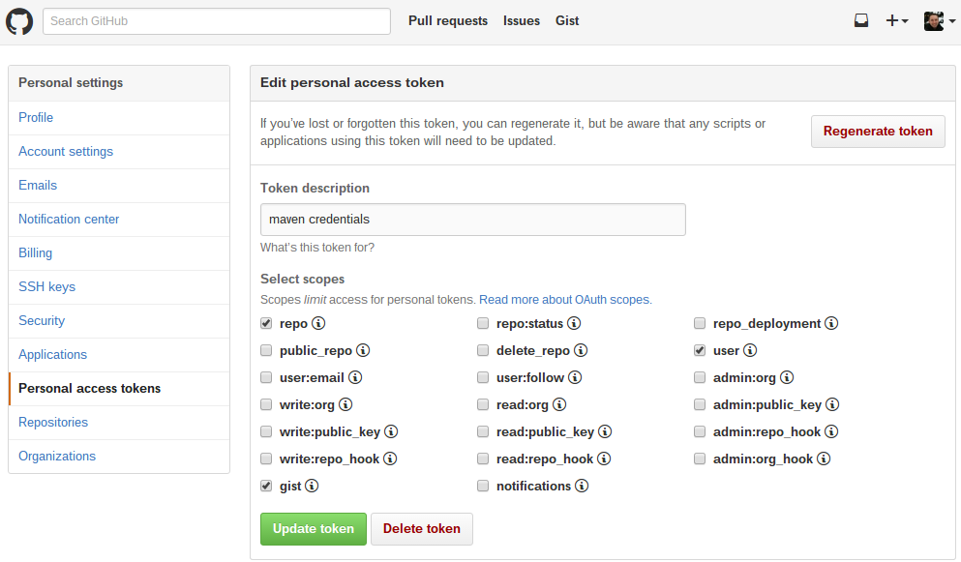
Sign in in GitHub and click on the profile picture -> Settings. Now just generate a new token and set the checkboxes from the screenshot. The Token-ID is the passwort.

Toecount
Toecount can be build with the following command:

/opt/local/bin/mvn clean compile assembly:single

Release
Now to the release:
You will need a git client on the console, if that's available can e.g. be checked with "git --version" .
Change to the root of the repo.
Change to the project directory and run
- "/opt/local/bin/mvn clean install" . If that works you can
- clean the release with „/opt/local/bin/mvn release:clean“ and prepare the release with
- "/opt/local/bin/mvn release:prepare" and enter the version numbers.
- After that is through you can create a new release via "/opt/local/bin/mvn release:perform -Darguments="-Dmaven.javadoc.skip=true"
- Last time this failed with some deployment repo configuration issue. But it worked when I manually ran
- „/opt/local/bin/mvn deploy“ .This will also update the maven repo.
Afterwards you can access the release page and update the documentation, e.g. upload the jar, the jar javadoc and ZugferdDev. You can also enter a changelog and a better title.

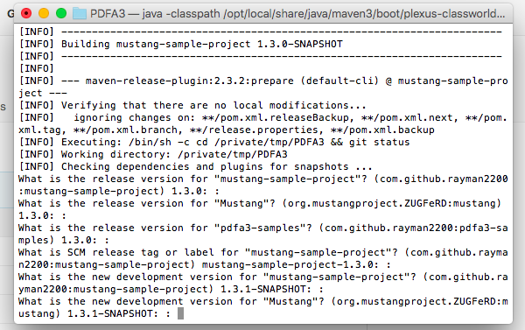

Release process
- Update documentation
- Update version number in ZUGFeRD Exporter
- write/translate announcement
- release via/for mvn
- Publish a github release
- update mustangproject.org RE
  - version number and release date
  - sample file?
  - Deployment jar
- put announcement on usegroup
- email the mailing list
- freshcode.club
- hschlosser

