Launched 3 ec2 instances and using boots trap method.

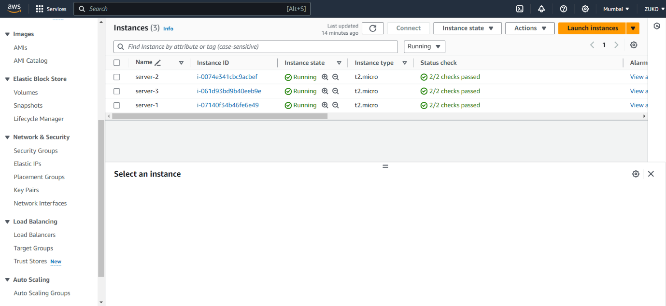

#! /bin/bash

yum install httpd -y

service httpd start

echo "\*\*\*\*\*\*\*\*\*\*\*" > /var/www/html/index.html

Created target group

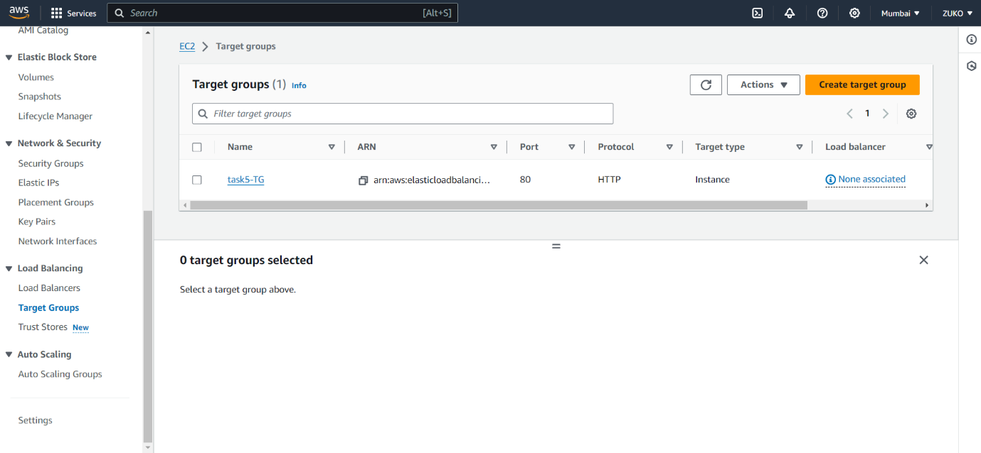

Registered all three instances to the Target group created.

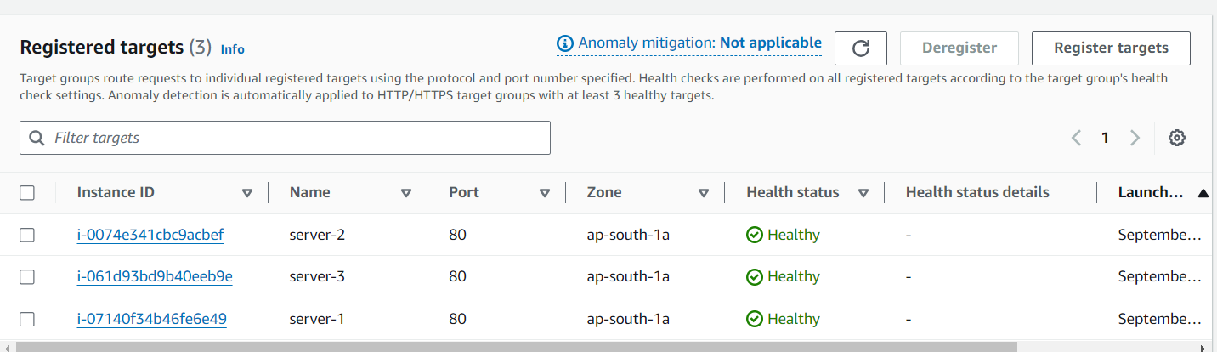

Created ALB and attached it to the Target Group.

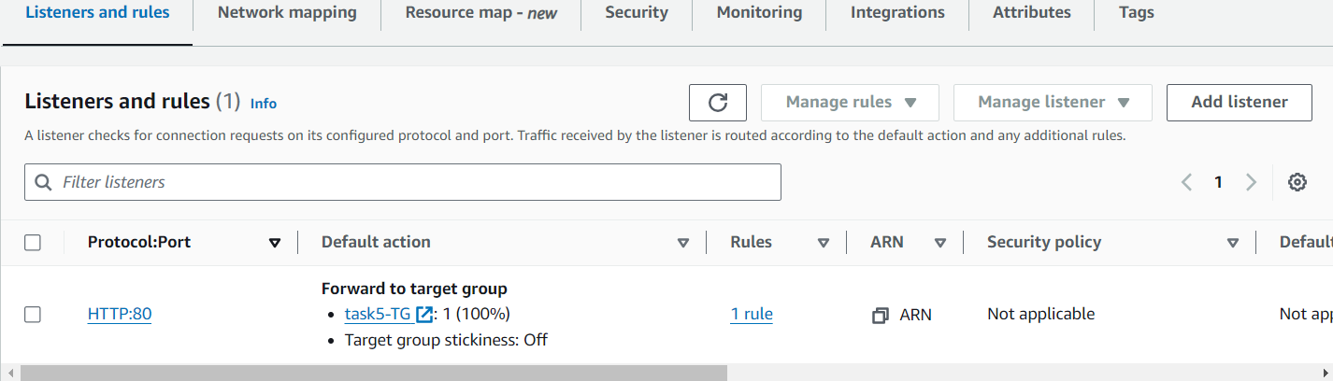

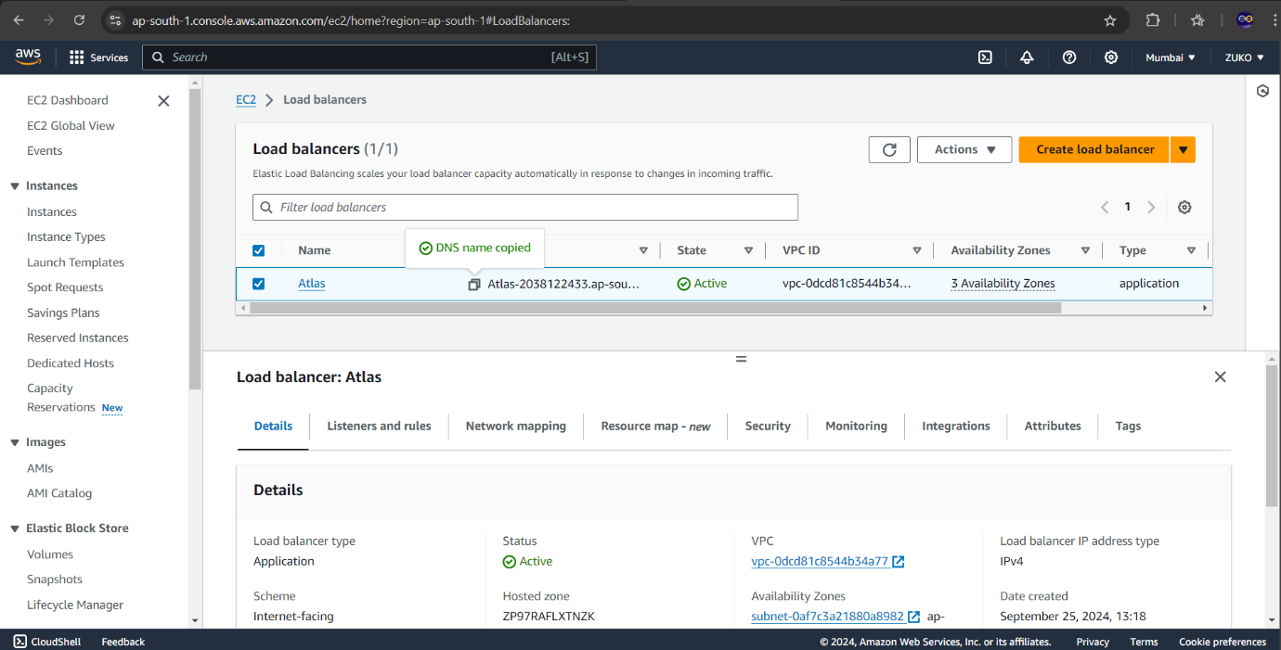

When hitting the DNS name of the load balancer

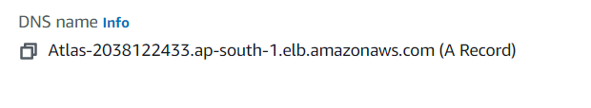

OUTPUT

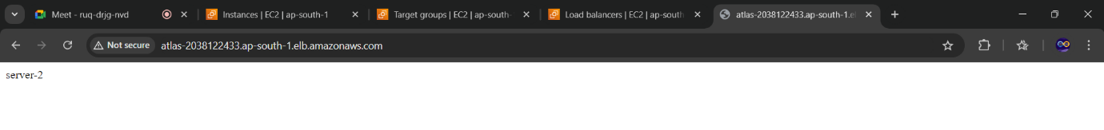

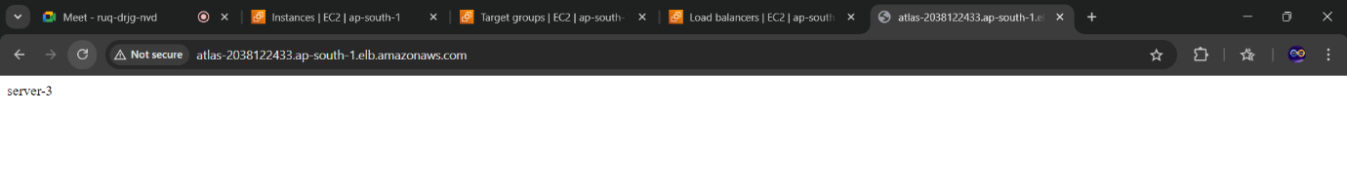

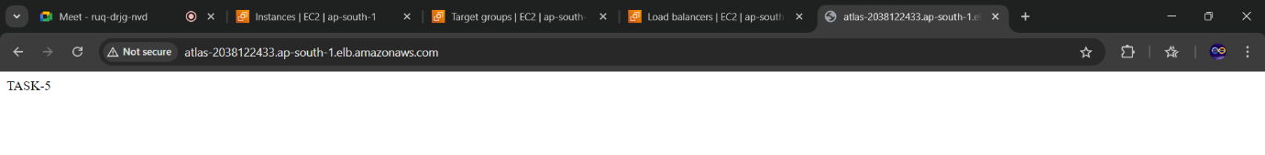

Round‑robin load balancing is one of the simplest methods for distributing client requests across a group of servers. Going down the list of servers in the group, the round‑robin load balancer forwards a client request to each server in turn.